Supplementary Information
Location | Instrument | Measured Parameters | Resolution
Stack | CO Analyzer | CO, CO₂ concentrations | 1 sec
 | NOx Analyzer | NO, NO_{x} concentrations | 1 sec
Aerosol Sampling Van | Single Particle Soot Photometer (SP2) | Black carbon number and mass size distributions | 1 sec
 | High Resolution – Time of Flight - Aerosol Mass Spectrometer (HR-ToF-AMS) | Non-refractory particle components: organic, sulfate, nitrate, ammonium, and chloride | 5 min: 2 min V, 2 min W, 1 min LS
 | Particle filter sampling (PM 0.18, PM1) – Fourier Transform Infrared Spectroscopy (FTIR) | Alkane, amine, hydroxyl, carbonyl and carboxylic acid functional groups | ~1 hr
 | Scanning Electrical Mobility Sizer (SEMS) | Particle size distributions  (0.01 – 1 μm) | 5 min
 | Aerodynamic Particle Sizer (APS), | Particle size distributions  (0.3 – 10 μm) | 5 min
 | Optical Particle Sizer (OPS) | Particle size distributions  (0.5 – 20 μm) | 5 min
 | Licor CO₂ Analyzer | CO₂ concentrations | 1 sec
Lower NO_{x} but Higher Particle Number and Black Carbon Emissions from Renewable Diesel compared to Ultra Low Sulfur Diesel in at-sea Operations for a Research Vessel
Raghu Betha¹, Lynn M. Russell^{1*}, Kevin J. Sanchez¹, Jun Liu¹, Derek J. Price¹, Maryam A. Lamjiri¹, Chia-Li Chen ¹, Xiaobi M. Kuang², Gisele O. da Rocha^{2,3}, Suzanne E. Paulson², J. Wayne Miller⁴, David R. Cocker⁴

¹Scripps Institution of Oceanography, University of California San Diego, La Jolla, California, USA
²Department of Atmospheric and Oceanic Sciences, University of California Los Angeles, Los Angeles, California, USA
³Instituto de Química, Universidade Federal de Bahia, Bahia, Brazil
⁴Bournes College of Engineering – Center for Environmental Research and Technology, University of California Riverside, Riverside, California, USA.

Table S1: Sampling instruments and measured parameters

Table S2. Criteria used to determine measurements in plume.
Instrument | Measurement | Criteria used to determine measurements in plume
Licor | CO₂ | (CO₂ - CO_{2,bgd}) > 10 ppm
HR-ToF-AMS | Mass fragments of organic particle components and their distribution | Organic mass concentration > 2 µg m⁻³ (> 0.5 for aged).
SEMS | Submicron particle number concentrations and size distributions | SEMS number concentration > 10⁵ cm⁻³.
CPC | Total particle number concentrations | CPC number concentration > 10⁴ cm⁻³.
SP2 | Black carbon number, mass concentrations, and size distributions | Black carbon mass > 2 µg m⁻³.

Date | Test Cycle Time | Fuel | Instrument | 1600 rpm | 1300 rpm | 1000 rpm | 700 rpm
9/29/14 | 14:00 - 17:00 | HDRD | SEMS | 80% | 80% | 70% | 55%
9/30/14 | 07:00-11:00 | HDRD |  | 55% | 30% | 30% | 30%
 | 13:00-17:00 |  |  | 25% | 40% | 44% | 20%
10/1/14 | 07:00-11:00 | ULSD |  |  |  | 50% | 10%
 | 14:00 - 17:00 |  |  | 35% | 15% | 15%
10/2/14 | 06:00 - 10:00 | HDRD |  | 25% |  |  | 20%
 | 10:00 - 14:00 |  |  | 55%
9/4/15 | 07:30 - 10:30 | HDRD | SEMS |  | 60% | 40% | 70%
 |  |  | Gases | 100% | 100% | 100% | 100%
 |  |  | SP2 |  |  | 21% | 38%
 | 17:00 - 21:00 |  | SEMS | 80% | 70% | 54% | 40%
 |  |  | Gases | 100% | 100% | 100% | 100%
 |  |  | SP2 | 58% | 54% | 45% | 48%
9/5/15 | 07:00-11:00 | ULSD | SEMS | 27% | 30% | 36%
 |  |  | Gases | 100% | 100% | 100% | 100%
 |  |  | SP2 | 52% | 34% | 45% | 45%
 | 15:30-19:10 |  | SEMS | 100% | 100% | 100% | 45%
 |  |  | Gases | 100% | 100% | 100% | 100%
 |  |  | SP2 | 57% | 82% | 78% | 79%
9/26/15 | 07:00-11:00 | HDRD | SEMS | 16% | 30%
 |  |  | Gases | 100% | 100% | 100% | 100%
 |  |  | SP2 | 37.50% | 22% | 27% | 28%
 | 17:00 - 21:00 |  | SEMS |  | 30% | 40% | 70%
 |  |  | Gases | 100% | 100% | 100% | 100%
 |  |  | SP2 | 5% | 40% | 51% | 54%
9/27/15 | 06:00 - 13:00 | HDRD | SEMS |  |  | 40% | 40%
 |  |  | Gases | 100% | 100% | 100% | 100%
 |  |  | SP2 | 5% | 5% | 50% | 50%
 | 19:00 - 22:00 |  | SEMS | 20% | 90% | 20%
 |  |  | Gases | 100% | 100% | 100% | 100%
 |  |  | SP2 | 50% | 44% | 17%
Table S3: Engine test cycles considered for data analysis: Categorized based on instruments (a) Scanning Electrical Mobility Sizer (SEMS), (b) Single Particle Soot photometer (SP2), (c) CO and NOx Gas Analyzers. Data from the SP2 and Gas analyzers were not available for the 2014 cruise.

Table S4: Gas and particle emission factors for HDRD and ULSD (Mean ± Std.Dev).

 | HDRD | ULSD
 | $${EF}_{{NO}_{X}}$$
1600 rpm | 51 ± 2.0 | 51 ± 0.78
1300 rpm | 47 ± 2.4 | 52 ± 0.61
1000 rpm | 50 ± 1.9 | 57 ± 0.90
700 rpm | 56 ± 2.2 | 64 ± 0.60
 | $${EF}_{CO}$$
1600 rpm | 3.9 ± 0.20 | 4.0 ± 0.07
1300 rpm | 5.1 ± 0.26 | 5.5 ± 0.17
1000 rpm | 7.9 ± 0.43 | 9.1 ± 0.04
700 rpm | 9.3 ± 0.45 | 12 ± 0.34
 | $${EF}_{N}$$
1600 rpm | 1.7 ± 0.54 x 10¹⁶ | 1.1 ± 0.37 x 10¹⁶
1300 rpm | 2.1 ± 0.64 x 10¹⁶ | 1.0 ± 0.51 x 10¹⁶
1000 rpm | 1.3 ± 0.47 x 10¹⁶ | 0.85 ± 0.39 x 10¹⁶
700 rpm | 0.89 ± 0.38 x 10¹⁶ | 0.59 ± 0.43 x 10¹⁶
 | $${EF}_{M}$$
1600 rpm | 1.1 ± 0.72 | 0.77 ± 0.32
1300 rpm | 1.2 ± 0.52 | 0.50 ± 0.31
1000 rpm | 1.7 ± 0.46 | 0.78 ± 0.43
700 rpm | 1.1 ± 0.47 | 1.2 ± 0.71
 | $${EF}_{BCN}$$
1600 rpm | 1.5 ± 0.71 x 10¹⁴ | 1.0 ± 0.13 x 10¹⁴
1300 rpm | 2.0 ± 0.49 x 10¹⁴ | 0.42 ± 0.20 x 10¹⁴
1000 rpm | 1.6 ± 0.57 x 10¹⁴ | 0.38 ± 0.21 x 10¹⁴
700 rpm | 1.7 ± 0.53 x 10¹⁴ | 0.40 ± 0.13 x 10¹⁴
 | $${EF}_{BCM}$$
1600 rpm | 0.13 ± 0.05 | 0.11 ± 0.02
1300 rpm | 0.17 ± 0.04 | 0.05 ± 0.03
1000 rpm | 0.14 ± 0.05 | 0.05 ± 0.03
700 rpm | 0.16 ± 0.05 | 0.05 ± 0.02

Table S5: Wind speed (m/s) during different engine cycle tests
Date | Test Cycle Time | Fuel | 1600 rpm | 1300 rpm | 1000 rpm | 700 rpm
9/29/14 | 14:00 - 17:00 | HDRD | 9.4 | 5.2 | 6.4 | 5.8
9/30/14 | 07:00-11:00 | HDRD | 4.1 | 3.2 | 3.4 | 3.2
 | 13:00-17:00 |  | 4.3 | 6.0 | 7.7 | 8.9
10/1/14 | 07:00-11:00 | ULSD | 3.2 | 0.9 | 3.4 | 2.6
 | 14:00 - 17:00 |  | 4.3 | 3.3 | 3.2 | 2.6
10/2/14 | 06:00 - 10:00 | HDRD | 4.0 | 2.9 | 2.6 | 2.5
 | 10:00 - 14:00 |  | 4.0 | 3.0 | 2.3 | 2.6
9/4/15 | 07:30 - 10:30 | HDRD | 3.2 | 3.6 | 2.7 | 3.0
 | 17:00 - 21:00 |  | 4.4 | 4.3 | 4.3 | 4.0
9/5/15 | 07:00-11:00 | ULSD | 3.5 | 3.3 | 2.7 | 2.1
 | 15:30-19:10 |  | 5.1 | 4.8 | 4.2 | 4.6
9/26/15 | 07:00-11:00 | HDRD | 3.0 | 2.9 | 2.4 | 2.4
 | 17:00 - 21:00 |  | 2.9 | 3.0 | 2.7 | 3.0
9/27/15 | 06:00 - 13:00 | HDRD | 2.8 | 2.3 | 2.8 | 2.4
 | 19:00 - 22:00 |  | 3.4 | 3.7 | 2.9

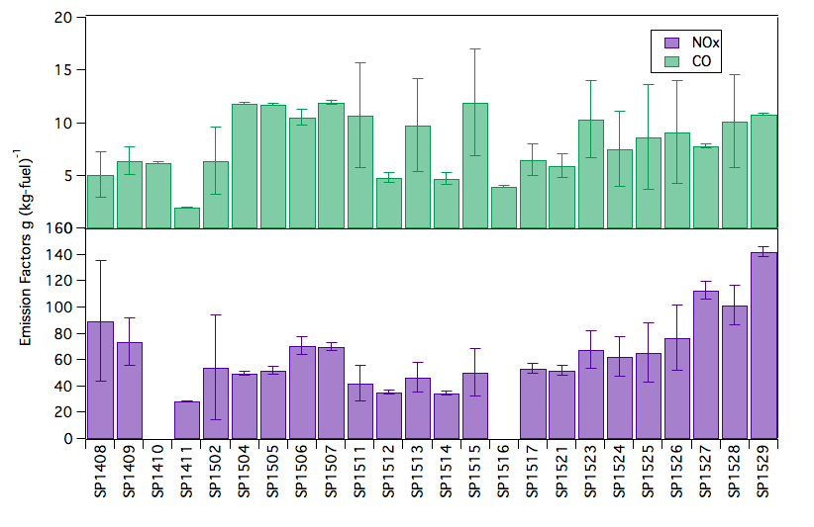

Figure S1. Emission factors (EF) of CO and NOx for HDRD during non-dedicated cruises of R/V Sproul between 11/15/14 – 11/20/15. (Cruise numbers are provided on x-axis). NOx analyzer data was not available for SP1410 and SP1516 due to instrument maintenance.

Variability in particle and BC emission factors

Particle and BC emission factors generally increased with increasing engine speeds for typical underway engine speeds; however, at each engine speed EF_{N} and EF_{M} were varied substantially between cycles, with cycle-to-cycle standard deviations that ranged from 28 to 40%. The variability in EF_{M} and EF_{N} at different engine speeds likely resulted from several factors, including both sampling limitations (the time resolution of the submicron size distributions) and differences in engine load (associated with changes in relative wind and current direction and speed as well as sea state).

The sampling limitation is that the 5-sec time resolution of each size bin of the SEMS meant that plume conditions varied within each bin, contributing to measurement variability. However, normalizing by the simultaneous 5-sec excess CO₂ concentration reduced much of the variability within each 1-hr engine speed sample, resulting in standard deviations of 20-35%.

During the different engine cycles (shown in Figure 2), emissions were measured at sea under a variety of ocean conditions, such that some of the cycle-to-cycle variability in the results can be explained by the sea state. Figure S2 shows that particle and BC emission factors generally decreased with increasing vessel speed, with decreasing variability in vessel pitch (estimated as the standard deviation (SD) of the reported pitch), and with decreasing roll for the same engine speed. The roll, pitch and speed of vessel (at constant engine speed) provide indicators of the sea state for the same relative current, so that higher variability in pitch, higher roll, and decreased vessel speed for the same engine speed typically indicate higher sea state. However, since current also varied during the at sea operations and the number of engine cycles measured was small, moderate to strong correlations between sea state and emissions were only found at certain speeds.

EF_{N} and EF_{M} had correlations to the standard deviation of pitch of the vessel higher than R² >0.4 at 1600 rpm and to the roll at 700 rpm. Vessel speed generally decreased with increasing variability in the pitch and roll of the vessel, but the correlations of EF_{N} and EF_{M} to vessel speed (at constant engine speed) were all weak. The dependence of EF_{BCN} and EF_{BCM} on pitch variability, roll and speed of the vessel were similar to the results for particle number and mass emission factors, respectively.

In summary, EF_{M}, EF_{N,} EF_{BCM} and EF_{BCN} generally increased with increasing variability in pitch, increasing roll, and decreasing vessel speed (all of which indicate higher engine load). However, since the sample number was small and ocean current varied along the 2014 and 2015 cruise tracks, the correlations were very weak at most engine speeds.

Table S6: R² values for the correlation between Particle Number (EF_{N}), Particle Mass (EF_{M}) and Black Carbon Number (EF_{BCN}) and Black Carbon Mass (EF_{BCM}) emission factors for HDRD and Pitch Standard Deviation (SD), Vessel Speed, and Roll of the ship at the engine speed specified.

 | Pitch SD | Speed | Roll
1600 rpm
EF_{M} | 0.45 | 0.01 | 0.33
EF_{N} | 0.82 | 0.05 | 0.01
EF_{BCM} | 0.64 | 0.02 | 0.25
EF_{BCN} | 0.63 | 0.05 | 0.53
1300 rpm
EF_{M} | 0.57 | 0.16 | 0.18
EF_{N} | 0.23 | 0.02 | 0.03
EF_{BCM} | 0.11 | 0.08 | 0.1
EF_{BCN} | 0.13 | 0.01 | 0.17
1000 rpm
EF_{M} | 0.26 | 0.25 | 0.32
EF_{N} | 0.27 | 0.35 | 0.33
EF_{BCM} | 0.14 | 0.01 | 0.05
EF_{BCN} | 0.12 | 0.25 | 0.35
700 rpm
EF_{M} | 0.01 | 0 | 0.8
EF_{N} | 0.34 | 0.15 | 0.87
EF_{BCM} | 0.14 | 0.09 | 0.62
EF_{BCN} | 0.03 | 0.1 | 0.51

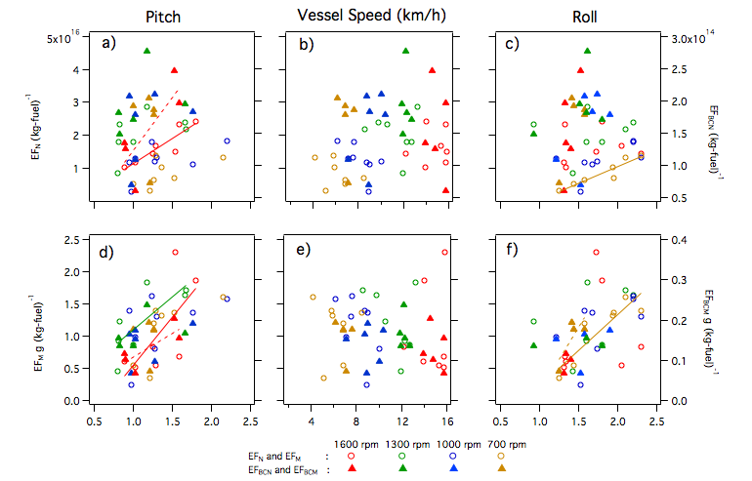
Figure S2. Particle and black carbon emission factors (EF) at 1600, 1300, 1000, and 700 rpm as functions of vessel speed, variability in pitch (indicated as standard deviation, SD, of pitch), and roll measured during the 2014 cruise (9/29/14 – 10/3/14) and the 2015 cruise (9/4/15 – 9/6/15 and 9/26/15 – 9/28/15). The line fits are shown only for the variables with R² greater than 0.4. (R² for all engine speeds are given in Table S5 in supplemental information.) (EF_{BCN}: Black Carbon Number; EF_{BCM}: Black Carbon Mass; EF_{N}: Particle Number; and EF_{M}: Particle Mass)

