Appendix A. Further details on the experiments. This appendix provides a map of the study area showing the location of the 15 sites (Fig. A1); an illustrated description of the categories used to classify the seed set success of Dryas (Fig. A2); an illustration of the devices used to exclude pollinators (Fig A3) and a graphical representation of the sticky traps used to sample flower visitors (Fig A4).

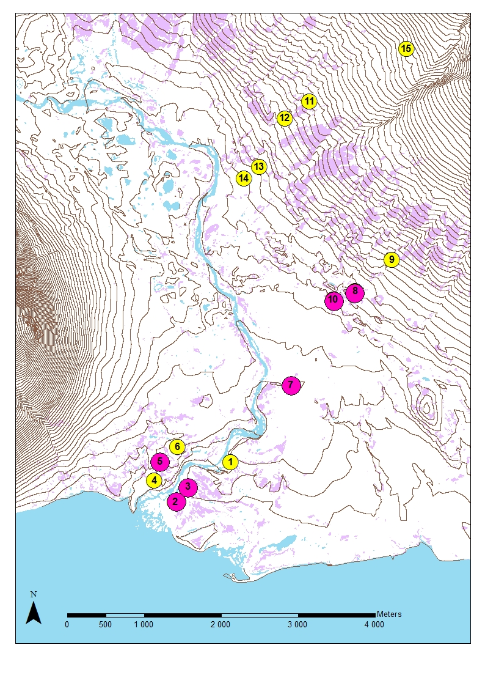
Fig. A1. Map of the study area with the location of the 15 sites. The colour coding identifies sites sampled only in the early season (yellow symbols) versus in both the early and the late season (pink circles). Purple areas on the base map represent Dryas heathlands. Contour lines show elevation at 10 meter intervals.
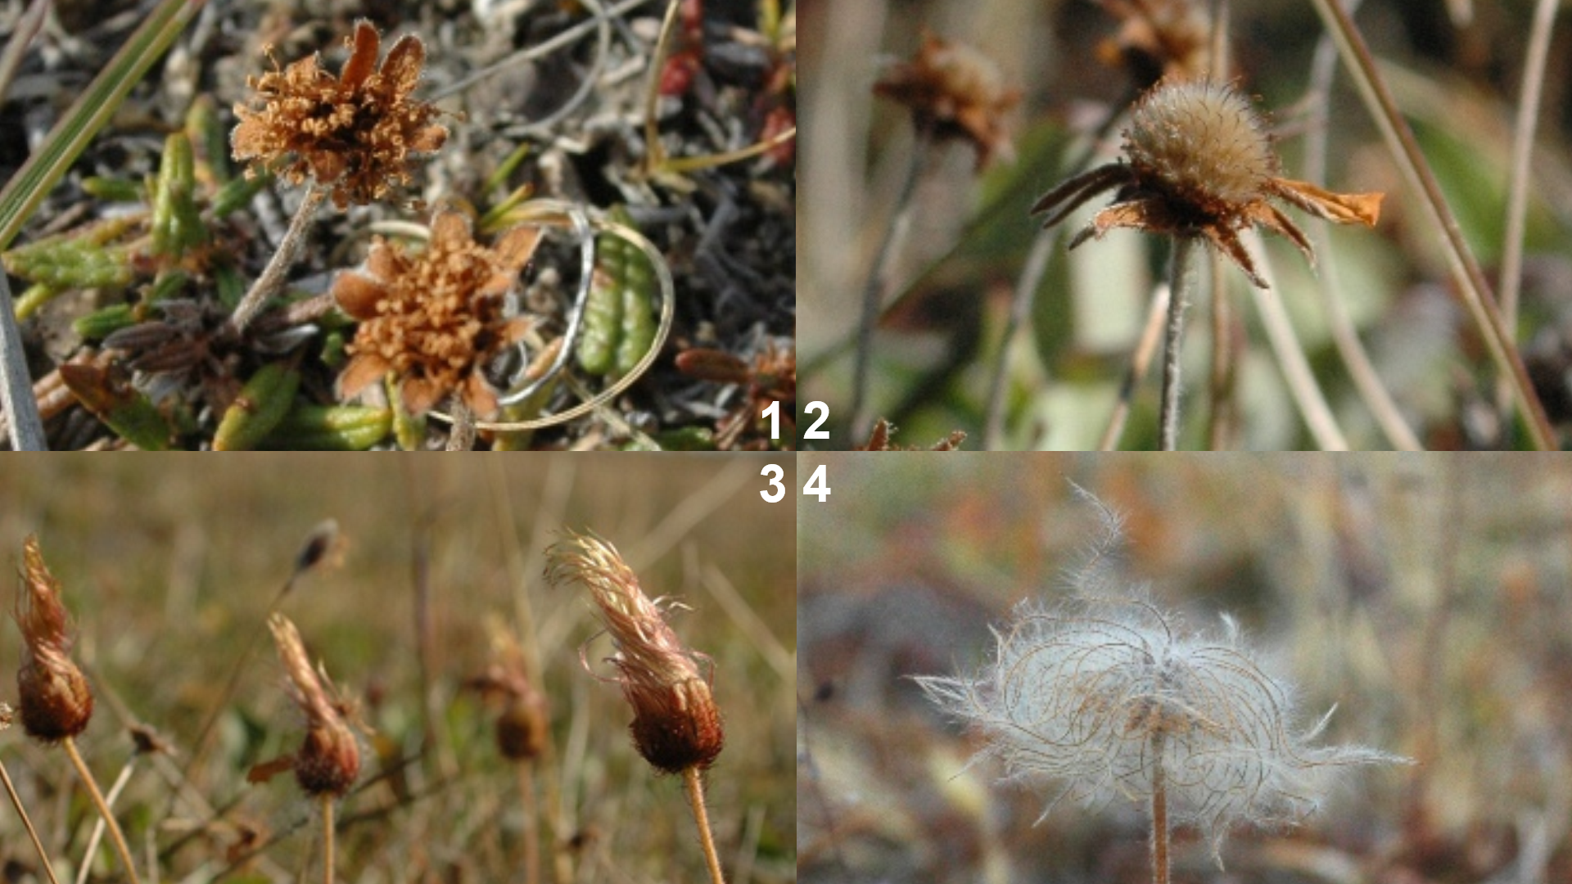
Fig. A2. Classification used to score the success of seed set in individual seed heads of Dryas. At the end of the season, we counted all the seed heads of Dryas in the study squares and classified them in to four categories:
1. Dry flower: no pistil or seed head visible
2. Flower with visible, round pistil but no clear seed head
3. Flower with clear, “torch”-like seed head
4. Open, umbrella-like seed head
Since fully-developed Dryas seeds possess a clear pappus, categories 3 and 4 were assumed to reflect viable seeds, while categories 1 and 2 were assumed to represent failed seed production.

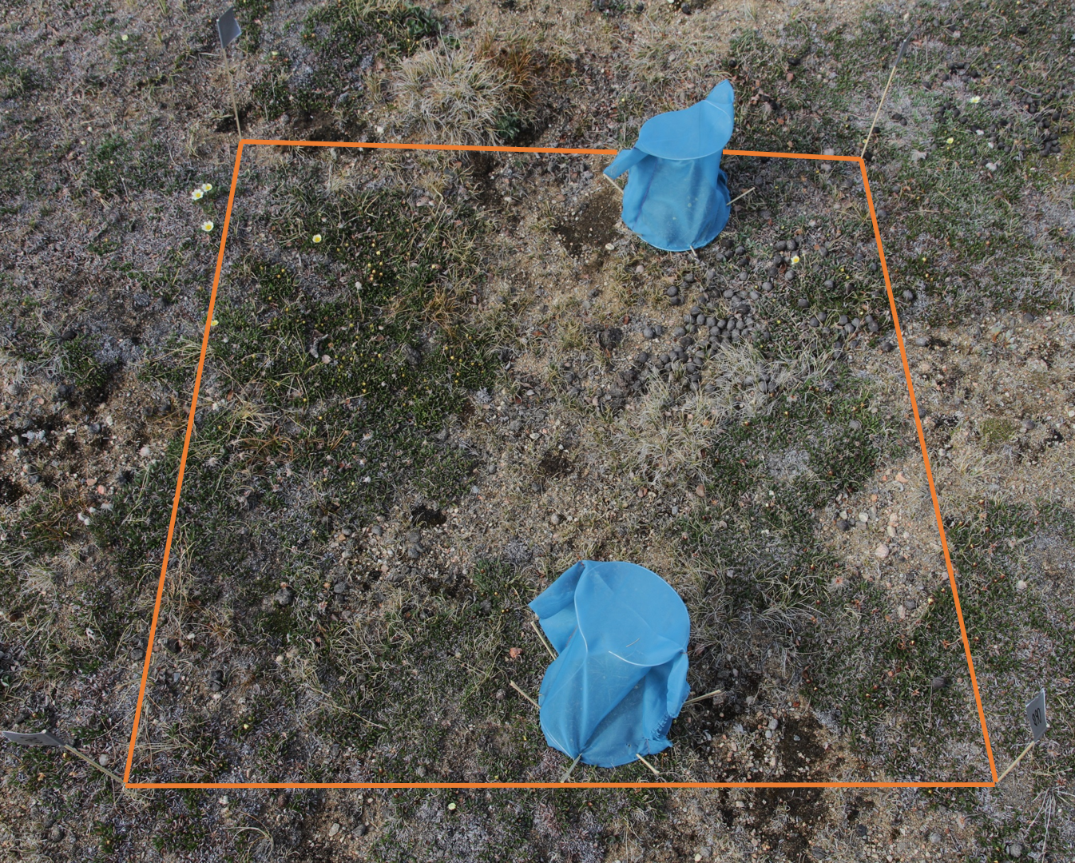
Fig A3. Devices used to exclude insect visitors. Sampling grids of 1m × 1m were marked with small flags made out of cocktail sticks and duct tape. To exclude pollinators from visiting selected flowers in each study square, we used two small tents. Twenty sticky traps (see Fig. A4) were placed within each sampling grid once half of the Dryas flowers had opened.

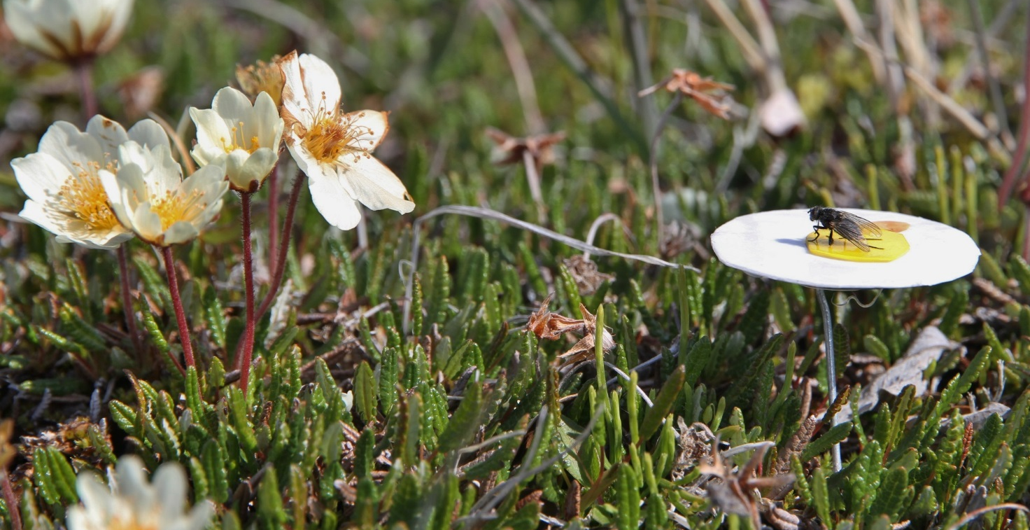
Fig A4. Sticky traps used to sample flower visitors. Each of these traps was made of two circular pieces of sticky paper: a white piece (ø30 mm; made of Sticky Roll, Barrettine Environmental Health, Barrettine Group, Bristol, UK) to represent the petals and a yellow piece (ø8 mm; Yellow Sticky Board, Barrettine Environmental Health, Barrettine Group, Bristol, UK) to represent the stamen. For attachment, we used a “stem” made out of iron wire, stuck into the soil to a depth exposing the flower mimic level with natural flower heads.

