Supplementary Fig 1.
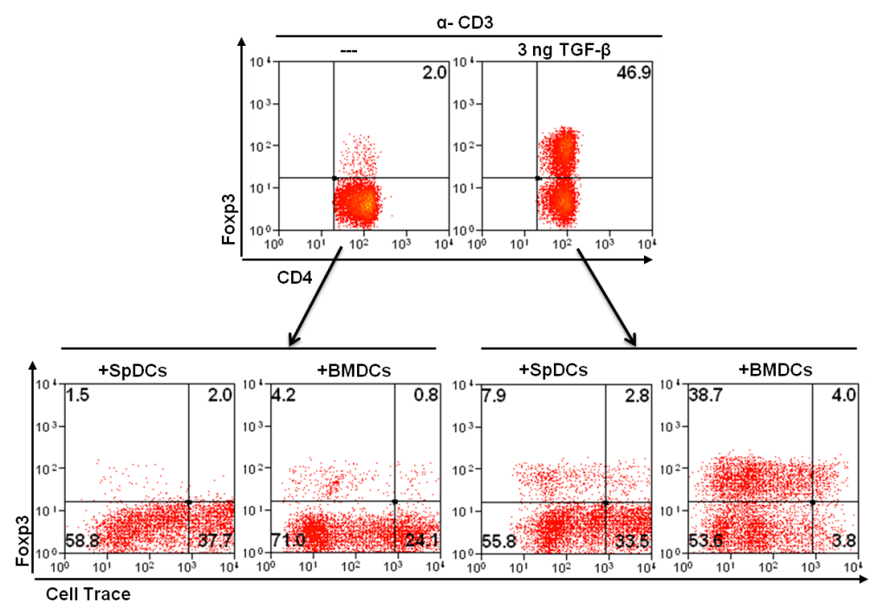
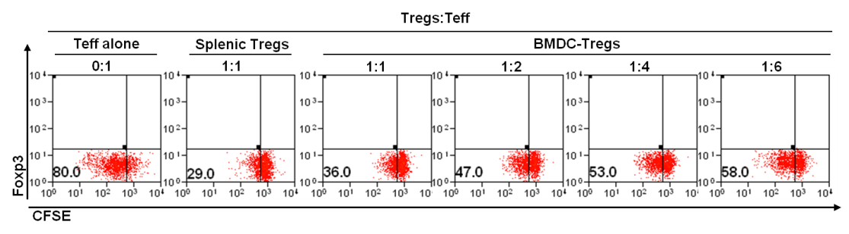
A
B

Supplementary Fig 1. BMDC are capable of expanding iTregs induced ex-vivo. A) CD4+CD25- T cells were purified from the spleens of NOD mice and cultured for 48hrs with α-CD3 alone (control) or α-CD3+TGF-β to induce Tregs. In the presence of TGF-β, about 50% of cells converted into Tregs, as marked by the Foxp3 expression (top panel). Cells were washed, labeled with Cell-Trace Violet, and co-cultured with either SpDCs (control) or BMDCs. Only BMDC-CD4 co-cultured show sustained expression and proliferation of Foxp3+ Tregs, compared to SpDCs controls (bottom panel). B) BMDC expanded Tregs retain their suppressive function. CD4+CD25- T effectors were isolated from the spleens of NOD mice, CFSE labeled and cultured in the presence of APCs+α-CD3 to induce proliferations. Tregs were isolated from 5 day BMDC-CD4+ T cells co-cultures. Tregs isolated directly from the spleen (splenic Tregs) were used as a positive control. BMDC-Tregs were co-cultured with CFSE-labeled Teff at different ratios. After 3 days in culture, cells were analyzed for Teffector proliferation using FACS. Teff cells show reduced proliferation in the presence of BMDC-Tregs.

Supplementary Fig 2
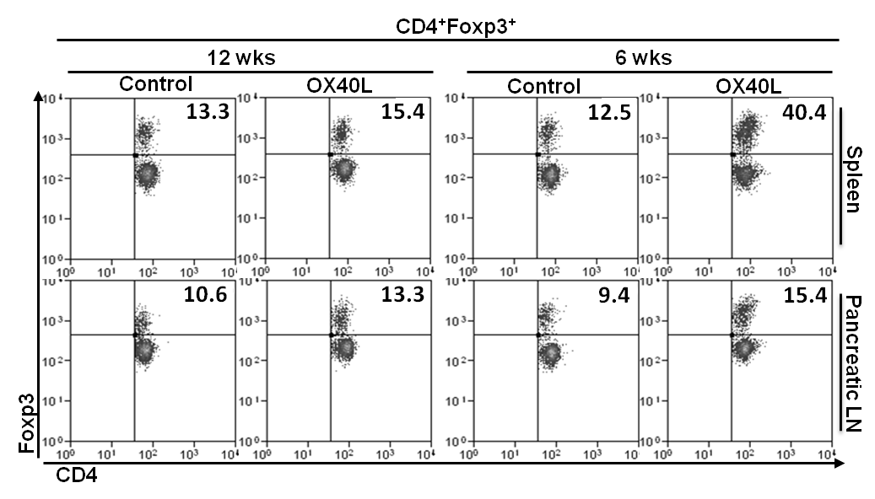
B
A
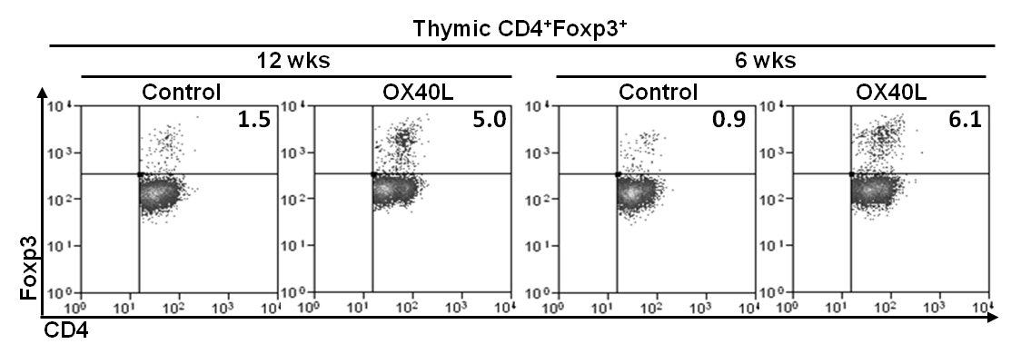

Supplementary Fig 2. Soluble OX40L treatment exhibits dichotomy in the expansion of Tregs in-vivo between 6 wk and 12 wk old NOD mice: A) Representative histograms comparing Treg percentages in spleen (top) and PLN (bottom) isolated from 12 or 6 wk old NOD mice, after three treatments of OX40L compared to controls. Cells were analyzed for Foxp3 expression by FACS. B) Representative histograms comparing Treg percentages in thymic tissues isolated from 12 or 6 wk old NOD mice, after three treatments of OX40L compared to controls. Cells were analyzed for Foxp3 expression by FACS.

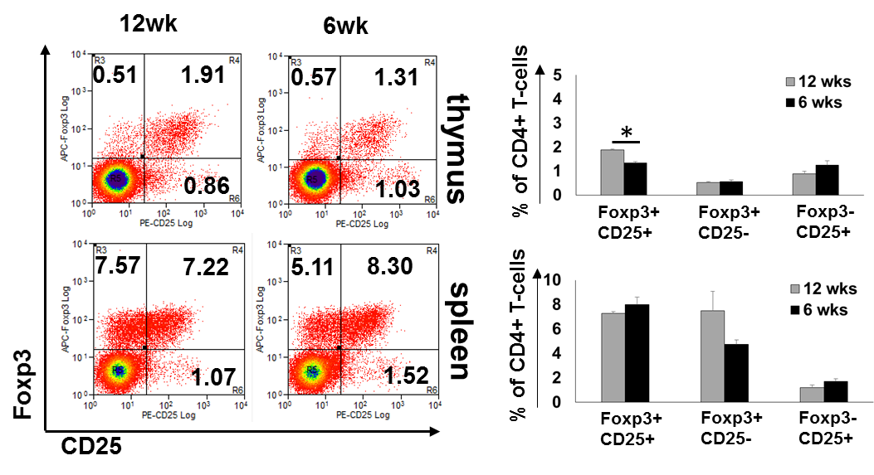
Supplementary Fig 3

Supplementary Fig 3. Analysis of CD25 and Foxp3 expression between 12 wk and 6 wk old NOD mice: Representative histograms (left) and summary bar graphs (right) showing Foxp3 and CD25 expression within CD4+ T-cell populations in thymus (top) and spleen (bottom) of 12 and 6-week old NOD mice comparing Treg percentages in spleen (top) and PLN (bottom) isolated from 12 or 6 wk old NOD mice, after three treatments of OX40L compared to controls. Cells were stained for CD4, CD25 and Foxp3 and analyzed by FACS (* indicates p<0.05).

