Supplementary Information

The simulation of magnetic field which induces separation of leukemia cells and prostate cancer cells was performed by referring to the magnet arrangement as demonstrated in Figure S4 in the Supporting Information of the article reported by Song and coworkers [1]. The simulation was carried out by module ‘Magnetic Fields’ from COMSOL Multiphysics version 5.1. Since the remanent magnetic flux density of the magnet is not given, the magnitude of 1.45 T was adopted in this simulation as this is the remanent magnetic flux density generated by NdFeB magnet. As illustrated in Figure S1, the 2D plot of magnetic field gradient simulated is similar to that of Figure S4 in the Supporting Information reported by Song and coworkers. Figure S2 illustrates the magnetic field gradient profiles along the magnetic scaffold (indicated by blue line in Figure S1). According to Figure S2, it can be observed that the magnetic field gradient involved in this magnetic separating is ranging from 0 to about 100 T/m, which can be classified as LGMS.

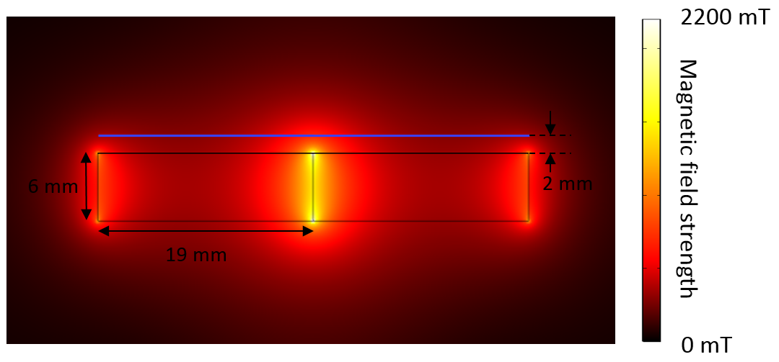
Figure S1. 2D plot of magnetic field strength according to magnet configuration in the magnetic separation as reported by Song and coworkers. This figure is similar to Figure S4 in the Supporting Information provided by the given work.
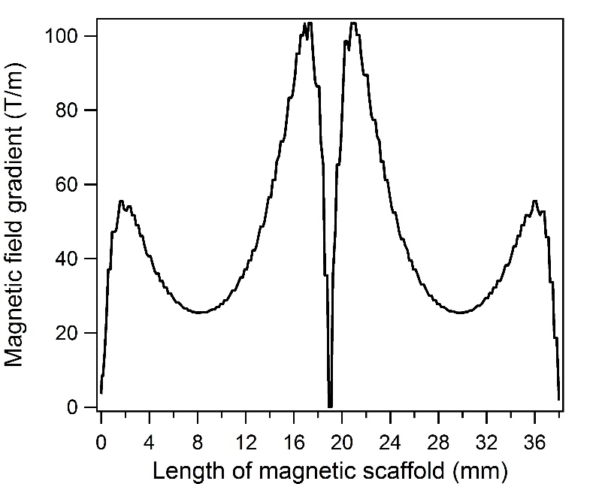
Figure S2. Magnetic field gradient along the magnetic scaffold (indicated by blue line in Figure S1).

References
[1] Song, E.-Q., Hu, J., Wen, C.-Y., Tian, Z.-Q., Yu, X., Zhang, Z.-L., Shi, Y.-B. & Pang, D.-W. 2011 Fluorescent-Magnetic-Biotargeting Multifunctional Nanobioprobes for Detecting and Isolating Multiple Types of Tumor Cells. ACS Nano 5, 761-770. (doi:10.1021/nn1011336).

