Fuzzy Decision Making Approach to Identify Optimum Enzyme Targets and Drug Dosage for Remedying Presynaptic Dopamine Deficiency

Kai-Cheng Hsu and Feng-Sheng Wang*
Department of Chemical Engineering
National Chung Cheng University
Chiayi 62102, Taiwan
Email: Kai-Cheng Hsu - edwardfirst@gmail.com; Feng-Sheng Wang* - chmfsw@ccu.edu.tw

Supplementary file 2:
The kinetic model of the presynaptic dopamine metabolic pathway (S2-1 Fig) was modified from Qi et al. (2008). Detailed lists of all metabolites, variable names in the model, and abbreviations are presented in Supplementary S2-1 Table. Metabolites for the therapeutic effect are highlighted in red, whereas toxic species, reactive oxygen and nitrogen species for adverse effects are highlighted in yellow.
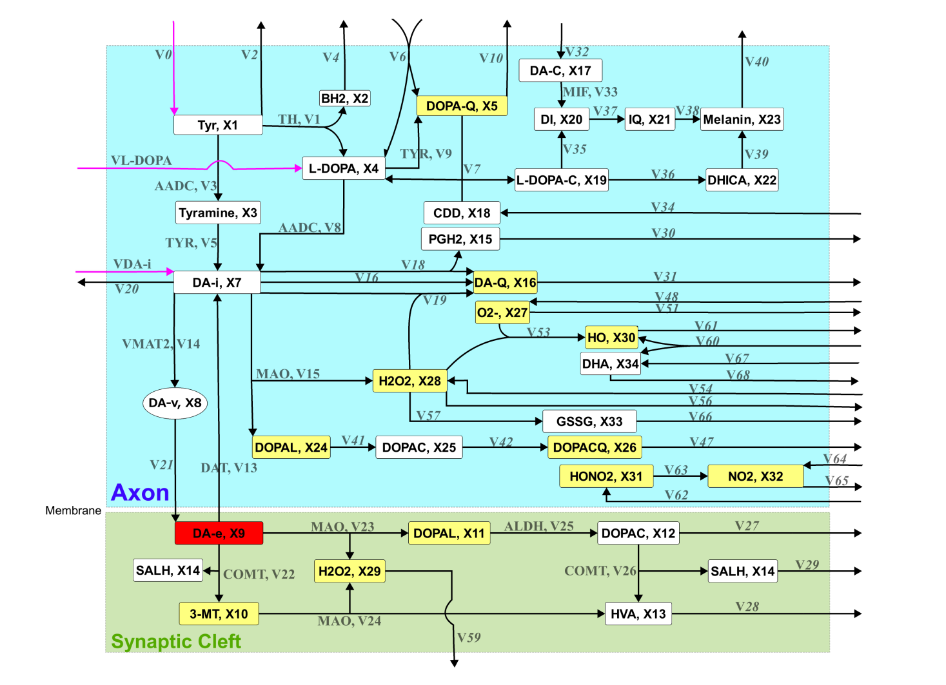 S2-1 Fig. Schematic network diagram of the presynaptic dopamine metabolic pathway.

S2-1 Table. ID and name of dependent and independent metabolites.
Variable (ID) | Name

Time dependent metabolites
x1 | Tyrosine
x2 | Dihydrobiopterin
x3 | Tyramine
x4 | L-DOPA produced from tyrosine
x5 | Dopaquinone
x6 | Pyrrolo-quinoline quinone
x7 | Intracellular dopamine
x8 | Dopamine packed in vesicles
x9 | Extracellular dopamine
x10 | 3-Methoxytyramine
x11 | Extracellular DOPAL
x12 | Extracellular DOPAC
x13 | HVA
x14 | S-Adenosyl-L-homocysteine
x15 | Prostaglandin H2
x16 | Dopamine quinone
x17 | Dopamine chrome
x18 | 2-Carboxy-2,3-dihydro-5,6-dihydroxyindole
x19 | L-Dopachrome
x20 | 5,6-Dihydroxyindole
x21 | Indole-5,6-quinone
x22 | 5,6-Dihydroxyindole-2-carboxylate
x23 | Melanin
x24 | Intracellular DOPAL
x25 | Intracellular DOPAC
x26 | DOPAC quinone
x27 | Superoxide O2 − .
x28 | Intracellular hydrogen peroxide H2O2
x29 | Extracellular hydrogen peroxide H 2 O 2
x30 | hydroxyl radical HO·
x31 | Peroxynitrite HO· — NO2 .
x32 | Nitrogen dioxide NO2
x33 | Oxidized glutathione
x34 | Dehydroascorbate

Non-time dependent metabolites
x35 | Tyrosine hydroxylase
x36 | Tyrosinase
x37 | Prostaglandin G/H synthase
x38 | XO xanthine oxidase
x39 | ALDH aldehyde dehydrogenase
x40 | Monoamine oxidase
x41 | Semicarbazide-sensitive amine oxidase
x42 | DOPA decarboxylase
x43 | Dopachrome isomerase
x44 | Catalase
x45 | Superoxide dismutase
x46 | Extracellular aldehyde dehydrogenase
x47 | Extracellular monoamine oxidase
x48 | Catechol O-methyltransferase
x49 | Glutathione peroxidase
x50 | Glutathione reductase
x51 | Extracellular semicarbazide-sensitive amine oxidas
x52 | Migration inhibitory factor

S2-2 Table. Reaction equation and its corresponding identifier in the metabolic network.
Identifier | Enzyme | Reaction Equation
uldopa | L-DOPA input | -> x4
udopamine | dopamine input | -> x7
utyrosine | tyrosine input | -> x1
v1 | tyrosine hydroxylase (TH) | x1 -> x2 + x4
v2 | tyrosine output | x1 ->
v3 | DOPA decarboxylase (AADC) | x1 -> x3
v4 | BH2 output | x2 ->
v5 | tyrosinase (TYR) | x3 -> x7
v6 |  | -> x4 + x5
v7 |  | x5 + x18 -> x4 + x19
v8 | DOPA decarboxylase (AADC) | x4 -> x7
v9 | tyrosinase (TYR) | x4 -> x5
v10 |  | x5 ->
v11 |  | -> x6
v12 |  | x6 ->
v13 | dopamine transporter(DAT) | x9 -> x7
v14 | vesicular monoamine transporter(VMAT2) | x7 -> x8
v15 | monoamine oxidase(MAO), semicarbazide-sensitive amine oxidase (SSAO) | x7 -> x24 + x28
v16 | autoxidation, TYR, X53, XO | x7 -> x16
v17 | autoxidation, TYR, X53, XO | x7 -> x16
v18 | autoxidation, TYR, X53, XO | x7 -> x15 + x16
v19 |  | x7 + x28 -> x16
v20 |  | x7 ->
v21 | vesicle secretion | x8 -> x9
v22 | catechol-O-methyltransferase(COMT) | x9 -> x10 + x14
v23 | MAO, SSAO | x9 -> x11 + x29
v24 | ALDH, MAO | x10 -> x13 + x29
v25 | aldehyde dehydrogenase (ALDH) | x11 -> x12
v26 | catechol-O-methyltransferase(COMT) | x12 -> x13 + x14
v27 |  | x12 ->
v28 |  | x13 ->
v29 |  | x14 ->
v30 |  | x15 ->
v31 |  | x16 ->
v32 |  | -> x17
v33 | migration inhibitory factor (MIF) | x17 -> x20
v34 |  | -> x18
v35 | tyrosinase (TYR) | x19 -> x20
v36 | dopachrome isomerase (DCT) | x19 -> x22
v37 | tyrosinase (TYR) | x20 -> x21
v38 |  | x21 -> x23
v39 |  | x22 -> x23
v40 |  | x23 ->
v41 | aldehyde dehydrogenase (ALDH) | x24 -> x25
v42 | tyrosinase (TYR) | x25 -> x26
v43 | tyrosinase (TYR) | x25 -> x26
v44 | tyrosinase (TYR) | x25 -> x26
v45 | tyrosinase (TYR) | x25 -> x26
v46 | tyrosinase (TYR) | x25 -> x26
v47 |  | x26 ->
v48 |  | -> x27
v49 |  | -> x27
v50 |  | -> x27
v51 |  | x27 ->
v52 |  | x27 ->
v53 |  | x27 + x28 -> x30
v54 |  | -> x28
v55 |  | -> x28
v56 |  | x28 ->
v57 |  | x28 -> x33
v58 |  | x28 ->
v59 |  | x29 ->
v60 |  | -> x30 + x34
v61 |  | x30 ->
v62 |  | -> x31
v63 |  | x31 -> x32
v64 |  | -> x32
v65 |  | x32 ->
v66 |  | x33 ->
v67 |  | -> x34
v68 |  | x34 ->

The rate equations were obtained from Qi et al. (2008). The value for each rate constant was evaluated at the healthy state.
Rate equations | Rate law
uldopa | uldopa
udopamine | udopamine
utyrosine | utyrosine
v1 | 12.34409 (X1^0.5) (X4^-0.3) (X5^-0.3) (X7^-0.3) (X16^-0.3) X35
v2 | 0.0005656854 (X1^0.5) (X4^0.5) X36
v3 | 0.01009356 (X1^0.5) (X7^-0.3) X42
v4 | 300.4164 (X2^0.5)
v5 | 0.001825742 (X3^0.5) (X4^0.5) X36
v6 | 0.0002828427 (X1^0.5) (X4^0.5) X36
v7 | 2.767677 (X5^0.5) (X18^0.5)
v8 | 6.670782 (X4^0.5) (X7^-0.3) X42
v9 | 0.3478394 X4 (X30^0.5)
v10 | 24.75485 (X5^0.5)
v11 | 18.2567 (X5^0.5)
v12 | 9.128352 (X6^0.5)
v13 | 4.198429 X9
v14 | 2.998878 X7
v15 | 0.001785214 (X7^0.5) X40 X41
v16 | 0.03710922 X7 (X30^0.5)
v17 | 0.0009917856 (X7^0.5) X36
v18 | 0.0009917856 (X7^0.5) X37
v19 | 0.00044354 (X7^0.5) (X28^0.5) X38
v20 | 0.2975357 (X7^0.5)
v21 | 0.03894646 X8
v22 | 0.6772013 (X9^0.5) (X12^-0.3) (X14^-0.3) X48
v23 | 0.001049607 (X9^0.5) X47 X51
v24 | 0.004693986 (X10^0.5) X46 X47
v25 | 2.642754 (X11^0.5) (X12^-0.3) X46
v26 | 1.642312 (X9^-0.3) (X12^0.5) (X14^-0.3) X48
v27 | 4.198429 (X12^0.5)
v28 | 30.85202 (X13^0.5)
v29 | 168.9835 (X14^0.5)
v30 | 1.173497 (X15^0.5)
v31 | 14.10638 (X16^0.5)
v32 | 12.69575 (X16^0.5)
v33 | 0.1269575 (X17^0.5) X52
v34 | 6.188713 (X5^0.5)
v35 | 0.005569842 (X4^0.5) (X19^0.5) X36
v36 | 0.006188713 (X19^0.5) X43
v37 | 0.02352434 (X4^0.5) (X20^0.5) X36
v38 | 23.52434 (X21^0.5)
v39 | 0.6188713 (X22^0.5)
v40 | 17.07183 (X23^0.5)
v41 | 15.07592 (X24^0.5) (X25^-0.3) X39
v42 | 0.3578389 X25 (X30^0.5)
v43 | 0.02677821 (X25^0.5) X36
v44 | 0.004463035 (X25^0.5) X45
v45 | 0.3155842 (X25^0.5) (X31^0.5)
v46 | 0.6311685 (X25^0.5) (X32^0.5)
v47 | 149.3617 (X26^0.5)
v48 | 0.6956788 X4 (X30^0.5)
v49 | 0.07421844 X7 (X30^0.5)
v50 | 0.7156778 X25 (X30^0.5)
v51 | 3.065113 (X27^0.5) X45
v52 | 38.13551 X27
v53 | 0.171345 X27 X28
v54 | 1.532556 (X27^0.5) X45
v55 | 33.41228 X27
v56 | 1.308324 (X28^0.5) X44
v57 | 1.308324 (X28^0.5) X49
v58 | 78.01336 X28
v59 | 296.8737 (X29^0.5)
v60 | 39.00668 X28
v61 | 140.9384 (X30^0.5)
v62 | 4.723232 X27
v63 | 0.01686869 X25 X31
v64 | 23.61616
v65 | 0.03373737 X25 X32
v66 | 0.2925501 (X33^0.5) X50
v67 | 16.70614 X27
v68 | 27.85641 (X34^0.5)

The material balance equations in the metabolic network are expressed as follows:
x1' = utyrosine –v1 –v2 –v3
x2' = v1 –v4
x3' = v3 –v5
x4' = uldopa + v1 + v6 + v7 - v8- v9
x5' = v9 + v6 - v10 - v7
x6' = v11 - v12
x7' = udopamine + v8 + v5 + v13 - v14 - v15 - v16 - v17 - v18 - v19 - v20
x8' = v14 - v21
x9' = v21 - v22 - v23 - v13
x10' = v22 - v24
x11' = v23 - v25
x12' = v25 - v26 - v27
x13' = v24 + v26 -v28
x14' = v22 + v26 - v29
x15' = v18 - v30
x16' = v16 + v17 + v18 + v19 - v31
x17' = v32 - v33
x18' = v34 - v7
x19' = v7 - v35 - v36
x20' = v35 + v33 - v37
x21' = v37 - v38
x22' = v36 - v39
x23' = v38 + v39 - v40
x24' = v15 - v41
x25' = v41 - v42 - v43 - v44 - v45 - v46
x26' = v42 + v43 + v44 + v45 + v46- v47
x27' = v48 + v49 + v50 - v51 -v52 - v53
x28' = v15 + v54 + v55 - v56 - v57 -v58 - v53 - v19
x29' = v24 + v23 - v59
x30' = v60 +v53 - v61
x31' = v62 - v63
x32' = v64 + v63 - v65
x33' = v57 - v66
x34' = v67 + v60 -v68

