Electronic Supplementary Informations
Facile preparation of colorful liquid marbles and liquid marbles used in water pollutant detection
Zhihong Zhao, Yan Zhang, Liwei Ren, Bin Xiang, Jian Li *
Key Laboratory of Eco-Environment-Related Polymer Materials, Ministry of Education of China, Key Laboratory of Gansu Polymer Materials, College of Chemistry and Chemical Engineering, Northwest Normal University, Lanzhou 730070, China
*Corresponding author email: jianli83@126.com;

Supplementary figure:
Figure S1. FI-IR spectra of stearic acid and stearate powders.
Figure S2. The XRD pattern of copper stearate.
Figure S3. (a) Photograph of the copper stearate surface prepared by spraying copper stearate ethanol suspension on a stainless steel substrate. The water droplet on the surface with (b) a contact angle of 162 ± 1° and (c) a sliding angle as low as 4°.
Figure S4. The liquid marble enwrapped with superhydrophobic copper stearate floating on the water surface.

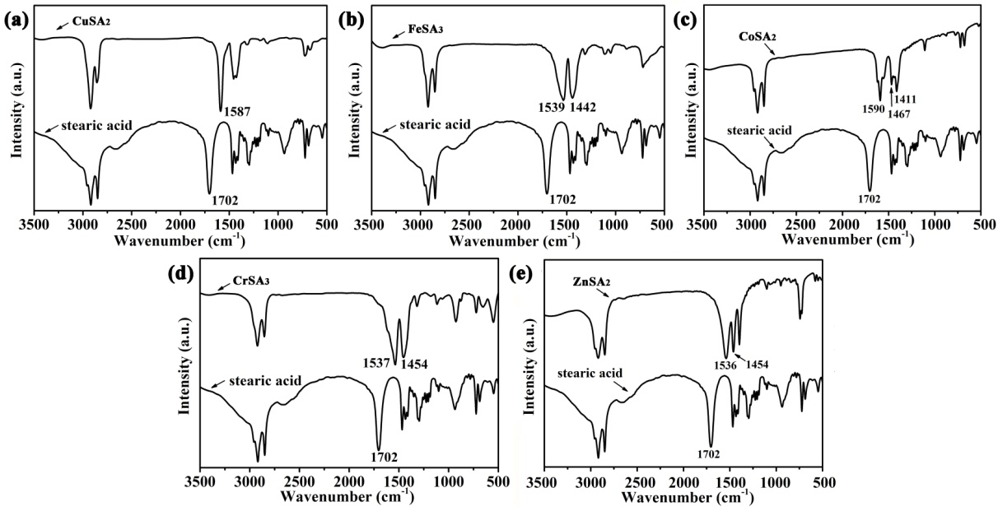
Figure S1. FI-IR spectra of stearic acid and stearate powders. 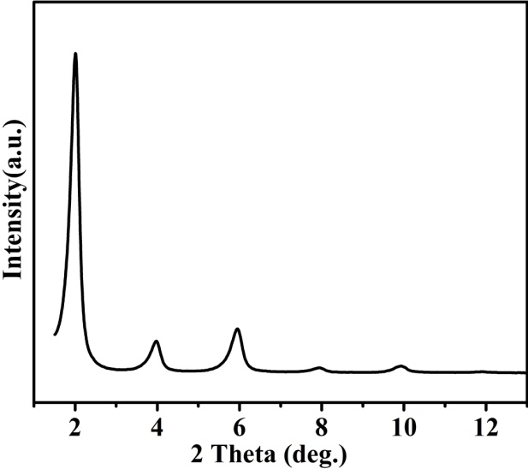
Figure S2. The XRD pattern of copper stearate.
In our study, it is the copper stearate particle to be the represent sample of the superhydrophobic colored stearate particles during the whole measurement. In hot water, Cu²⁺ ions coordinated with CH₃(CH₂)₁₆COO⁻ ions to form copper stearate. FT-IR spectrum and XRD pattern demonstrate the particle has the chemical composition of Cu[CH₃(CH₂)₁₆COO]₂. As shown in Fig. S1a, the FT-IR spectrum indicates that the free COO band from stearic acid at 1702 cm⁻¹ is no longer present, and a new band appears at 1587 cm⁻¹, corresponding to coordinated COO moieties [1, 2]. The XRD pattern (Fig. S2) further reveals that the as-prepared particle is crystallized and the distinct peaks appearing in the spectrum are assigned to stearate, which is consistent with the previous reported data of Huang [3]. Thus, we conclude that the obtained particle has a composition of Cu[CH₃(CH₂)₁₆COO]₂. From Fig. S3, it can be seen that the as-prepared copper stearate is superhydrophobic, so are the other stearate powders.
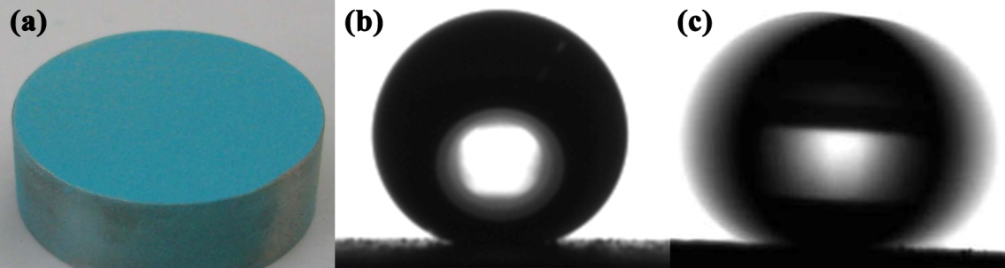
Figure S3. (a) Photograph of the copper stearate surface prepared by spraying copper stearate ethanol suspension on a stainless steel substrate. The water droplet on the surface with (b) a contact angle of 162 ± 1° and (c) a sliding angle as low as 4°.
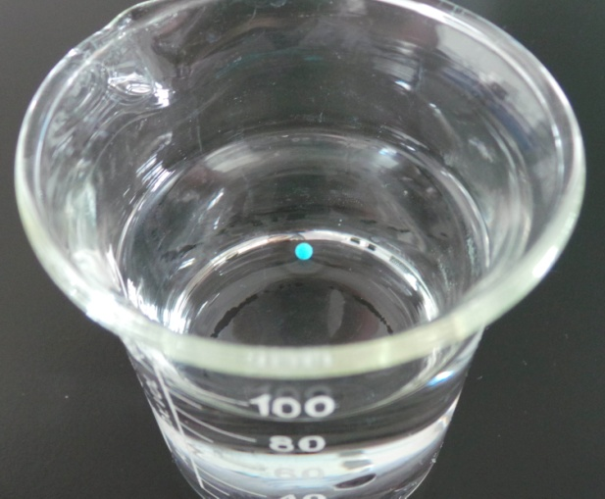
Figure S4. The liquid marble enwrapped with superhydrophobic copper stearate floating on the water surface.
References
[1] Li J, Jing Z, Zha F, Yang Y, Wang Q, Lei Z. Facile spray-coating process for the fabrication of tunable adhesive superhydrophobic surfaces with heterogeneous chemical compositions used for selective transportation of microdroplets with different volumes. ACS Appl. Mater. Interfaces 2014;6:8868–8877.
[2] Wang S, Feng L, Jiang L. One-Step Solution-Immersion Process for the Fabrication of Stable Bionic Superhydrophobic Surfaces. Adv. Mater. 2006;18:767–770.
[3] Huang Y, Sarkar DK, Chen XG. A one-step process to engineer superhydrophobic copper surfaces. Mater. Lett. 2010;64:2722–2724.

