**Synthesis of 4-phenyloxazinones via DBU catalysed cleavage of 4-bromomethylcoumarins**

Devadas Shamala and Kalegowda Shivashankar

*P.G. Department of Chemistry, Central College Campus, Bangalore University, Bangalore- 560 001, Karnataka, India.*

**Corresponding author.** Tel: +91-80-22961249, *E-mail address*: shivashankark@gmail.com (K. Shivashankar)

***Supporting Information***

***The general procedure for the preparation of 4-(2-hydroxyphenyl)-6H-1,2-oxazin-6-one (3b-l).***

To a stirring solution of hydroxyl amine (0.06g, 0.0018 mol) in ethanol (10 ml), DBU (5 mol%) was added, which was heated to 70 °C in an oil bath. Later 4-bromomethylcoumarin (0.0018 mol) was added. After completion of the reaction (monitered by tlc), the mixture was cooled to room temperature. The solvent was then removed under reduced pressure. The residue obtained was recrystallised from ethanol to give the desired product.

***4-(2-Hydroxy-4-methylphenyl)-6H-1,2-oxazin-6-one .* (3b)**

Yield 92%; colorless solid; m.p. 227-229 °C; IR (KBr, cm‾1): 1762 (C=O), 3208 (OH); 1H NMR (400 MHz, CDCl3): δ 2.53 (s, 3H, C10-CH3), 6.98 (s, 1H, C5-H), 7.32 (d, 1H, C11-H, *J1,2*= 8.4 Hz), 7.42 (d, 1H, C12-H, *J1,2*= 8.4 Hz), 7.86 (s, 1H, C9-H), 8.43 (s, 1H, C3-H), 9.32 (s, 1H, OH) ppm; 13C NMR (100 MHz, DMSO-*d6*): δ 20.4, 114.6, 116.9, 124.0, 125.8, 133.9, 134.3, 144.3, 146.0, 149.8, 160.0 ppm; Anal. C11H9NO3. Cald For: C, 65.02; H, 4.46; N, 6.89. Found: C, 64.97; H, 4.40; N, 6.83.

***4-(2-Hydroxy-5-methoxyphenyl)-6H-1,2-oxazin-6-one .* (3c)**

Yield 90%; colorless solid; m.p. 209-211 °C; IR (KBr, cm‾1): 1715 (C=O), 3212 (OH); 1H NMR (400 MHz, CDCl3): δ 3.47 (s, 3H, C11-OCH3), 7.05 (s, 1H, C5-H), 7.34 (d, 1H, C9-H, *J1,2*= 8.8 Hz), 7.63 (d, 1H, C10-H, *J1,2*= 6.4 Hz), 8.02 (s, 1H, C12-H), 8.47 (s, 1H, C3-H), 9.65 (s, 1H, OH) ppm; 13C NMR (100 MHz, DMSO-*d6*): δ 53.2, 114.2, 116.0, 123.2, 125.1, 130.1, 133.5, 144.2, 146.1, 150.0, 160.2 ppm; Anal. C11H9NO4. Cald For: C, 60.27; H, 4.14; N, 6.39. Found: C, 60.21; H, 4.09; N, 6.31.

***4-(2-Hydroxy-5-methylphenyl)-6H-1,2-oxazin-6-one .* (3d)**

Yield 94%; colorless solid; m.p. 285-287 °C; IR (KBr, cm‾1): 1692 (C=O), 3238 (OH); 1H NMR (400 MHz, CDCl3): δ 2.43 (s, 3H, C11-CH3), 6.74 (s, 1H, C5-H), 7.25 (d, 1H, C9-H, *J1,2*= 8.4 Hz), 7.37 (d, 1H, C10-H, *J1,2*= 8.4 Hz), 7.94 (s, 1H, C12-H), 8.35 (s, 1H, C3-H), 8.49 (s, 1H, OH) ppm; 13C NMR (100 MHz, DMSO-*d6*): δ 20.4, 115.1, 116.1, 125.1, 126.4, 132.5, 133.6, 144.0, 146.1, 151.6, 159.8 ppm; Anal. C11H9NO3. Cald For: C, 65.02; H, 4.46; N, 6.89. Found: C, 64.98; H, 4.42; N, 6.81.

***4-(2-Hydroxy-5-isopropylphenyl)-6H-1,2-oxazin-6-one .* (3e)**

Yield 93%; colorless solid; m.p. 157-159 °C; IR (KBr, cm‾1): 1712 (C=O), 3275 (OH); 1H NMR (400 MHz, CDCl3): δ 1.26 (d, 6H, 2-CH3 of isopropyl, *J*1,2 = 6 Hz), 2.95 (m, 1H, CH of isopropyl), 6.56 (s, 1H, C5-H), 7.30 (d, 1H, C9-H, *J1,2*= 8.4 Hz), 7.44 (d, 1H, C10-H, *J1,2*= 9.6 Hz), 7.86 (s, 1H, C12-H), 8.42 (s, 1H, C3-H), 9.04 (s, 1H, OH) ppm; 13C NMR (100 MHz, CDCl3): δ 24.0 (2C), 33.7, 114.5, 117.0, 117.3, 120.9, 130.7, 138.3, 145.3, 148.5, 152.0, 160.4 ppm; Anal. C13H13NO3. Cald For: C, 67.52; H, 5.67; N, 6.06. Found: C, 67.48; H, 5.59; N, 6.02.

***4-(2-Hydroxy-3,5-dimethylphenyl)-6H-1,2-oxazin-6-one .* (3f)**

Yield 90%; colorless solid; m.p. 213-215 °C; IR (KBr, cm‾1): 1732 (C=O), 3215 (OH); 1H NMR (400 MHz, CDCl3): δ 2.39 (m, 6H, dimethyl group), 6.68 (s, 1H, C5-H), 7.26 (s, 1H, C3-H merged with solvent peak), 7.73 (s, 1H, C10-H), 8.22 (s, 1H, OH), 8.35 (s, 1H, C12-H) ppm; 13C NMR (100 MHz, DMSO-*d6*): δ 15.2, 20.4, 114.4, 115.9, 124.0, 125.1, 132.9, 134.2, 144.3, 146.0, 149.9, 159.8 ppm; Anal. C12H11NO3. Cald For: C, 66.35; H, 5.10; N, 6.45. Found: C, 66.28; H, 5.02; N, 6.41.

***4-(5-tert-Butyl-2-hydroxyphenyl)-6H-1,2-oxazin-6-one .* (3g)**

Yield 95%; colorless solid; m.p. 209-211 °C; IR (KBr, cm‾1): 1675 (C=O), 3318 (OH); 1H NMR (400 MHz, CDCl3): δ 1.37 (s, 9H, *tert*-Butyl group), 7.05 (s, 1H, C5-H), 7.26 (d, 1H, C9-H, *J1,2*= 8.8 Hz), 7.63 (d, 1H, C10-H, *J1,2*= 6.4 Hz), 8.02 (s, 1H, C12-H), 8.47 (s, 1H, C3-H), 9.65 (s, 1H, OH) ppm; 13C NMR (100 MHz, CDCl3): δ 31.3 (3C), 43.7, 114.5, 116.6, 117.0, 119.6, 129.9, 133.8, 147.6, 148.7, 151.8, 160.4 ppm; Anal. C14H15NO3. Cald For: C, 68.56; H, 6.16; N, 5.71. Found: C, 68.49; H, 6.09; N, 5.68.

***4-(5-Benzyl-hydroxyphenyl)-6H-1,2-oxazin-6-one .* (3h)**

Yield 93%; colorless solid; m.p. 234-236 °C; IR (KBr, cm‾1): 1705 (C=O), 3201 (OH); 1H NMR (400 MHz, CDCl3): δ 4.05 (s, 2H, C11-CH2), 6.86 (s, 1H, C5-H), 7.16-8.96 (m, 10H, Ar-H & OH) ppm; 13C NMR (100 MHz, CDCl3): δ 20.6, 115.6, 116.3, 117.3, 124.4, 126.0, 128.5, 129.5, 130.3, 132.7, 136.0, 137.0, 140.8, 144.1, 146.4, 152.8, 159.7 ppm; Anal. C17H13NO3. Cald For: C, 73.11; H, 4.69; N, 5.02. Found: C, 73.03; H, 4.65; N, 4.95.

***4-(2-Hydroxynapthalen-1yl)-6H-1,2-oxazin-6-one .* (3i)**

Yield 91%; colorless solid; m.p. 218-220 °C; IR (KBr, cm‾1): 1725 (C=O), 3211 (OH); 1H NMR (400 MHz, CDCl3): δ 6.74 (s, 1H, C5-H), 7.52-8.15 (m, 7H, Ar-H), 8.66 (s, 1H, OH) ppm; 13C NMR (100 MHz, CDCl3): δ 113.7, 116.3, 116.4, 121.0, 123.7, 126.5, 129.8, 133.1, 147.0, 148.6, 150.4, 151.1, 154.5, 159.5 ppm; Anal. C14H9NO3. Cald For: C, 70.29; H, 3.79; N, 5.86. Found: C, 70.22; H, 3.71; N, 5.81.

***4-(5-Chloro-hydroxyphenyl)-6H-1,2-oxazin-6-one .* (3j)**

Yield 88%; colorless solid; m.p. 207-209 °C; IR (KBr, cm‾1): 1721 (C=O), 3201 (OH); 1H NMR (400 MHz, CDCl3): δ 6.59 (s, 1H, C5-H), 7.33 (d, 1H, C9-H, *J1,2*= 8.8 Hz), 7.54 (d, 1H, C10-H, *J1,2*= 6.4 Hz), 8.16 (s, 1H, C3-H), 8.22 (s, 1H, OH), 8.41 (s, 1H, C12-H) ppm; 13C NMR (100 MHz, CDCl3): δ 116.1, 117.2, 118.0, 119.3, 127.5, 133.4, 140.8, 145.2, 151.0, 159.1 ppm; Anal. C10H6ClNO3. Cald For: C, 53.71; H, 2.70; N, 6.26. Found: C, 53.67; H, 2.67; N, 6.21.

***4-(5-Bromo-hydroxyphenyl)-6H-1,2-oxazin-6-one .* (3k)**

Yield 85%; colorless solid; m.p. 194-196 °C; IR (KBr, cm‾1): 1718 (C=O), 3216 (OH); 1H NMR (400 MHz, CDCl3): δ 6.59 (s, 1H, C5-H), 7.26 (d, 1H, C9-H merged with CDCl3), 7.65 (d, 1H, C10-H, *J1,2*= 6.8 Hz), 8.11 (s, 1H, C12-H), 8.23 (s, 1H, C3-H), 8.55 (s, 1H, OH) ppm; 13C NMR (100 MHz, CDCl3): δ 116.2, 117.5, 118.0, 119.0, 129.4, 134.5, 142.7, 146.8, 152.6, 159.2 ppm; Anal. C10H6BrNO3. Cald For: C, 44.81; H, 2.26; N, 5.23. Found: C, 44.78; H, 2.19; N, 5.19.

***4-(5-Flouro-2-hydroxyphenyl)-6H-1,2-oxazin-6-one .* (3l)**

Yield 83%; colorless solid; m.p. 199-201 °C; IR (KBr, cm‾1): 1715 (C=O), 3221 (OH); 1H NMR (400 MHz, CDCl3): δ 6.62 (s, 1H, C5-H), 7.32-8.22 (m, 5H, Ar-H & OH) ppm; 13C NMR (100 MHz, CDCl3): δ 115.2, 116.2, 117.0, 119.8, 130.4, 133.9, 147.6, 148.1, 151.7, 160.1 ppm; Anal. C10H6FNO3. Cald For: C, 57.98; H, 2.92; N, 6.61. Found: C, 57.91; H, 2.87; N, 6.58.

|  |  |  |
| --- | --- | --- |
| Entry | Compounds | Spectra |
| S6 | 3a | 1H and 13C |
| S7 | 3a | HRMS & D2Oexchange |
| S8 | 3b | 1H and 13C |
| S9 | 3c | 1H and 13C |
| S10 | 3d | 1H and 13C |
| S11 | 3e | 1H and 13C |
| S12 | 3f | 1H and 13C |
| S13 | 3g | 1H and 13C |
| S14 | 3h | 1H and 13C |
| S15 | 3i | 1H and 13C |
| S16 | 3j | 1H and 13C |
| S17 | 3k | 1H and 13C |
| S18 | 3l | 1H and 13C |

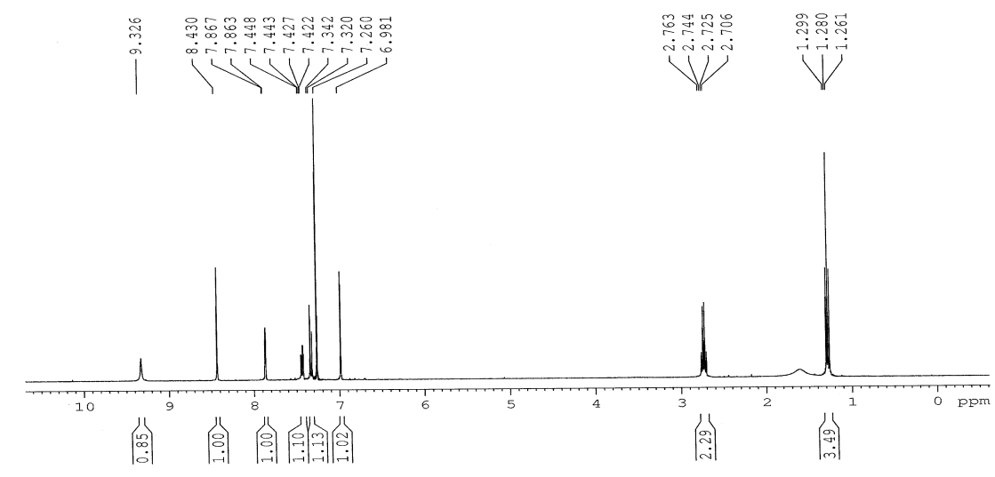



**1H NMR spectrum of 4-(5-ethyl-2-hydroxyphenyl)-6*H*-1,2-oxazin-6-one (3a)**

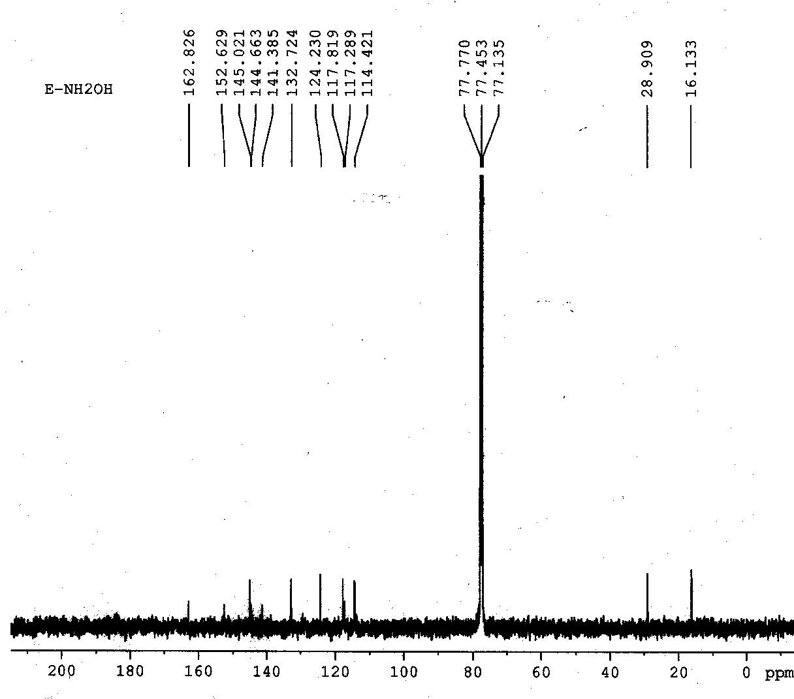

**13C NMR spectrum of 4-(5-ethyl-2-hydroxyphenyl)-6*H*-1,2-oxazin-6-one (3a)**

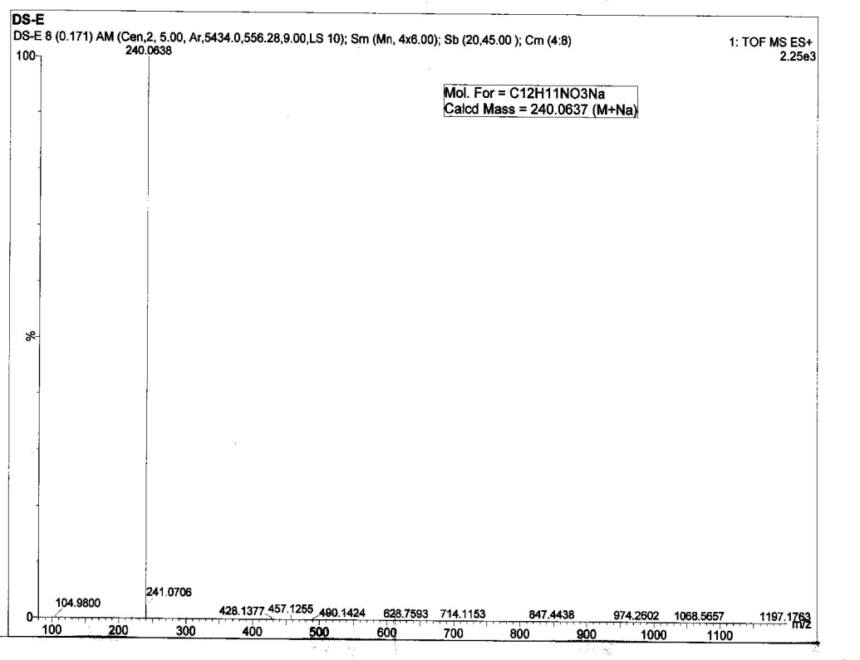

**HR-MSspectrum of 4-(5-ethyl-2-hydroxyphenyl)-6*H*-1,2-oxazin-6-one (3a)**

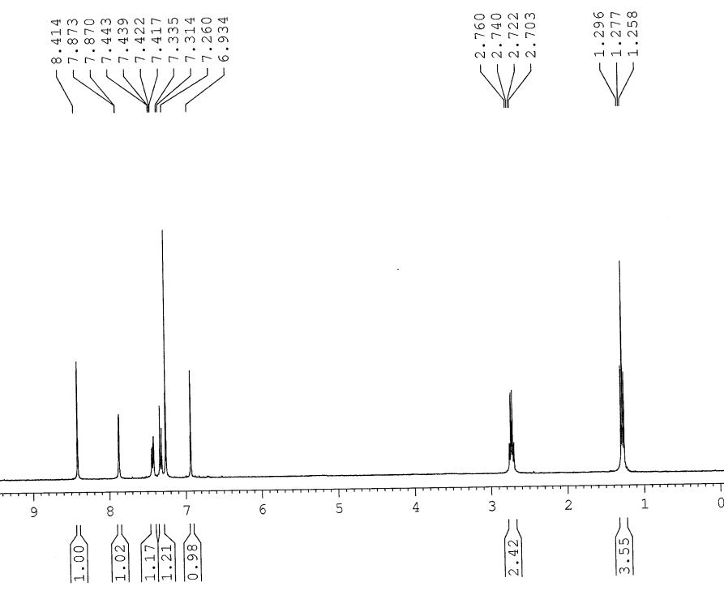

**D2O exchange spectrum of 4-(5-ethyl-2-hydroxyphenyl)-6*H*-1,2-oxazin-6-one (3a)**

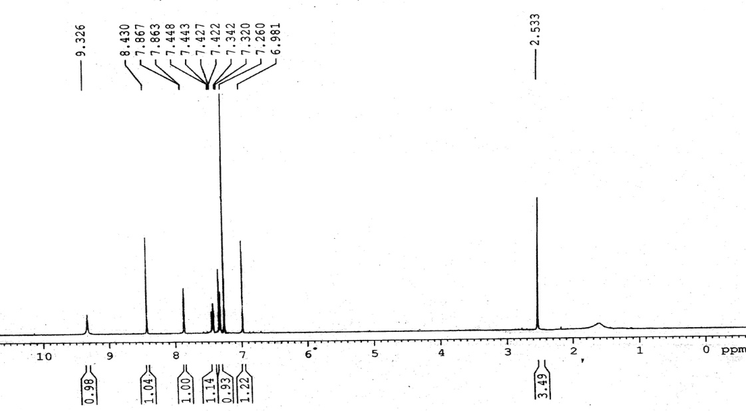



**1H NMR spectrum of *4-(2-hydroxy-4-methylphenyl)-6H-1,2- oxazin-6-one .* (3b)**

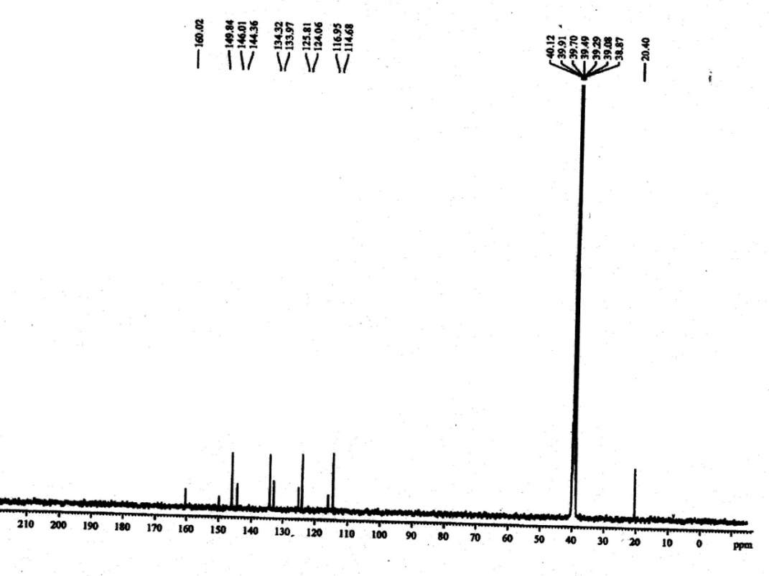

**13C NMR spectrum of *4-(2-hydroxy-4-methylphenyl)-6H-1,2- oxazin-6-one .* (3b)**

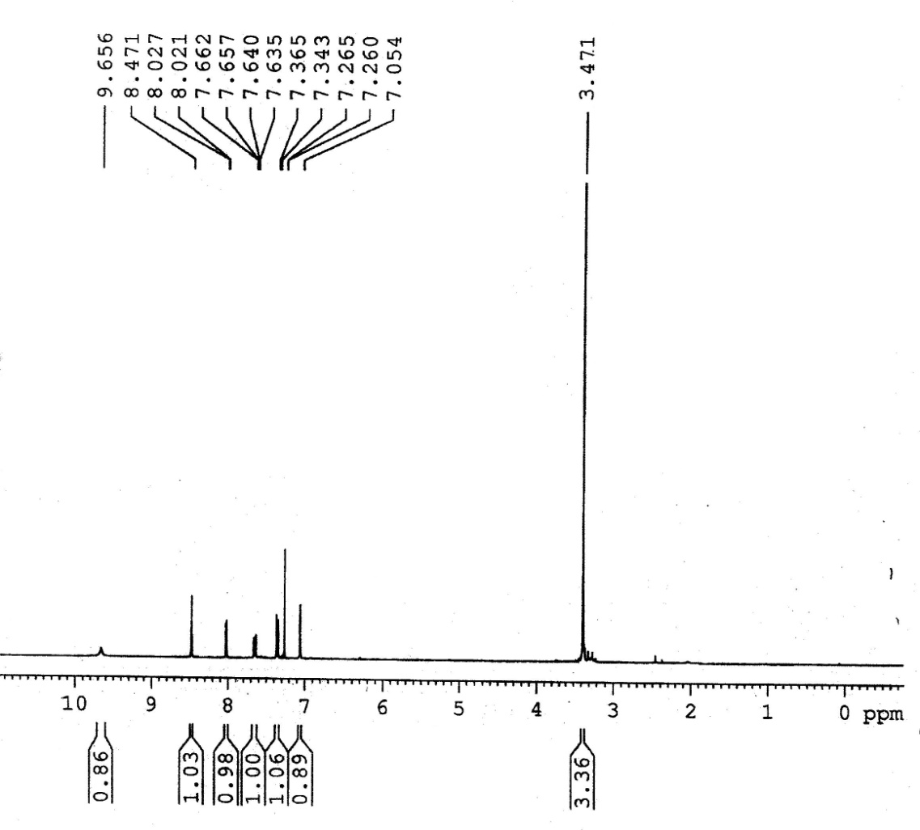



**1H NMR spectrum of *4-(2-hydroxy-5-methoxyphenyl)-6H-1,2- oxazin-6-one .* (3c)**

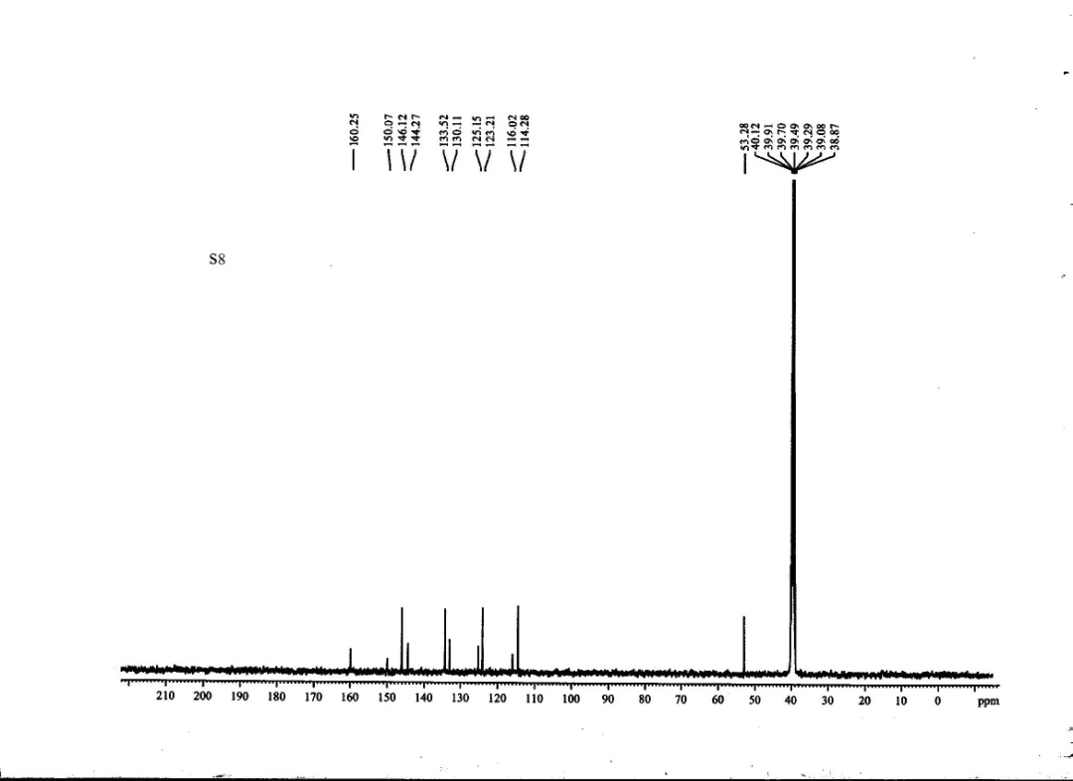

**13C NMRspectrum of *4-(2-hydroxy-5-methoxyphenyl)-6H-1,2- oxazin-6-one .* (3c)**

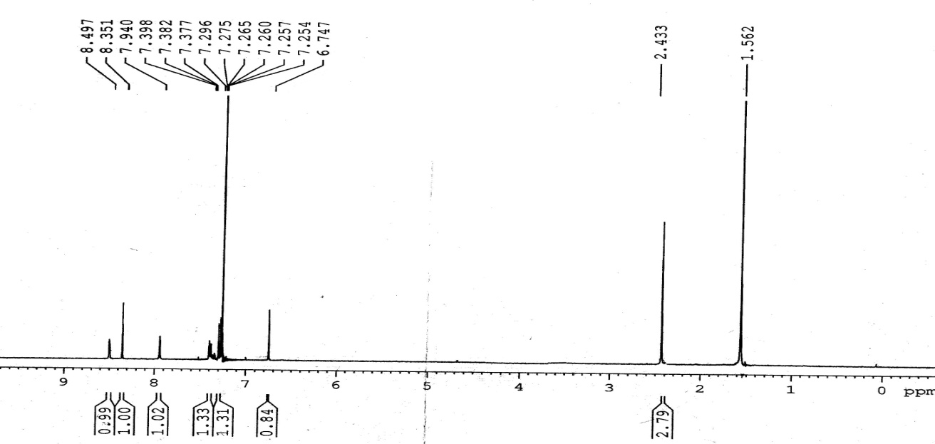



**1H NMR spectrum of *4-(2-hydroxy-5-methylphenyl)-6H-1,2- oxazin-6-one .*(3d)**

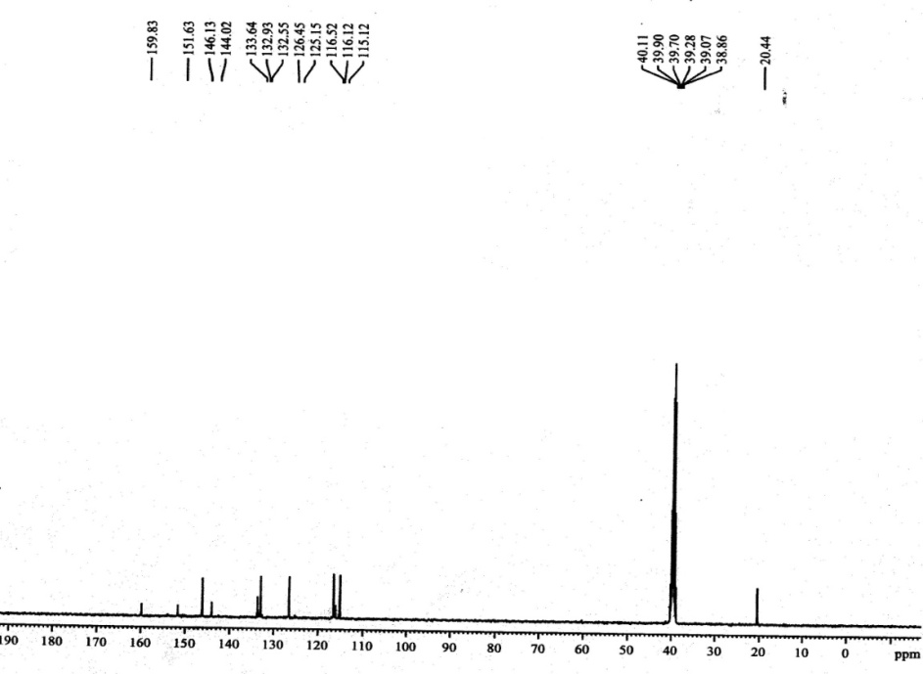

**13C NMR spectrum of *4-(2-hydroxy-5-methylphenyl)-6H-1,2- oxazin-6-one .*(3d)**

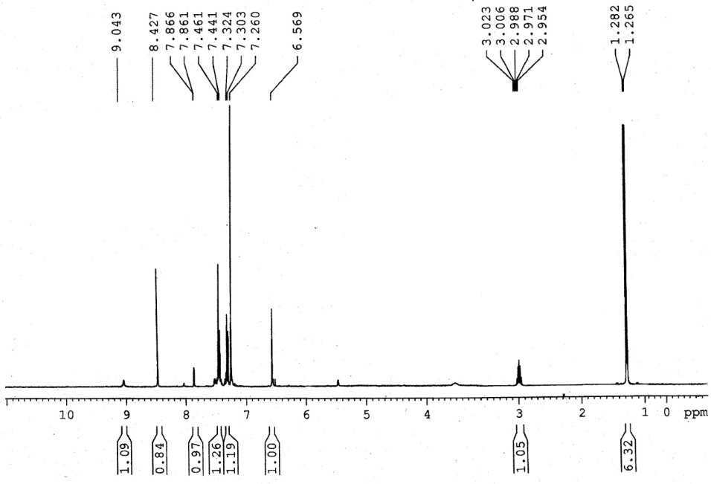



**1H NMR spectrum of *4-(2-hydroxy-5-isopropylphenyl)-6H-1,2- oxazin-6-one .* (3e)**

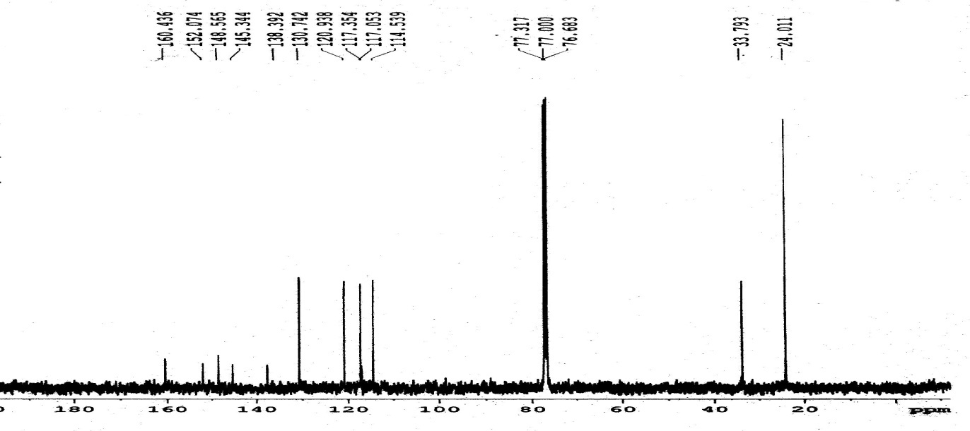

**13C NMRspectrum of *4-(2-hydroxy-5-isopropylphenyl)-6H-1,2- oxazin-6-one .* (3e)**

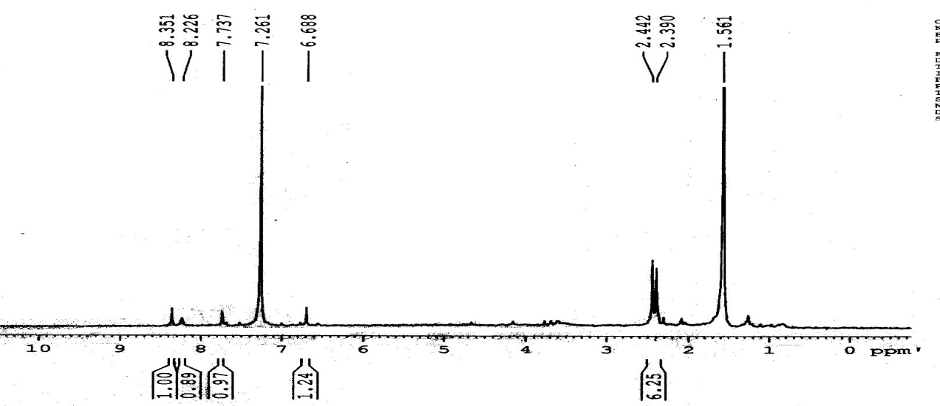



**1H NMR spectrum of *4-(2-hydroxy-3,5-dimethylphenyl)-6H-1,2- oxazin-6-one .* (3f)**

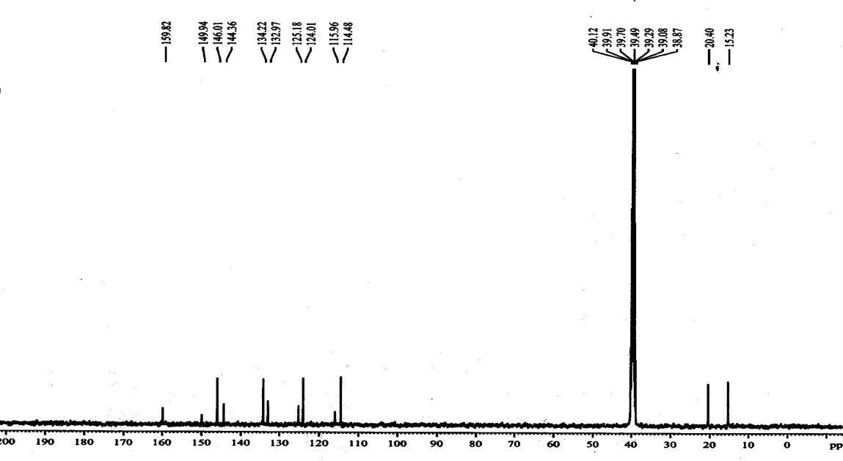

**13C NMR spectrum of *4-(2-hydroxy-3,5-dimethylphenyl)-6H-1,2- oxazin-6-one .* (3f)**

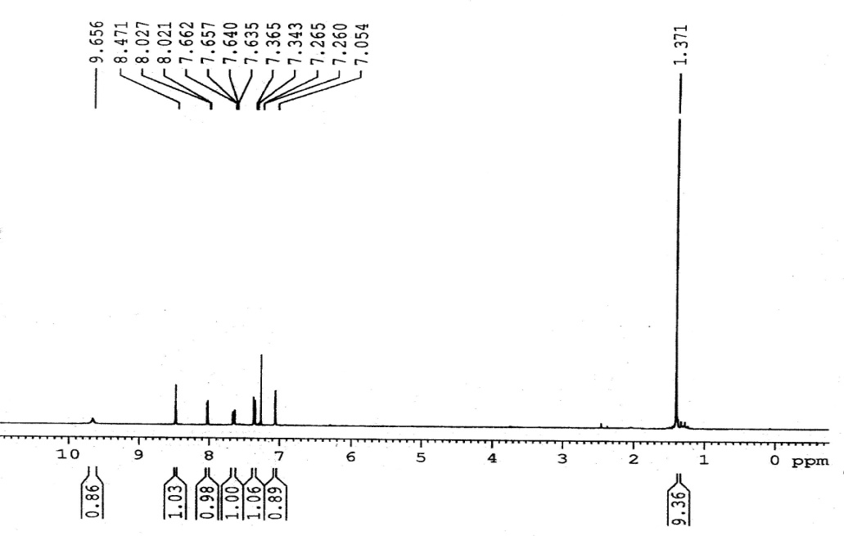



**1H NMR spectrum of *4-(5-tert-butyl-2-hydroxyphenyl)-6H-1,2- oxazin-6-one .* (3g)**

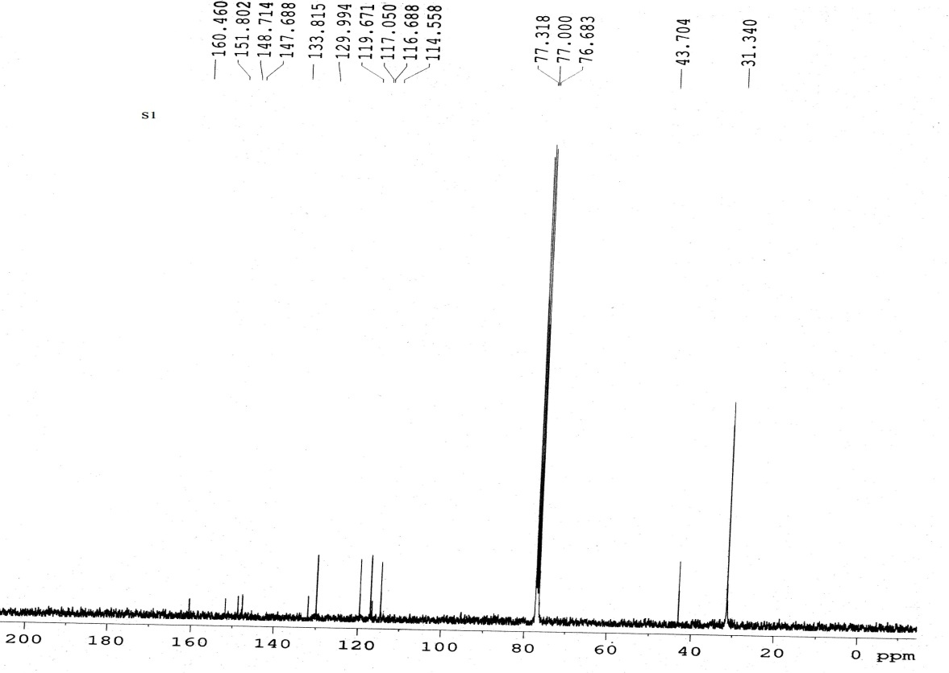

**13C NMR spectrum of *4-(5-tert-butyl-2-hydroxyphenyl)-6H-1,2- oxazin-6-one .* (3g)**

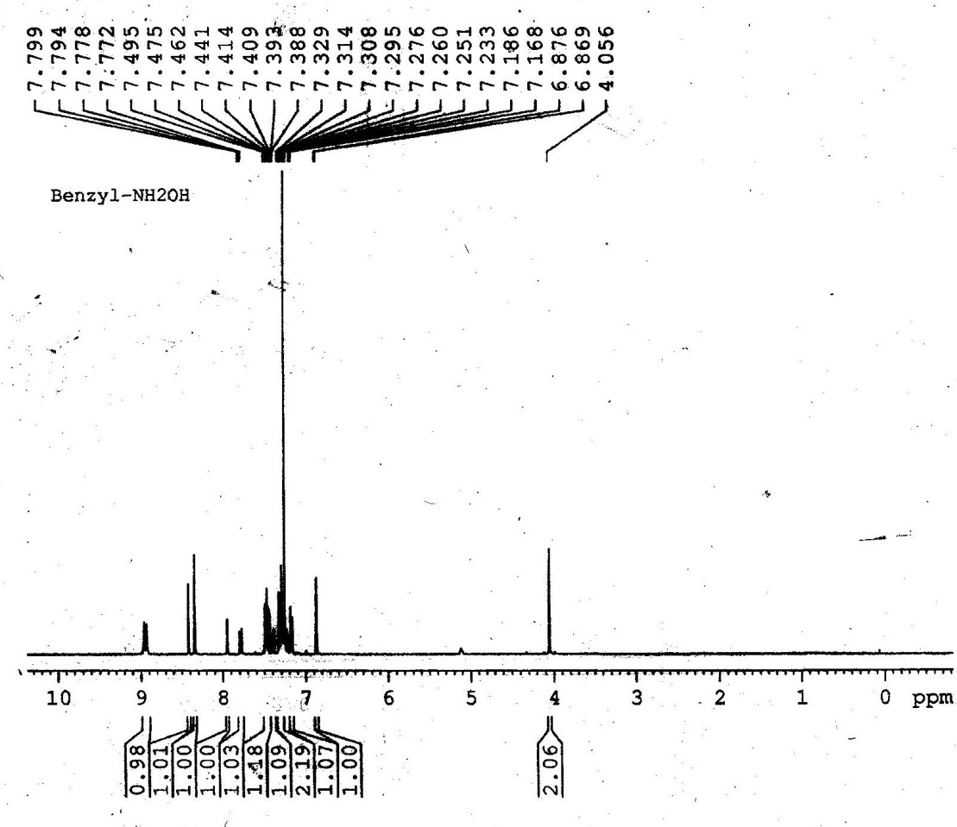



**1H NMR spectrum of *4-(5-benzyl-hydroxyphenyl)-6H-1,2- oxazin-6-one .* (3h)**

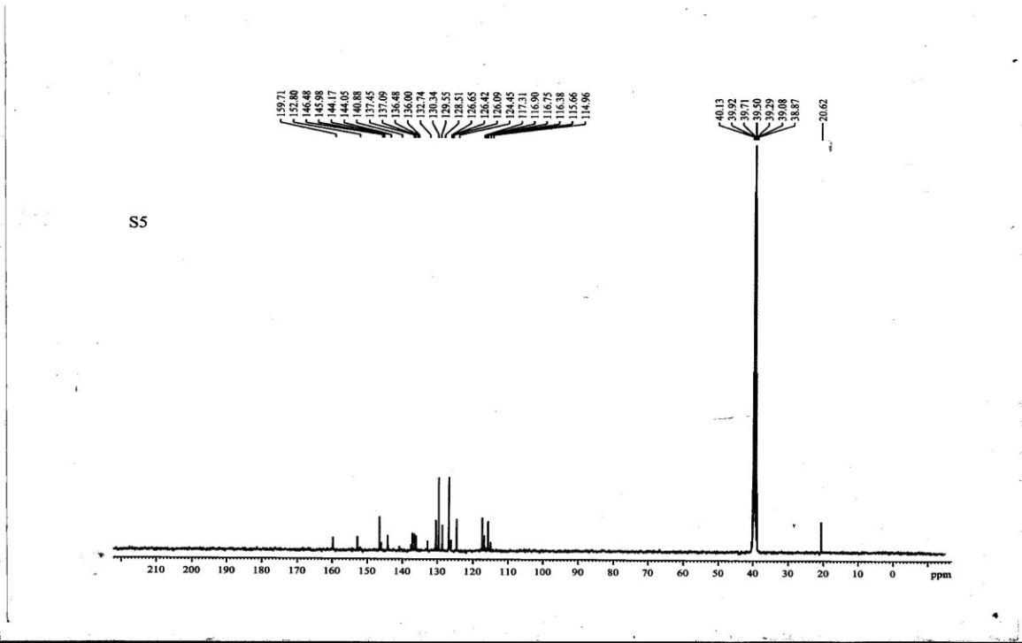

**13C NMR spectrum of *4-(5-benzyl-hydroxyphenyl)-6H-1,2- oxazin-6-one .* (3h)**

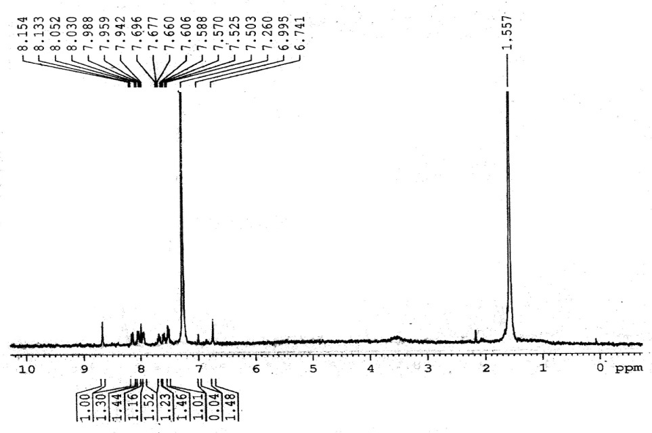



**1H NMR spectrum of *4-(2-hydroxynapthalen-1yl)-6H-1,2- oxazin-6-one .* (3i)**

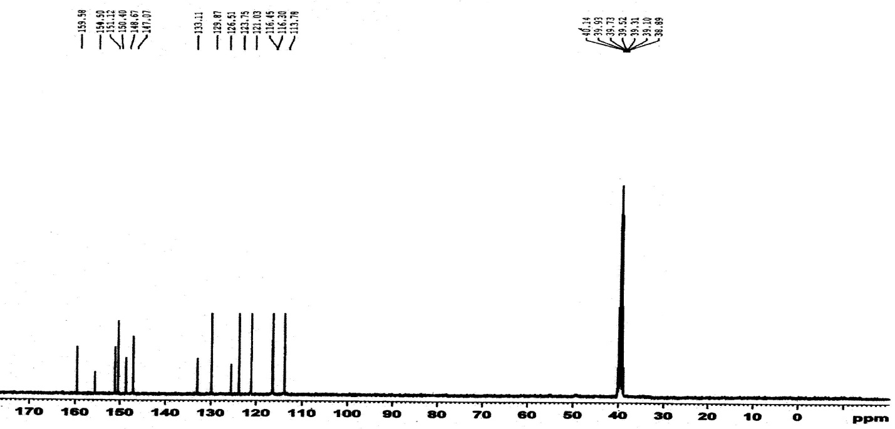

**13C NMR spectrum of *4-(2-hydroxynapthalen-1yl)-6H-1,2- oxazin-6-one .* (3i)**

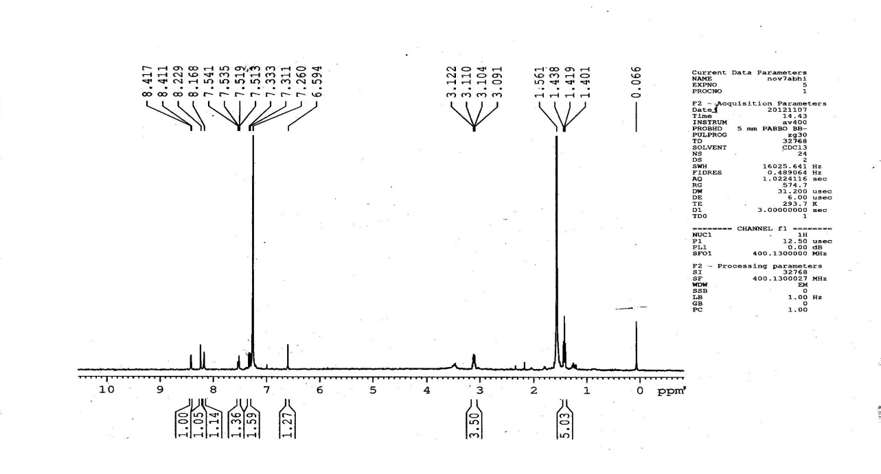



**1H NMR spectrum of *4-(5-chloro-hydroxyphenyl)-6H-1,2- oxazin-6-one .* (3j)**

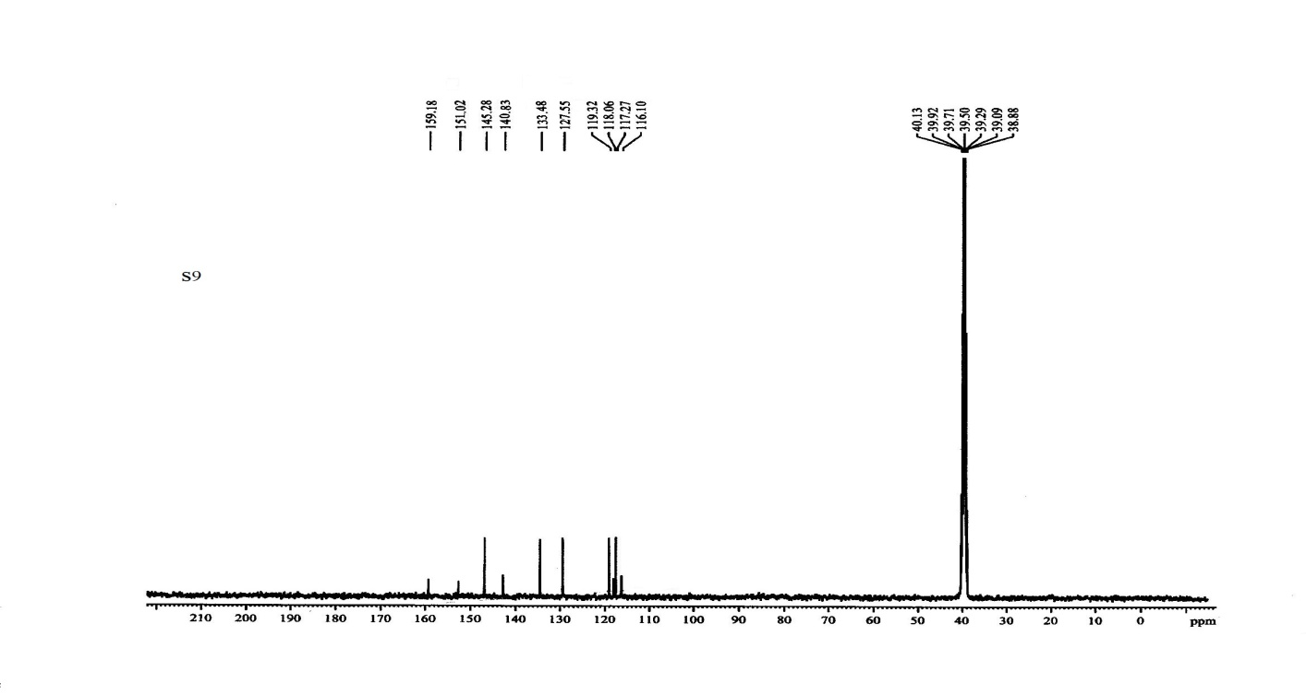

**13C NMR spectrum of *4-(5-chloro-hydroxyphenyl)-6H-1,2- oxazin-6-one .* (3j)**

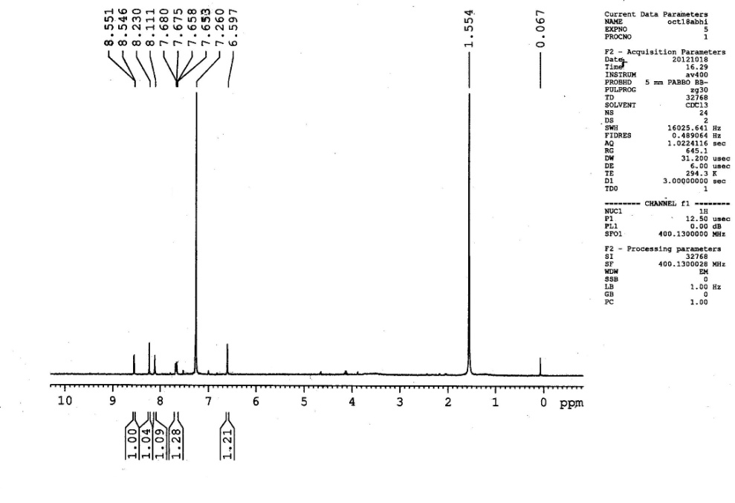



**1H NMR spectrum of *4-(5-bromo-hydroxyphenyl)-6H-1,2- oxazin-6-one .* (3k)**

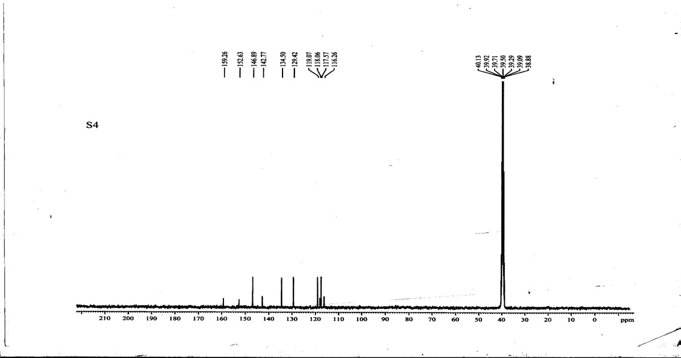

**13C NMR spectrum of *4-(5-bromo-hydroxyphenyl)-6H-1,2- oxazin-6-one .* (3k)**

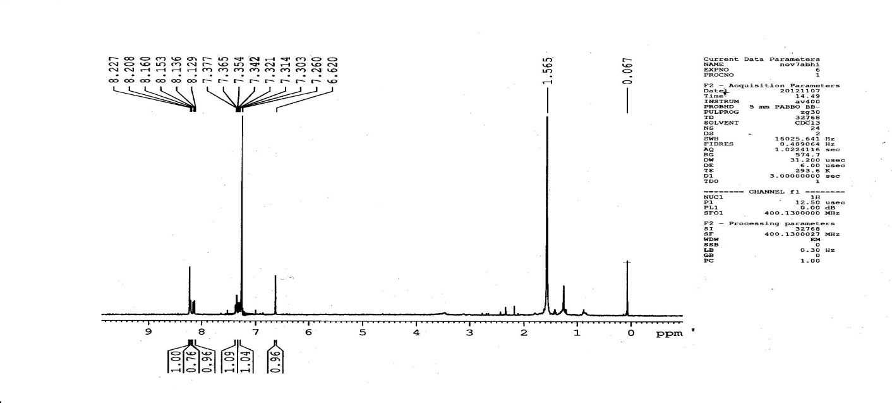



**1H NMR spectrum of *4-(5-flouro-2-hydroxyphenyl)-6H-1,2- oxazin-6-one .* (3l)**

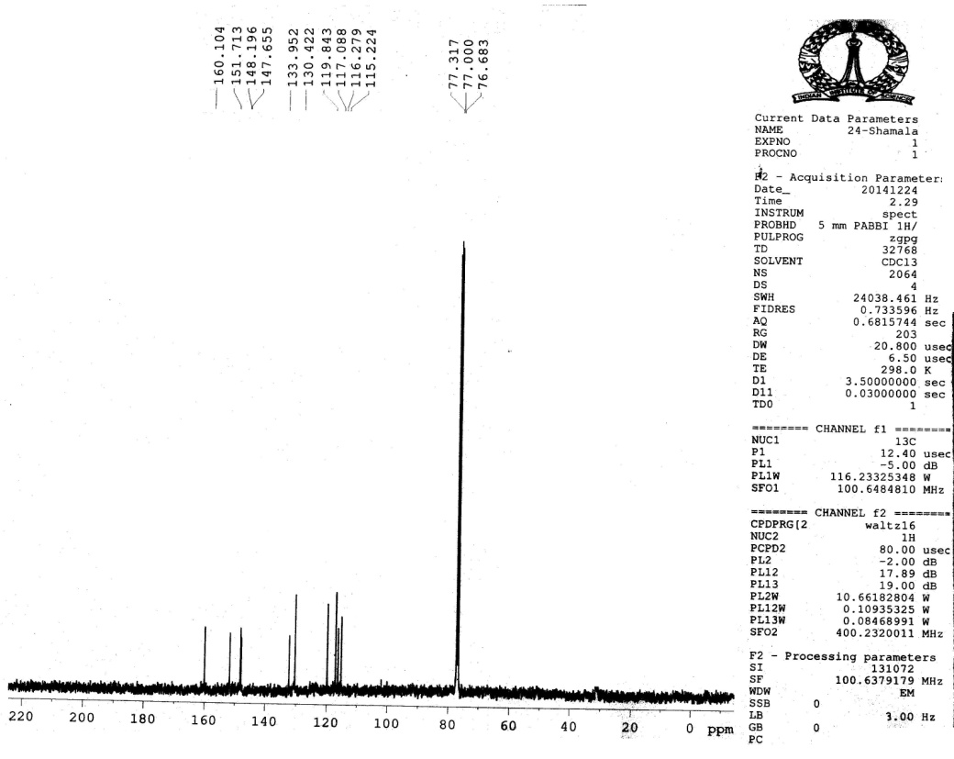

**13C NMR spectrum of *4-(5-flouro-2-hydroxyphenyl)-6H-1,2- oxazin-6-one .* (3l)**