**Synthesis and anti-inflammatory activity of triazole based macrocyclic amides through click chemistry**

Ramasamy Anandhan,* Ayyavoo Kannan and Perumal Rajakumar*

Department of Organic Chemistry, University of Madras, Guindy Campus Chennai-600 025, India.

Email:perumalrajakumar@gmail.com/ananthanramasamy@gmail.com

Fax: +91 044 22300488; Tel: +91 044 22351269 ext. 213

**SUPPORTING INFORMATIONS**

1. Experimental procedure **……………...........…................................……**  p 2- 7
2. In vitro anti-inflammatory activity procedure **……………...........….........**  p 7-8
3. 1H and 13C NMR spectra of compounds **14**, **20**, **21**, **22**, **1**, **4**, **5**, **7** and **10…** p 9- 26
4. Mass spectra of compound **4 …........................…………...........………**  p 27

**General procedure for the synthesis of precyclophane amides:**

A solution of the diacid chloride (1 mmol) in dry chloroform (100 mL) and a solution of the amine (2 mmol) and triethylamine (2.1 mmol) in dry chloroform (100 mL) were simultaneously added drop wise to a well-stirred solution of chloroform (500 mL) during 6 h. After the addition was complete, the reaction mixture was stirred for another 6 h. The solvent was removed under reduced pressure and the residue obtained was then dissolved in chloroform (300 mL), washed with water (2 x 100 mL) to remove triethylamine hydrochloride and then dried over sodium sulphate. Removal of the chloroform gave the precyclophane as a crude material, which was purified by column chromatography (SiO2).

**Triazole based macrocyclic amide 2:** Yield: 71%; 1H NMR (300 MHz, CDCl3): δ 4.00 (s, 4H), 5.14 (s, 4H), 6.87-6.95 (m, 6H), 7.20 (d, *J* = 2.4 Hz, 3H), 7.35 (s, 2H), 8.04 (s, 3H), 8.32 (s, 3H), 10.70 (s, 2H) ppm. 13C NMR (75 MHz, CDCl3): δ = 30.6, 53.3, 122.3, 122.7, 125.5, 125.6, 128.3, 129.4, 135.0, 139.0, 139.3, 144.2, 149.1, 161.7 ppm. MS(EI): *m/z* = 645 [M+]. Elemental Anal.Calcd for C33H27N9O2S2: C, 61.38; H, 4.21; N, 19.52 %. Found: C, 61.31; H, 4.08; N, 19.46 %.

**Triazole based cyclophane amide 3:** Yield: 58%; 1H NMR (300 MHz, CDCl3): δ 3.52 (s, 6H), 4.01 (s, 4H), 5.24 (s, 4H), 6.57 (s, 2H), 6.95 (t, *J* = 7.5 Hz, 2H), 7.05 (s, 2H), 7.21(t, *J* = 7.5 Hz, 2H), 7.47(t, *J* = 7.2 Hz, 2H), 7.61(t, *J* = 7.8 Hz, 1H), 8.05 (d, *J* = 7.8 Hz, 2H), 8.15 (d, *J* = 8.4 Hz, 2H), 8.40 (s, 1H), 9.41 (s, 2H) ppm. 13C NMR (75 MHz, CDCl3): δ = 31.6, 48.7, 55.9, 113.0, 121.2, 122.4, 123.4, 124.1, 124.7, 125.9, 129.9, 130.0, 130.8, 134.8, 135.9, 140.1, 143.8, 150.7, 164.0 ppm. MS(EI): *m/z* = 704 [M+]. Elemental Anal.Calcd for C36H32N8O4S2: C, 61.35; H, 4.58; N, 15.90 %. Found: C, 61.27; H, 4.58; N, 15.81 %.

**Triazole based macrocyclic amide 4:** Yield: 55%; 1H NMR (300 MHz, CDCl3): δ 3.57 (s, 6H), 4.00 (s, 4H), 5.21 (s, 4H), 6.55 (s, 1H), 6.97 (s, 4H), 7.22 (s, 4H), 7.40 (d, *J* = 6.9 Hz, 2H), 8.06 (d, *J* = 7.2 Hz, 2H), 8.40 (d, *J* = 7.5 Hz, 2H), 10.71 (s, 2H) ppm. 13C NMR (75 MHz, CDCl3): δ = 28.6, 46.5, 53.9, 110.9, 120.3, 120.5, 122.1, 123.2, 123.4, 123.6, 127.2, 132.6, 136.8, 137.1, 147.1, 148.7, 159.6 ppm. MS(EI): *m/z* = 705 [M+]. Elemental Anal.Calcd for C36H31N9O4S2: C, 59.56; H, 4.43; N, 17.86 %. Found: C, 59.51; H, 4.33; N, 17.74 %.

**Triazole based macrocyclic amide 5:** Yield: 75%; 1H NMR (300 MHz, CDCl3): δH 4.18 (s, 4H), 5.43 (s, 4H), 6.72 (d, *J* = 7.8 Hz, 2H), 7.06 (t, *J* = 7.8 Hz, 1H), 7.19-7.24 (m, 2H), 7.45-7.51 (m, 2H), 7.55 (d, *J* = 7.8 Hz, 2H), 7.72 (d, *J* = 7.8 Hz, 2H), 7.78 (d, *J* = 7.5 Hz, 2H), 7.89 (s, 2H), 8.63 (d, *J* = 8.1 Hz, 2H), 9.29 (s, 2H) ppm. 13C NMR (75 MHz, CDCl3): δ­C 32.6, 55.0, 119.7, 121.3, 122.4, 123.2, 125.1, 129.5, 130.7, 133.7, 136.6, 136.9, 138.1, 139.2, 140.1, 145.0, 154.3, 163.3 ppm. MS(EI): *m/z* = 646 [M+]. Elemental Anal.Calcd for C33H27N9O2S2: C, 61.38; H, 4.21; N, 19.52 %. Found: C, 61.34; H, 4.18; N, 19.49 %.

**Triazole based macrocyclic amide 6:** Yield: 73%; 1H NMR (300 MHz, CDCl3): δH 4.20 (s, 4H), 5.35 (s, 4H), 7.09-7.14 (m, 2H), 7.34 (s, 2H), 7.49-7.51 (m, 3H), 7.87 (s, 2H), 8.12-8.01 (m, 3H), 8.23 (d, *J* = 8.1 Hz, 2H), 8.47 (d, *J* = 7.8 Hz, 2H), 10.71 (s, 2H) ppm. 13C NMR (75 MHz, CDCl3): δ­C 48.6, 55.7, 113.1, 121.5, 122.4, 123.4, 124.1, 124.7, 125.9, 129.9, 130.0, 130.8, 134.8, 135.9, 140.1, 143.8, 150.7, 164.0 ppm. MS(EI): *m/z* = 645 [M+]. Elemental Anal.Calcd for C32H26N10O2S2: C, 59.43; H, 4.05; N, 21.66 %. Found: C, 59.39; H, 4.01; N, 21.62 %.

**Triazole based macrocyclic amide 7:** Yield: 72%; 1H NMR (300 MHz, CDCl3): δH 4.09 (s, 4H), 5.39 (s, 4H), 7.07 (s, 4H), 7.17 (s, 2H), 7.44 (d, *J* = 7.2 Hz, 2H), 7.62-7.69 (m, 2H), 7.73 (s, 2H), 8.16 (d, *J* = 7.8 Hz, 2H), 8.48 (d, *J* = 8.1 Hz, 2H), 9.46 (s, 2H) ppm. 13C NMR (75 MHz, CDCl3): δ­C 43.3, 53.6, 120.3, 121.6, 122.3, 124.8, 128.5, 128.8, 129.9, 131.2, 134.9, 136.6, 140.0, 143.8, 143.9, 158.8 ppm. MS(EI): *m/z* = 651 [M+]. Elemental Anal.Calcd for C32H26N8O2S3: C, 59.06; H, 4.03; N, 17.22%. Found: C, 59.02; H, 4.01; N, 17.18%.

**Triazole based macrocyclic amide 8:** Yield: 63%; 1H NMR (300 MHz, CDCl3): δH 3.71 (s, 6H), 4.12 (s, 4H), 5.30 (s, 4H), 6.74 (s, 2H), 7.12-7.19 (m, 2H), 7.34 (s, 2H), 7.55 (t, *J* = 7.2 Hz, 2H), 7.65-7.74 (m, 2H), 8.45 (d, *J* = 8.1 Hz, 2H), 8.02 (d, *J* = 7.5 Hz, 2H), 9.22 (s, 2H) ppm. 13C NMR (75 MHz, CDCl3): δ­C 29.7, 49.5, 56.2, 113.6, 120.3, 122.3, 122.9, 123.8, 124.9, 128.9, 130.5, 136.3, 140.0, 143.2, 143.9, 151.3, 158.6 ppm. MS(EI): *m/z* = 711 [M+]. Elemental Anal.Calcd for C34H30N8O4S3: C, 57.45; H, 4.25; N, 15.76 %. Found: C, 57.41; H, 4.22; N, 15.71 %.

**Triazole based macrocyclic amide 9:** Yield: 77%; 1H NMR (300 MHz, CDCl3): δH 4.23 (s, 4H), 5.40 (s, 4H), 7.08-7.15 (m, 2H), 7.09-7.15 (m, 2H), 7.41 (s, 2H), 7.55-7.57 (m, 2H), 7.65-7.74 (m, 3H), 8.12 (d, *J* = 7.6 Hz, 2H), 8.41 (d, *J* = 7.8 Hz, 2H), 9.32 (s, 2H) ppm. 13C NMR (75 MHz, CDCl3): δ­C 49.4, 56.1, 113.3, 120.1, 121.3, 122.3, 123.2, 124.4, 127.9, 130.1, 135.3, 139.5, 142.2, 143.4, 150.3, 158.5 ppm. MS(EI): *m/z* = 652 [M+]. Elemental Anal.Calcd for C31H25N9O2S3: C, 57.12; H, 3.87; N, 19.34 %. Found: C, 57.08; H, 3.82; N, 19.31 %.

**Triazole based macrocyclic amide 10:** Yield: 63%; 1H NMR (300 MHz, CDCl3): δ 3.42 (s, 4H), 4.46 (d, *J* = 14.7 Hz, 2H), 4.53 (d, *J* = 14.4 Hz, 2H), 5.15 (s, 4H), 6.45 (s, 2H), 6.82 (d, *J* = 5.1 Hz, 2H), 6.90 (s, 4H), 7.11-7.29 (m, 10H), 7.43 (d, *J* = 8.4 Hz, 2H), 7.81 (d, *J* = 5.1 Hz, 2H), 7.95 (s, 4H), 8.72 (s, 2H) ppm. 13C NMR (75 MHz, CDCl3): δ = 29.7, 53.2, 69.7, 115.9, 120.2, 120.9, 122.0, 122.9, 124.8, 125.4, 127.1, 128.3, 128.9, 129.7, 130.3, 130.6, 133.9, 135.1, 135.4, 138.6, 144.0, 153.1, 166.2 ppm. MS(EI): *m/z* = 880 [M+]. Elemental Anal.Calcd for C50H40N8O4S2: C, 68.16; H, 4.58; N, 12.72 %. Found: C, 68.12; H, 4.64; N, 12.52 %.

**Triazole based macrocyclic amide 11:** Yield: 59%; 1H NMR (300 MHz, CDCl3): δ 3.40 (s, 4H), 3.58 (s, 6H), 4.48 (d, *J* = 14.5 Hz, 2H), 4.55 (d, *J* = 14.2 Hz, 2H), 5.21 (s, 4H), 6.59 (s, 4H), 6.75-6.79 (m, 2H), 7.00 (d, *J* = 11.1 Hz, 4H), 7.21 (d, *J* = 8.7 Hz, 4H), 7.42 (d, *J* = 7.5 Hz, 2H), 7.80 (s, 4H), 7.93 (s, 4H), 8.71 (s, 2H) ppm. 13C NMR (75 MHz, CDCl3): δ = 29.7, 48.5, 56.0, 69.7, 113.1, 115.8, 121.0, 123.1, 124.2, 124.7, 125.4, 127.1, 128.2, 129.5, 130.1, 130.3, 130.6, 134.0, 135.2, 138.5, 150.8, 153.0, 166.2 ppm. MS(EI): *m/z* = 940 [M+]. Elemental Anal.Calcd for C52H44N8O6S2: C, 66.37; H, 4.71; N, 11.91 %. Found: C, 66.20; H, 4.68; N, 11.80 %.

**Triazole based macrocyclic amide 12:** Yield: 69%; 1H NMR (300 MHz, CDCl3): δH 3.43 (s, 4H), 4.51 (d, *J* = 6.4 Hz, 4H), 5.15 (s, 4H), 6.45 (s, 2H), 6.82 (d, *J* = 5.1 Hz, 2H), 7.09-7.14 (m, 2H), 7.15-7.39 (m, 11H), 7.43 (d, *J* = 8.1 Hz, 2H), 7.81 (d, *J* = 5.2 Hz, 2H), 7.95 (s, 4H), 8.73 (s, 2H) ppm. 13C NMR (75 MHz, CDCl3): δ­C 29.6, 53.3, 69.5, 115.9, 120.2, 120.9, 122.0, 122.9, 124.8, 124.1, 126.3, 128.2, 128.7, 129.2, 130.1, 130.3, 133.6, 134.8, 135.3, 138.5, 143.5, 153.2, 165.6 ppm. MS(EI): *m/z* = 882 [M+]. Elemental Anal.Calcd for C49H39N9O4S2: C, 66.72; H, 4.46; N, 14.29 %. Found: C, 66.69; H, 4.42; N, 14.26%.

***S*-propargyloxy-2-aminothiophenol 14:**

A mixture of 2-aminothiophenol **13** (1.17 g, 9.35 mmol), propargyl bromide (1.22 g, 10.3 mmol), TBAB (5 mg), KOH (0.78 g, 14.0 mmol), in toluene (20 mL) and water (20 mL) is stirred overnight at room temperature. Toluene layer was separated, washed with 5% KOH solution (2 x 10 mL) and with water (20 mL). The toluene layer after drying over Na2SO4 was evaporated under vacuum and the dark red coloured residue **14** obtained was purified by column chromatography using chloroform: hexane (1:1) as eluting solvent; yield: 83%; 1H NMR (300 MHz, CDCl3): δH 2.22(t, *J* = 2.7 Hz, 1H), 3.44 (d, *J* = 2.4 Hz, 2H), 4.40 (bs, 2H), 6.71 (dd, *J* = 6.9Hz, 2H), 7.16 (t, *J* = 6.3 Hz, 1H), 7.46 (dd, *J* = 6 Hz, 1H) ppm. 13C NMR (75 MHz, CDCl3): δ 22.9, 71.9, 80.2, 115.0, 116.4, 118.6, 130.7, 136.7, 148.7 ppm. MS (EI): *m/z* = 163 [M+]. Elemental Anal.Calcd for C9H9NS: C, 66.22; H, 5.56; N, 8.58 %. Found: C, 66.01; H, 5.61; N, 8.49 %.

**precyclophane amide 19:** Yield: 65%; 1H NMR (300 MHz, CDCl3): δ 2.22 (t, *J* = 2.4 Hz, 2H), 3.50 (d, *J* = 2.4 Hz, 4H), 7.15 (t, *J* = 7.5 Hz, 2H), 7.47 (t, *J* = 7.8 Hz, 2H), 7.69 (t, *J* = 7.5 Hz, 3H), 8.19 (d, *J* = 7.8 Hz, 2H), 8.60 (d, *J* = 8.4 Hz, 3H), 9.61 (s, 2H) ppm. 13C NMR (75 MHz, CDCl3): δ = 25.3, 72.8, 79.6, 120.6, 122.0, 124.7, 125.9, 129.6, 130.7, 131.0, 135.6, 136.5, 140.3, 164.2 ppm. MS(EI): *m/z* = 456 [M+]. Elemental Anal.Calcd for C26H20N2O2S2: C, 68.40; H, 4.42; N, 6.14 %. Found: C, 68.34; H, 4.32; N, 6.06 %.

**precyclophane amide 20:** Yield: 71%; 1H NMR (300 MHz, CDCl3): δ 2.00 (t, *J* = 2.4 Hz, 2H), 3.49 (d, *J* = 2.4 Hz, 4H), 7.18-7.26 (m, 3H), 7.47 (t, *J* = 7.5 Hz, 2H), 7.69 (t, *J* = 7.8 Hz, 2H), 8.43 (d, *J* = 8.4 Hz, 2H), 8.51 (s, 2H), 10.70 (s, 2H) ppm. 13C NMR (75 MHz, CDCl3): δ = 24.5, 72.4, 79.0, 121.9, 124.2, 125.5, 126.0, 130.2, 135.3, 138.7, 148.4, 150.7, 160.4 ppm. MS(EI): *m/z* = 457 [M+]. Elemental Anal.Calcd for C26H19N3O2S2: C, 65.62; H, 4.19; N, 9.18 %. Found: C, 65.37; H, 4.16; N, 9.06 %.

**precyclophane amide 21:** Yield: 64%; 1H NMR (300 MHz, CDCl3): δH 2.21 (t, *J* = 2.7 Hz, 2H), 3.49 (d, *J* = 2.4 Hz, 4H), 7.14 (t, *J* = 7.2 Hz, 2H), 7.45 (t, *J* = 7.5 Hz, 2H), 7.65 (d, *J* = 9.0 Hz, 2H), 7.72 (s, 2H), 8.53 (d, *J* = 8.1 Hz, 2H), 9.47 (s, 2H) ppm. 13C NMR (75 MHz, CDCl3): δ­C 25.3, 72.8, 79.4, 120.3, 121.6, 124.8, 128.8, 131.2,   136.5, 139.9, 143.8, 158.8 ppm. MS(EI): *m/z* = 462 [M+]. Elemental Anal.Calcd for C24H18N2O2S3: C, 62.31; H, 3.92; N, 6.06 %. Found: C, 62.29; H, 3.86; N, 6.03 %.

**Chiral precyclophane amide 22:** Yield: 68%; 1H NMR (300 MHz, CDCl3): δ 2.00 (t, *J* = 2.4 Hz, 2H), 2.80 (dq, *J* = 14.4 Hz, *J* = 2.4 Hz, 4H), 4.65 (d, *J* = 1.8 Hz, 4H), 7.03 (t, *J* = 7.2 Hz, 2H), 7.13 (d, *J* = 8.4 Hz, 2H), 7.25-7.32 (m, 5H), 7.36-7.49 (m, 5H), 7.89 (d, *J* = 8.1 Hz, 2H), 8.15 (d, *J* = 9.0 Hz, 2H), 8.18 (d, *J* = 8.1 Hz, 2H), 8.98 (s, 2H) ppm. 13C NMR (75 MHz, CDCl3): δ = 39.7, 55.9, 75.8, 78.4, 100.9, 101.5, 106.7, 108.2, 108.4, 110.6, 114.9, 117.2, 118.5, 130.2, 130.6, 136.6, 140.8, 148.7, 158.5 ppm. MS(EI): *m/z* = 692 [M+]. Elemental Anal.Calcd for C42H32N2O4S2: C, 72.81; H, 4.66; N, 4.04 %. Found: C, 72.71; H, 4.54; N, 3.99 %.

**In vitro anti-inflammatory activity;**

The human red blood cell membrane stabilization has been used as a method1 to study the anti-inflammatory activity using prednisolone as standard drug. Blood samples were collected from healthy volunteers. The collected blood sample was mixed with equal volume of sterilised Alsever solution (2% dextrose, 0.8% sodium citrate, 0.05% citric acid and 0.42% sodium chloride in water). The blood sample was centrifuged at 3000 rpm and packed cells were washed with isotonic sodium chloride (0.85%, pH 7.2) and a 10% (w/v) suspension of the centrifused blood sample was kept in isotonic sodium chloride. The assay mixture contained the drug (concentration as mentioned in Table.1), phosphate buffer (1 mL, 0.15M, pH 7.4), hypotonic NaCl (2 mL, 0.36%) and HRBC suspension (0.5 mL). Prednisolone, (100 µg) was used as the reference drug. Instead of hypotonic sodium chloride, distilled water (2 mL) was used in the control. All the assay mixtures were incubated at 37 oC for 30 min. and centrifuged. The hemoglobin content in the supernatant solution was estimated using spectrophotometer (Systronic UV-Vis Spectrophotometer 118) at 560 nm. The percentage hemolysis was calculated by assuming the hemolysis produced in the presence of distilled water as 100%. The percentage of HRBC membrane stabilization or protection was calculated using the formula.

% protection = 100 – O.D of drug treated samples/O.D of control x 100 instead of %.

**Reference:**

1. (a) R. Ghandisan, A. Thamaraichelvan, C. Baburaj, *Fitoterapia* 1991, ***62***, 81; (b) R. Lavanya, S. Umamaheshwari, G. Harish, J. Bharathraj, S. Kamali, D. Hemamalani, J. Bharathvarma, C. Umamaheswara Reddy. *RJPBCS*. 2010,***1***, 753.

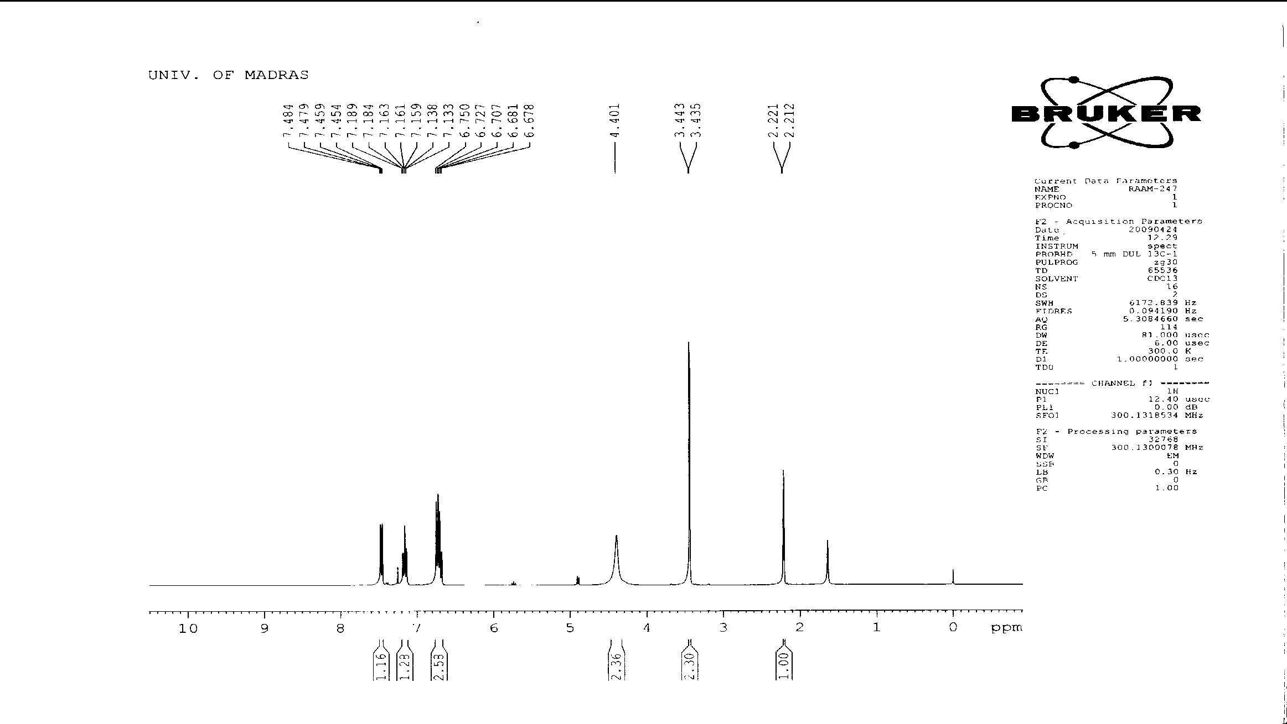

**1H NMR spectrum (300 MHz, CDCl3) of S-proporgyloxy-2-aminothiophenol 14**

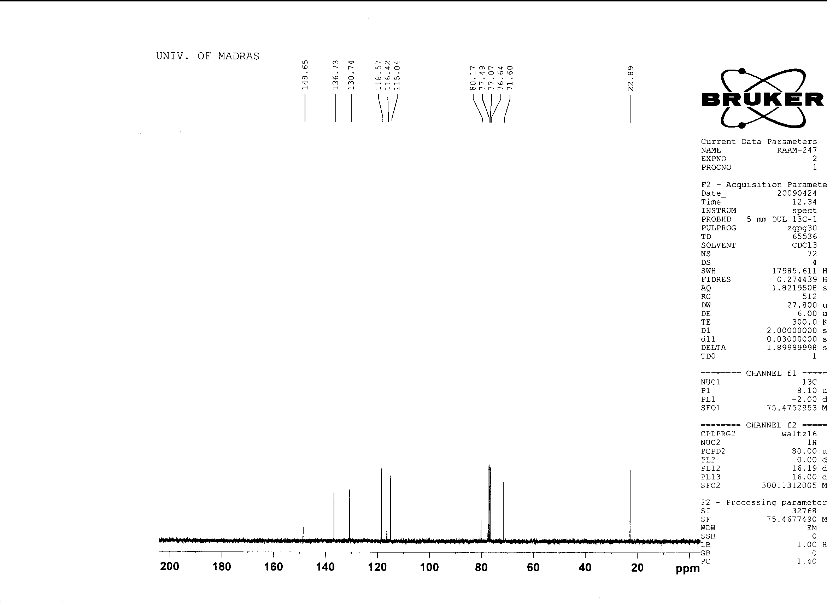

**13C NMR spectrum (75 MHz, CDCl3) of S-proporgyloxy-2-aminothiophenol 14**

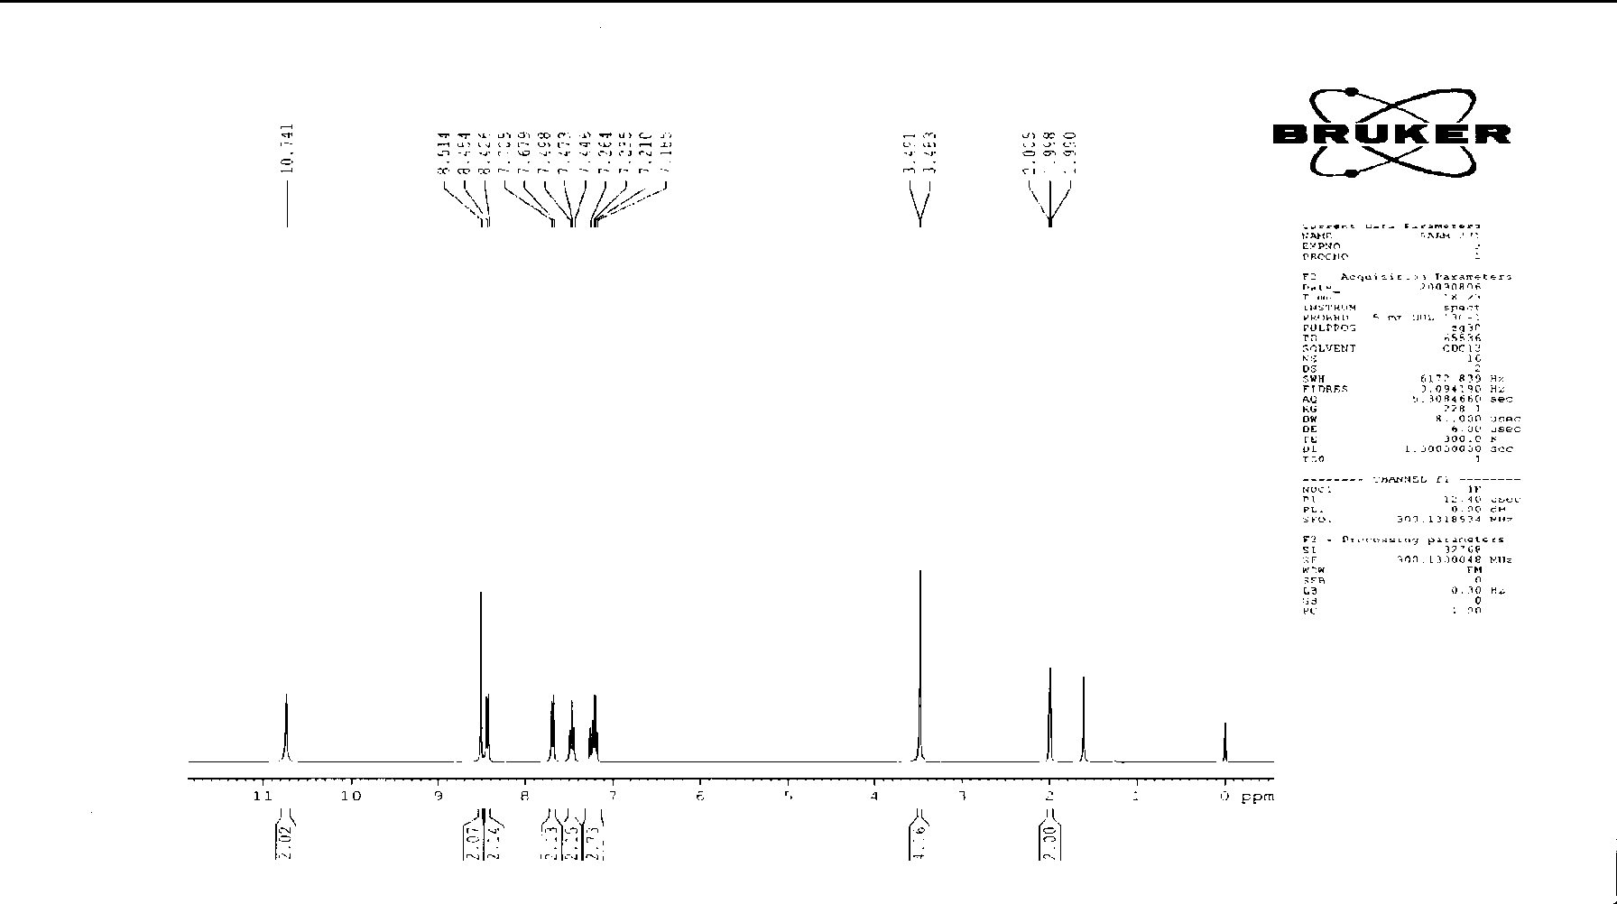

**1H NMR spectrum (300 MHz, CDCl3) of precyclophane 20**

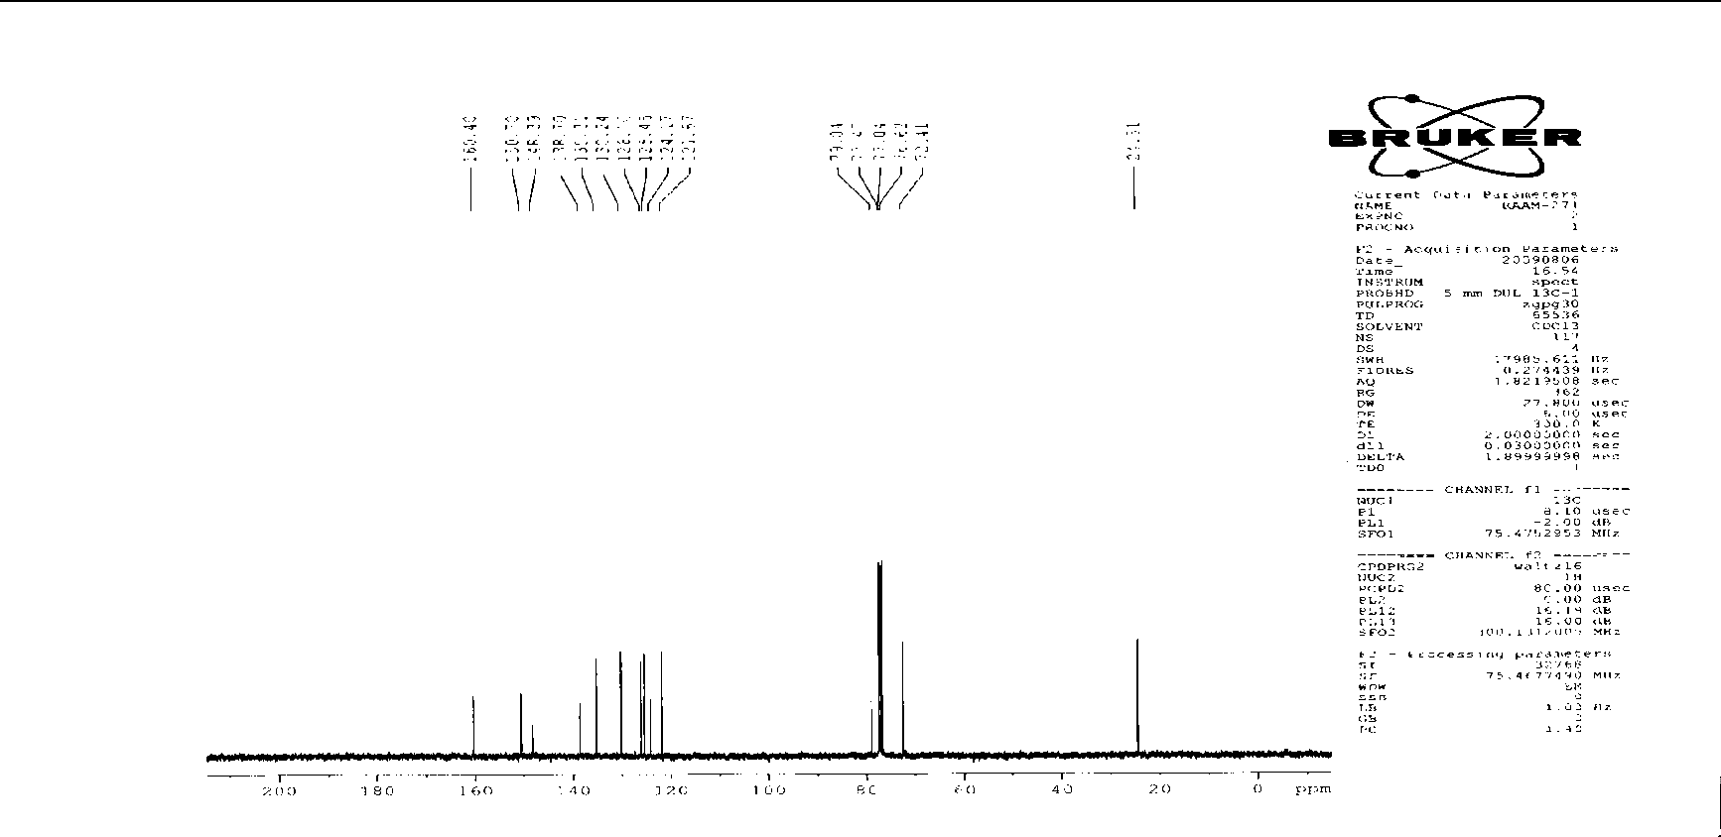

**13C NMR spectrum (75 MHz, CDCl3) of precyclophane 20**

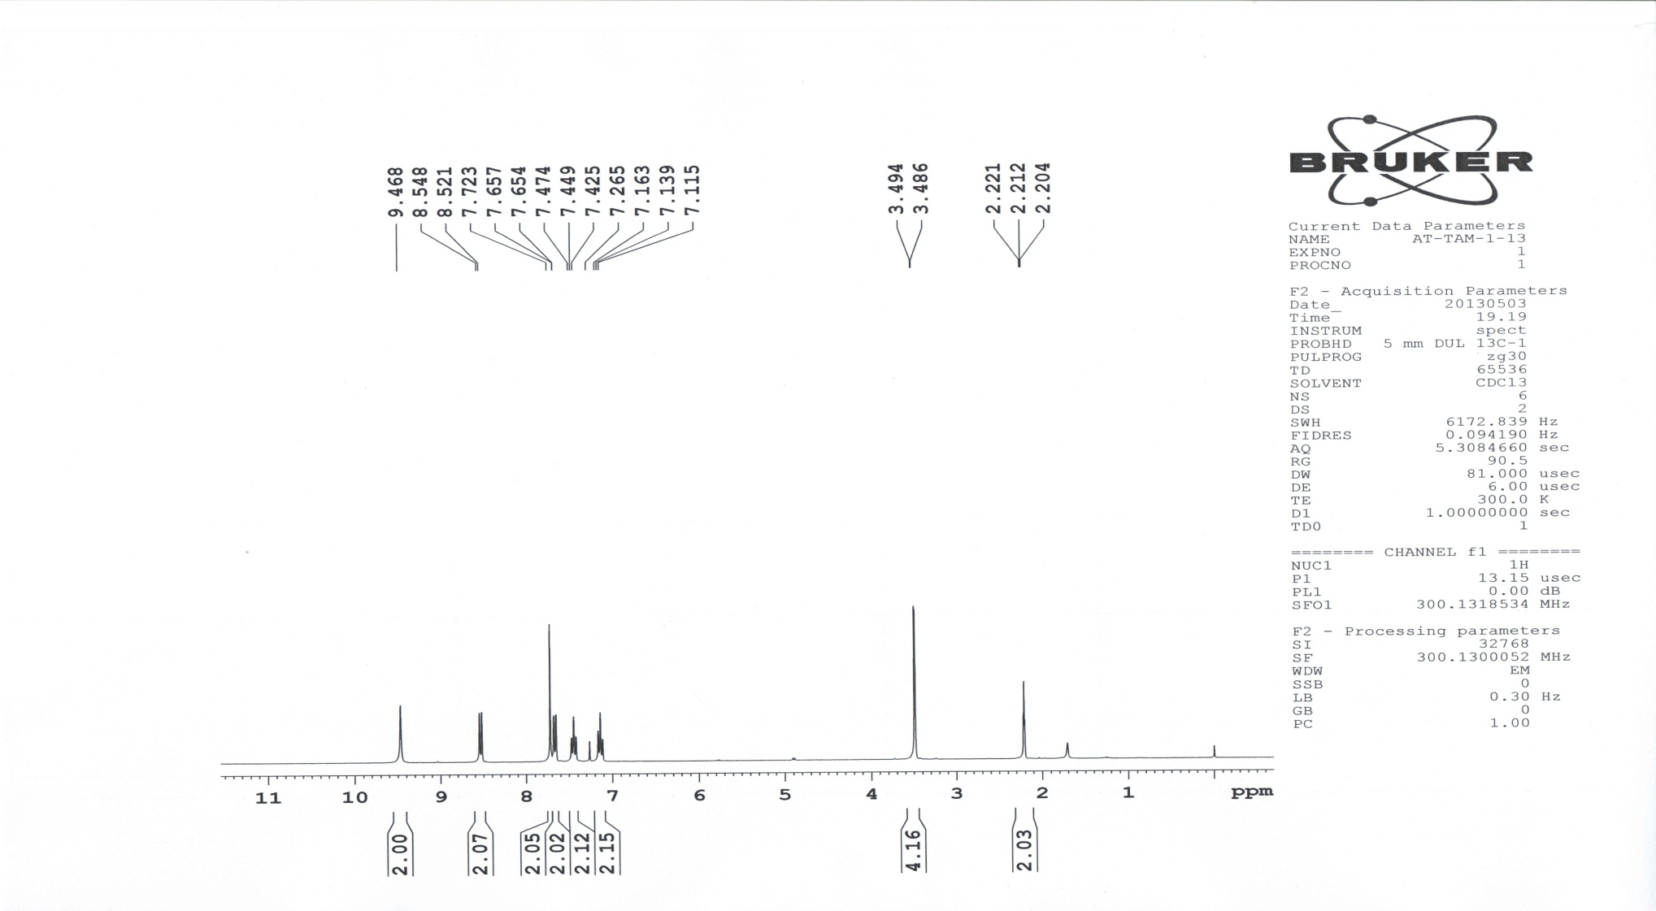

**1H NMR spectrum (300 MHz, CDCl3) of precyclophane 21**

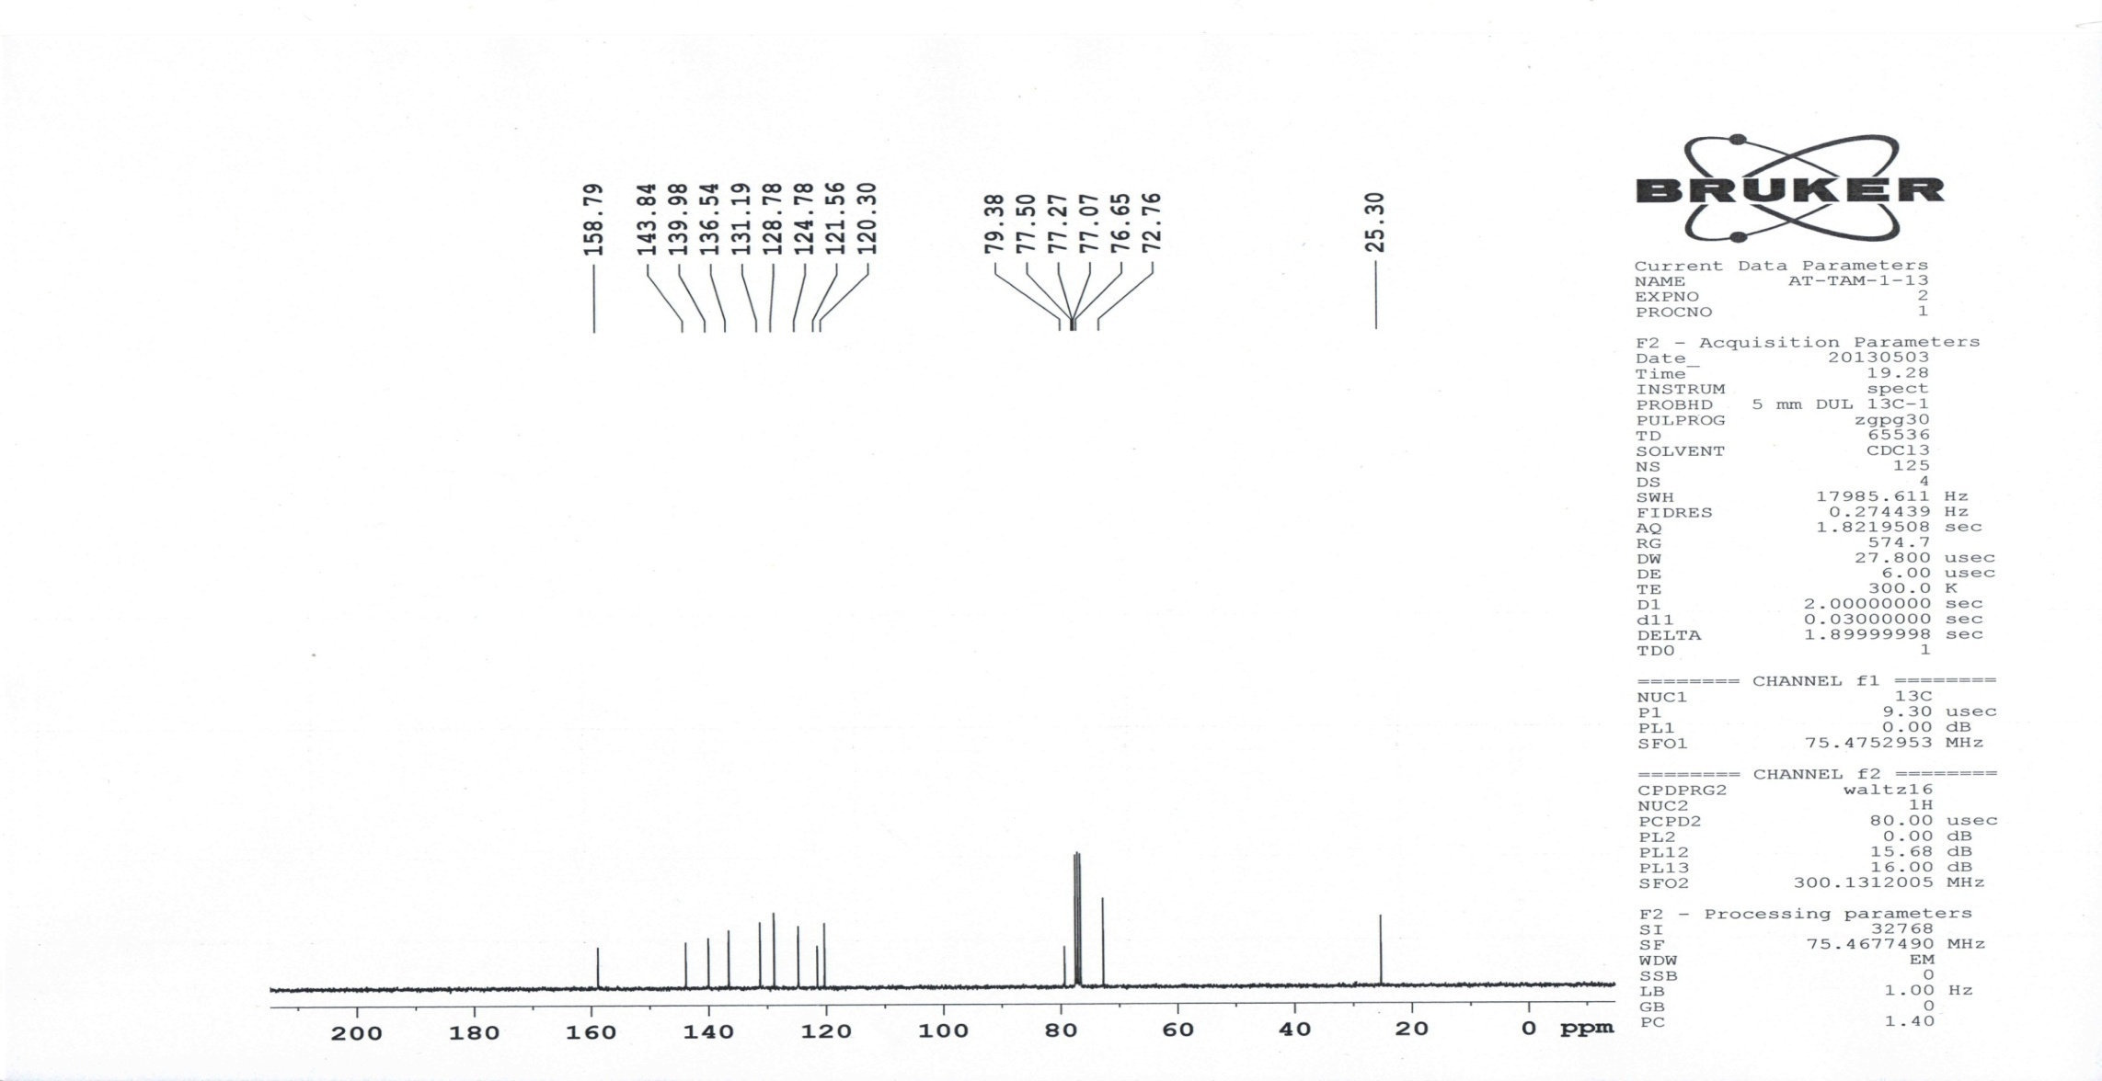

**13C NMR spectrum (75 MHz, CDCl3) of precyclophane 21**

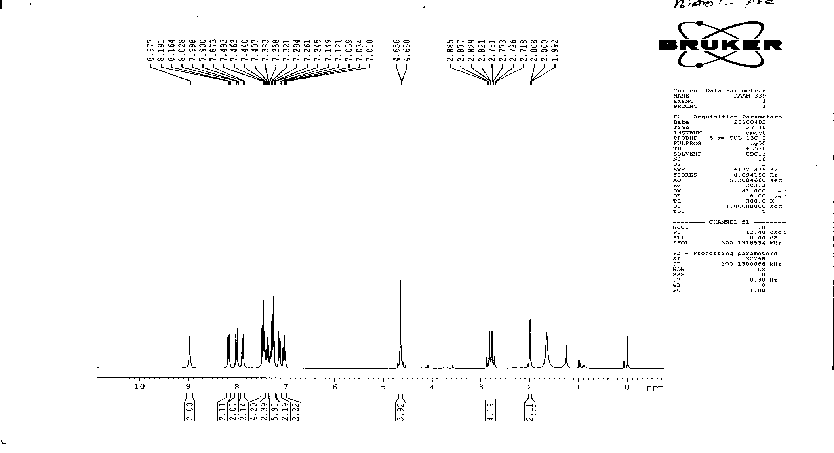

**1H NMR spectrum (300 MHz, CDCl3) of amide precyclophane 22**

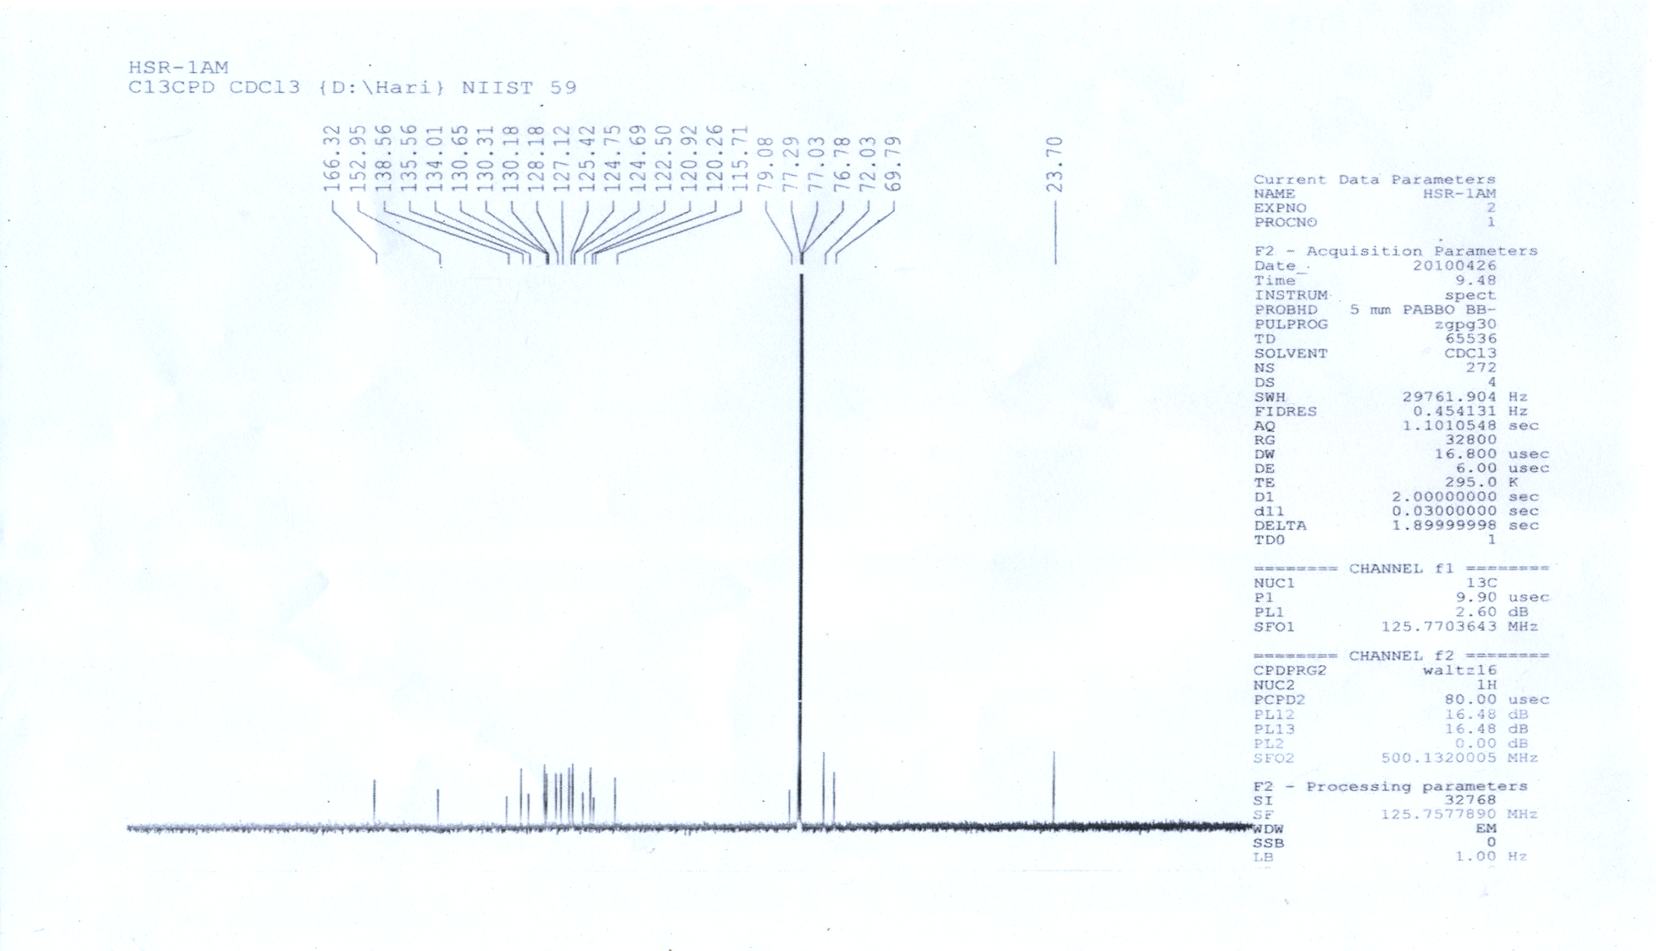

**13C NMR spectrum (100 MHz, CDCl3) of amide precyclophane 22**

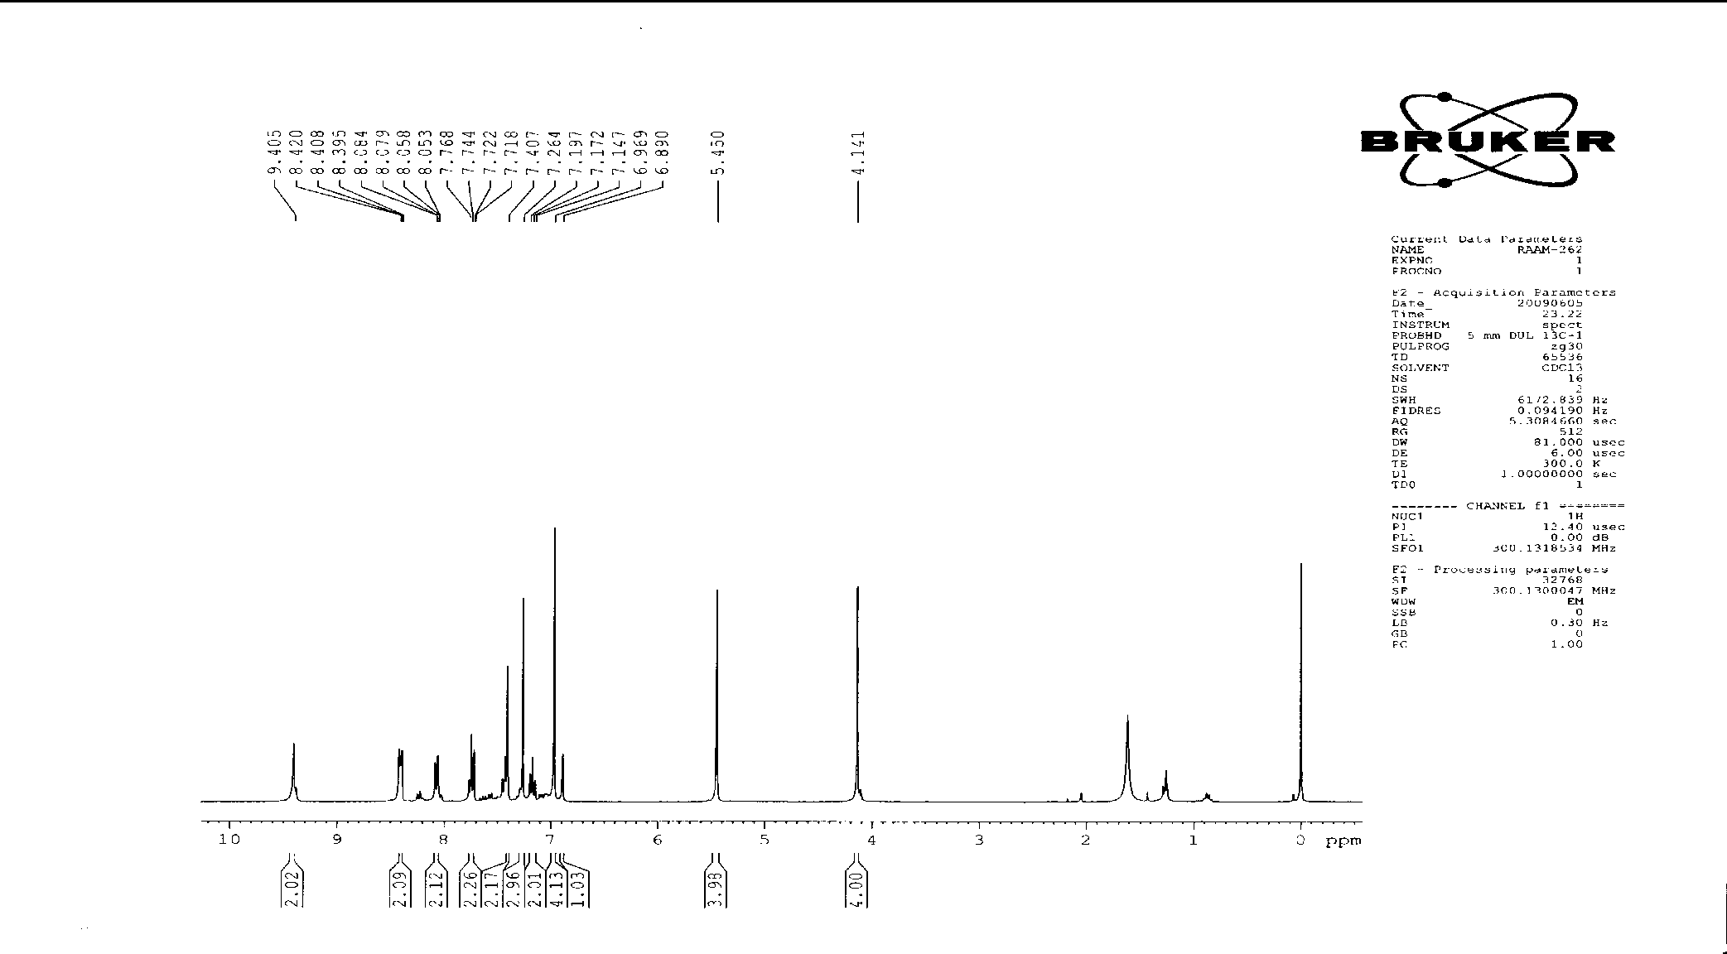

**1H NMR spectrum (300 MHz, CDCl3) of amide cyclophane 1**

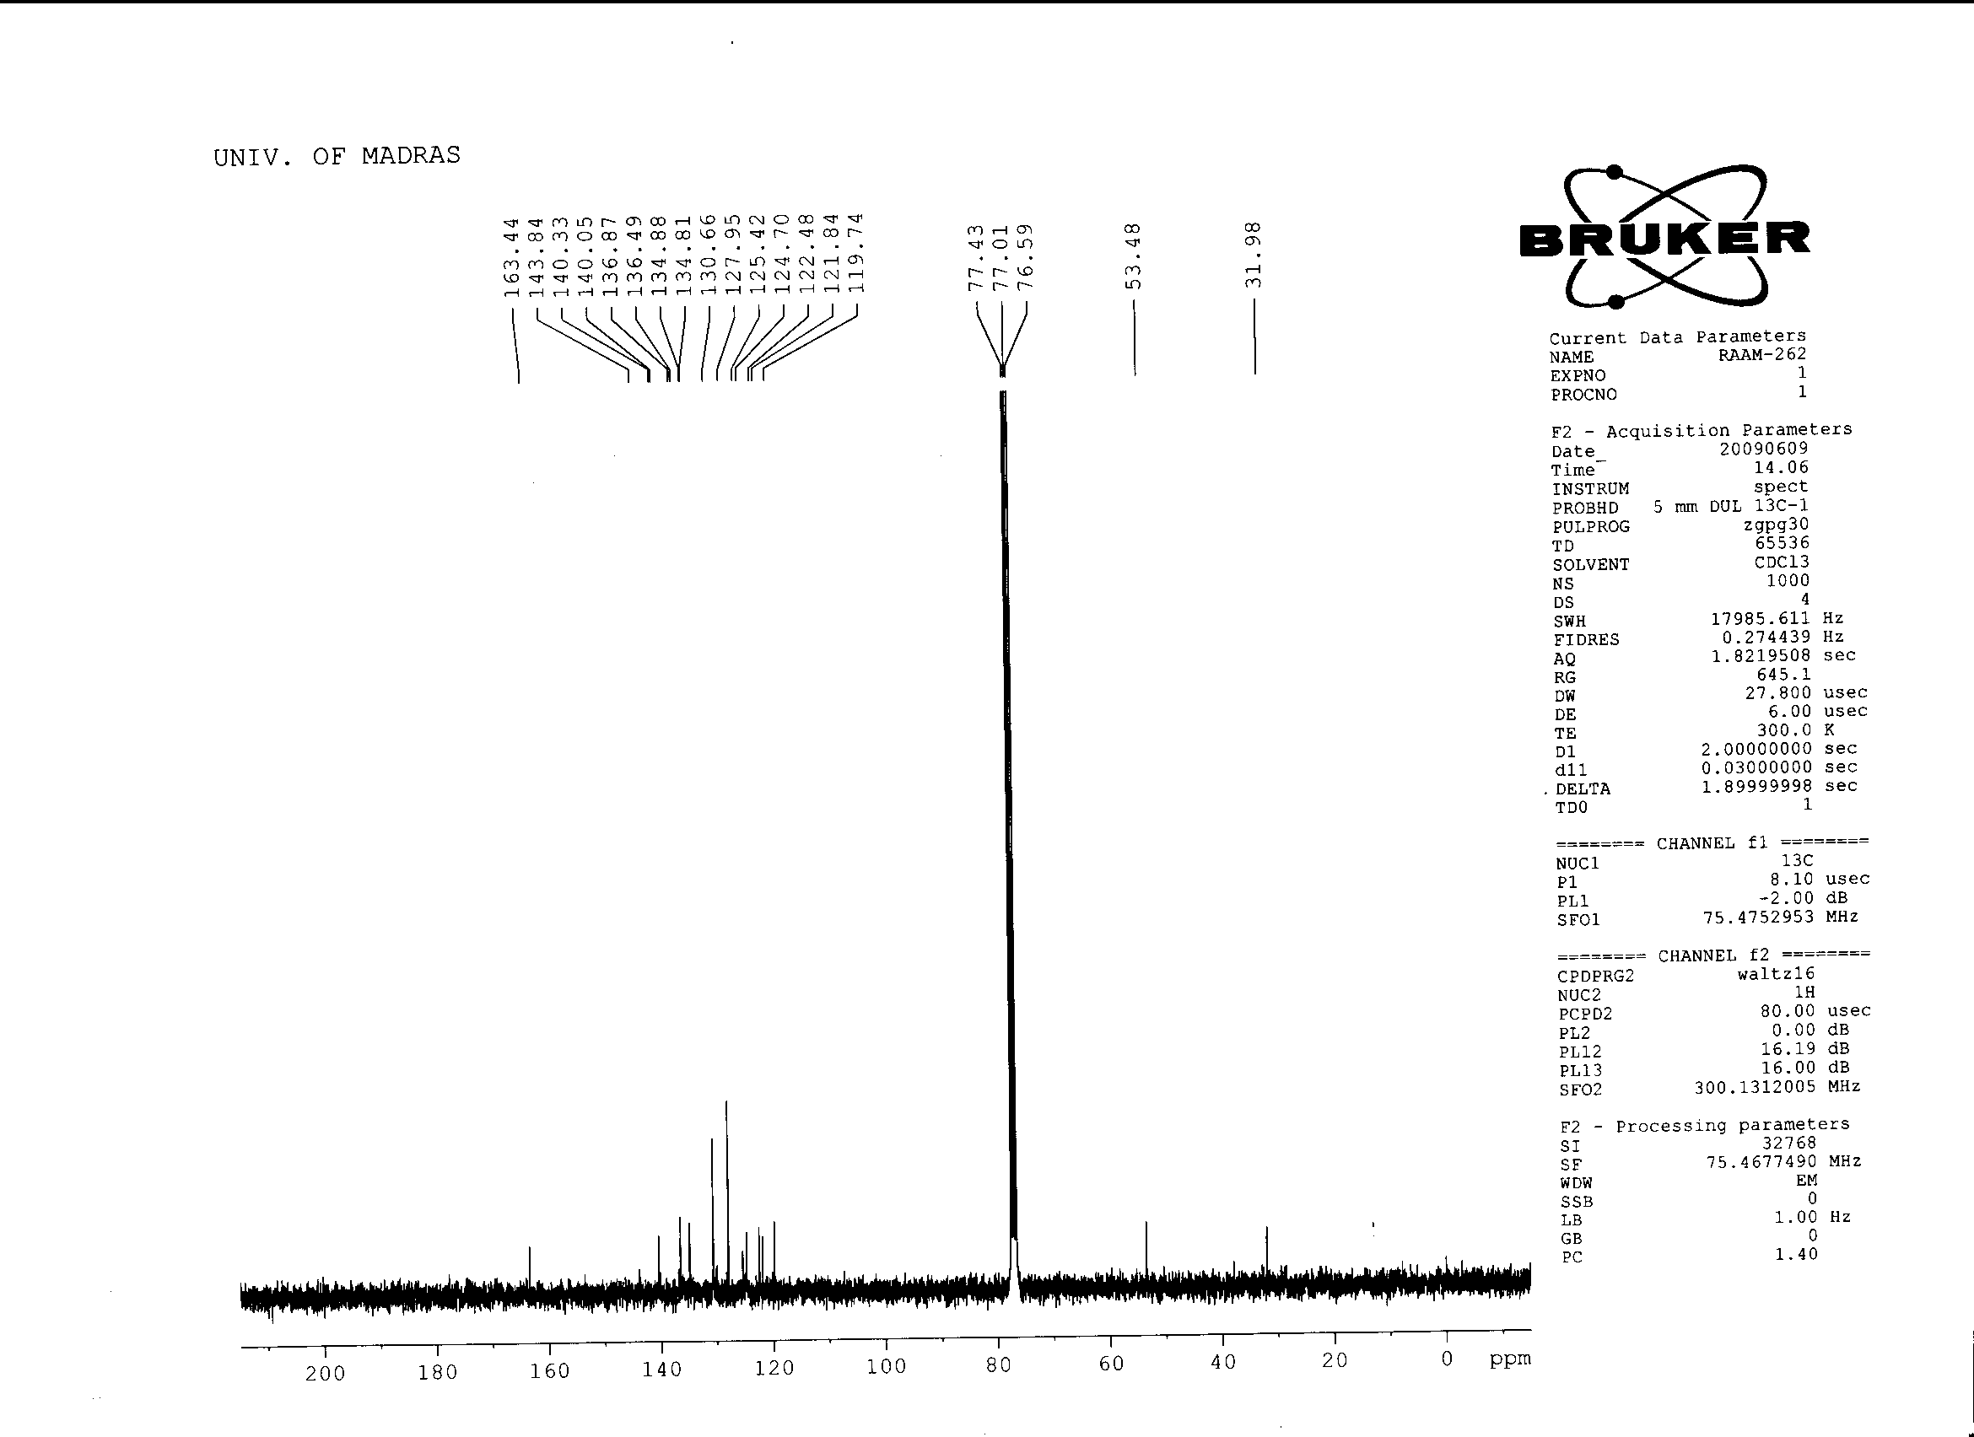

**13C NMR spectrum (75 MHz, CDCl3) of amide cyclophane 1**

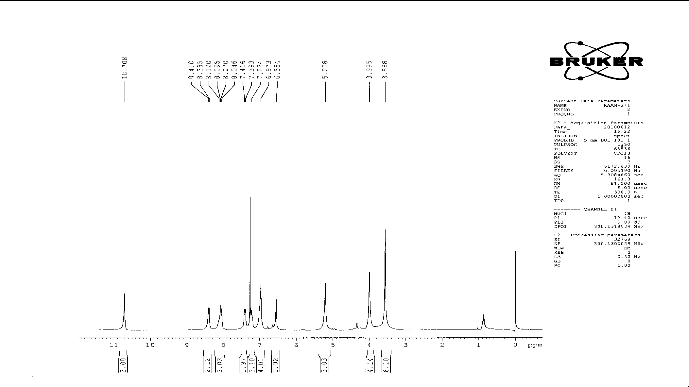

**1H NMR spectrum (300 MHz, CDCl3) of amide cyclophane 4**

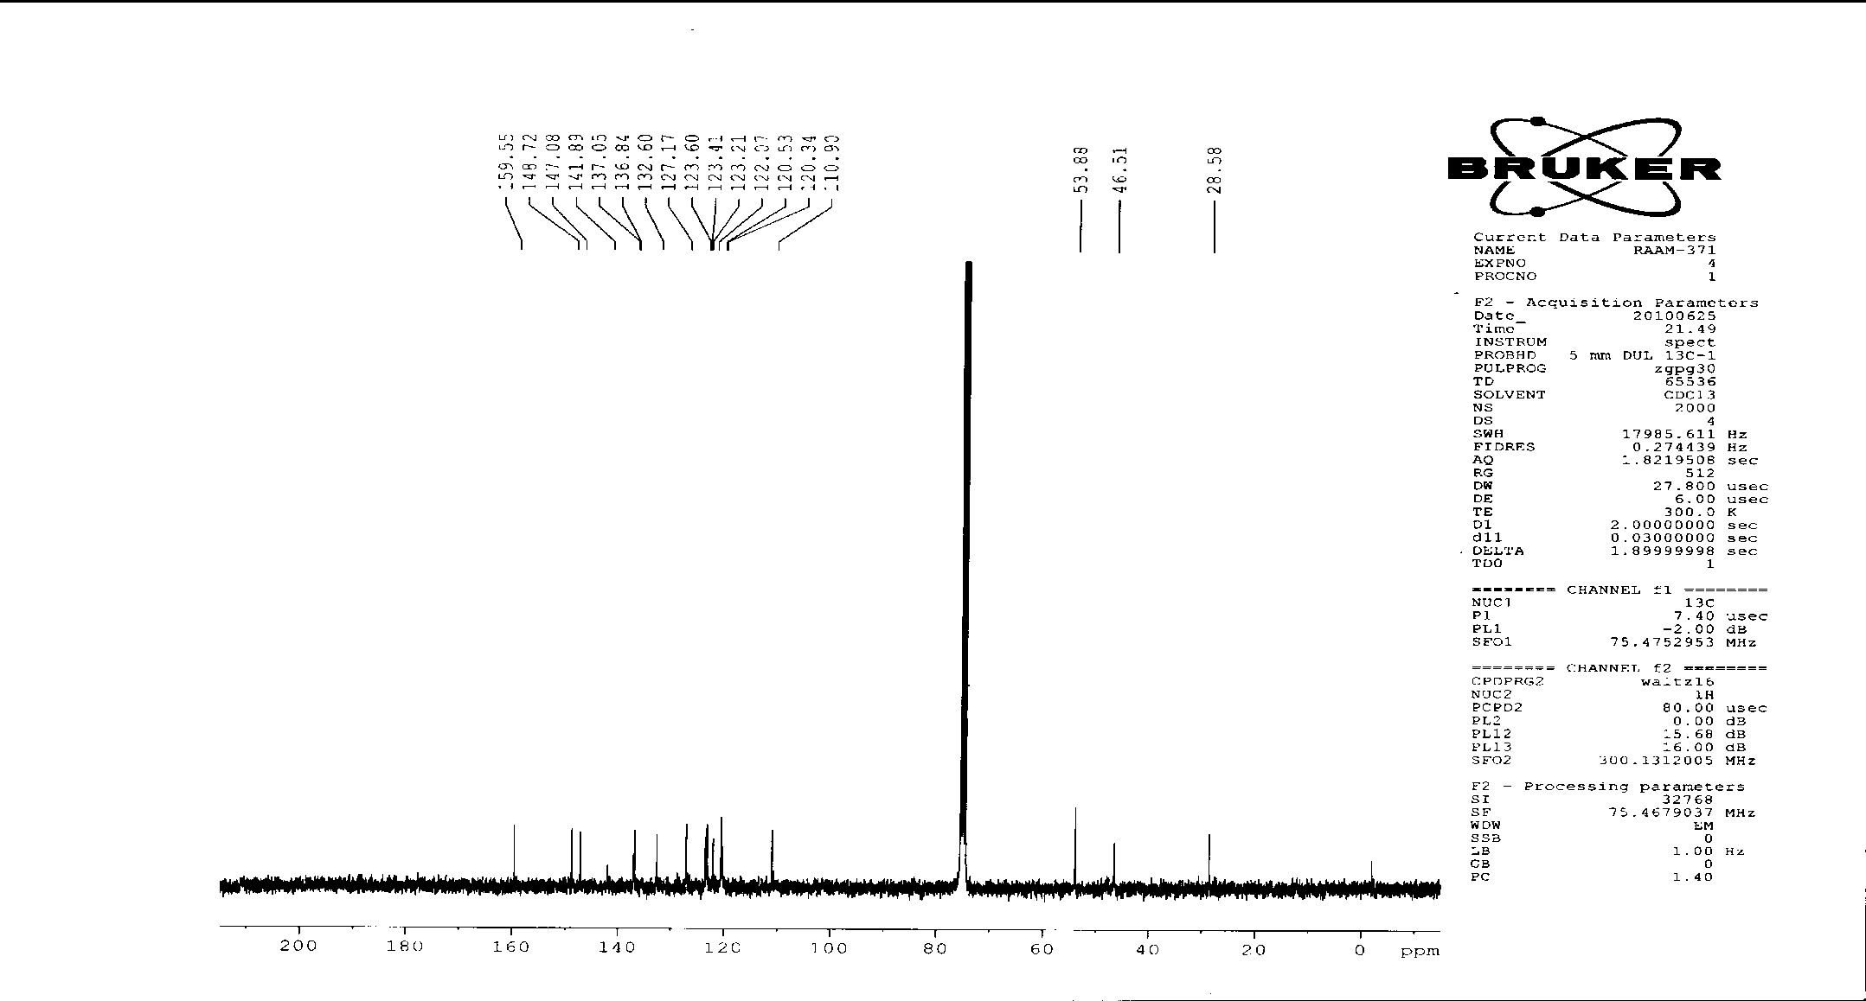

**13C NMR spectrum (75 MHz, CDCl3) of amide cyclophane 4**

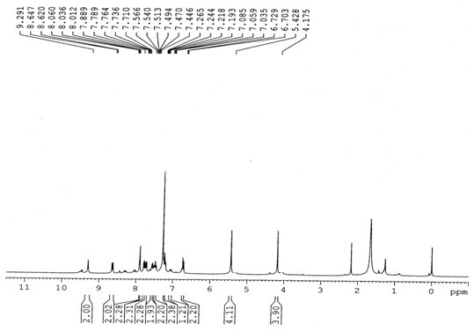

**1H NMR spectrum (300 MHz, CDCl3) of amide cyclophane 5**

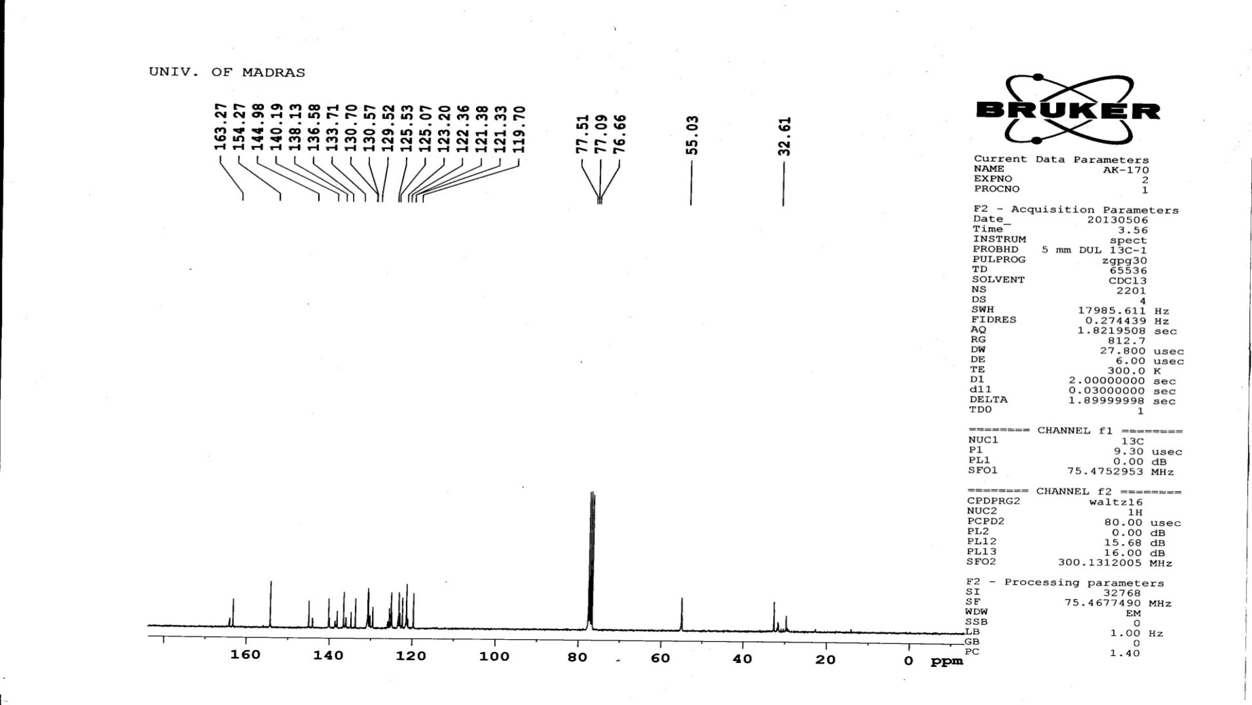

**13C NMR spectrum (75 MHz, CDCl3) of amide cyclophane 5**

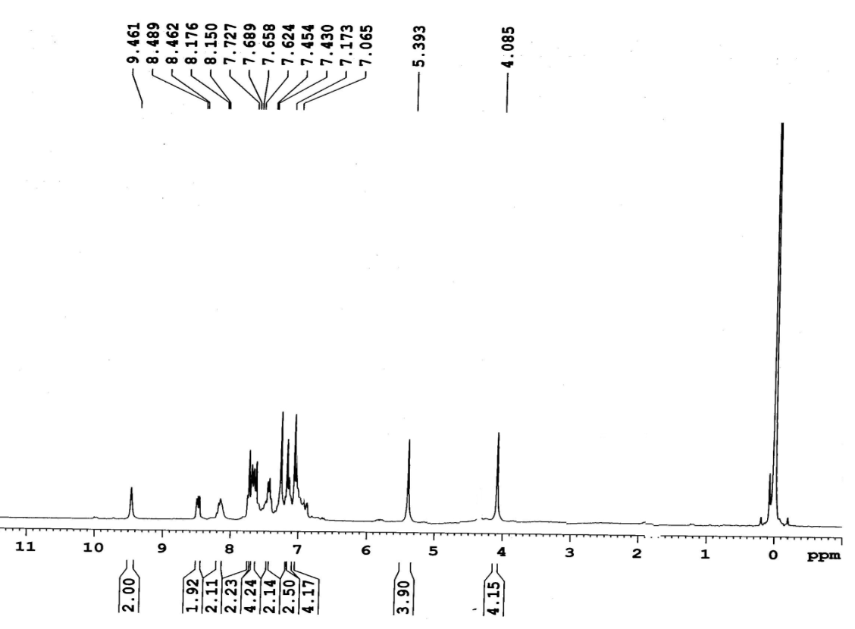

**1H NMR spectrum (300 MHz, CDCl3) of amide cyclophane 7**

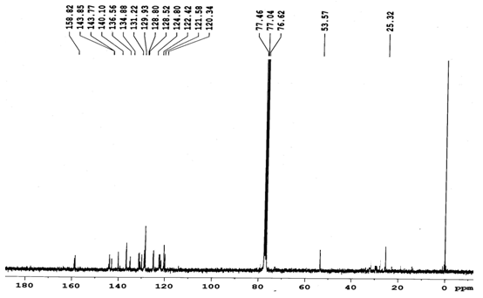

**13C NMR spectrum (75 MHz, CDCl3) of amide cyclophane 7**

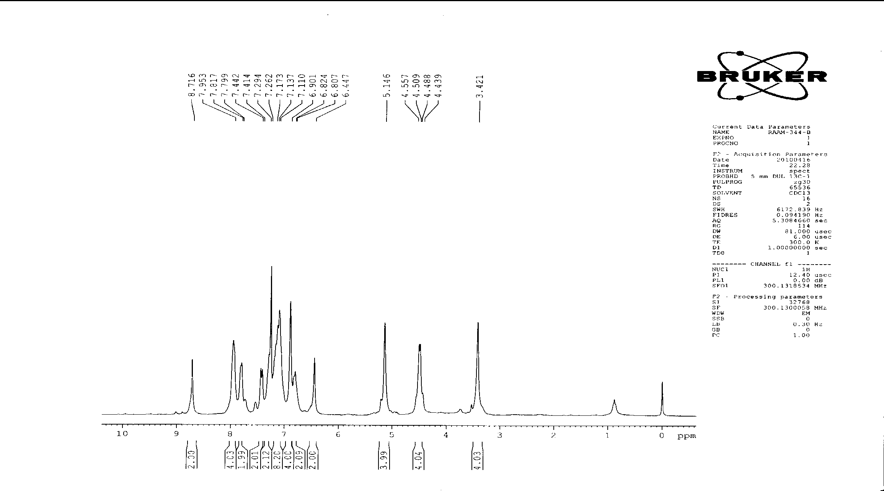

**1H NMR spectrum (300 MHz, CDCl3) of amide cyclophane 10**

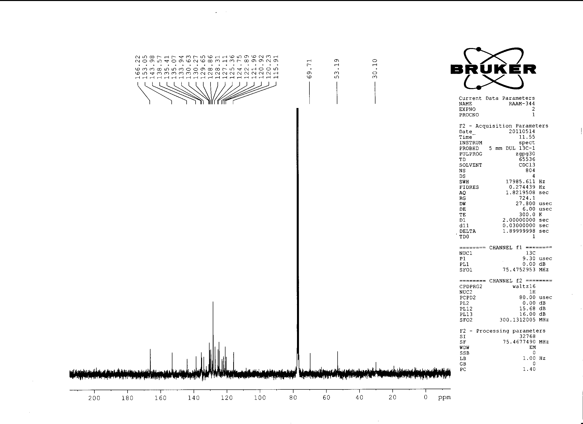

**13C NMR spectrum (75 MHz, CDCl3) of amide cyclophane 10**

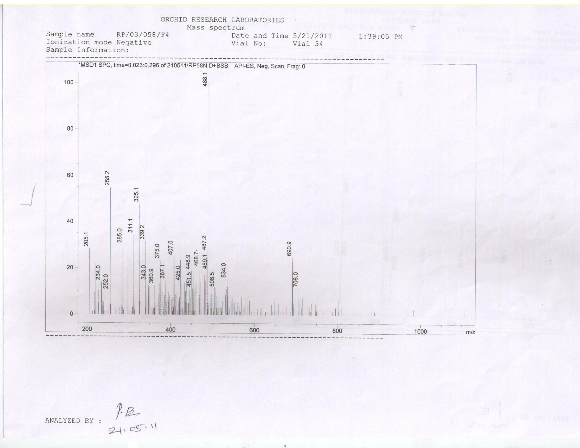



**Mass spectrum (EI) of amide cyclophane 4**