Supplementary Data

**One-pot Synthesis of Spiro[chromeno[2,3-*c*]pyrazole-4,3´-indoline]-diones using Sulfonic Acid Functionalized Nanoporous Silica SBA-Pr-SO3H** **and Study of Their Antimicrobial Properties**

**Ghodsi Mohammadi Ziarani1[1]*, Razieh Moradi1, Negar Lashgari2,Alireza Badiei2 and Ali Abolhassani Soorki3**

*1 Department of Chemistry, Alzahra University, P.O. Box 1993891176, Tehran, Iran*

*2 School of Chemistry, College of Science, University of Tehran, Tehran, Iran*

*3 ACECR-Research Institute of Applied Sciences, Shahid Beheshti University, Tehran, Iran*

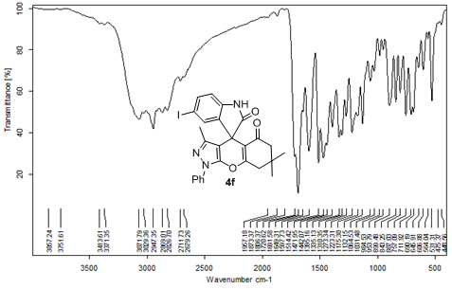

**IR spectrum of compound 4f**

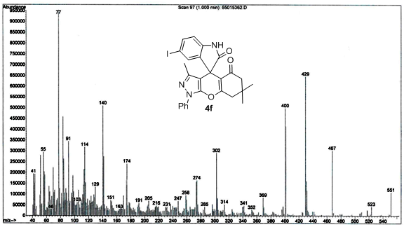

**Mass spectrum of compound 4f**

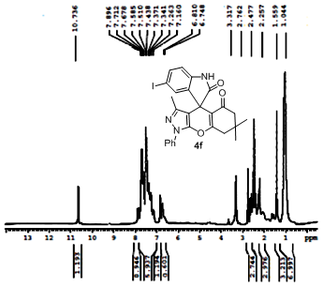

**1H NMR spectrum of compound 4f**

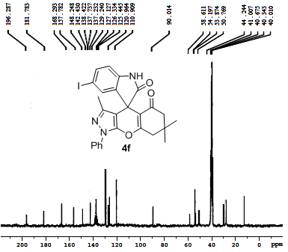

**13C NMR spectrum of compound 4f**

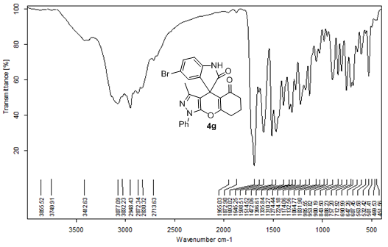

**IR spectrum of compound 4g**

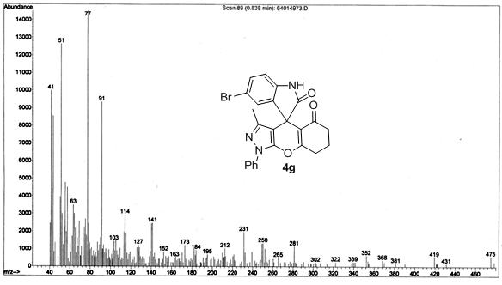

**Mass spectrum of compound 4g**

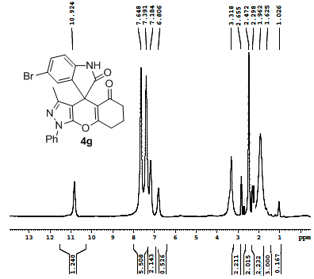

**1H NMR spectrum of compound 4g**

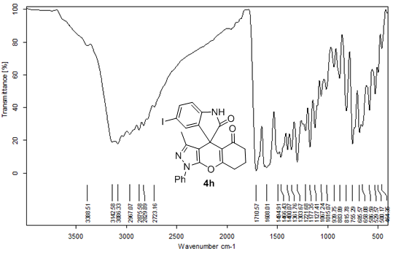

**IR spectrum of compound 4h**

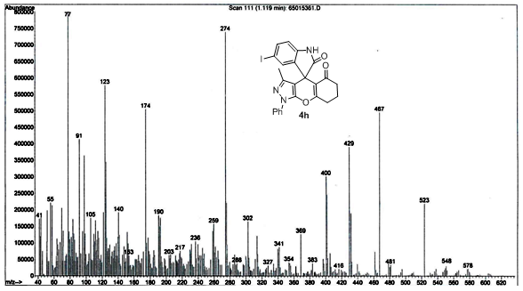

**Mass spectrum of compound 4h**

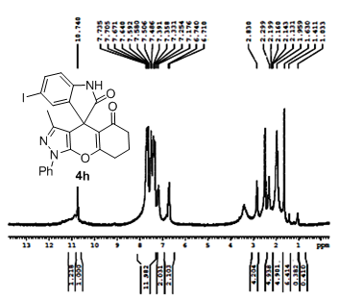

**1H NMR spectrum of compound 4h**

**13C NMR spectrum of compound 4h**

1. * Corresponding author. Tel.: +98 21 88041344; fax: +98 21 88041344.

   E-mail address: [*gmziarani@hotmail.com*](mailto:gmziarani@hotmail.com)*;* [*gmohammadi@alzahra.ac.ir*](mailto:gmohammadi@alzahra.ac.ir) (G. Mohammadi Ziarani).