Supporting Information
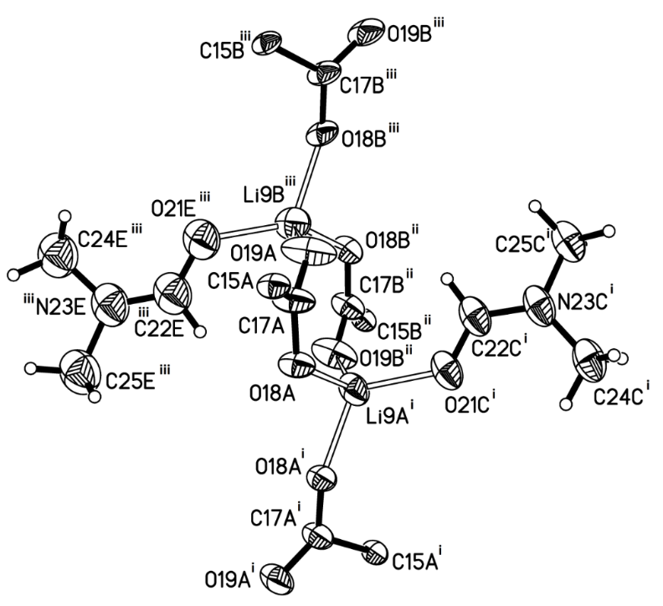
Figure S1: Environment of Li centres observed in MnLi, showing the coordinated carboxylate groups and DMF molecules, along with the numbering scheme used. Displacement ellipsoids drawn at 50% probability level. Symmetry codes: i) 1-x, 1-y, +z; ii) 0.5-x, -0.5+y, 0.5+z; iii) -0.5+x, 1.5-y, 0.5+z.

Additional details of Structural Refinement.
For ReLi, the asymmetric unit contains half of the Re(diimine)(CO)₃Cl moiety, so the axial position is shared by the Cl⁻ ligand and the axial CO; the occupancies of the components were refined to be exactly 0.5. The coordinated DMF molecule is disordered over two orientations, the occupancies of the components were refined competitively converging to a ratio of 0.63(2):0.37(2). Rigid bond and similarity restraints were applied to the anisotropic thermal displacement parameters of all atoms. The lithium-DMF oxygen bond distances were restrained to be approximately equal. The atoms of both components of the coordinated DMF molecule (O21A to C25A and O21B to C25B) were restrained to be planar. The structure has unresolved issues with regard to areas of significant electron density in chemically nonsensical positions, possibly as a result of unresolved twinning; although the structure of the coordination network can be identified, bond lengths, angles and their estimated standard deviations cannot be determined reliably. For MnLi the partially refined structure was run through PLATON/TWINROTMATRIX;³¹ this revealed the presence of a pseudo-merohedral twin with a BASF of ~0.48. A new HKLF5 file was written, the structure was refined against this and the BASF converged to 0.52(11):0.48(11). The coordinated DMF molecules are disordered over two orientations, the occupancies of the components were refined competitively converging to a ratio of 0.54(2):0.46(2). Rigid bond and similarity restraints were applied to the anisotropic thermal displacement parameters of all atoms. Chemically equivalent 1,2 and 1,3 distances of both components of the disordered DMF molecules were restrained to be approximately equal. All lithium-DMF oxygen bond distances were restrained to be approximately equal. The atoms of coordinated DMF molecule O21E to C25E (the major component) and O21F to C25F (its equivalent minor component) were restrained to be planar.

