Language background conditions variation in English stop pronunciation on Croker Island

Phonetic differences between Aboriginal varieties of English and Standard Australian English have been reported (see e.g. Butcher 2008, Fletcher & Butcher 2014). However, the reasons for these differences are still under-researched (Eades 2014: 438). While it is commonly suspected that relevant local Australian Indigenous languages are at least partially responsible for phonetic differences (see e.g. Butcher 2008: 627, already Elwell 1979: 150), this has so far not been demonstrated in a published case study. Based on acoustic experimental data, we will argue that the local Indigenous languages Iwaidja and Kunwinjku have influenced the pronunciation of English stops by Iwaidja/Kunwinjku bilinguals but in different ways due to differences in the phonological and phonetic setup of these languages.
To support this argument, we will present results from an acoustic analysis of English stop and affricate phonemes, investigating three parameters, closure duration, voice onset time and lenition (measured as intensity abatement, see Ennever, Meakins & Round subm.). The main research question we asked was whether the way these parameters pattern in Iwaidja and Kunwinjku show parallels to English spoken by Iwaidja/Kunwinjku-English bilinguals that English spoken by non-Iwaidja/Kunwinjku speakers does not.
The data come from experiments conducted on Croker Island and in Western Sydney with four different populations: 4 Iwaidja-English bilinguals (2 male), 4 Kunwinjku-English bilinguals (2 male), 3 (Croker Island) Aboriginal English monolinguals (1 male), 4 Australian Standard English monolinguals (2 male). Suitable target words were elicited in English, Iwaidja and Kunwinjku (written stimuli or shadowing) with stop phonemes in initial, medial and final position embedded in a natural carrier phrase controlling for the phonological environment (4 target words per condition, 3 repetitions each). Recordings were made with a Countryman EMW microphone using an iPad with iRigPro preamp with a 16-bit sampling depth and a 48kHz sampling rate. The data was analysed using the Praat for R script developed by Ennever, Meakins & Round (subm.). We ran a linear mixed effects model with speaker as a random factor and language as a fixed factor investigating a main-effect on amplitude abatement.
The results give an affirmative answer to the research question: Especially with respect to lenition, the samples of English spoken by Iwaidja/Kunwinjku speakers show clear parallels to Iwaidja/Kunwinjku (see Figure 1). Both samples of English differ significantly from the sample of Aboriginal English and Australian Standard English speakers. This suggests that the differences in the pronunciation of stops found in English spoken by Iwaidja/Kunwinjku bilinguals are indeed due to contact between these Australian languages and English in the repertoires of the relevant speakers. The second conclusion is that English on Croker Island is heterogenous, and that it is questionable whether it should be regarded as one variety or rather as a bundle of varieties or a repertoire. Third, all samples of English from Croker Island show maintenance of the phonological “voicing” opposition in stops. This contrast is often neutralised in other varieties of Aboriginal English (see e.g. Butcher 2008: 627).
Our study contributes to the sociolinguistics of English, by describing the phonetics of English spoken on Croker Island for the first time and by demonstrating that key features are best interpreted as results of language contact. We also show that English on Croker Island is likely to be not a monolithic variety, which has also important ramifications for sociolinguistic theory and the history of English.
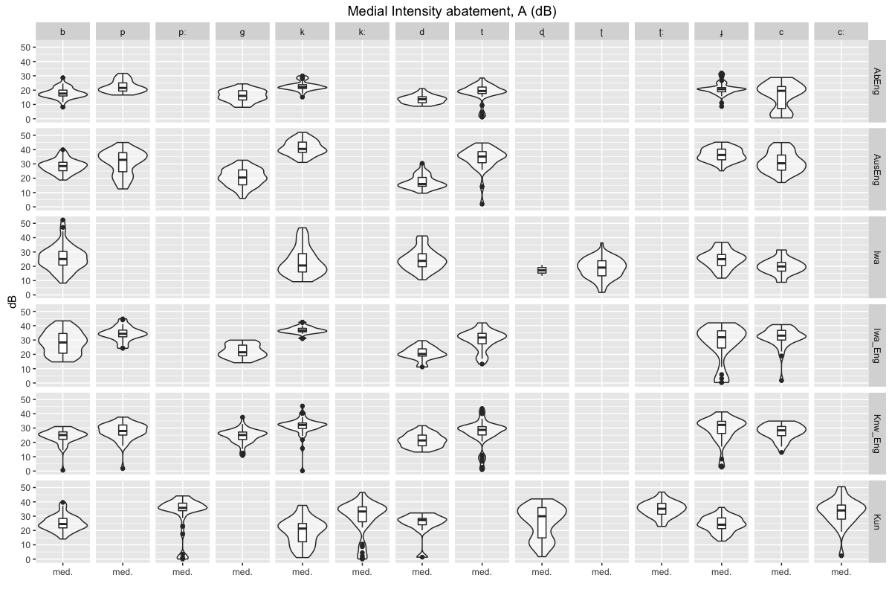

Figure 1: Intensity abatement (lenition) in medial position in all samples (AbEng = monolingual English sample from Croker Island; AusEng = monolingual sample from Western Sydney; Iwa = Iwaidja sample from bilingual Iwaidja-English speakers; Iwa_Eng = English sample from bilingual Iwaidja-English speakers; Knw_Eng = English sample from bilingual Kunwinjku-English speakers; Kun = Kunwinjku sample from Kunwinjku-English speakers)
References
Butcher, Andrew. 2008. Linguistic aspects of Australian Aboriginal English. Clinical Linguistics & Phonetics 22.8, 625-42.
Eades, Diana. 2014. Aboriginal English. In Harold Koch & Rachel Nordlinger (eds.), The languages and linguistics of Australia: a comprehensive guide, 417-47. Berlin/New York: De Gruyter Mouton.
Elwell, Vanessa. 1979. English as a second language in Aborignal Australia as a second language in Aboriginal Australia: a case study of Milingimbi. dissertation, Australian National University.
Ennever, Thomas, Felicity Meakins & Erich Round. subm. An acoustic measure of lenition, Gurindji stops, and the puzzle of Australian obstruents. Ms.Reprint Edition.
Fletcher, Janet & Andrew Butcher. 2014. Sound patterns of Australian Languages. In Harold Koch & Rachel Nordlinger (eds.), The languages and linguistics of Australia: a comprehensive guide. Berlin/New York: De Gruyter Mouton.

