An efficient novel synthesis of pyrano[3,2-a]- and pyrazolo[4,3-a]- acridines
Rajendran Satheeshkumarª, Werner Kaminsky^{b}, Karnam Jayarampillai Rajendra Prasadª*
ª Department of Chemistry, Bharathiar University, Coimbatore 641 046, Tamil Nadu, India.
^{b} Department of Chemistry, University of Washington, Seattle, WA 98195, USA.

Supporting Information

Experimental Section
General
Melting points (M.p.) were determined on a Mettler FP 51 apparatus (Mettler Instruments, Switzerland) and are uncorrected. They are expressed in degree centigrade (°C).
A Nicolet Avatar Model FT-IR spectrophotometer was used to record the IR spectra (4000–400 cm⁻¹). ¹H NMR and ¹³C NMR spectra were recorded on Bruker AV 400 (400 MHz (¹H) and 100 MHz (¹³C)) spectrometers using tetramethylsilane (TMS) as an internal reference. The chemical shifts are expressed in parts per million (ppm). Coupling constants (J) are reported in hertz (Hz). The terms J_{o} and J_{m} refer to ortho coupling constant and meta coupling constant. The terms s, d, t, dd refer to singlet, doublet, triplet and doublet of doublet, respectively, b s refers to a broad singlet. Microanalyses were performed on a Vario EL III model CHNS analyzer (Vario, Germany) at the Department of Chemistry, Bharathiar University. X-ray diffraction measurements were performed on a Bruker-Nonius FR590 Kappa CCD diffractometer at 130 K using monochromatic Mo Kα radiation. When known compounds had to be prepared according to literature procedures, pertinent references are given. The purity of the products was tested by TLC with plates coated with silica gel-G using petroleum ether and ethyl acetate in the ratio of 1:1 as developing solvents.

* Corresponding author e-mail: prasad_125@yahoo.com, Tel: +91-422-2422311, Fax: +91-
422-2422387
Synthesis
General procedure for the synthesis of 2-Amino-9-chloro-7-phenyl-4-aryl-5,6-dihydro-4H-pyrano[3,2-a]acridin-3-carbonitrile (4)
A mixture of 7-chloro-9-phenyl-2,3-dihydroacridin-4(1H)-one (1, 0.001 mol), aromatic / hetero aromatic aldehyde (2, 0.001 mol), malononitrile (3, 0.001 mol), and piperidine (3-5 drops) in dry ethanol (15 mL) was heated under reflux for 1.5 hrs. After completion of the reaction, the residue was poured in ice water and neutralised with 1:1HCl followed by extracted with ethyl acetate. Combined organic layers were dried over anhydrous magnesium sulphate. It was then purified on a silica-gel column chromatography (eluent: petroleum ether/ethyl acetate, 95:5). The pure product was recrystallised from ethyl acetate.

2-Amino-9-chloro-4-(4'-methoxyphenyl)-7-phenyl-5,6-dihydro-4H-pyrano[3,2-a]acridin-3-carbonitrile (4a)
Brownish yellow solid; M.p. 266-268 ºC Yield = 89%; FT-IR (KBr, cm⁻¹) ν_{max}: 3457, 3360, 2210, 1613; ¹H NMR (CDCl₃ 400 MHz) (ppm) δ: 2.530-2.560 (m, 2H, C₅-H₂), 2.630-2.670 (m, 2H, C₆-H₂), 3.860 (s, 3H, C₄'-OCH₃), 3.900 (s, 1H, C₄-H), 5.420 (s, 2H, NH₂), 6.950-7.010 (m, 2H, C₃'-, C₅'-H), 7.220-7.260 (m, 3H, C₁₀-, C₃'-, C₅'-H), 7.450-7.540 (m, 5H, C₂''-, C₃''-, C₄''-,C₅''-, C₆''-H), 7.670 (d, 1H, C₈-H, J_{m} = 2.00 Hz), 8.280 (d, 1H, C₁₁-H, J_{o} = 8.80 Hz); ¹³C NMR (CDCl₃, 100 MHz) (ppm) δ: 25.22, 25.95, 30.10, 55.30, 113.78, 114.23, 116.20, 124.90, 128.44, 128.66, 128.92, 129.35, 129.57, 130.14, 130.33, 131.31, 132.82, 135.36, 141.10, 145.00, 145.18, 148.32, 149.52, 151.87, 160.28; Anal. Calcd. for: C₃₀H₂₂ClN₃O₂: C, 73.24; H, 4.51; N, 8.54; Found: C, 73.31; H, 4.42; N, 8.49%.

2-Amino-9-chloro-4-(4'-fluorophenyl)-7-phenyl-5,6-dihydro-4H-pyrano[3,2-a]acridin-3-carbonitrile (4b)
Reddish brown solid; M.p. 272-274 ºC Yield = 87%; FT-IR (KBr, cm⁻¹) ν_{max}: 3450, 3371, 2210, 1610; ¹H NMR (CDCl₃ 400 MHz) (ppm) δ: 2.000-2.300 (m, 2H, C₅-H₂), 2.940-3.140 (m, 2H, C₆-H₂), 4.200 (s, 1H, C₄-H), 4.650 (s, 2H, NH₂), 7.180-7.230 (m, 3H, C₃'-, C₅'-, C₈-H), 7.270-7.300 (m, 2H, C₃'-, C₅'-H), 7.350-7.410 (m, 2H, C₂''-, C₆''-H), 7.530-7.630 (m, 3H, C₃''-, C₄''-,C₅''-H), 7.730 (dd, 1H, C₁₀-H, J_{m} = 2.40 Hz, J_{o} = 8.80 Hz), 7.990 (d, 1H, C₁₁-H, J_{o} = 8.80 Hz); ¹³C NMR (CDCl₃, 100 MHz) (ppm) δ: 23.50, 32.07, 41.66, 57.08, 115.56, 115.78, 118.06, 119.64, 120.67, 124.65, 127.83, 128.77, 128.83, 129.77, 129.85, 130.71, 131.07, 137.65, 139.85, 140.21, 144.49, 158.31, 159.02, 160.31; Anal. Calcd. for: C₂₉H₁₉ClFN₃O: C, 72.57; H, 3.99; N, 8.76; Found: C, 72.64; H, 4.05; N, 8.69%.
2-Amino-9-chloro-4-(thiophen-2'-yl)-7-phenyl-5,6-dihydro-4H-pyrano[3,2-a]acridin-3-carbonitrile (4c)
Brownish yellow solid; M.p. 242-244 ºC Yield = 89%; FT-IR (KBr, cm⁻¹) ν_{max}: 3413, 3328, 2201, 1634; ¹H NMR (CDCl₃ 400 MHz) (ppm) δ: 2.250-2.470 (m, 2H, C₅-H₂), 2.980-3.120 (m, 2H, C₆-H₂), 4.530 (s, 1H, C₄-H), 5.010 (s, 2H, NH₂), 6.980-7.230 (m, 3H, C₃'-, C₄'-, C₅'-H), 7.350-7.460 (m, 3H, C₈-, C₂''-, C₆''-H), 7.570-7.600 (m, 3H, C₃''-, C₄''-,C₅''-H), 7.750 (d, 1H, C₁₀-H, J_{m} = 2.00 Hz), 8.000 (d, 1H, C₁₁-H, J_{o} = 8.00 Hz); ¹³C NMR (CDCl₃, 100 MHz) (ppm) δ: 23.53, 32.21, 57.47, 118.09, 119.54, 120.59, 124.64, 125.38, 125.89, 127.07, 127.84, 128.79, 130.04, 130.71, 131.08, 137.47, 139.95, 140.08, 144.52, 148.32, 158.39, 159.01; Anal. Calcd. for: C₂₇H₁₈ClN₃OS: C, 69.30; H, 3.88; N, 8.98; S, 6.85; Found: C, 69.36; H, 3.82; N, 8.91; S, 6.92%.

2-Amino-9-chloro-4-(4'-naphthyl)-7-phenyl-5,6-dihydro-4H-pyrano[3,2-a]acridin-3-carbonitrile (4d)
Brownish yellow solid; M.p. 286-288 ºC Yield = 82%; FT-IR (KBr, cm⁻¹) ν_{max}: 3434, 3341, 2218, 1619; ¹H NMR (CDCl₃ 400 MHz) (ppm) δ: 2.045-2.274 (m, 2H, C₅-H₂), 2.421-2.685 (m, 2H, C₆-H₂), 3.690-3.861 (m, 1H, C₄-H), 4.492 (s, 2H, NH₂), 6.839-7.053 (m, 3H, C₂'-, C₃'-, C₄'-H), 7.138-7.192 (m, 3H, C₅'-, C₆'-, C₇'-H), 7.278-7.579 (m, 5H, C₂''-, C₃''-, C₄''-,C₅''-, C₆''-H), 7.908-7.928 (m, 2H, C₈'-, C₈-H), 8.597 (d, 1H, C₁₀-H, J_{o} = 8.00 Hz), 8.975 (d, 1H, C₁₁-H, J_{o} = 8.00 Hz); ¹³C NMR (CDCl₃, 100 MHz) (ppm) δ: 23.55, 32.10, 55.04, 114.12, 118.45, 119.64, 120.61, 124.49, 127.66, 127.91, 128.08, 128.17, 128.64, 128.69, 128.89, 129.76, 130.54, 130.90, 135.23, 137.56, ,139.55, 139.77, 144.28, 158.01, 158.45; Anal. Calcd. for: C₃₃H₂₂ClN₃O: C, 77.41; H, 4.33; N, 8.21; Found: C, 77.50; H, 4.26; N, 8.17%.

2-Amino-9-chloro-4,7-diphenyl-5,6-dihydro-4H-pyrano[3,2-a]acridin-3-carbonitrile (4e)
Brownish yellow solid; M.p. 232-234 ºC Yield = 87%; FT-IR (KBr, cm⁻¹) ν_{max}: 3454, 3416, 2212, 1622; ¹H NMR (CDCl₃ 400 MHz) (ppm) δ: 2.297-2.343 (m, 2H, C₅-H₂), 2.565-2.639 (m, 2H, C₆-H₂), 3.770 (s, 1H, C₄-H), 4.402 (s, 2H, NH₂), 7.189-7.207 (m, 3H, C₃'-, C₄'-, C₅'-H), 7.260-7.273 (m, 2H, C₂'-, C₆'-H), 7.372-7.392 (m, 2H, C₈-, C₁₀-H), 7.477-7.572 (m, 5H, C₂''-, C₃''-, C₄''-, C₅''-, C₆''-H), 8.664 (d, 1H, C₁₁-H, J_{o} = 8.80 Hz); ¹³C NMR (CDCl₃, 100 MHz) (ppm) δ: 27.56, 29.25, 57.60, 108.30, 111.44, 111.88, 115.65, 117.62, 125.31, 125.42, 126.81, 127.03, 128.40, 129.13, 129.24, 130.01, 130.32, 131.00, 131.42, 135.25, 141.67; Anal. Calcd. for: C₂₉H₂₀ClN₃O: C, 75.40; H, 4.36; N, 9.10; Found: C, 75.33; H, 4.42; N, 9.17%.
2-Amino-9-chloro-4-(4'-methylphenyl)-7-phenyl-5,6-dihydro-4H-pyrano[3,2-a]acridin-3-carbonitrile (4f)
Brownish yellow solid; M.p. 250-252 ºC Yield = 89%; FT-IR (KBr, cm⁻¹) ν_{max}: 3438, 3386, 2211, 1595; ¹H NMR (CDCl₃ 400 MHz) (ppm) δ: 2.015-2.388 (m, 2H, C₅-H₂), 2.877-3.078 (m, 2H, C₆-H₂), 2.498 (s, 3H, C₄'-CH₃), 4.069 (s, 1H, C₄-H), 4.856 (s, 2H, NH₂), 6.898-6.919 (m, 2H, C₃'-, C₅'-H), 7.129-7.210 (m, 3H, C₁₀-, C₃'-, C₅'-H), 7.326-7.594 (m, 5H, C₂''-, C₃''-, C₄''-,C₅''-, C₆''-H), 7.710 (dd, 1H, C₁₀-H, J_{m} = 2.00 Hz, J_{o} = 8.00 Hz), 7.971 (d, 1H, C₁₁-H, J_{o} = 8.00 Hz); ¹³C NMR (CDCl₃, 100 MHz) (ppm) δ: 24.87, 26.37, 55.30,116.67, 125.14, 125.25, 125.79, 126.39, 126.55, 127.12, 129.10, 129.15, 129.25, 130.02, 130.29, 130.71, 131.02; Anal. Calcd. for: C₃₀H₂₂ClN₃O: C, 75.70; H, 4.66; N, 8.83; Found: C, 75.64; H, 4.71; N, 8.77%.

General procedure for synthesis of 7-Chloro-4-hydroxy-9-aryl-1,2-dihydroacridin-3-carbaldehyde (9)
A mixture of an appropriate 7-chloro-9-aryl-2,3-dihydroacridin-4(1H)-one (1, 1 mmol) and ethylformate (1.2 mmol) was added to in dry ethanol (20 mL) was added to an ice-cooled solution of 1.00 g of sodium hydride (degreased with petroleum ether) in dry toluene (10 mL) at 0 ºC to room temperature for 4-5 hrs. After completion of the reaction as indicated by TLC, the reaction mixture was quenched with water (45 mL) and neutralized with 1:1 HCl, then extracted with EtOAc (2 × 10 mL) and dried over anhydrous magnesium sulphate. Evaporation of the solvent afforded a yellow solid which was on recrystallization from ethyl acetate to yield the corresponding 7-chloro-4-hydroxy-9-aryl-1,2-dihydroacridin-3-carbaldehyde (9).

7-Chloro-4-hydroxy-9-phenyl-1,2-dihydroacridin-3-carbaldehyde (9a)
Yellow solid; M.p. 174-176 ºC Yield = 75%; FT-IR (KBr, cm⁻¹) ν_{max}: 3076, 1733; ¹H NMR (CDCl₃ 400 MHz) (ppm) δ: 2.577-2.614 (m, 2H, C₂-H₂), 2.783-2.819 (m, 2H, C₁-H₂), 7.249-7.263 (m, 3H, C₈-, C₂'-, C₆'-H), 7.429 (s, 1H, C₃-CHO), 7.526-7.601 (m, 3H, C₃'-, C₄'-, C₅'-H), 7.643 (d, 1H, C₆-H, J_{o}= 8.80 Hz), 8.120 (d, 1H, C₅-H, J_{o}= 8.80 Hz), 10.130 (s, 1H, OH); ¹³C NMR (CDCl₃, 100 MHz) (ppm) δ: 21.05, 24.80, 125.12, 128.77, 129.03, 129.12, 129.52, 130.08, 130.52, 131.08, 134.09, 134.95, 145.94, 147.84, 189.65; Anal. Calcd. for: C₂₀H₁₄ClNO₂: C, 71.54; H, 4.20; N, 4.17. Found: C, 71.59; H, 4.28; N, 4.10%.

7-Chloro-9-(2'-fluorophenyl)-4-hydroxy-1,2-dihydroacridin-3-carbaldehyde (9b)
Yellow solid; M.p. 162-164 ºC Yield = 70%; FT-IR (KBr, cm⁻¹) ν_{max}: 3072, 1733; ¹H NMR (CDCl₃ 400 MHz) (ppm) δ: 2.548-2.643 (m, 2H, C₂-H₂), 2.660-2.887 (m, 2H, C₁-H₂), 7.235-7.286 (m, 2H, C₃'-, C₅'-H), 7.309-7.595 (m, 4H, C₄'-, C₆'-, C₃-CHO, C₈-H), 7.663 (dd, 1H, C₆-H, J_{m} = 2.00 Hz, J_{o} = 8.80 Hz), 8.128-8.209 (m, 1H, C₅-H), 10.129 (s, 1H, OH); ¹³C NMR (CDCl₃, 100 MHz) (ppm) δ: 24.70, 29.70, 116.36, 116.57, 122.17, 124.58, 124.77, 124.80, 129.30, 130.68, 131.24, 131.30, 134.44, 139.73, 147.82, 158.32, 189.68; Anal. Calcd. for: C₂₀H₁₃ClFNO₂: C, 67.90; H, 3.70; N, 3.96. Found: C, 67.84; H, 3.63; N, 3.90%.

7-Chloro-9-(2'-chlorophenyl)-4-hydroxy-1,2-dihydroacridin-3-carbaldehyde (9c)
Yellow solid; M.p. 148-150 ºC Yield = 73%; FT-IR (KBr, cm⁻¹) ν_{max}: 3080, 1727; ¹H NMR (CDCl₃ 400 MHz) (ppm) δ: 2.553-2.696 (m, 2H, C₂-H₂), 2.713-2.828 (m, 2H, C₁-H₂), 7.249-7.263 (m, 2H, C₃'-, C₅'-H), 7.461-7.767 (m, 5H, C₄'-, C₆'-, C₃-CHO, C₆, C₈-H), 8.140 (d, 1H, C₅-H, J_{o}= 8.80 Hz), 10.117 (s, 1H, OH); ¹³C NMR (CDCl₃, 100 MHz) (ppm) δ: 21.05, 24.53, 128.99, 130.25, 130.49, 130.70, 130.75, 130.85, 131.25, 131.70, 132.04, 133.44, 133.58, 133.85, 134.43, 142.99, 144.33; Anal. Calcd. for: C₂₀H₁₃Cl₂NO₂: C, 64.88; H, 3.54; N, 3.78. Found: C, 64.96; H, 3.47; N, 3.71%.

General procedure for synthesis of 8-chloro-6-aryl-4,5-dihydro-2H-pyrazolo[4,3-a]acridine (10)
A stochiometric mixture of 7-chloro-4-hydroxy-9-aryl-1,2-dihydroacridin-3-carbaldehyde (9, 1 mmol) and hydrazine hydrate (1.2 mmol) in 20 mL ethanol was let to react for 2-3 hrs. After completion of the reaction as indicated by TLC, the reaction mixture was quenched with water (45 mL) and extracted with EtOAc (2 × 10 mL) and dried over anhydrous magnesium sulphate. Evaporation of the solvent afforded a yellow solid, which was recrystallization from ethanol to yield the corresponding 8-chloro-6-aryl-4,5-dihydro-2H-pyrazolo[4,3-a]acridine (10).

8-Chloro-6-phenyl-4,5-dihydro-2H-pyrazolo[4,3-a]acridine (10a)
Yellow solid; M.p. 202-204 ºC Yield = 61%; FT-IR (KBr, cm⁻¹) ν_{max}: 3224, 1604, 1549; ¹H NMR (DMSO-d₆, 400 MHz) (ppm) δ: 2.873-2.907 (m, 2H, C₄-H₂), 3.135-3.252 (m, 2H, C₅-H₂), 7.132 (s, 1H, C₃-H), 7.271-7.286 (m, 2H, C₂'-, C₆'-H), 7.491-7.532 (m, 4H, C₇-, C₃'-, C₄'-, C₅'-H), 7.671 (d, 1H, C₉-H, J_{o}= 8.80 Hz), 7.995 (d, 1H, C₁₀-H, J_{o}= 8.80 Hz), 12.691 (s, 1H, NH); ¹³C NMR (DMSO-d₆, 100 MHz) (ppm) δ: 18.05, 34.65, 117.49, 124.35, 127.66, 128.21, 128.90, 129.28, 130.49, 130.69, 137.07, 144.04, 160.18; Anal. Calcd. for: C₂₀H₁₄ClN₃: C, 72.40; H, 4.25; N, 12.66. Found: C, 64.40; H, 4.29; N, 12.60%.

8-Chloro-6-(2'-fluorophenyl)-4,5-dihydro-2H-pyrazolo[4,3-a]acridine (10b)
Yellow solid; M.p. 186-188 ºC Yield = 58%; FT-IR (KBr, cm⁻¹) ν_{max}: 3207, 1600, 1562; ¹H NMR (DMSO-d₆, 400 MHz) (ppm) δ: 2.755-2.787 (m, 4H, C₄-H₂, C₅-H₂), 7.179 (s, 1H, C₃-H), 7.477-7.519 (m, 4H, C₃'-, C₄'-, C₅'-, C₆'-H), 7.655-7.749 (m, 2H, C₇-, C₉-H), 8.082 (d, 1H, C₁₀-H, J_{o}= 8.40 Hz), 13.740 (s, 1H, NH); ¹³C NMR (DMSO-d₆, 100 MHz) (ppm) δ: 14.06, 18.13, 116.02, 116.23, 123.73, 125.16, 130.86, 131.39, 131.59, 157.69; Anal. Calcd. for: C₂₀H₁₃ClFN₃: C, 68.67; H, 3.75; N, 12.01. Found: C, 68.61; H, 3.70; N, 12.08%.

8-Chloro-6-(2'-chlorophenyl)-4,5-dihydro-2H-pyrazolo[4,3-a]acridine (10c)
Yellow solid; M.p. 196-198 ºC Yield = 59%; FT-IR (KBr, cm⁻¹) ν_{max}: 3214, 1606, 1555; ¹H NMR (DMSO-d₆, 400 MHz) (ppm) δ: 2.747 (s, 4H, C₄-H₂, C₅-H₂), 7.035 (s, 1H, C₃-H), 7.456-7.645 (m, 4H, C₃'-, C₄'-, C₅'-, C₆'-H), 7.720-7.765 (m, 2H, C₇-, C₉-H), 8.083 (d, 1H, C₁₀-H, J_{o}= 8.80 Hz), 13.746 (s, 1H, NH); ¹³C NMR (DMSO-d₆, 100 MHz) (ppm) δ: 18.09, 34.60, 117.42, 123.60, 124.35, 127.94, 128.21, 128.90, 129.82, 130.42, 130.21, 132.29, 137.77, 144.14, 160.58; Anal. Calcd. for: C₂₀H₁₃Cl₂N₃: C, 65.59; H, 3.58; N, 11.47. Found: C, 65.67; H, 3.51; N, 11.41%.

Figure S1 FT-IR spectrum of compound (4a)

Figure S2 ¹H NMR spectrum of the compound (4a)

Figure S3 ¹³C NMR spectrum of the compound (4a)

Figure S4 ¹H NMR spectrum of the compound (4b)

Figure S5 ¹³C NMR spectrum of the compound (4b)

Figure S6 ¹H NMR spectrum of the compound (4c)

Figure S7 ¹³C NMR spectrum of the compound (4c)

Figure S8 ¹H NMR spectrum of the compound (4d)

Figure S9 ¹³C NMR spectrum of the compound (4d)

Figure S10 ¹H NMR spectrum of the compound (4e)

Figure S11 ¹³C NMR spectrum of the compound (4e)

Figure S12 ¹H NMR spectrum of the compound (4f)

Figure S13 ¹³C NMR spectrum of the compound (4f)

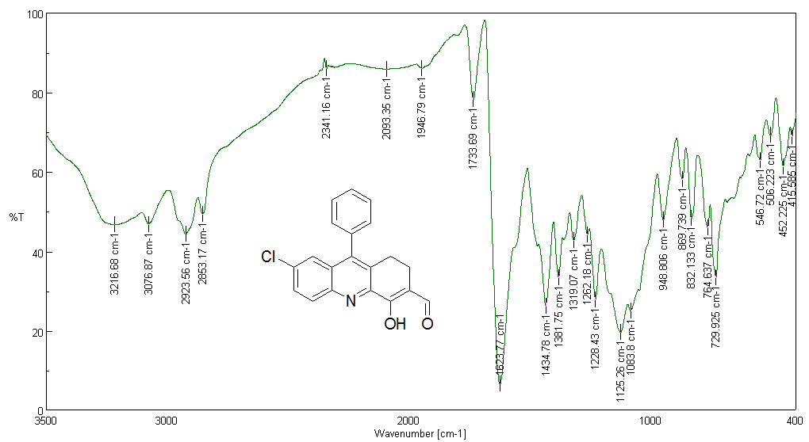
Figure S14 FT-IR spectrum of compound (9a)

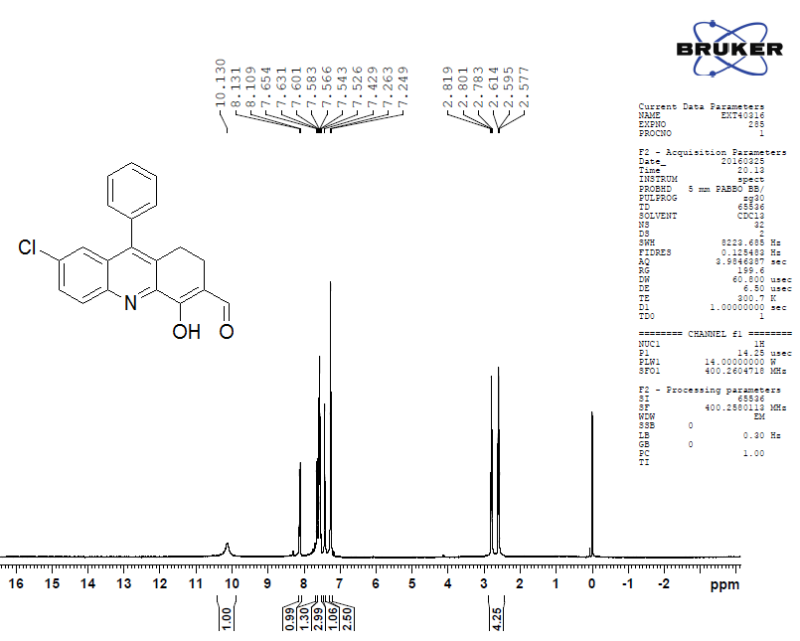
Figure S15 ¹H NMR spectrum of the compound (9a)

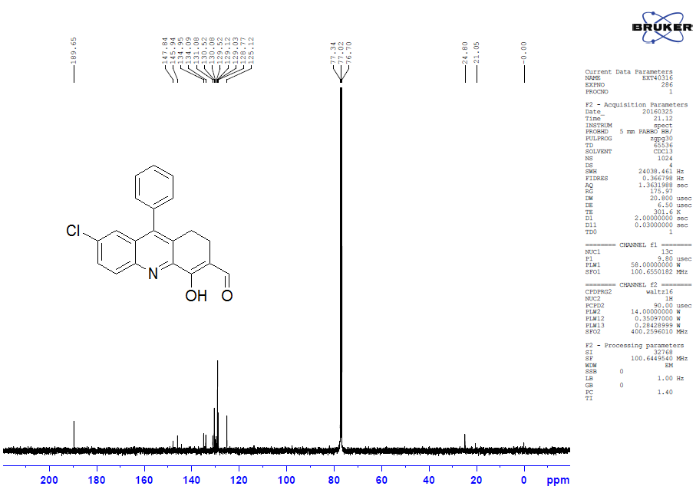
Figure S16 ¹³C NMR spectrum of the compound (9a)

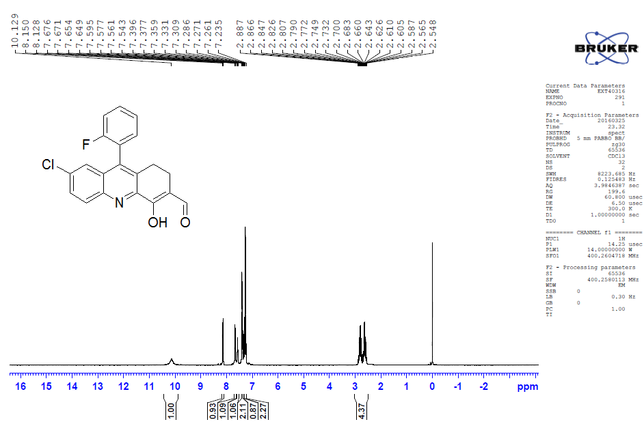
Figure S17 ¹H NMR spectrum of the compound (9b)

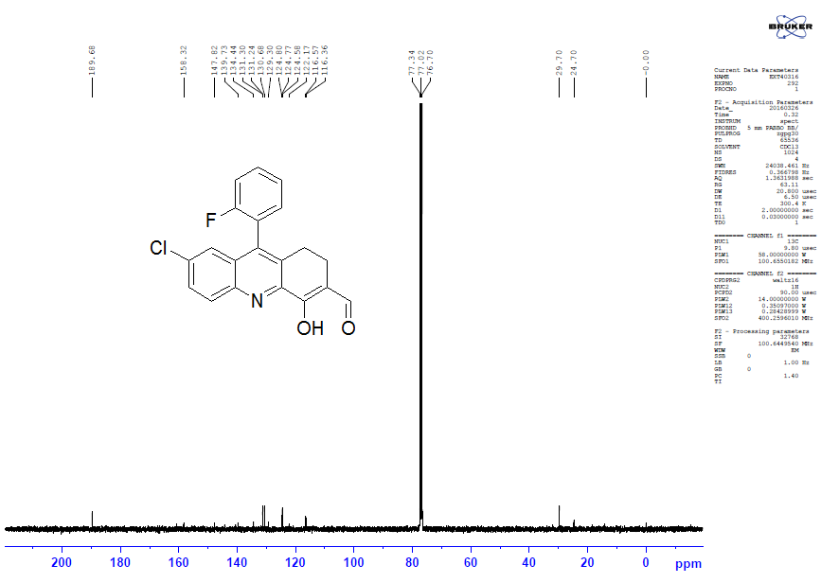
Figure S18 ¹³C NMR spectrum of the compound (9b)

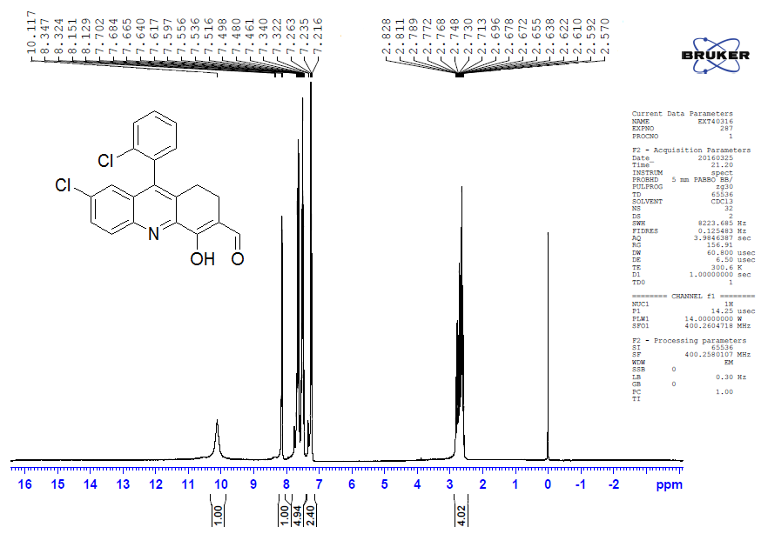
Figure S19 ¹H NMR spectrum of the compound (9c)

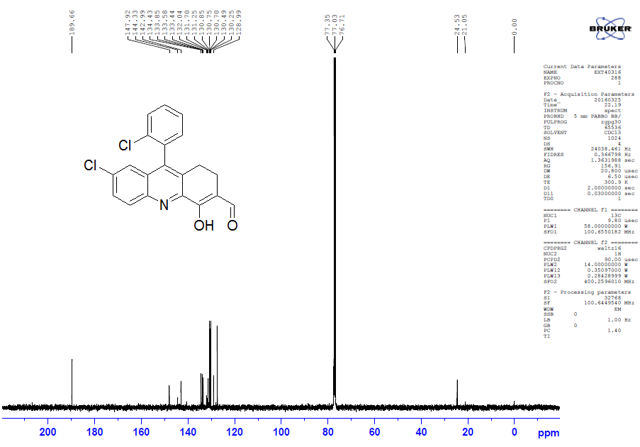
Figure S20 ¹³C NMR spectrum of the compound (9c)

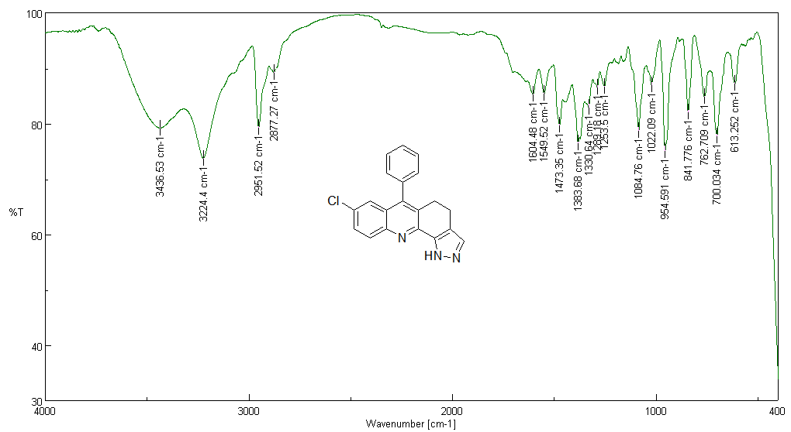
Figure S21 FT-IR spectrum of compound (10a)

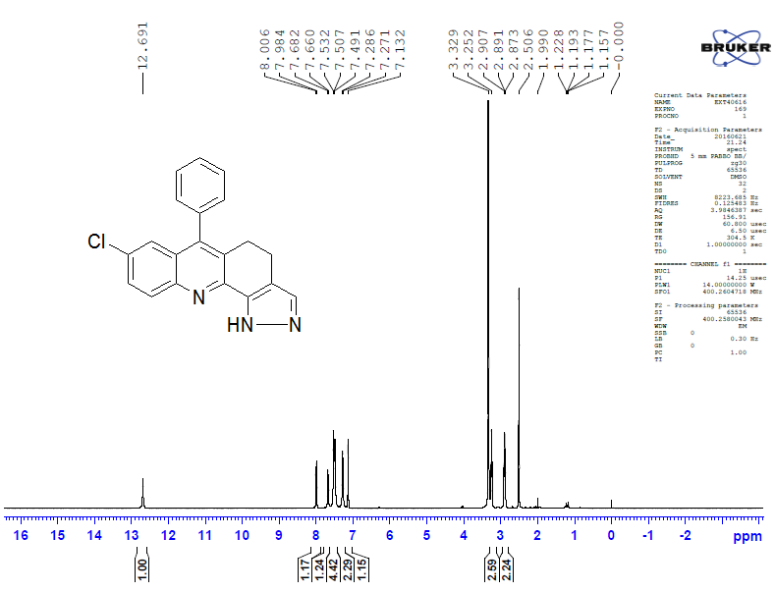
Figure S22 ¹H NMR spectrum of the compound (10a)

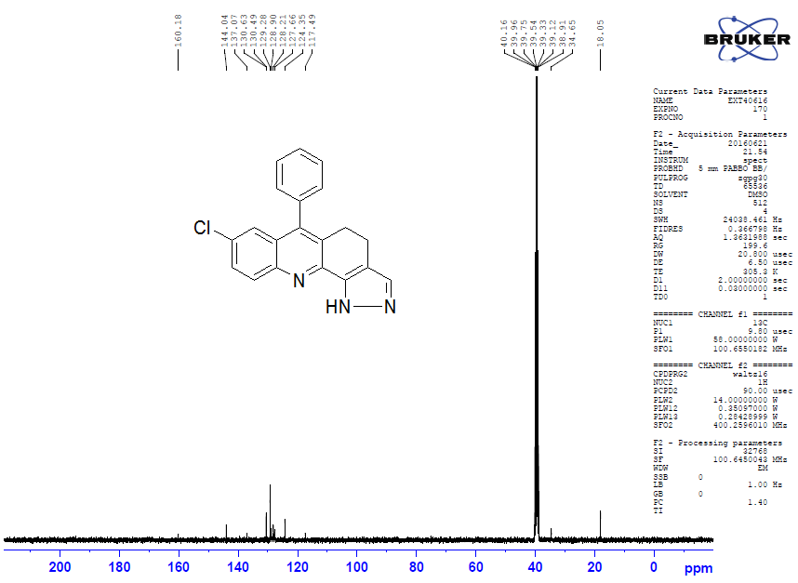
Figure S23 ¹³C NMR spectrum of the compound (10a)

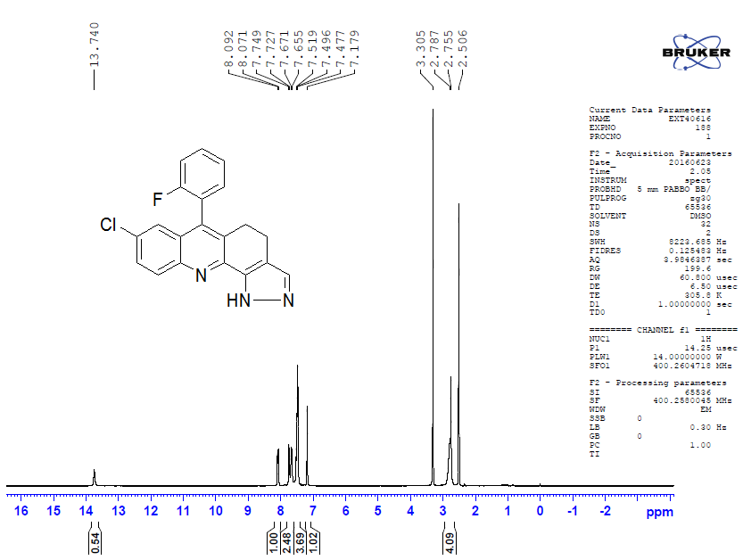
Figure S24 ¹H NMR spectrum of the compound (10b)
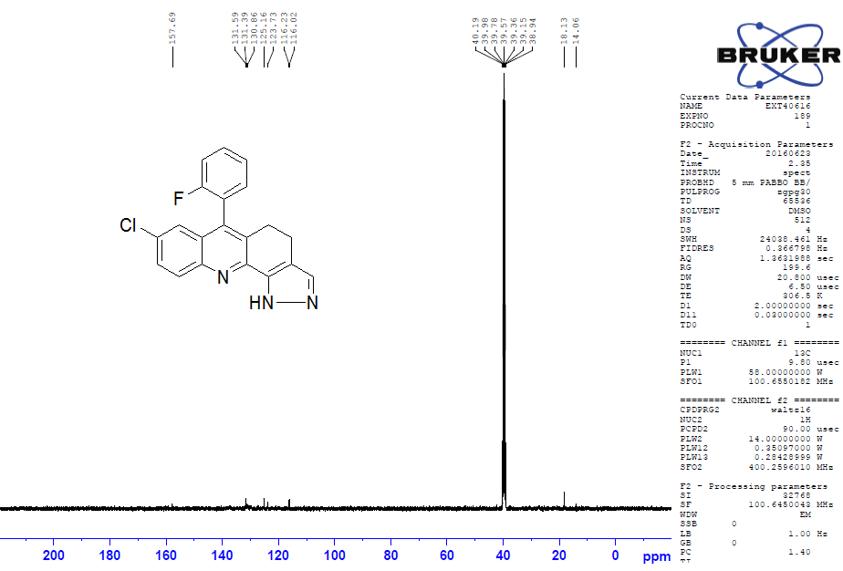
Figure S25 ¹³C NMR spectrum of the compound (10b)

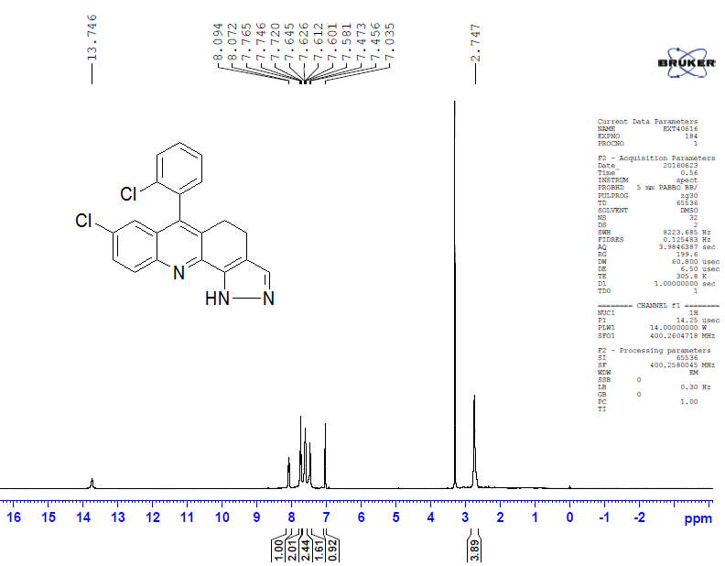
Figure S26 ¹H NMR spectrum of the compound (10c)

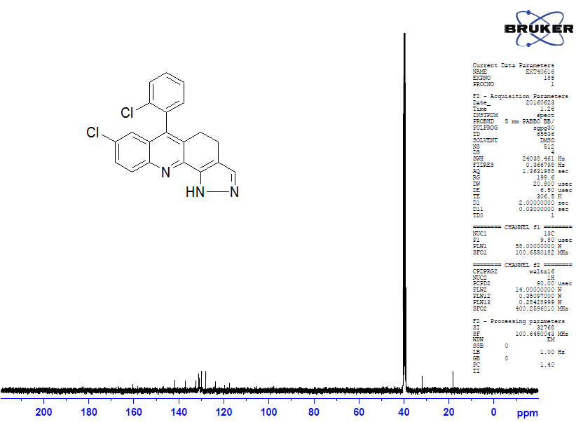
Figure S27 ¹³C NMR spectrum of the compound (10c)

