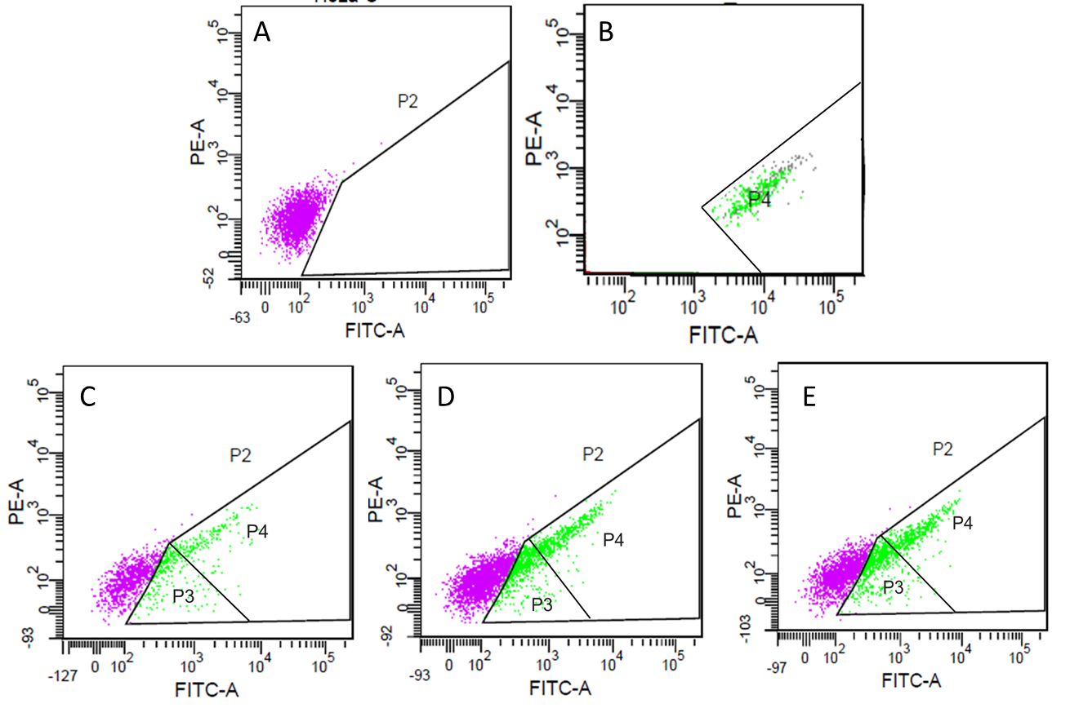

Distribution of cellular population determined by FACS. (A) HeLa cells incubated without IBs (negative control) are represented by P2 population, and (B) purified VP1GFP IBs in absence of cells are delimited by P4 population. Uptaking HeLa cells are represented by P3 population, upon incubation with VP1GFP IBs produced in E. coli (C), P. pastoris LY (D) or P. pastoris HY (E).

