Appendix for Reviewer: Diagnostics of empirical models
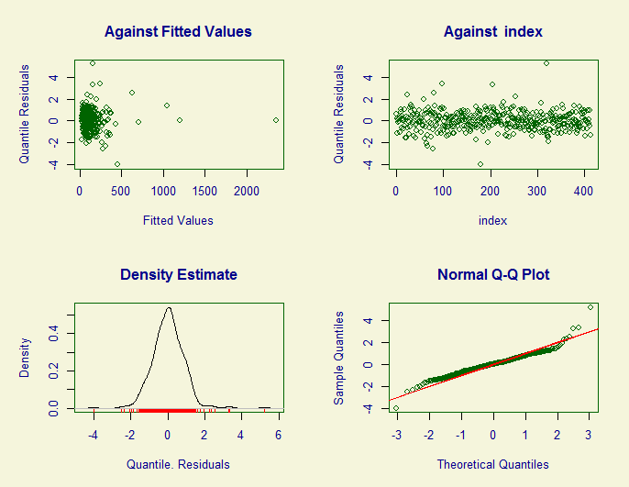
Figure 1: Diagnostics GP-density model.

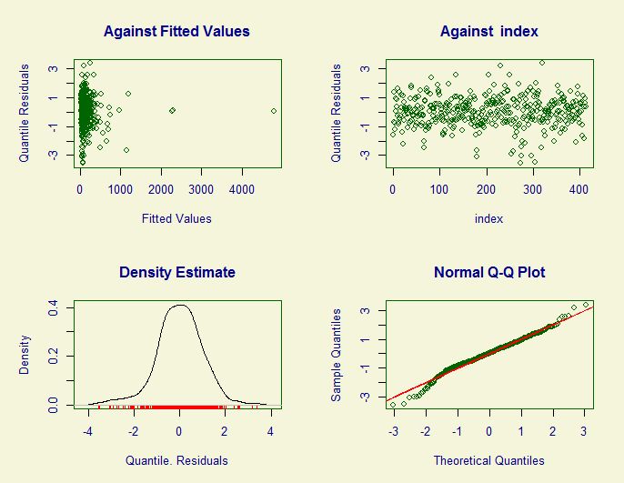
Figure 2: Diagnostics specialists-density model.

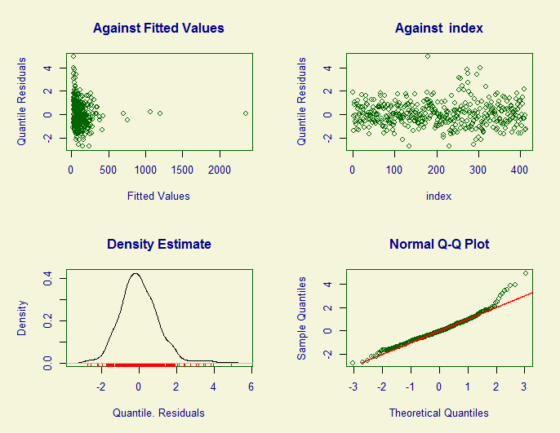
Figure 3: Diagnostics ratio model.

Intercepts of the different ASHIPs
As can be seen in the below table A1, all intercepts of ASHIPs in the states of former East Germany (marked by E) have a negative association with the ratio of GPs to specialists. Only the ASHIP regions of the former West German (marked by E) states Westphalia and Saarland also show negative correlations.
Table A1: Varying intercepts of the three zero-truncated, negative binomial GLMs for GP density, specialists density and ratio of GPs divided by specialists.
 | General physicians |  | Specialists |  | Ratio GPs/specialists
ASHIP | Estimate | p-value | Estimate | p-value | Estimate | p-value
Brandenburg (E) | Reference
Berlin (W) | 0.217 | 0.000*** | 0.382 | 0.035* | -0.152 | 0.381
Baden Württemberg (W) | 0.103 | 0.014* | 0.072 | 0.346 | 0.061 | 0.406
Bavaria (W) | 0.193 | 0.000*** | 0.059 | 0.452 | 0.187 | 0.013*
Bremen (W) | 0.122 | 0.049* | 0.148 | 0.260 | -0.113 | 0.393
Hessen (W) | 0.062 | 0.134 | 0.156 | 0.037* | -0.066 | 0.366
Hamburg (W) | 0.173 | 0.002** | 0.138 | 0.434 | 0.056 | 0.738
Mecklenburg-  Western Pomerania (E) | 0.064 | 0.154 | -0.020 | 0.779 | 0.074 | 0.294
Niederrhein (W) | 0.082 | 0.036* | 0.019 | 0.795 | 0.085 | 0.226
Lower Saxony (W) | 0.038 | 0.293 | 0.102 | 0.113 | -0.057 | 0.357
Rhineland-  Palatinate(W) | 0.098 | 0.022* | 0.028 | 0.713 | 0.088 | 0.227
Saxony Anhalt (E) | 0.030 | 0.445 | 0.027 | 0.692 | -0.025 | 0.705
Schleswig-Holstein (W) | 0.149 | 0.000*** | 0.095 | 0.221 | 0.068 | 0.361
Saarland (W) | 0.237 | 0.000*** | 0.234 | 0.019* | -0.030 | 0.755
Saxony (E) | 0.070 | 0.045* | 0.124 | 0.068 | -0.048 | 0.460
Thuringia (E) | 0.074 | 0.072 | 0.047 | 0.489 | 0.028 | 0.670
Westfalia-Lippe (W) | 0.006 | 0.883 | -0.038 | 0.595 | 0.059 | 0.391

