DNA Microarray of Global Transcription Factor Mutant Reveals Membrane-Related Proteins Involved in n-Butanol Tolerance in Escherichia coli

Supplementary Online Material
Additional file 4. Transcription profile analysis of genes exhibiting significantly different expression levels in σ⁷⁰ mutant B8 and WT. Hierarchical clustering using differentially expressed genes (probe sets) (p<0.05; FC≥2). Abscissa represents samples of B8 and WT, the ordinate represents different genes. Three biological replicates were performed. (Fig. S3)

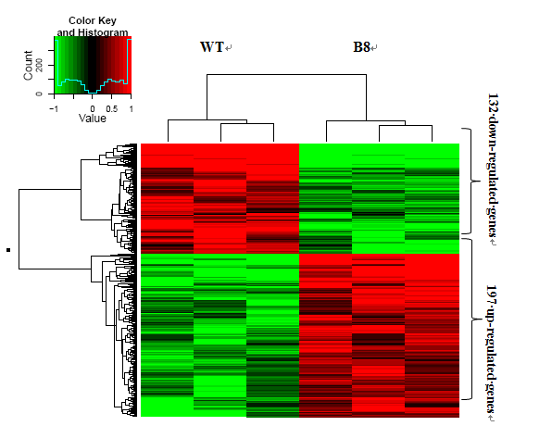
Fig. S3

