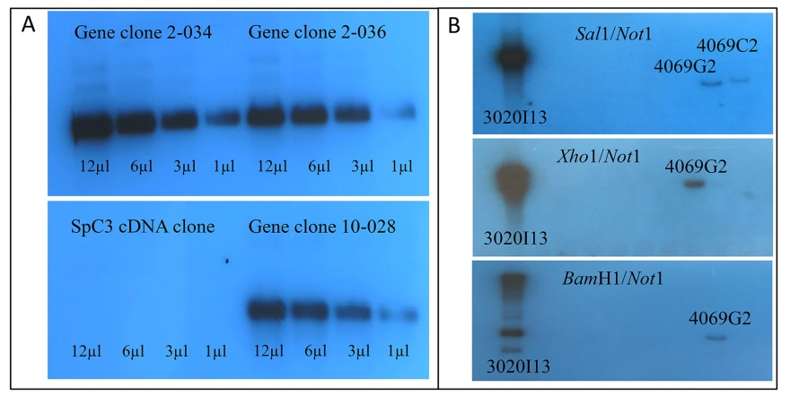

Additional file 3: Figure S2: Three BACs are positive for Sp185/333 gene sequences by Southern blot. A. The ³²P-RNA probe was generated according to [22] from linearized gene clones that were employed as templates (2-034 [GenBank acc. no. EF607716], 4-1521 [EF607770], 4-1543 [EF607784]; [21]). Target sequences on the blot are genes 2-034, 2-036 (EF607718) and 10-028 (EF607645) that were amplified by PCR from genomic DNA, inserted into the pCR4-TA vector [21], and released using EcoR1 restriction digests. The negative control was a cDNA clone in the pBluescript vector (pBsc-063X) that encoded a complement homologue, SpC3 [59], from which the insert was released with Not1/Xho1. Digests were loaded on the agarose gel in varying volumes as indicated, blotted and probed according to [27]. B. Restriction digests as indicated were performed for all Sp185/333 BAC clones that did not support PCR using primers specific for Sp185/333 sequences. Digests were separated by gel electrophoresis and blotted. The ³²P-RNA probe described in A hybridized to BAC clones 3020I13 and 4069G2 for all digests, whereas it hybridized to BAC clone 4069C2 only for the Sal1/Not1 digest. BAC clone numbers are indicated only for those BACs to which the probe hybridized.

