Communication Skills Training - Pre-Assessment

Participating medical undergraduates
Self-Rating of Communication Competence

Dear participants of the research project
Didactic Optimisation of Communication Skills Training – a randomised-controlled trial in the field of Medical Didactics,

in the following we want you to provide some information regarding your previous ‘doctor-patient-conversations´.
Please answer the questions completely and truthfully.

Data will be treated as strictly confidential. According to data protection regulations informations you provide will be evaluated anonymously and used only for research purposes.

The following example explains to you how the questions should be answered:

After each statement there is a 10 cm line indicating a continuum between two extremes, e.g. ‘I agree’ to ‘I disagree’. Please answer the question drawing a vertical stroke on the given line: The closer the stroke is to ‘I agree’ the stronger you go along with the statement; the closer it is to ‘I disagree’ the stronger your dissent about that phrase. We are interested in your subjective assessment.

In case, you want to make corrections, e.g. because you made the stroke at the wrong place, we ask you – as seen in the following sample – to completely colour the ‘wrong’ stroke and to set another one at the correct place.

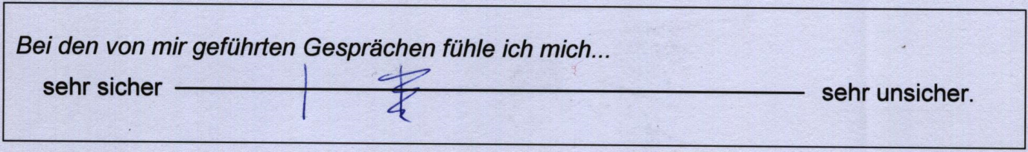

Anonymisation Code:
Month and year of your birthday (MM.YY) ☐☐☐☐
Your mother’s initials ☐☐
Today’s date (DD.MM.YY) ☐☐☐☐☐☐
Group-No.: [IG/CG]

How do you experience your previous ‘doctor-patient-conversations’ in general?

I feel
_{A1} very safe very unsafe
about how to start a conversation.

I find it
_{A2} very easy very hard
to assess patient´s perception.

I find it
_{B1*} very easy very hard
to formulate a shared main conversation topic.

I find it
_{B2*} very easy very hard
to set subtopics within the conversation.

In talks hold by myself I can recognise patient´s emotions

_{C1*} very well very poorly.

In talks hold by myself I can emotionally support patients
_{C2*} very well very poorly.

I find it
_{E1*} very easy very hard
to assess if the patient understands the wording I use.

Please turn round!

I find it
_{E2*} very easy very hard
to assess if my non-verbal communication reaches the patient.

I find it
_{E3*} very easy very hard
to assess if and when within the talk pauses are adequate.

I find it
_{E4*} very easy very hard
to assess if the patient could ask all the questions wanted.

I find it
_{E5*} very easy very hard
to assess if the patient has understood the previous points discussed.

I feel
_{D1} very safe very unsafe
about how to set an end of conversation.

Globally, I rate my communication competence as
_{F1} very good very poor.

I rate the quality of communication within the talks hold by myself as
very good very poor.

Within the talks hold by myself I feel
very self-confident very self-inconfident.

I have
very good very poor
theoretical knowledge about how to conduce conversations best according to actual standards.

I can apply my knowledge in concrete settings
very well very poorly.

Thank you for completing this report!
* Statistical Sub-Scales:
B1/B2 = Structure of Conversation; C1/C2 = Patient´s Emotions; E1- E5 = Communication Skills

