Additional file 14: Figure S10
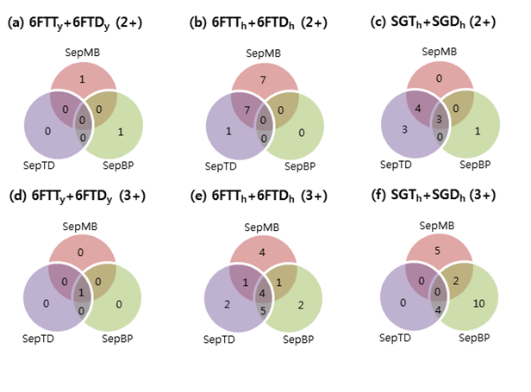
Figure S10. Comparison of novel peptides identified from real proteogenomic databases (‘6FTT_{y} + 6FTD_{y}’ for yeast, ‘6FTT_{h} + 6FTD_{h}’ and ‘SGT_{h} + SGD_{h}’ for human). Database searches were performed by Comet. The number of peptides with charge 2+ ((a), (b), and (c)) and 3+ ((d), (e), and (f)) at 1% FDR is shown. Three separate filtering methods (SepTD, SepBP, and SepMB) were used for search result validation.

