Supplemental material for: Working with what you’ve got: unattractive males show greater mate-guarding effort in a duetting songbird

Published in Biology Letters

Jenélle Dowling^{1*} and Michael S. Webster²

¹Division of Biological Sciences, University of Montana, Missoula, MT 59812
²Cornell Lab of Ornithology, Cornell University, 159 Sapsucker Woods Road, Ithaca, NY 14850

STATISTICAL METHODS
We used generalized linear mixed models (GLMM, glmer function in R package lme4) for models that did not conform to linear model assumptions. Models with a proportion as the response were modeled with binomial counts as outcomes and a weight argument specified. Rate data were modeled with a Poisson distribution and an offset argument when appropriate. We used linear mixed models (LMM, lmer function in R package lme4) for other mixed models and generalized linear models (GLM) for models that did not require a random effect (reproductive success analyses). Effect sizes and 95% confidence intervals were calculated using formulae in Nakagawa and Cuthill (2007). Principal component analyses for male response during playback experiments used the R function prcomp.
For all models, we tested for effects of weather (heat index – defined as the relation of the amount of evaporation required as related to the maximum ability of the average person to perspire –, humidity, and average wind speed) and auxiliary presence
(present/absent) by adding these as covariates in each model, where appropriate. The covariates were removed from models when non-significant. We conducted post-hoc tests using the lsmeans package in R. Least-squares means were computed for specified factors or factor combinations from each model, and we made comparisons among them using the Tukey method to adjust P-values when multiple comparisons were made. Least-squares means were back-transformed to show response in the original scale in figures and tables.

PLAYBACK EXPERIMENT METHODS
We conducted a dual speaker playback experiment using stimulus songs for three different treatment categories: male solo, female solo and simultaneous duet. In the duet treatment, the male and female duet contributions were played from separate speakers, 10m apart, to simulate realistic pair duetting behavior. Sets of stimulus songs played to each focal group were unique (16 different male solos and 16 different female solos) and were from high quality recordings. Male and female duet components were combined so that they began at the exact same time for all duet treatments. For each treatment type, we played one song every 20 seconds and the total playback length was 5 minutes. This song rate was chosen because red-backed fairy wrens sing approximately one song every 20 seconds during aggressive interactions and during the dawn chorus. Simultaneous duets were used because the majority of red-backed fairy-wren duets are sung with complete or near complete overlap.

Playback procedure
Each focal group was played all three playback treatments (male solo, female solo and duet) once in each of three breeding stages (pre-breeding, female receptive, incubation). For this analysis, only experiments conducted during the female’s receptive stage were included. We conducted 135 total playbacks on 16 groups. We conducted 44 duet treatment, 45 male solo treatment and 45 female solo treatment playbacks. Stimuli played to each group were recorded from non-neighbouring birds from the same population that were at least 5 territories away. Playback of each treatment was separated by approximately 60 min (91 ± 31 min, ranging from 40 – 200 min separation). The duet presented to each pair was composed of the same male solo and female solo that was presented to them in the solo treatments. A unique set of playback stimulus songs was presented to each focal group, and the same set was presented to that group in a different order in each of three breeding stages (once each with male solo first, female solo first and duet played first, with the treatment for the first experiment for each group determined randomly).
Experiments were conducted between 05:30 and 12:30, which is after the red-backed fairy-wren dawn chorus ends and is an active time of day for singing and other behaviors (J. Dowling, personal observation). At the start of each experiment, two speakers (Pignose Legendary 7-100, Pignose-Gorilla, Las Vegas, NV, U.S.A.) were set up 10 meters apart, within the focal territory and greater than 10m from a territory boundary. Songs were played from an iPod nano (Apple Inc., Cupertino, CA) connected to each speaker via a 30-meter cable. The first observer stood about 20 meters from the speakers, with both speakers in clear view, and operated the iPod, while the second observer kept track of focal birds. When all members of the focal group were located and within 25m of speakers, the playback began. For solo treatments, the male solo and female solo were played from the same speaker, and for duet treatments the speaker that played the male and female contribution to the duet was determined beforehand and balanced. Songs were broadcast at 90 dB at 1 meter. Each of two observers was equipped with a Marantz PMD661 solid-state digital recorder (Marantz America, Itasca, IL, USA) and Sennheiser ME67 highly directional long-gun microphone (Sennheiser Corp., Old Lyme, CT, USA) with a Rycote softie windshield and mount. Observers dictated the bird’s behaviors and details about vocalizations into the recorder during the experiment.
We observed birds for a 5-minute pre-playback period of silence, 5-minute playback period, and 5-minute post-playback period of silence. During these observation periods, both observers immediately began to dictate the following behaviors as they occurred: distance of each group member from each speaker throughout the entire period, closest approach of each group member to each speaker, number of flights over each speaker, all group member flights and flight following, distance between group members and latency to approach within 5 meters of each speaker. Distance was estimated using the distance between the two playback speakers (10 meters) as a standard. When birds did not approach within 5 meters of speakers during the entire period, their latency to approach was coded as the total time in the period (the maximum possible latency given the period length).
Supplemental Table 1. Results of mixed models, describing the effect of male age/plumage, breeding stage and auxiliary presence on four male mate guarding behaviors: the male’s duet rate with his mate, male mate following, male time close to mate and time male spent on his territory.

Response: Proportion of female songs the male joins in duet
Full GLMM |  |  | Chi sq | Df | p value
Breeding Stage |  |  | 13.59 | 2 | 0.001
Male age/plumage type |  |  | 5.14 | 2 | 0.08
Aux |  |  | 29.51 | 1 | <.0001
Breeding Stage:Male age/plumage type |  |  | 17.13 | 4 | 0.002
Post-hoc contrasts
Pre-breed Stage | Estimate |  | SE | z ratio | p value
Brown - YoungRB | -0.12 |  | 0.64 | -0.18 | 0.98
Brown - OldRB | 0.54 |  | 0.49 | 1.11 | 0.51
YoungRB - OldRB | 0.66 |  | 0.67 | 0.97 | 0.59
Female receptive Stage
Brown - YoungRB | 0.65 |  | 0.64 | 1.00 | 0.58
Brown - OldRB | 2.33 |  | 0.55 | 4.23 | 0.0001
YoungRB - OldRB | 1.68 |  | 0.67 | 2.50 | 0.03
Post-receptive Stage
Brown - YoungRB | 1.13 |  | 0.94 | 1.19 | 0.45
Brown - OldRB | 0.84 |  | 0.84 | 0.99 | 0.58
YoungRB - OldRB | -0.29 |  | 0.67 | -0.44 | 0.90
Response: Proportion of male time close to female
Full GLMM |  |  | Chi sq | Df | p value
Breeding Stage |  |  | 32.34 | 2 | <0.0001
Male age/plumage type |  |  | 19.30 | 2 | <0.0001
Aux |  |  | 0.77 | 1 | 0.38
Breeding Stage:Male age/plumage type |  |  | 3.41 | 4 | 0.49
Aux:Male age/plumage type |  |  | 12.6 | 2 | 0.002
Post-hoc contrasts
Pre-breed Stage | Estimate |  | SE | t ratio | p value
Brown - YoungRB | 0.48 |  | 0.19 | 2.46 | 0.04
Brown - OldRB | 0.21 |  | 0.12 | 1.83 | 0.16
YoungRB - OldRB | -0.26 |  | 0.18 | -1.45 | 0.31
Female receptive Stage
Brown - YoungRB | 0.29 |  | 0.15 | 1.91 | 0.14
Brown - OldRB | 0.32 |  | 0.11 | 2.79 | 0.015
YoungRB - OldRB | 0.03 |  | 0.13 | 0.23 | 0.97
Post-receptive Stage
Brown - YoungRB | 0.18 |  | 0.14 | 1.26 | 0.42
Brown - OldRB | 0.24 |  | 0.14 | 1.77 | 0.18
YoungRB - OldRB | 0.06 |  | 0.07 | 0.92 | 0.63
Response: Proportion of male time on territory
Full LMM |  |  | Chi sq | Df |  | p value
Male age/plumage type |  |  | 13.59 | 2 |  | 0.001
Breeding Stage |  |  | 24.48 | 2 |  | <.0001
Aux |  |  | 0.11 | 1 |  | 0.74
Male age/plumage type:Breeding Stage |  |  | 14.73 | 4 |  | 0.005
Aux:Male age/plumage type |  |  | 52.57 | 2 |  | <.0001
Post-hoc contrasts
Pre-breed Stage |  | Estimate | SE | z ratio |  | p value
Brown - YoungRB |  | 0.40 | 0.67 | 0.60 |  | 0.82
Brown - OldRB |  | 2.30 | 0.50 | 4.62 |  | <.0001
YoungRB - OldRB |  | 1.90 | 0.71 | 2.66 |  | 0.02
Female receptive Stage
Brown - YoungRB |  | -0.41 | 0.65 | -0.62 |  | 0.81
Brown - OldRB |  | 2.63 | 0.56 | 4.72 |  | <.0001
YoungRB - OldRB |  | 3.04 | 0.64 | 4.71 |  | <.0001
Post-receptive Stage
Brown - YoungRB |  | 0.75 | 0.63 | 1.20 |  | 0.46
Brown - OldRB |  | 1.96 | 0.68 | 2.87 |  | 0.01
YoungRB - OldRB |  | 1.21 | 0.45 | 2.67 |  | 0.02

Supplemental Table 2. Results of linear mixed model used to determine how male aggressive response varied with his plumage type (red/black vs. brown), the type of intrusion simulated (solo male, solo female or mated pair) and interactions.

Response: Male response to simulated intrusion
Full LMM |  | Chi sq | Df | p value
Plumage type |  | 7.47 | 1 | 0.01
Playback treatment |  | 8.11 | 2 | 0.02
Plumage type*Playback treatment |  | 0.93 | 2 | 0.63
Post-hoc contrasts
M solo treatment | Estimate | SE | t ratio | p value
Brown - RB | -1.86 | 0.76 | -2.45 | 0.02
F solo treatment
Brown - RB | -0.96 | 0.73 | -1.31 | 0.20
Duet
Brown - RB | -1.38 | 0.72 | -1.93 | 0.06

Supplemental Table 3. Correlations of 4 behavioral response variables with the first principle component in a principle component analysis.
 | Male response score PC1
Eigenvalue | 2.65
Percent variation | 66.3
Time spent within 5m of speakers | 0.50
Latency to approach within 5m of speakers | -0.58
Closest approach to speakers | -0.51
Number of flights over the speakers | 0.40

Supplemental Table 4. Results of generalized linear models, describing number of within-pair, extra-pair and total young sired by each male age/plumage type.

Full GLM: Within-pair young sired |  | Chi sq | Df | p value
Male age/plumage type |  | 4.64 | 2 | 0.098
Post-hoc contrasts: Within-pair young sired | z ratio | SE | Df | p value | Effect size | 95% confidence interval
Brown - YoungRB | -1.29 | 0.34 | 2 | 0.198 | 0.51 | ±0.67
Brown - OldRB | -2.18 | 0.34 | 2 | 0.029 | 0.81 | ±0.67
YoungRB - OldRB | -0.89 | 0.34 | 2 | 0.65 | -0.28 | ±0.67
Full GLM: Extra-pair young sired |  | Chi sq | Df | p value
Male age/plumage type |  | 11.19 | 2 | 0.004
Post-hoc contrasts: Extra-pair young sired | z ratio | SE | Df | p value | Effect size | 95% confidence interval
Brown - YoungRB | 2.11 | 1.03 | 2 | 0.034 | 0.83 | ±2.02
Brown - OldRB | 2.27 | 1.02 | 2 | 0.023 | 0.84 | ±2.0
YoungRB - OldRB | 0.42 | 0.34 | 2 | 0.91 | 0.51 | ±0.67
Full GLM: Total young sired |  | Chi sq | Df | p value
Male age/plumage type |  | 0.25 | 2 | 0.88
Post-hoc contrasts: Total young sired | z ratio | SE | Df | p value | Effect size | 95% confidence interval
Brown - YoungRB | -0.10 | 0.30 | 2 | 0.99 | 0.04 | ±0.58
Brown - OldRB | 0.31 | 0.29 | 2 | 0.95 | -0.11 | ±0.56
YoungRB - OldRB | 0.49 | 0.24 | 2 | 0.88 | -0.15 | ±0.47

Supplemental figure 3. Variation in male aggressive response across types of simulated intrusions (solo male, solo female or mated pair) and between male plumage types (brown vs. red/black, all red/black males subjects were 3 or more years old). All simulated intrusions were done during the female’s receptive stage.
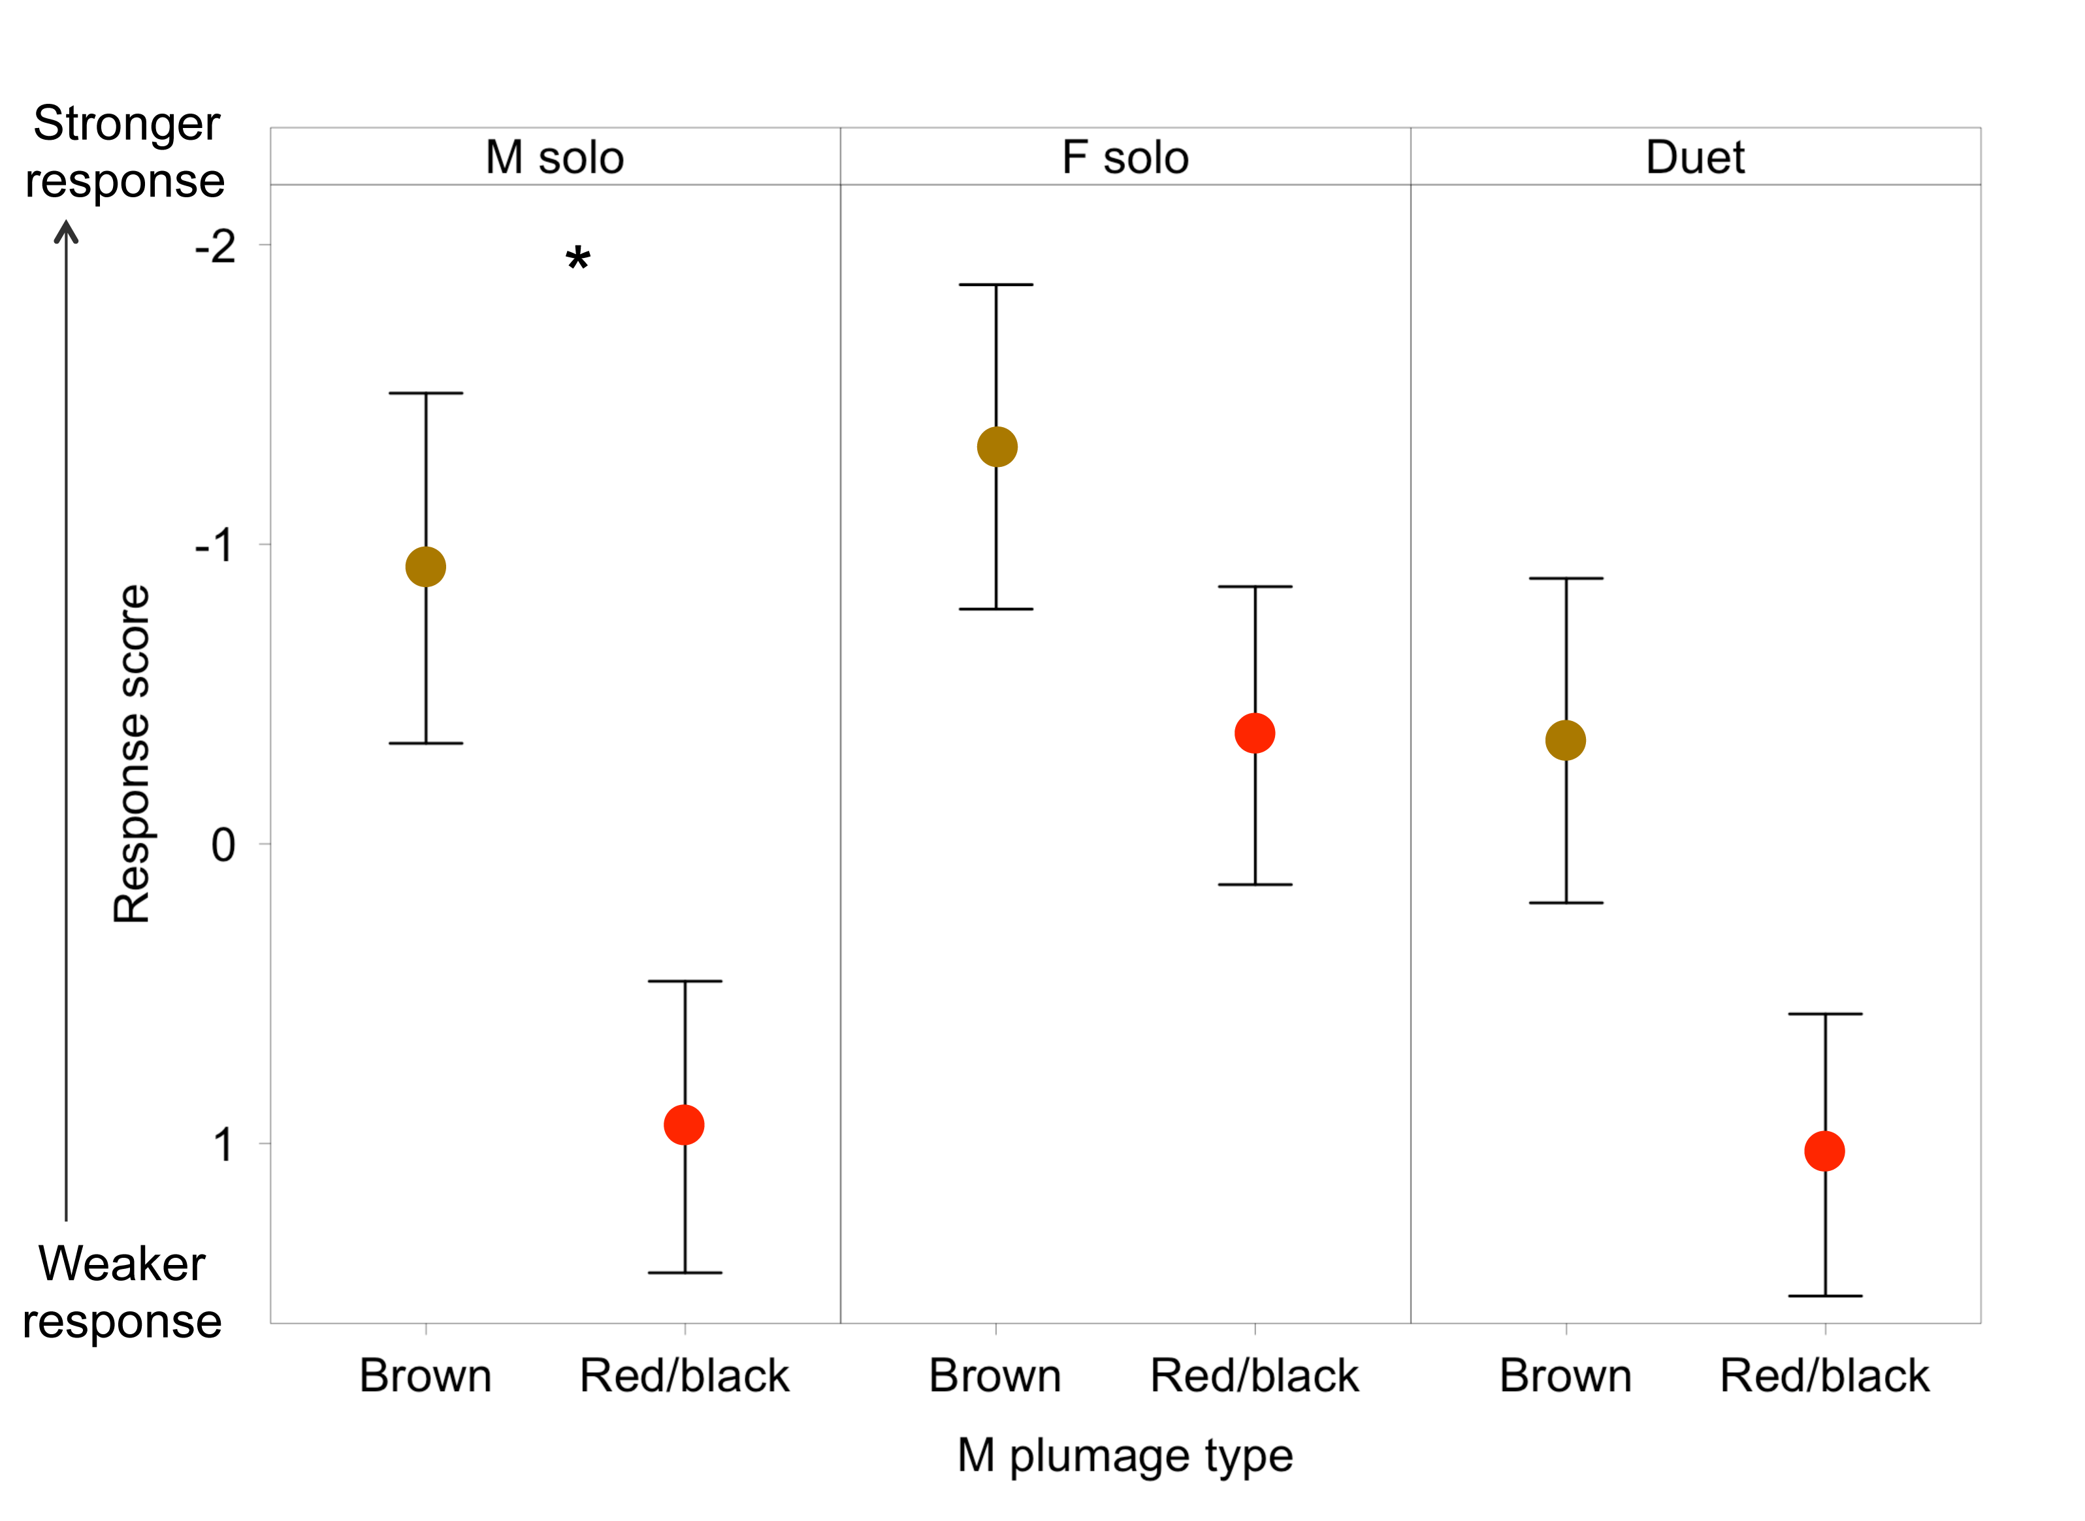

Supplemental figure 4. Effect of male age and plumage type on: the male’s duet rate with his mate (proportion of female songs the male answered to form a duet) (a), proportion of a male’s time present he spent <10 meters from his mate (b), and proportion of the observation the male spent on territory (c), with data split into old and young red-black and brown males. Points show mean ± one standard error. Points with different letters are significantly different at P<0.05.
