Electronic supplementary material 1

Tropical ancient DNA reveals relationships of the extinct Bahamian giant tortoise Chelonoidis alburyorum

Christian Kehlmaier, Axel Barlow, Alexander K. Hastings, Melita Vamberger, Johanna L. A. Paijmans, David W. Steadman, Nancy A. Albury, Richard Franz, Michael Hofreiter, Uwe Fritz

Proc. R. Soc. B 20162235.
http://dx.doi.org/10.1098/rspb.2016.2235

(a) Amplicon sequencing
Amplicon sequencing was utilised for modern samples that provided high molecular weight DNA. PCR reactions were performed in 50 μl volumes, containing 1–6 μl of DNA extract and 1 unit of TaKaRa LA Taq DNA Polymerase, Hot-Start Version (Clontech Laboratories Inc., Mountain View, CA, USA), following the reaction mixture recommended by the manufacturer. For primer sequences, see electronic supplementary material, table S1. PCR conditions comprised an initial denaturation at 93°C for 3 min, followed by 35 cycles of 93°C for 15 sec, 60°C for 30 sec, 68°C for 9 min, before a final elongation at 68°C for 10 min. PCR products were visualised and excised from a 2% agarose gel and purified using the peqGOLD Gel Extraction Kit (PEQLAB Biotechnologie GmbH, Erlangen, Germany). Only two of the three primer pairs successfully amplified the desired DNA fragments; those encompassing the control region did not amplify, probably due to the presence of large repetitive DNA blocks in the control region. Therefore, the combined long-range PCR products covered most of the mitochondrial genome from almost the beginning of 12S to almost the end of cyt b.
To complete the cyt b sequence and verify the authenticity of the long-range PCR products, this gene, in addition to 12S and ND4, was PCR-amplified and Sanger-sequenced using well-established primers (electronic supplementary material, table S1) and standard laboratory procedures (Fritz et al. 2014). For cycle sequencing, the total reaction volume of 10 μl contained 2 μl sequencing buffer, 1 μl premix, 0.5 μM of the respective primer, 1 μl DNA template, and ultrapure H₂O. Using the ABI PRISM Big Dye Terminator v.3.1 Cycle Sequencing Kit (Applied Biosystems, Foster City, CA, USA), 25 cycles were performed at 96°C for 10 sec, 50°C for 5 sec and 60°C for 4 min. Reaction products were purified by gel filtration using the Performa® DTR V3 96-Well Short Plate Kit (EdgeBio, Gaithersburg, MD, USA) and 400 µl of a 5% Sephadex solution (GE Healthcare, Munich, Germany). Sequencing was performed on an ABI 3130xl Genetic Analyser (Applied Biosystems). No ambiguities were detected between the assembled complete mitogenomes and their respective Sanger-sequenced gene fragments.

(b) Mitochondrial genomes from GenBank used for phylogenetic analyses
All available mitochondrial genomes of tortoise species (Testudinidae) were downloaded from GenBank: Aldabrachelys gigantea (accession number KT613185), Astrochelys yniphora (JX317746), Indotestudo elongata (DQ080043), I. forstenii (DQ080044), Malacochersus tornieri (DQ080042), Manouria emys (DQ080040), M. impressa (EF661586), Stigmochelys pardalis (DQ080041), Testudo graeca (DQ080049 and DQ080050), T. hermanni (DQ080046), T. horsfieldii (DQ080045), T. kleinmanni (DQ080048), T. marginata (DQ080047), representing all major lineages of tortoises (Le et al. 2006; Fritz & Bininda-Emonds 2007). Mitochondrial genomes of the geoemydid Mauremys reevesii (FJ469674) and the emydid Emys orbicularis (JN999703) were added as outgroups. Geoemydidae and Emydidae are the successive sister groups of Testudinidae (Joyce et al. 2013). Since the cyt b gene of GenBank sequence DQ080041 has been shown to be chimerical with having a partial numt included (Fritz et al. 2010), the numt in DQ080041 was replaced for an authentic mitochondrial cyt b sequence of a S. pardalis (FN646157) from a collection site in close proximity (Fritz et al. 2010).

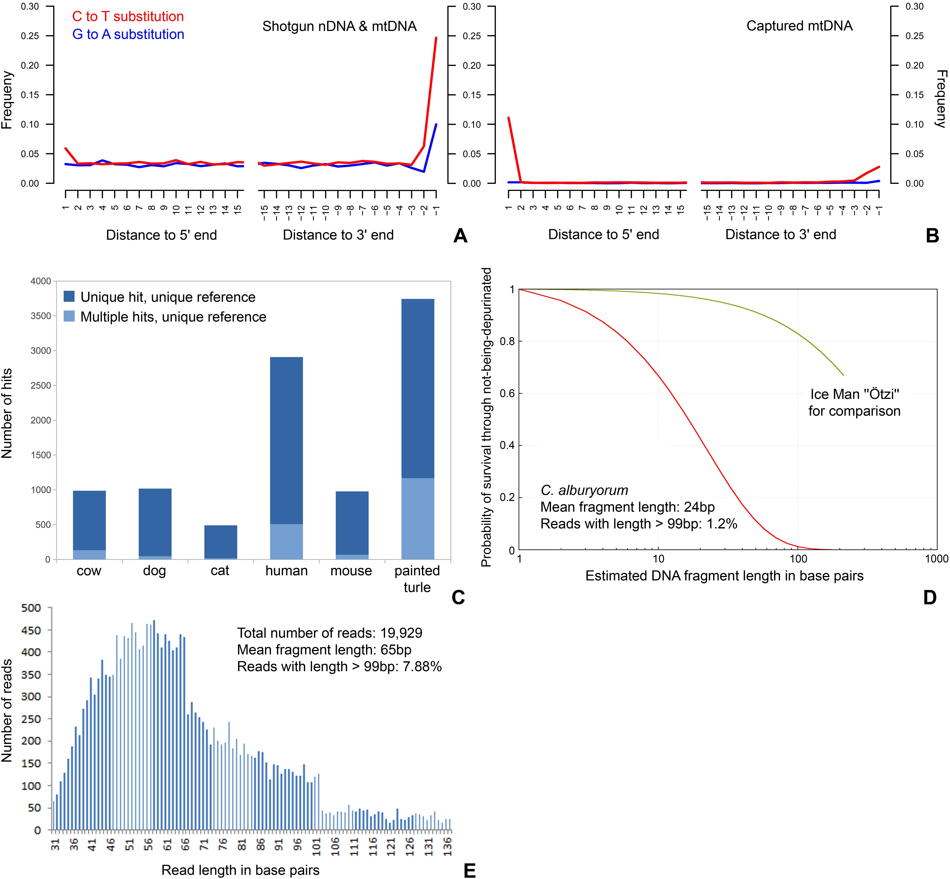

Figure S1. (A) Misincorporation plot for shotgun (pre-enriched) reads of Chelonoidis alburyorum mapped to the nuclear genome of the painted turtle (Chrysemys picta bellii). Depicted are the frequencies of substitutions in the reads relative to the reference, and their location from the 5' and the 3' read ends. (B) Misincorporation plot for captured reads mapped to the assembled partial mitochondrial genome of Chelonoidis alburyorum. (C) Contamination screening plot to assess endogenous DNA content in relation to potential contamination sources. Reported are number of reads that map uniquely to a given set of reference sequences. (D) Predicted DNA preservation for a bone sample deposited in a terrestrial environment of the Bahamas. (E) Fragment length distribution making up the assembled C. alburyorum contig.

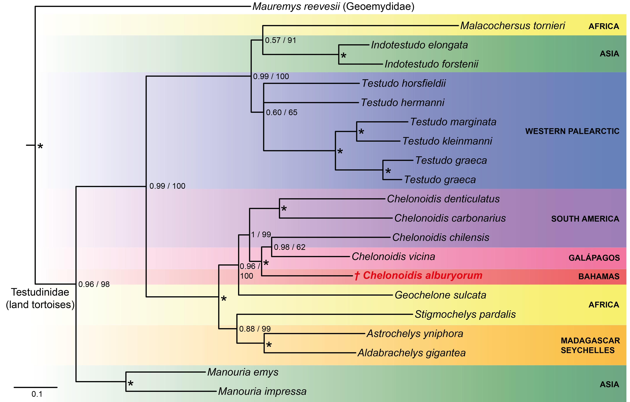

Figure S2. Mitochondrial phylogeny of Chelonoidis species and other land tortoises inferred from Maximum Likelihood analyses using complete or nearly complete mitochondrial genomes. Outgroup (Emys orbicularis) removed for clarity. Numbers along nodes indicate branch support under Maximum Likelihood (1,000 bootstrap replicates) and Bayesian analyses (posterior probabilities). Asterisks indicate maximum support under both tree-building methods.
Table S1. PCR primer pairs and Sanger sequencing primers used in this study, including their amplified product lengths and overlap. Primers without references were designed for the present study.

Long-range PCR primer pairs designed for amplicon sequencing and bait-library preparation |  | Product size | Overlap
Chelonoidis spp. based on Chelonoidis niger (JN999704) and Stigmochelys pardalis (DQ080041)
Chelo_12S-ATP6_For | 5'-GCRTACCAGTGAAAAYACCC-3' | 8,212 bp
Chelo_12S-ATP6_Rev | 5'-TTGGGATRAGTGGGGTTGGG-3' |  | 392 bp
Chelo_ATP6-cytb_For | 5'-AAGCCCACAAAYCCTWGGAA-3' | 7,141 bp
Chelo_ATP6-cytb_Rev | 5'-GGATTAGGAGRATTGTGAAGT-3' |  | 1,363 bp
Chelo_ND6-12S_For | 5'-AACYAACATCCCRCCCAAAT-3' | estimated 2,650 bp
Chelo_ND6-12S_Rev | 5'-TTGACCAACCCTYTTTGC-3'
Geochelone sulcata based on G. sulcata (KJ489404)
sulcata_12S-CO3_For | 5'-ACAGCCCAAGACATCTAGCT-3' | 8,040 bp
sulcata_12S-CO3_Rev | 5'-CCTGTTAGTGGTCATGGGCT-3' |  | 410 bp
sulcata_ATP6-cytb_For | 5'-AGCCACAGTACTCACAGGAC-3' | 6,103 bp
sulcata_ATP6-cytb_Rev | 5'-CATCTCGGGTGATATGGGCT-3' |  | 92 bp
sulcata_cytb-12S_For | 5'-CCTACAAATCACCACCGGAA-3' | estimated 3,300 bp
sulcata_cytb-12S_Rev | 5'-CCTTGTTACGACTTGCCT-3'
Internal sequencing primers for 12S and ND4
12S-L1091¹ | 5'-AAAAAGCTTCAAACTGGGATTAGATACCCCACTAT-3'
L-ND4² | 5'-GTAGAAGCCCCAATCGCAG-3'
Primers for amplification and Sanger sequencing of cyt b
CytbG³ | 5'-AACCATCGTTGTWATCAACTAC-3' | 794 bp
mt-E-Rev2⁴ | 5'-GCRAATARRAAGTATCATTCTGG-3' |  | 383 bp
mt-c-For2⁴ | 5'-TGAGGVCARATATCATTYTGAG-3' | 740 bp
mt-f-na⁴ | 5'-AGGGTGGAGTCTTCAGTTTTTGGTTTACAAGACCAATG-3'

¹ Kocher et al. (1989) ³ Spinks et al. (2004)

² Stuart & Parham (2004) ⁴ Fritz et al. (2006)

Table S2. Evolutionary models according to PartitionFinder.

Alignment position | Partitition | Model
1–69 | tRNA | JC
70–2019 | non-coding | F81
2020–2090 | tRNA-Phe | K80+I
2091–3087 | 12S rRNA | GTR+I+G
3088–3160 | tRNA-Val | HKY+G
3161–4825 | 16S rRNA | GTR+I+G
4826–4907 | tRNA-Leu | K80+I+G
4908–5885\3 | ND1 | HKY+I+G
4909–5885\3 | ND1 | SYM+I+G
4910–5885\3 | ND1 | HKY+I+G
5886–6104 | tRNAs (Ile, Gln, Met) | SYM+G
6105–7148\3 | ND2 | HKY+G
6106–7148\3 | ND2 | HKY+G
6107–7148\3 | ND2 | HKY+I+G
7149–7548 | tRNA (Trp, Ala, Asn, Cyc, Tyr) | HKY+I+G
7549–9142\3 | Cox1 | GTR+I+G
7550–9142\3 | Cox1 | SYM+I+G
7551–9142\3 | Cox1 | HKY+I
9143–9282 | tRNA (Ser, Asp) | HKY+G
9283–9969\3 | Cox2 | K80+I+G
9284–9969\3 | Cox2 | HKY+I
9285–9969\3 | Cox2 | HKY+I+G
9970–10053 | tRNA-Lys | HKY+G
10054–10238\3 | ATP8 | HKY+G
10055–10238\3 | ATP8 | HKY+I
10056–10238\3 | ATP8 | GTR+G
10239–10910\3 | ATP6 | GTR+I+G
10240–10910\3 | ATP6 | HKY+G
Alignment position | Partitition | Model
10241–10910\3 | ATP6 | GTR+G
10911–11695\3 | Cox3 | GTR+I+G
10912–11695\3 | Cox3 | SYM+G
10913–11695\3 | Cox3 | HKY+I
11696–11783 | tRNA-Gly | HKY+G
11784–12142\3 | ND3 | HKY+I+G
11785–12142\3 | ND3 | HKY+G
11786–12142\3 | ND3 | HKY+G
12143–12216 | tRNA-Arg | HKY+G
12217–12516\3 | ND4L | K80+G
12218–12516\3 | ND4L | HKY+G
12219–12516\3 | ND4L | GTR+I+G
12517–13902\3 | ND4 | HKY+G
12518–13902\3 | ND4 | HKY+I+G
12519–13902\3 | ND4 | HKY+I+G
13903–14138 | tRNA (His, Ser, Leu) | HKY+I+G
14139–16254\3 | ND5 | HKY+I+G
14140–16254\3 | ND5 | GTR+I+G
14141–16254\3 | ND5 | GTR+G
16255–16777\3 | ND6 | HKY+G
16256–16777\3 | ND6 | HKY+G
16257–16777\3 | ND6 | HKY+G
16778–16847 | tRNA-Glu | HKY+G
16848–17998\3 | cyt b | HKY+I+G
16849–17998\3 | cyt b | HKY+I+G
16850–17998\3 | cyt b | GTR+I+G
17999–18152 | tRNA-Pro | HKY+G
18153–22485 | control region | HKY+I+G

Table S3. Read information of sequenced voucher specimens.

Taxon | Voucher | Laboratory method | # raw reads | # merged single reads without duplicates | min. read  length | ENA accession number  mitogenome (NGS) | ENA accession number  cyt b (Sanger)
Chelonoidis alburyorum | NMB.AB50.0008 | shotgun sequencing | 4,413,742 | 1,730,143 | 20 bp | — | —
Chelonoidis alburyorum | NMB.AB50.0008 | hybridization capture | 80,053,092 | 19,907,639 | 30 bp | LT599482 | —
Chelonoidis carbonarius | MTD-T5138 | hybridization capture | 13,423,226 | 5,521,627 | 30 bp | LT599483 | LT599488
Chelonoidis chilensis | MTD-T5754 | amplicon sequencing | 1,593,456 | 435,394 | 40 bp | LT599484 | LT599489
Chelonoidis denticulatus | MTD-T7255 | hybridization capture | 7,667,786 | 3,099,237 | 30 bp | LT599485 | LT599490
Chelonoidis vicina | MTD-T14174 | amplicon sequencing | 2,503,830 | 549,936 | 30 bp | LT599486 | LT599491
Geochelone sulcata | MTD-T872 | amplicon sequencing | 2,097,698 | 454,726 | 45 bp | LT599487 | LT599492
Table S4. Observed content of endogenous tortoise DNA from a shotgun sequenced single-stranded DNA library of Chelonoidis alburyorum, and of the captured library and extraction blanks.

Sample | Laboratory method | Raw reads | Minimum read length | Merged reads | Mapped reads | Endogenous DNA content | Reference genome
C. alburyorum | shotgun sequencing | 4,413,742 | 20 bp | 1,730,143 | 164 | 0.0095% | Chelonoidis alburyorum  (newly assembled)
C. alburyorum | shotgun sequencing | 4,413,742 | 20 bp | 1,730,143 | 24,362 | 1.4081% | Chrysemys picta bellii  (whole genome, AHGY00000000)
C. alburyorum | hybridization capture | 80,053,092 | 30 bp | 29,558,259 | 13,767 | 0.0466% | Chelonoidis niger (JN999704)
library blank 1 | hybridization capture | 3,566,976 | 30 bp | 1,124,048 | 41 | 0.0037% | Chelonoidis niger (JN999704)
library blank 2 | hybridization capture | 325,348 | 30 bp | 85,675 | 7 | 0.0082% | Chelonoidis niger (JN999704)
extraction blank 1 | hybridization capture | 1,979,628 | 30 bp | 646,034 | 10 | 0.0016% | Chelonoidis niger (JN999704)
extraction blank 2 | hybridization capture | 4,075,920 | 30 bp | 1,257,736 | 57 | 0.0045% | Chelonoidis niger (JN999704)

Table S5. Published records of fossil Chelonoidis and indeterminate testudinids for the circum-Caribbean, Central America, and South America shown in Figure 2. Paleomaps in Figure 2 compiled from different sources (Iturralde-Vinent & MacPhee 1999; Scotese 2001; Iturralde-Vinent 2006; Hoorn et al. 2010; Roddaz et al. 2010; Montes et al. 2015), with conjectural paleorivers (Hoorn et al. 2010). When the Chelonoidis ancestor dispersed from Africa to South America, the Atlantic was roughly as wide as it is today (Scotese 2001). Equatorial paleocurrents moving then from Africa to South America (Fratantoni et al. 2000; Poulsen et al. 2001) would have created potentially favourable conditions for marine long-distance dispersal. When C. alburyorum diverged from C. vicina and C. chilensis in the mid-Miocene, shearing of the Caribbean plate against northern South America placed the growing Lesser Antilles island arc closer to the mainland than today (Iturralde-Vinent 2006; Xie & Mann 2014), facilitating overseas dispersal. Alternatively, the ancestor of C. alburyorum may have crossed into southern Central America via the proposed Panamanian connection with South America in the early middle Miocene (Montes et al. 2015). From there, the ancestor may have reached the Caribbean over the Yucatan Peninsula to Cuba and spread through the Greater Antillean arc.

Geological time | Taxonomic identification | Location | Sources/Remarks
 |  | Circum-Caribbean
? Holocene | Chelonoidis sp. | Eleuthera, Moore’s Island, Acklins and Mayaguana, Bahamas | Franz & Franz (2009)
Holocene | “Geochelone” sp. | Middle Caicos, Turks and Caicos Islands | Franz et al. (2001)
Holocene | “Geochelone” sp. | Grand Turk, Turks and Caicos Islands | Carlson (1999)
Late Pleistocene–Holocene | Chelonoidis alburyorum | Abaco, Bahamas | Steadman et al. (2007); Franz & Franz (2009); Steadman et al. (2014, 2015)
? Late Pleistocene | “Geochelone” sp. | San Cristobal Province, Dominican Republic | Franz & Woods (1982)
Late Pleistocene | “Testudo” monensis | Mona Island | Williams (1952); Auffenberg (1967)
Late Pleistocene | “Geochelone” sp. | Andros and New Providence, Bahamas | Auffenberg (1967)
Pleistocene | “Testudo” cubensis | Cienfuegos, Sancti Spíritus and Matanzas Provinces, Cuba | Leidy (1868); Williams (1950); Auffenberg (1967)
Pleistocene | “Testudo” sombrerensis | Sombrero Island, Anguilla | Leidy (1868); Williams (1950); Auffenberg (1967)
Pleistocene | “Geochelone” sp. | Navassa Island | Auffenberg (1967)
Pleistocene | cf. “Geochelone” carbonaria | Anguilla | Cope (1883); Lazell (1993)
? Pleistocene | Testudinidae | San Salvador | Olson et al. (1982)
Pleistocene | cf. “Geochelone” | Barbados | Ray (1964)
Pleistocene | “Geochelone” sp. | Curacao | Hooijer (1963)
 |  | Central America
Late Pleistocene | “Geochelone” sp. | San Miguel, El Salvador | Webb & Perrigo (1984)
Late Miocene | “Geochelone” sp. | Gracias, Honduras | Webb & Perrigo (1984)
Early-Middle Miocene | Testudinidae incertae sedis | Panama Canal Zone, Panama | Cadena et al. (2012)
 |  | South America
Late Pleistocene | Chelonoidis chilensis | Santa Fé Province, northern Argentina | de la Fuente (1997a, 1999)
Late Pleistocene | Chelonoidis denticulatus | Entre Ríos Province, northern Argentina | Manzano et al. (2009)
Late Pleistocene | “Testudo” elata | Brazil | Gervais (1877); Auffenberg (1974)  Fossils considered non-diagnostic: de Lapparent de Broin (1993); Zacarías et al. (2014)
Late Pleistocene | Chelonoidis lutzae | Corrientes Province, northern Argentina | Zacarías et al. (2013)
Pleistocene | “Testudo” sellowi | Paysandu, western Uruguay | Weiss (1830); Giebel (1847); Couto (1948); Auffenberg (1974)
Early–Middle Pliocene | Chelonoidis australis | Buenos Aires Province, northeastern Argentina | Moreno (1889); Rovereto (1914); Williams (1950); Auffenberg (1974); de la Fuente & Cabrera (1988); de la Fuente (1997b)
Early–Middle Pliocene | Chelonoidis chilensis | Córdoba Province, northern Argentina | de la Fuente (1988)
Late Miocene | Chelonoidis gallardoi | Catamarca Province, northern Argentina | Rovereto (1914); Auffenberg (1974); de la Fuente (1988, 1997a)
Middle Miocene | Chelonoidis sp. | Huila, central Colombia | Wood (1997)
Middle Miocene | Chelonoidis hesternus | Huila, central Colombia | Auffenberg (1971); de la Fuente (2014)
Middle Miocene | cf. Chelonoidis | Quebrada Honda, southern Bolivia | Cadena et al. (2015)
Early–Middle Miocene | Chelonoidis sp. | Alta Guajira, northern Colombia | Cadena & Jaramillo (2015)
Early Miocene | Chelonoidis gringorum | Chubut Province, central Argentina | Simpson (1942); Loveridge & Williams (1957); Auffenberg (1971, 1974); de la Fuente (1988, 1994)
Late Oligocene | ? Chelonoidis sp. | Quebrada Saguayo, Central Bolivia | de Broin (1991)

References
Auffenberg W. 1967 Notes on West Indian tortoises. Herpetologica 23, 34–44.
Auffenberg W. 1971 A new fossil tortoise, with remarks on the origin of South American Testudinines. Copeia 1971, 106–117. (doi:10.2307/1441604)
Auffenberg W. 1974 Checklist of fossil land tortoises (Testudinidae). Bull. Florida St. Mus., Biol. Sci. 18, 121–251.
Cadena E, Jaramillo C. 2015 Early to Middle Miocene turtles from the northernmost tip of South America: Giant testudinids, chelids, and podocnemidids from the Castilletes Formation, Colombia. Ameghiniana 52, 188–203. (doi:10.5710/AMGH.10.11.2014.2835)
Cadena E, Bourque JR, Rincon AF, Bloch JI, Jaramillo CA, MacFadden BJ. 2012 New turtles (Chelonia) from the late Eocene through late Miocene of the Panama Canal Basin. J. Paleontol. 86, 539–557. (doi: 10.1666/11-106.1)
Cadena E, Anaya F, Croft DA. 2015 Giant fossil tortoise and freshwater chelid turtle remains from the middle Miocene, Quebrada Honda, Bolivia: Evidence for lower paleoelevations for the southern Altiplano. J. South Amer. Earth Sci. 64, 190–198. (doi:10.1016/j.jsames.2015.10.013)
Carlson LA. 1999 Aftermath of a feast: Human colonization of the southern Bahamian archipelago and its effects on the indigenous fauna. Unpublished Ph.D. dissertation. Gainesville, Florida: University of Florida.
Cope ED. 1883 On the contents of a bone cave in the island of Anguilla (West Indies). Smithson. Contrib. Knowl. 25(3), 1–30.
de Broin F. 1991 Fossil turtles from Bolivia. In Fósiles y Facies de Bolivia, vol. 1, Vertebrados (ed. R Suarez-Soruco), pp. 509–527. Santa Cruz, Bolivia: Revista Técnica de Yacimientos Petroliferos Fiscales Boliviano, Vol 12.
de Paula Couto C. 1948 Sobre os vertebrados fósseis de coleção Sellow, do Uruguai. Bol. Depart. Nac. Prod. Min., Divis. Geol. Mineral. (Rio de Janeiro) 125, 1–14.
de la Fuente MS. 1988 Las tortugas Chelidae (Pleurodira) y Testudinidae (Cryptodira) del Cenozoico argentino. Doctoral dissertation. La Plata, Argentina: Universidad Nacional de La Plata.
de la Fuente MS. 1994 Descripción de nuevos especímenes y relaciones filogenéticas de Chelonoidis gringorum (Chelonii: Testudinidae) del Mioceno temprano de Patagonia central. Stud. Geol. Salmant. 30, 107–131.
de la Fuente MS. 1997a Las tortugas pleistocenas del extremo meridional de la provinciade Santa Fé, Argentina. Stud. Geol. Salmant. 33, 67–90.
de la Fuente MS. 1997b Las tortugas terrestres gigantes del Mioceno tardío-Plioceno del territorio argentino. Stud. Geol. Salmant. 33, 91–120.
de la Fuente MS. 1999 A review of the Pleistocene reptiles of Argentina: Taxonomic and palaeoenvironmental considerations. Quaternary South Amer. Antarct. Penins. 12, 111–138.
de la Fuente MS, Cabrera M. 1988 Comentarios sobre las tortugas fósiles de Sierra Chica (Provincial de Córdoba, Argentina). Bol. Asoc. Herpetol. Argentina 4, 65–74.
de la Fuente MS, Sterli J, Maniel I. 2014 Origin, Evolution and Biogeographic History of South American Turtles. Heidelberg, New York, Dordrecht, London: Springer. (doi:10.1007/978-3-319-00518-8)
de Lapparent de Broin F, Bocquentin J, Negri FR. 1993 Gigantic turtles (Pleurodira, Podocnemididae) from the Late Miocene–Early Pliocene of South Western Amazon. Bull. Inst. franç. Étud. andin. 22, 657–670.
Franz R, Franz SE. 2009 A new fossil land tortoise in the genus Chelonoidis (Testudines: Testudinidae) from the northern Bahamas, with an osteological assessment of other neotropical tortoises. Bull. Florida Mus. Nat. Hist. 49, 1–44.
Franz R, Woods CA. 1983 A fossil tortoise from Hispaniola. J. Herpetol. 17, 79–81. (doi:10.2307/1563787)
Franz R, Carlson LA, Owen R, Steadman DW. 2001 Fossil tortoises from the Turks and Caicos Islands, BWI. In Proceedings of the Bahamas Field Station, San Salvador, Symposium, 1999, pp. 5–9. San Salvador, Bahamas: Gerace Research Center.
Fratantoni DM, Johns WE, Townsend TL, Hurlburt HE. 2000 Low latitude circulation and mass transport pathways in a model of the tropical Atlantic Ocean. J. Phys. Oceanogr. 30, 1944–1966. (doi:10.1175/1520-0485(2000)030<1944:LLCAMT>2.0.CO;2)
Fritz U, Bininda-Emonds ORP. 2007 When genes meet nomenclature: Tortoise phylogeny and the shifting generic concepts of Testudo and Geochelone. Zoology 110, 298–307. (doi:10.1016/j.zool.2007.02.003)
Fritz U, Auer M, Bertolero A, Cheylan M, Fattizzo T, Hundsdörfer AK, Martín Sampayo M, Pretus JL, Široký P, Wink M. 2006 A rangewide phylogeography of Hermann’s tortoise, Testudo hermanni (Reptilia: Testudines: Testudinidae): implications for taxonomy. Zool. Scr. 35, 531–543. (doi:10.1111/j.1463-6409.2006.00242.x)
Fritz U, Daniels SR, Hofmeyr MD, González J, Barrio-Amorós CL, Široký P, Hundsdörfer AK, Stuckas H. 2010 Mitochondrial phylogeography and subspecies of the wide-ranging sub-Saharan leopard tortoise Stigmochelys pardalis (Testudines: Testudinidae) – a case study for the pitfalls of pseudogenes and GenBank sequences. J. Zool. Syst. Evol. Res. 48, 348–359. (doi:10.1111/j.1439-0469.2010.00565.x)
Fritz U, Gemel R, Kehlmaier C, Vamberger M, Praschag P. 2014 Phylogeography of the Asian softshell turtle Amyda cartilaginea (Boddaert, 1770): evidence for a species complex. Vertebr. Zool. 64, 229–243.
Gervais FLP. 1836 Énumération de quelques espèces de reptiles provenant de Barbarie. Ann. Sci. Nat., Zool. Biol. Anim., Sér. 2 6, 308–313.
Giebel CG. 1847 Fauna der Vorwelt. Band 1, Wirbelthiere, Theil II. Vögel und Amphibien. Leipzig: Brockhaus.
Hooijer DA. 1963 Geochelone from the Pleistocene of Curacao, Netherlands Antilles. Copeia 1963, 579–580. (doi: 10.2307/1441492)
Hoorn C, Wesselingh FP, ter Steege H, Bermudez MA, Mora A, Sevink J, Sanmartín I, Sanchez-Meseguer A, Anderson CL, Figueiredo JP, Jaramillo C, Riff D, Negri FR, Hooghiemstra H, Lundberg J, Stadler T, Särkinen T, Antonelli A. 2010 Amazonia through time: Andean uplift, climate change, landscape evolution, and biodiversity. Science 330, 927–931. (10.1126/science.1194585)
Iturralde-Vinent MA. 2006 Meso-Cenozoic Caribbean paleogeography: Implications for the historical biogeography of the region. Intern. Geol. Rev. 48, 791–827. (doi:10.2747/0020-6814.48.9.791)
Iturralde-Vinent MA, MacPhee RDE. 1999 Paleogeography of the Caribbean region: Implications for Cenozoic biogeography. Bull. Am. Mus. Nat. Hist. 238, 1–95.
Joyce WG, Parham J F, Lyson TR, Warnock RCM, Donoghue PCJ. 2013 A divergence dating analysis of turtles using fossil calibrations: An example of best practices. J. Paleontol. 87, 612–634. (doi:10.1666/12-149)
Kocher TD, Thomas WK, Meyer A, Edwards SV, Pääbo S, Villablanca FX, Wilson AC. 1989 Dynamics of mitochondrial DNA evolution in mammals: Amplification and sequencing with conserved primers. Proc. Natl Acad. Sci. USA 86, 6196–6200.
Lazell JD. 1993 Tortoise, cf. Geochelone carbonaria, from the Pleistocene of Anguilla, northern Lesser Antilles. J. Herpetol. 27, 485–486. (doi:10.2307/1564846)
Le M, Raxworthy CJ, McCord WP, Mertz L. 2006 A molecular phylogeny of tortoises (Testudines: Testudinidae) based on mitochondrial and nuclear genes. Mol. Phylogenet. Evol. 40, 517–531. (doi:10.1016/j.ympev.2006.03.003)
Leidy J. 1868 Notice of some vertebrate remains from the West Indian islands. Proc. Acad. Nat. Sci. Philadelphia 1868, 178–180.
Loveridge A, Williams EE. 1957 Revision of the African tortoises and turtles of the suborder Cryptodira. Bull. Mus. Comp. Zool. 115, 163–557.
Manzano A, Noriega JI, Joyce W. 2009 The tropical tortoise Chelonoidis denticulata (Testudines: Testudinidae) from the late Pleistocene of Argentina and its paleoclimatological implications. J. Paleontol. 83, 975–980. (doi:10.1666/09-031.1)
Montes C, Cardona A, Jaramillo C, Pardo A, Silva JC, Valencia V, Ayala C, Pérez-Angel LC, Rodriguez-Parra A, Ramirez V, Niño H. 2015 Middle Miocene closure of the Central American Seaway. Science 348, 226–229. (doi:10.1126/science.aaa2815)
Moreno FP. 1889 Breve reseña de los progresos del Museo de la Plata, durante el segundo semestre de 1888. Bol. Mus. La Plata 2, 1–44.
Olson S, Pregill G, Hilgartner WB. 1982 Studies on fossils and extant vertebrates from San Salvador (Watling’s) Island, Bahamas. Smithson. Contrib. Zool. 508, 1–15.
Poulsen CJ, Barron EJ, Arthur MA, Peterson WH. 2001 Response of the mid-Cretaceous global oceanic circulation to tectonic and CO₂ forcings. Paleoceanography 16, 576–592. (doi:10.1029/2000PA000579)
Ray CE. 1964 A small assemblage of vertebrate fossils from Spring Bay, Barbados. J. Barbados Mus. Nat. Sci. 31, 11–22.
Roddaz M, Hermoza W, Mora A, Baby P, Parra M, Christophoul F, Brusset S, Espurt N. 2010 Cenozoic sedimentary evolution of the Amazonian Foreland Basin System. In Amazonia: Landscape and Species Evolution (eds C Hoorn, FP Wesselingh), pp. 61–88. Chichester, West Sussex, UK: Wiley-Blackwell. (doi:10.1002/9781444306408.ch4)
Rovereto C. 1914 Los Estratos Araucanos y sus fósiles. An. Mus. Nac. Hist. Nat. Buenos Aires 25, 1–24.
Scotese CR. 2001 Digital Paleogeographic Map Archive on CD-ROM. Arlington, Texas: PALEOMAP Project.
Simpson GG. 1942 A Miocene tortoise from Patagonia. Am. Mus. Novit. 1209, 1–6.
Spinks PQ, Shaffer HB, Iverson JB, McCord WP. 2004 Phylogenetic hypotheses for the turtle family Geoemydidae. Mol. Phylogenet. Evol. 32, 164–182. (doi:10.1016/j.ympev.2003.12.015)
Steadman DW, Franz R, Morgan GS, Albury NA, Kakuk B, Broad K, Franz SE, Tinker K, Pateman MP, Lott TA, Jarzen DM, Dilcher DL. 2007 Exceptionally well preserved late Quaternary plant and vertebrate fossils from a blue hole on Abaco, The Bahamas. Proc. Natl Acad. Sci. USA 104, 19897–19902. (doi:10.1073/pnas.0709572104)
Steadman DW, Albury NA, Maillis P, Mead JI, Slapcinsky J, Krysko KL, Singleton HM, Franklin J. 2014 Late-Holocene faunal and landscape change in the Bahamas. Holocene 24, 220–230. (doi:10.1177/0959683613516819)
Steadman DW, Albury NA, Kakuk B, Mead JI, Soto-Centeno JA, Singleton HM, Franklin J. 2015 Vertebrate community on an ice-age Caribbean island. Proc. Natl Acad. Sci. USA 112, E5963–E5971. (doi:10.1073/pnas.1516490112)
Stuart BL, Parham JF. 2004 Molecular phylogeny of the critically endangered Indochinese box turtle (Cuora galbinifrons). Mol. Phylogenet. Evol. 31, 164–177. (doi:10.1016/S1055-7903(03)00258-6)
Webb SD, Perrigo SC. 1984 Late Cenozoic vertebrates from Honduras and El Salvador. J. Vert. Paleontol. 4, 237–254. (doi:10.1080/02724634.1984.10012006)
Weiss CS. 1830 Über das südliche Ende des Gebirgszuges von Brasilien in der Provinz S. Pedro do Sul und der Banda Oriental oder dem Staate von Monte Video: nach den Sammlungen des Herrn Fr. Sellow. Abh. physikal. Kl. Königl. Akad. Wissensch. Berlin 1830, 217–293.
Williams EE. 1950 Testudo cubensis and the evolution of Western Hemisphere tortoises. Bull. Am. Mus. Nat. Hist. 95, 1–36.
Williams EE. 1952 A new fossil tortoise from Mona Island, West Indies, and a tentative arrangement of the tortoises of the world. Bull. Am. Mus. Nat. Hist. 99, 541–560.
Wood RC. 1997 Turtles. In Vertebrate Paleontology in the Neotropics. The Miocene Fauna of La Venta (eds R Kays, R Madden, R Cifelli, J Flynn), pp. 155–170. Washington, D.C.: Smithsonian Institution Press.
Xie X, Mann, P. 2014 U-Pb detrital zircon age patterns of Cenozoic clastic sedimentary rocks in Trinidad and its implications. Sediment. Geol. 307, 7–16 (doi:10.1016/j.sedgeo.2014.04.001)
Zacarías GG, de la Fuente MS, Fernández MS, Zurita AE. 2013 Nueva especie de tortuga terrestre gigante del género Chelonoidis Fitzinger, 1835 (Cryptodira: Testudinidae), del Miembro Inferior de la Formación Toropí/Yupoí (Pleistoceno Tardío/Lujanense), Bella Vista, Corrientes, Argentina. Ameghiniana 50, 298–318. (doi:10.5710/AMGH.05.03.2013.549)
Zacarías GG, de la Fuente MS, Zurita AE. 2014 Testudinoidea Fitzinger (Testudines: Cryptodira) de la Formación Toropí/Yupoí (ca. 58-28 ka) en la Provincia de Corrientes, Argentina: Taxonomía y aspectos paleoambientales. Rev. Bras. Paleontol. 17, 389–404. (doi:10.4072/rbp.2014.3.09)

