Supporting Information

Pd(II)-Catalysed Monoarylation of 2-Phenylpyridine N-Oxides with Iodobenzene in Water
Wei Zhang, ¹ Zhengkai Li, ¹ Yihan Zhang, ¹ Li Yang, ^{1, 2} and Xiangge Zhou *¹

¹College of Chemistry, Sichuan University, Chengdu 610064, P. R. China.
² College of Chemistry & Chemical Engineering, Yibin University, Yibin 644000, P. R. China
Email: zhouxiangge@scu.edu.cn, Fax: +86-28-85412904.

Table of Contents
- General remarks 3
- General procedure for the preparation of 2-phenylpyridine N-oxides 3-4
- Optimization of the arylation of C-H bonds 4-5
- General procedure for 2-phenylpyridine N-oxides-assisted arylation of C-H bonds 5
- Experimental data for the described substances 5-16
- Mechanistic study 16-18
- General procedure for the preparation of COX-2 inhibitor analog 18-19
- X-Ray Data 19-20
- NMR spectra 21-65
- References 65

1. General remarks
Analytical thin layer chromatography (TLC) was performed using silica gel GF254 plates. Column chromatography was performed using silica gel (300-400 mesh) eluting with ethyl acetate, petroleum and methanol. All products were characterized by their NMR and HRMS. ¹H NMR spectra were recorded at 400 MHz and ¹³C NMR spectra were recorded at 100 MHz (Bruker DPX) with CDCl₃ as solvent. Chemical shifts are reported in ppm using TMS as internal standard. HRMS was recorded on a commercial apparatus (ESI Source, TOF). X-Ray single-crystal diffraction data were collected on an Agilent Technologies Gemini single crystal diffractometer. GC/MS analyses were performed on a Agilent 5973N-GC/MSD apparatus.
Unless otherwise noted, all reagents were purchased from commercial suppliers and used without further purification.
- General procedure for the preparation of 2-phenylpyridine N-oxides
2.1 General procedure for the preparation of 2-phenylpyridines
4a₁ was prepared according to literature procedures.^{[1]}
4b_{1,} 4d_{1,} 4e₁ were prepared according to general procedure A.^{[2]} 4c₁ was prepared according to general procedure B.^{[3]}
Procedure A
A mixture of 2-bromopyridines (2 mmol), boronic acids (3 mmol), Pd(OAc)₂ (6.8 mg, 1.5 mol%), K₃PO₄·7H₂O (1.35 g, 4 mmol) in mixture of isopropanol (10 mL) and water (10 mL) was stirred at 80 ºC overnight. The mixture was added brine (40 mL) and extracted four times with ethyl acetate (4 x 25 mL), the solvent was evaporated under reduced pressure and the product was isolated by short column chromatography using ethyl acetate and petroleum as eluent.
Procedure B
A mixture of 2-chloro-4-methylpyridine (25 mmol), boronic acids (30 mmol), Pd(PPh₃)₄ (0.86 g, 3 mol%) in mixture of toluene (75 mL), ethanol (10 mL) and potassium carbonate (2.0 M in water, 28mL) was stirred at 80 ºC for 48 h. The mixture was added brine (40 mL) and extracted four times with ethyl acetate (4 x 25 mL), the solvent was evaporated under reduced pressure and the product was isolated by short column chromatography using ethyl acetate and petroleum as eluent.
2.2 General procedure for the preparation of 2-phenylpyridine N-oxides
2-phenylpyridine N-oxides could be obtained by addition of H₂O₂^{[4]} into the solution of 2-phenylpyridines in water without purification, and the catalytic reaction were performed by adding directly catalysts.
On the other hand, the N-oxides could also be prepared according to general procedure C.^{[5]}
Procedure C
To a stirred solution of 2-phenylpyridines (6 mmol) in CHCl₃ (2 mL) was added 70% m-CPBA (1 equiv.), portionwise at 0 ºC. The resulting mixture was stirred at room temperature for 12 h, at which time complete consumption of starting material was observed by TLC. The reaction mixture was diluted with CHCl₃, and solid K₂CO₃ (4 equiv.) was added. The resulting mixture was stirred for an additional 10 min. The solid was separated by filtration, and the filtrate was dried over Na₂SO₄ and concentrated under reduced pressure to afford the 2-phenylpyridine N-oxides in yields of 60-85%.

- Optimization of reaction conditions of arylation of C-H bonds
A Schlenk tube with a magnetic stir bar was charged with catalyst (10 mol%), silver salt (1.1 equiv.), additive (20 mol%), 2-phenylpyridine N-oxide 1a (0.25 mmol, 0.0388 g), iodobenzene 2a (1.5 equiv.) and H₂O (1 mL). The resulting solution was stirred at the indicated temperature. The resulting organic layer was extracted with trichloromethane, treated with Na₂SO₄ and concentrated in vacuo. The residue was purified by silica gel column chromatography (EtOAc/CH₃OH = 100/1, v/v) to provide 3a.
Table S1. Optimization of the reaction conditionsª
entry | catalyst | silver salt | additive | Yield^{b} of 3a (%) | Conv.^{c} of 1a  (%)
1 | Pd(OAc)₂ |  |  | 23 | 30
2 | Pd(OAc)₂ | AgOAc |  | 37 | 43
3 | Pd(OAc)₂ | AgTFA |  | 51 | 61
4 | Pd(OAc)₂ | Ag₂O |  | 18 | 27
5 | Pd(OAc)₂ | Ag₂CO₃ |  | trace | 10
6 | Pd(OAc)₂ | AgSbF₆ |  | 36 | 45
7 | Pd(OAc)₂ | AgBF₄ |  | 48 | 56
8 | Pd(OAc)₂ | CH₃(CH₂)₂COOAg |  | 20 | 27
9 | Pd(OAc)₂ | CH₃(CH₂)₃COOAg |  | 23 | 29
10 | Pd(OAc)₂ | AgNO₃ |  | 59 | 67
11 | Pd(OAc)₂ | AgOTf |  | 68 | 79
12 | Pd(TFA)₂ | AgOTf |  | 64 | 77
13 | Pd(PPh₃)₂Cl₂ | AgOTf |  | 39 | 48
14 | Pd(PPh₃)₄ | AgOTf |  | 28 | 36
15 | Pd(OAc)₂ | AgOTf | TBAB | 84 | 90
16 | Pd(OAc)₂ | AgOTf | TPPTS | 73 | 84
17 | Pd(OAc)₂ | AgOTf | TBAI | 72 | 79
18 | Pd(OAc)₂ | AgOTf | SDS | 70 | 78
19 | Pd(OAc)₂ | AgOTf | SDBS | 75 | 83
20 | Pd(OAc)₂ | AgOTf | TsOH | 74 | 85
21 | Pd(OAc)₂ | AgOTf | PPh₃ | 30 | 41
22 | Pd(OAc)₂ | AgOTf | Phen | NR | 0
23^{d} | Pd(OAc)₂ | AgOTf | TBAB | 75 | 91
24e | Pd(OAc)₂ | AgOTf | TBAB | 70 | 85
25^{f} | Pd(OAc)₂ | AgOTf | TBAB | 84 | 92
26^{g} | Pd(OAc)₂ | AgOTf | TBAB | 61 | 90
27^{h} | Pd(OAc)₂ | AgOTf | TBAB | 74 | 82
28^{i} | Pd(OAc)₂ | AgOTf | TBAB | trace | 8
29^{j} | Pd(OAc)₂ | AgOTf | TBAB | trace | 5
ª The reactions were conducted with 0.25 mmol of 1a, 0.375 mmol of 2a, 10.0 mol% of catalyst, 1.1 equiv. of silver salt, 20 mol% of additive, and 1 mL of H₂O and stirred for 12 h unless otherwise noted. ^{b} Isolated yields. ^{c} Consideration determined by GC/MS based on 2-phenylpyridine N-oxides (internal standard: tetradecane). ^{d} 110 ºC. ^{e} 90 ºC. ^{f} 4 equiv. of 2a. ^{g} 24 h. ^{h} 5 mol% Pd(OAc)₂. ^{i} Bromobenzene was used instead of 2a. ^{j} Chlorobenzene was used instead of 2a. TPPTS: triphenylphosphine-3,3',3''-trisulfonicacidtrisodium salt; SDS: sodium dodecyl sulfonate; SDBS: sodium dodecyl benzene sulfonate; Phen:1,10-phenanthroline

- General procedure for 2-phenylpyridine N-oxides-assisted arylation of C-H bonds
A Schlenk tube with a magnetic stir bar was charged with Pd(OAc)₂ (10 mol%, 0.0056 g), AgOTf (1.1 equiv., 0.0707 g), TBAB (20 mol%, 0.0161g), 2-phenylpyridine N-oxides 1 (0.25 mmol), iodobenzene and its derivatives 2 (0.375 mmol) and H₂O (1 mL). The resulting solution was stirred at 100 ºC for 12 h. The resulting organic layer was extracted with trichloromethane, treated with Na₂SO₄ and concentrated in vacuo. The product was isolated by short column chromatography using ethyl acetate and methanol as eluent.
The role of AgOTf:
After the reaction, AgOTf was turned to be AgI. We have checked the reaction residue by XRD analysis (as shown below) and the result indicated the existence of AgI without Ag(0). The black line represents the sample and the blue line represents the standard AgI.^{[6]}
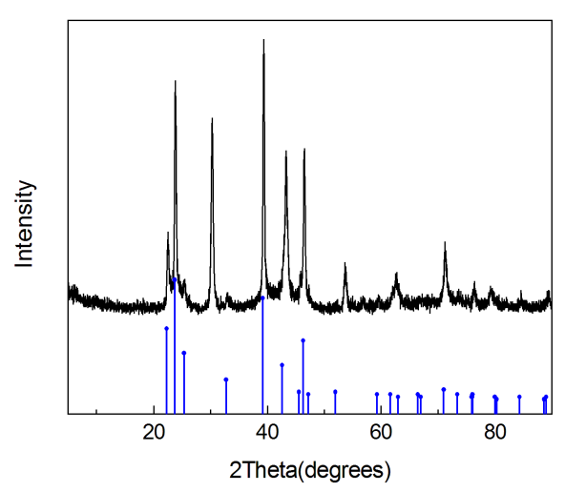
5. Experimental data for the described substances
2-Phenylpyridine 1-oxide (1a)^{[7]}
Purification via column chromatography on silica gel (EtOAc/CH₃OH = 20/1, v/v) afforded 1a as a white solid. ¹H NMR (400 MHz, CDCl₃) δ 7.15-7.34 (m, 2H), 7.36-7.56 (m, 4H), 7.81 (dd, J = 7.9, 1.4 Hz, 2H), 8.31 (d, J = 6.4 Hz, 1H) ppm. ¹³C NMR (100 MHz, CDCl₃) δ 123.49, 124.56, 126.38, 127.27, 128.25, 128.58, 131.64, 139.51, 148.29 ppm.
Pyridine, 2-[1, 1'-biphenyl]-2-yl-, 1-oxide (3a)
Purification via column chromatography on silica gel (EtOAc/CH₃OH = 100/1, v/v) afforded 3a as a brown oil. ¹H NMR (400 MHz, CDCl₃) δ 6.93 (d, J = 7.8 Hz, 1H), 7.02 (t, J = 7.7 Hz, 1H), 7.11 (t, J = 6.0 Hz, 1H), 7.16-7.30 (m, 5H), 7.40-7.58 (m, 4H), 8.24 (d, J = 6.4 Hz, 1H) ppm. ¹³C NMR (100 MHz, CDCl₃) δ 123.53, 123.94, 126.11, 126.24, 127.08, 127.38, 127.52, 128.48, 128.97, 129.00, 130.71, 138.79, 139.44, 140.66, 149.03 ppm. HRMS (ESI): calcd for C₁₇H₁₃NO [M+H]⁺ 248.0997, found 248.1067.
Pyridine, 2-(2'-fluoro[1, 1'-biphenyl]-2-yl)-, 1-oxide (3b)
Purification via column chromatography on silica gel (EtOAc/CH₃OH = 100/1, v/v) afforded 3b as a pale yellow solid. ¹H NMR (400 MHz, CDCl₃) δ 6.90-7.15 (m, 5H), 7.16-7.36 (m, 2H), 7.43-7.63 (m, 4H), 8.19 (d, J = 6.3 Hz, 1H) ppm. ¹³C NMR (100 MHz, CDCl₃) δ 114.22, 114.44, 122.91, 122.94, 123.74, 123.82, 126.75, 126.90, 126.99, 127.19, 128.29, 128.31, 128.39, 128.98, 129.84, 130.26, 130.29, 131.75,134.62, 138.80, 148.58, 157.05, 159.50. HRMS (ESI): calcd for C₁₇H₁₂NOF [M+H]⁺ 266.0903, found 266.0963.
Pyridine, 2-(3'-fluoro[1, 1'-biphenyl]-2-yl)-, 1-oxide (3c)
Purification via column chromatography on silica gel (EtOAc/CH₃OH = 100/1, v/v) afforded 3c as a pale yellow solid. ¹H NMR (400 MHz, CDCl₃) δ 6.91 (t, J = 8.5 Hz, 1H), 6.97-7.23 (m, 6H), 7.44-7.61 (m, 4H), 8.25 (d, J = 6.5 Hz, 1H). ¹³C NMR (100 MHz, CDCl₃) δ 113.03, 113.24, 114.15, 114.37, 123.19, 123.22, 123.91, 124.14, 126.85, 127.43, 128.64, 128.70, 128.93, 129.19, 130.79, 138.91, 139.50, 139.52, 141.75, 141.82, 148.80, 160.31, 162.75. HRMS (ESI): calcd for C₁₇H₁₂NOF [M+H]⁺ 266.0903, found 266.0985.
Pyridine, 2-(3'-chloro[1, 1'-biphenyl]-2-yl)-, 1-oxide (3d)
Purification via column chromatography on silica gel (EtOAc/CH₃OH = 100/1, v/v) afforded 3d as a pale yellow solid. ¹H NMR (400 MHz, CDCl₃) δ 7.01 (d, J = 7.8 Hz, 1H), 7.08-7.22 (m, 5H), 7.27-7.29 (m, 1H), 7.44-7.61 (m, 4H), 8.26 (d, J = 6.5 Hz, 1H) ppm. ¹³C NMR (100 MHz, CDCl₃) δ 123.91, 124.10, 125.69, 126.36, 126.90, 127.35, 127.47, 128.43, 128.73, 128.92, 129.21, 130.81, 133.01, 138.93, 139.33, 141.36, 148.74 ppm. HRMS (ESI): calcd for C₁₇H₁₂NOCl [M+H]⁺ 282.0607, found 282.0675.
Pyridine, 2-(3'-bromo[1, 1'-biphenyl]-2-yl)-, 1-oxide (3e)
Purification via column chromatography on silica gel (EtOAc/CH₃OH = 100/1, v/v) afforded 3e as a brown oil. ¹H NMR (400 MHz, CDCl₃) δ 7.00 (d, J = 5.7 Hz, 1H), 7.04-7.13 (m, 2H), 7.15-7.24 (m, 2H), 7.34 (d, J = 7.9 Hz, 1H), 7.44 (t, J = 1.8 Hz, 1H),7.46-7.63 (m, 4H), 8.25 (d, J = 6.4 Hz, 1H) ppm. ¹³C NMR (100 MHz, CDCl₃) δ 121.19, 123.93, 124.16, 126.13, 126.92, 127.48, 128.72, 128.73, 128.91, 129.21, 129.26, 130.23, 130.79, 138.91, 139.20, 141.59, 148.71 ppm. HRMS (ESI): calcd for C₁₇H₁₂NOBr [M+H]⁺ 326.0102, found 326.0245.
Pyridine, 2-[3'-(trifluoromethyl)[1, 1'-biphenyl]-2-yl]-, 1-oxide (3f)
Purification via column chromatography on silica gel (EtOAc/CH₃OH = 100/1, v/v) afforded 3f as a brown solid. ¹H NMR (400 MHz, CDCl₃) δ 7.04 (d, J = 7.8 Hz, 1H), 7.11 (t, J = 7.6 Hz, 1H), 7.15-7.22 (m, 1H), 7.37 (t, J = 8.0 Hz, 1H), 7.45-7.64 (m, 7H), 8.22 (d, J = 6.4 Hz, 1H) ppm. ¹³C NMR (100 MHz, CDCl₃) δ 122.58, 123.85, 123.89, 123.92, 123.96, 124.86, 124.89, 124.93, 125.00, 125.02, 125.29, 128.10, 128.37, 128.75, 129.84, 130.27, 130.56, 130.88, 131.82, 131.96, 139.87, 140.27, 141.33, 149.65. HRMS (ESI): calcd for C₁₈H₁₂NOF₃ [M+H]⁺ 316.0871, found 316.0942.
[1, 1'-Biphenyl]-3-carbonitrile, 2'-(2-pyridinyl-1-oxide)- (3g)
Purification via column chromatography on silica gel (EtOAc/CH₃OH = 100/1, v/v) afforded 3g as a pale yellow solid. ¹H NMR (400 MHz, CDCl₃) δ 7.05-7.25 (m, 3H), 7.35 (t, J = 8.1 Hz, 1H), 7.43-7.66 (m, 7H), 8.19 (d, J = 6.2 Hz, 1H) ppm. ¹³C NMR (100 MHz, CDCl₃) δ 111.24, 117.61, 124.23, 124.27, 127.33, 127.45, 128.09, 128.78, 128.95, 129.35, 129.86, 130.51, 130.83, 131.87, 138.61, 138.90, 140.98, 148.40 ppm. HRMS (ESI): calcd for C₁₈H₁₂N₂O [M+H]⁺ 273.0950, found 273.1016.
Pyridine, 2-(3'-nitro[1, 1'-biphenyl]-2-yl)-, 1-oxide (3h)
Purification via column chromatography on silica gel (EtOAc/CH₃OH = 100/1, v/v) afforded 3h as a pale yellow solid. ¹H NMR (400 MHz, CDCl₃) δ 7.13-7.24 (m, 3H), 7.41 (t, J = 7.9 Hz, 1H), 7.46-7.69 (m, 5H), 8.09 (d, J = 8.2 Hz, 1H), 8.13 (t, J = 1.9 Hz, 1H), 8.17 (d, J = 5.4 Hz, 1H) ppm. ¹³C NMR (100 MHz, CDCl₃) δ 121.16, 121.93, 124.23, 124.28, 127.33, 127.60, 128.19, 128.80, 129.04, 129.40, 130.91, 133.51, 138.52, 138.96, 141.36, 147.05, 148.47 ppm. HRMS (ESI): calcd for C₁₇H₁₂N₂O₃ [M+H]⁺ 293.0848, found 293.0915.
Pyridine, 2-(3'-methyl[1, 1'-biphenyl]-2-yl)-, 1-oxide (3i)
Purification via column chromatography on silica gel (EtOAc/CH₃OH = 100/1, v/v) afforded 3i as abrown solid. ¹H NMR (400 MHz, CDCl₃) δ 2.25 (s, 3H), 6.94 (d, J = 7.8 Hz, 1H), 6.98-7.07 (m, 3H), 7.06-7.17 (m, 3H), 7.36-7.66 (m, 4H), 8.26 (d, J = 6.5 Hz, 1H).¹³C NMR (100 MHz, CDCl₃) δ 21.38. 124.59, 125.13, 125.61, 127.22, 127.99, 128.04, 128.69, 129.22, 129.56, 130.11, 130.11, 131.72, 137.80, 139.85, 140.44, 141.81, 150.21. HRMS (ESI): calcd for C₁₈H₁₅NO [M+H]⁺ 262.1154, found 262.1224.
Pyridine, 2-(3'-methoxy[1, 1'-biphenyl]-2-yl)-, 1-oxide (3j)
Purification via column chromatography on silica gel (EtOAc/CH₃OH = 100/1, v/v) afforded 3j as a pale yellow solid. ¹H NMR (400 MHz, CDCl₃) δ 3.68 (s, 3H), 6.76 (d, J = 7.8 Hz, 1H), 6.82-6.88 (m, 2H), 6.95 (d, J = 7.8 Hz, 1H), 7.05 (t, J = 7.4 Hz, 1H), 7.09-7.18 (m, 2H), 7.41-7.60 (m, 4H), 8.27 (d, J = 6.4 Hz, 1H). ¹³C NMR (100 MHz, CDCl₃) δ 54.09, 112.38, 112.39, 119.88, 123.71, 124.33, 126.40, 127.56, 128.21, 128.56, 128.95, 129.12, 130.74, 138.78, 140.50, 140.86, 149.07, 158.32. HRMS (ESI): calcd for C₁₈H₁₅NO₂ [M+H]⁺ 278.1103, found 278.1170.
Pyridine, 2-(4'-methyl[1, 1'-biphenyl]-2-yl)-, 1-oxide(3k)
Purification via column chromatography on silica gel (EtOAc/CH₃OH = 100/1, v/v) afforded 3k as a brown oil. ¹H NMR (400 MHz, CDCl₃) δ 2.28 (s, 3H), 6.95 (d, J = 7.8 Hz, 1H), 7.00-7.07 (m, 3H), 7.10-7.15 (m, 3H), 7.38-7.58 (m, 4H), 8.26 (d, J = 6.5 Hz, 1H) ppm. ¹³C NMR (100 MHz, CDCl₃) δ 20.08, 123.59, 124.27, 126.09, 127.31, 127.62, 127.94, 128.55, 129.06, 129.09, 130.67, 135.90, 136.56, 138.87, 140.66, 149.23 ppm. HRMS (ESI): calcd for C₁₈H₁₅NO [M+H]⁺ 262.1154, found 262.1306.
Pyridine, 2-(4'-methoxy[1, 1'-biphenyl]-2-yl)-, 1-oxide (3l)
Purification via column chromatography on silica gel (EtOAc/CH₃OH = 100/1, v/v) afforded 3l as a brown oil. ¹H NMR (400 MHz, CDCl₃) δ 3.75 (s, 3H), 6.75 (d, J = 8.6 Hz, 2H), 6.93 (d, J = 7.3 Hz, 1H), 7.02-7.12 (m, 2H), 7.17 (d, J = 8.6 Hz, 2H), 7.39-7.58 (m, 4H), 8.27 (d, J = 5.9 Hz, 1H). ¹³C NMR (100 MHz, CDCl₃) δ 54.13, 112.66, 123.58, 124.62, 125.97, 127.62, 128.55, 128.61, 128.99, 129.13, 130.63, 131.90, 138.99, 140.31, 149.19, 157.86. HRMS (ESI): calcd for C₁₈H₁₅NO₂ [M+H]⁺ 278.1103, found 278.1175.
Pyridine, 2-(4'-chloro[1, 1'-biphenyl]-2-yl)-, 1-oxide (3m)
Purification via column chromatography on silica gel (EtOAc/CH₃OH = 100/1, v/v) afforded 3m as a pale yellow solid. ¹H NMR (400 MHz, CDCl₃) δ 7.00 (d, J = 7.8 Hz, 1H), 7.11 (t, J = 7.7 Hz, 1H), 7.15-7.23 (m, 5H), 7.44-7.59 (m, 4H), 8.26 (d, J = 6.5 Hz, 1H) ppm. ¹³C NMR (100 MHz, CDCl₃) δ 123.89, 124.23, 126.73, 127.41, 127.45, 128.68, 128.72, 128.91, 129.15, 130.78, 132.38, 138.07, 138.94, 139.59, 148.92 ppm. HRMS (ESI): calcd for C₁₇H₁₂NOCl [M+H]⁺ 282.0607, found 282.0681.
Pyridine, 2-(4'-bromo[1, 1'-biphenyl]-2-yl)-, 1-oxide (3n)
Purification via column chromatography on silica gel (EtOAc/CH₃OH = 100/1, v/v) afforded 3n as a pale yellow solid. ¹H NMR (400 MHz, CDCl₃) δ 7.00 (d, J = 7.7 Hz, 1H), 7.07-7.22 (m, 4H), 7.35 (d, J = 8.4 Hz, 2H), 7.44-7.58 (m, 4H), 8.24 (d, J = 6.3 Hz, 1H) ppm. ¹³C NMR (100 MHz, CDCl₃) δ 120.62, 123.92, 124.27, 126.75, 127.43, 128.73, 128.85, 129.00, 129.17, 130.34, 130.71, 138.53, 138.90, 139.55, 148.85 ppm. HRMS (ESI): calcd for C₁₇H₁₂NOBr [M+H]⁺ 326.0102, found 326.0167.
Pyridine, 2-[4'-(trifluoromethyl)[1, 1'-biphenyl]-2-yl]-, 1-oxide (3o)
Purification via column chromatography on silica gel (EtOAc/CH₃OH = 100/1, v/v) afforded 3o as a pale yellow solid. ¹H NMR (400 MHz, CDCl₃) δ 7.03 (d, J = 7.7 Hz, 1H), 7.11 (t, J = 7.6 Hz, 1H), 7.15-7.23 (m, 1H) , 7.39 (d, J = 8.0 Hz, 2H), 7.46-7.60 (m, 6H), 8.22 (d, J = 6.4 Hz, 1H) ppm. ¹³C NMR (100 MHz, CDCl₃) δ 122.81, 125.11, 125.14, 125.18, 125.21, 125.26, 125.52, 128.19, 128.42, 128.69, 129.16, 129.49, 129.84, 129.97, 130.31, 131.90, 139.95, 140.46, 144.32, 149.70. HRMS (ESI): calcd for C₁₈H₁₂NOF₃ [M+H]⁺ 316.0871, found 316.0940.
[1, 1'-Biphenyl]-4-carbonitrile, 2'-(2-pyridinyl-1-oxide)- (3p)
Purification via column chromatography on silica gel (EtOAc/CH₃OH = 100/1, v/v) afforded 3p as a pale yellow solid. ¹H NMR (400 MHz, CDCl₃) δ 7.07 (d, J = 7.8 Hz, 1H), 7.15 (t, J = 7.6 Hz, 1H), 7.18-7.24 (m, 1H), 7.39 (d, J = 8.5 Hz, 2H), 7.46-7.63 (m, 6H), 8.20 (d, J = 6.4 Hz, 1H). ¹³C NMR (100 MHz, CDCl₃) δ 111.11, 118.77, 125.25, 125.31, 128.33, 128.58, 129.00, 129.74, 129.96, 130.41, 131.81, 132.03, 139.99, 140.11, 145.48, 149.54. HRMS (ESI): calcd for C₁₈H₁₂N₂O [M+H]⁺ 273.0950, found 273.1019.
Pyridine, 2-(4'-nitro[1, 1'-biphenyl]-2-yl)-, 1-oxide (3q)
Purification via column chromatography on silica gel (EtOAc/CH₃OH = 100/1, v/v) afforded 3q as a pale yellow solid. ¹H NMR (400 MHz, CDCl₃) δ 7.07-7.24 (m, 3H), 7.40-7.69 (m, 6H), 8.10 (d, J = 8.8 Hz, 2H), 8.19 (d, J = 5.8 Hz, 1H) ppm. ¹³C NMR (100 MHz, CDCl₃) δ 122.48, 124.20, 124.31, 127.26, 127.76, 128.06, 128.72, 128.95, 129.45, 130.87, 138.72, 138.98, 146.01, 146.52, 148.43 ppm. HRMS (ESI): calcd for C₁₇H₁₂N₂O₃ [M+H]⁺ 293.0848, found 293.0915.
[1, 1'-Biphenyl]-4-carboxylic acid, 2'-(2-pyridinyl-1-oxide)-, methyl ester (3r)
Purification via column chromatography on silica gel (EtOAc/CH₃OH = 100/1, v/v) afforded 3r as a pale yellow solid. ¹H NMR (400 MHz, CDCl₃) δ 3.88 (s, 3H), 6.99 (d, J = 7.8 Hz, 1H), 7.07 (t, J = 7.7 Hz, 1H), 7.12-7.22 (m, 1H), 7.34 (d, J = 8.5 Hz, 2H), 7.44-7.65 (m, 4H), 7.91 (d, J = 8.5 Hz, 2H), 8.22 (d, J = 6.5 Hz, 1H) ppm. ¹³C NMR (100 MHz, CDCl₃) δ 51.07, 123.96, 124.15, 127.03, 127.39, 127.44, 127.87, 128.49, 128.72, 128.87, 129.25, 130.82, 138.89, 139.72, 144.29, 148.69, 165.86. HRMS (ESI): calcd for C₁₉H₁₅NO₃ [M+H]⁺ 306.1052, found 306.1121.
Pyridine, 2-(3', 5'-difluoro[1, 1'-biphenyl]-2-yl)-, 1-oxide (3s)
Purification via column chromatography on silica gel (EtOAc/CH₃OH = 100/1, v/v) afforded 3s as a pale yellow solid. δ ¹H NMR (400 MHz, CDCl₃) δ 6.66 (t, J = 9.0 Hz, 1H), 6.83 (dd, J = 8.3, 2.3 Hz, 2H), 7.07 (d, J = 7.7 Hz, 1H), 7.16 (d, J = 7.7 Hz, 1H), 7.19-7.24 (m, 1H), 7.42-7.62 (m, 4H), 8.24 (d, J = 6.3 Hz, 1H) ppm. ¹³C NMR (100 MHz, CDCl₃) δ 101.44, 101.70, 101.95, 110.12, 110.19, 110.31, 110.38, 124.19, 124.22, 127.23, 127.35, 128.72, 128.82, 129.32, 130.75, 138.56, 138.93, 142.84, 142.94, 143.04, 148.45, 160.33, 160.46, 162.80, 162.93. HRMS (ESI): calcd for C₁₇H₁₁NOF₂ [M+H]⁺ 284.0809, found 284.0882.
Pyridine, 2-(3', 5'-dichloro[1, 1'-biphenyl]-2-yl)-, 1-oxide (3t)
Purification via column chromatography on silica gel (EtOAc/CH₃OH = 100/1, v/v) afforded 3t as a pale yellow solid. ¹H NMR (400 MHz, CDCl₃) δ 7.06 (d, J = 7.8 Hz, 1H), 7.12-7.27 (m, 5H), 7.40-7.60 (m, 4H), 8.25 (d, J = 6.3 Hz, 1H). ¹³C NMR (100 MHz, CDCl₃) δ 124.18, 124.22, 125.72, 126.33, 127.28, 127.42, 128.71, 128.85, 129.36, 130.79, 133.62, 138.07, 138.90, 142.51, 148.33. HRMS (ESI): calcd for C₁₇H₁₁NOCl₂ [M+H]⁺ 316.0218, found 316.0301.
Pyridine, 2-(3',4'-dimethyl[1, 1'-biphenyl]-2-yl)-, 1-oxide (3u)
Purification via column chromatography on silica gel (EtOAc/CH₃OH = 100/1, v/v) afforded 3u as a pale yellow solid. ¹H NMR (400 MHz, CDCl₃) δ 2.16 (s, 3H), 2.18 (s, 3H), 6.90-6.98 (m, 3H), 6.99-7.07 (m, 2H), 7.08-7.16 (m, 1H), 7.34-7.66 (m, 4H), 8.25 (d, J = 6.5 Hz, 1H) ppm. ¹³C NMR (100 MHz, CDCl₃) δ 18.38, 18.69, 123.52, 124.10, 124.82, 125.95, 127.64, 128.44, 128.48, 128.62, 129.05, 129.09, 130.62, 134.54, 135.36, 136.98, 138.75, 140.67, 149.27 ppm. HRMS (ESI): calcd for C₁₉H₁₇NO [M+H]⁺ 276.1310, found 276.1337.
Pyridine, 2-[2-(2-thienyl)phenyl]-, 1-oxide (3v)
Purification via column chromatography on silica gel (EtOAc/CH₃OH = 100/1, v/v) afforded 3v as an orange solid. ¹H NMR (400 MHz, CDCl₃) δ 6.87-6.94 (m, 2H), 7.12-7.33 (m, 4H), 7.41-7.55 (m, 3H), 7.64 (d, J = 7.6 Hz, 1H), 8.29 (d, J = 6.3 Hz, 1H). ¹³C NMR (100 MHz, CDCl₃) δ 125.19, 125.36, 125.89, 125.94, 127.35, 127.80, 128.42, 129.69, 130.15, 130.29, 131.63, 134.31, 139.89, 141.78, 149.85 ppm. HRMS (ESI): calcd for C₁₅H₁₁NOS [M+H]⁺ 254.0561, found 254.0647.
2-Methyl-6-phenylpyridine(4a₁)^{[8]}
Purification via column chromatography on silica gel (petroleum/EtOAc = 100/1, v/v) afforded 4a₁. ¹H NMR (400 MHz, CDCl₃) δ 2.61 (s, 3H) ,7.06 (d, J = 7.6 Hz, 1H), 7.33-7.53 (m, 4H), 7.59 (t, J = 7.7 Hz, 1H), 7.97 (d, J = 7.0 Hz, 2H) ppm. ¹³C NMR (100 MHz, CDCl₃) δ 23.68, 116.53, 120.52, 125.94, 127.61, 127.63, 135.80, 138.71, 155.88, 157.26 ppm.
2-Methyl-6-phenylpyridine 1-oxide (4a₂)
Purification via column chromatography on silica gel (EtOAc/CH₃OH = 100/1, v/v) afforded 4a₂ as a white solid. ¹H NMR (400 MHz, CDCl₃) δ 2.58 (s, 3H), 7.17-7.27 (M, 2H), 7.31 (d, J = 7.5 Hz, 1H), 7.39-7.51 (m, 3H), 7.79 (dd, J = 7.9, 1.5 Hz, 2H). ¹³C NMR (100 MHz, CDCl₃) δ 18.53, 124.71, 124.97, 125.11, 128.10, 129.26, 129.41, 133.36, 149.41, 149.88. HRMS (ESI): calcd for C₁₂H₁₁NO [M+H]⁺ 186.0841, found 186.0916.
Pyridine, 2-methyl-6-([1, 1'-biphenyl]-2-yl)-, 1-oxide (4a)
Purification via column chromatography on silica gel (EtOAc/CH₃OH = 100/1, v/v) afforded 4a as a brown oil. ¹H NMR (400 MHz, CDCl₃) δ 2.50 (s, 3H), 6.84 (d, J = 7.8 Hz, 1H), 6.94 (t, J = 7.7 Hz, 1H), 7.13 (d, J = 7.7 Hz, 1H), 7.17-7.25 (m, 5H), 7.41-7.55 (m, 4H). ¹³C NMR (100 MHz, CDCl₃) δ 22.83, 123.10, 124.04, 125.13, 126.01, 126.15, 127.02, 127.47, 128.19, 128.94, 129.17, 131.55, 139.75, 140.59, 148.31, 148.97. HRMS (ESI): calcd for C₁₈H₁₅NO [M+H]⁺ 262.1154, found 262.1224.
5-Methyl-2-phenylpyridine (4b₁)^{[1]}
Purification via column chromatography on silica gel (petroleum/EtOAc = 100/1, v/v) afforded 4b₁. ¹H NMR (400 MHz, CDCl₃) δ 2.34 (s, 3H), 7.38 (t, J = 7.3 Hz, 1H), 7.45 (t, J = 7.4 Hz, 2H), 7.52 (d, J = 8.1 Hz, 1H), 7.60 (d, J = 8.1 Hz, 1H), 7.96 (d, J = 7.1 Hz, 2H), 8.51 (s, 1H). ¹³C NMR (100 MHz, CDCl₃) δ 17.10, 118.97, 125.64, 127.53, 127.65, 130.53, 136.24, 138.38, 149.03, 153.75.
5-Methyl-2-phenylpyridine 1-oxide (4b₂)
Purification via column chromatography on silica gel (EtOAc/CH₃OH = 100/1, v/v) afforded 4b₂ as a white solid. ¹H NMR (400 MHz, CDCl₃) δ 2.33 (s, 3H), 7.13 (d, J = 8.1 Hz, 1H), 7.31 (d, J = 8.1 Hz, 1H), 7.39-7.51 (m, 3H), 7.80 (dd, J = 8.1, 1.4 Hz, 2H), 8.20 (s, 1H) ppm. ¹³C NMR (100 MHz, CDCl₃) δ 17.01, 125.69, 126.09, 127.22, 128.24, 128.31, 131.65, 134.11, 139.27, 145.48 ppm. HRMS (ESI): calcd for C₁₂H₁₁NO [M+H]⁺ 186.0841, found 186.0942.
Pyridine, 5-methyl-2-([1, 1'-biphenyl]-2-yl)-, 1-oxide (4b)
Purification via column chromatography on silica gel (EtOAc/CH₃OH = 100/1, v/v) afforded 4b as a pale yellow solid. ¹H NMR (400 MHz, CDCl₃) δ 2.26 (s, 3H), 6.82 (d, J = 8.0 Hz, 1H), 6.88 (d, J = 8.0 Hz, 1H), 7.16-7.31 (m, 5H), 7.41-7.60 (m, 4H), 8.15 (s, 1H) ppm. ¹³C NMR (100 MHz, CDCl₃) δ 17.04, 125.65, 126.12, 126.27, 126.88, 127.16, 127.50, 128.40, 129.07, 129.29, 130.74, 134.20, 138.64, 139.65, 140.78, 146.19 ppm. HRMS (ESI): calcd for C₁₈H₁₅NO [M+H]⁺ 262.1154, found 262.1242.
4-Methyl-2-phenylpyridine (4c₁)^{[8]}
Purification via column chromatography on silica gel (petroleum/EtOAc = 100/1, v/v) afforded 4c₁. ¹H NMR (400 MHz, CDCl₃) δ 2.13 (s, 3H), 6.79 (d, J = 4.4 Hz, 1H), 7.20 (t, J = 7.3 Hz, 1H), 7.27 (t, J = 7.6 Hz, 2H), 7.31 (s, 1H), 7.82 (d, J = 7.2 Hz, 2H), 8.36 (d, J = 5.0 Hz, 1H). ¹³C NMR (100 MHz, CDCl₃) δ 19.99, 120.30, 122.00, 125.80, 127.54, 127.68, 138.39, 146.55, 148.25, 156.13.
4-Methyl-2-phenylpyridine 1-oxide (4c₂)
Purification via column chromatography on silica gel (EtOAc/CH₃OH = 100/1, v/v) afforded 4c₂ as a pale yellow solid. ¹H NMR (400 MHz, CDCl₃) δ 2.37 (s, 3H), 7.02 (d, J = 6.6 Hz, 1H), 7.22 (d, J = 2.6 Hz, 1H), 7.36-7.62 (m, 3H), 7.81 (dd, J = 8.1, 1.6 Hz, 2H), 8.22 (d, J = 6.6 Hz, 1H). ¹³C NMR (100 MHz, CDCl₃) δ 20.32, 125.31, 127.99, 128.23, 129.28, 129.46, 132.78, 137.08, 139.81, 148.43. HRMS (ESI): calcd for C₁₂H₁₁NO [M+H]⁺ 186.0841, found 186.0922. Elemental analysis: C, 77.81; H, 5.99; N, 7.56 %. Found: C, 77.65; H, 5.73; N, 7.65 %.
Pyridine, 4-methyl-2-([1, 1'-biphenyl]-2-yl)-, 1-oxide (4c)
Purification via column chromatography on silica gel (EtOAc/CH₃OH = 100/1, v/v) afforded 4c as a brown oil. ¹H NMR (400 MHz, CDCl₃) δ 2.14 (s, 3H), 6.77 (d, J = 2.2 Hz, 1H), 6.93 (dd, J = 6.6, 2.2 Hz, 1H), 7.14-7.34 (m, 5H), 7.41-7.61 (m, 4H), 8.13 (d, J = 6.6 Hz, 1H) ppm. ¹³C NMR (100 MHz, CDCl₃) δ 20.09, 125.54, 127.17, 127.28, 128.17, 128.45, 129.07, 129.50, 130.04, 130.10, 131.86, 136.92, 139.07, 140.57, 141.70, 149.33 ppm. HRMS (ESI): calcd for C₁₈H₁₅NO [M+H]⁺ 262.1154, found 262.1233.
5-Fluoro-2-phenylpyridine (4d₁)^{[1]}
Purification via column chromatography on silica gel (petroleum/EtOAc = 100/1, v/v) afforded 4d₁. ¹H NMR (400 MHz, CDCl₃) δ 7.39-7.49 (m, 4H), 7.71-7.74 (m, 1H), 7.94 (d, J = 7.0 Hz, 2H), 8.55 (d, J = 2.9 Hz, 1H). ¹³C NMR (100 MHz, CDCl₃) δ 121.30, 121.34, 123.43, 123.61, 126.79, 128.82, 128.90, 137.65, 137.89, 138.45, 153.78, 153.82, 157.58, 160.13.
5-Fluoro-2-phenylpyridine 1-oxide (4d₂)
Purification via column chromatography on silica gel (EtOAc/CH₃OH = 100/1, v/v) afforded 4d₂ as a white solid. ¹H NMR (400 MHz, CDCl₃) δ 7.13 (t, J = 9.0 Hz, 1H), 7.34-7.56 (m, 4H), 7.74 (dd, J = 7.9, 1.7 Hz, 2H), 8.29 (dd, J = 4.4, 2.4 Hz, 1H). ¹³C NMR (100 MHz, CDCl₃) δ 113.78, 113.97, 127.03, 127.12, 128.41, 129.25, 129.72, 130.10, 130.47, 131.74, 158.03, 160.54. HRMS (ESI): calcd for C₁₁H₈NOF [M+H]⁺ 190.0590, found 190.0667.
Pyridine, 5-fluoro-2-([1, 1'-biphenyl]-2-yl)-, 1-oxide (4d)
Purification via column chromatography on silica gel (EtOAc/CH₃OH = 100/1, v/v) afforded 4d as a pale yellow solid. ¹H NMR (400 MHz, CDCl₃) δ 6.85 (t, J = 7.8 Hz, 1H), 6.89-6.99 (m, 1H), 7.16-7.31 (m, 5H), 7.43-7.62 (m, 4H), 8.19 (dd, J = 4.4, 2.3 Hz, 1H). ¹³C NMR (100 MHz, CDCl₃) δ 113.17, 113.36, 127.36, 127.43, 128.16, 128.25, 128.30, 128.39, 129.59, 129.81, 129.94, 130.19, 130.28, 130.81, 140.43, 142.04, 147.12, 158.03, 160.54. HRMS (ESI): calcd for C₁₇H₁₂NOF [M+H]⁺ 266.0903, found 266.0973.
5-Chloro-2-phenylpyridine(4e₁)^{[9]}
Purification via column chromatography on silica gel (petroleum/EtOAc = 100/1, v/v) afforded 4e₁. ¹H NMR (400 MHz, CDCl₃) δ 7.40-7.49 (m, 3H), 7.54-7.71 (m, 2H), 7.95 (d, J = 6.9 Hz, 2H), 8.63 (d, J = 2.2 Hz, 1H) ppm. ¹³C NMR (100 MHz, CDCl₃) δ 121.13, 126.83, 128.88, 129.30, 130.63, 136.46, 138.23, 148.52, 155.60 ppm.
5-Chloro-2-phenylpyridine 1-oxide (4e₂)
Purification via column chromatography on silica gel (EtOAc/CH₃OH = 100/1, v/v) afforded 4e₂ as a white solid. ¹H NMR (400 MHz, CDCl₃) δ 7.30 (dd, J = 8.6, 1.9 Hz, 1H), 7.37 (d, J = 8.6 Hz, 1H), 7.42-7.58 (m, 3H), 7.77 (dd, J = 7.7, 2.0 Hz, 2H), 8.37 (s, 1H) ppm. ¹³C NMR (100 MHz, CDCl₃) δ 125.92, 127.08, 128.42, 129.20, 129.93, 131.58, 131.63, 139.67, 147.98 ppm. HRMS (ESI): calcd for C₁₁H₈NOCl [M+H]⁺ 206.0294, found 206.0371.
Pyridine, 5-chloro-2-([1, 1'-biphenyl]-2-yl)-, 1-oxide (4e)
Purification via column chromatography on silica gel (EtOAc/CH₃OH = 100/1, v/v) afforded 4e as a pale yellow solid. ¹H NMR (400 MHz, CDCl₃) δ 6.88 (d, J = 8.5 Hz, 1H), 7.03 (dd, J = 8.5, 1.9 Hz, 1H), 7.17-7.34 (m, 5H), 7.42-7.60 (m, 4H), 8.28 (d, J = 1.9 Hz, 1H) ppm. ¹³C NMR (100 MHz, CDCl₃) δ 125.26, 127.41, 127.42, 128.32, 128.35, 128.42,129.89, 130.14, 130.23, 130.70, 131.61, 139.16, 140.36, 141.91, 148.79. HRMS (ESI): calcd for C₁₇H₁₂NOCl [M+H]⁺ 282.0607, found 282.0682.
2-(2-Phenylphenyl)pyridine (compound 5)^{[10]}
Purification via column chromatography on silica gel (petroleum/EtOAc = 4/1, v/v) afforded product as light orange solid. ¹H NMR (400 MHz, CDCl₃) δ 6.88 (d,J = 7.9 Hz, 1H) , 7.09 (ddd, J = 7.5, 4.9, 1.0 Hz, 1H), 7.19-7.13 (m, 2H), 7.28-7.20 (m, 3H), 7.37 (td, J = 7.7, 1.8 Hz, 1H), 7.51-7.41 (m, 3H), 7.73-7.65 (t, 1H), 8.63 (d, J = 4.9 Hz, 1H). ¹³C NMR (100 MHz, CDCl₃) δ 121.31, 125.37, 126.67, 127.63, 128.03, 128.49, 129.69, 130.46, 130.47, 135.15, 139.48, 140.59, 141.34, 149.42, 159.24,
2-(3,4-Difluorophenyl)-5-methylpyridine
Purification via column chromatography on silica gel (petroleum/EtOAc = 100/1, v/v) afforded product as a white solid. ¹H NMR (400 MHz, CDCl₃) δ 2.37 (s, 3H), 7.09-7.40 (m, 1H), 7.56 (d, J = 1.2 Hz, 2H), 7.68 (s, 1H), 7.76-8.02 (m, 1H), 8.50 (s, 1H). ¹³C NMR (100 MHz, CDCl₃) δ 16.79, 114.38, 114.56, 116.02, 116.20, 118.33, 121.30, 121.34, 121.37, 121.40, 131.13, 135.44, 135.47, 135.49, 135.53, 136.22, 148.22, 148.31, 148.34, 148.44, 148.99, 150.67, 150.79, 150.92, 151.08. HRMS (ESI): calcd for C₁₂H₉F₂N [M+H]⁺ 206.0703, found 206.0766. Elemental analysis: C, 70.24; H, 4.42; N, 6.83 %. Found: C, 70.08; H, 4.37; N, 6.85 %.
2-(3,4-Difluorophenyl)-5-methylpyridine 1-oxide
Purification via column chromatography on silica gel (EtOAc/CH₃OH = 100/1, v/v) afforded product as a white solid. ¹H NMR (400 MHz, CDCl₃) δ 2.35 (s, 3H), 7.15 (d, J = 8.0 Hz, 1H), 7.20-7.34 (m, 2H), 7.51 (s, 1H), 7.71-8.01 (m, 1H), 8.19 (s, 1H). ¹³C NMR (100 MHz, CDCl₃) δ 18.04, 117.02, 117.19, 118.73, 118.93, 125.80, 125.83, 125.86, 125.90, 126.47, 127.32, 129.35, 129.39, 129.41, 129.45, 135.89, 140.33, 144.24, 148.54, 148.67, 149.48, 149.61, 151.00, 151.13, 151.99, 152.11. HRMS (ESI): calcd for C₁₂H₉F₂NO [M+H]⁺ 222.0652, found 222.0722.
2-(4,5-Difluoro-4'-methoxy-biphenyl-2-yl)-5-methyl-pyridine 1-oxide
Purification via column chromatography on silica gel (EtOAc/CH₃OH = 100/1, v/v) afforded product as a yellow solid. ¹H NMR (400 MHz, CDCl₃) δ 2.27 (s, 3H), 3.76 (s, 3H), 6.72-6.81 (m, 3H), 6.89 (d, J = 8.0 Hz, 1H), 7.12 (d, J = 8.7 Hz, 2H), 7.26 (dd, J = 10.7, 7.5 Hz, 1H), 7.33-7.41 (m, 1H), 8.13 (s, 1H). ¹³C NMR (100 MHz, CDCl₃) δ 18.12, 55.19, 113.84, 118.57, 118.75, 119.36, 119.54, 126.71, 127.92, 129.60, 131.19, 135.79, 138.83, 138.87, 138.89, 138.93, 139.75, 145.40, 147.87, 148.00, 149.20, 149.33, 150.35, 150.48, 151.70, 151.83, 159.22. HRMS (ESI): calcd for C₁₉H₁₅F₂NO₂ [M+H]⁺ M=328.1071, found 328.1152. Elemental analysis: C, 69.72; H, 4.62; N, 4.28 %. Found: C, 69.58; H, 4.46; N, 4.42 %.
2-(4,5-Difluoro-4'-methoxy-biphenyl-2-yl)-5-methyl-pyridine (compound 6)
Purification via column chromatography on silica gel (petroleum/EtOAc = 100/1, v/v) afforded product as a white solid. ¹H NMR (400 MHz, CDCl₃) δ 2.30 (s, 3H), 3.79 (s, 3H), 6.72 (d, J = 8.0 Hz, 1H), 6.78 (d, J = 8.8 Hz, 2H), 7.02 (d, J = 8.8 Hz, 2H), 7.24-7.13 (m, 2H), 7.51 (dd, J = 11.3, 8.3 Hz, 1H), 8.45 (s, 1H). ¹³C NMR (100 MHz, CDCl₃) δ 18.14, 55.22, 113.75, 118.87, 119.04, 119.24, 119.42, 124.71, 130.63, 131.32, 131.94, 135.89, 135.93, 135.98, 136.15, 136.93, 136.97, 136.99, 137.03, 148.15, 148.28, 148.55, 148.68, 149.95, 150.62, 150.74, 151.04, 151.16, 154.47, 158.90. HRMS (ESI): calcd for C₁₉H₁₅F₂NO [M+H]⁺ M=312.1122, found 312.1187. Elemental analysis: C, 73.30; H, 4.86; N, 4.50 %. Found: C, 73.06; H, 4.78; N, 4.65 %.
6. Mechanistic study
6.1 Hydrogen-deuterium exchange experiment
A Schlenk tube with a magnetic stir bar was charged with Pd(OAc)₂ (5.6 mg, 25 μmol), AgOTf (70.7 mg, 0.275 mmol), TBAB (0.0161g, 50 μmol), 2-phenylpyridine N-oxide 1a (38.8 mg, 0.25 mmol), D₂O (2 mL). The resulting mixture was stirred at 100 ºC for 5 h and then diluted with 3 mL of trichloromethane. The solution was filtered through a celite pad and washed with 10-20 mL of trichloromethane. The filtrate was concentrated and the residue was purified by column chromatography on silica gel (EtOAc/CH₃OH = 100/1, v/v) to provide [D_{n}]-1a. ¹H NMR analysis showed that cleavage of the ortho C-H bond was basically complete response.
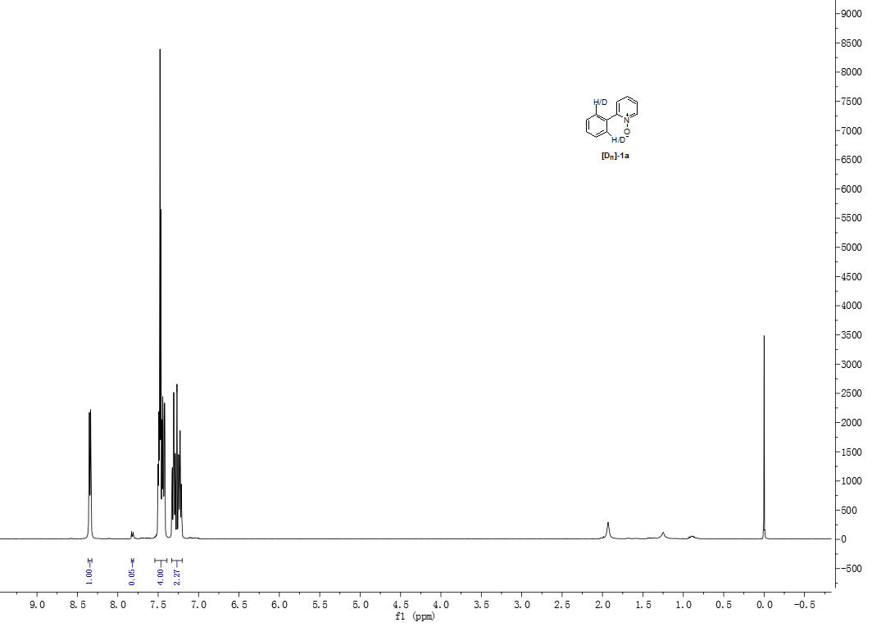

6.2 Intermolecular kinetic isotope effect
Two Schlenk tubes with magnetic stir bars were separately charged with 1a (38.8 mg, 0.25 mmol) and [D₂]-1a (44 mg, 0.25 mmol), and to each tube was added Pd(OAc)₂ (11.2 mg, 50 μmol), AgOTf (141.4 mg, 55 μmol), TBAB (0.0161 g, 50 μmol), iodobenzene(42 μL, 0.375 mmol), then added to the water and deuterium generation water respectively. The resulting mixture was stirred at 100 ºC for 5 h. The resulting organic layer was extracted with trichloromethane, treated with Na₂SO₄ and concentrated in vacuo.
GC-MS was used to analyze the results, and the value is the proportion of GC response of 3a or [D₁]-3a to the internal standard (tetradecane).
The data in the early stages of the reactions were chosen to determine the KIE value.
entry | 1 | 2 | 3 | 4 | 5
Time/min | 15 | 30 | 45 | 60 | 75
3a | 0.15 | 0.21 | 0.29 | 0.39 | 0.48
[D₁]-3a | 0.12 | 0.17 | 0.24 | 0.32 | 0.42

The calculated k_{H}/k_{D} = 0.005/0.005 = 1.0
7. General procedure for the preparation of COX-2 inhibitor analog
a: A 200 mL two-necked bottle with a magnetic stirrer was charged with 2-chloro-5-methylpyridine (2.7 mL, 25 mmol), 3,4-difluorophenyl boronic acid (4.2 g, 30 mmol) and Pd(PPh₃)₄ (0.86 g, 3 mol%) under argon. To the mixture, toluene (75 mL), ethanol (10 mL) and potassium carbonate (2.0 M in water, 28 mL) were added successively and the whole mixture was refluxed for 48 h. Then, it was cooled to room temperature. The aqueous layer was separated and extracted three times with dichloromethane. The combined organic layer was dried over anhydrous Na₂SO_{4.} The crude product was purified by column chromatography on silica gel eluting with hexane and ethyl acetate to give 2-(3,4-difluorophenyl)-5-methylpyridine.^{[3]}
b, c: 2-(3,4-Difluorophenyl)-5-methylpyridine 1-oxide could be obtained by addition of H₂O₂^{[4]} into the solution of 2-(3,4-difluorophenyl)-5-methylpyridine in water, and the catalytic reaction was performed by adding directly catalysts without purification, then 2-(4,5-difluoro-4'-methoxy- biphenyl-2-yl)-5-methyl-pyridine 1-oxide was obtained.
d: A three-necked, 500 mL roundbottomed flask equipped with a condenser, a thermometer, a glass stopper and a magnetic stirrer is charged with 2-(5,6-difluoro-4'-methoxy-biphenyl-2-yl)- 5-methyl-pyridine 1-oxide (1.06 g, 1 mmol, 1 equiv.). Tetrahydrofuran (3.75 mL) is added, followed by saturated aqueous NH₄Cl solution (120 mL). This addition caused a slight increase of the reaction temperature from 22 ºC up to 28 ºC. Zinc dust is added in 4 portions (0.33 g, 5 mmol, 5 equiv.) within 10 min under stirring to this biphasic mixture. Again, an increase of the reaction temperature from 25 ºC up to 38 ºC over a period of 15 min is observed. The reaction mixture is stirred for 20 min until TLC analysis reveals complete consumption of the starting material. The mixture is filtered through a celite pad and is washed with MTBE (8 mL). The organic layers are consecutively washed with half-saturated aqueous NaHCO₃ solution (4 mL) and with brine (4 mL). The combined organic layers are then dried over MgSO₄ (0.1 g), filtered and concentrated. The crude product was purified by column chromatography on silica gel eluting with ethyl acetate and petroleum to give the compound 6.^{[11]}
The isolated compounds in the NMR spectra of hydrogen, carbon and two-dimensional spectroscopy spectra (600 MHz, solvent: dimethyl sulfoxide-d₆) were analysed on the structural aspect.
8. X-Ray Data
X-Ray diffraction: Data sets were collected with a Nonius KappaCCD diffractometer. Programs used: data collection, COLLECT (Nonius B.V., 1998); data reduction DenzoSMN;^{[12]} absorption correction, Denzo;^{[13]} structure solution SHELXS-97;^{[14]} structure refinement SHELXL-97 ^{[15]} and graphics, XP (BrukerAXS, 2000). Thermals ellipsoids are shown with 30% probability, R-values are given for observed reflections, and wR2 values are given for all reflections.
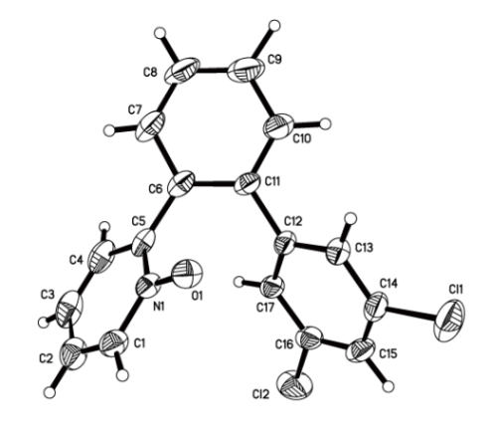
3t
Empirical formula C₁₇H₁₁Cl₂NO, formula weight 316.17, temperature 0(2) K, wavelength 0.71073 Å, crystal system monoclinic, space group P2(1)/c, unit cell dimensions a = 11.1722(18) Å, b = 13.771(2) Å, c = 10.0685(15) Å, α= 90°, β= 96.431(4)°, γ= 90°, volume 1539.3(4) Å3, Z 4, density (calculated) 1.364 Mg/m3, absorption coefficient 0.419 mm-1, F(000) 648, crystal size 0.20 x 0.18 x 0.10 mm3, theta range for data collection 2.36 to 27.55°, index ranges -14<=h<=14, -15<=k<=17, -13<=l<=11, reflections collected 12244, independent reflections 3497 [R(int) = 0.0713], Completeness to theta = 27.55° 98.3 %, absorption correction semi-empirical from equivalents, max. and min. transmission 0.7456 and 0.6295, refinement method full-matrix least-squares on F2, data / restraints / parameters 3497 / 0 / 227, goodness-of-fit on F2 1.003, final R indices [I>2sigma(I)] R1 = 0.0724, wR2 = 0.1583, R indices (all data) R1 = 0.1792, wR2 = 0.2042, extinction coefficient 0.0006(8), largest diff. peak and hole 0.319 and -0.388 e.Å-3.
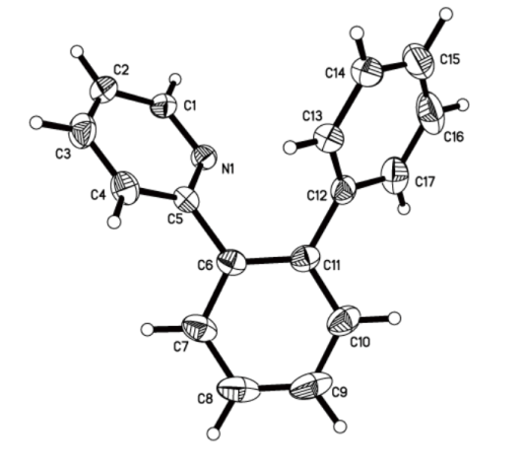
5

Empirical formula C₁₇H₁₃N, formula weight 231.28, temperature 0(2) K, wavelength 0.71073 Å, crystal system monoclinic, space group P2(1)/c, unit cell dimensions a = 11.8380(9) Å, b = 11.3408(9) Å, c = 10.1226(8) Å, α= 90°, β= 108.954(2)°, γ= 90°, volume 1285.30(17) Å3, Z 4, density (calculated) 1.195 Mg/m3, absorption coefficient 0.069 mm-1, F(000) 488, crystal size 0.26 x 0.18 x 0.08 mm3, theta range for data collection 2.56 to 27.57°, index ranges -15<=h<=15, -14<=k<=14, -13<=l<=13, reflections collected 29784, independent reflections 2980 [R(int) = 0.0575], completeness to theta = 27.57° 99.8 %, absorption correction semi-empirical from equivalents, max. and min. transmission 0.7456 and 0.6629, refinement method full-matrix least-squares on F2, data / restraints / parameters 2980 / 0 / 207, goodness-of-fit on F2 1.000, final R indices [I>2sigma(I)] R1 = 0.0578, wR2 = 0.1119, R indices (all data) R1 = 0.1188, wR2 = 0.1373, largest diff. peak and hole 0.131 and -0.197 e.Å-3.
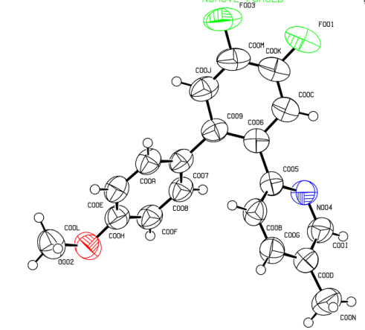
6

Empirical formula C₁₇H₁₁Cl₂NO, formula weigh 316.17, temperature 0(2) K, wavelength 0.71073 Å, crystal system monoclinic, space group P2(1)/c, unit cell dimensions a = 11.1722(18) Å, b = 13.771(2) Å, c = 10.0685(15) Å, α= 90°,β= 96.431(4)°, γ= 90°, volume 1539.3(4) Å3, Z 4, density (calculated) 1.364 Mg/m3, absorption coefficient 0.419 mm-1, F(000) 648, crystal size 0.20 x 0.18 x 0.10 mm3, theta range for data collection 2.36 to 27.55°, index ranges -14<=h<=14, -15<=k<=17, -13<=l<=11, reflections collected 12244, independent reflections 3497 [R(int) = 0.0713], completeness to theta = 27.55° 98.3 %, absorption correction semi-empirical from equivalents, max. and min. transmission 0.7456 and 0.6295, refinement method full-matrix least-squares on F2, data / restraints / parameters 3497 / 0 / 227, goodness-of-fit on F2 1.003, final R indices [I>2sigma(I)] R1 = 0.0724, wR2 = 0.1583, R indices (all data) R1 = 0.1792, wR2 = 0.2042, extinction coefficient 0.0006(8), largest diff. peak and hole 0.319 and -0.388 e.Å-3.
9. NMR Spectra
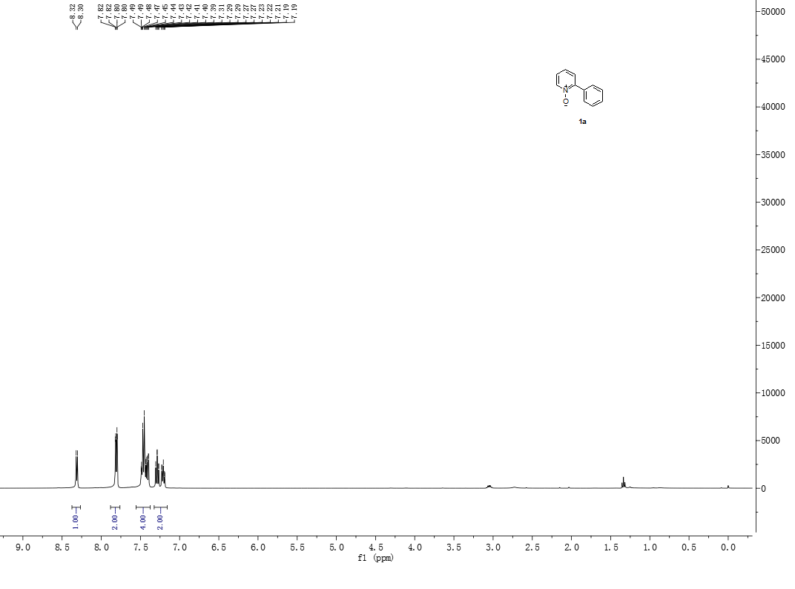
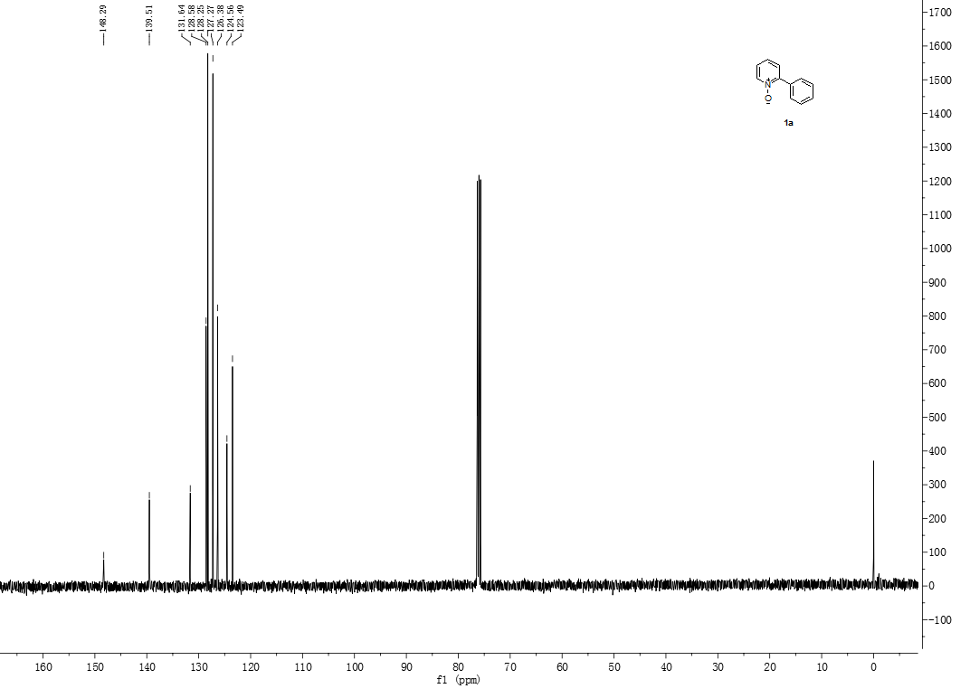
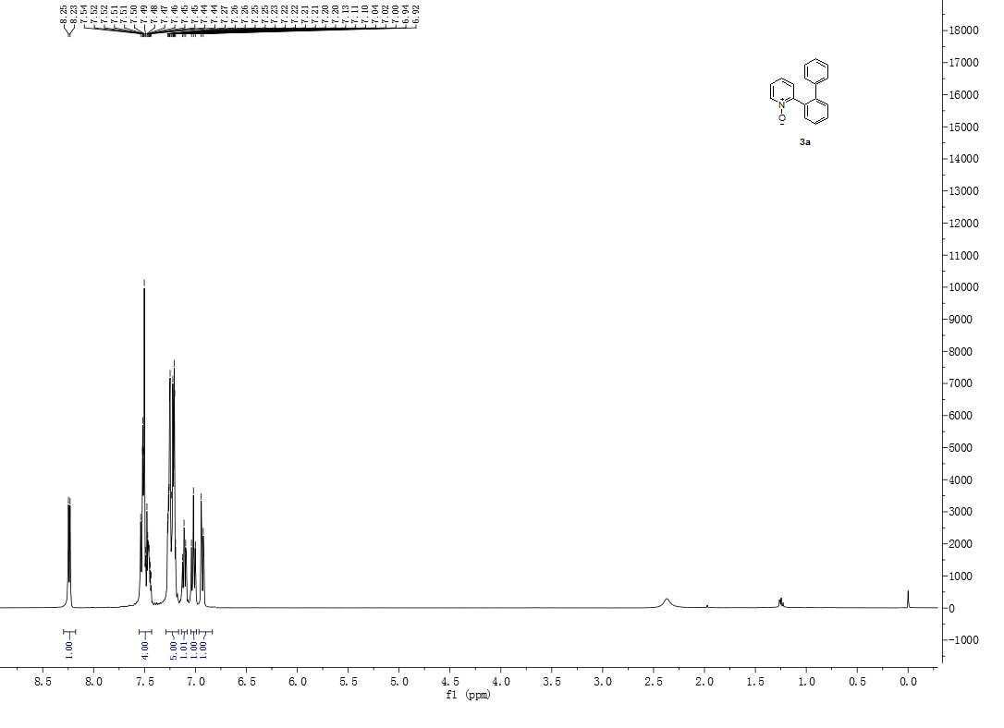
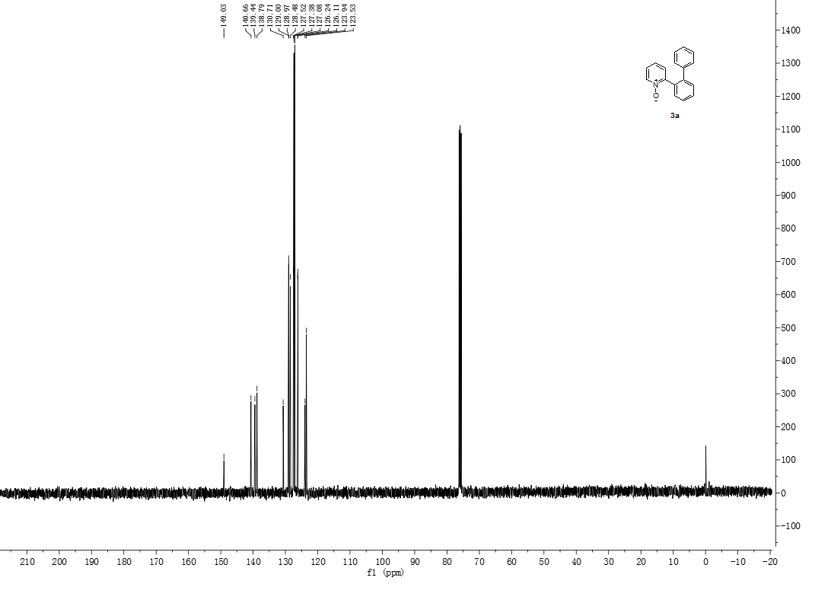
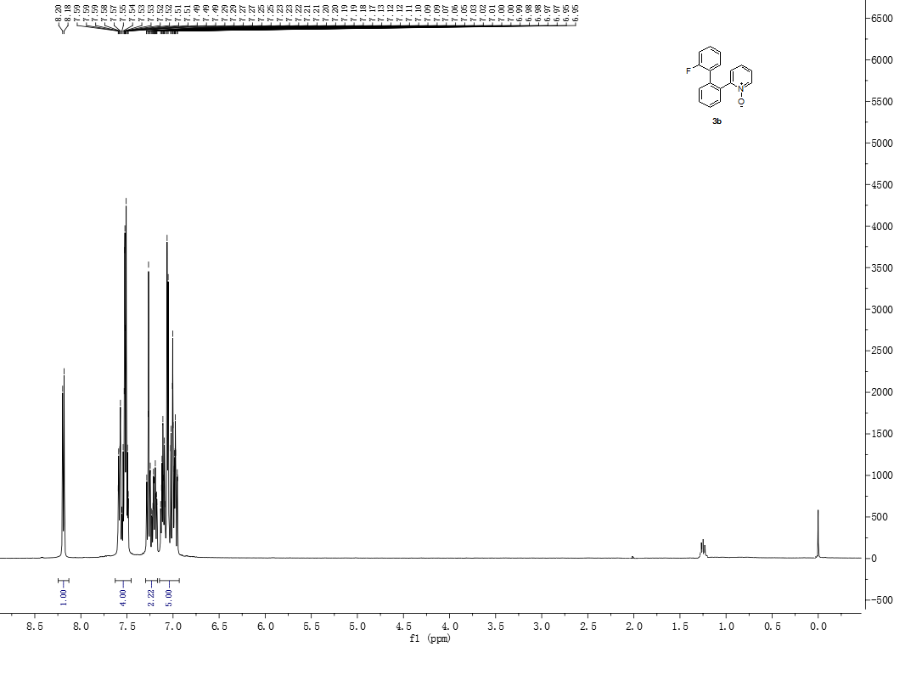
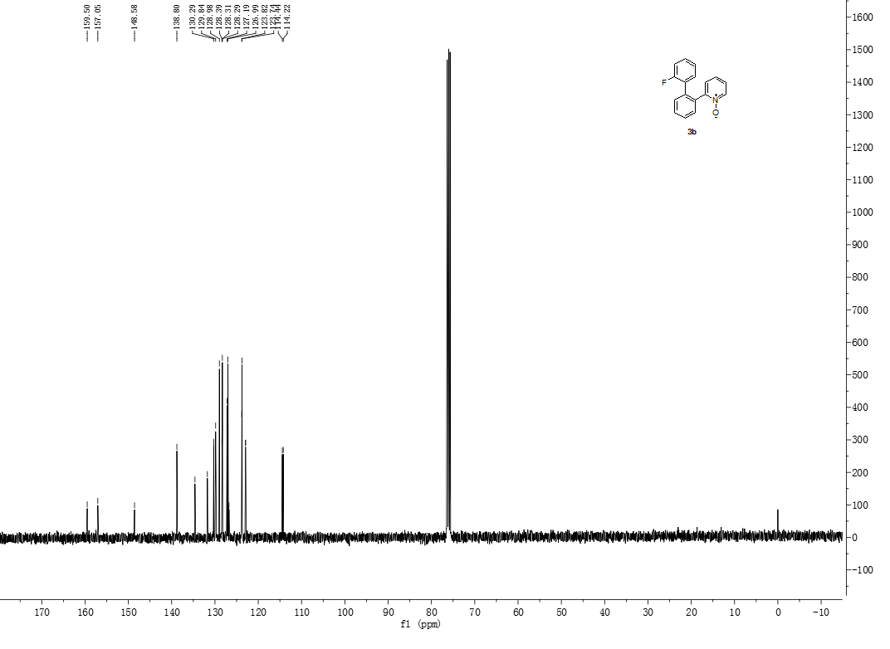
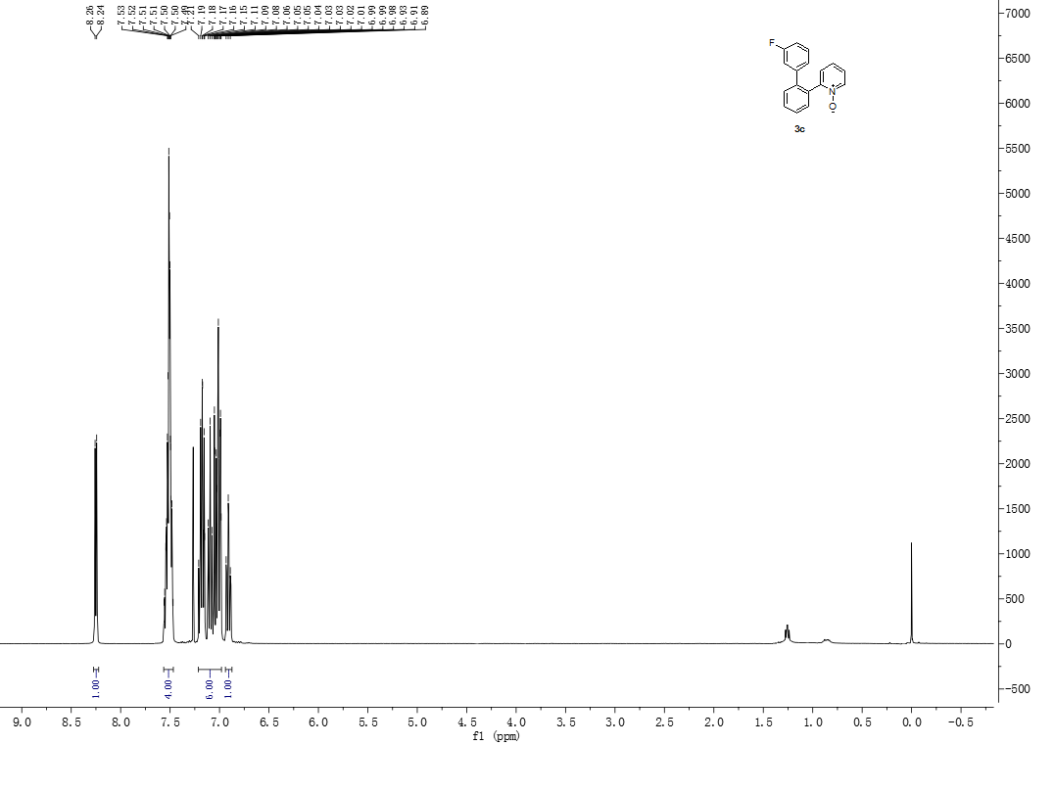
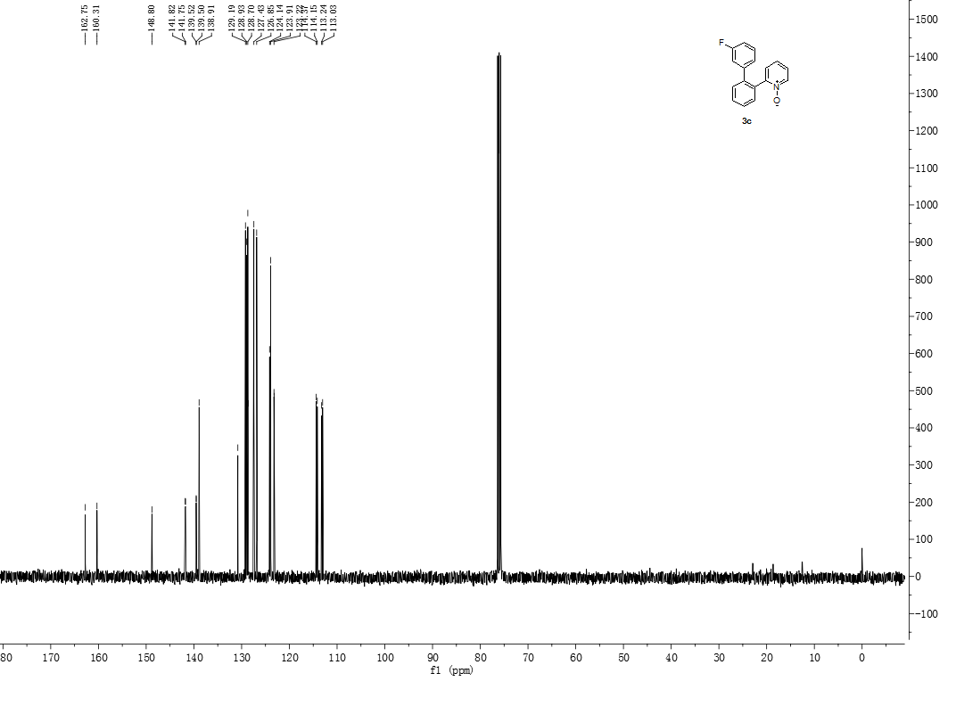
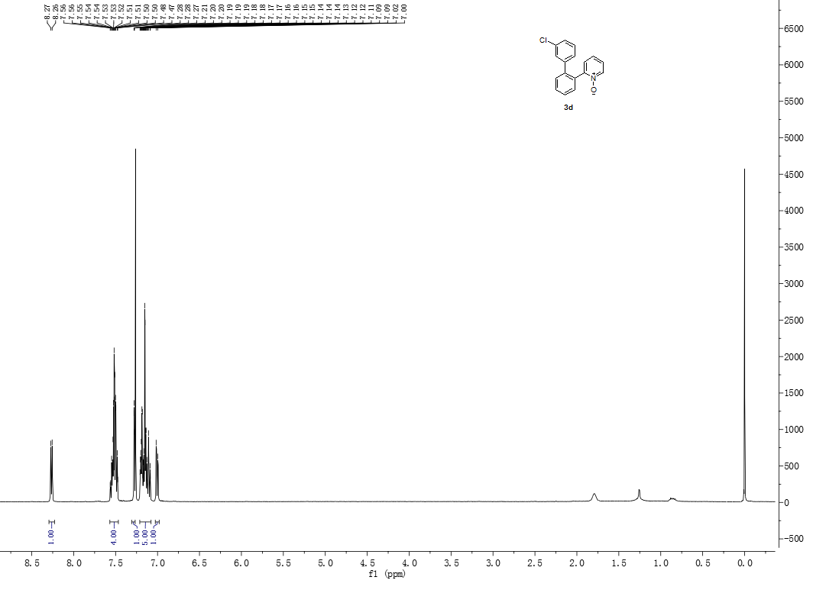

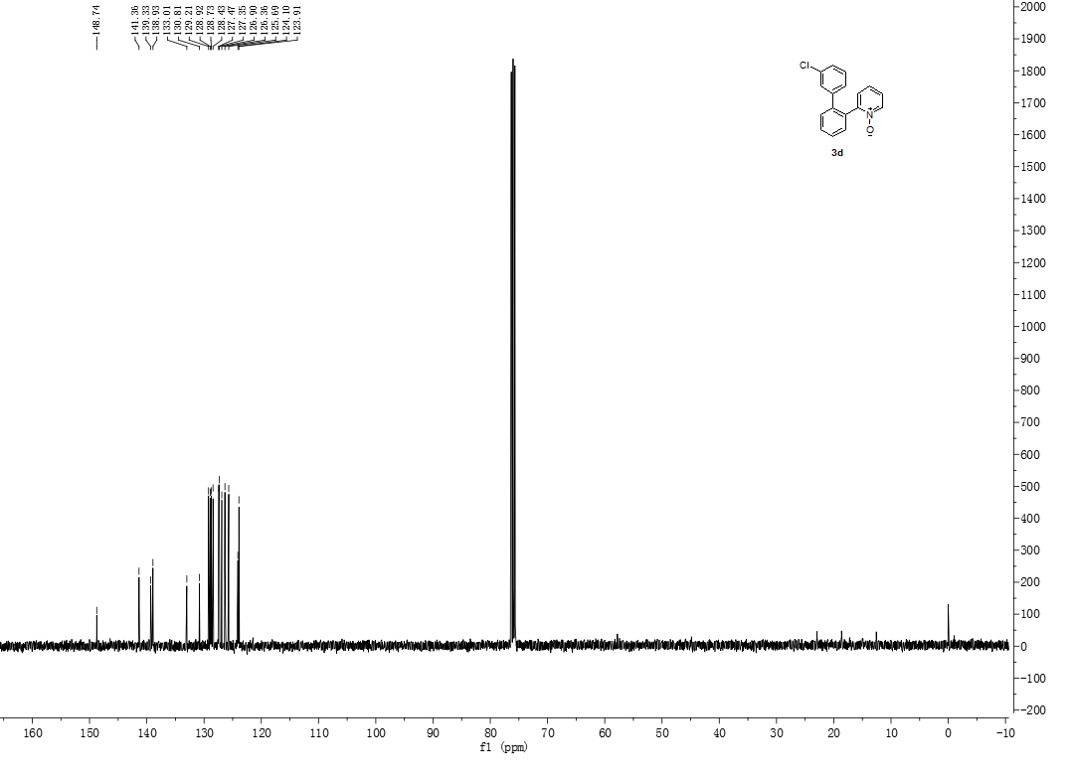
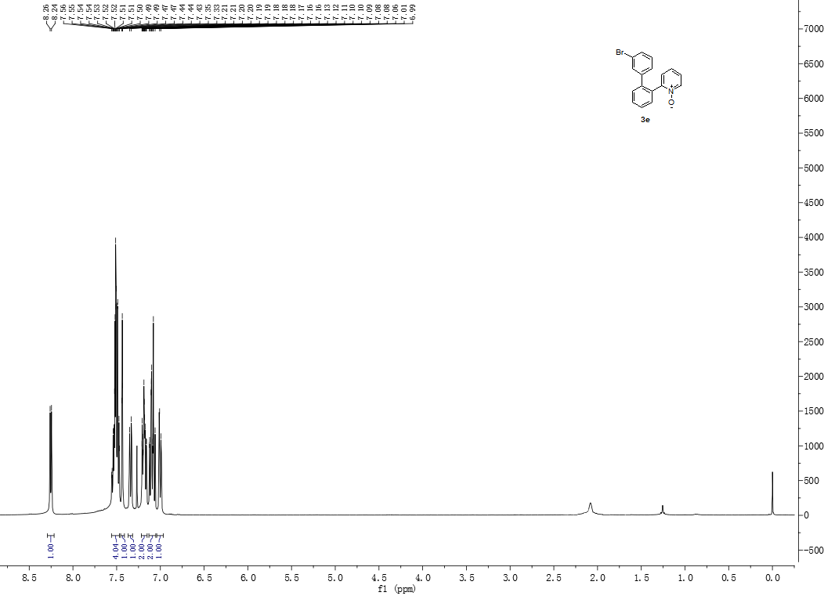
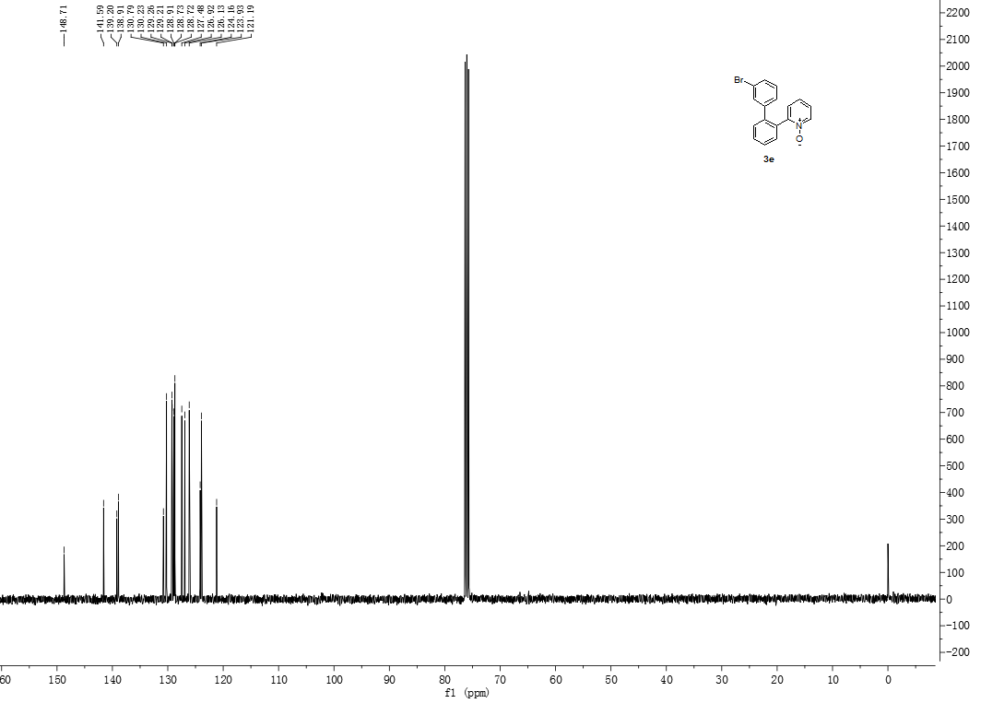
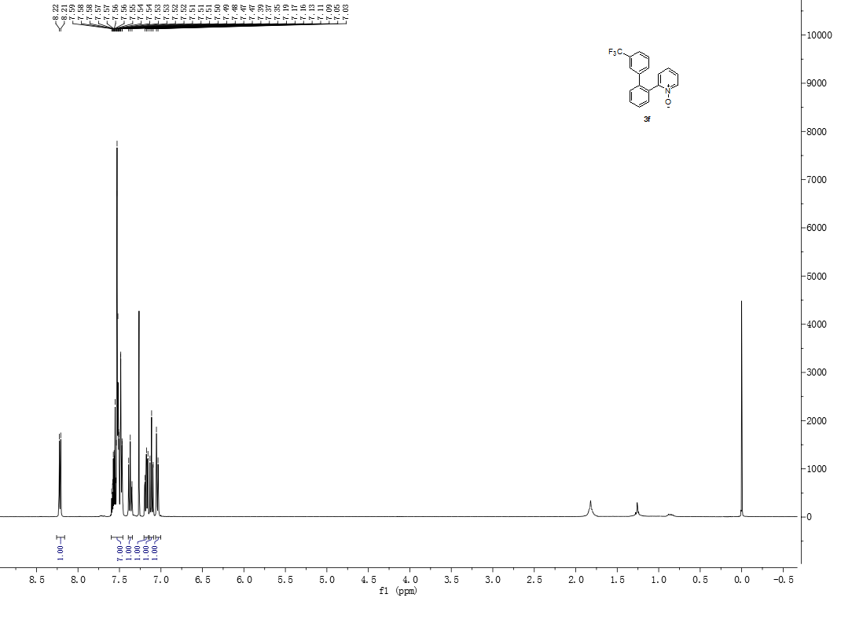
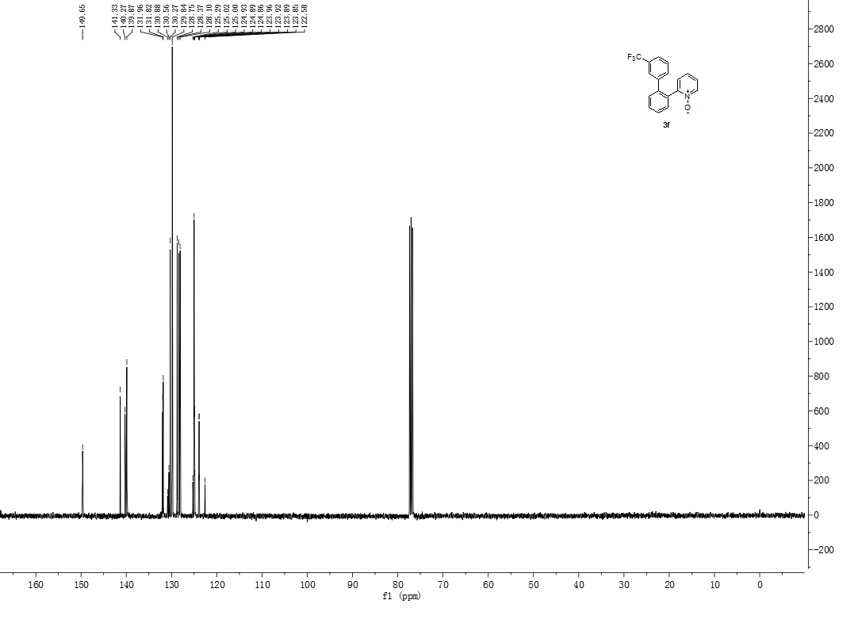
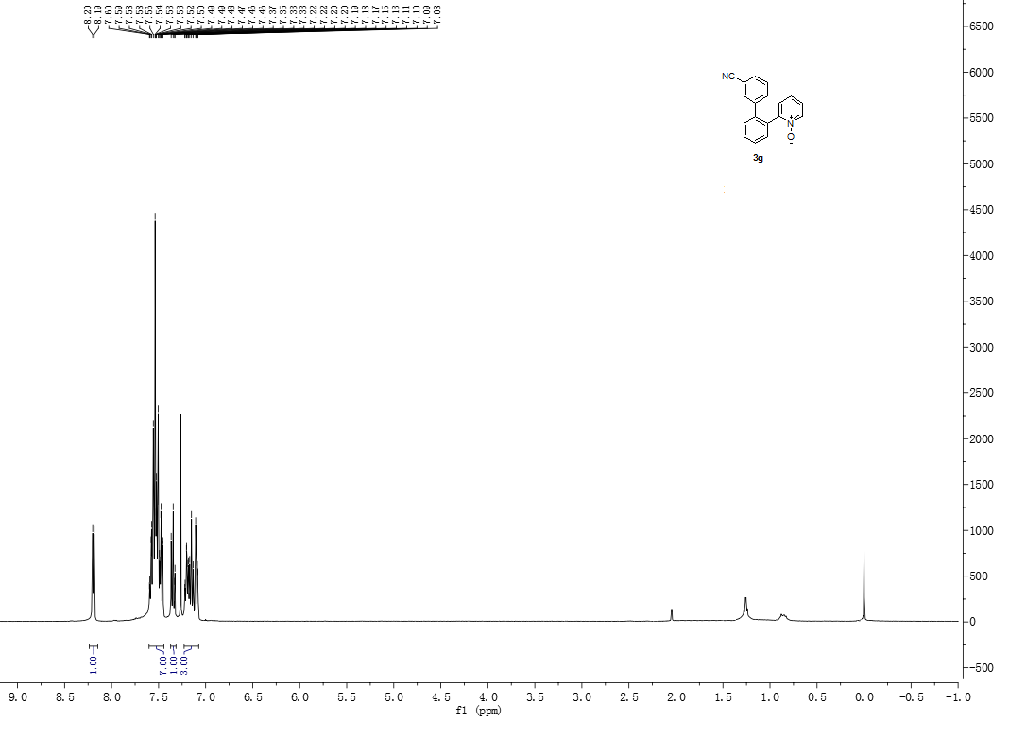
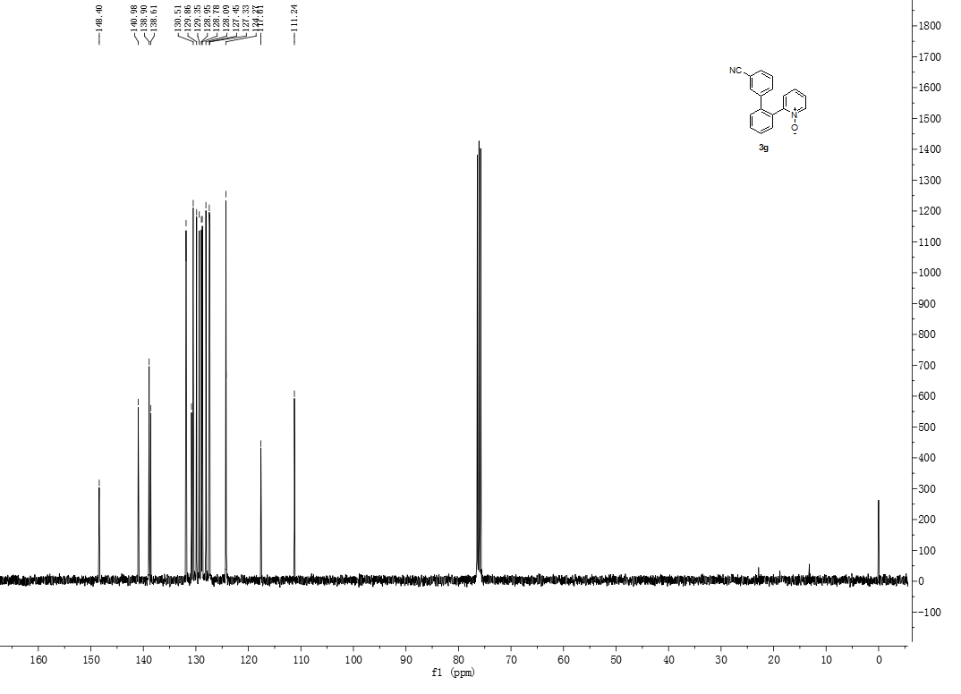
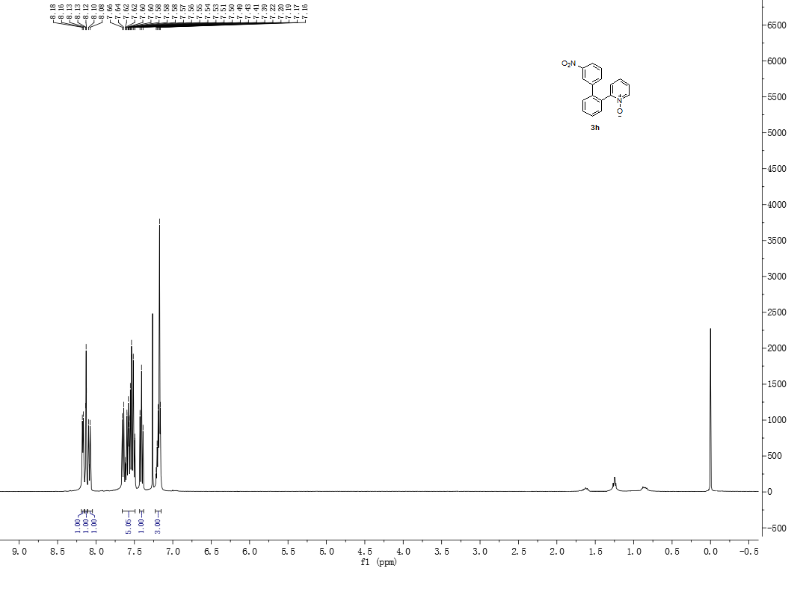

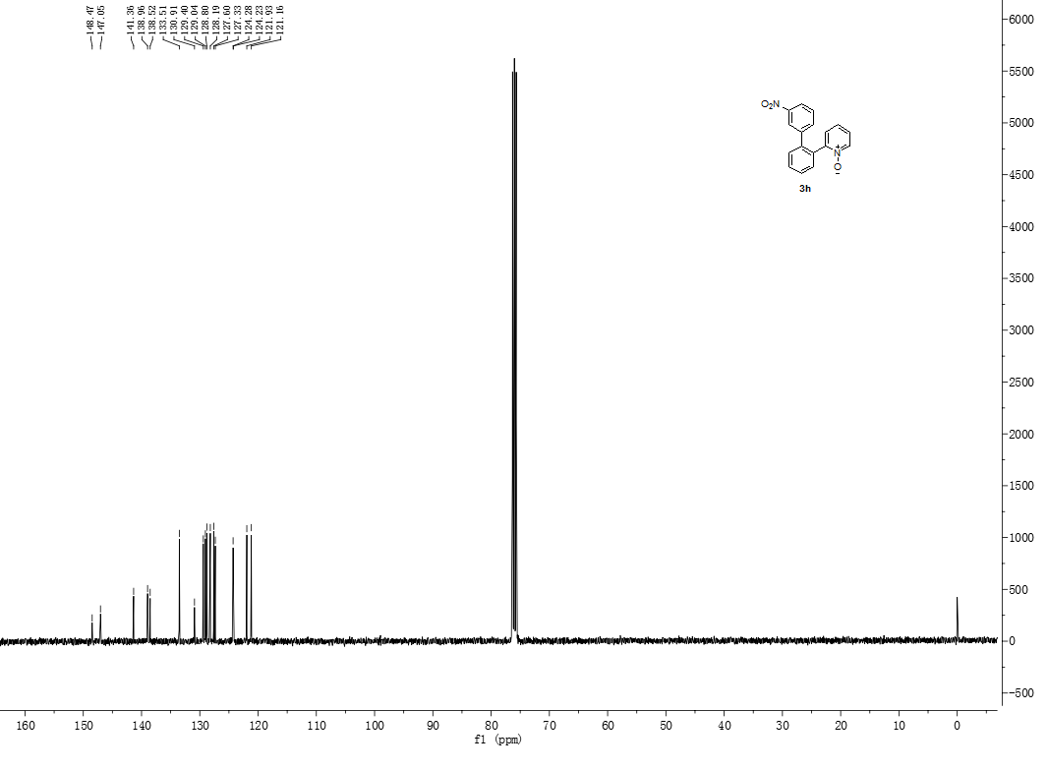
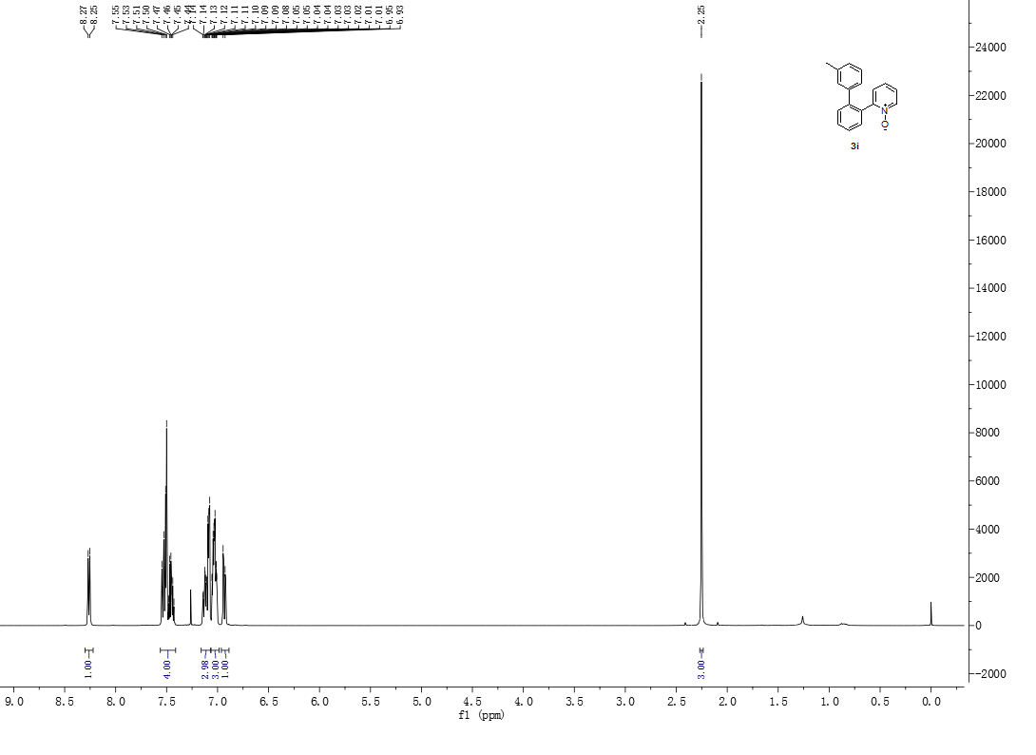
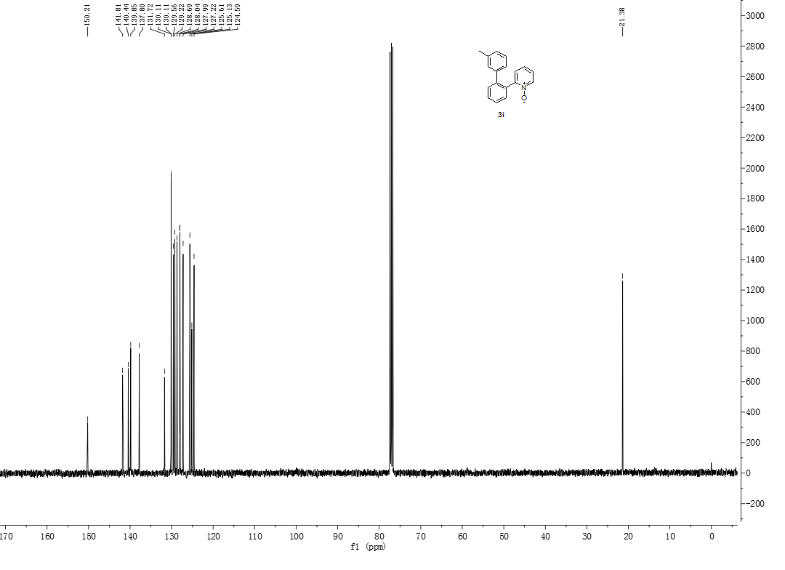
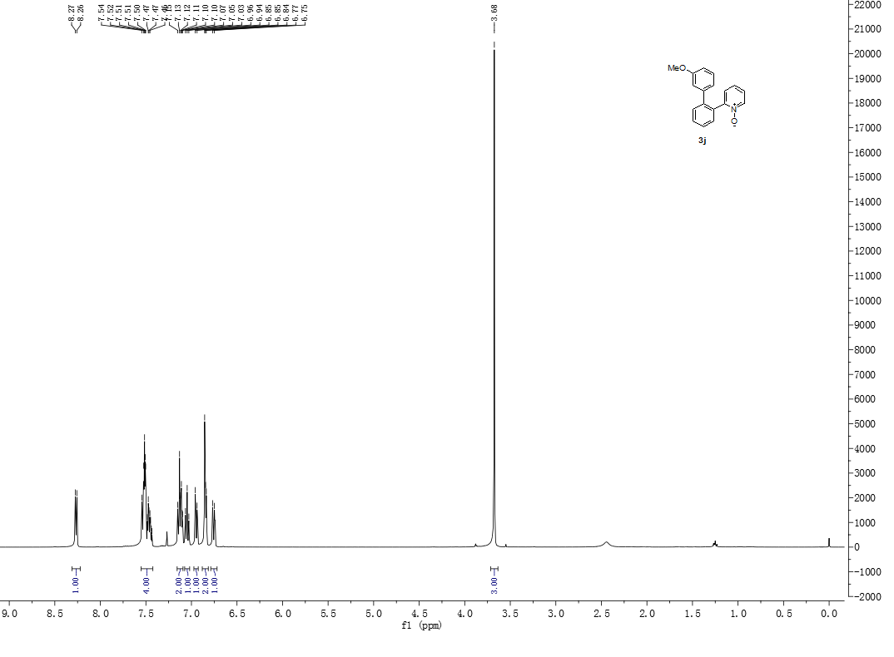
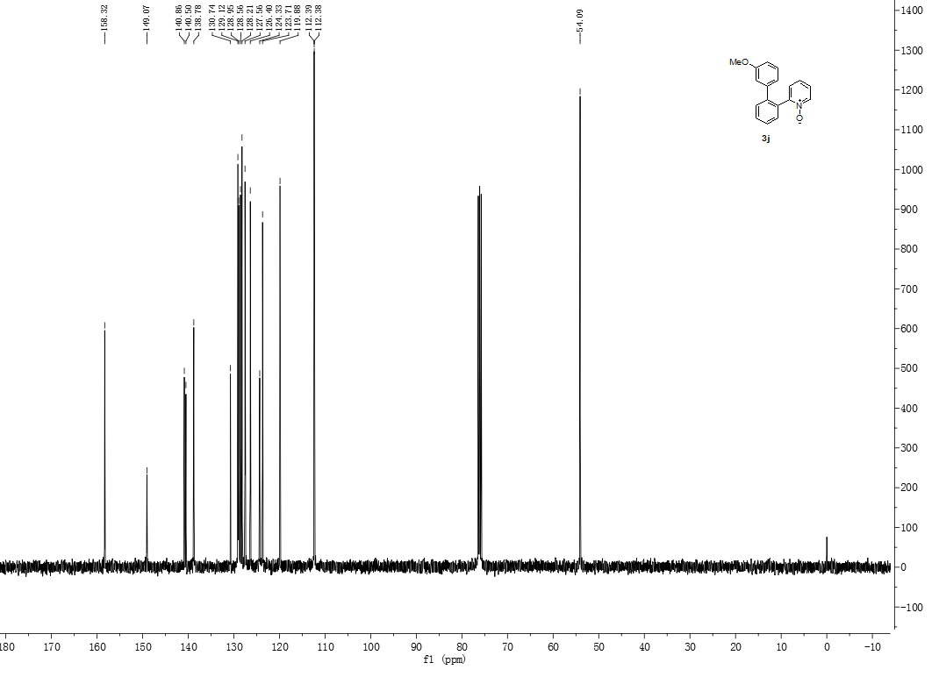
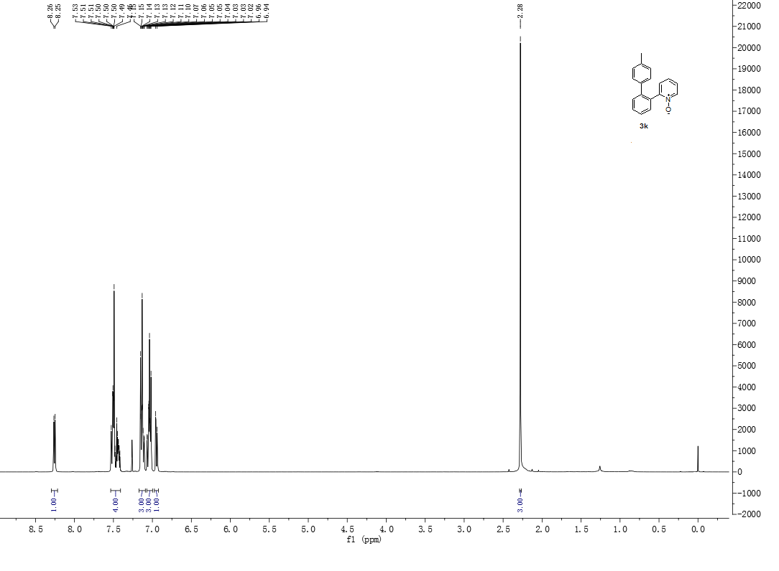
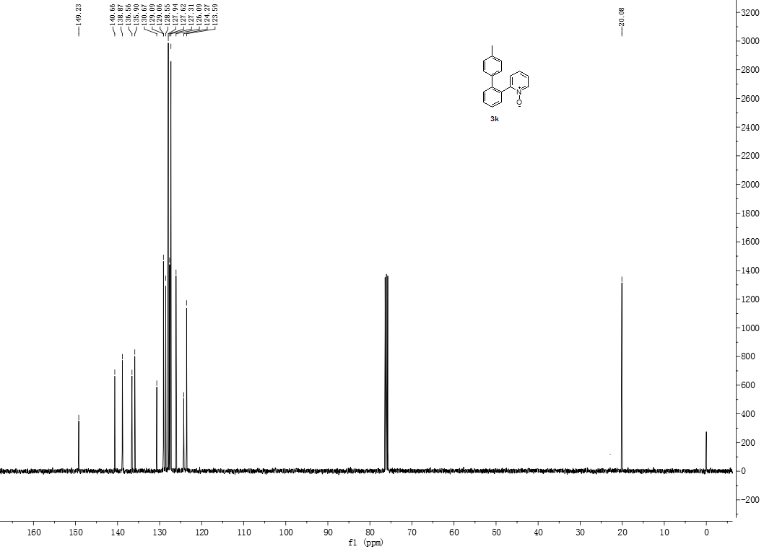
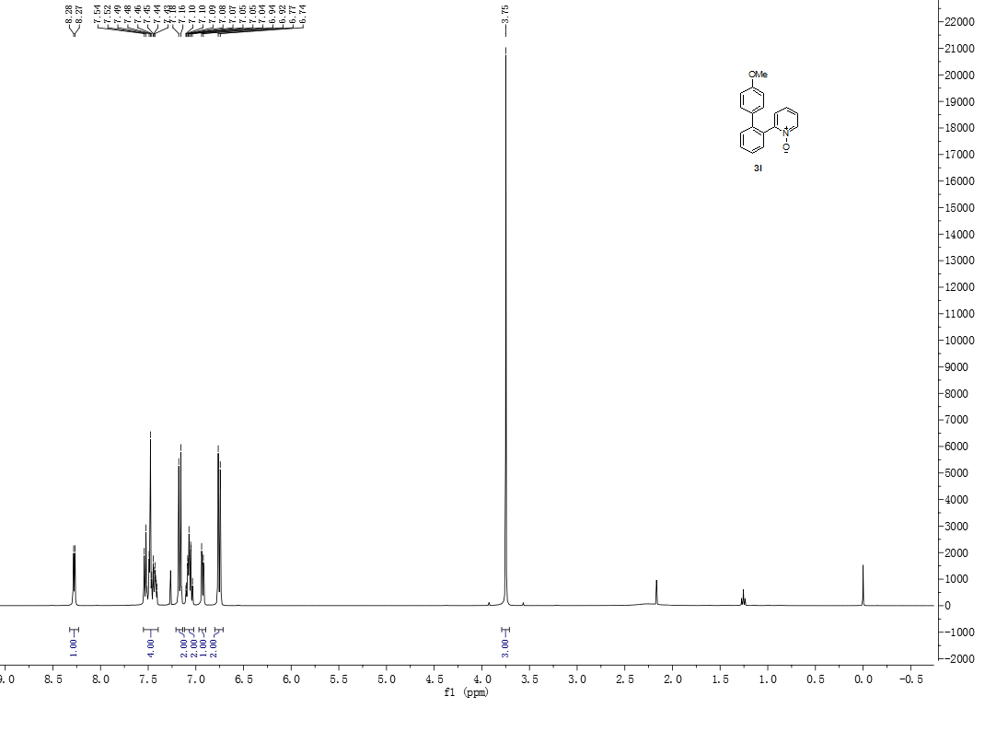
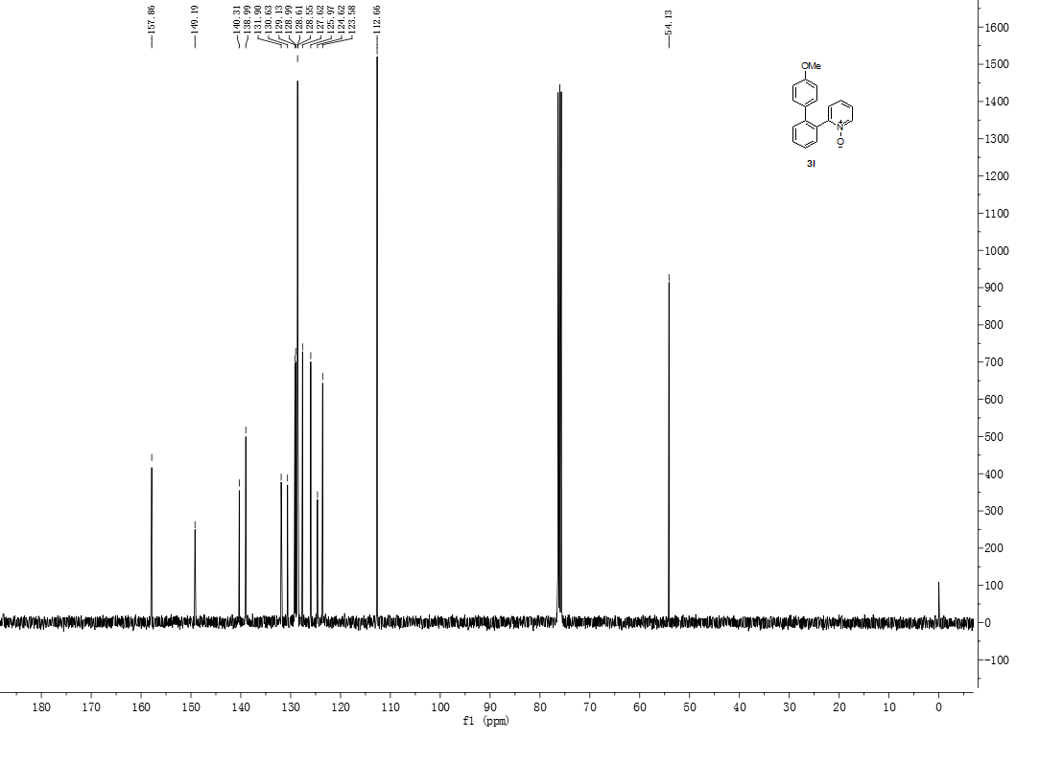
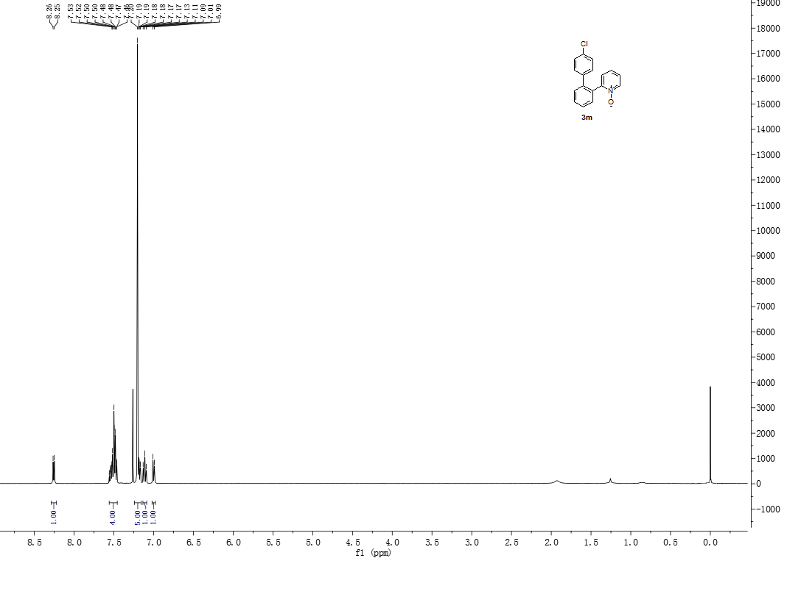
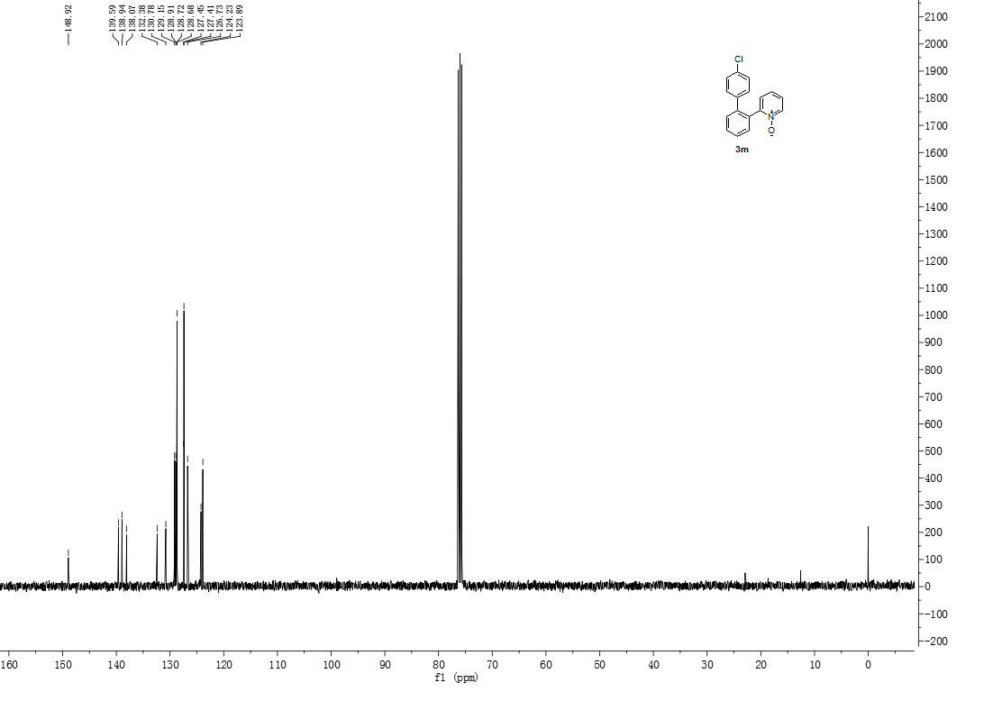
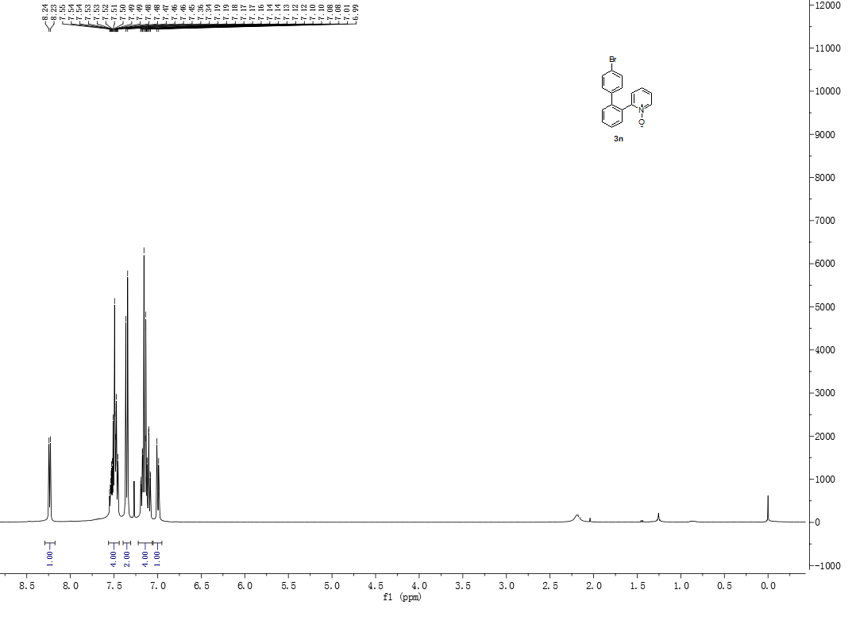
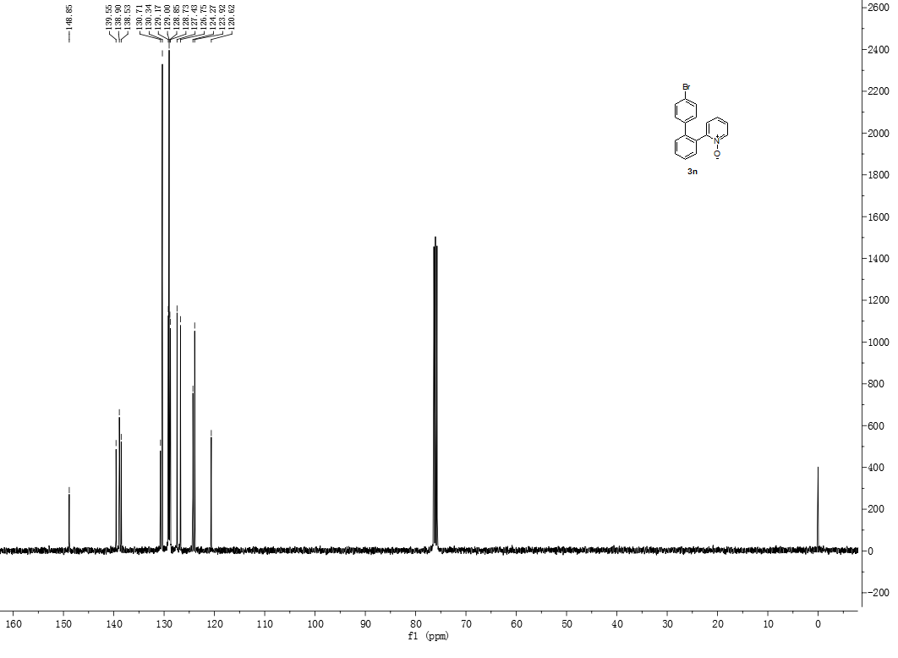
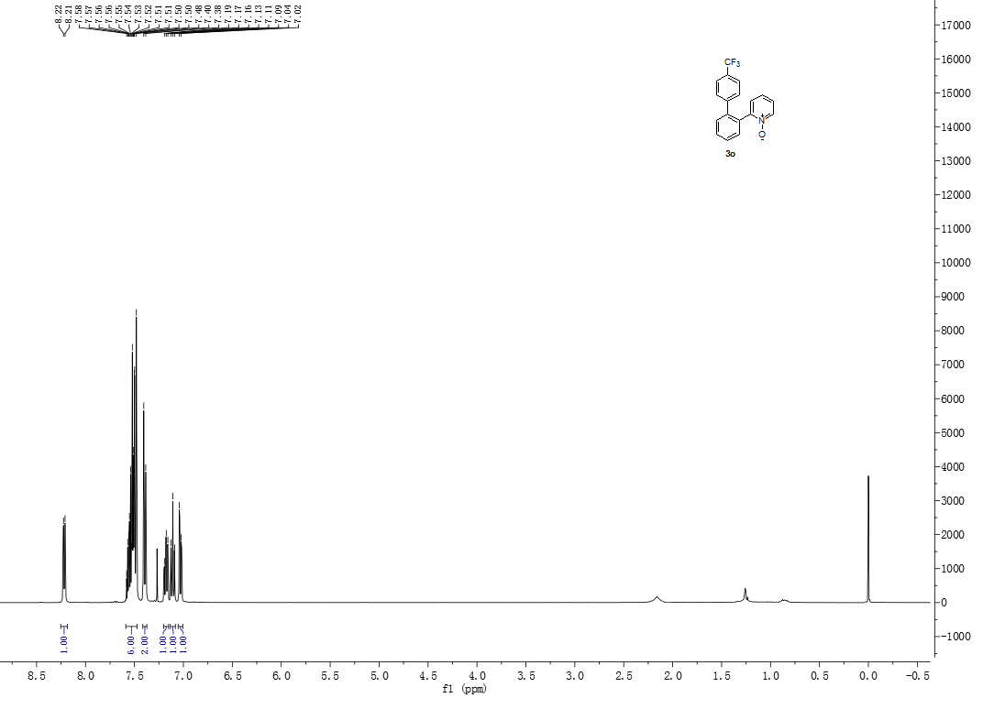
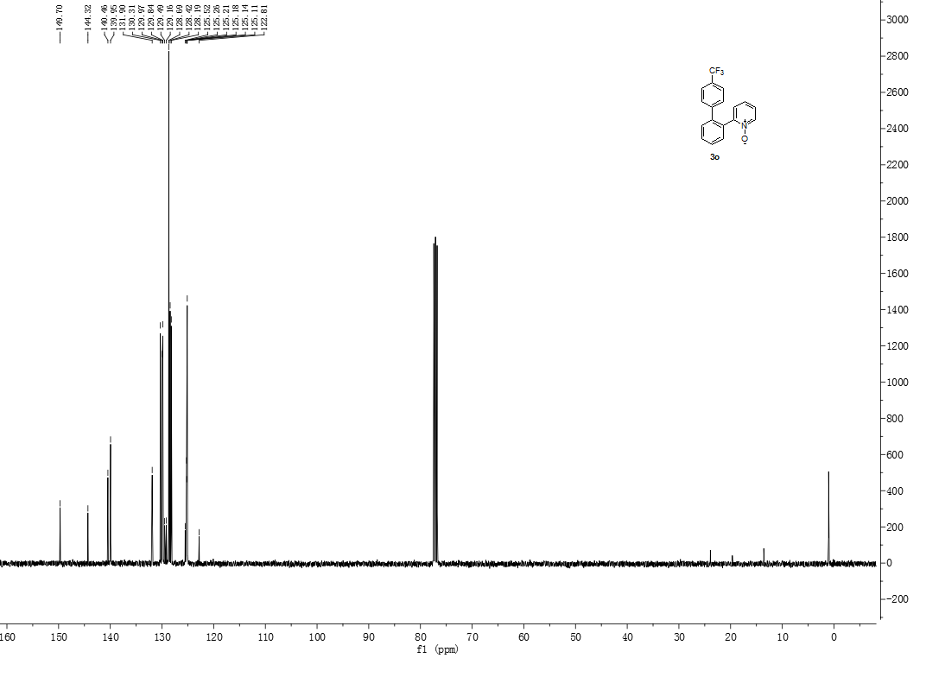
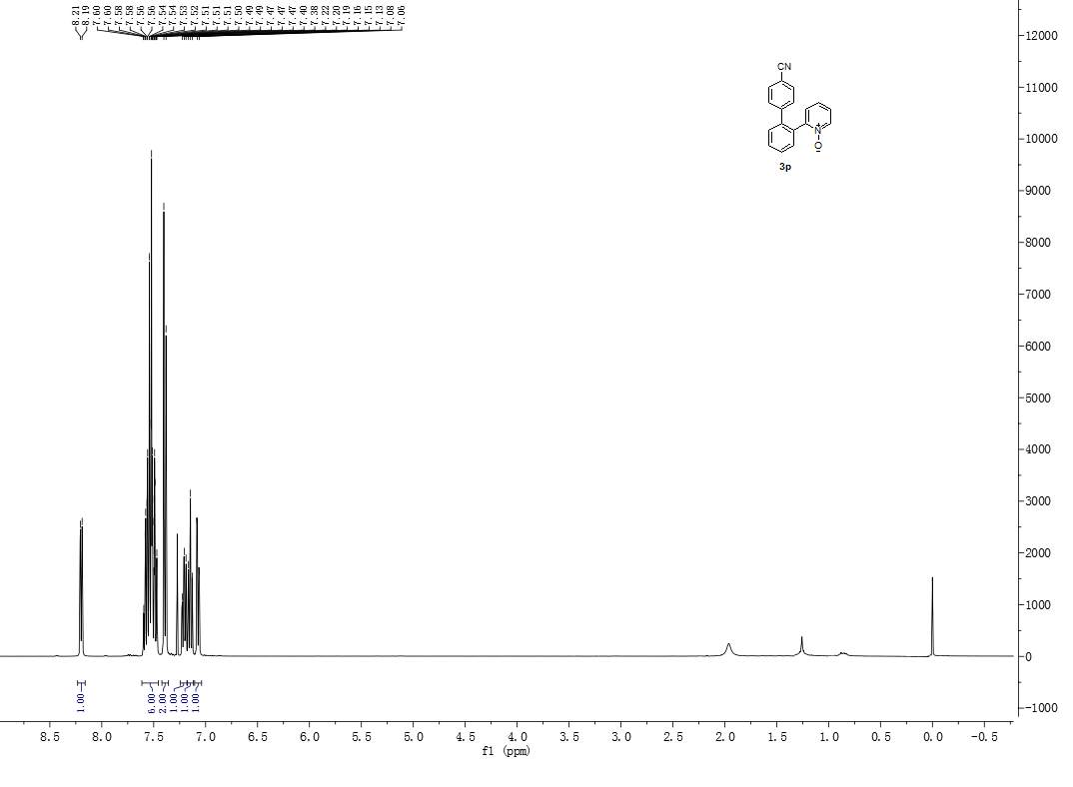

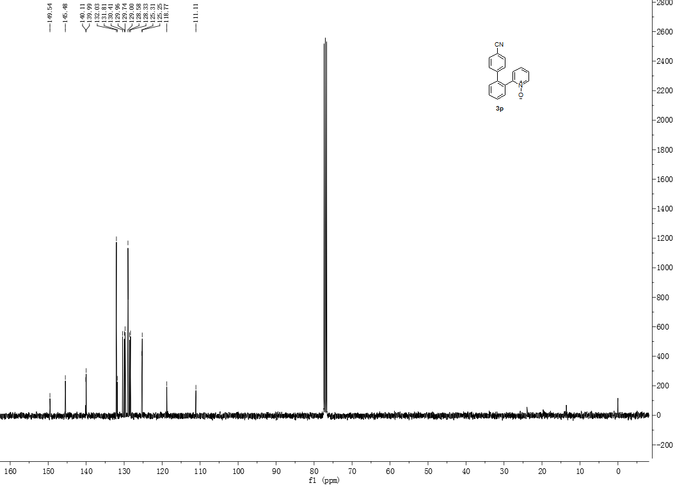
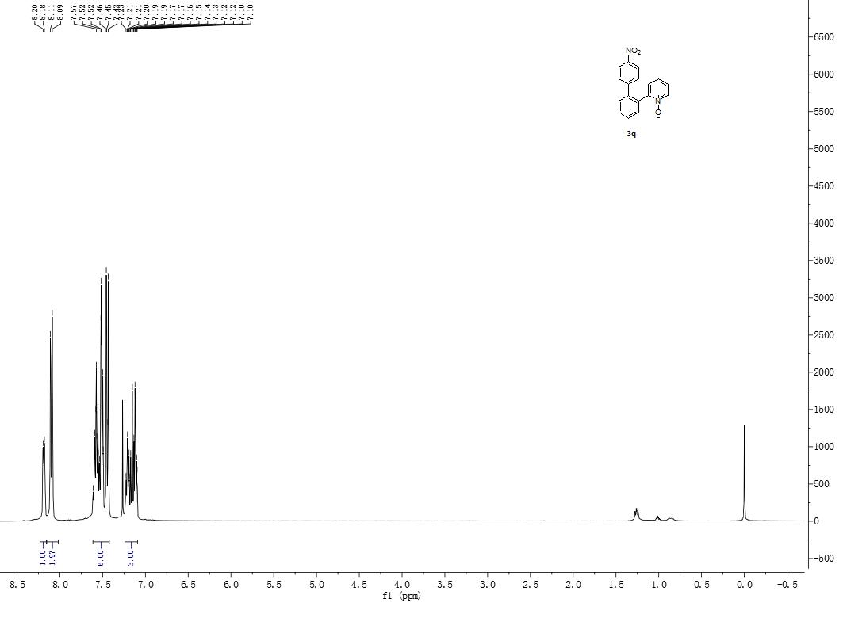
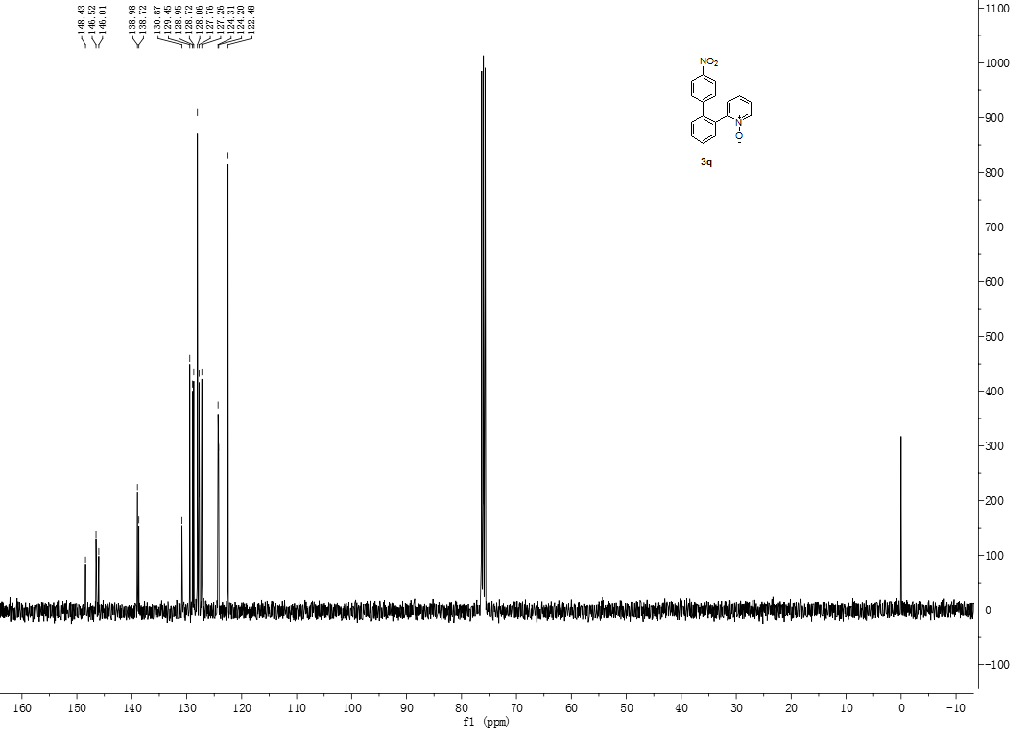
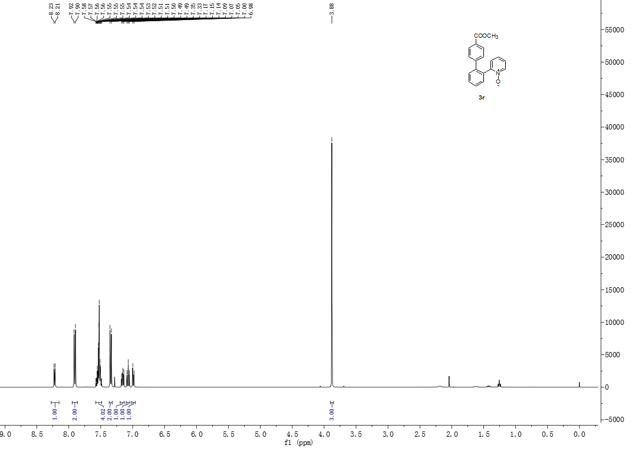

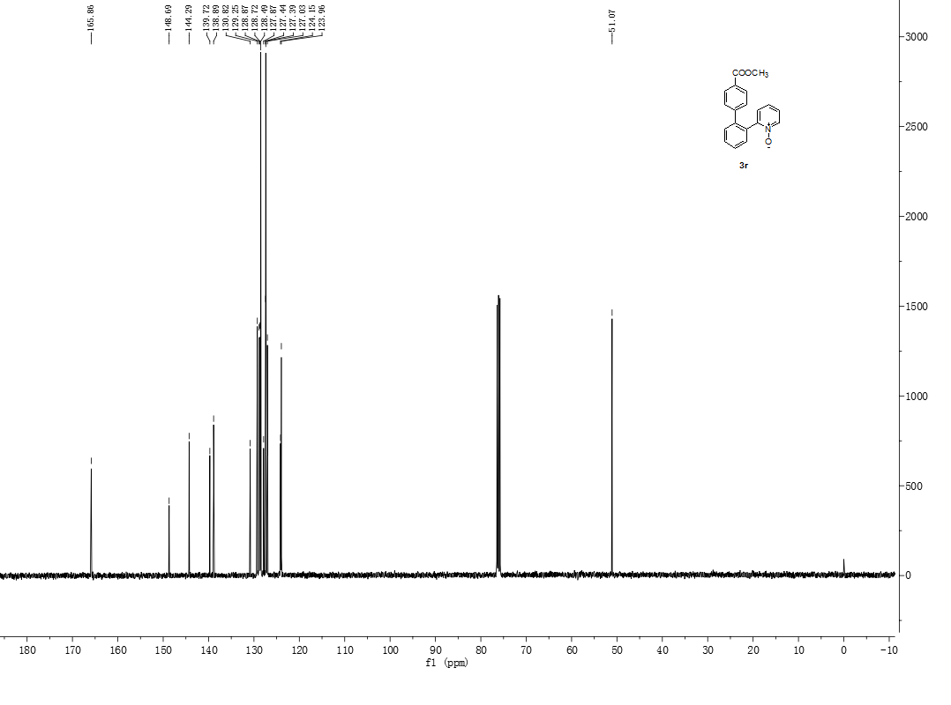
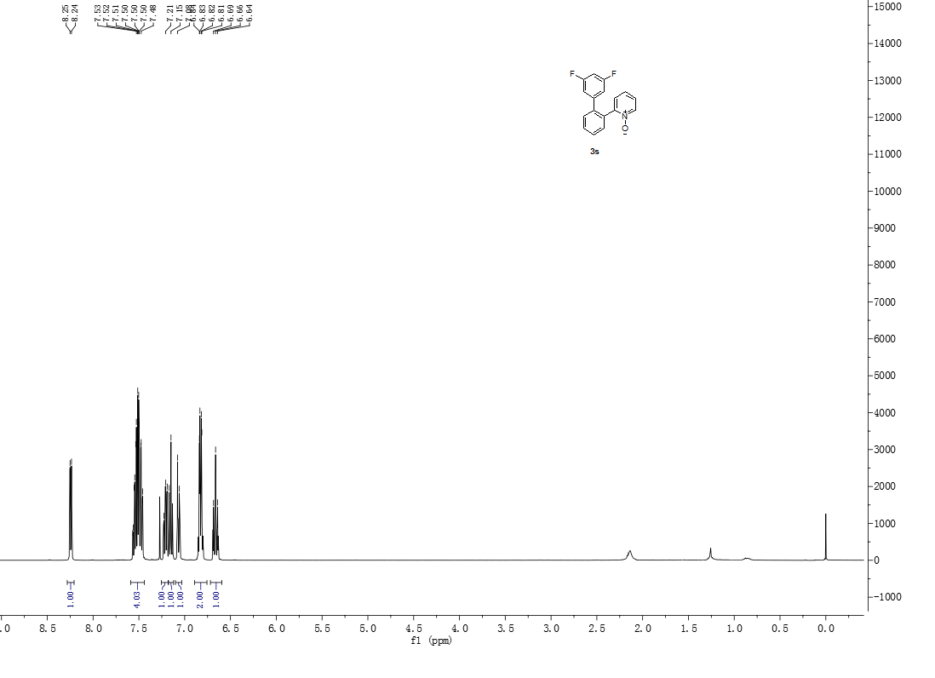
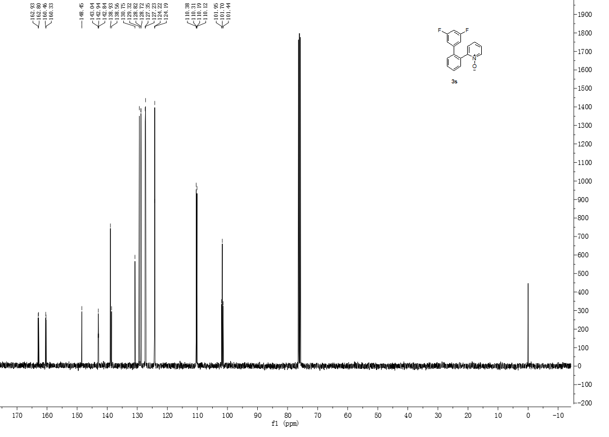
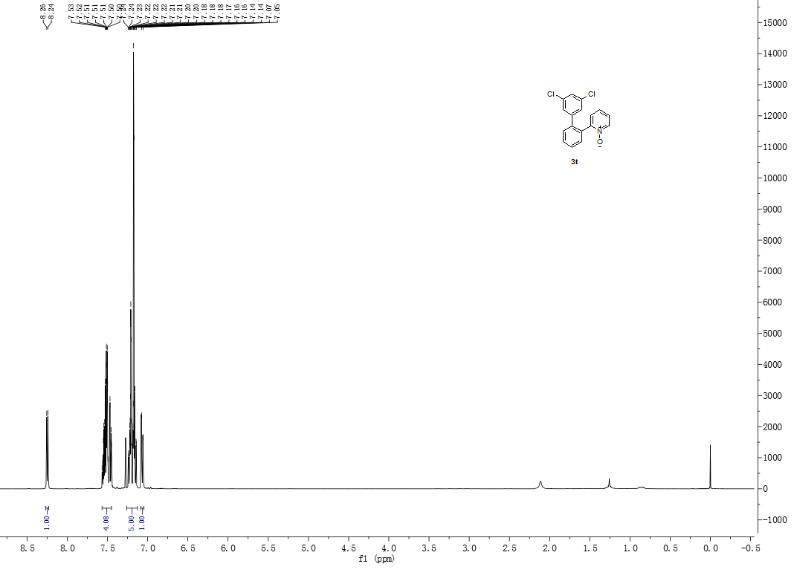
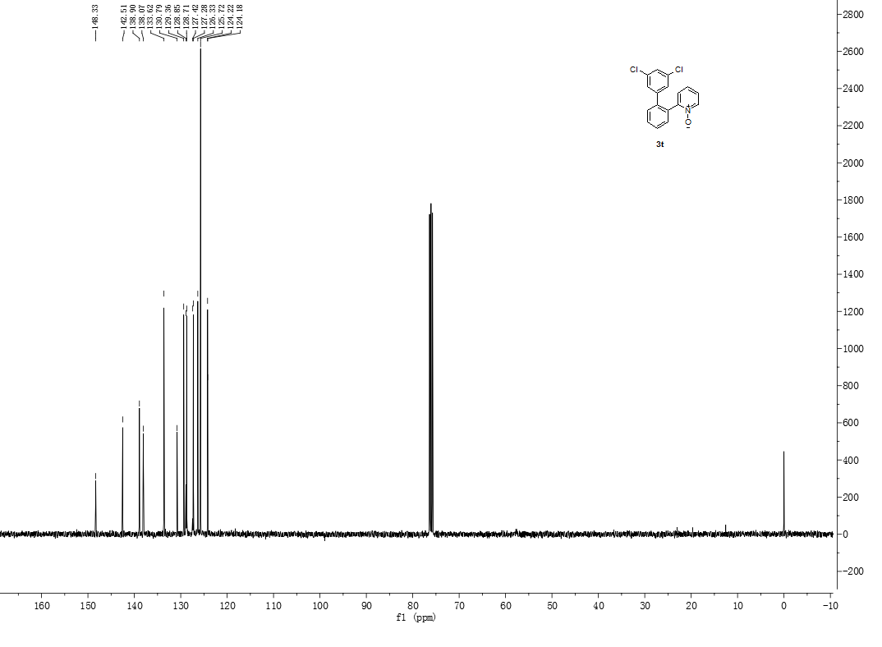

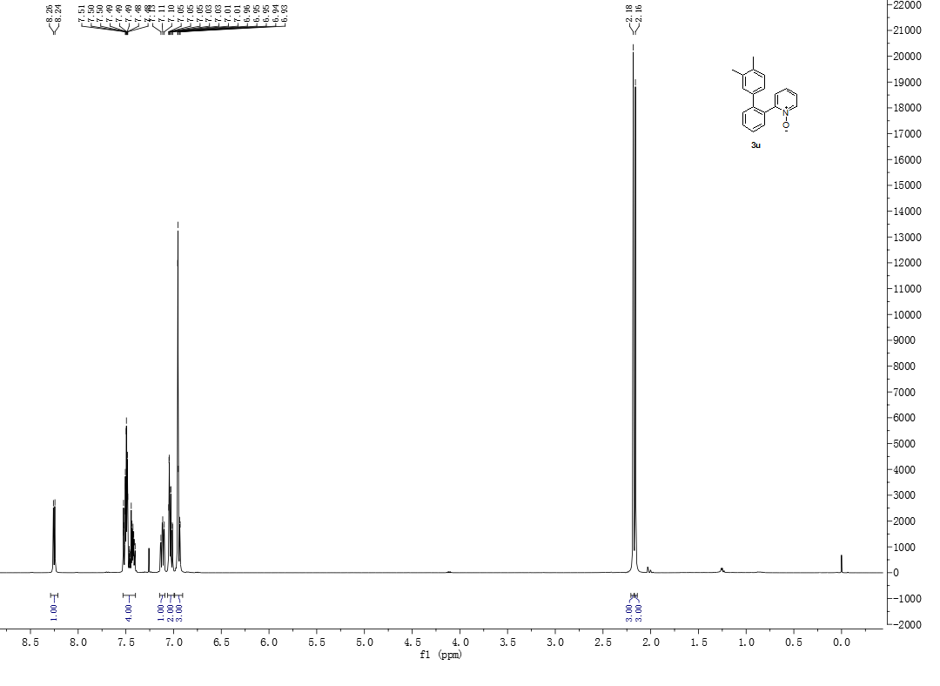
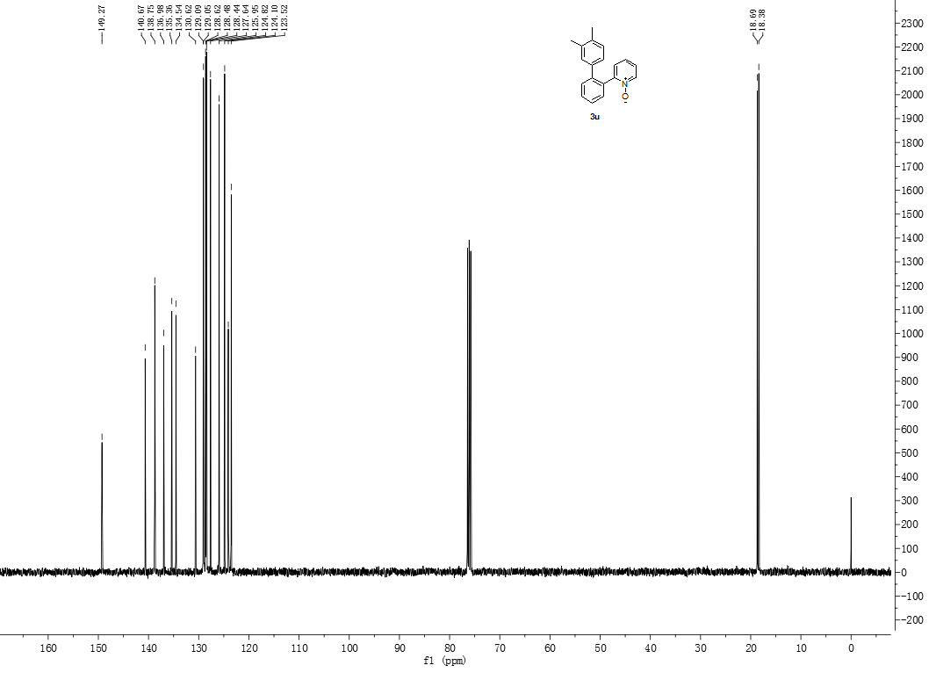
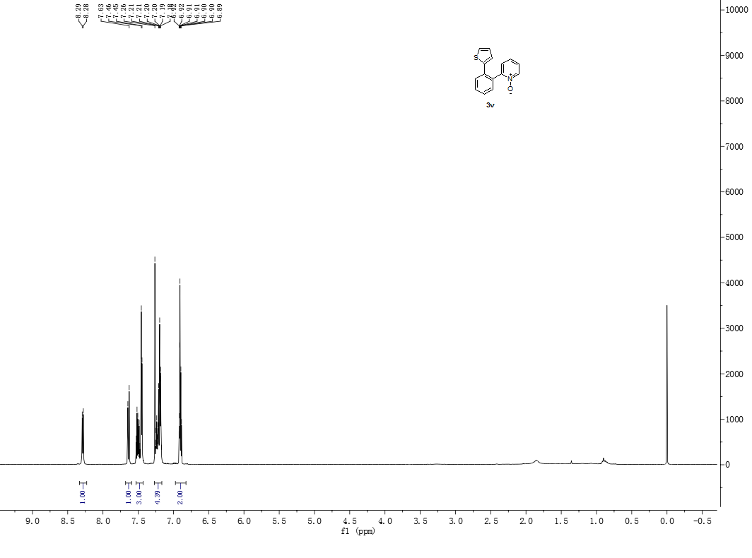

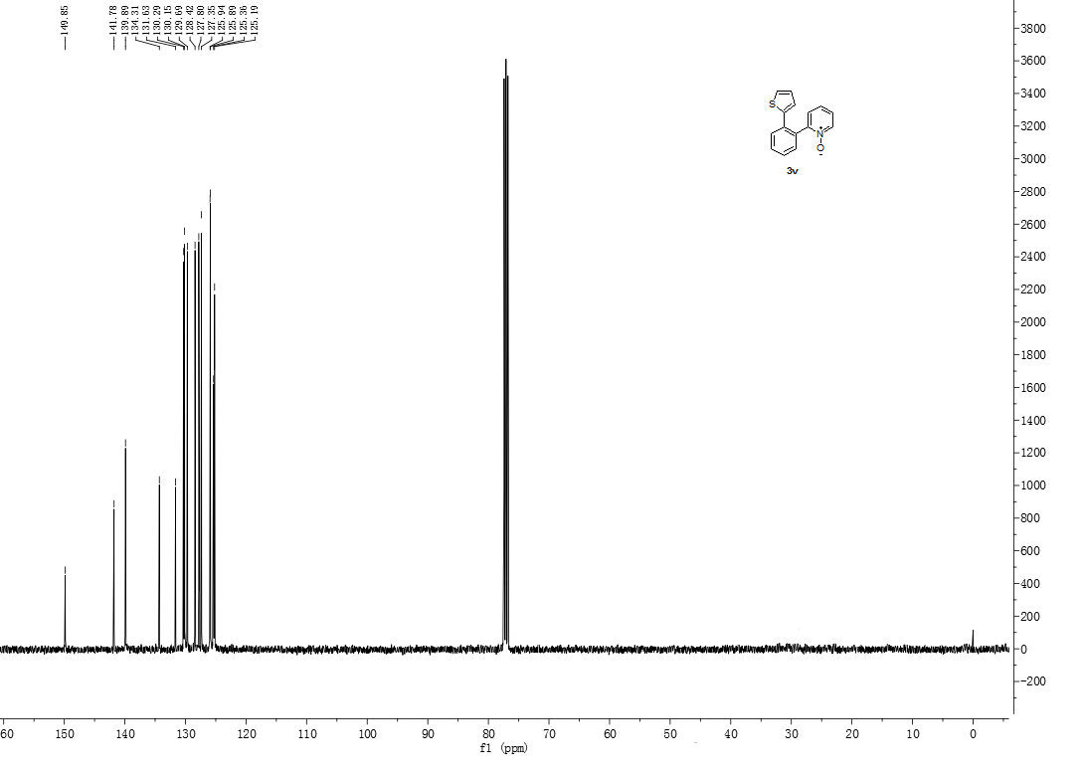
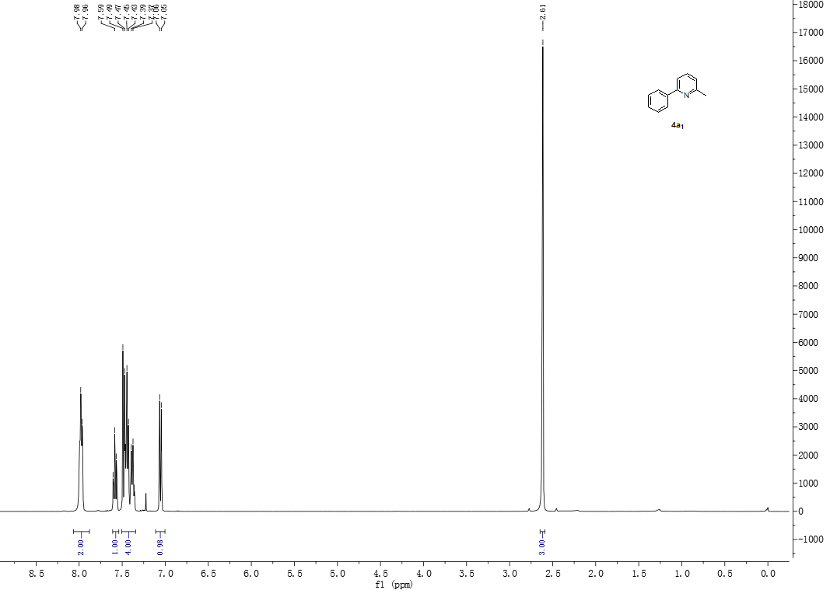
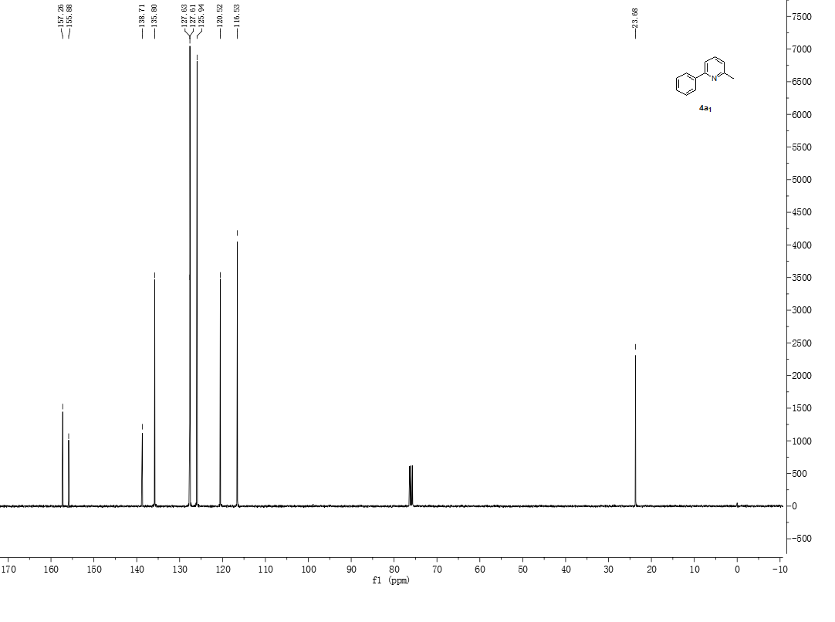
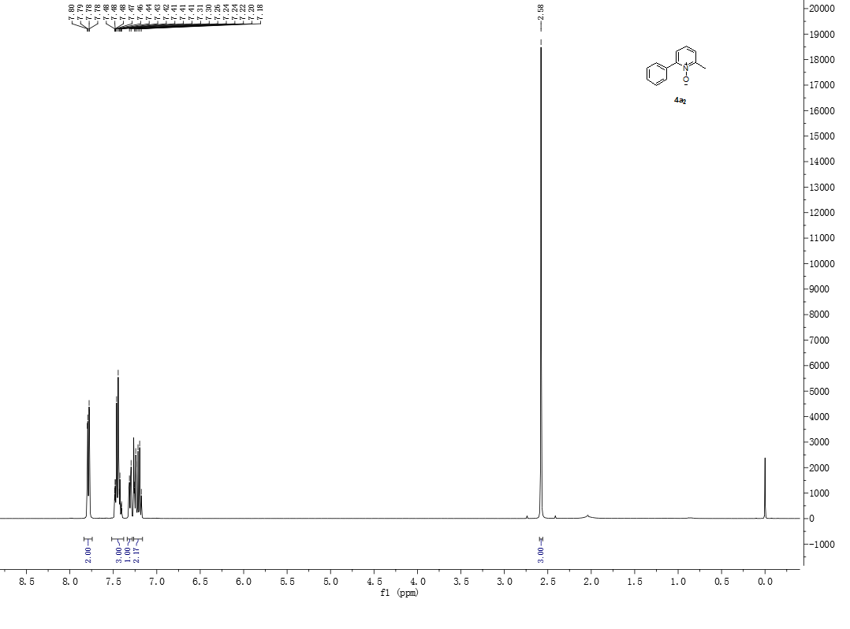
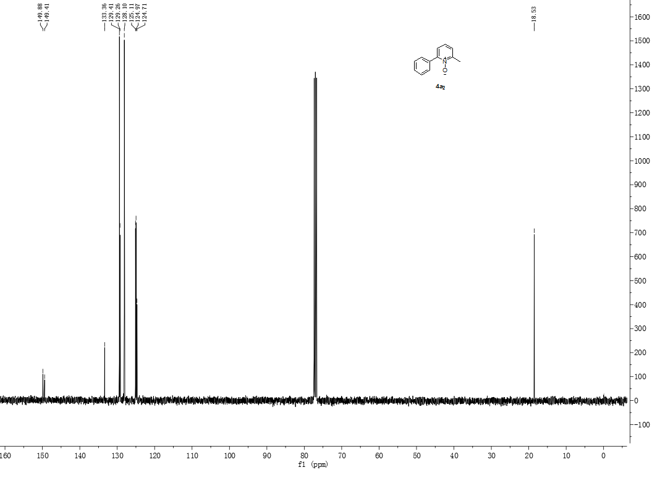
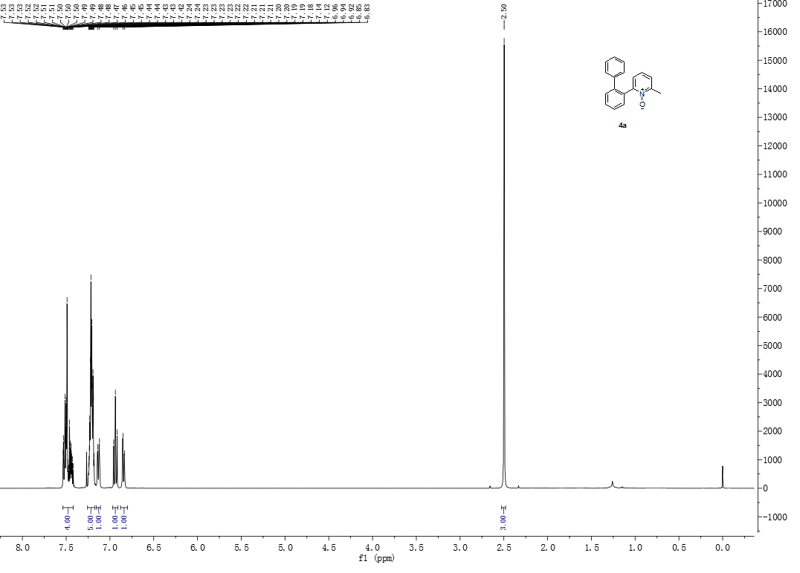
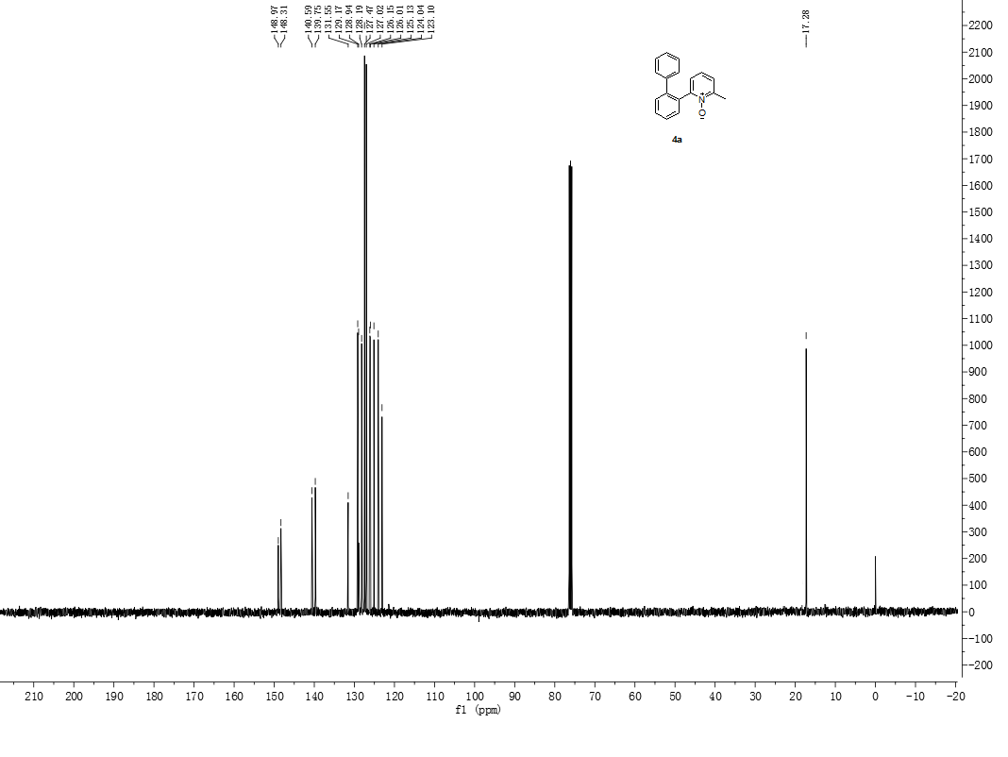
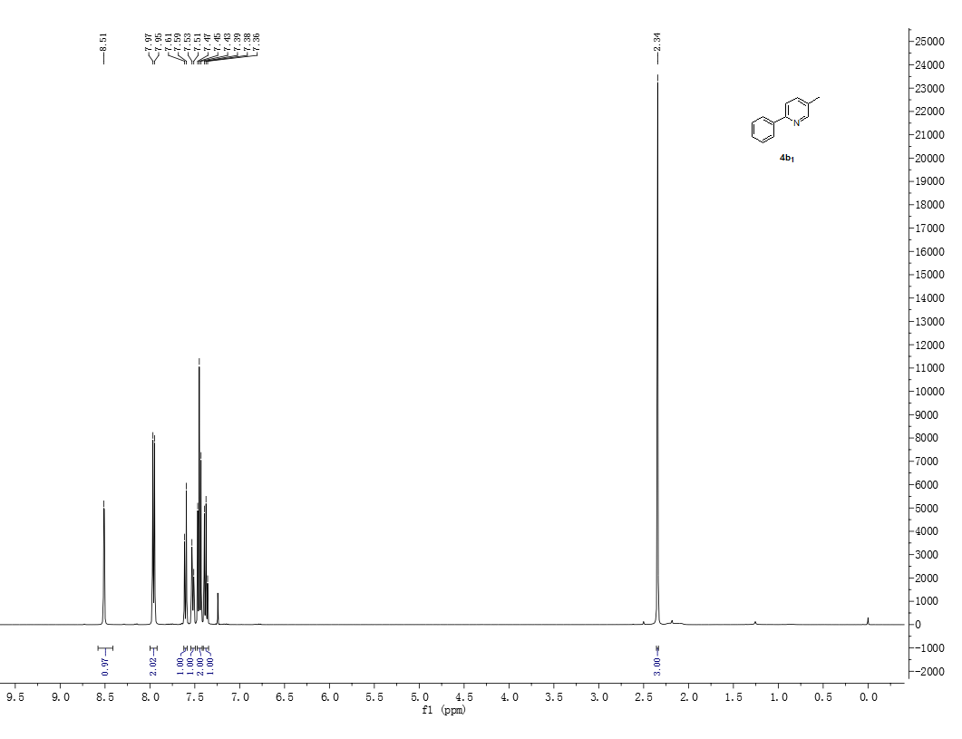
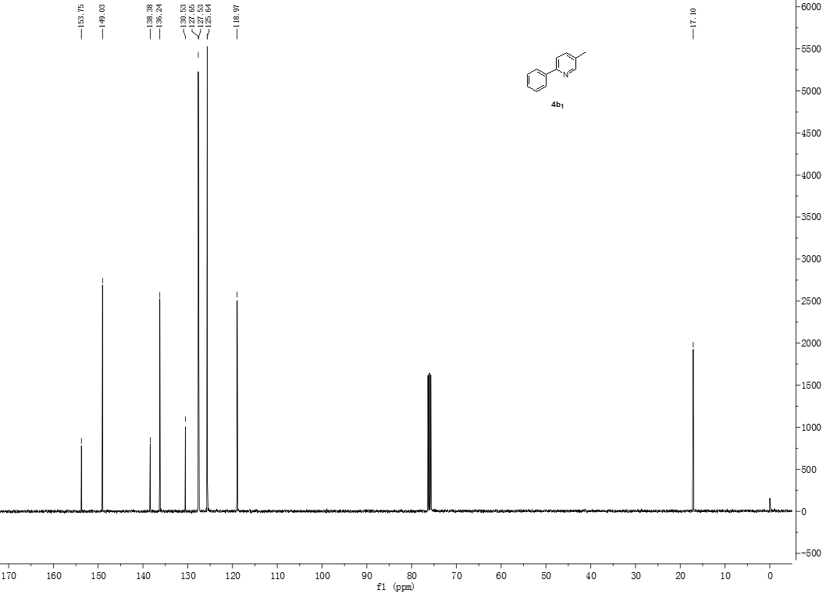
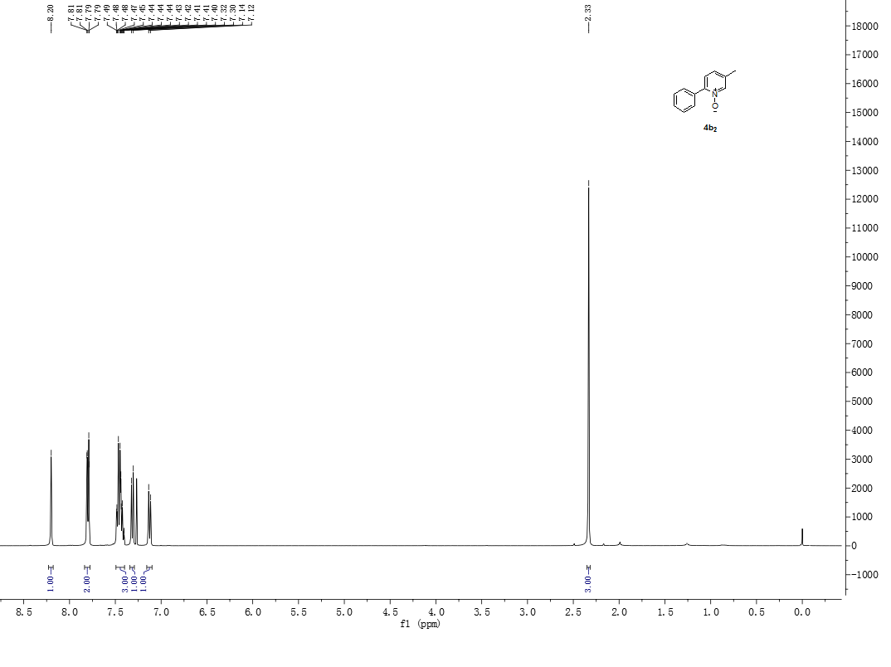
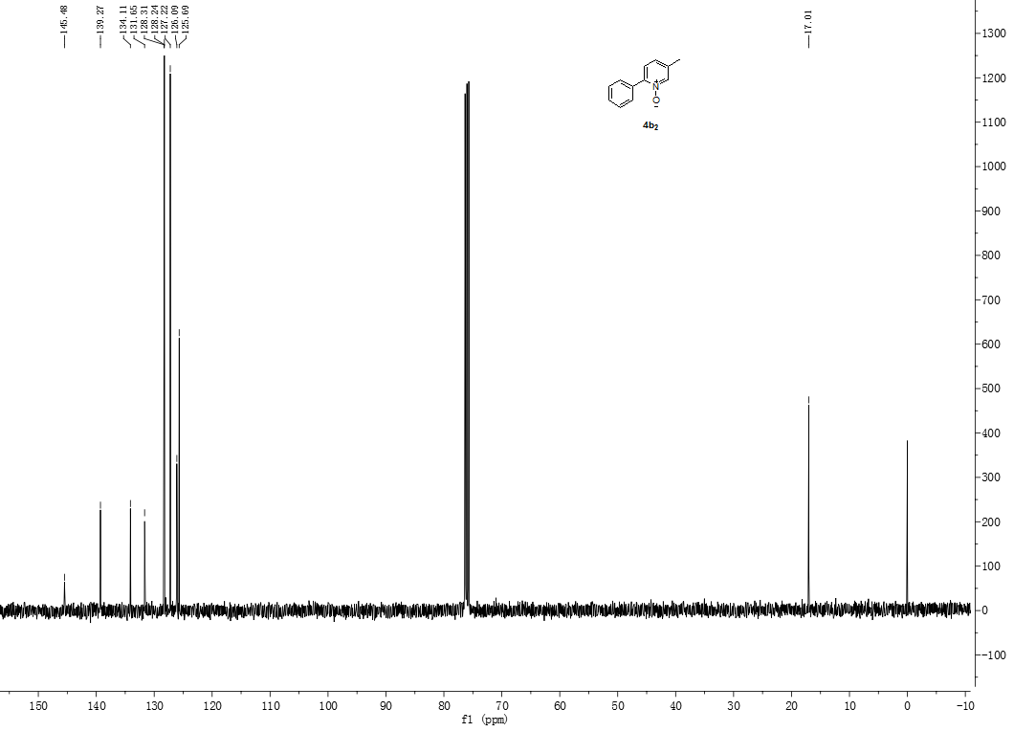
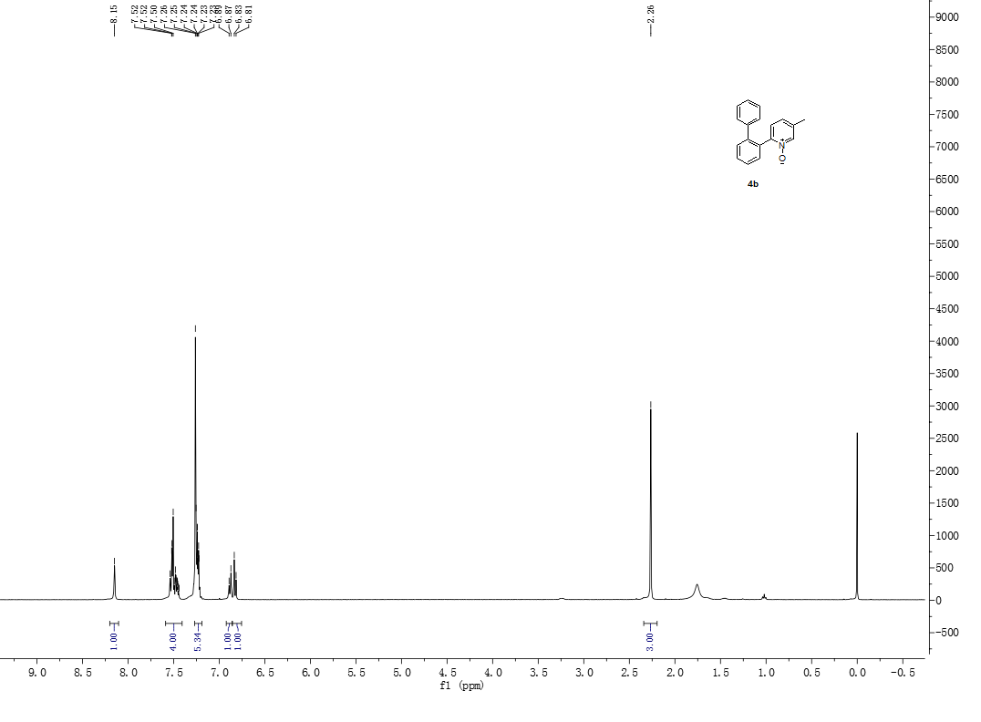
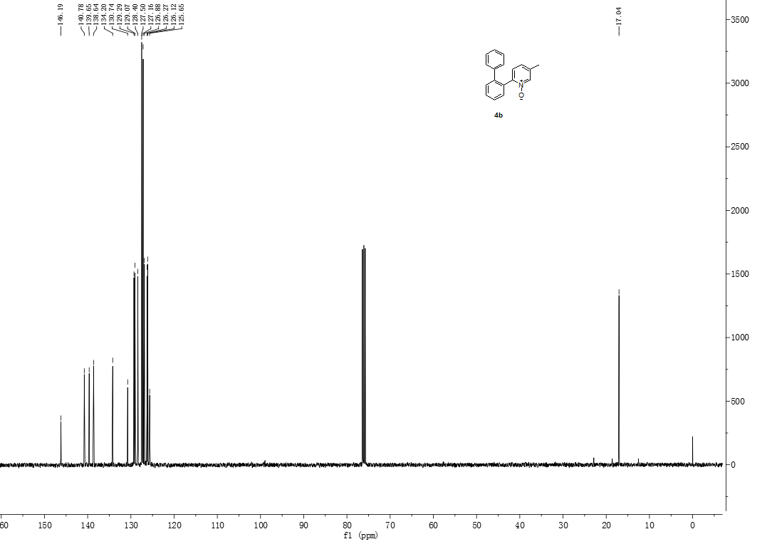
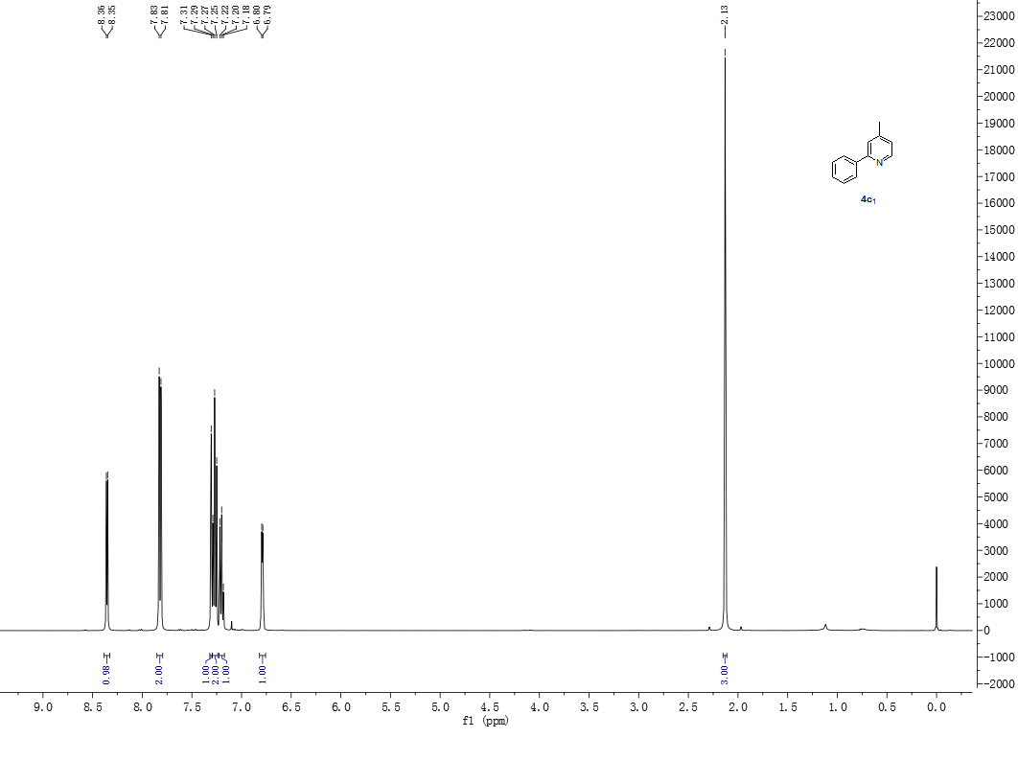
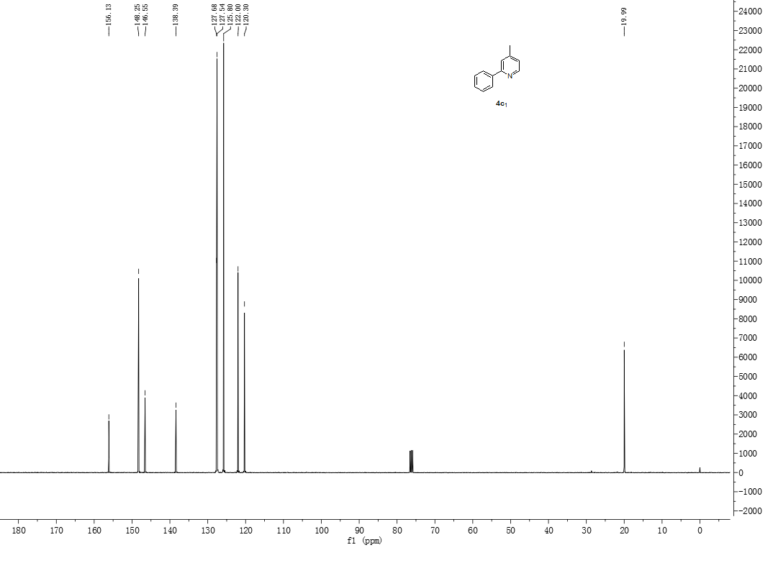
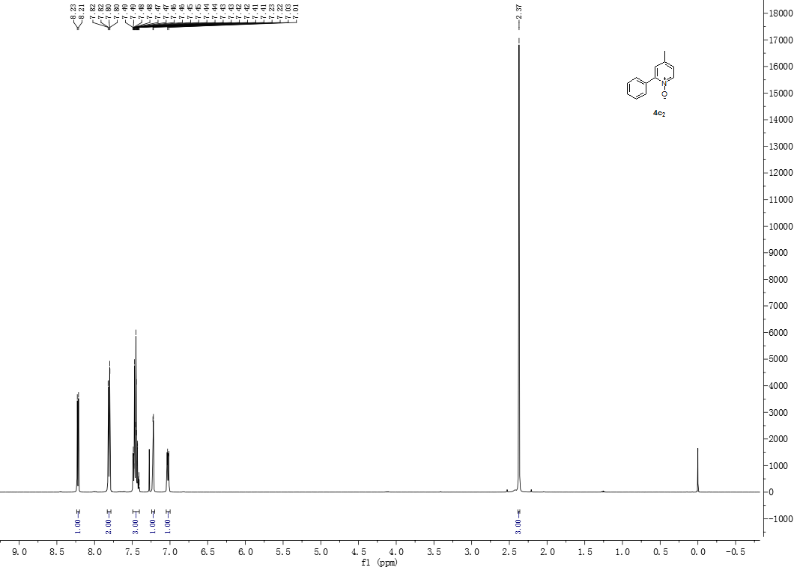
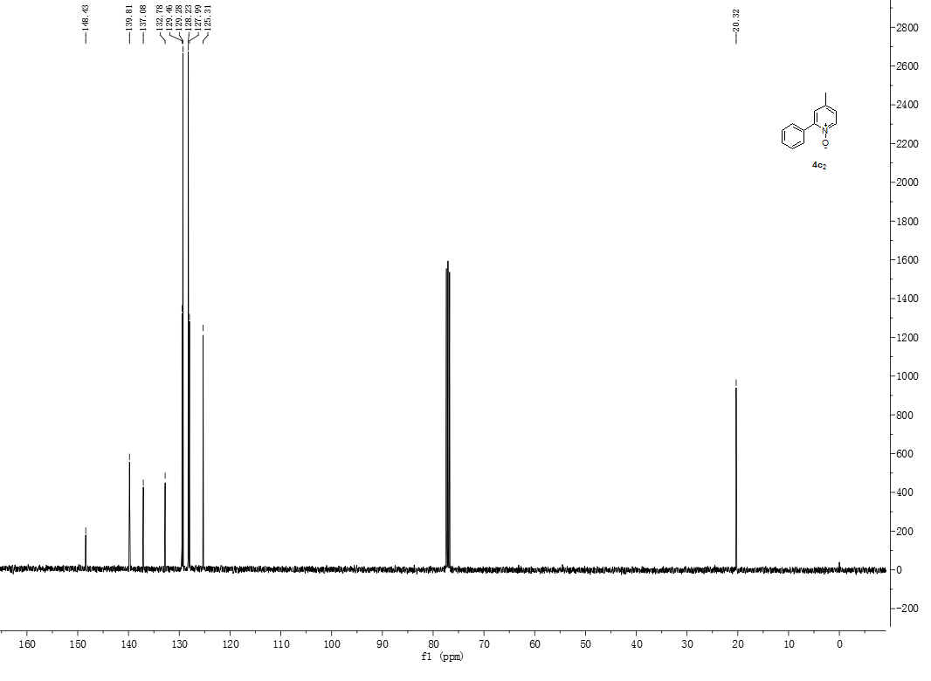
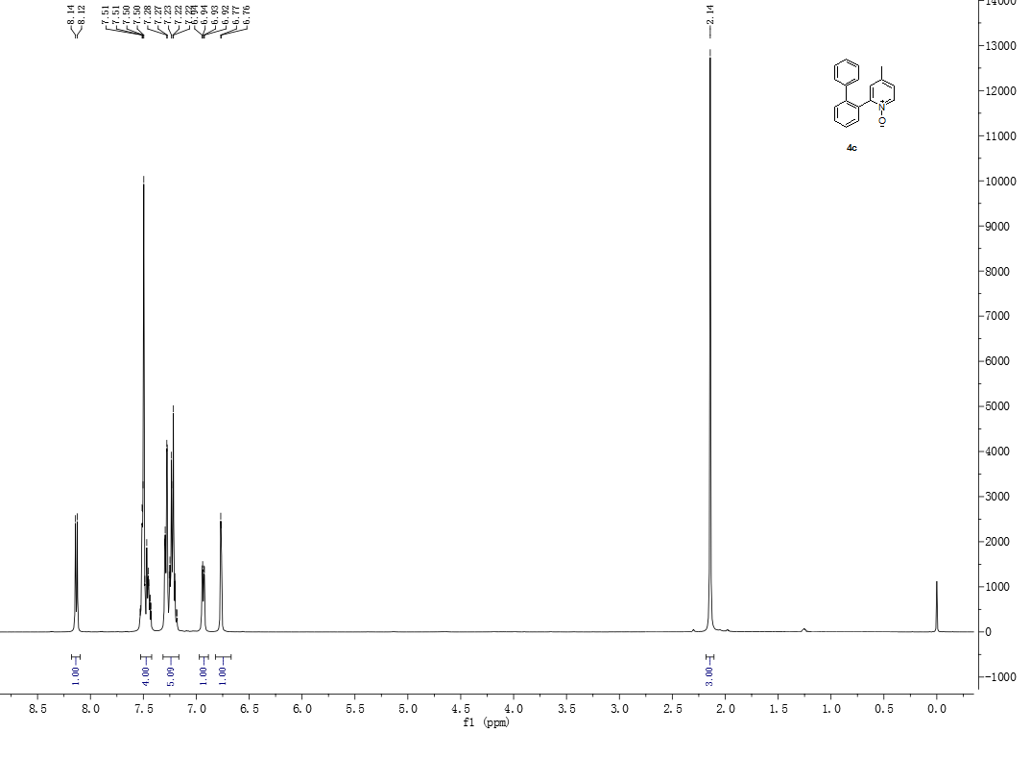

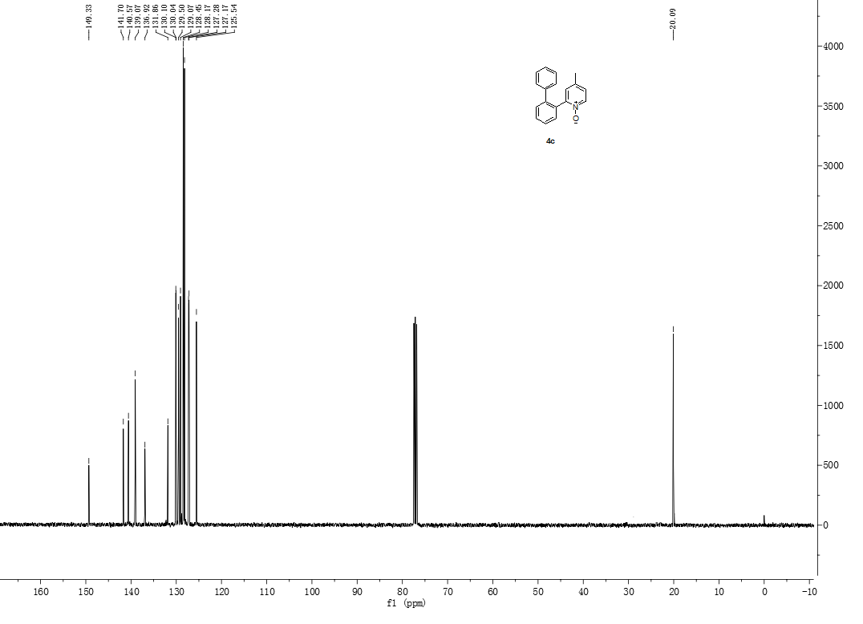
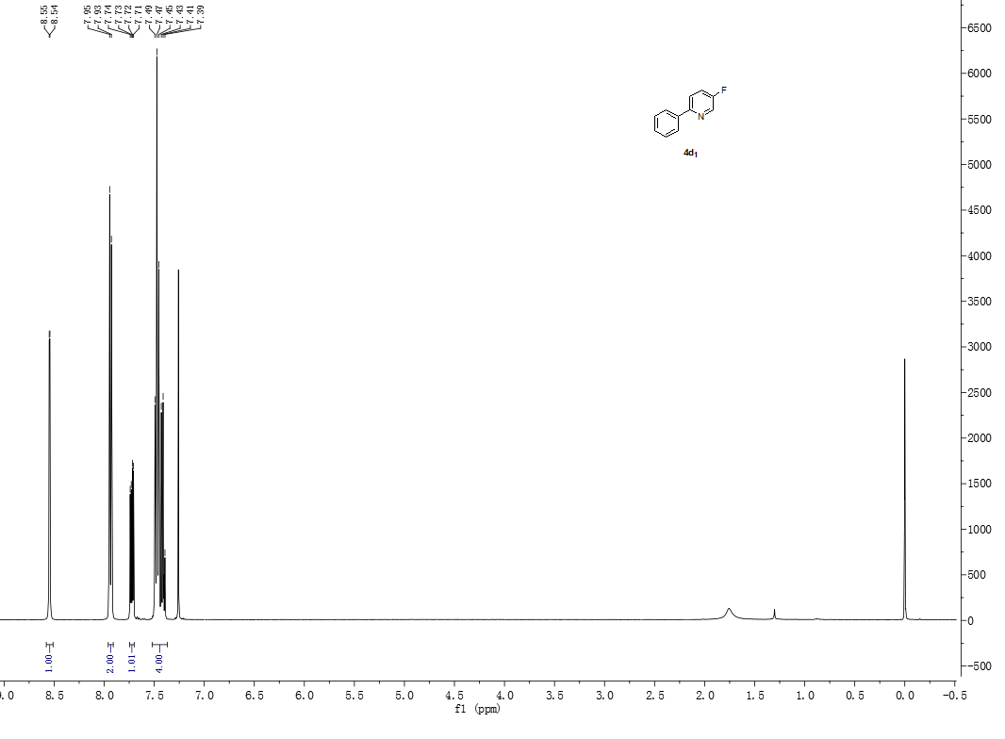
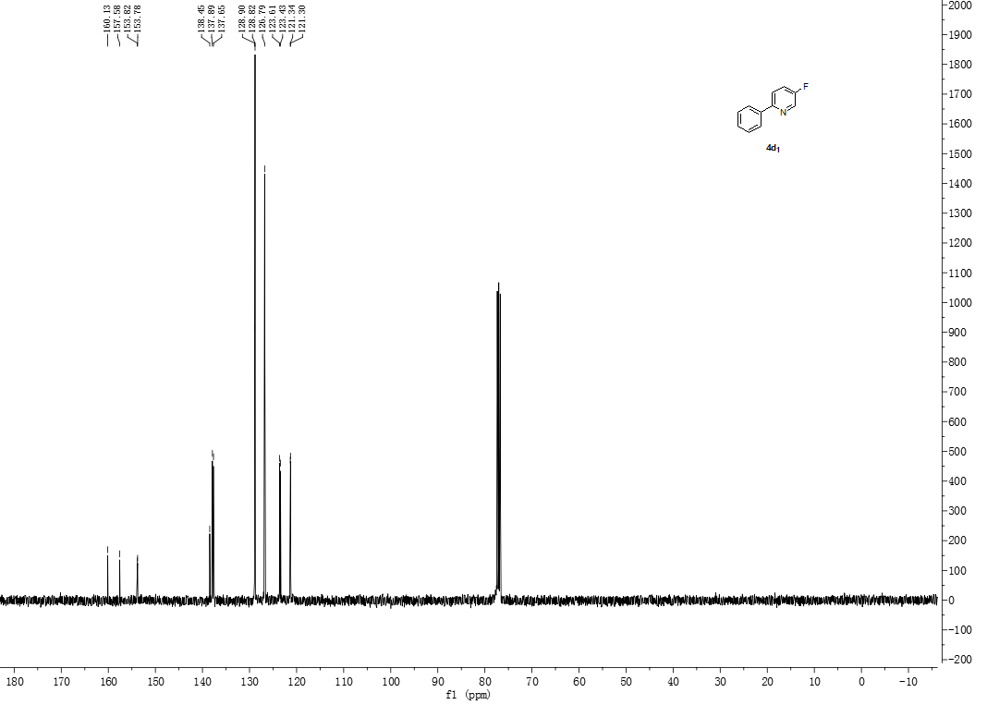
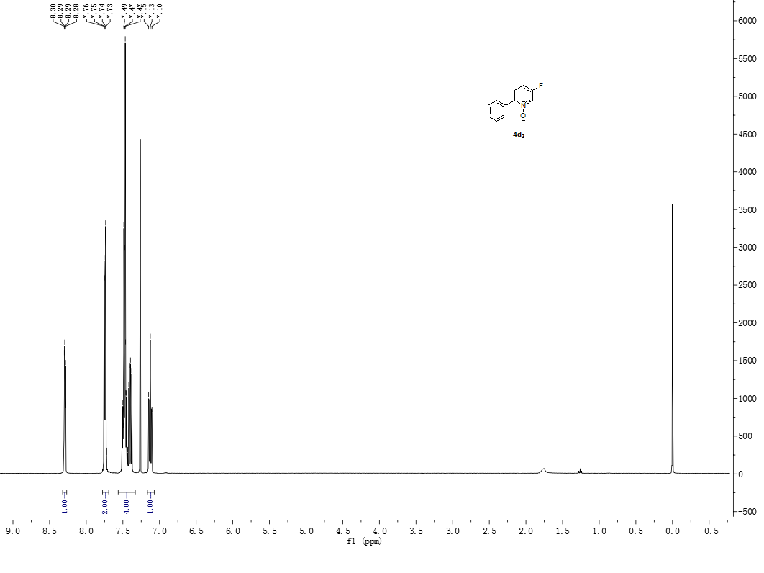
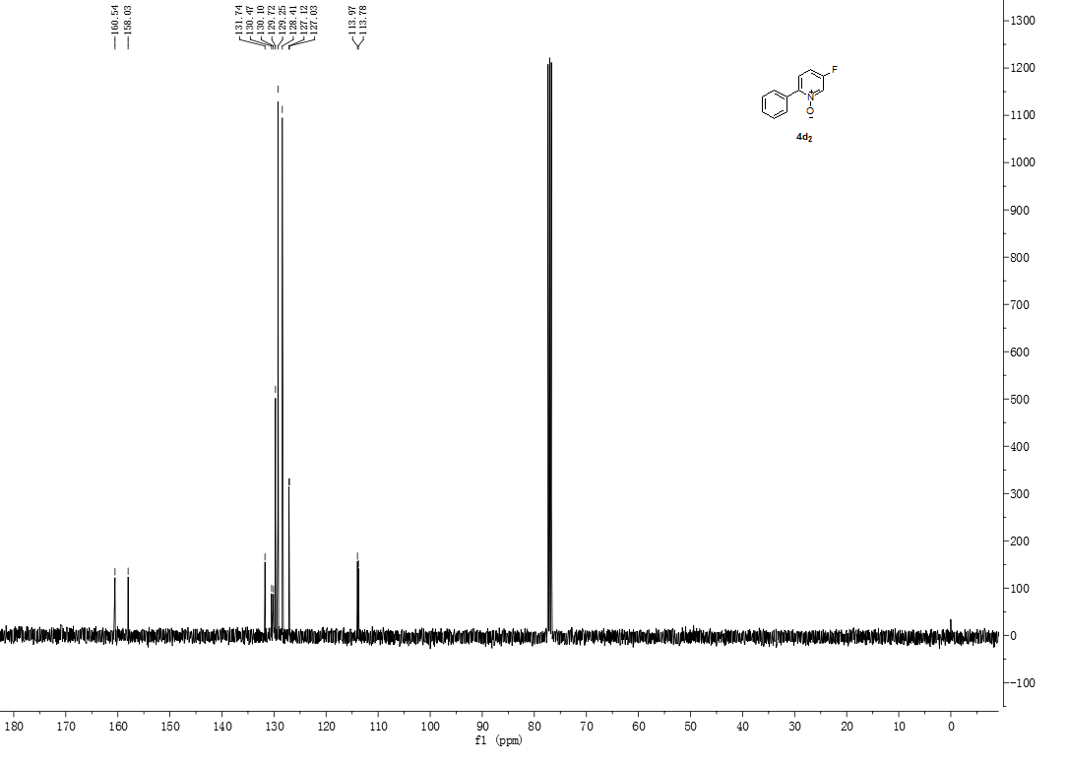
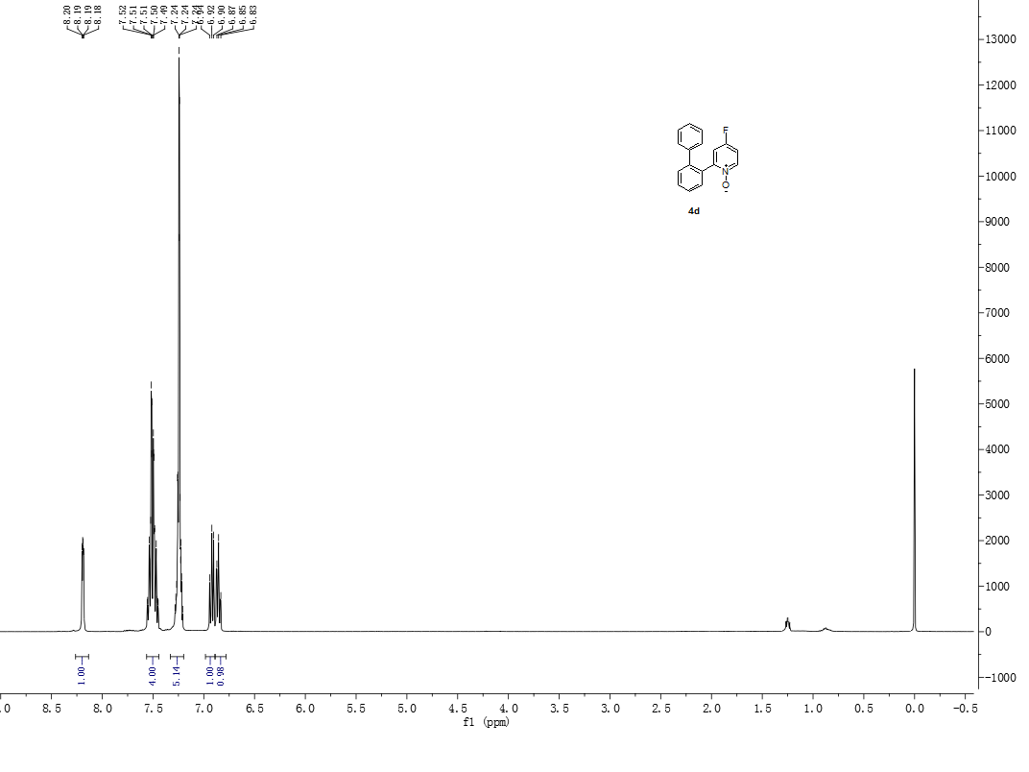
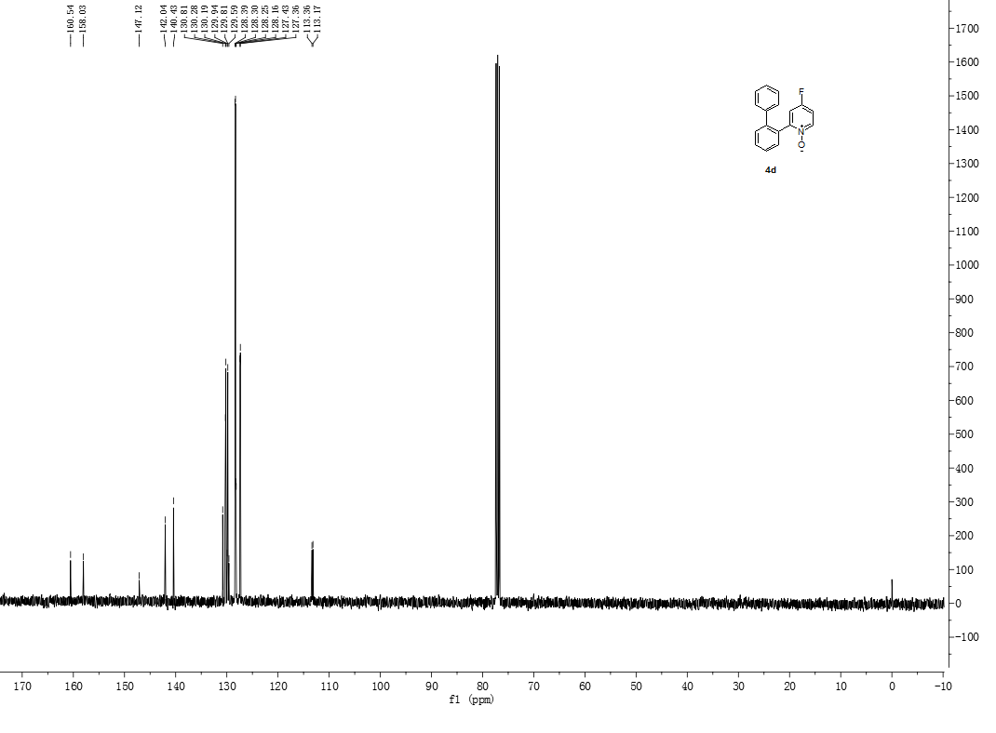
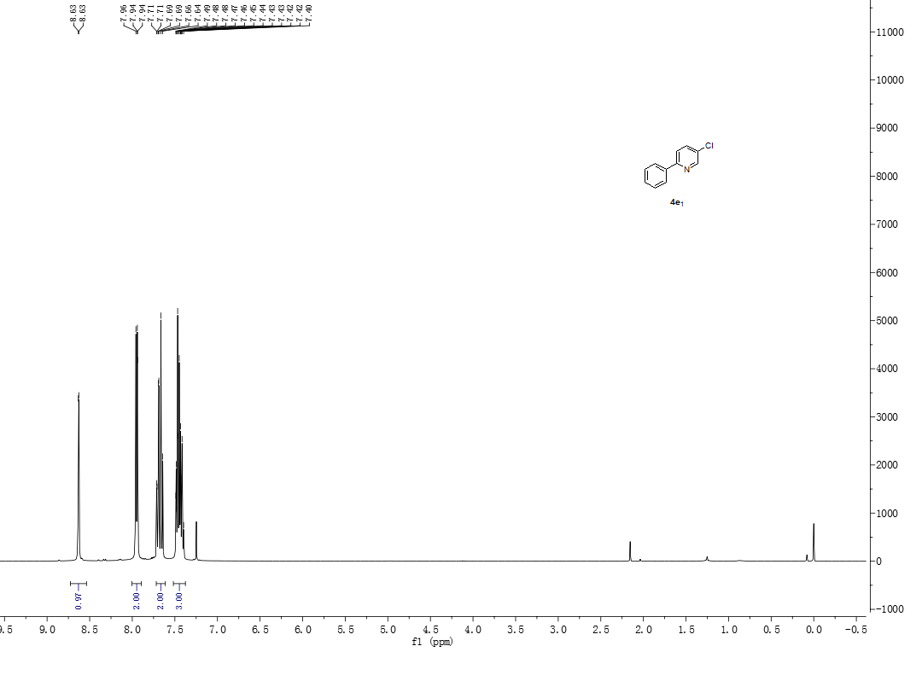
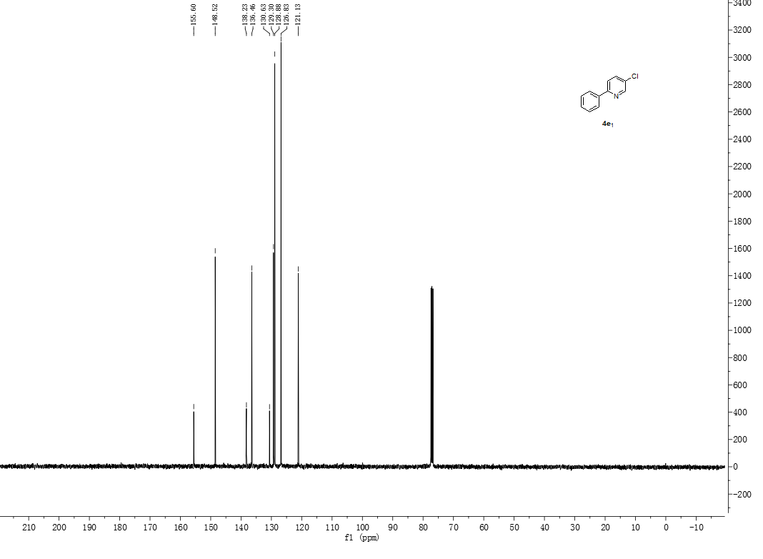
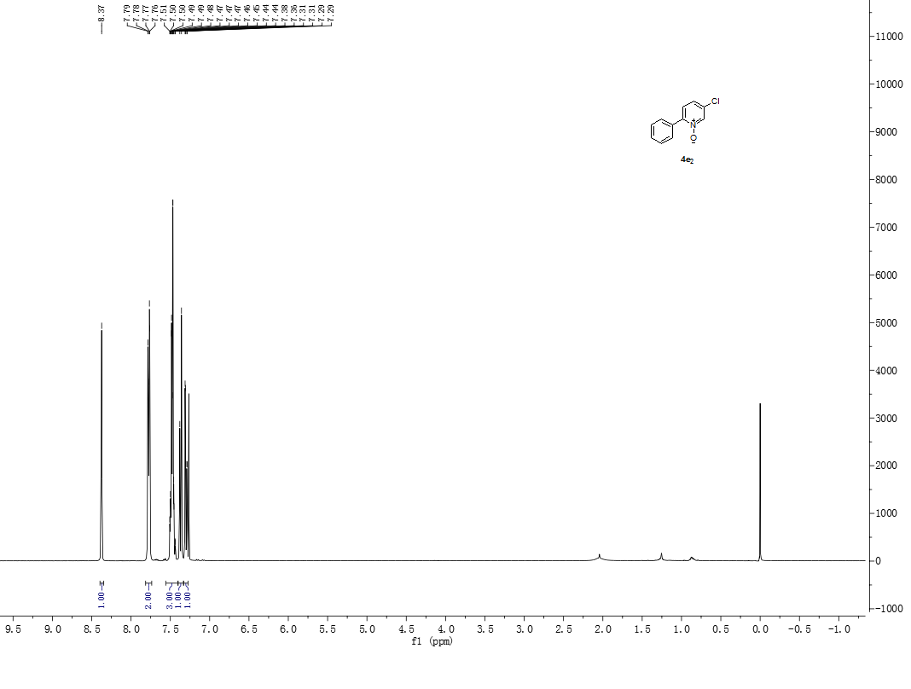
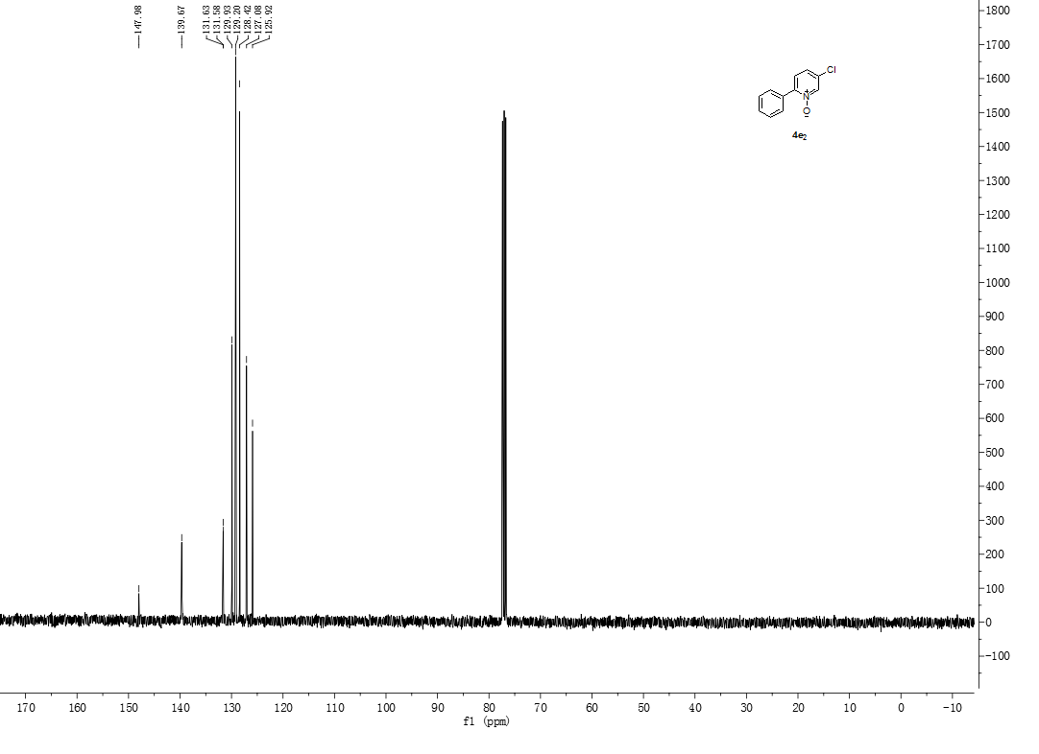
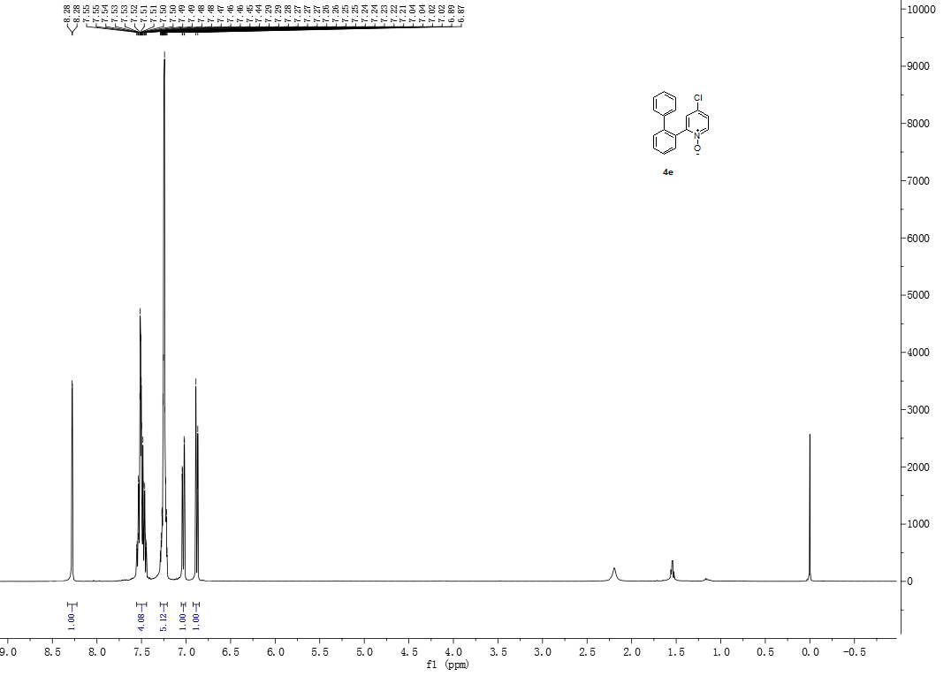
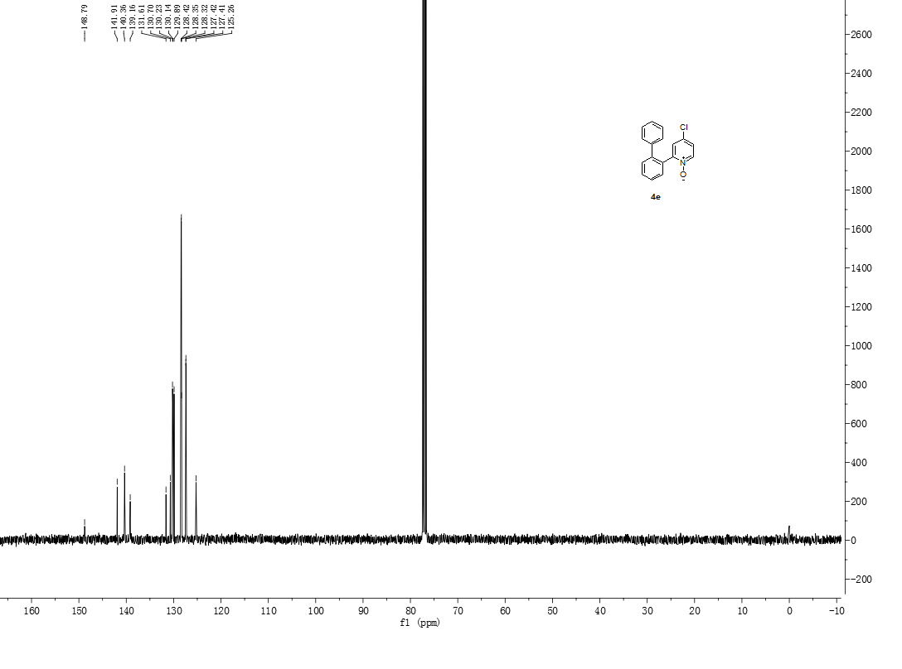
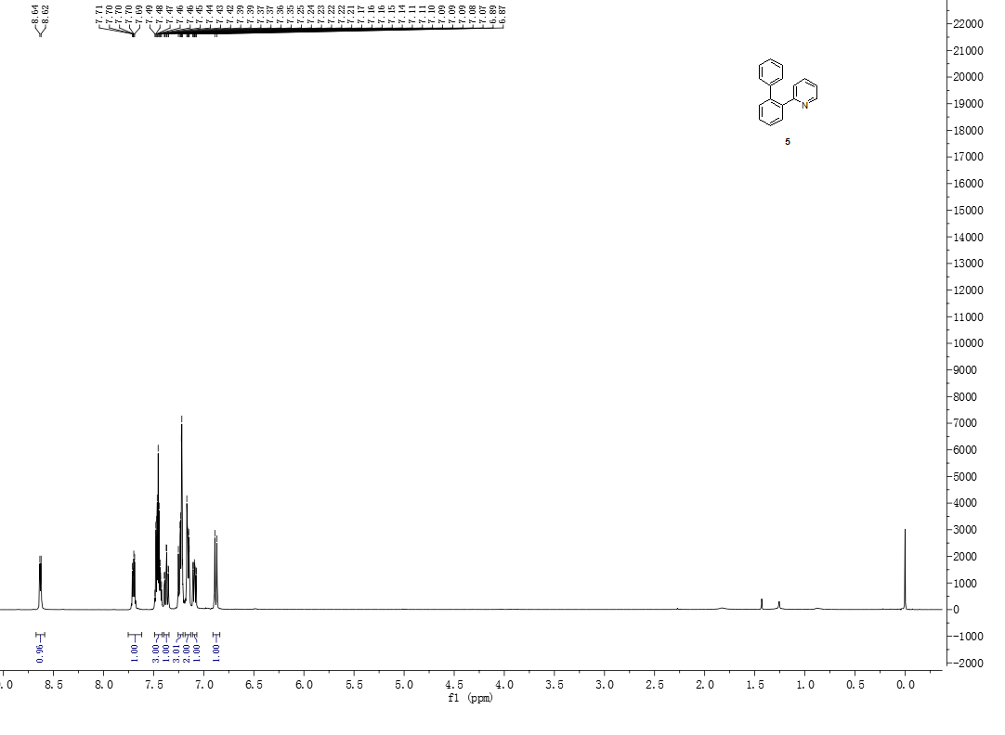
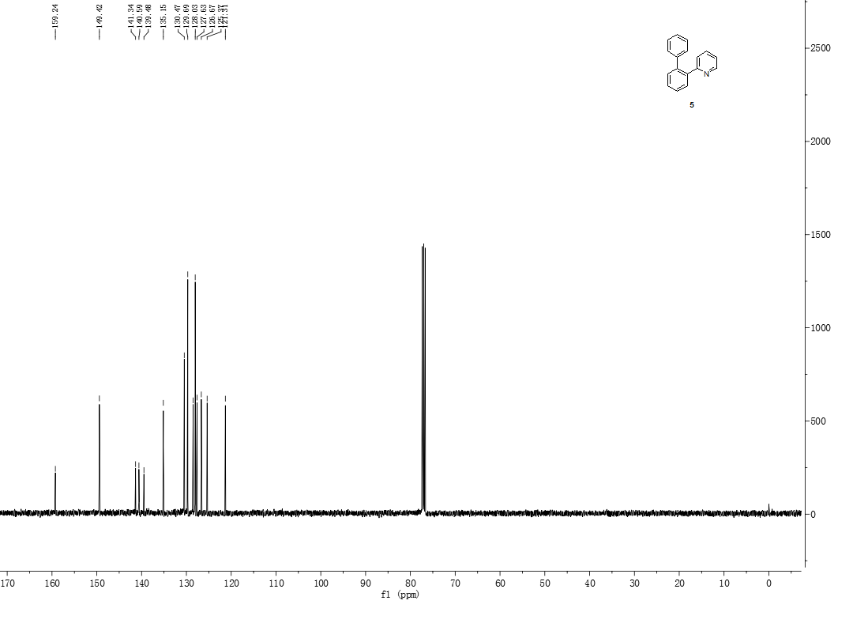
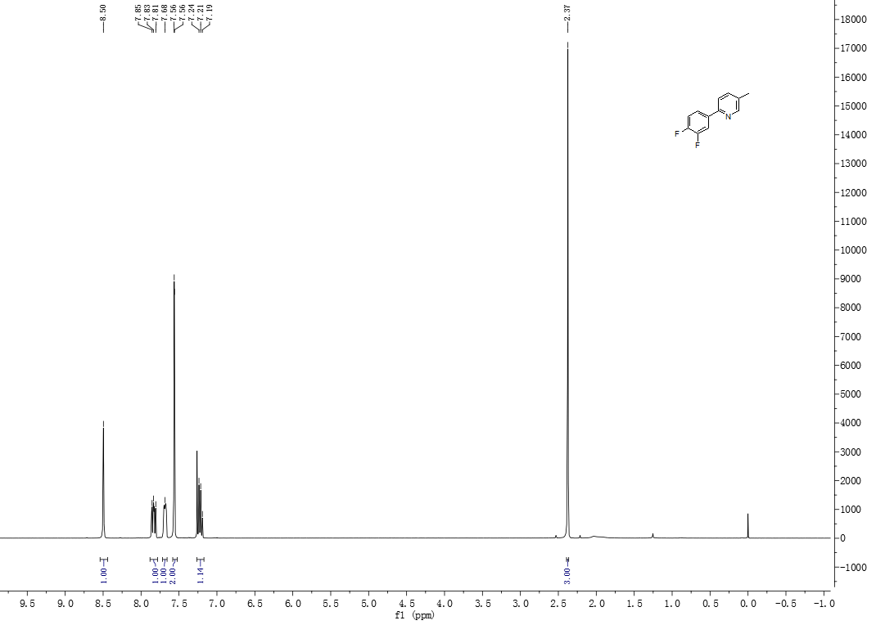
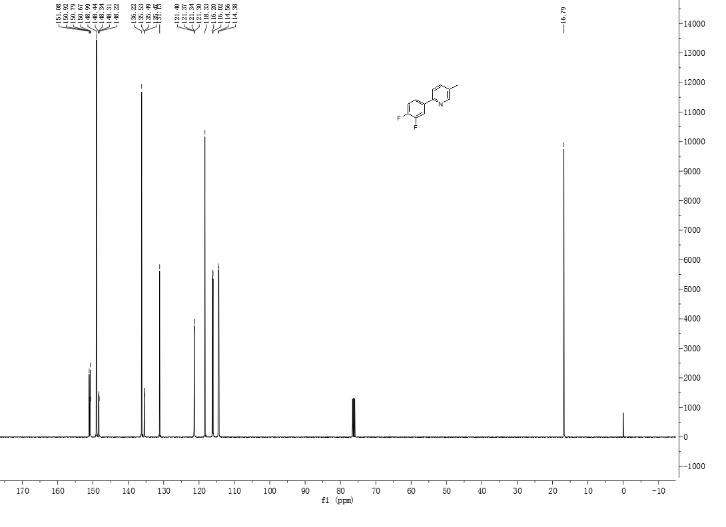
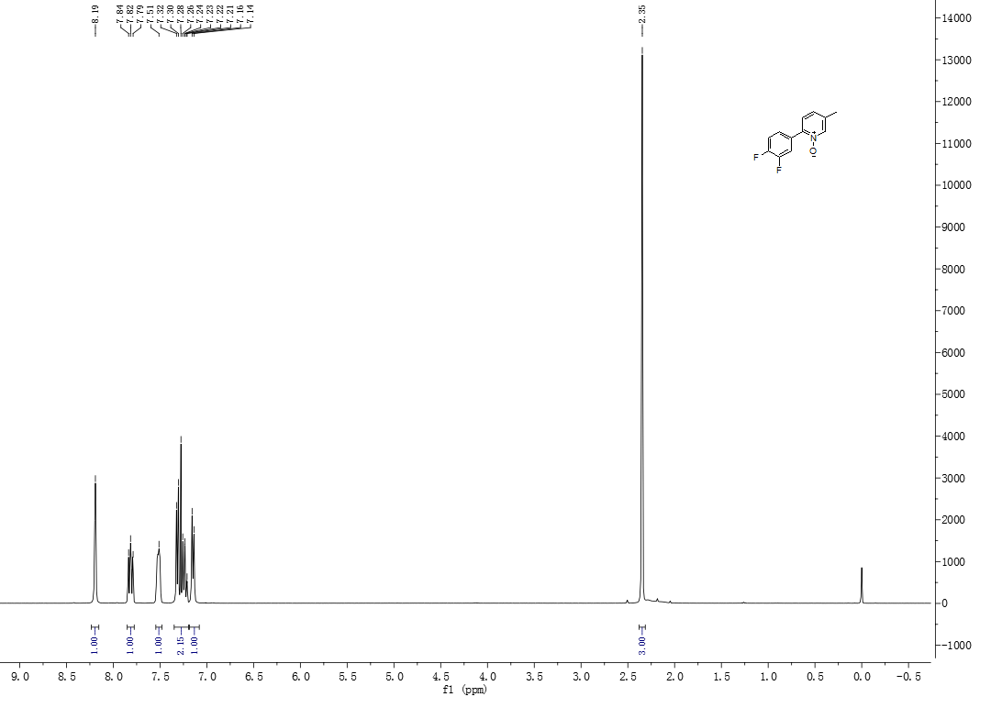
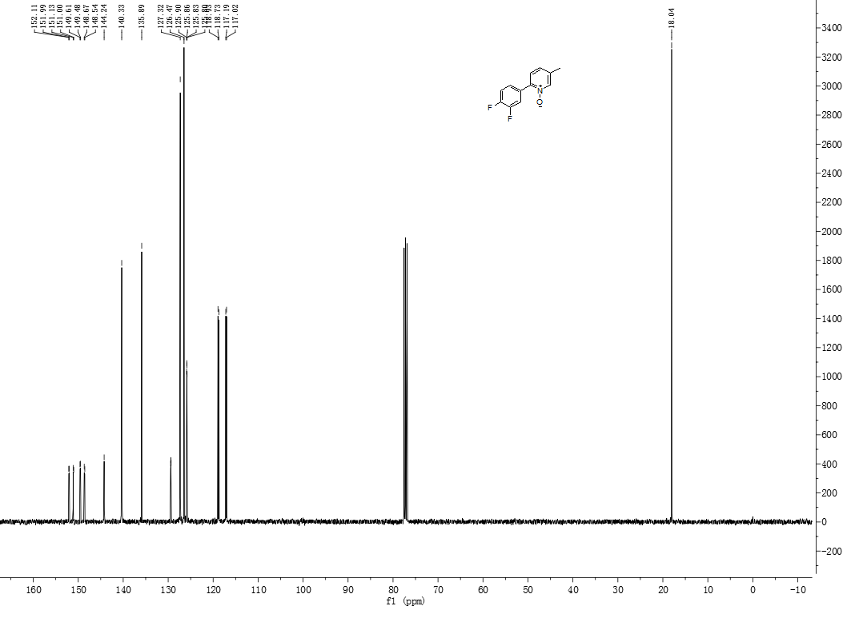
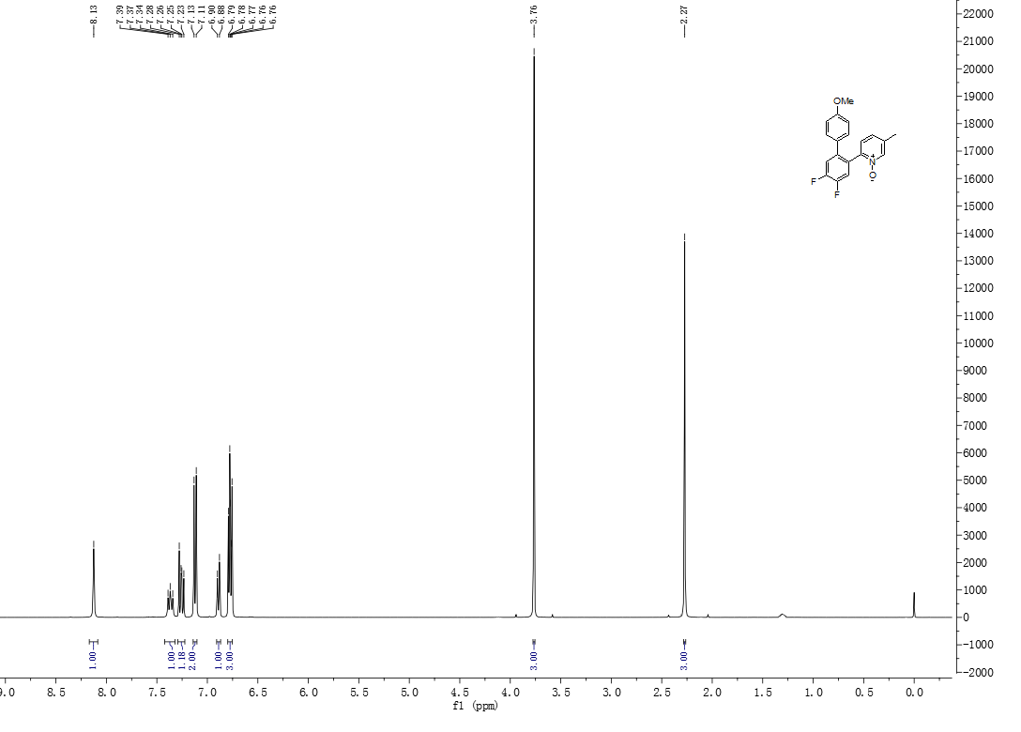
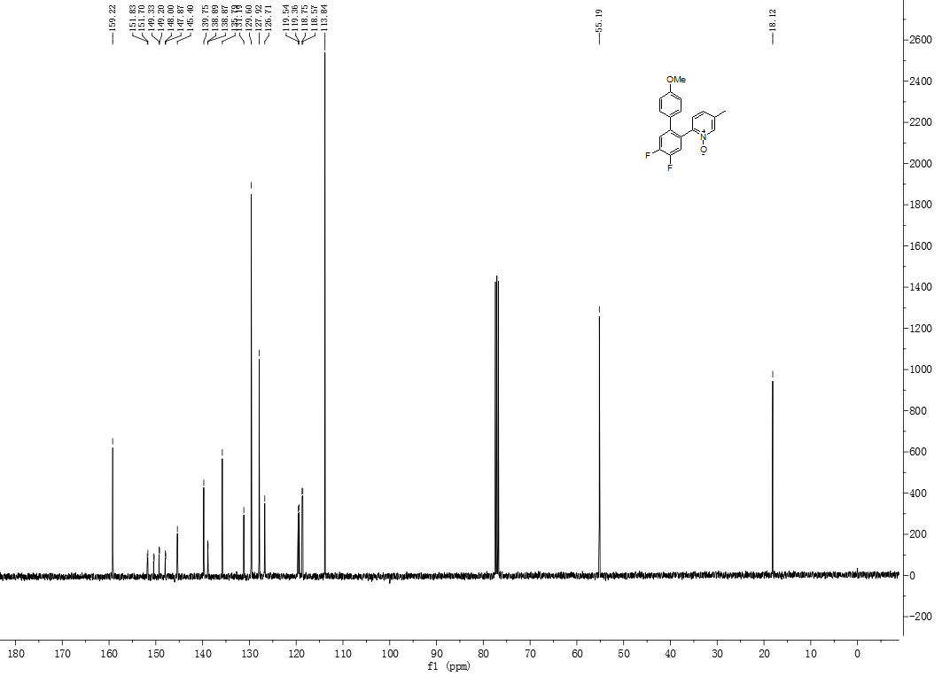
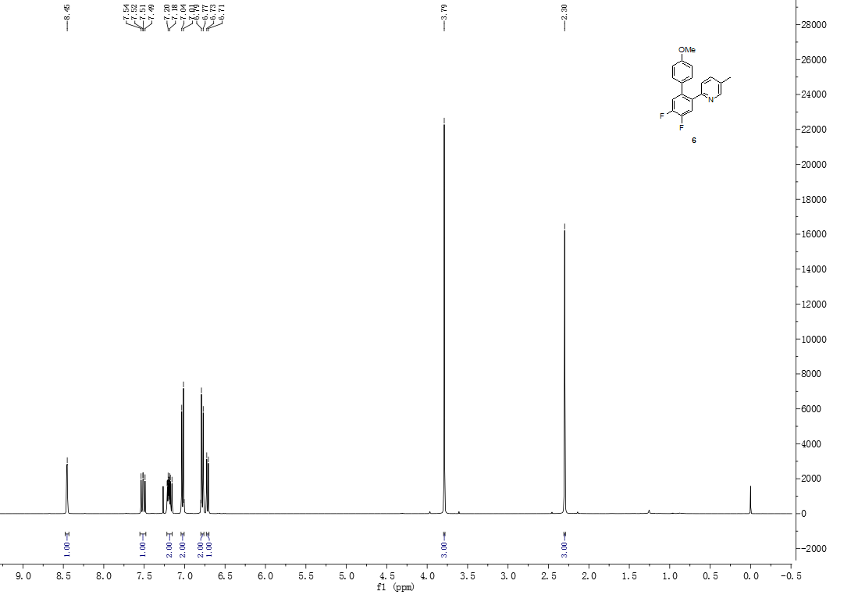
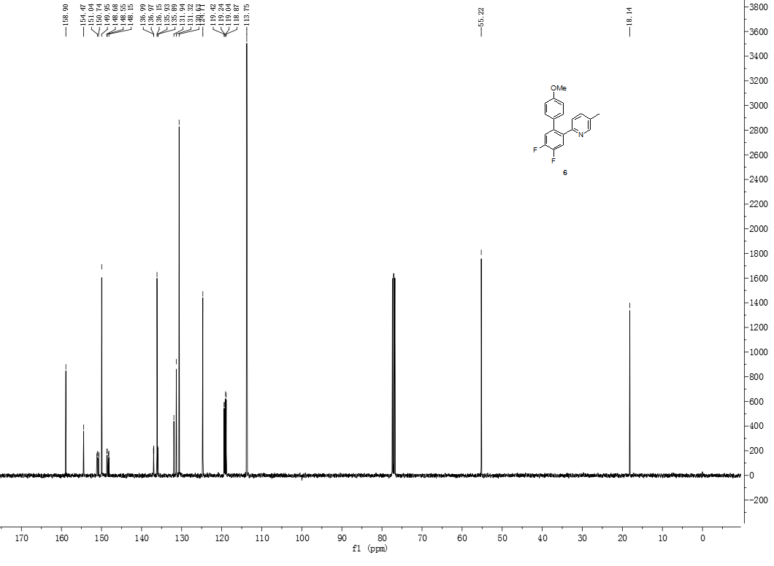

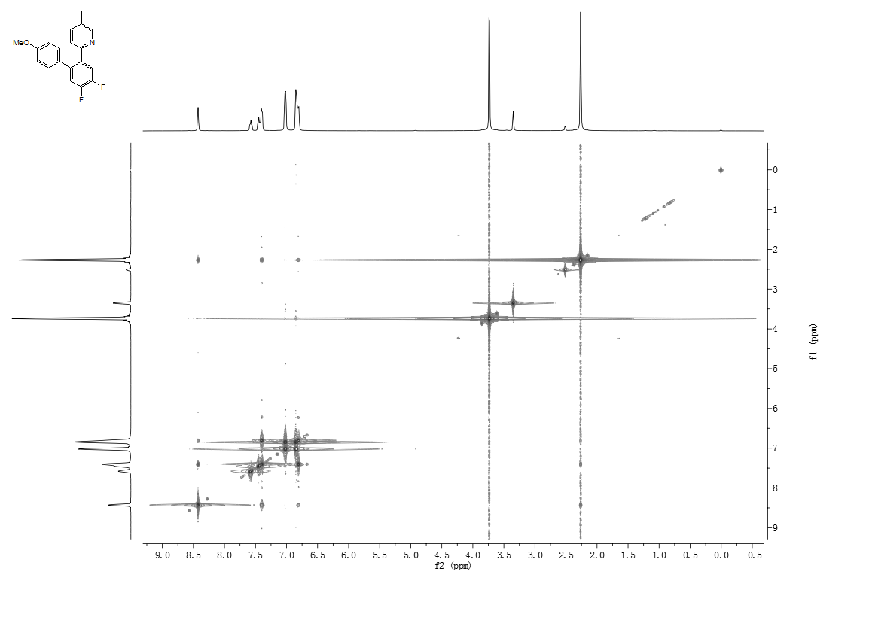
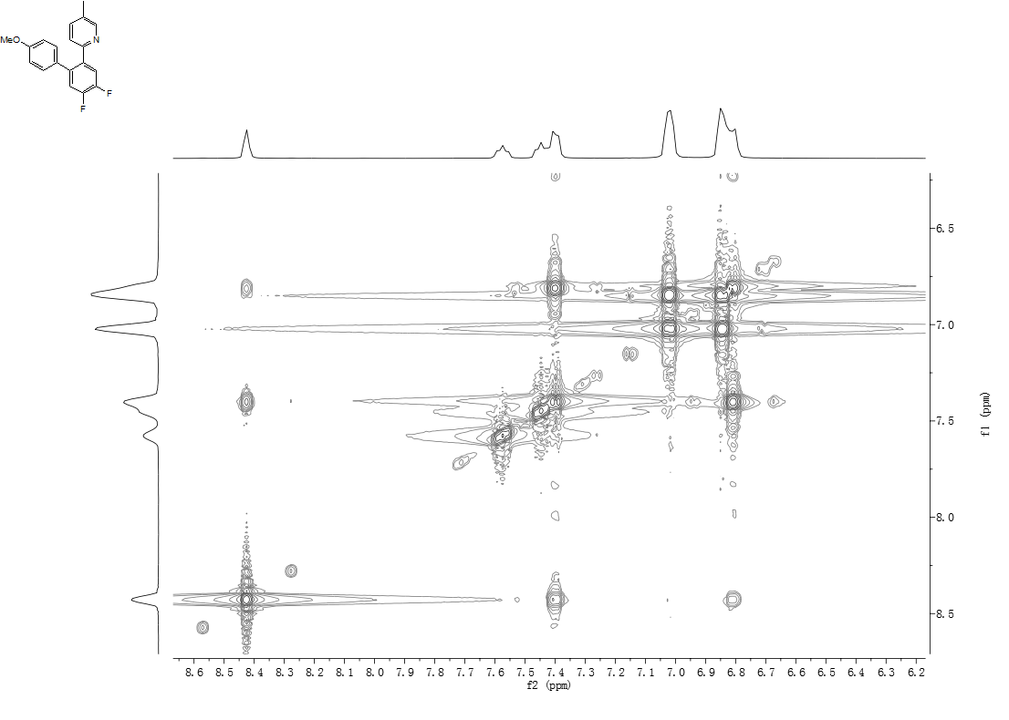
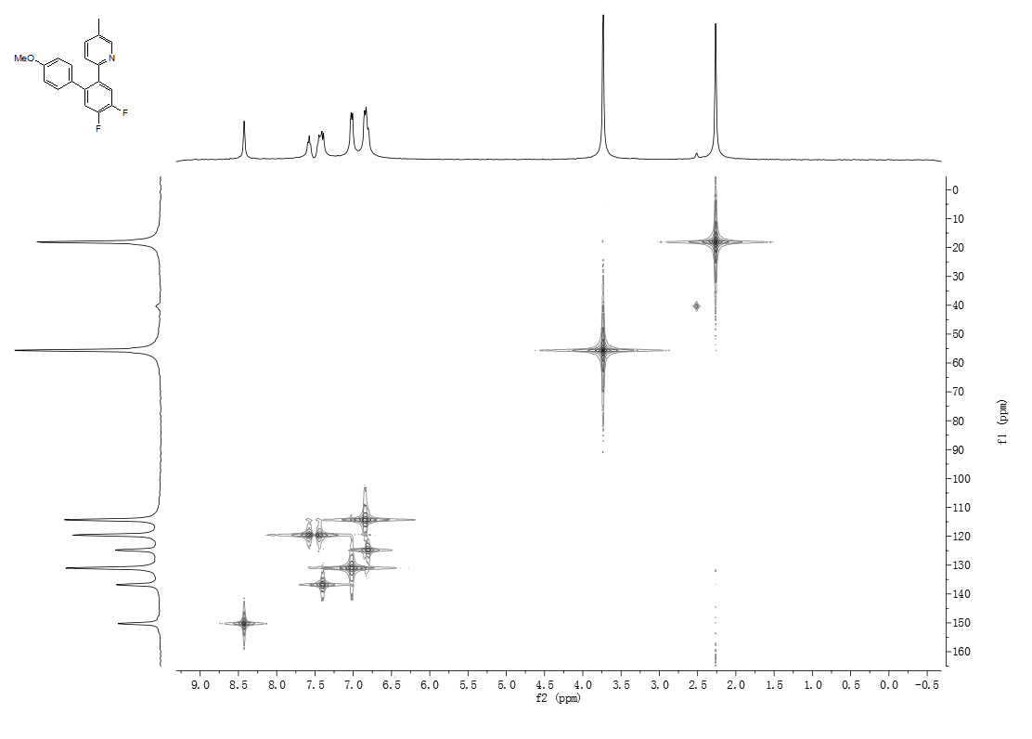
- References
[1] Wong, S. M.; So, C. M.; Chung, K. H.; Lau, C. P.; Kwong, F. Y. Eur. J. Org. Chem. 2012, 4172-4177.
[2] Liu, C.; Yang, W. B. Chem. Commun. 2009, 6267-6269.
[3] Moriuchi, T.; Mao, L. S.; Wu, H. L.; Ohmura, S. D.; Watanabe, M.; Hirao, T. Dalton Trans. 2012, 41, 9519-9525.
[4] Zhu, C. W.; Yi, M. L.; Wei, D. H.; Chen, X.; Wu, Y. J; Cui, X. L. Org. Lett. 2014, 16, 1840-1843.
[5] Kokatla, H. P.; Thomson, P. F.; Bae, S.; Doddi, V. R.; Lakshman, M. K. J. Org. Chem. 2011, 76, 7842-7848.
[6] (a) Feng, R. K.; Yao, J. Z.; Liang, Z. J.; Liu, Z. X.; Zhang, Y. H. J. Org. Chem. 2013, 78, 3688-3696; (b) Thirunavukkarasu, V. S.; Parthasarathy, K.; Cheng, C. H. Angew. Chem. Int. Ed. 2008, 47, 9462-9465.
[7] Do, H. Q.; Khan, R. M. K.; Daugulis, O. J. Am. Chem. Soc. 2008, 130, 15185-15192.
[8] Ohashi, M.; Takeda, I.; Ikawa, M.; Ogoshi, S. J. Am. Chem. Soc. 2011, 133,18018-18021.
[9] Liu, K. M.; Liao, L. Y.; Duan, X. F. Chem. Commun. 2015, 51, 1124-1127.
[10] Shuai, Q.; Yang, L.; Guo, X. Y.; Basle, O.; Li, C. J. J. Am. Chem. Soc. 2010, 132, 12212-12213.
[11] Campeau, L. C.; Fagnou, K. Org. Synth. 2011, 88, 22-32.
[12] Otwinowski, Z.; Minor, W. Methods Enzymol. 1997, 276, 307-326.
[13] Otwinowski, Z.; Borek, D.; Majewski, W.; Minor, W. Acta Crystallogr. Sect. A 2003, 59, 228-234.
[14] Sheldrick, G. M. Acta Crystallogr. Sect. A 1990, 46, 467-473.
[15] Sheldrick, G. M. Acta Crystallogr. Sect. A 2008, 64, 112-122.

