Additional file 1

1. Defining Quetelet Index (QI) for topic and disease status relationship analysis

Quetelet Index (QI) is an index introduced by Mirkin in 2001[3] to represent the correlation between variables k and l as the relative change in the probability of l when k is taken into account.

QI(l/k) = (P(l/k) - P(l)) / P(l)

In MetaTopics, considering the substantial needs in the analysis of the relationship between each sub-community and a certain disease status, the original definition of QI is adopted to estimate the relative change of the observation frequency of a specific latent sub-community among all the samples compared to that among the samples with a certain disease status. In this way, QI is defined to quantitatively describe the degree of the influence of a specific topic on a certain disease. Specifically, in order to analyze the correlation between the established latent sub-communities and disease status, it is presumed that a sub-community will be identified as a meaningful observation in an individual sample if it has an occurring probability bigger that a threshold, for example, 0.05. Then the QI is applied as the formula below:

QI (Topic i | Disease j) = (P(Topic i | Disease j) - P(Topic i )) / P(Topic i)

Where P (Topic i) is estimated by the occurring frequency of the meaningful observed topic i among all the samples, while P(Topic i | Disease j ) is estimated by the occurring frequency of the meaningful observed topic i among the samples with a certain disease status j . As an example, , the QI for each latent sub-community under three different status (NOT_OLP, OLP_no-erosive, and OLP_erosive for our oral metagenomics data; lean, obese, and overweight for the gut metagenomics data ) are separately shown in Table 1 and 2. A positive value of QI indicates that the considered topic occurs more frequently than average in a certain status, while a negative one indicates the topic occurs less frequently than average.

Table S1. Calculation of QIs for the 10 topics under 3 different status for our or

our oral metagenomics data

 | NOT_OLP | OLP_no-erosive | OLP_erosive
Topic 1 | 0.08 | 0.15 | -0.23
Topic 2 | 0.77 | -1 | -0.23
Topic 3 | 0.03 | -0.14 | 0.07
Topic 4 | -0.13 | 0.46 | -0.19
Topic 5 | 0.08 | -0.01 | -0.1
Topic 6 | 0 | -0.17 | 0.14
Topic 7 | 0.06 | 0.19 | -0.23
Topic 8 | -0.41 | -0.26 | 0.74
Topic 9 | -0.05 | 0.06 | 0.03
Topic 10 | 0.05 | -0.12 | 0.03

Table S2. Calculation of QIs for the 60 topics under 3 different status for the or

gut metagenomics data

 | lean | obese | overweight
Topic1 | 0.850758 | -0.24805 | -0.30982
Topic2 | 0.962925 | -0.45313 | 0.756818
Topic3 | -0.13631 | -0.09767 | 0.9325
Topic4 | 0.439479 | 0.002594 | -1
Topic5 | -1 | 0.503891 | -1
Topic6 | 0.143115 | -0.11536 | 0.420956
Topic7 | 1.159218 | -0.24805 | -1
Topic8 | -0.38308 | 0.289049 | -1
Topic9 | 0.110455 | -0.09767 | 0.380357
Topic10 | 0.439479 | -0.4987 | 2.220833
Topic11 | -0.00344 | 0.041155 | -0.25673
Topic12 | -1 | 0.503891 | -1
Topic13 | -0.4602 | -0.06007 | 1.415625
Topic14 | -0.09764 | 0.010076 | 0.153731
Topic15 | -1 | 0.503891 | -1
Topic16 | -1 | 0.002594 | 2.220833
Topic17 | 0.591003 | -0.05017 | -1
Topic18 | -0.21483 | 0.093739 | -0.12159
Topic19 | -0.38308 | 0.002594 | 0.840476
Topic20 | -0.42421 | 0.203113 | -0.35583
Topic21 | 1.591061 | -0.54883 | -0.03375
Topic22 | 0.818289 | -0.28763 | 0.017105
Topic23 | -0.05534 | 0.080922 | -0.39609
Topic24 | -1 | 0.503891 | -1
Topic25 | -0.42421 | 0.203113 | -0.35583
Topic26 | -0.53731 | 0.181629 | 0.035268
Topic27 | 0.079609 | -0.06007 | 0.207813
Topic28 | 0.328749 | 0.041155 | -1
Topic29 | -0.13631 | 0.203113 | -1
Topic30 | -1 | 0.503891 | -1
Topic31 | -0.13631 | -0.09767 | 0.9325
Topic32 | -1 | 0.503891 | -1
Topic33 | 1.159218 | -0.24805 | -1
Topic34 | 0.660937 | -0.19021 | -0.25673
Topic35 | -1 | 0.503891 | -1
Topic36 | 0.850758 | -0.14063 | -1
Topic37 | -1 | 0.503891 | -1
Topic38 | -0.38308 | 0.074208 | 0.380357
Topic39 | -0.64013 | 0.127918 | 0.610417
Topic40 | 2.238827 | -0.62403 | -1
Topic41 | -0.56816 | -0.39844 | 3.83125
Topic42 | -1 | 0.503891 | -1
Topic43 | -0.21483 | 0.093739 | -0.12159
Topic44 | -0.38308 | 0.289049 | -1
Topic45 | -0.28026 | 0.253243 | -1
Topic46 | 3.318436 | -1 | -1
Topic47 | 0.259544 | -0.18539 | 0.610417
Topic48 | -0.4602 | 0.315905 | -1
Topic49 | -0.42421 | 0.303372 | -1
Topic50 | -0.43673 | 0.176958 | -0.15978
Topic51 | 1.159218 | -0.24805 | -1
Topic52 | 1.159218 | -0.24805 | -1
Topic53 | 1.591061 | -0.39844 | -1
Topic54 | 1.159218 | -0.24805 | -1
Topic55 | -1 | 0.503891 | -1
Topic56 | -0.36494 | -0.11536 | 1.557721
Topic57 | 0.439479 | -0.06902 | -0.53988
Topic58 | -1 | 0.002594 | 2.220833
Topic59 | 2.454749 | -0.69922 | -1
Topic60 | -1 | 0.127918 | 1.415625

2. Interactive visualization of topic model by LDAvis

MetaTopics seamlessly incorporates package LDAvis, which is presented by Carson and Kenneth to offer a web-based tool for interactive visualization of Topic Models [1-5]. The MDS (Multidimensional Scaling) method combined with the marginal distributional of each topic is used to show the relationship among topics. Besides, two parameters, saliency and relevance, are used to rank the importance of the words, i.e. the bacteria in this application, overall and in specific topic respectively. Saliency, introduced by Chuang et. al [6], is used to quantitatively measure the overall importance of the bacteria for visualization. Relevance balances the conditional probability P(bacteria|topic), i.e. the topic-specific probability, and the lift probability, defined as P(bacteria|topic)/P(bacteria) with a weight [4]. A snapshot of the interactive visualization of the analysis results on our oral metagenomics data and gut metagenomics data are separately shown in Figure 1 and 2.

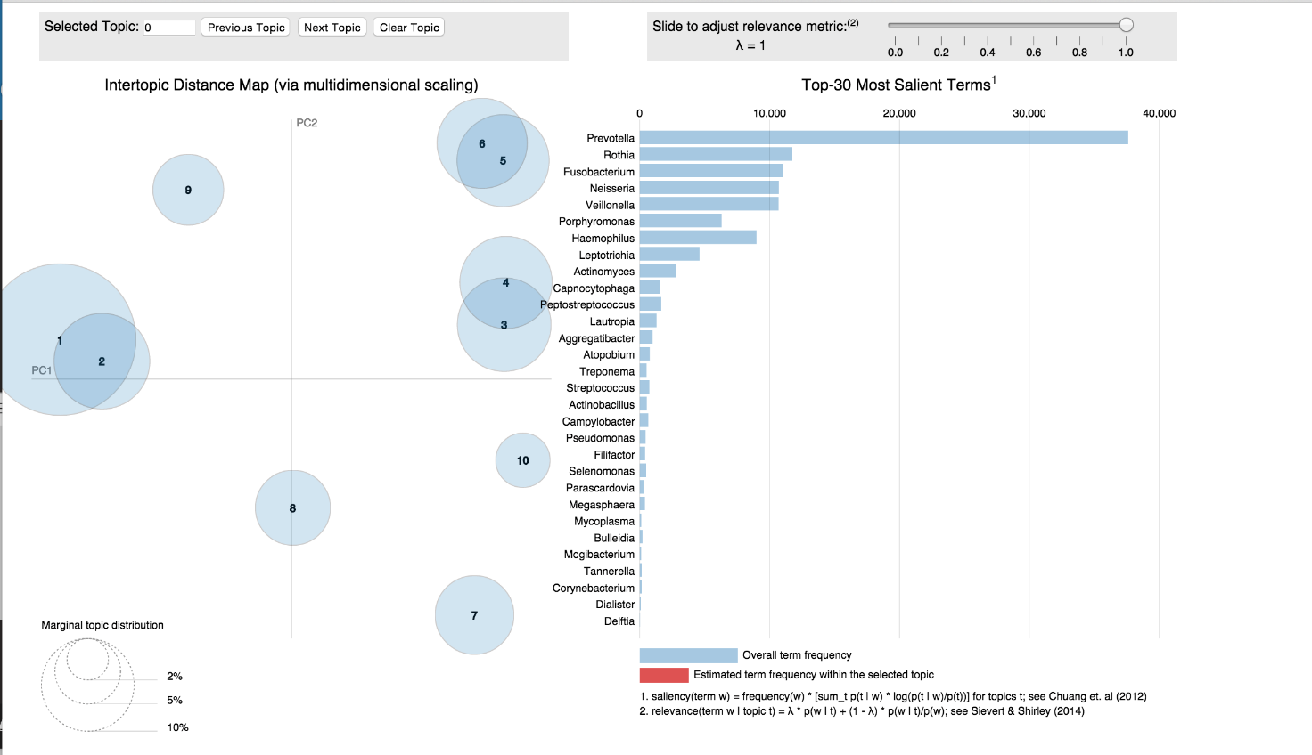
Figure S1. A snapshot of the interactive visualization of the analysis results on our oral metagenomics data
Figure S2. A snapshot of the interactive visualization of the analysis results on public gut metagenomics data

Reference
[1] Blei, D.M. Probabilistic topic models. Communications of the ACM 2012;55(4):77-84.

[2] Blei, D.M., Ng, A.Y. and Jordan, M.I. Latent dirichlet allocation. the Journal of machine Learning research 2003;3:993-1022.

[3] Mirkin, B. Eleven ways to look at the chi-squared coefficient for contingency tables. The American Statistician 2001;55(2):111-120.

[4] Carson Sievert and Kenny Shirley, LDAvis: Interactive Visualization of Topic Models. R package version 0.2. http://CRAN.R-project.org/package=LDAvis, 2015.

[5] Carson Sievert and Kenny Shirley, LDAvis: A method for visualizing and interpreting topics, Proceedings of the Workshop on Interactive Language Learning, Visualization, and Interfaces, pages 63–70,2014.

[6] Jason Chuang, Christopher D. Manning and Jeffrey Heer, Termite: Visualization Techniques for Assessing Textual Topic Models. AVI, 2012.

