Electronic Supplementary Materials

Enhanced Hydrogen Evolution Reaction on Hybrids of Cobalt Phosphide and Molybdenum Phosphide

Si-Ling Fang,¹ Tsu-Chin Chou,¹ Satyanarayana Samireddi,^{2,3} Kuei-Hsien Chen,^{1,2} Li-Chyong Chen¹ and Wei-Fu Chen¹*

¹ Center for Condensed Matter Sciences, National Taiwan University, Taipei 10617, Taiwan, Republic of China.
² Institute of Atomic and Molecular Sciences, Academia Sinica, Taipei 10617, Taiwan, Republic of China.
³ Department of Chemistry, National Tsing Hua University, Hsinchu 30012, Taiwan, Republic of China.

*Corresponding author: Tel: +886–2–33665296; Fax: +886–2–2365–5404
E–mail: wfchen@ntu.edu.tw

Figure S1 Comparison of XRD patterns between the Co^{0.5}Mo^{0.5}P hybrid and the ICSD h-CoMoP₂ database (ICSD No. 624219).

Figure S2 XPS spectra of the Co_{0.5}Mo_{0.5}P hybrid in the (a) Co 2P, (b) Mo 3d and (c) P 2P regions.

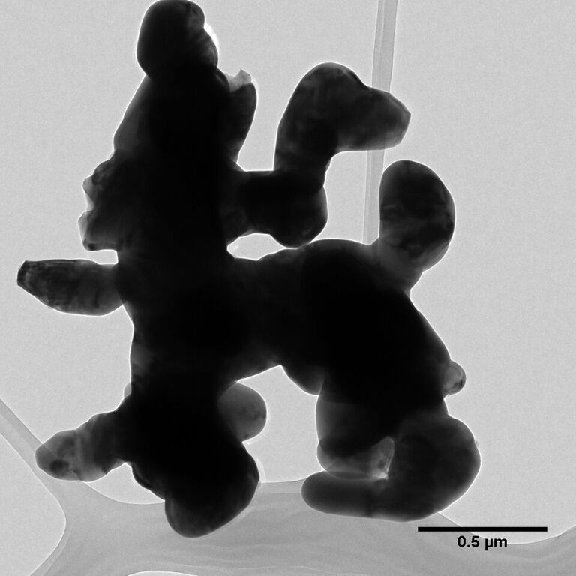
Figure S3. A TEM image of the Co_{0.5}Mo_{0.5}P hybrid.

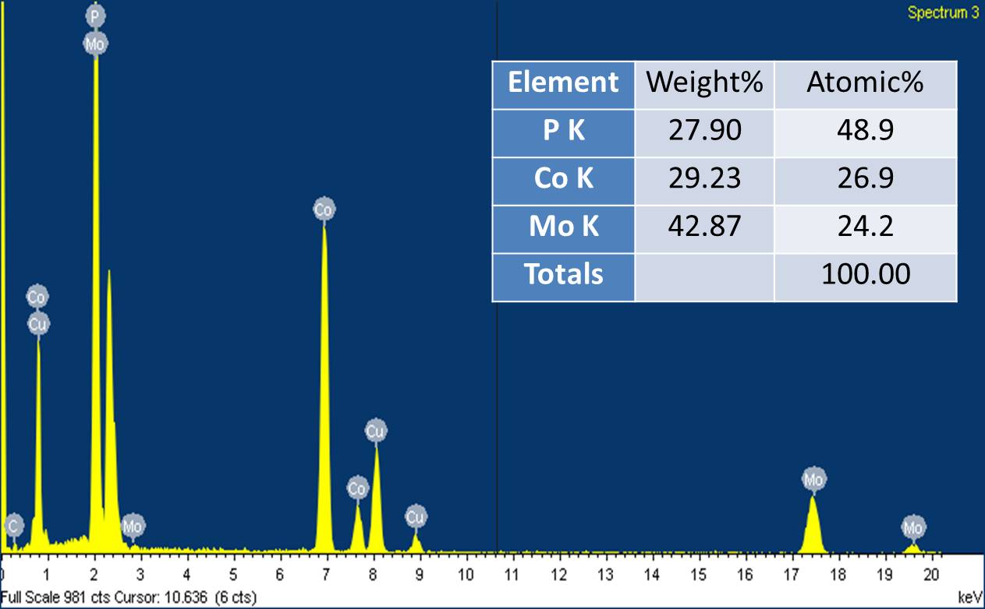

Figure S4 EDX spectrum of the Co_{0.5}Mo_{0.5}P hybrid collected by a HRTEM, and the elementary compositions are shown in the inset.

Figure S5 Comparison of polarization curves of the CoP, MoP and three physical mixtures with CoP:MoP = 1:1 (weight ratio) in hydrogen–purged 0.1 M HClO₄.

Figure S6 The equivalent circuit model with two–time constant for fitting the electrochemical impedance spectroscopy under electrocatalytic condition in the hydrogen evolution reaction. R_{s}, the series resistance; R_{ct,} the charge transfer resistance; R_{p,} resistance related to the surface roughness or porosity of the catalytic layer; C_{d1} and C_{d2}, the double layer capacitances.

Figure S7 Nyquist plots of experimental and simulated data for the (a) Co^{0.5}Mo^{0.5}P, (b) MoP (b) and (c) CoP annealed at 800ºC simulated by the two-time constant model.

Figure S8 Cathodic current density of the Co^{0.5}Mo^{0.5}P hybrid catalyst versus time at an overpotential of 165 mV for 6 hours.

