***Photo-catalytic Properties of Anatase TiO2 supported on CNTs, SBA-15 and silica coated MWCNTs nano-hybrid***

Nteseng O Ramoraswia and Patrick G Ndungub

*aSchool of Chemistry, University of KwaZulu-Natal, Westville Campus, Durban, South Africa*

*bDepartment of Applied Chemistry, University of Johannesburg, P.O. Box 17011, Doornfontein, Johannesburg, 2028, South Africa*

**Supplementary Information**



**S1:** Raman spectra of SBA-15.



**S2:** Raman spectra of SBA-15 coated aCNTs.



**S3:** Raman spectra of the synthesized TiO2.



S4: Raman spectra of TiO2 on different supports.



**S5**: FTIR spectra of raw (a) and functionalized (b) CNTs

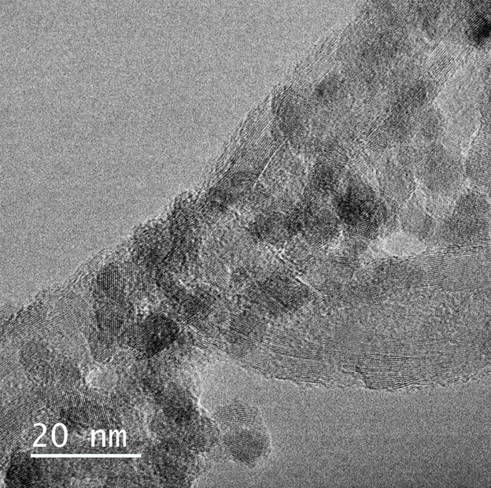

S6: HRTEM micrograph of TiO2/CNTs.



**S7:** Pore size distribution for the raw and acid treated CNTs (a), the SBA-CNT nanocomposites and SBA-15 (b), and the unsupported and supported titania materials (c).