Additional file

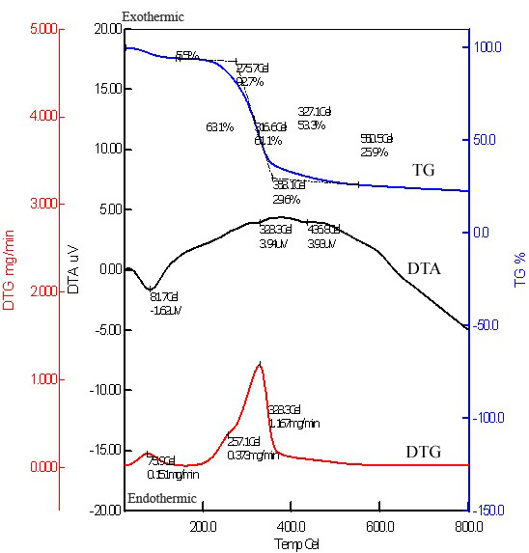

Figure S6 Thermo-gravimetric spectrum of Anethum sowa L. root powder.

