Supplementary Material:

Supplementary Figure S1. Correlation between number of unique surnames and number of houses per zone

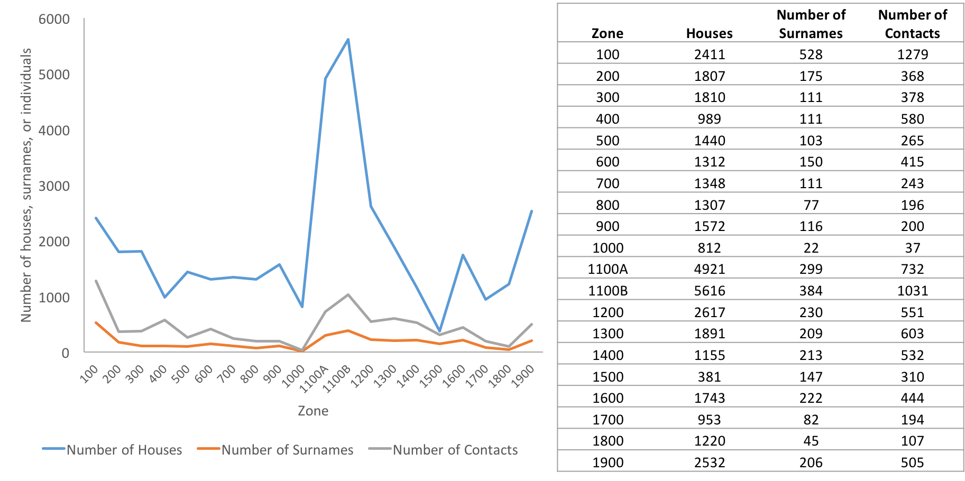

Supplementary Table S1. Temporal trends in types of contacts reported by cases
Type of contact* | July | August | September | October
Touched the body fluids of the case | 10 (19.6) | 79 (22.8) | 131 (27.7) | 102 (40.3)
Had direct physical contact with the body of the case | 23 (45.1) | 136 (39.2) | 235 (49.7) | 165 (65.2)
Touched or shared the linens, clothes, or dishes/eating utensils of the case | 10 (19.6) | 87 (25.1) | 183 (38.7) | 119 (47.0)
Slept, ate, or spent time in the same household or room as the case | 12 (23.5) | 81 (23.3) | 172 (36.4) | 120 (47.4)
*Categories defined by the Viral Hemorrhagic Fever Case Investigation Form

Supplementary Table S2. Temporal trends in characteristics of individuals who developed Ebola virus disease after contact with symptomatic cases
 |  | Reported by Single Source  (n=193)  n (%) |  |  |  |  |  | Reported by Multiple Sources  (n=91)  n (%)
 | July |  |  | August | September |  | July |  | August | September
Sex of Contact Becoming Case
Male | 2 (20.0) |  |  | 28 (46.7) | 12 (34.3) |  | 2 (100.0) |  | 4 (50.0) | 4 (30.8)
Female | 8 (80.0) |  |  | 32 (53.3) | 23 (65.7) |  | 0 (0.0) |  | 4 (50.0) | 9 (69.2)
Age of Contact Becoming Case
<15 years | 0 (0.0) |  |  | 12 (20.0) | 11 (33.3) |  | 0 (0.0) |  | 0 (0.0) | 5 (38.5)
15-45 years | 9 (75.0) |  |  | 36 (60.0) | 14 (42.4) |  | 1 (50.0) |  | 10 (90.9) | 6 (46.2)
>45 years | 3 (25.0) |  |  | 12 (20.0) | 8 (24.2) |  | 1 (50.0) |  | 1 (9.1) | 2 (15.4)

