SUPPLEMENTAL INFORMATION

Acetylation Targets HSD17B4 for Degradation via the CMA Pathway in Response to Estrone

Ye Zhang^{1#}, Ying-Ying Xu^{1#}, Chuan-Bo Yao¹, Jin-Tao Li¹, Xiang-Ning Zhao¹, Hong-Bin Yang¹, Min Zhang¹, Miao Yin¹*, Jing Chen²*, Qun-Ying Lei¹*

Inventory of Supplemental Information
Figure S1: Linked to Figure 1
Figure S2: Linked to Figure 2
Figure S3: Linked to Figure 3
Figure S4: Linked to Figure 4
Figure S5: Linked to Figure 5
Figure S6: Linked to Figure 6
Figure S7: Linked to Figure 7

A

B
D
C
K669Ac antibody
+
+
+
-
+
-
-
-
+
-
-
-
HSD17B4 antibody
Acetyl-peptide

-
-
+
-
Unmodified peptide

70 kDa
K669Ac
ACTB
40 kDa
Acetyl-K669 peptide

200 ng

100 ng

50 ng

20 ng

Unmodified peptide

F
E
NAM
MG132
HSD17B4
70 kDa
HSD17B4:ACTB ratio
40 kDa
1.0
0.5
+
+
-
+
-
+
-
1.0
0.5
ACTB
-
CTNNB1
70 kDa
NAM
HSD17B4
70 kDa
+
+
-
-
HSD17B4: ACTB ratio
+
+
-
-
ACTB
1.0
0.9
0.4
0.9
40 kDa
BAF

Position | Gene Names | Mascot Score | PTM Score | Modified Sequence | m/z | Mass Error [ppm]
46 | HSD17B4; DBP; MFE-2 | 93.8 | 167.3 | _DLGGDFK(ac)GVG_ | 596.33 | 0.33
139 | HSD17B4; DBP; MFE-2 | 27.47 | 78.3 | _AAWEHMK(ac)K_ | 521.7 | -0.21
565 | HSD17B4; DBP; MFE-2 | 56.77 | 139.73 | _FAK(ac)PVYPGQT_ | 1033.5 | -0.12
669 | HSD17B4; DBP; MFE-2 | 45.45 | 97.77 | _WTIDLK(ac)SGSGK_ | 617.32 | -0.89
702 | HSD17B4; DBP; MFE-2 | 30.68 | 126.79 | _LDPQK(ac)AFFSGR_ | 654.34 | -0.14

Figure S1. HSD17B4 is acetylated at lysine 669 (K669) to promote its degradation via autophagy. (A) Identification of acetylated HSD17B4 peptide by mass spectrometry. (B) The specificity of the K669 site-specific acetylation antibody was determined by dot blotting assay. (C) The K669Ac antibody is specific to HSD17B4 K669 acetylation. The 4 replicate lanes were clipped into four membranes and were exposed to antibodies as indicated, separately. For peptide block, acetylated K669 peptide or nonacetylated K669 peptide were added to the diluted K669Ac antibodies, cultivated at 37℃ for 1 h before used for western blotting. (D) NAM treatment decreases HSD17B4 expression at the post-transcriptional level. HSD17B4 mRNA was determined by qPCR and normalized against ACTB. Error bars represent ± SD of triplicate experiments. The two-tailed Student t test was used. NS, no significance. (E) Bafilomycin A₁ (BAF) inhibits NAM-induced HSD17B4 degradation. HEK293T cells were treated as indicated and HSD17B4 protein was detected by western blotting. (F) HSD17B4 is not degraded by the ubiquitin proteasome system (UPS). HEK293T cells were treated as indicated and HSD17B4 protein level was analyzed by western blotting.

Wortmannin
MG132
HSD17B4
NH₄Cl
MCF7
MDA-MB-231
HSD17B4:ACTB ratio
-
+
+
-
+
-
-
-
-
-
-
-
-
+
+
-
+
-
-
-
-
-
-
-
ACTB

70 kDa
40 kDa
1.0
1.1
1.0
1.9
1.0
0.9
1.1
1.7
A

C
B
Flag-HSD17B4
HA-HSPA8
NAM
HA-HSPA8
FLAG-HSD17B4
IP: FLAG
Input
HA-HSPA8
FLAG-HSD17B4
70 kDa
70 kDa
70 kDa
70 kDa
-
+
-
+
+
+
+
-
+
70 kDa
100 kDa
40 kDa
shLAMP2A
-
+
HSD17B4
ACTB

LAMP2A

Figure S2. HSD17B4 degradation induced by acetylation requires CMA. (A) NH₄Cl exposure accumulates HSD17B4 protein, while MG132 or wortmannin treatment does not. MCF7 or MDA-MB-231 cells were treated as indicated. The levels of total HSD17B4 protein were determined by western blotting. (B) NAM promotes HSD17B4 binding with HSPA8 in HEK293T cells. Ectopically expressed HSD17B4 was cotransfected with HSPA8 into HEK293T cells followed by NAM treatment, the binding between HSD17B4 and HSPA8 was analyzed by western blotting. (C) LAMP2A knockdown accumulates HSD17B4 protein. LAMP2A was stably knocked down in HEK293 cells by shRNA. HSD17B4 and LAMP2A protein levels were determined by western blotting.

Figure S3. E1 increases HSD17B4 acetylation at K669 to promote its degradation via CMA. E1 treatment decreases HSD17B4 at the post-transcriptional level. HSD17B4 mRNA was determined by qPCR and normalized against ACTB. Error bars represent ±SD of triplicate experiments. The two-tailed Student t test was used. NS, no significance.

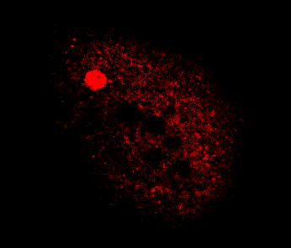
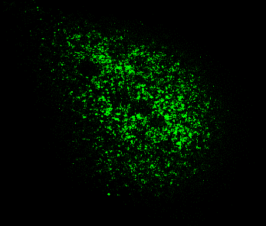
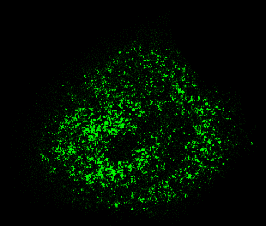
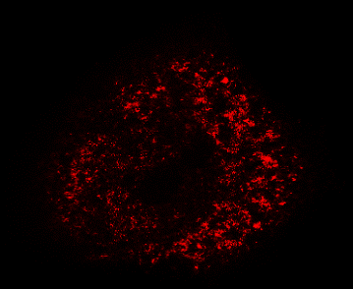
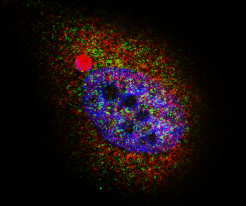
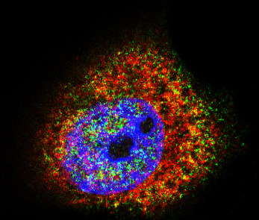
Normal condition
E1 treatment
LAMP2A
HSPA8
Merge
A

B

Figure S4. HSD17B4 is a substrate of CMA. (A and B) E1 treatment activates CMA. MCF7 cells were cultured with or without E1 for 24 h as indicated, then paraformaldehyde fixed, blocked, and processed for double immunofluorescence with antibodies against LAMP2A (green) and HSPA8 (red). Merged images of both channels are shown on the right. Bar: 5 μm (A). Relative LAMP2A colocalization with HSPA8 was calculated by ImageJ software, the ratio was quantified. Mean values were calculated from the individual distributions in 10 cells per condition (B).

FLAG-CREBBP
K669Ac:HSD17B4 ratio
HSD17B4
HSD17B4

HSD17B4:ACTB ratio
ACTB

FLAG-CREBBP
1.0
1.7
1.5
2.0
+
+
+
-
-
+
-
-
1.0
1.5
1.2
1.9
+
+
+
-
-
+
-
-
1.0
1.3
0.4
1.9
1.0
1.9
0.6
1.4
MCF7
MDA-MB-231
K669Ac

70 kDa
70 kDa
70 kDa
40 kDa
300 kDa
BAF

Figure S5. CREBBP acetylates HSD17B4 at K669. BAF blocks the reduction of HSD17B4 protein induced by CREBBP overexpression. FLAG-CREBBP was transfected into MCF7 and MDA-MB-231 cells with or without BAF treatment and cell lysates were analyzed by western blotting.

A
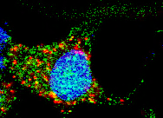
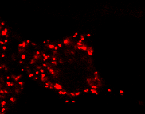
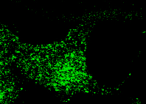
SIRT3
HSD17B4
Merge

B
40 kDa
70 kDa
NH4Cl
SIRT3
HSD17B4 antibody
IP:HSD17B4
SIRT3:HSD17B4 ratio

CLQ
HSD17B4
Input:
HSD17B4
70 kDa
+
+
+
-
+
-
+
-
-
-
-
-
1.0
1.00
1.1

Figure S6. SIRT3 deacetylates HSD17B4 at K669. (A) SIRT3 colocalizes with HSD17B4. Cultured MCF7 cells were paraformaldehyde fixed, blocked, and processed for double immunofluorescence with antibodies against SIRT3 (green) and HSD17B4 (red). Merged images of both channels are shown on the right. Bar: 5 μm. (B) Neither CLQ nor NH₄Cl affect the interaction between endogenous HSD17B4 and SIRT3 in MCF7 cells. MCF7 cells were cultured with or without CLQ or NH₄Cl for 24 h before harvest. The interaction between endogenous HSD17B4 and SIRT3 was determined by coIP and western blotting.

A
B
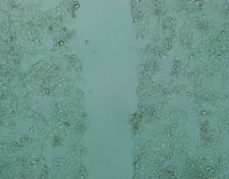
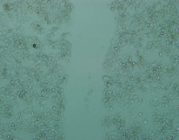
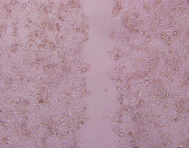
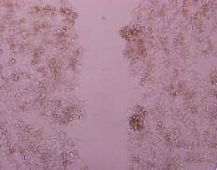
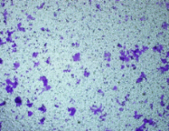
pMKO
shHSD17B4
0 h
24 h
200 μm
200 μm
200 μm
200 μm
pMKO
shHSD17B4

C
pMKO
shHSD17B4

Figure S7. K669 mutants increase cell migration and invasion. (A) Knockdown of HSD17B4 inhibits migration of MCF7 cells. MCF7 stable cells treated as indicated were analyzed for migration by a wound-healing assay. Scale bars: 200 μm. (B) Knockdown of HSD17B4 inhibits migration of MCF7 cells. MCF7 stable cells treated as indicated were analyzed by migration assays in 24-well chambers without matrigel. (C) Knockdown of HSD17B4 inhibits invasion of MCF7 cells. MCF7 stable cells treated as indicated were analyzed by invasion assays in 24-well invasion matrigel chambers.

