Electronic Supplementary Material

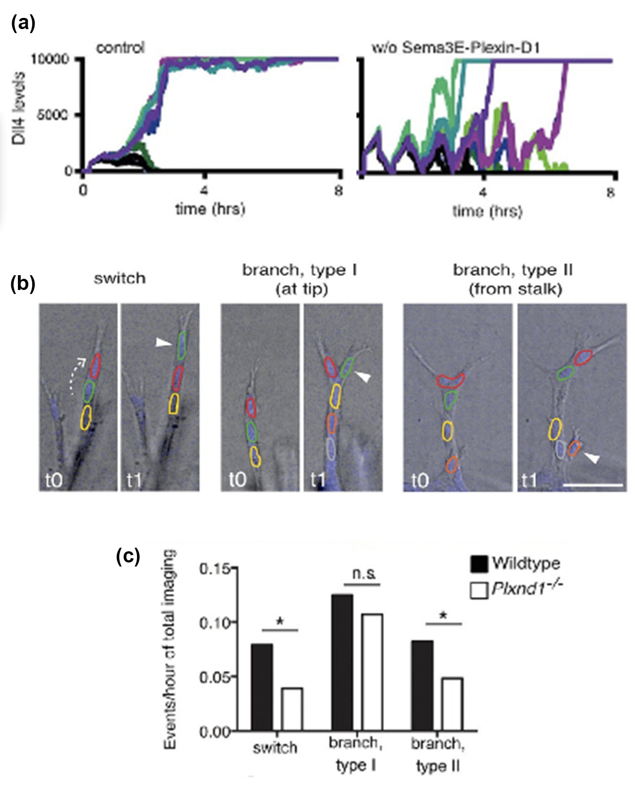
Figure S1. Sema3E-PlexinD1 speeds up the CPG increasing branching density. (a) MSM simulations predict sparser branching due to longer time spent battling in low level dll4 oscillations before amplifying differences enough to select tip/stalk states (b,c) Live imaging quantification of cell dynamics in sprouting mouse lung explants ex vivo show that tip cell selection (either by position interchanging, branching at the tip or from the stalk) frequency is lower: rearrangement and sprouting takes longer to occur in the absence of PlexinD1. All figures reproduced from [55] with permission.

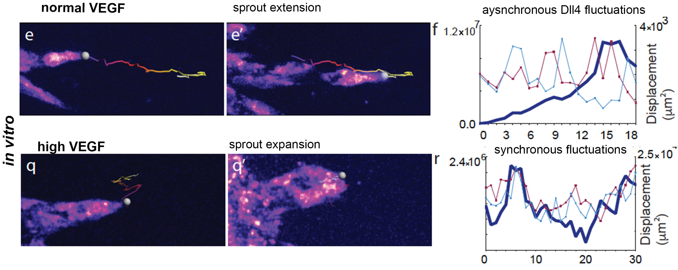
Figure S2. Pathologically High VEGF synchronized the CPG and promotes vessel expansion. (e,e’, q,q’) Start and end point of confocal time-lapse acquisitions of 3Dll4-dVenus (dynamic Dll4 reporter) embryoid bodies cultured in normal Vegf (50 ng/ml) and high Vegf (500 ng/ml). (f,r) Quantification by time-lapse microscopy of the sprout tip displacement in x,y,z dimensions (trailing multi-coloured lines on frames) y axis only – (thick blue line on graph) and Dll4 intensity at individual regions of the sprout.

