Supplementary figure 2.
Microglial activation scores correlations between CD68 and Iba1 antibodies
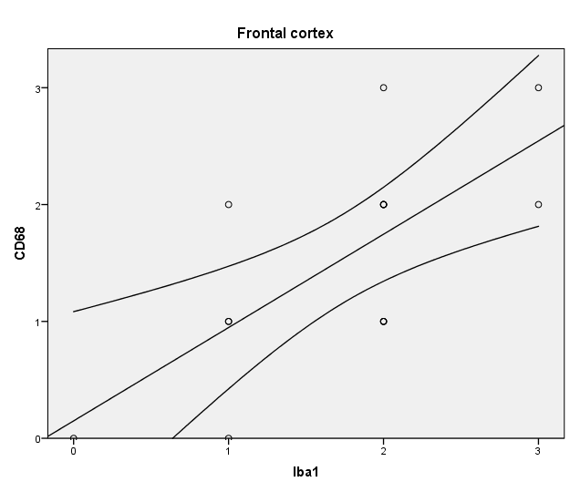

r = 0.609
p < 0.01

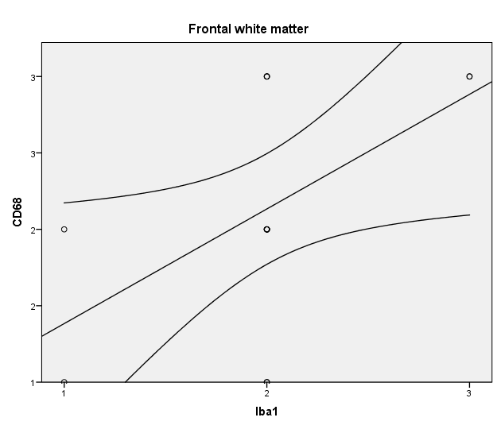

r = 0.514
p < 0.05

