**Title:** Early social learning triggers neurogenomic expression changes in a swordtail fish

**Authors:** Rongfeng Cui1,2*, Pablo J. Delclos1,3*, Molly Schumer1,3,4,5, and Gil G. Rosenthal1,3

*denotes equal contribution

**Affiliations:**

1Department of Biology, Texas A&M University, College Station, TX 77843, USA

2Present address: Max-Planck Institute for the Biology of Aging, Cologne, 50931, Germany

3Centro de Investigaciones Científicas de las Huastecas “Aguazarca”, Calnali, Hidalgo, Mexico

4Department of Ecology & Evolutionary Biology, Princeton University, Princeton, NJ 08544, USA

5Present address: Department of Biological Sciences, Columbia University, NY 10027, USA

**Supporting Information**

**I. Fish husbandry**

Sixteen *X. malinche* females were collected from the Arroyo Xontla at Chicayotla, Calnali, Hidalgo, Mexico [1] in March 2010 [2] and transported to Texas A&M University facilities where they gave birth. When offspring reached approximately 2 months of age, families were evenly pooled and separated into 3 treatment groups: 1) M-EXP (starting N=33 both sexes, females surviving to adulthood N=17) exposed to 2 males and 2 females of adult *X. malinche* from the Chicayotla locality; 2) B-EXP (starting N=34 both sexes, surviving females N=18) exposed to 2 males and 2 females of adult *X. birchmanni* from the Garces locality [2] and 3) Controls (starting N=55 both sexes, surviving females N=26) which did not receive adult stimulus exposure. Exposure treatments were performed in adjacent 208L aquaria where adults and juveniles were divided by a transparent, perforated Plexiglas board which allowed for transmission of both visual and olfactory cues [3]. The control tank did not contain a divider. Juvenile males were isolated from the subject females upon the first sign of maturation (hardening of the anal fin to form the gonopodium). At an average age of 11 months, we tested female preference for visual and olfactory cues of *X. birchmanni* and *X. malinche*. After all behavioural trials were concluded, females were rinsed in tank water and returned to their respective treatment for an additional 2 months (at age of 13 months) before sample collection to minimize possible short-term effects from behavioural trials. Visual and olfactory exposure thus continued until the time of sample collection.

To compare the preferences of lab-reared and naturally-raised individuals, we also tested mate preference of wild-caught *X. malinche* females. For these trials, 23 individuals were collected using baited minnow traps from the Río Claro at Tlatzintla, Hidalgo, Mexico (20º 52' 51" N, 98º 47' 56" W) in 2004 and 2005 (2 individuals were non-responsive). This population is upstream from *X. birchmanni* populations and other *Xiphophorus*.

**II. Preference trial methods**

We conducted visual preference trials to compare the effects of learning between sensory modalities. We used previously described computer animation playback techniques [3-5] to test focal females’ preferences for *X. birchmanni* versus *X. malinche* visual cues. As previously described [3], CRT monitors displayed male courtship animations with mean *X. birchmanni* and *X. malinche* phenotypes controlled by a video server synchronized with the Viewer (Biobserve GmbH, Bonn, Germany) recording software. For wild-caught females (*N* = 19), videos were started manually and association times (see below) were scored by direct visual observation.

The trial tanks (51 x 28 cm filled to a depth of 20 cm) were opaque on all sides except at the short ends, which are placed against the CRT screens. Female position during the trial was recorded at 8 frames per second using an overhead camera. The tank was equally divided along its length into three virtual zones with the middle one defined as the neutral zone.

CRT monitors displayed a blank screen with a uniform green colour identical to the background in the animation stimulus during the 10-min acclimatization period. At the end of acclimatization, standard-length matched *X. birchmanni* and *X. malinche* visual stimuli started playing on each side for 5 min followed by 5 min blank screen and then another 5 min of stimuli with the sides switched. Association time for each stimulus was summed from the two 5-min stimulation periods. Association time is a standard measure of preference and predicts mate choice in poeciliids [6, 7].

If the female spent more than 290s in one of the preference zones in both trial periods, she was defined as non-responsive and excluded from data analysis. Side of first presentation was systematically altered across trials. We tested 26 (19 responsive) control, 18 (18 responsive) B-EXP and 17 (13 responsive) M-EXP females.

Olfactory preference trials

Two days after the visual trials, we tested female preference for conspecific versus heterospecific male odours following a protocol described in previous studies [3, 8, 9]. Briefly, to produce the olfactory cues, 20L aquaria were thoroughly cleaned with 1:1 mixture of hydrogen peroxide and Alconox and rinsed with carbon-filtered water 6 times. Groups of four male *X. birchmanni* and four male *X. malinche* were separately placed in 16 litres of carbon-filtered water and visually exposed to 6 females from their own population in adjacent identical tanks for 4 hours. In total, 6 male *X. birchmanni* from Garces and 6 male *X. malinche* from Chicayotla were used to make the stimulus water. Model males in the exposure treatments were never used to produce stimulus water.

During the preference tests, trial tank configurations were as reported above except that the two transparent ends were blocked with opaque white paper. Ten minutes before each trial, the focal female was introduced to the testing tank for acclimation. After the 10-minute period, stimulus water started dripping on both far ends of the tank driven by a computer-controlled peristaltic pump (VWR) until the end of trial, at a flow rate of approximately 5 ml/min. When cue exposure began, we allowed 5 min for the focal female to visit both preference zones. If the subject failed to do so, she was defined as unresponsive and excluded from data analysis. Starting at the moment the subject entered the third zone, the time in each zone was recorded for a total of 5 min. Each female was tested twice back-to-back with the first presentation of cues randomized by sides. Then the cue sides were switched in the second trial. We averaged the association time in the two trials for data analysis. If the female was unresponsive in one trial, we only included association time from the other trial in analysis. We tested 26 (18 responsive) control, 18 (17 responsive) B-EXP and 17 (17 responsive) M-EXP females. Wild-caught females described above were also tested for olfactory preference (N=10 responsive).

**III. RNA extraction, library preparation and read mapping**

RNA was extracted from the above tissue using a standard Trizol reagent protocol following manufacturer’s instructions and quantified and assessed for quality on a Bioanalyzer 2100 (Agilent Technologies). Briefly, tissue was completely homogenized in Trizol (Life Technologies) with a hand-held TissueRuptor (Qiagen) then extracted with 100μL of bromochloropropane, followed by overnight precipitation with isopropanol in -80˚C and two washes of 75% ethanol. RNA quality indices from the Bioanalyzer ranged from 8.3-9.8. One microgram of total RNA was used to prepare libraries following Illumina’s TruSeq mRNA Sample Prep Kit with minor modifications. All libraries were prepared simultaneously. Briefly, mRNA was purified from total RNA using manufacturer provided beads. Following cDNA synthesis, mRNA was chemically fragmented and following end repair and A-tailing, samples were uniquely indexed by ligation. Libraries were PCR-amplified for 18 cycles and library size distribution and quality was verified on a Bioanalyzer 2100. Libraries were quantified on a Qubit fluorimeter, pooled in equal quantities, and sequenced on two Illumina HiSeq 2000 lanes (with 101 bp reads). Adaptor and PCR primer sequences and low quality bases in the raw reads were removed and trimmed by Trimnomatic (leading, trailing and sliding window quality >= 20 PHRED scale). Only reads >80 bp after filtering were kept for the downstream analyses.

Read mapping

We use the previously described pseudogenome assembly for *X. malinche* at ~35X coverage [10, 11] as the reference sequence for read mapping. Heterozygous sites were hard-masked with “N”s in the pseudo-genome. First, we mapped pooled reads from all individuals using TopHat 2.0.10 to obtain a comprehensive alternative junction list. We then mapped reads for each individual sample separately guided by this junction list. We allowed three mismatches to the reference per read (3/101 bp) and used default settings for the other parameters (--read-gap-length 1 --read-mismatches 3 --read-edit-dist 3 --b2-very-sensitive). We note that all analyses were repeated with the *X. maculatus* reference genome (which was generated by de-novo assembly [12]) to confirm that results were robust to the choice of reference sequence (Supporting Information I). We also confirm that major conclusions are insensitive to the choice of different read mapping programs (Supporting Information II).

**IV. Comparison using a different reference sequence**

To determine whether we have introduced bias by using the *X. malinche* pseudogenome as the reference, we used the same TopHat parameters to map the reads to the original *X. maculatus* reference genome, which the pseudogenome was based on. As expected, the total number of mappable reads is slightly lower than mapping to the conspecific pseudogenome reference (79.7% vs. 81.2%). On the other hand, the gene read counts output by HTSeq were highly correlated between the two references, with the regression coefficients R ranging from 0.995 to 0.997. Because of the slightly better mapping performance, we based our subsequent analyses on the pseudogenome reference.

**V. Comparison of different alignment methods**

Methods of aligning reads to the genome and stringency of alignment parameters can potentially have major effects on genes detected as differentially expressed. To investigate the possible impact of different aligners and different alignment parameters on the genes detected in our analyses, we repeated alignment and all downstream analysis steps with STAMPY [13] with an expected divergence of 0.02. STAMPY does not use an explicit intron-exon model in mapping and also maps more divergent reads than other aligners. In addition, we repeated TopHat analysis using a more stringent mismatch parameter (2 allowed mismatches instead of 3). The results of these three analyses were strikingly similar (Figure S3), suggesting that our major results are not very sensitive to the aligner or alignment parameters used.

**VI. Odorant receptor identification and molecular evolution**

To identify odorant receptors not annotated in the *X. maculatus* genome from which the *X. malinche* genome was built, we followed a previously described workflow [14, 15]. A total of 25 V2R paralogs (from stickleback), 55 OR paralogs (from medaka), 17 TAAR paralogs (from pufferfish) from teleost species were obtained from a previous study [14], and 82 V1R sequences (28 species, each 1-7 paralogs) were downloaded from NCBI Genbank as the probe sequences. These probe sequences are provided as supplementary materials (Supplementary files 1-4). They were translated into amino acid sequences, aligned to each other by Muscle [16] using MEGA 5 [17] with default parameters, and translated back to in-frame nucleotide sequences. An HMM model was built with this initial amino acid alignment with hmmer 2.3.2 [18]. Genewise 2.2.0 [19] is able to identify full coding sequences in correct open reading frames (ORFs) given the HMM model and a genomic or transcriptome sequence. Because the algorithm is intractable on full genomes or transcriptomes, we first performed discontiguous megablast (megablast-dc) using the initial nucleotide probe sequences, merged overlapping hits if hit coordinates are within 5kb, and extracted the merged hit region plus 5kb 5’- and 3’- flanking regions. These extracted genomic fragments were used as input for Genewise. Inferred coding sequences were then added back to the alignment, realigned to the correct reading frames, and used as probes and HMM inputs for the next iteration, repeating the above procedure. Two iterations were performed before no more new V2R, OR, TAAR or V1R sequences were identified by Genewise (see Supplementary file 5 for the GTF annotations, matched to *X. maculatus* genome, Ensembl version 74). Phylogenies of the identified sequences were reconstructed with RAxML 7.2.6 [20] with GTR+Gamma model with 100 rapid bootstraps for each family (Figure 5, Supplementary files 6-8) except for V1R because we found only two paralogs.

We extracted orthologous odorant receptor sequences from pseudogenomes of five *Xiphophorus* species [10-12] using the exon structure identified by Genewise. Heterozygous sites were hard-masked as “N”s in these genomes. Mismapped reads from paralogs will result in masking of all differing sites in the pseudogenome, thus our method is conservative for detecting dN/dS. Each gene alignment was checked for premature stop codons; genes containing premature stop codons were discarded from further analysis (11 ORs, 8 TAARs, 0 V1R and 8 V2Rs excluded). We then inferred gene trees for each odorant receptor gene for the 5 species using GTR+Gamma model with RAxML [21]. Some gene alignments failed the RAxML step due to extensive missing data in certain taxa. As a result, they were also excluded (2 ORs, 0 TAAR, 0 V1R, 6 V2Rs). Finally, we tested for positive selection using the ML tree in Codeml with a likelihood ratio test between the M8 and the M8a models (d.f. = 1) or M8-M7 (d.f. = 2) [22, 23]. The M8 model assumes that some proportion (p1) of the sites is constrained or nearly neutral, with dN/dS ratios (0<ω1≤1) following a beta distribution, with p2 = 1-p1 of the sites falling into a distinct, positively selected category with dN/dS ratios ω2 ≥ 1. The parameters for the beta distribution as well as p2 and ω2 are estimated from data with maximum likelihood. This model can be compared to two null models M7 and M8a using likelihood ratio tests. Model M7 disallows positively selected sites by removing p2 and ω2 from the M8 model (d.f.=2). Model M8a keeps both parameters, but fixes the value of ω2 at 1, essentially removing one free parameter (d.f.=1). These two approaches are complementary because M8-M8a has a higher sensitivity but higher false positive rate, while M8-M7 has a lower sensitivity and lower false positive rate [24].

**VII. DESeq differential expression analysis**

Raw counts from the python package htseq-count were imported into the R package DESeq (version 1.20.0). Analyses were conducted according to the user manual using default parameters [25]. The adjusted p value was used to evaluate differential gene expression between exposure treatments. We performed the same sets of analyses for differential expression, applying the same 0.5 CPM threshold, as done in edgeR.

*Differential expression results*

We detected fewer differentially expressed genes using DESeq than in edgeR across all treatment comparisons. After coverage filtering, 17,765 genes were retained. 1,927 genes were significantly differentially expressed between the control group and combined exposed groups. 1,523 and 1,478 genes were significantly differentially expressed between the control group and *birchmanni* and *malinche* stimulus treated groups respectively. 64% of genes differentially expressed in the *birchmanni* treated group relative to controls were shared with the *malinche* treated group, and 66% of differentially expressed genes in the *malinche* treated group were shared with the *birchmanni* treated group. 61 genes were significantly differentially expressed between the *malinche* and *birchmanni* treated stimulus groups. All genes that were found to be significantly differentially expressed between treatments using DESeq were also significant using edgeR. After false discovery correction, no olfactory receptors were significantly differentially expressed among treatments using DESeq analyses. These results are consistent with previous simulation studies showing that DESeq controls false discovery rate (FDR) better but has less power than edgeR [26].

**VIII. Differential expression and GO analysis excluding muscle and skin-related genes**

In order to ensure that the results on differential expression and gene ontology (GO) and pathway enrichment analyses were due to neural differences between treatment groups, we reanalyzed all RNAseq data after identifying and excluding genes that have significantly higher expression in the skin compared to both the olfactory epithelium and the brain. To do this, we obtained previously published RNAseq datasets taken from the zebrafish *Danio rerio* olfactory epithelia (n = 6 Saraiva et al. 2015 Scientific Reports), whole brain and skin (n = 7 Baumgart et al. 2016 Cell Syst), and muscle (n=3 Hartig et al. 2016, Biology Open). Raw fastq.gz files were mapped to the zebrafish genome (release 87) to obtain raw counts following the same pipeline as described for *X. malinche* in the main text. We then tested for differential expression as previously described to identify genes that were significantly more expressed in skin or muscle samples relative to both whole brain and olfactory epithelia samples, based on separate pairwise comparisons between non-neural and neural tissue samples (FDR < 0.05). We identified 1,558 “skin-related” zebrafish genes. Using Ensembl’s BioMart (release 87), we downloaded a list of all *D. rerio* Ensembl genes with confident orthologous *X. maculatus* Ensembl ID’s (Dataset: Zebrafish genes (GRCz10), Filters: Orthologous Platyfish Genes: Only, Attributes: Gene ID, Platyfish gene stable ID, Platyfish orthology confidence [0 low, 1 high]). Using this list, we found confident orthologous *X. maculatus* Ensembl ID’s for 1,047 of the genes found to be more highly expressed in either muscle or skin tissue than in both brain and olfactory epithelia samples in the zebrafish dataset. These genes were then excluded from all *X. malinche* count data, and we then ran edgeR analyses for differential expression as described in the main text.

After excluding muscle and skin-related genes, we found 329 differentially expressed genes between B-EXP and M-EXP individuals (90.9% of genes matched with the analysis in the main text), 1,926 between controls and M-EXP (93.6% match), and 2,224 between controls and M-EXP (93.6 % match, see electronic supplementary materials for gene lists). We then conducted GO enrichment analysis and obtained functionally similar results as those described in the main text (Fig. S3, see electronic supplementary materials for significant GO terms for all differentially expressed gene lists). For example, 62 of the 76 significant GO terms found in the list of differentially expressed genes between B-EXP and M-EXP samples were also found in the main analysis GO term list. Therefore the major conclusions are unlikely driven by the inclusion of extraneous tissue in the sample.

**IX. qPCR validation of candidate genes**

Upon discovering differentially expressed genes in RNAseq analysis, we chose the following candidate genes for validation using qPCR with increased sample size (n=8) from each experimental group: V2R6 and V2R40. Total RNA extraction method was identical with that used in RNAseq library preparation. We used the NCBI primer design tool (http://www.ncbi.nlm.nih.gov/tools/primer-blast/) to find optimal primers for qPCR requiring a product size range of 80-120 bp, using Genewise prediction of odorant receptor coding sequences as input. We require primers to have no off-target hits as identified by the online tool by blasting to the *X. maculatus* genome. The following primer pairs are designed from exon 2 of V2R_6, exon 7 of V2R_40: V2R_6-F 5’- ACAAGGCTGTGTATGCAATAGGG-3’, V2R_6-R 5’- GACGCATGTGTTTGTCACACTG-3’; V2R_40-F 5’- CCCTGTAAAGGTGCCAGGGTC -3’, V2R_40-R 5’- AAGCAGCATACAGGCTCCCC -3’.

Following extraction, RNA was quantified on a Nanodrop 1000 (Thermo Scientific) and 500-1000 ng were reverse transcribed into cDNA using the GoScript Reverse Transcription System (Promega) following manufacturer’s instructions. Efficiency of each primer pair was determined by a 6-step 2-fold serial dilution series run in triplicate and ranged from 91-98%. Following efficiency determination, each sample was quantified for each of the four genes of interest by running 1μl of cDNA per qPCR reaction in triplicate. qPCR was performed on an Applied Biosystems StepOne Plus system using 12.5 μl of the Applied Biosystems SYBR Mastermix, 2.25 μl forward primer, 2.25 μl reverse primer, and 7 μl H2O per reaction. The cycling program used default parameters except for V2R6 and OR6 which were annealed at 58° C. All samples for a particular gene were quantified on the same plate and Ct was automatically determined by the StepOne Applied Biosystems software for each plate. To control for DNA concentration, we quantified the 2 μl of input cDNA in triplicate using the Qubit Fluorometer (Invitrogen) High Sensitivity kit. We used this input cDNA concentration to normalize the Ct values before analysing differential expression between treatment groups.

We used the following approach to normalize CT values by total input cDNA, and we compare the means between groups using non-parametric tests (Wilcoxon for pairwise and Krusalis-Wallis for three groups (Supporting information IV).



Where *E* is primer efficiency, *Ct* is cycle number to reach the target threshold, and *D* is amount of cDNA (ng) used in the qPCR reaction.

**X. Proof of qPCR normalization method**

$$T=r^{c}a_{0}$$

$$\frac{T}{r^{c}}=a_{0}$$

$$\frac{T}{{Ir}^{c}}=\frac{a_{0}}{I}$$

$\log_{r}{\frac{a_{0}}{I}}=\log_{r}{T}-c-\log_{r}{I}$ (1)

*T* - Final target DNA amount after amplification

*a0* – Initial gene cDNA amount

*c* – CT value (number of cycles used to reach T).

*r* – copying rate, taking efficiency into account ( 2efficiency)

*I* – Total input cDNA amount

- Initial gene cDNA concentration

Because $\log_{r}{T}$ is a constant (T is set to the same value for all qPCR reactions), $\log_{r}{\frac{a_{0}}{I}}$ is asymptotically monotonic with $(-c-\log_{r}{I)}$.

However, the measurement unit for DNA amount differs for the input DNA and the amplified target (initial cDNA amount is measured in unit $U_{1}$, usually in ng, final DNA amount at T is measured with fluorescent unit $U_{2}$, a constant conversion factor w is required to convert unit $U_{1}$ to $U_{2}$, such that $U_{1}=wU_{2}$).

(1) can be rewritten as:

$\log_{r}{\frac{{U_{1}a}_{0}}{U_{1}I}}=\log_{r}{{wU}_{2}T}-c-\log_{r}{U_{1}I}$ (2)

$\log_{r}{{wU}_{2}T}$ is still a constant given that all qPCR reactions have the same ending fluorescent strength. Therefore, asymptotically $-c-\log_{r}{U_{1}I}$ predicts the value of $\frac{a_{0}}{I_{}}$, proof:

Let $c_{1}$, $c_{2}$ be the CT values and $I_{1}$, $I_{2}$ the initial cDNA input amounts in 2 qPCR reactions,

Let $-c_{1}-\log_{r}U_{1}{I_{1}< -c_{2}-\log_{r}{U_{1}I_{2} } }$

Add constant $\log_{r}{{wU}_{2}T}$ to both sides of the inequality:

$$\log_{r}{{wU}_{2}T}-c_{1}-\log_{r}{U_{1}I_{1}< \log_{r}{{wU}_{2}T}-c_{2}-\log_{r}{U_{1}I_{2} } }$$

Substitute using (2)

$$\log_{r}{\frac{{U_{1}a}_{1}}{U_{1}I_{1}}}< \log_{r}{\frac{{U_{1}a}_{2}}{U_{1}I_{2}}}$$

Because r > 1, the log function is asymptotically increasing:

$$∴{\frac{{U_{1}a}_{1}}{U_{1}I_{1}}}< \frac{{U_{1}a}_{2}}{U_{1}I_{2}}$$

$$∴{\frac{a_{1}}{I_{1}}}< \frac{a_{2}}{I_{2}}$$

Figures

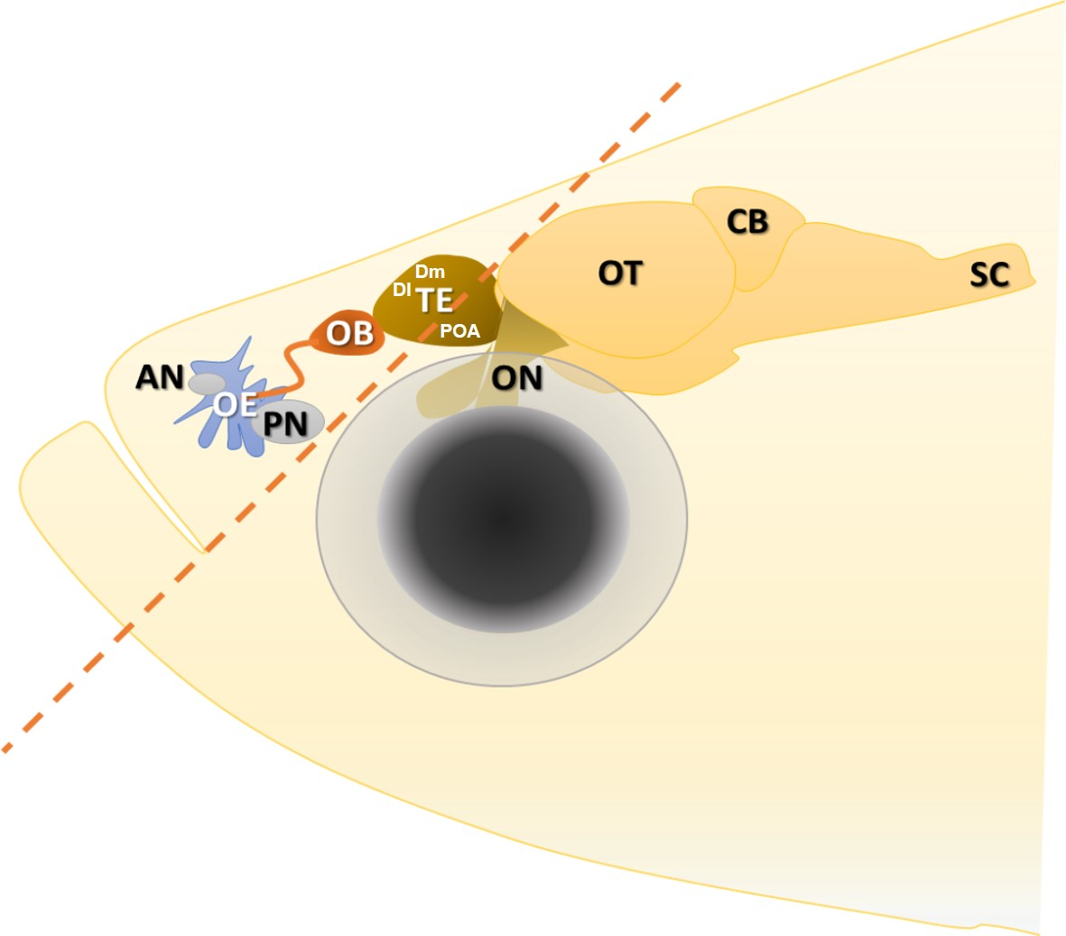

Figure S1. Sampling method of pooled sensory and brain tissue, brain structure drawing modified from [27]. A single 45 degree cut was made in front of the orbits, taking tissues including lips, olfactory epithelium, olfactory bulb and dorsal part of telencephalon (specifically the medial (Dm) and lateral (Dl) zones of the dorsal telencephalon). Abbreviations: AN – anterior nostril, PN – posterior nostril, OE – olfactory epithelium, OB - olfactory bulb, TE – telencephalon, ON – optic nerve, OT – optic tectum, CB- cerebellum, SC – spinal cord.

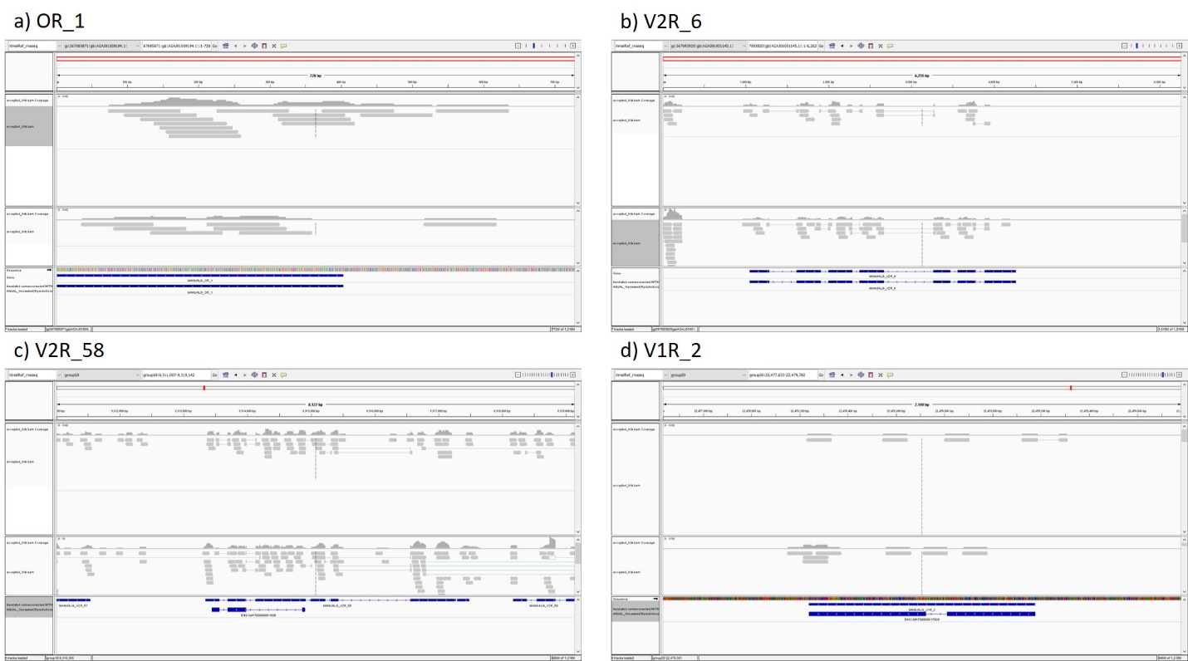Figure S2- Representative screenshot images of IGV plots for odorant receptor genes comparing the predicted gene models (top blue bar) with Ensembl gene predictions (bottom blue bar) and RNAseq reads (grey bars). Note how the predicted gene models largely overlap better with the RNAseq reads than Ensemble v 74 gene predictions, which are completely missing (OR_1, V2R_6), missing exons (V2R_58) or include unsupported introns based on RNAseq reads (V1R_2).

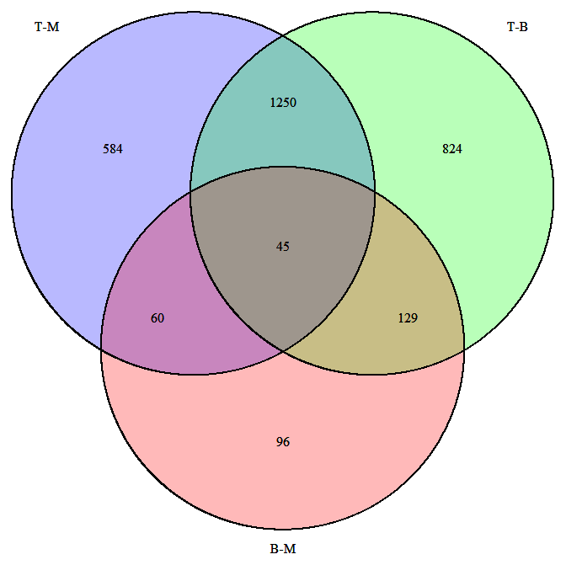

Control vs M

Control vs B

M vs B

Figure S3 - Venn diagram showing overlaps of differentially expressed genes between three comparisons: 1) Control vs. *malinche* exposed (Control vs M) 2) Control vs. *birchmanni* exposed (Control vs B) and 3) *malinche* vs *birchmanni* exposed (M vs B).

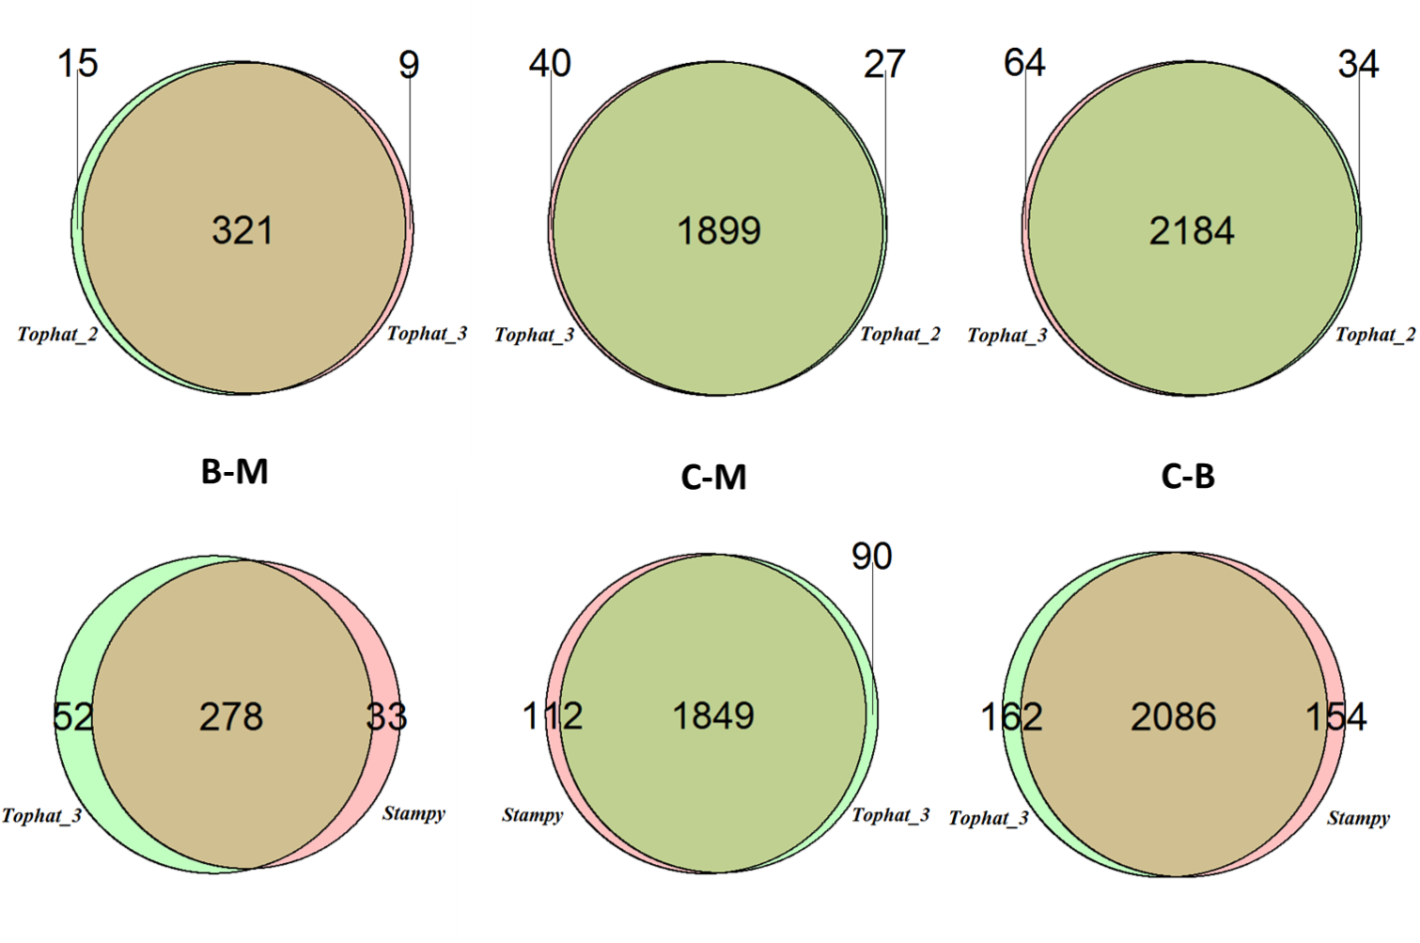

Figure S4. Repeatability of differential expression analysis with different read mappers. Tophat_2: allowing for two mismatches; Tophat_3: allowing for three mismatches; Stampy: expected divergence 0.02. B-M: Differentially expressed (DE) genes between *birchmanni*-*malinche* exposure treatments; C-M: between control group and malinche exposed group; C-B: between control and *birchmanni*-exposed group. Comparisons are performed using an FDR cutoff of 0.05.

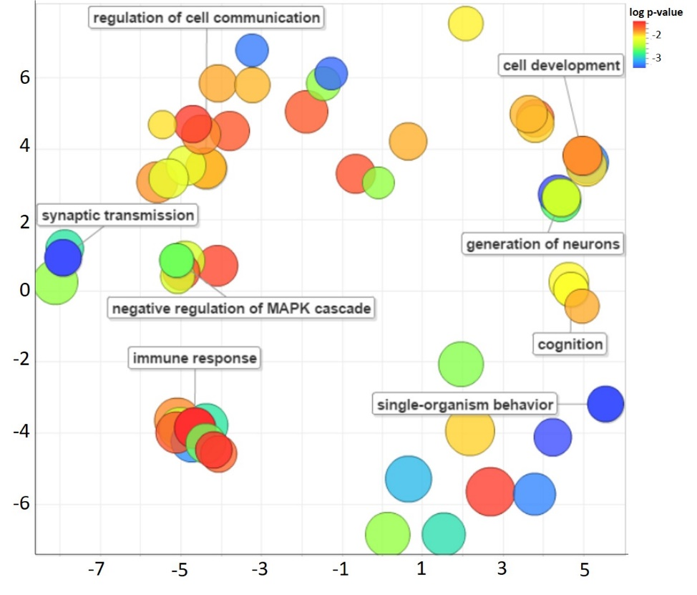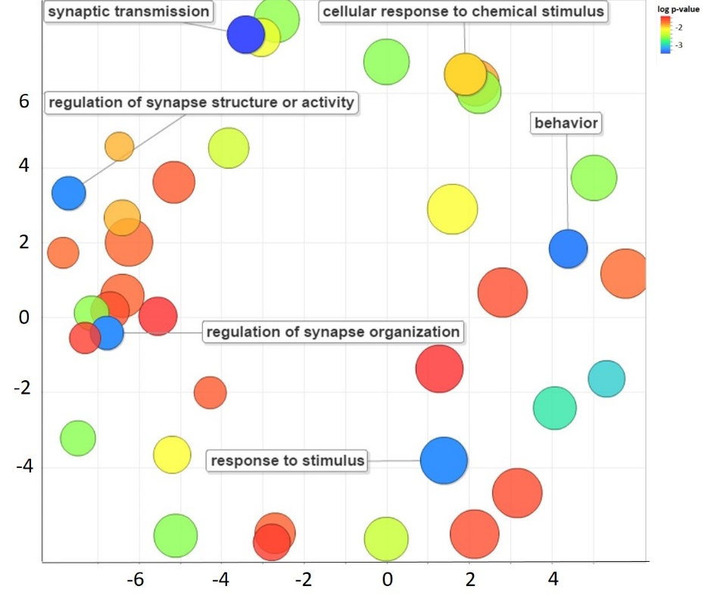

Figure S5- Gene ontology terms of differentially expressed genes for the *X. birchmanni* – *X. malinche*- exposed comparison a) before and b) after excluding “muscle and skin-related” genes, visualized with Revigo using the SimRel term similiarity index. Color of circle represents –log(p value), with warmer colors representing highly significant terms. Size of circles refer to the amount of sub-categories contained within a given category. Axes values denote semantic space values according to SimRel.

Fosb V2R_6

AB

Figure S6. qPCR verification of differential expression genes with n=8 females in each group. A) Fosb; B) V2R_6.

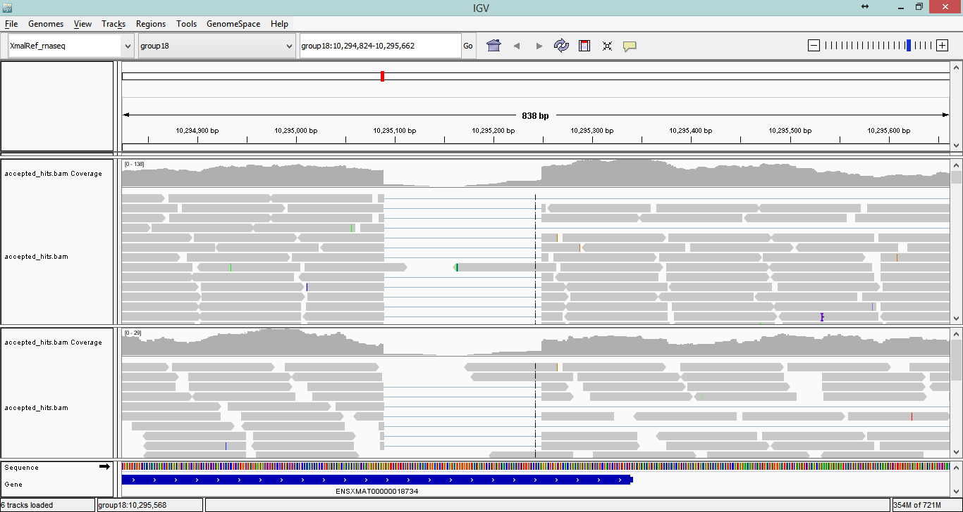

|  |  |
| --- | --- |
| **Species** | 5’ splice site Branch point pyrimidine tract 3’ splice site |
| *Homo sapiens* | 5' CGAGgtgaga acctgac cttctctcttt cagTGAAGT 3' |
| *Rattus norvegicus* | 5' GGAGgtgaga acctgac cttctctcttt cagTGAAGT 3' |
| *Danio rerio* | 5' GAGCctgcgg acataac agaaacatatt tcgTGGAGT 3' |
| *Xiphophorus malinche* | 5' GGAGgtagag acctggt tcatttgtgtt cagAGGGAG 3' |

Figure S7. Screen shot of IGV genome browser showing representative RNAseq reads mapped to the *fosb* locus. The majority of transcripts contain a characteristic spliced variation at the 3’ end that’s homologous to the stable ΔFosB found in other vertebrates. Uppercase letters are located within exonic regions, lowercase letters represent alternatively spliced intronic region. Spliced sites for other species are obtained from Marinescu et al. (2007)[28]. Note that the branch point in *X. malinche* is palindromic.

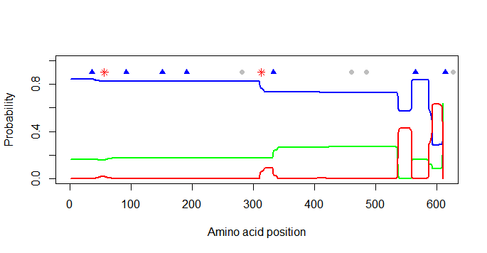

Figure S8. Transmembrane regions of V2R 6 from *X. malinche* inferred by TMHMM-2.0 (Blue line- extracellular domain, red line – transmembrane domain, green line – intracellular domain). Amino acid differences between *X. birchmanni* and *X. malinche* are shown: red asterisk – mutation unique to this species pair; blue triangles – mutation also found in one or more of *X. clemenciae*, *X. hellerii* and *X. maculatus*; grey rounded dots – ambiguous due to missing data in another species. Putative ligand binding region in V2R locates on the extracellular N-terminus (closer to position 0).

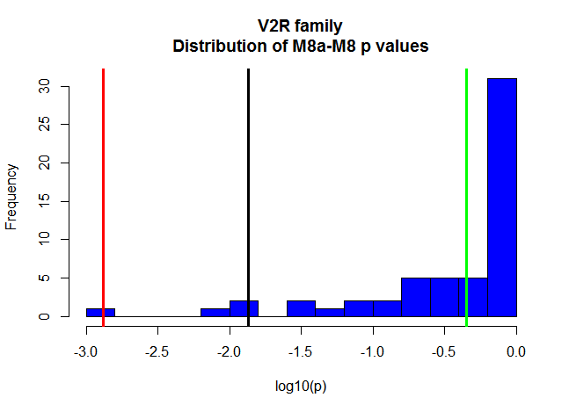

Figure S9. dNdS M8a-M8 tests p value distribution of the V2R family. Differentially expressed gene (DEG, raw p<0.01) between B-EXP and M-EXP: V2R_6 (red line), V2R_46 (green line). DEG between Control and B-EXP: V2R_40 (black line).

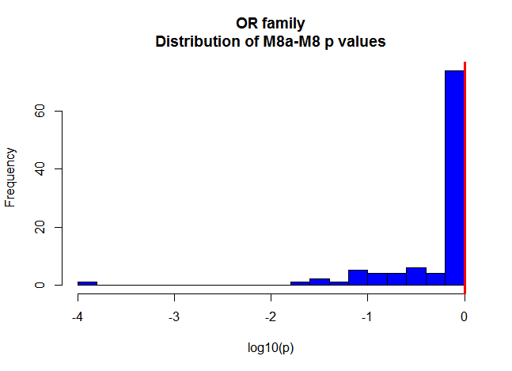

Figure S10. dNdS M8a-M8 tests p value distribution of the OR family. Differentially expressed gene (DEG, raw p<0.01) between Control and M-EXP: OR_16 (red line).

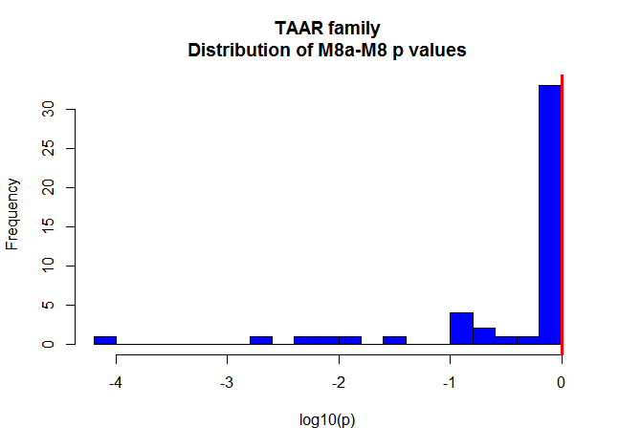

Figure S11. dNdS M8a-M8 tests p value distribution of the TAAR family. Differentially expressed gene (DEG, raw p<0.01) between Control and B-EXP: TAAR_25 (red line).

Figure S12- Gene expression levels (log + 1 transformed counts) of representative odorant receptor genes in *Danio rerio* olfactory epithelium (OE) and whole brain, highlighting the negligible effect differences in brain gene expression would have on observed total differences in odorant receptor gene expression. Counts were obtained from the *D. rerio* dataset described in Supporting Information VIII. Error bars represent SEM.

Table S1 -Alignment statistics for the samples used in this study with tophat, allowing for 3 mismatches

|  |  |  |  |
| --- | --- | --- | --- |
| Sample | Number of reads | Percent Mapped | Percent multiple alignments |
| Control female 1 | 21828760 | 83.1 | 1.3 |
| Control female 2 | 26403288 | 81.0 | 2.1 |
| Control female 3 | 25922662 | 82.0 | 1.9 |
| Control female 4 | 24819697 | 81.8 | 2.2 |
| *malinche* treated 1 | 23865638 | 81.9 | 1.9 |
| *malinche* treated 2 | 25122442 | 82.0 | 1.9 |
| *malinche* treated 3 | 22644001 | 81.8 | 1.9 |
| *malinche* treated 4 | 25581923 | 82.1 | 1.8 |
| *birchmanni* treated 1 | 24367400 | 82.1 | 1.8 |
| *birchmanni* treated 2 | 25207335 | 80.8 | 1.9 |
| *birchmanni* treated 3 | 23926948 | 74.7 | 2.4 |
| *birchmanni* treated 4 | 21840338 | 81.5 | 1.7 |

Table S2 - Differentially expressed genes shared between at least two comparisons: FDR p values for BM: *birchmanni*-exposed vs. *malinche*-exposed; CM: control vs. *malinche*-exposed; CB: control vs. *birchmanni*-exposed. Only genes annotated with gene symbols are shown, for full table, refer to file diff_exp_supptable.xlsx.

| **GeneName** | **GeneID** | **BM** | **CM** | **CB** |
| --- | --- | --- | --- | --- |
| FOSB | ENSXMAG00000018663 | 0.000 | 0.000 | 0.000 |
| DUSP5 | ENSXMAG00000007046 | 0.000 | 0.000 | 0.000 |
| SERPINE1 | ENSXMAG00000011952 | 0.000 | 0.000 | 0.037 |
| HSD3B7 | ENSXMAG00000008008 | 0.000 | 0.000 | 0.000 |
| PTGS2 | ENSXMAG00000002418 | 0.000 | 0.000 | 0.000 |
| LAMC2 | ENSXMAG00000011284 | 0.000 | 0.000 | 0.000 |
| ZBTB7C | ENSXMAG00000004232 | 0.000 | 0.000 | 0.001 |
| EGR1 | ENSXMAG00000008996 | 0.001 | 0.000 | 0.000 |
| HGFAC | ENSXMAG00000015841 | 0.001 | 0.046 | 0.000 |
| KLF4 | ENSXMAG00000014131 | 0.002 | 0.000 | 0.000 |
| GLDC | ENSXMAG00000003032 | 0.003 | 0.000 | 0.000 |
| EEF2K | ENSXMAG00000015752 | 0.004 | 0.000 | 0.000 |
| HMGA1 | ENSXMAG00000016571 | 0.005 | 0.000 | 0.000 |
| DUSP1 | ENSXMAG00000009651 | 0.006 | 0.000 | 0.021 |
| LAMB3 | ENSXMAG00000018790 | 0.006 | 0.000 | 0.000 |
| ATF3 | ENSXMAG00000004443 | 0.006 | 0.000 | 0.000 |
| LAMA3 | ENSXMAG00000016504 | 0.006 | 0.001 | 0.000 |
| DUSP8 | ENSXMAG00000019232 | 0.012 | 0.000 | 0.000 |
| HAS1 | ENSXMAG00000010604 | 0.017 | 0.000 | 0.001 |
| FOS | ENSXMAG00000004017 | 0.018 | 0.000 | 0.000 |
| BNC1 | ENSXMAG00000000835 | 0.019 | 0.000 | 0.000 |
| KLF2 | ENSXMAG00000000640 | 0.023 | 0.000 | 0.000 |
| FOSL1 | ENSXMAG00000013157 | 0.000 | > 0.05 | 0.000 |
| MMP1 | ENSXMAG00000013976 | 0.000 | > 0.05 | 0.000 |
| SLC16A12 | ENSXMAG00000017203 | 0.000 | > 0.05 | 0.000 |
| RFX2 | ENSXMAG00000002530 | 0.000 | > 0.05 | 0.000 |
| EGR3 | ENSXMAG00000001144 | 0.000 | 0.000 | > 0.05 |
| MT1F | ENSXMAG00000020384 | 0.000 | 0.000 | > 0.05 |
| CCKAR | ENSXMAG00000009902 | 0.000 | 0.000 | > 0.05 |
| USP30 | ENSXMAG00000018244 | 0.001 | 0.000 | > 0.05 |
| CPNE2 | ENSXMAG00000005853 | 0.001 | > 0.05 | 0.024 |
| SP140L | ENSXMAG00000001258 | 0.001 | 0.018 | > 0.05 |
| PRDM8 | ENSXMAG00000009993 | 0.001 | 0.010 | > 0.05 |
| GRIN1 | ENSXMAG00000003092 | 0.001 | 0.008 | > 0.05 |
| NPAS4 | ENSXMAG00000013170 | 0.001 | > 0.05 | 0.045 |
| NRN1 | ENSXMAG00000012826 | 0.001 | > 0.05 | 0.029 |
| CD44 | ENSXMAG00000000801 | 0.001 | > 0.05 | 0.000 |
| PHLDA2 | ENSXMAG00000019767 | 0.001 | 0.015 | > 0.05 |
| ZNFX1 | ENSXMAG00000005859 | 0.001 | > 0.05 | 0.000 |
| NPY | ENSXMAG00000000838 | 0.001 | > 0.05 | 0.001 |
| NEDD9 | ENSXMAG00000016120 | 0.002 | 0.002 | > 0.05 |
| NRSN2 | ENSXMAG00000013627 | 0.002 | > 0.05 | 0.001 |
| SOX11 | ENSXMAG00000020179 | 0.002 | > 0.05 | 0.000 |
| NECAB2 | ENSXMAG00000013000 | 0.002 | > 0.05 | 0.007 |
| CEBPB | ENSXMAG00000019665 | 0.002 | 0.000 | > 0.05 |
| TMEM240 | ENSXMAG00000012610 | 0.002 | > 0.05 | 0.027 |
| CREM | ENSXMAG00000006361 | 0.002 | 0.000 | > 0.05 |
| RAMP3 | ENSXMAG00000006290 | 0.003 | 0.017 | > 0.05 |
| SLC6A15 | ENSXMAG00000002814 | 0.003 | > 0.05 | 0.003 |
| DLK1 | ENSXMAG00000007730 | 0.004 | > 0.05 | 0.006 |
| NAB2 | ENSXMAG00000003591 | 0.005 | 0.020 | > 0.05 |
| SEZ6L2 | ENSXMAG00000011571 | 0.005 | > 0.05 | 0.024 |
| RSAD1 | ENSXMAG00000012923 | 0.005 | 0.000 | > 0.05 |
| SYBU | ENSXMAG00000007087 | 0.006 | > 0.05 | 0.027 |
| SLC6A11 | ENSXMAG00000017478 | 0.006 | > 0.05 | 0.029 |
| GABRD | ENSXMAG00000019394 | 0.006 | > 0.05 | 0.028 |
| PADI3 | ENSXMAG00000017865 | 0.006 | 0.016 | > 0.05 |
| MAFK | ENSXMAG00000009331 | 0.006 | 0.000 | > 0.05 |
| PRRT1 | ENSXMAG00000014134 | 0.012 | > 0.05 | 0.011 |
| KIFC2 | ENSXMAG00000014088 | 0.013 | > 0.05 | 0.019 |
| SKIL | ENSXMAG00000000477 | 0.016 | > 0.05 | 0.000 |
| FZD10 | ENSXMAG00000020088 | 0.017 | > 0.05 | 0.001 |
| AHNAK | ENSXMAG00000010087 | 0.019 | > 0.05 | 0.000 |
| AK5 | ENSXMAG00000016357 | 0.020 | > 0.05 | 0.015 |
| ELAVL2 | ENSXMAG00000004750 | 0.022 | > 0.05 | 0.043 |
| SNCA | ENSXMAG00000014135 | 0.022 | > 0.05 | 0.031 |
| RASA3 | ENSXMAG00000019239 | 0.022 | > 0.05 | 0.000 |
| TIMP3 | ENSXMAG00000010147 | 0.023 | > 0.05 | 0.007 |
| INPP1 | ENSXMAG00000003597 | 0.024 | 0.000 | > 0.05 |
| TPPP | ENSXMAG00000014084 | 0.024 | 0.006 | > 0.05 |
| STAT2 | ENSXMAG00000002056 | 0.024 | > 0.05 | 0.000 |
| DNER | ENSXMAG00000010820 | 0.027 | > 0.05 | 0.018 |
| NAV2 | ENSXMAG00000010189 | 0.031 | > 0.05 | 0.000 |
| RABGAP1 | ENSXMAG00000010078 | 0.031 | 0.009 | > 0.05 |
| MAP3K5 | ENSXMAG00000016278 | 0.037 | 0.000 | > 0.05 |
| GPR152 | ENSXMAG00000019184 | 0.038 | 0.000 | > 0.05 |
| ESRP1 | ENSXMAG00000013126 | 0.039 | 0.029 | > 0.05 |
| RASSF6 | ENSXMAG00000004159 | 0.039 | > 0.05 | 0.004 |
| HBEGF | ENSXMAG00000010006 | 0.041 | 0.001 | > 0.05 |
| ZFPM2 | ENSXMAG00000003403 | 0.041 | > 0.05 | 0.041 |
| NDRG4 | ENSXMAG00000015838 | 0.041 | > 0.05 | 0.010 |
| TNMD | ENSXMAG00000013726 | 0.045 | > 0.05 | 0.000 |
| ACTG1 | ENSXMAG00000015551 | 0.045 | > 0.05 | 0.002 |
| AMER2 | ENSXMAG00000000702 | 0.046 | > 0.05 | 0.008 |
| ABCA12 | ENSXMAG00000015970 | > 0.05 | 0.000 | 0.043 |
| ABCB7 | ENSXMAG00000009070 | > 0.05 | 0.007 | 0.028 |
| ABCE1 | ENSXMAG00000001778 | > 0.05 | 0.004 | 0.024 |
| ABCF2 | ENSXMAG00000001927 | > 0.05 | 0.000 | 0.000 |
| ABCF3 | ENSXMAG00000014038 | > 0.05 | 0.004 | 0.001 |
| ABHD14B | ENSXMAG00000016772 | > 0.05 | 0.047 | 0.044 |
| ABHD15 | ENSXMAG00000008472 | > 0.05 | 0.000 | 0.000 |
| ABHD17B | ENSXMAG00000001288 | > 0.05 | 0.000 | 0.000 |
| ABTB1 | ENSXMAG00000015862 | > 0.05 | 0.006 | 0.005 |
| ACBD3 | ENSXMAG00000007475 | > 0.05 | 0.000 | 0.000 |
| ACER2 | ENSXMAG00000005820 | > 0.05 | 0.038 | 0.004 |
| ACOT7 | ENSXMAG00000018646 | > 0.05 | 0.000 | 0.000 |
| ACOX1 | ENSXMAG00000006043 | > 0.05 | 0.027 | 0.006 |
| ADA | ENSXMAG00000001249 | > 0.05 | 0.000 | 0.000 |
| ADAM19 | ENSXMAG00000010315 | > 0.05 | 0.000 | 0.000 |
| ADAMTS18 | ENSXMAG00000014796 | > 0.05 | 0.032 | 0.034 |
| AFTPH | ENSXMAG00000015767 | > 0.05 | 0.037 | 0.007 |
| AGO3 | ENSXMAG00000007141 | > 0.05 | 0.000 | 0.000 |
| AGTR1 | ENSXMAG00000020155 | > 0.05 | 0.000 | 0.000 |
| AGXT2L1 | ENSXMAG00000014966 | > 0.05 | 0.000 | 0.000 |
| AGXT2L2 | ENSXMAG00000008961 | > 0.05 | 0.018 | 0.003 |
| ALPK1 | ENSXMAG00000011532 | > 0.05 | 0.005 | 0.035 |
| AMMECR1 | ENSXMAG00000005004 | > 0.05 | 0.001 | 0.003 |
| AMT | ENSXMAG00000019322 | > 0.05 | 0.013 | 0.013 |
| ANGPTL5 | ENSXMAG00000010840 | > 0.05 | 0.002 | 0.000 |
| ANKFN1 | ENSXMAG00000016934 | > 0.05 | 0.007 | 0.041 |
| ANKRD13B | ENSXMAG00000012073 | > 0.05 | 0.004 | 0.029 |
| ANKRD32 | ENSXMAG00000019402 | > 0.05 | 0.002 | 0.037 |
| ANKRD50 | ENSXMAG00000018353 | > 0.05 | 0.009 | 0.000 |
| ANO6 | ENSXMAG00000004021 | > 0.05 | 0.008 | 0.008 |
| AP1G1 | ENSXMAG00000005983 | > 0.05 | 0.006 | 0.005 |
| APLP1 | ENSXMAG00000010499 | > 0.05 | 0.006 | 0.000 |
| APPL2 | ENSXMAG00000017453 | > 0.05 | 0.002 | 0.008 |
| AQP3 | ENSXMAG00000019407 | > 0.05 | 0.000 | 0.000 |
| ARFGAP2 | ENSXMAG00000014012 | > 0.05 | 0.025 | 0.031 |
| ARG2 | ENSXMAG00000014792 | > 0.05 | 0.000 | 0.000 |
| ARHGEF26 | ENSXMAG00000001477 | > 0.05 | 0.000 | 0.000 |
| ARHGEF33 | ENSXMAG00000017168 | > 0.05 | 0.001 | 0.004 |
| ARID5B | ENSXMAG00000018209 | > 0.05 | 0.000 | 0.000 |
| ARL14EP | ENSXMAG00000000016 | > 0.05 | 0.013 | 0.003 |
| ARNTL | ENSXMAG00000015619 | > 0.05 | 0.000 | 0.001 |
| ARTN | ENSXMAG00000003941 | > 0.05 | 0.031 | 0.006 |
| ASTE1 | ENSXMAG00000004808 | > 0.05 | 0.043 | 0.016 |
| ATAD3A | ENSXMAG00000016601 | > 0.05 | 0.000 | 0.000 |
| ATL2 | ENSXMAG00000018291 | > 0.05 | 0.004 | 0.015 |
| ATP10B | ENSXMAG00000009322 | > 0.05 | 0.000 | 0.039 |
| ATP11C | ENSXMAG00000013304 | > 0.05 | 0.000 | 0.002 |
| ATP13A1 | ENSXMAG00000013346 | > 0.05 | 0.002 | 0.002 |
| ATP8B1 | ENSXMAG00000002723 | > 0.05 | 0.000 | 0.004 |
| ATXN1L | ENSXMAG00000005978 | > 0.05 | 0.009 | 0.023 |
| ATXN2L | ENSXMAG00000010133 | > 0.05 | 0.003 | 0.000 |
| AVPI1 | ENSXMAG00000020097 | > 0.05 | 0.000 | 0.004 |
| BANK1 | ENSXMAG00000008559 | > 0.05 | 0.000 | 0.024 |
| BARD1 | ENSXMAG00000015997 | > 0.05 | 0.012 | 0.032 |
| BARX1 | ENSXMAG00000007527 | > 0.05 | 0.003 | 0.044 |
| BARX2 | ENSXMAG00000000962 | > 0.05 | 0.000 | 0.000 |
| BAZ1A | ENSXMAG00000004820 | > 0.05 | 0.005 | 0.004 |
| BCKDK | ENSXMAG00000008794 | > 0.05 | 0.000 | 0.000 |
| BMP4 | ENSXMAG00000000766 | > 0.05 | 0.034 | 0.024 |
| BSPRY | ENSXMAG00000005501 | > 0.05 | 0.000 | 0.000 |
| BTBD1 | ENSXMAG00000015211 | > 0.05 | 0.028 | 0.047 |
| C10ORF118 | ENSXMAG00000008110 | > 0.05 | 0.001 | 0.000 |
| C10ORF54 | ENSXMAG00000004819 | > 0.05 | 0.010 | 0.010 |
| C12ORF23 | ENSXMAG00000001688 | > 0.05 | 0.003 | 0.001 |
| C2CD4A | ENSXMAG00000020324 | > 0.05 | 0.000 | 0.000 |
| CABLES1 | ENSXMAG00000016420 | > 0.05 | 0.003 | 0.002 |
| CAD | ENSXMAG00000005369 | > 0.05 | 0.007 | 0.006 |
| CAPN8 | ENSXMAG00000006017 | > 0.05 | 0.000 | 0.005 |
| CAPN9 | ENSXMAG00000016015 | > 0.05 | 0.000 | 0.005 |
| CARD11 | ENSXMAG00000001085 | > 0.05 | 0.011 | 0.001 |
| CARM1 | ENSXMAG00000002542 | > 0.05 | 0.000 | 0.000 |
| CASC3 | ENSXMAG00000013937 | > 0.05 | 0.000 | 0.000 |
| CASZ1 | ENSXMAG00000011322 | > 0.05 | 0.000 | 0.000 |
| CAT | ENSXMAG00000019152 | > 0.05 | 0.004 | 0.022 |
| CCBE1 | ENSXMAG00000004414 | > 0.05 | 0.004 | 0.001 |
| CCDC85B | ENSXMAG00000019513 | > 0.05 | 0.005 | 0.000 |
| CCDC89 | ENSXMAG00000004854 | > 0.05 | 0.005 | 0.022 |
| CCNT2 | ENSXMAG00000002028 | > 0.05 | 0.000 | 0.000 |
| CCPG1 | ENSXMAG00000014277 | > 0.05 | 0.004 | 0.040 |
| CDC42BPB | ENSXMAG00000013537 | > 0.05 | 0.000 | 0.000 |
| CDCA7 | ENSXMAG00000005311 | > 0.05 | 0.002 | 0.012 |
| CDK12 | ENSXMAG00000008716 | > 0.05 | 0.000 | 0.000 |
| CDS1 | ENSXMAG00000010049 | > 0.05 | 0.000 | 0.010 |
| CDV3 | ENSXMAG00000001835 | > 0.05 | 0.006 | 0.008 |
| CHMP2B | ENSXMAG00000008780 | > 0.05 | 0.000 | 0.001 |
| CHPF2 | ENSXMAG00000001943 | > 0.05 | 0.011 | 0.000 |
| CKAP4 | ENSXMAG00000001319 | > 0.05 | 0.030 | 0.001 |
| CLDN23 | ENSXMAG00000020077 | > 0.05 | 0.000 | 0.000 |
| CLIC3 | ENSXMAG00000001265 | > 0.05 | 0.000 | 0.000 |
| CLPTM1 | ENSXMAG00000004298 | > 0.05 | 0.001 | 0.000 |
| CLTC | ENSXMAG00000000159 | > 0.05 | 0.002 | 0.035 |
| CMIP | ENSXMAG00000006193 | > 0.05 | 0.001 | 0.000 |
| CNKSR1 | ENSXMAG00000013641 | > 0.05 | 0.030 | 0.002 |
| CNPPD1 | ENSXMAG00000003024 | > 0.05 | 0.000 | 0.014 |
| COASY | ENSXMAG00000015601 | > 0.05 | 0.041 | 0.013 |
| COQ10A | ENSXMAG00000011840 | > 0.05 | 0.000 | 0.000 |
| CPEB2 | ENSXMAG00000002128 | > 0.05 | 0.009 | 0.012 |
| CPEB3 | ENSXMAG00000007652 | > 0.05 | 0.011 | 0.044 |
| CRY1 | ENSXMAG00000009278 | > 0.05 | 0.002 | 0.008 |
| CSNK1D | ENSXMAG00000003430 | > 0.05 | 0.002 | 0.000 |
| CXADR | ENSXMAG00000001502 | > 0.05 | 0.008 | 0.022 |
| CYB5B | ENSXMAG00000003284 | > 0.05 | 0.005 | 0.000 |
| CYP1A2 | ENSXMAG00000016761 | > 0.05 | 0.002 | 0.005 |
| CYP24A1 | ENSXMAG00000010218 | > 0.05 | 0.000 | 0.000 |
| CYP26C1 | ENSXMAG00000004889 | > 0.05 | 0.000 | 0.022 |
| CYP27B1 | ENSXMAG00000005176 | > 0.05 | 0.000 | 0.022 |
| CYSLTR1 | ENSXMAG00000017569 | > 0.05 | 0.000 | 0.000 |
| DAO | ENSXMAG00000018217 | > 0.05 | 0.035 | 0.039 |
| DAPL1 | ENSXMAG00000011382 | > 0.05 | 0.007 | 0.037 |
| DCUN1D5 | ENSXMAG00000004471 | > 0.05 | 0.020 | 0.000 |
| DDB2 | ENSXMAG00000003694 | > 0.05 | 0.001 | 0.003 |
| DDC | ENSXMAG00000000755 | > 0.05 | 0.047 | 0.002 |
| DDHD1 | ENSXMAG00000009680 | > 0.05 | 0.002 | 0.017 |
| DDIT3 | ENSXMAG00000017918 | > 0.05 | 0.014 | 0.025 |
| DDX47 | ENSXMAG00000008268 | > 0.05 | 0.027 | 0.034 |
| DGKG | ENSXMAG00000005254 | > 0.05 | 0.007 | 0.036 |
| DGKQ | ENSXMAG00000015446 | > 0.05 | 0.017 | 0.015 |
| DHDDS | ENSXMAG00000013272 | > 0.05 | 0.001 | 0.000 |
| DHDH | ENSXMAG00000000038 | > 0.05 | 0.034 | 0.014 |
| DHRS1 | ENSXMAG00000009929 | > 0.05 | 0.001 | 0.025 |
| DHX30 | ENSXMAG00000016336 | > 0.05 | 0.001 | 0.003 |
| DNAJC4 | ENSXMAG00000003217 | > 0.05 | 0.000 | 0.003 |
| DNAJC9 | ENSXMAG00000018555 | > 0.05 | 0.025 | 0.022 |
| DNMT3B | ENSXMAG00000009115 | > 0.05 | 0.000 | 0.025 |
| DNTTIP2 | ENSXMAG00000003347 | > 0.05 | 0.001 | 0.000 |
| DOM3Z | ENSXMAG00000001092 | > 0.05 | 0.033 | 0.036 |
| DOT1L | ENSXMAG00000012854 | > 0.05 | 0.000 | 0.000 |
| DPAGT1 | ENSXMAG00000005959 | > 0.05 | 0.007 | 0.030 |
| DSC1 | ENSXMAG00000016712 | > 0.05 | 0.000 | 0.000 |
| DTWD2 | ENSXMAG00000018696 | > 0.05 | 0.023 | 0.016 |
| DTX1 | ENSXMAG00000015100 | > 0.05 | 0.003 | 0.016 |
| DUSP2 | ENSXMAG00000014933 | > 0.05 | 0.000 | 0.000 |
| ECE1 | ENSXMAG00000017683 | > 0.05 | 0.000 | 0.000 |
| EDA | ENSXMAG00000009620 | > 0.05 | 0.002 | 0.049 |
| EDAR | ENSXMAG00000016298 | > 0.05 | 0.000 | 0.000 |
| EGFL6 | ENSXMAG00000004416 | > 0.05 | 0.047 | 0.017 |
| EGFL8 | ENSXMAG00000005711 | > 0.05 | 0.032 | 0.008 |
| EGLN3 | ENSXMAG00000000068 | > 0.05 | 0.000 | 0.000 |
| EHHADH | ENSXMAG00000015547 | > 0.05 | 0.017 | 0.012 |
| ELANE | ENSXMAG00000012492 | > 0.05 | 0.017 | 0.008 |
| ELF2 | ENSXMAG00000017764 | > 0.05 | 0.000 | 0.011 |
| ELF4 | ENSXMAG00000013721 | > 0.05 | 0.001 | 0.003 |
| ELOVL5 | ENSXMAG00000010261 | > 0.05 | 0.000 | 0.000 |
| ELOVL7 | ENSXMAG00000015573 | > 0.05 | 0.000 | 0.000 |
| ELTD1 | ENSXMAG00000017894 | > 0.05 | 0.049 | 0.001 |
| EMC4 | ENSXMAG00000001312 | > 0.05 | 0.006 | 0.015 |
| ENTPD3 | ENSXMAG00000000746 | > 0.05 | 0.000 | 0.000 |
| ENTPD7 | ENSXMAG00000005683 | > 0.05 | 0.000 | 0.000 |
| EPGN | ENSXMAG00000010272 | > 0.05 | 0.000 | 0.013 |
| EPS15L1 | ENSXMAG00000000632 | > 0.05 | 0.019 | 0.020 |
| EPT1 | ENSXMAG00000010844 | > 0.05 | 0.000 | 0.000 |
| ERBB2 | ENSXMAG00000018390 | > 0.05 | 0.000 | 0.000 |
| ERGIC1 | ENSXMAG00000009666 | > 0.05 | 0.028 | 0.002 |
| ETF1 | ENSXMAG00000004958 | > 0.05 | 0.001 | 0.000 |
| ETNK2 | ENSXMAG00000008864 | > 0.05 | 0.000 | 0.000 |
| ETV7 | ENSXMAG00000008241 | > 0.05 | 0.036 | 0.027 |
| EYA2 | ENSXMAG00000019373 | > 0.05 | 0.014 | 0.000 |
| EZH1 | ENSXMAG00000009130 | > 0.05 | 0.002 | 0.015 |
| EZH2 | ENSXMAG00000012115 | > 0.05 | 0.015 | 0.006 |
| FAHD2B | ENSXMAG00000014921 | > 0.05 | 0.003 | 0.022 |
| FAM101A | ENSXMAG00000011724 | > 0.05 | 0.000 | 0.000 |
| FAM110C | ENSXMAG00000007737 | > 0.05 | 0.002 | 0.001 |
| FAM120C | ENSXMAG00000009559 | > 0.05 | 0.000 | 0.000 |
| FAM13A | ENSXMAG00000009862 | > 0.05 | 0.001 | 0.011 |
| FAM175B | ENSXMAG00000012550 | > 0.05 | 0.024 | 0.037 |
| FAM208B | ENSXMAG00000016889 | > 0.05 | 0.001 | 0.020 |
| FAM214A | ENSXMAG00000018302 | > 0.05 | 0.005 | 0.004 |
| FAM60A | ENSXMAG00000009068 | > 0.05 | 0.000 | 0.011 |
| FAM65C | ENSXMAG00000012157 | > 0.05 | 0.005 | 0.023 |
| FAM83C | ENSXMAG00000017094 | > 0.05 | 0.039 | 0.001 |
| FBXO10 | ENSXMAG00000012473 | > 0.05 | 0.045 | 0.001 |
| FBXO30 | ENSXMAG00000015378 | > 0.05 | 0.000 | 0.002 |
| FBXW7 | ENSXMAG00000008053 | > 0.05 | 0.000 | 0.000 |
| FCGBP | ENSXMAG00000010439 | > 0.05 | 0.000 | 0.001 |
| FDFT1 | ENSXMAG00000003786 | > 0.05 | 0.031 | 0.045 |
| FECH | ENSXMAG00000001624 | > 0.05 | 0.000 | 0.000 |
| FERMT2 | ENSXMAG00000009635 | > 0.05 | 0.003 | 0.001 |
| FGF16 | ENSXMAG00000009107 | > 0.05 | 0.000 | 0.001 |
| FGF18 | ENSXMAG00000008345 | > 0.05 | 0.000 | 0.000 |
| FGF2 | ENSXMAG00000018373 | > 0.05 | 0.034 | 0.000 |
| FGFR2 | ENSXMAG00000009512 | > 0.05 | 0.004 | 0.025 |
| FILIP1L | ENSXMAG00000009955 | > 0.05 | 0.000 | 0.000 |
| FKBP5 | ENSXMAG00000015416 | > 0.05 | 0.000 | 0.000 |
| FKBP8 | ENSXMAG00000012879 | > 0.05 | 0.049 | 0.050 |
| FOXN1 | ENSXMAG00000011786 | > 0.05 | 0.000 | 0.000 |
| FOXN3 | ENSXMAG00000001667 | > 0.05 | 0.037 | 0.031 |
| FOXO4 | ENSXMAG00000013124 | > 0.05 | 0.000 | 0.000 |
| FOXO5 | ENSXMAG00000003269 | > 0.05 | 0.000 | 0.000 |
| FOXRED1 | ENSXMAG00000011302 | > 0.05 | 0.001 | 0.033 |
| G3BP1 | ENSXMAG00000019255 | > 0.05 | 0.000 | 0.000 |
| G3BP2 | ENSXMAG00000010011 | > 0.05 | 0.000 | 0.000 |
| GALNT3 | ENSXMAG00000011705 | > 0.05 | 0.000 | 0.002 |
| GAN | ENSXMAG00000006216 | > 0.05 | 0.050 | 0.015 |
| GAS2L1 | ENSXMAG00000017929 | > 0.05 | 0.002 | 0.000 |
| GCLC | ENSXMAG00000010230 | > 0.05 | 0.006 | 0.012 |
| GDPD2 | ENSXMAG00000013255 | > 0.05 | 0.005 | 0.002 |
| GDPD3 | ENSXMAG00000011975 | > 0.05 | 0.000 | 0.000 |
| GFM1 | ENSXMAG00000000261 | > 0.05 | 0.000 | 0.000 |
| GFOD1 | ENSXMAG00000005406 | > 0.05 | 0.026 | 0.017 |
| GFOD2 | ENSXMAG00000014083 | > 0.05 | 0.009 | 0.032 |
| GFPT2 | ENSXMAG00000008775 | > 0.05 | 0.041 | 0.044 |
| GLCE | ENSXMAG00000000463 | > 0.05 | 0.020 | 0.002 |
| GMPPB | ENSXMAG00000013349 | > 0.05 | 0.000 | 0.001 |
| GNA15 | ENSXMAG00000013441 | > 0.05 | 0.000 | 0.000 |
| GNE | ENSXMAG00000006581 | > 0.05 | 0.000 | 0.000 |
| GOPC | ENSXMAG00000005257 | > 0.05 | 0.014 | 0.037 |
| GPR124 | ENSXMAG00000001857 | > 0.05 | 0.020 | 0.009 |
| GPR132 | ENSXMAG00000019758 | > 0.05 | 0.004 | 0.001 |
| GRAP2 | ENSXMAG00000000013 | > 0.05 | 0.003 | 0.011 |
| GRASP | ENSXMAG00000011711 | > 0.05 | 0.000 | 0.003 |
| GRB7 | ENSXMAG00000016919 | > 0.05 | 0.029 | 0.001 |
| GRHL3 | ENSXMAG00000013634 | > 0.05 | 0.002 | 0.001 |
| H1F0 | ENSXMAG00000020306 | > 0.05 | 0.000 | 0.000 |
| HACL1 | ENSXMAG00000013857 | > 0.05 | 0.001 | 0.013 |
| HEATR6 | ENSXMAG00000010799 | > 0.05 | 0.000 | 0.000 |
| HERPUD1 | ENSXMAG00000015722 | > 0.05 | 0.032 | 0.028 |
| HEYL | ENSXMAG00000006950 | > 0.05 | 0.014 | 0.008 |
| HIF3A | ENSXMAG00000003186 | > 0.05 | 0.000 | 0.000 |
| HIGD1C | ENSXMAG00000005817 | > 0.05 | 0.000 | 0.000 |
| HMGXB3 | ENSXMAG00000008628 | > 0.05 | 0.009 | 0.014 |
| HNRNPU | ENSXMAG00000010356 | > 0.05 | 0.030 | 0.042 |
| HOMER2 | ENSXMAG00000002059 | > 0.05 | 0.000 | 0.000 |
| HOMEZ | ENSXMAG00000020098 | > 0.05 | 0.005 | 0.001 |
| HOOK2 | ENSXMAG00000009113 | > 0.05 | 0.000 | 0.012 |
| HPRT1 | ENSXMAG00000017356 | > 0.05 | 0.002 | 0.006 |
| HPS1 | ENSXMAG00000002534 | > 0.05 | 0.009 | 0.021 |
| HSD17B3 | ENSXMAG00000015794 | > 0.05 | 0.000 | 0.002 |
| HSPA12B | ENSXMAG00000008789 | > 0.05 | 0.008 | 0.038 |
| HSPA13 | ENSXMAG00000010122 | > 0.05 | 0.003 | 0.000 |
| HYAL4 | ENSXMAG00000014418 | > 0.05 | 0.004 | 0.005 |
| HYOU1 | ENSXMAG00000001626 | > 0.05 | 0.000 | 0.004 |
| ICMT | ENSXMAG00000004596 | > 0.05 | 0.004 | 0.005 |
| ID2 | ENSXMAG00000008031 | > 0.05 | 0.000 | 0.003 |
| IDE | ENSXMAG00000007681 | > 0.05 | 0.000 | 0.013 |
| IER5L | ENSXMAG00000000145 | > 0.05 | 0.000 | 0.000 |
| IFFO2 | ENSXMAG00000017316 | > 0.05 | 0.000 | 0.000 |
| IFRD1 | ENSXMAG00000009043 | > 0.05 | 0.000 | 0.000 |
| IGSF8 | ENSXMAG00000017842 | > 0.05 | 0.018 | 0.000 |
| IKBIP | ENSXMAG00000001321 | > 0.05 | 0.034 | 0.033 |
| IL17C | ENSXMAG00000006238 | > 0.05 | 0.000 | 0.003 |
| IL17RE | ENSXMAG00000015725 | > 0.05 | 0.008 | 0.000 |
| IL1RAP | ENSXMAG00000014781 | > 0.05 | 0.041 | 0.000 |
| IL20RA | ENSXMAG00000007111 | > 0.05 | 0.000 | 0.011 |
| ILVBL | ENSXMAG00000001360 | > 0.05 | 0.008 | 0.013 |
| IMP4 | ENSXMAG00000004915 | > 0.05 | 0.007 | 0.010 |
| INPP5F | ENSXMAG00000007830 | > 0.05 | 0.022 | 0.011 |
| IPMK | ENSXMAG00000014549 | > 0.05 | 0.000 | 0.000 |
| IPO4 | ENSXMAG00000006041 | > 0.05 | 0.007 | 0.005 |
| IPO5 | ENSXMAG00000004307 | > 0.05 | 0.000 | 0.000 |
| IPO7 | ENSXMAG00000009410 | > 0.05 | 0.005 | 0.012 |
| IPPK | ENSXMAG00000004787 | > 0.05 | 0.000 | 0.001 |
| IRF7 | ENSXMAG00000015063 | > 0.05 | 0.000 | 0.047 |
| IRS4 | ENSXMAG00000014720 | > 0.05 | 0.021 | 0.015 |
| IRX3 | ENSXMAG00000016177 | > 0.05 | 0.000 | 0.011 |
| ISCA1 | ENSXMAG00000002782 | > 0.05 | 0.000 | 0.000 |
| ITGA4 | ENSXMAG00000001540 | > 0.05 | 0.000 | 0.000 |
| ITGB4 | ENSXMAG00000012430 | > 0.05 | 0.000 | 0.000 |
| ITSN1 | ENSXMAG00000013547 | > 0.05 | 0.000 | 0.000 |
| JAG1 | ENSXMAG00000006308 | > 0.05 | 0.011 | 0.000 |
| JHDM1D | ENSXMAG00000004648 | > 0.05 | 0.000 | 0.000 |
| JMJD1C | ENSXMAG00000014154 | > 0.05 | 0.000 | 0.002 |
| JUP | ENSXMAG00000000209 | > 0.05 | 0.000 | 0.005 |
| KAT2B | ENSXMAG00000003253 | > 0.05 | 0.035 | 0.004 |
| KCNQ5 | ENSXMAG00000012035 | > 0.05 | 0.001 | 0.006 |
| KCTD3 | ENSXMAG00000017642 | > 0.05 | 0.000 | 0.010 |
| KDELC1 | ENSXMAG00000011560 | > 0.05 | 0.000 | 0.004 |
| KEAP1 | ENSXMAG00000007183 | > 0.05 | 0.000 | 0.000 |
| KIAA0196 | ENSXMAG00000008620 | > 0.05 | 0.017 | 0.047 |
| KIAA1324 | ENSXMAG00000010362 | > 0.05 | 0.004 | 0.013 |
| KIF7 | ENSXMAG00000013974 | > 0.05 | 0.004 | 0.000 |
| KLC1 | ENSXMAG00000018455 | > 0.05 | 0.005 | 0.004 |
| KLF12 | ENSXMAG00000011014 | > 0.05 | 0.030 | 0.001 |
| KLF13 | ENSXMAG00000003301 | > 0.05 | 0.000 | 0.000 |
| KLF8 | ENSXMAG00000005126 | > 0.05 | 0.018 | 0.041 |
| KLF9 | ENSXMAG00000001428 | > 0.05 | 0.000 | 0.000 |
| KLHL12 | ENSXMAG00000011484 | > 0.05 | 0.001 | 0.000 |
| KLHL9 | ENSXMAG00000012602 | > 0.05 | 0.037 | 0.000 |
| KPNA3 | ENSXMAG00000011285 | > 0.05 | 0.000 | 0.000 |
| KPNA6 | ENSXMAG00000000350 | > 0.05 | 0.003 | 0.040 |
| KREMEN1 | ENSXMAG00000002678 | > 0.05 | 0.000 | 0.000 |
| LACTB2 | ENSXMAG00000006526 | > 0.05 | 0.042 | 0.043 |
| LEPR | ENSXMAG00000002246 | > 0.05 | 0.000 | 0.000 |
| LEPREL2 | ENSXMAG00000011089 | > 0.05 | 0.023 | 0.035 |
| LETM1 | ENSXMAG00000008107 | > 0.05 | 0.013 | 0.009 |
| LGR6 | ENSXMAG00000008206 | > 0.05 | 0.005 | 0.000 |
| LHPP | ENSXMAG00000016538 | > 0.05 | 0.043 | 0.016 |
| LIMK2 | ENSXMAG00000018076 | > 0.05 | 0.000 | 0.000 |
| LMTK2 | ENSXMAG00000014669 | > 0.05 | 0.018 | 0.034 |
| LPL | ENSXMAG00000003404 | > 0.05 | 0.005 | 0.001 |
| LRCH3 | ENSXMAG00000014055 | > 0.05 | 0.008 | 0.015 |
| LRIG3 | ENSXMAG00000010178 | > 0.05 | 0.004 | 0.000 |
| LRR1 | ENSXMAG00000010950 | > 0.05 | 0.000 | 0.000 |
| LRRC1 | ENSXMAG00000010214 | > 0.05 | 0.000 | 0.000 |
| LRRC45 | ENSXMAG00000014712 | > 0.05 | 0.032 | 0.015 |
| LRRC58 | ENSXMAG00000004050 | > 0.05 | 0.024 | 0.005 |
| LRRCC1 | ENSXMAG00000007622 | > 0.05 | 0.001 | 0.033 |
| LSM12 | ENSXMAG00000017589 | > 0.05 | 0.047 | 0.027 |
| LSR | ENSXMAG00000006612 | > 0.05 | 0.008 | 0.002 |
| MACC1 | ENSXMAG00000010861 | > 0.05 | 0.003 | 0.000 |
| MAP3K19 | ENSXMAG00000002035 | > 0.05 | 0.000 | 0.006 |
| MAP3K4 | ENSXMAG00000009609 | > 0.05 | 0.019 | 0.000 |
| MAPK7 | ENSXMAG00000013778 | > 0.05 | 0.003 | 0.031 |
| MAPRE1 | ENSXMAG00000009094 | > 0.05 | 0.017 | 0.011 |
| MARK2 | ENSXMAG00000008732 | > 0.05 | 0.003 | 0.030 |
| MARS | ENSXMAG00000017920 | > 0.05 | 0.020 | 0.005 |
| MBD3L2 | ENSXMAG00000003932 | > 0.05 | 0.013 | 0.000 |
| MBD4 | ENSXMAG00000017444 | > 0.05 | 0.022 | 0.036 |
| MBOAT1 | ENSXMAG00000009682 | > 0.05 | 0.000 | 0.000 |
| MDC1 | ENSXMAG00000010974 | > 0.05 | 0.018 | 0.011 |
| MEIS2 | ENSXMAG00000009557 | > 0.05 | 0.000 | 0.001 |
| MEX3D | ENSXMAG00000019311 | > 0.05 | 0.001 | 0.001 |
| MFSD12 | ENSXMAG00000018868 | > 0.05 | 0.030 | 0.009 |
| MFSD6 | ENSXMAG00000010414 | > 0.05 | 0.000 | 0.000 |
| MFSD6L | ENSXMAG00000020358 | > 0.05 | 0.001 | 0.002 |
| MFSD9 | ENSXMAG00000011576 | > 0.05 | 0.001 | 0.000 |
| MGLL | ENSXMAG00000009052 | > 0.05 | 0.050 | 0.007 |
| MGST1 | ENSXMAG00000015719 | > 0.05 | 0.006 | 0.000 |
| MIDN | ENSXMAG00000012420 | > 0.05 | 0.000 | 0.000 |
| MKNK2 | ENSXMAG00000002666 | > 0.05 | 0.002 | 0.000 |
| MLEC | ENSXMAG00000002971 | > 0.05 | 0.000 | 0.000 |
| MORC3 | ENSXMAG00000004110 | > 0.05 | 0.013 | 0.004 |
| MPV17L2 | ENSXMAG00000002525 | > 0.05 | 0.002 | 0.000 |
| MSX1 | ENSXMAG00000018444 | > 0.05 | 0.012 | 0.006 |
| MTHFR | ENSXMAG00000012737 | > 0.05 | 0.023 | 0.025 |
| MXD1 | ENSXMAG00000004566 | > 0.05 | 0.000 | 0.003 |
| MYCN | ENSXMAG00000003386 | > 0.05 | 0.001 | 0.010 |
| MYH14 | ENSXMAG00000012405 | > 0.05 | 0.000 | 0.000 |
| MYO1E | ENSXMAG00000006657 | > 0.05 | 0.000 | 0.002 |
| MYO5B | ENSXMAG00000013502 | > 0.05 | 0.000 | 0.003 |
| MYSM1 | ENSXMAG00000011201 | > 0.05 | 0.046 | 0.039 |
| MYZAP | ENSXMAG00000014372 | > 0.05 | 0.000 | 0.003 |
| NAA25 | ENSXMAG00000005930 | > 0.05 | 0.039 | 0.038 |
| NAA30 | ENSXMAG00000008386 | > 0.05 | 0.004 | 0.032 |
| NCLN | ENSXMAG00000018708 | > 0.05 | 0.000 | 0.000 |
| NEDD4 | ENSXMAG00000011211 | > 0.05 | 0.000 | 0.000 |
| NEIL1 | ENSXMAG00000015912 | > 0.05 | 0.000 | 0.000 |
| NEK1 | ENSXMAG00000011778 | > 0.05 | 0.039 | 0.044 |
| NFE2L3 | ENSXMAG00000001015 | > 0.05 | 0.000 | 0.000 |
| NIPA2 | ENSXMAG00000016124 | > 0.05 | 0.000 | 0.000 |
| NIPAL3 | ENSXMAG00000007686 | > 0.05 | 0.001 | 0.000 |
| NKRF | ENSXMAG00000013716 | > 0.05 | 0.020 | 0.009 |
| NOD1 | ENSXMAG00000001359 | > 0.05 | 0.004 | 0.029 |
| NOS1 | ENSXMAG00000002504 | > 0.05 | 0.000 | 0.000 |
| NOXO1 | ENSXMAG00000007295 | > 0.05 | 0.021 | 0.021 |
| NPC1 | ENSXMAG00000016426 | > 0.05 | 0.000 | 0.000 |
| NR1I2 | ENSXMAG00000003990 | > 0.05 | 0.038 | 0.005 |
| NT5C | ENSXMAG00000002512 | > 0.05 | 0.013 | 0.044 |
| NT5DC2 | ENSXMAG00000016109 | > 0.05 | 0.000 | 0.000 |
| NTHL1 | ENSXMAG00000012778 | > 0.05 | 0.006 | 0.026 |
| NUFIP2 | ENSXMAG00000012404 | > 0.05 | 0.004 | 0.008 |
| NUMB | ENSXMAG00000003561 | > 0.05 | 0.000 | 0.000 |
| NUP153 | ENSXMAG00000003437 | > 0.05 | 0.001 | 0.002 |
| OAF | ENSXMAG00000008884 | > 0.05 | 0.002 | 0.000 |
| ODC1 | ENSXMAG00000018490 | > 0.05 | 0.000 | 0.000 |
| OFD1 | ENSXMAG00000004394 | > 0.05 | 0.037 | 0.002 |
| OSR1 | ENSXMAG00000015661 | > 0.05 | 0.000 | 0.000 |
| OSTC | ENSXMAG00000015007 | > 0.05 | 0.001 | 0.000 |
| P2RY6 | ENSXMAG00000018087 | > 0.05 | 0.007 | 0.042 |
| PACS1 | ENSXMAG00000008449 | > 0.05 | 0.030 | 0.039 |
| PAQR5 | ENSXMAG00000000461 | > 0.05 | 0.000 | 0.000 |
| PARD6A | ENSXMAG00000016111 | > 0.05 | 0.000 | 0.003 |
| PCGF2 | ENSXMAG00000018149 | > 0.05 | 0.011 | 0.001 |
| PCK1 | ENSXMAG00000010445 | > 0.05 | 0.000 | 0.001 |
| PDCD4 | ENSXMAG00000006928 | > 0.05 | 0.002 | 0.021 |
| PDE4D | ENSXMAG00000015552 | > 0.05 | 0.047 | 0.007 |
| PDE8A | ENSXMAG00000002082 | > 0.05 | 0.020 | 0.040 |
| PDGFC | ENSXMAG00000002233 | > 0.05 | 0.007 | 0.006 |
| PDK2 | ENSXMAG00000014954 | > 0.05 | 0.000 | 0.000 |
| PDK3 | ENSXMAG00000019098 | > 0.05 | 0.008 | 0.026 |
| PDP1 | ENSXMAG00000013155 | > 0.05 | 0.000 | 0.000 |
| PDPK1 | ENSXMAG00000018875 | > 0.05 | 0.002 | 0.003 |
| PDS5B | ENSXMAG00000008480 | > 0.05 | 0.003 | 0.000 |
| PDZD11 | ENSXMAG00000013263 | > 0.05 | 0.000 | 0.000 |
| PEX1 | ENSXMAG00000002844 | > 0.05 | 0.011 | 0.004 |
| PEX5 | ENSXMAG00000011133 | > 0.05 | 0.018 | 0.006 |
| PFAS | ENSXMAG00000011539 | > 0.05 | 0.030 | 0.038 |
| PGBD4 | ENSXMAG00000020313 | > 0.05 | 0.041 | 0.003 |
| PGP | ENSXMAG00000011747 | > 0.05 | 0.024 | 0.000 |
| PHKG2 | ENSXMAG00000018776 | > 0.05 | 0.000 | 0.000 |
| PHYHD1 | ENSXMAG00000005677 | > 0.05 | 0.007 | 0.002 |
| PIAS4 | ENSXMAG00000012759 | > 0.05 | 0.022 | 0.020 |
| PIGO | ENSXMAG00000004993 | > 0.05 | 0.024 | 0.012 |
| PIM1 | ENSXMAG00000016388 | > 0.05 | 0.002 | 0.000 |
| PITPNB | ENSXMAG00000001916 | > 0.05 | 0.000 | 0.000 |
| PITX1 | ENSXMAG00000008331 | > 0.05 | 0.000 | 0.043 |
| PLCB4 | ENSXMAG00000008481 | > 0.05 | 0.011 | 0.015 |
| PLCG1 | ENSXMAG00000015379 | > 0.05 | 0.000 | 0.003 |
| PLEKHG7 | ENSXMAG00000001345 | > 0.05 | 0.000 | 0.000 |
| PLIN4 | ENSXMAG00000013240 | > 0.05 | 0.000 | 0.031 |
| PLSCR3 | ENSXMAG00000015802 | > 0.05 | 0.032 | 0.033 |
| PMM1 | ENSXMAG00000006944 | > 0.05 | 0.000 | 0.003 |
| PNKP | ENSXMAG00000002791 | > 0.05 | 0.008 | 0.008 |
| PNPLA2 | ENSXMAG00000003849 | > 0.05 | 0.008 | 0.000 |
| POLG | ENSXMAG00000000917 | > 0.05 | 0.002 | 0.002 |
| POLR2A | ENSXMAG00000015687 | > 0.05 | 0.002 | 0.027 |
| POLR3B | ENSXMAG00000001568 | > 0.05 | 0.006 | 0.015 |
| POLR3C | ENSXMAG00000016215 | > 0.05 | 0.010 | 0.030 |
| POLRMT | ENSXMAG00000012464 | > 0.05 | 0.030 | 0.003 |
| PPARGC1B | ENSXMAG00000019179 | > 0.05 | 0.014 | 0.000 |
| PPL | ENSXMAG00000014943 | > 0.05 | 0.000 | 0.000 |
| PPP2R2D | ENSXMAG00000012743 | > 0.05 | 0.002 | 0.019 |
| PPP4C | ENSXMAG00000002510 | > 0.05 | 0.002 | 0.000 |
| PRDM15 | ENSXMAG00000013849 | > 0.05 | 0.012 | 0.002 |
| PRKAA1 | ENSXMAG00000016837 | > 0.05 | 0.008 | 0.007 |
| PRMT5 | ENSXMAG00000000469 | > 0.05 | 0.000 | 0.000 |
| PRPF4B | ENSXMAG00000001762 | > 0.05 | 0.029 | 0.011 |
| PRRG4 | ENSXMAG00000014189 | > 0.05 | 0.026 | 0.000 |
| PRSS12 | ENSXMAG00000017835 | > 0.05 | 0.013 | 0.018 |
| PTDSS2 | ENSXMAG00000000545 | > 0.05 | 0.000 | 0.000 |
| PTGES | ENSXMAG00000005893 | > 0.05 | 0.046 | 0.018 |
| PTGFRN | ENSXMAG00000004148 | > 0.05 | 0.000 | 0.000 |
| PTK6 | ENSXMAG00000009161 | > 0.05 | 0.001 | 0.035 |
| PTPN21 | ENSXMAG00000010368 | > 0.05 | 0.000 | 0.000 |
| PTPRJ | ENSXMAG00000018596 | > 0.05 | 0.002 | 0.026 |
| PTPRQ | ENSXMAG00000003867 | > 0.05 | 0.029 | 0.047 |
| QTRT1 | ENSXMAG00000013159 | > 0.05 | 0.024 | 0.004 |
| R3HDM2 | ENSXMAG00000017978 | > 0.05 | 0.039 | 0.006 |
| RANBP2 | ENSXMAG00000003519 | > 0.05 | 0.000 | 0.000 |
| RAPGEFL1 | ENSXMAG00000012565 | > 0.05 | 0.000 | 0.000 |
| RASSF9 | ENSXMAG00000002858 | > 0.05 | 0.004 | 0.000 |
| REEP3 | ENSXMAG00000014205 | > 0.05 | 0.001 | 0.000 |
| REG1A | ENSXMAG00000008221 | > 0.05 | 0.001 | 0.008 |
| RELA | ENSXMAG00000011436 | > 0.05 | 0.000 | 0.000 |
| RER1 | ENSXMAG00000017376 | > 0.05 | 0.021 | 0.023 |
| REXO1L10P | ENSXMAG00000002681 | > 0.05 | 0.013 | 0.004 |
| RFC1 | ENSXMAG00000009566 | > 0.05 | 0.001 | 0.003 |
| RGS3 | ENSXMAG00000005690 | > 0.05 | 0.029 | 0.035 |
| RHBDF2 | ENSXMAG00000006018 | > 0.05 | 0.000 | 0.000 |
| RILP | ENSXMAG00000008504 | > 0.05 | 0.004 | 0.003 |
| RIPK2 | ENSXMAG00000004540 | > 0.05 | 0.022 | 0.035 |
| RNF111 | ENSXMAG00000014476 | > 0.05 | 0.006 | 0.033 |
| RNF13 | ENSXMAG00000005738 | > 0.05 | 0.003 | 0.001 |
| RNPEPL1 | ENSXMAG00000014126 | > 0.05 | 0.000 | 0.000 |
| RPRD1A | ENSXMAG00000003172 | > 0.05 | 0.017 | 0.001 |
| RPS6KB2 | ENSXMAG00000004706 | > 0.05 | 0.009 | 0.011 |
| RPS6KC1 | ENSXMAG00000003715 | > 0.05 | 0.001 | 0.015 |
| RRAD | ENSXMAG00000019054 | > 0.05 | 0.000 | 0.034 |
| RRP12 | ENSXMAG00000013498 | > 0.05 | 0.022 | 0.025 |
| RSL1D1 | ENSXMAG00000012616 | > 0.05 | 0.008 | 0.004 |
| SAR1B | ENSXMAG00000008294 | > 0.05 | 0.027 | 0.021 |
| SART3 | ENSXMAG00000018160 | > 0.05 | 0.034 | 0.031 |
| SBNO2 | ENSXMAG00000012091 | > 0.05 | 0.001 | 0.000 |
| SCAP | ENSXMAG00000019115 | > 0.05 | 0.000 | 0.034 |
| SCEL | ENSXMAG00000011150 | > 0.05 | 0.000 | 0.000 |
| SCXA | ENSXMAG00000008863 | > 0.05 | 0.043 | 0.017 |
| SCYL2 | ENSXMAG00000018567 | > 0.05 | 0.010 | 0.047 |
| SDR42E2 | ENSXMAG00000000979 | > 0.05 | 0.046 | 0.037 |
| SEC23B | ENSXMAG00000004757 | > 0.05 | 0.000 | 0.023 |
| SEC24A | ENSXMAG00000008298 | > 0.05 | 0.008 | 0.015 |
| SEC24C | ENSXMAG00000015879 | > 0.05 | 0.002 | 0.015 |
| SESN1 | ENSXMAG00000003264 | > 0.05 | 0.017 | 0.000 |
| SETDB1 | ENSXMAG00000016600 | > 0.05 | 0.003 | 0.004 |
| SFXN3 | ENSXMAG00000002825 | > 0.05 | 0.005 | 0.005 |
| SH3RF1 | ENSXMAG00000014129 | > 0.05 | 0.029 | 0.000 |
| SH3YL1 | ENSXMAG00000001042 | > 0.05 | 0.004 | 0.048 |
| SHC1 | ENSXMAG00000007234 | > 0.05 | 0.002 | 0.000 |
| SIK1 | ENSXMAG00000012114 | > 0.05 | 0.000 | 0.000 |
| SIK2 | ENSXMAG00000003840 | > 0.05 | 0.000 | 0.000 |
| SIK3 | ENSXMAG00000002893 | > 0.05 | 0.002 | 0.000 |
| SIX2 | ENSXMAG00000016855 | > 0.05 | 0.046 | 0.002 |
| SLC12A6 | ENSXMAG00000001221 | > 0.05 | 0.000 | 0.000 |
| SLC16A4 | ENSXMAG00000010114 | > 0.05 | 0.001 | 0.000 |
| SLC16A7 | ENSXMAG00000010168 | > 0.05 | 0.000 | 0.003 |
| SLC17A3 | ENSXMAG00000016257 | > 0.05 | 0.039 | 0.006 |
| SLC23A2 | ENSXMAG00000014856 | > 0.05 | 0.007 | 0.016 |
| SLC25A22 | ENSXMAG00000003828 | > 0.05 | 0.011 | 0.000 |
| SLC25A30 | ENSXMAG00000011434 | > 0.05 | 0.000 | 0.000 |
| SLC25A35 | ENSXMAG00000012090 | > 0.05 | 0.018 | 0.024 |
| SLC25A37 | ENSXMAG00000001218 | > 0.05 | 0.013 | 0.004 |
| SLC25A42 | ENSXMAG00000019341 | > 0.05 | 0.000 | 0.002 |
| SLC27A4 | ENSXMAG00000001495 | > 0.05 | 0.000 | 0.001 |
| SLC30A1 | ENSXMAG00000017578 | > 0.05 | 0.000 | 0.000 |
| SLC35E1 | ENSXMAG00000002620 | > 0.05 | 0.000 | 0.000 |
| SLC38A9 | ENSXMAG00000007655 | > 0.05 | 0.002 | 0.002 |
| SLC44A4 | ENSXMAG00000014065 | > 0.05 | 0.000 | 0.024 |
| SLC45A3 | ENSXMAG00000016517 | > 0.05 | 0.000 | 0.000 |
| SLC6A8 | ENSXMAG00000013815 | > 0.05 | 0.000 | 0.000 |
| SLC7A11 | ENSXMAG00000010874 | > 0.05 | 0.011 | 0.000 |
| SLC7A3 | ENSXMAG00000000319 | > 0.05 | 0.000 | 0.000 |
| SLC7A5 | ENSXMAG00000016047 | > 0.05 | 0.000 | 0.000 |
| SLC7A8 | ENSXMAG00000001695 | > 0.05 | 0.000 | 0.001 |
| SMAD7 | ENSXMAG00000004239 | > 0.05 | 0.001 | 0.015 |
| SMARCA5 | ENSXMAG00000009678 | > 0.05 | 0.021 | 0.005 |
| SMC4 | ENSXMAG00000018289 | > 0.05 | 0.014 | 0.043 |
| SMC6 | ENSXMAG00000015209 | > 0.05 | 0.011 | 0.010 |
| SMOX | ENSXMAG00000005505 | > 0.05 | 0.000 | 0.000 |
| SMURF1 | ENSXMAG00000001013 | > 0.05 | 0.000 | 0.000 |
| SNRK | ENSXMAG00000002760 | > 0.05 | 0.039 | 0.000 |
| SOCS5 | ENSXMAG00000019827 | > 0.05 | 0.021 | 0.016 |
| SOLH | ENSXMAG00000019044 | > 0.05 | 0.000 | 0.000 |
| SORBS3 | ENSXMAG00000001865 | > 0.05 | 0.004 | 0.000 |
| SOX2 | ENSXMAG00000020128 | > 0.05 | 0.000 | 0.000 |
| SOX3 | ENSXMAG00000019515 | > 0.05 | 0.000 | 0.001 |
| SPATA2 | ENSXMAG00000015528 | > 0.05 | 0.000 | 0.000 |
| SPDEF | ENSXMAG00000017942 | > 0.05 | 0.005 | 0.012 |
| SPECC1 | ENSXMAG00000005351 | > 0.05 | 0.030 | 0.044 |
| SPRY4 | ENSXMAG00000001556 | > 0.05 | 0.002 | 0.000 |
| SRMS | ENSXMAG00000009154 | > 0.05 | 0.000 | 0.007 |
| SRP68 | ENSXMAG00000006101 | > 0.05 | 0.005 | 0.002 |
| SRPK2 | ENSXMAG00000012620 | > 0.05 | 0.009 | 0.002 |
| SRPR | ENSXMAG00000001315 | > 0.05 | 0.004 | 0.001 |
| SRPX2 | ENSXMAG00000013538 | > 0.05 | 0.040 | 0.005 |
| ST6GAL2 | ENSXMAG00000011642 | > 0.05 | 0.005 | 0.001 |
| STK35 | ENSXMAG00000012847 | > 0.05 | 0.000 | 0.000 |
| STK39 | ENSXMAG00000011767 | > 0.05 | 0.002 | 0.005 |
| STK40 | ENSXMAG00000014777 | > 0.05 | 0.000 | 0.000 |
| SWI5 | ENSXMAG00000001550 | > 0.05 | 0.026 | 0.034 |
| SYTL3 | ENSXMAG00000017431 | > 0.05 | 0.001 | 0.034 |
| TAS1R3 | ENSXMAG00000018681 | > 0.05 | 0.000 | 0.000 |
| TAT | ENSXMAG00000009040 | > 0.05 | 0.006 | 0.009 |
| TBC1D14 | ENSXMAG00000011398 | > 0.05 | 0.000 | 0.029 |
| TBC1D17 | ENSXMAG00000010584 | > 0.05 | 0.030 | 0.002 |
| TCEA3 | ENSXMAG00000010685 | > 0.05 | 0.000 | 0.000 |
| TCF7L2 | ENSXMAG00000014710 | > 0.05 | 0.000 | 0.004 |
| TCOF1 | ENSXMAG00000005588 | > 0.05 | 0.001 | 0.006 |
| TDP1 | ENSXMAG00000011680 | > 0.05 | 0.018 | 0.011 |
| TET2 | ENSXMAG00000005438 | > 0.05 | 0.002 | 0.002 |
| TFAP2A | ENSXMAG00000012878 | > 0.05 | 0.003 | 0.000 |
| TFB2M | ENSXMAG00000017710 | > 0.05 | 0.009 | 0.003 |
| TGIF2-C20ORF24 | ENSXMAG00000010500 | > 0.05 | 0.000 | 0.000 |
| TICAM1 | ENSXMAG00000008608 | > 0.05 | 0.001 | 0.027 |
| TIMM17A | ENSXMAG00000005996 | > 0.05 | 0.000 | 0.000 |
| TINAGL1 | ENSXMAG00000003194 | > 0.05 | 0.000 | 0.000 |
| TJP2 | ENSXMAG00000005032 | > 0.05 | 0.006 | 0.016 |
| TLCD1 | ENSXMAG00000011894 | > 0.05 | 0.000 | 0.000 |
| TLCD2 | ENSXMAG00000008589 | > 0.05 | 0.001 | 0.000 |
| TLE1 | ENSXMAG00000015157 | > 0.05 | 0.005 | 0.000 |
| TMED10 | ENSXMAG00000004020 | > 0.05 | 0.009 | 0.017 |
| TMEM159 | ENSXMAG00000000939 | > 0.05 | 0.009 | 0.025 |
| TMEM38B | ENSXMAG00000011387 | > 0.05 | 0.019 | 0.010 |
| TMEM41B | ENSXMAG00000009444 | > 0.05 | 0.000 | 0.000 |
| TMOD1 | ENSXMAG00000006094 | > 0.05 | 0.000 | 0.004 |
| TMTC4 | ENSXMAG00000013374 | > 0.05 | 0.000 | 0.000 |
| TNFAIP3 | ENSXMAG00000018214 | > 0.05 | 0.046 | 0.044 |
| TNFRSF19 | ENSXMAG00000001169 | > 0.05 | 0.000 | 0.000 |
| TNFSF11 | ENSXMAG00000000329 | > 0.05 | 0.001 | 0.034 |
| TOPBP1 | ENSXMAG00000001818 | > 0.05 | 0.009 | 0.003 |
| TP53INP1 | ENSXMAG00000013571 | > 0.05 | 0.001 | 0.000 |
| TP73 | ENSXMAG00000017360 | > 0.05 | 0.004 | 0.000 |
| TPP2 | ENSXMAG00000019214 | > 0.05 | 0.000 | 0.001 |
| TRABD | ENSXMAG00000019199 | > 0.05 | 0.006 | 0.022 |
| TRAM1L1 | ENSXMAG00000002721 | > 0.05 | 0.006 | 0.007 |
| TRPM5 | ENSXMAG00000011779 | > 0.05 | 0.000 | 0.035 |
| TSEN54 | ENSXMAG00000018818 | > 0.05 | 0.022 | 0.031 |
| TSPAN19 | ENSXMAG00000006666 | > 0.05 | 0.042 | 0.014 |
| TSPAN33 | ENSXMAG00000011021 | > 0.05 | 0.010 | 0.023 |
| TSPAN8 | ENSXMAG00000006565 | > 0.05 | 0.031 | 0.021 |
| TTC22 | ENSXMAG00000002256 | > 0.05 | 0.000 | 0.001 |
| TTC39A | ENSXMAG00000003295 | > 0.05 | 0.001 | 0.006 |
| TUBGCP2 | ENSXMAG00000014666 | > 0.05 | 0.050 | 0.037 |
| TXNRD3 | ENSXMAG00000009544 | > 0.05 | 0.000 | 0.000 |
| UBA6 | ENSXMAG00000012548 | > 0.05 | 0.000 | 0.000 |
| UBL3 | ENSXMAG00000008399 | > 0.05 | 0.000 | 0.000 |
| UBQLN4 | ENSXMAG00000003208 | > 0.05 | 0.024 | 0.023 |
| UEVLD | ENSXMAG00000015346 | > 0.05 | 0.001 | 0.006 |
| UPP1 | ENSXMAG00000014219 | > 0.05 | 0.000 | 0.000 |
| UROS | ENSXMAG00000016520 | > 0.05 | 0.044 | 0.033 |
| USP4 | ENSXMAG00000011719 | > 0.05 | 0.000 | 0.000 |
| USP44 | ENSXMAG00000015410 | > 0.05 | 0.003 | 0.007 |
| UST | ENSXMAG00000007576 | > 0.05 | 0.047 | 0.029 |
| UTP15 | ENSXMAG00000014206 | > 0.05 | 0.001 | 0.001 |
| VSIG10 | ENSXMAG00000002588 | > 0.05 | 0.000 | 0.002 |
| WARS | ENSXMAG00000007718 | > 0.05 | 0.009 | 0.000 |
| WDR11 | ENSXMAG00000007153 | > 0.05 | 0.018 | 0.021 |
| WNK3 | ENSXMAG00000010810 | > 0.05 | 0.000 | 0.003 |
| WNT10A | ENSXMAG00000001801 | > 0.05 | 0.000 | 0.000 |
| WNT5A | ENSXMAG00000002614 | > 0.05 | 0.000 | 0.000 |
| WNT9A | ENSXMAG00000005793 | > 0.05 | 0.011 | 0.008 |
| WNT9B | ENSXMAG00000009198 | > 0.05 | 0.000 | 0.000 |
| XYLT2 | ENSXMAG00000012122 | > 0.05 | 0.008 | 0.012 |
| YBX3 | ENSXMAG00000015755 | > 0.05 | 0.000 | 0.000 |
| YEATS2 | ENSXMAG00000015052 | > 0.05 | 0.043 | 0.011 |
| YPEL2 | ENSXMAG00000010954 | > 0.05 | 0.028 | 0.006 |
| YRDC | ENSXMAG00000014606 | > 0.05 | 0.001 | 0.000 |
| YTHDF2 | ENSXMAG00000018758 | > 0.05 | 0.034 | 0.006 |
| ZBED4 | ENSXMAG00000019580 | > 0.05 | 0.000 | 0.001 |
| ZBTB1 | ENSXMAG00000020178 | > 0.05 | 0.004 | 0.010 |
| ZBTB34 | ENSXMAG00000000202 | > 0.05 | 0.007 | 0.018 |
| ZBTB48 | ENSXMAG00000012617 | > 0.05 | 0.019 | 0.015 |
| ZBTB7A | ENSXMAG00000012740 | > 0.05 | 0.000 | 0.005 |
| ZBTB7B | ENSXMAG00000012652 | > 0.05 | 0.000 | 0.000 |
| ZC3H12D | ENSXMAG00000005023 | > 0.05 | 0.008 | 0.003 |
| ZCRB1 | ENSXMAG00000009359 | > 0.05 | 0.047 | 0.037 |
| ZDHHC24 | ENSXMAG00000009789 | > 0.05 | 0.028 | 0.021 |
| ZFP36 | ENSXMAG00000018206 | > 0.05 | 0.000 | 0.002 |
| ZFYVE28 | ENSXMAG00000013540 | > 0.05 | 0.001 | 0.001 |
| ZMYND19 | ENSXMAG00000005494 | > 0.05 | 0.049 | 0.000 |
| ZNF259 | ENSXMAG00000019854 | > 0.05 | 0.001 | 0.000 |
| ZNF598 | ENSXMAG00000001469 | > 0.05 | 0.000 | 0.000 |
| ZNF740 | ENSXMAG00000008098 | > 0.05 | 0.001 | 0.001 |
| ZNF862 | ENSXMAG00000006891 | > 0.05 | 0.038 | 0.000 |
| ZZEF1 | ENSXMAG00000005834 | > 0.05 | 0.000 | 0.008 |
| ATF6 | ENSXMAG00000013231 | > 0.05 | 0.000 | 0.000 |
| BOC | ENSXMAG00000010032 | > 0.05 | 0.007 | 0.000 |
| CCNT1 | ENSXMAG00000009357 | > 0.05 | 0.003 | 0.000 |
| CECR2 | ENSXMAG00000005401 | > 0.05 | 0.000 | 0.000 |

Table S3 - Differentially expressed odorant receptor (OR) genes in at least one treatment comparison, based on raw p values for BM: *birchmanni*-exposed vs. *malinche*-exposed; CM: control vs. *malinche*-exposed; CB: control vs. *birchmanni*-exposed. Bolded ID’s and p-values refer to those genes that remained significant at FDR < 0.05.

|  |  |  |  |
| --- | --- | --- | --- |
| OR ID | BM | CM | CB |
| **MANUALG_V2R_40** | 0.039094 | 0.260301 | **0.001594** |
| MANUALG_TAAR_25 | 0.506969 | 0.074713 | 0.009699 |
| MANUALG_V2R_14 | 0.82426 | 0.023616 | 0.045761 |
| **MANUALG_OR_16** | 0.201845 | **0.002293** | 0.062728 |
| MANUALG_V2R_41 | 0.015994 | 0.42756 | 0.108381 |
| MANUALG_V2R_6 | 0.005643 | 0.137528 | 0.203993 |
| MANUALG_V2R_64 | 0.045949 | 0.49123 | 0.206648 |
| MANUALG_V2R_46 | 0.006318 | 0.113622 | 0.243901 |
| MANUALG_TAAR_30 | 0.030682 | 0.326738 | 0.278961 |
| MANUALG_V2R_56 | 0.026783 | 0.23218 | 0.323136 |
| MANUALG_V2R_33 | 0.045517 | 0.258718 | 0.403444 |
| MANUALG_V2R_39 | 0.017337 | 0.10218 | 0.446057 |
| MANUALG_V2R_7 | 0.035286 | 0.146477 | 0.508894 |
| MANUALG_V2R_45 | 0.073486 | 0.016792 | 0.551894 |
| MANUALG_OR_44 | 0.102995 | 0.032548 | 0.604871 |
| MANUALG_V2R_66 | 0.068174 | 0.032596 | 0.783578 |
| MANUALG_V2R_58 | 0.02614 | 0.039928 | 0.875289 |
| MANUALG_V2R_58 | 0.02614 | 0.039928 | 0.875289 |
| MANUALG_V2R_60 | 0.012702 | 0.018253 | 0.899199 |
| MANUALG_V2R_11 | 0.027068 | 0.037964 | 0.929032 |
| MANUALG_V2R_11 | 0.027068 | 0.037964 | 0.929032 |

Table S4 -Biological process gene ontology results for *malinche* treated versus *birchmanni* treated differentially expressed genes at FDR <0.05.

|  |  |  |  |  |  |
| --- | --- | --- | --- | --- | --- |
| **Process ID** | **p-value** | **FDR** | **ExpCount** | **Count** | **Term** |
| GO:0044708 | 9.58E-08 | 6.52E-04 | 3.08 | 16 | single-organism behavior |
| GO:0007610 | 9.83E-08 | 6.52E-04 | 3.95 | 18 | behavior |
| GO:0007399 | 3.17E-07 | 1.10E-03 | 18.97 | 42 | nervous system development |
| GO:0022008 | 6.48E-07 | 1.10E-03 | 13.88 | 34 | neurogenesis |
| GO:0007267 | 6.85E-07 | 1.10E-03 | 5.52 | 20 | cell-cell signaling |
| GO:0048699 | 6.85E-07 | 1.10E-03 | 13.25 | 33 | generation of neurons |
| GO:0007154 | 8.16E-07 | 1.10E-03 | 39.02 | 66 | cell communication |
| GO:0044700 | 9.12E-07 | 1.10E-03 | 38.26 | 65 | single organism signaling |
| GO:0023052 | 9.53E-07 | 1.10E-03 | 38.3 | 65 | signaling |
| GO:0007268 | 1.00E-06 | 1.10E-03 | 3.68 | 16 | synaptic transmission |
| GO:0099537 | 1.00E-06 | 1.10E-03 | 3.68 | 16 | trans-synaptic signaling |
| GO:0099536 | 1.00E-06 | 1.10E-03 | 3.68 | 16 | synaptic signaling |
| GO:0030182 | 2.03E-06 | 2.07E-03 | 10 | 27 | neuron differentiation |
| GO:0071310 | 4.42E-06 | 4.19E-03 | 17.25 | 37 | cellular response to organic substance |
| GO:0032501 | 6.00E-06 | 5.30E-03 | 47.53 | 73 | multicellular organismal process |
| GO:0070887 | 6.84E-06 | 5.67E-03 | 20.55 | 41 | cellular response to chemical stimulus |
| GO:0048731 | 1.02E-05 | 7.54E-03 | 33.84 | 57 | system development |
| GO:0032677 | 1.08E-05 | 7.54E-03 | 0.48 | 6 | regulation of interleukin-8 production |
| GO:0048666 | 1.08E-05 | 7.54E-03 | 8.42 | 23 | neuron development |
| GO:0008152 | 1.22E-05 | 8.09E-03 | 87.62 | 63 | metabolic process |
| GO:0042221 | 1.41E-05 | 8.80E-03 | 30.81 | 53 | response to chemical |
| GO:0032502 | 1.46E-05 | 8.80E-03 | 43.98 | 68 | developmental process |
| GO:0009605 | 1.68E-05 | 9.28E-03 | 16.09 | 34 | response to external stimulus |
| GO:0050896 | 1.74E-05 | 9.28E-03 | 59.46 | 84 | response to stimulus |
| GO:0030154 | 1.78E-05 | 9.28E-03 | 26.92 | 48 | cell differentiation |
| GO:0048856 | 1.82E-05 | 9.28E-03 | 41.51 | 65 | anatomical structure development |
| GO:0048468 | 2.04E-05 | 1.00E-02 | 14.1 | 31 | cell development |
| GO:0050890 | 2.51E-05 | 1.18E-02 | 1.91 | 10 | cognition |
| GO:0032757 | 2.58E-05 | 1.18E-02 | 0.34 | 5 | positive regulation of interleukin-8 production |
| GO:0007165 | 2.73E-05 | 1.21E-02 | 35.79 | 58 | signal transduction |
| GO:0031175 | 2.84E-05 | 1.21E-02 | 7.1 | 20 | neuron projection development |
| GO:0044707 | 2.95E-05 | 1.22E-02 | 43.92 | 67 | single-multicellular organism process |
| GO:0060627 | 3.64E-05 | 1.46E-02 | 3.36 | 13 | regulation of vesicle-mediated transport |
| GO:0030100 | 4.03E-05 | 1.53E-02 | 1.61 | 9 | regulation of endocytosis |
| GO:0009653 | 4.04E-05 | 1.53E-02 | 20.57 | 39 | anatomical structure morphogenesis |
| GO:0007275 | 4.19E-05 | 1.53E-02 | 38.05 | 60 | multicellular organism development |
| GO:0070848 | 4.36E-05 | 1.53E-02 | 6.72 | 19 | response to growth factor |
| GO:0048812 | 4.38E-05 | 1.53E-02 | 6.13 | 18 | neuron projection morphogenesis |
| GO:0070372 | 4.95E-05 | 1.68E-02 | 1.66 | 9 | regulation of ERK1 and ERK2 cascade |
| GO:0007611 | 5.29E-05 | 1.75E-02 | 1.67 | 9 | learning or memory |
| GO:0048869 | 5.59E-05 | 1.81E-02 | 28.93 | 49 | cellular developmental process |
| GO:0051239 | 6.03E-05 | 1.86E-02 | 19.39 | 37 | regulation of multicellular organismal process |
| GO:0060192 | 6.10E-05 | 1.86E-02 | 0.07 | 3 | negative regulation of lipase activity |
| GO:0043409 | 6.17E-05 | 1.86E-02 | 1.32 | 8 | negative regulation of MAPK cascade |
| GO:0043408 | 6.48E-05 | 1.89E-02 | 6.32 | 18 | regulation of MAPK cascade |
| GO:0071704 | 6.57E-05 | 1.89E-02 | 79.67 | 57 | organic substance metabolic process |
| GO:0003008 | 7.64E-05 | 2.15E-02 | 9.55 | 23 | system process |
| GO:0044238 | 8.61E-05 | 2.34E-02 | 77.32 | 55 | primary metabolic process |
| GO:0071363 | 8.65E-05 | 2.34E-02 | 6.47 | 18 | cellular response to growth factor stimulus |
| GO:0048667 | 9.31E-05 | 2.47E-02 | 5.91 | 17 | cell morphogenesis involved in neuron differentiation |
| GO:0044237 | 1.00E-04 | 2.60E-02 | 77.1 | 55 | cellular metabolic process |
| GO:0050803 | 1.06E-04 | 2.70E-02 | 1.83 | 9 | regulation of synapse structure or activity |
| GO:0007409 | 1.37E-04 | 3.39E-02 | 5.52 | 16 | axonogenesis |
| GO:2000026 | 1.38E-04 | 3.39E-02 | 12.7 | 27 | regulation of multicellular organismal development |
| GO:0051128 | 1.48E-04 | 3.57E-02 | 18.69 | 35 | regulation of cellular component organization |
| GO:0044767 | 1.59E-04 | 3.76E-02 | 43.36 | 64 | single-organism developmental process |
| GO:0010640 | 1.64E-04 | 3.81E-02 | 0.1 | 3 | regulation of platelet-derived growth factor receptor signaling pathway |
| GO:0051716 | 1.98E-04 | 4.46E-02 | 49.26 | 70 | cellular response to stimulus |
| GO:0009607 | 2.02E-04 | 4.46E-02 | 5.71 | 16 | response to biotic stimulus |
| GO:0061564 | 2.02E-04 | 4.46E-02 | 5.71 | 16 | axon development |
| GO:0044089 | 2.11E-04 | 4.59E-02 | 2.96 | 11 | positive regulation of cellular component biogenesis |

Table S5 -Biological process gene ontology results (FDR <0.05) for *malinche* treated versus *control* differentially expressed genes.

|  |  |  |  |  |  |
| --- | --- | --- | --- | --- | --- |
| **Process ID** | **p-value** | **FDR** | **ExpCount** | **Count** | **Term** |
| GO:0006413 | 1.35E-09 | 1.79E-05 | 20.22 | 0 | translational initiation |
| GO:0006415 | 5.59E-08 | 2.79E-04 | 16.56 | 0 | translational termination |
| GO:0010033 | 7.90E-08 | 2.79E-04 | 169.59 | 235 | response to organic substance |
| GO:0071310 | 8.43E-08 | 2.79E-04 | 126.47 | 185 | cellular response to organic substance |
| GO:0006357 | 1.59E-07 | 3.60E-04 | 105.71 | 159 | regulation of transcription from RNA polymerase II promoter |
| GO:0032984 | 1.74E-07 | 3.60E-04 | 20.86 | 2 | macromolecular complex disassembly |
| GO:0043624 | 1.90E-07 | 3.60E-04 | 18.28 | 1 | cellular protein complex disassembly |
| GO:0070887 | 3.27E-07 | 5.10E-04 | 150.66 | 210 | cellular response to chemical stimulus |
| GO:0009719 | 3.51E-07 | 5.10E-04 | 102.92 | 154 | response to endogenous stimulus |
| GO:0043241 | 3.85E-07 | 5.10E-04 | 20 | 2 | protein complex disassembly |
| GO:0010941 | 5.81E-07 | 7.00E-04 | 94.63 | 143 | regulation of cell death |
| GO:0042981 | 1.18E-06 | 1.30E-03 | 88.4 | 134 | regulation of apoptotic process |
| GO:0043067 | 1.36E-06 | 1.37E-03 | 89.47 | 135 | regulation of programmed cell death |
| GO:0043588 | 1.45E-06 | 1.37E-03 | 10.43 | 29 | skin development |
| GO:0042127 | 2.52E-06 | 2.23E-03 | 84.74 | 128 | regulation of cell proliferation |
| GO:0045944 | 3.12E-06 | 2.50E-03 | 61.51 | 99 | positive regulation of transcription from RNA polymerase II promoter |
| GO:0071495 | 3.20E-06 | 2.50E-03 | 75.28 | 116 | cellular response to endogenous stimulus |
| GO:0009888 | 4.65E-06 | 3.42E-03 | 93.34 | 137 | tissue development |
| GO:0006793 | 5.35E-06 | 3.73E-03 | 153.35 | 206 | phosphorus metabolic process |
| GO:0042542 | 6.45E-06 | 3.83E-03 | 6.67 | 21 | response to hydrogen peroxide |
| GO:0030335 | 6.62E-06 | 3.83E-03 | 21.08 | 44 | positive regulation of cell migration |
| GO:1903508 | 6.64E-06 | 3.83E-03 | 86.46 | 128 | positive regulation of nucleic acid-templated transcription |
| GO:0045893 | 6.64E-06 | 3.83E-03 | 86.46 | 128 | positive regulation of transcription, DNA-templated |
| GO:0006629 | 7.79E-06 | 4.30E-03 | 76.78 | 116 | lipid metabolic process |
| GO:0010557 | 8.60E-06 | 4.56E-03 | 101.3 | 145 | positive regulation of macromolecule biosynthetic process |
| GO:0006950 | 1.07E-05 | 5.35E-03 | 226.8 | 285 | response to stress |
| GO:0006414 | 1.12E-05 | 5.35E-03 | 18.39 | 3 | translational elongation |
| GO:0051254 | 1.17E-05 | 5.35E-03 | 91.73 | 133 | positive regulation of RNA metabolic process |
| GO:0006796 | 1.18E-05 | 5.35E-03 | 149.05 | 199 | phosphate-containing compound metabolic process |
| GO:2000147 | 1.21E-05 | 5.35E-03 | 21.62 | 44 | positive regulation of cell motility |
| GO:0008544 | 1.36E-05 | 5.82E-03 | 13.66 | 32 | epidermis development |
| GO:1902680 | 1.41E-05 | 5.84E-03 | 88.72 | 129 | positive regulation of RNA biosynthetic process |
| GO:0040017 | 1.81E-05 | 7.11E-03 | 22.69 | 45 | positive regulation of locomotion |
| GO:0030334 | 1.84E-05 | 7.11E-03 | 37.42 | 65 | regulation of cell migration |
| GO:0060429 | 1.88E-05 | 7.11E-03 | 57.86 | 91 | epithelium development |
| GO:0051272 | 1.93E-05 | 7.11E-03 | 22.05 | 44 | positive regulation of cellular component movement |
| GO:0010556 | 2.23E-05 | 7.85E-03 | 224.33 | 280 | regulation of macromolecule biosynthetic process |
| GO:0033993 | 2.25E-05 | 7.85E-03 | 51.73 | 83 | response to lipid |
| GO:0009891 | 2.82E-05 | 9.28E-03 | 107.22 | 149 | positive regulation of biosynthetic process |
| GO:0045935 | 2.83E-05 | 9.28E-03 | 102.92 | 144 | positive regulation of nucleobase-containing compound metabolic process |
| GO:0000302 | 2.87E-05 | 9.28E-03 | 12.9 | 30 | response to reactive oxygen species |
| GO:0051173 | 2.95E-05 | 9.31E-03 | 109.05 | 151 | positive regulation of nitrogen compound metabolic process |
| GO:0048523 | 3.06E-05 | 9.40E-03 | 243.9 | 300 | negative regulation of cellular process |
| GO:0010628 | 3.12E-05 | 9.40E-03 | 104.85 | 146 | positive regulation of gene expression |
| GO:2000145 | 3.22E-05 | 9.49E-03 | 39.68 | 67 | regulation of cell motility |
| GO:1903506 | 3.35E-05 | 9.62E-03 | 194.22 | 246 | regulation of nucleic acid-templated transcription |
| GO:2000112 | 3.41E-05 | 9.62E-03 | 218.2 | 272 | regulation of cellular macromolecule biosynthetic process |
| GO:0031328 | 3.80E-05 | 1.05E-02 | 105.28 | 146 | positive regulation of cellular biosynthetic process |
| GO:0008284 | 4.64E-05 | 1.21E-02 | 44.09 | 72 | positive regulation of cell proliferation |
| GO:0031324 | 4.68E-05 | 1.21E-02 | 136.47 | 181 | negative regulation of cellular metabolic process |
| GO:2001236 | 4.77E-05 | 1.21E-02 | 9.46 | 24 | regulation of extrinsic apoptotic signaling pathway |
| GO:0006979 | 4.78E-05 | 1.21E-02 | 23.66 | 45 | response to oxidative stress |
| GO:2001141 | 4.84E-05 | 1.21E-02 | 195.29 | 246 | regulation of RNA biosynthetic process |
| GO:1901700 | 5.16E-05 | 1.26E-02 | 96.46 | 135 | response to oxygen-containing compound |
| GO:0031326 | 5.31E-05 | 1.26E-02 | 231.64 | 285 | regulation of cellular biosynthetic process |
| GO:0006355 | 5.32E-05 | 1.26E-02 | 192.82 | 243 | regulation of transcription, DNA-templated |
| GO:0009611 | 5.59E-05 | 1.30E-02 | 40.43 | 67 | response to wounding |
| GO:0009889 | 5.68E-05 | 1.30E-02 | 234.65 | 288 | regulation of biosynthetic process |
| GO:0040012 | 7.06E-05 | 1.58E-02 | 43.12 | 70 | regulation of locomotion |
| GO:0042060 | 7.14E-05 | 1.58E-02 | 36.89 | 62 | wound healing |
| GO:0001704 | 7.35E-05 | 1.60E-02 | 7.31 | 20 | formation of primary germ layer |
| GO:0051252 | 7.78E-05 | 1.64E-02 | 201.31 | 251 | regulation of RNA metabolic process |
| GO:0051270 | 7.79E-05 | 1.64E-02 | 42.48 | 69 | regulation of cellular component movement |
| GO:0022411 | 8.05E-05 | 1.67E-02 | 46.46 | 23 | cellular component disassembly |
| GO:0019219 | 9.36E-05 | 1.89E-02 | 219.49 | 270 | regulation of nucleobase-containing compound metabolic process |
| GO:1901701 | 9.40E-05 | 1.89E-02 | 60.54 | 91 | cellular response to oxygen-containing compound |
| GO:0070482 | 9.69E-05 | 1.91E-02 | 19.36 | 38 | response to oxygen levels |
| GO:0010634 | 9.78E-05 | 1.91E-02 | 6.88 | 19 | positive regulation of epithelial cell migration |
| GO:0044255 | 1.01E-04 | 1.91E-02 | 63.99 | 95 | cellular lipid metabolic process |
| GO:0070848 | 1.01E-04 | 1.91E-02 | 49.25 | 77 | response to growth factor |
| GO:0014070 | 1.03E-04 | 1.92E-02 | 53.34 | 82 | response to organic cyclic compound |
| GO:0016071 | 1.10E-04 | 2.03E-02 | 49.9 | 26 | mRNA metabolic process |
| GO:0048513 | 1.15E-04 | 2.08E-02 | 171.31 | 217 | animal organ development |
| GO:0042221 | 1.18E-04 | 2.08E-02 | 225.83 | 276 | response to chemical |
| GO:0009890 | 1.19E-04 | 2.08E-02 | 87.11 | 122 | negative regulation of biosynthetic process |
| GO:0051172 | 1.19E-04 | 2.08E-02 | 87.97 | 123 | negative regulation of nitrogen compound metabolic process |
| GO:0031327 | 1.25E-04 | 2.15E-02 | 85.49 | 120 | negative regulation of cellular biosynthetic process |
| GO:0045934 | 1.35E-04 | 2.29E-02 | 79.69 | 113 | negative regulation of nucleobase-containing compound metabolic process |
| GO:0001944 | 1.40E-04 | 2.35E-02 | 31.62 | 54 | vasculature development |
| GO:0071363 | 1.45E-04 | 2.40E-02 | 47.42 | 74 | cellular response to growth factor stimulus |
| GO:0051171 | 1.49E-04 | 2.44E-02 | 239.71 | 290 | regulation of nitrogen compound metabolic process |
| GO:0043065 | 1.52E-04 | 2.46E-02 | 35.6 | 59 | positive regulation of apoptotic process |
| GO:0050679 | 1.69E-04 | 2.68E-02 | 9.03 | 22 | positive regulation of epithelial cell proliferation |
| GO:0045892 | 1.70E-04 | 2.68E-02 | 64.95 | 95 | negative regulation of transcription, DNA-templated |
| GO:2001233 | 1.82E-04 | 2.80E-02 | 22.91 | 42 | regulation of apoptotic signaling pathway |
| GO:0072529 | 1.83E-04 | 2.80E-02 | 1.94 | 9 | pyrimidine-containing compound catabolic process |
| GO:0036293 | 1.84E-04 | 2.80E-02 | 17.85 | 35 | response to decreased oxygen levels |
| GO:0048545 | 1.87E-04 | 2.80E-02 | 28.18 | 49 | response to steroid hormone |
| GO:0048732 | 1.88E-04 | 2.80E-02 | 26.67 | 47 | gland development |
| GO:1903507 | 2.05E-04 | 3.02E-02 | 67 | 97 | negative regulation of nucleic acid-templated transcription |
| GO:0043068 | 2.07E-04 | 3.02E-02 | 36.03 | 59 | positive regulation of programmed cell death |
| GO:0001568 | 2.18E-04 | 3.12E-02 | 29.9 | 51 | blood vessel development |
| GO:0006396 | 2.19E-04 | 3.12E-02 | 68.93 | 42 | RNA processing |
| GO:0034330 | 2.25E-04 | 3.16E-02 | 11.83 | 26 | cell junction organization |
| GO:0060548 | 2.27E-04 | 3.16E-02 | 56.35 | 84 | negative regulation of cell death |
| GO:0010942 | 2.29E-04 | 3.16E-02 | 37.75 | 61 | positive regulation of cell death |
| GO:0043066 | 2.31E-04 | 3.16E-02 | 52.26 | 79 | negative regulation of apoptotic process |
| GO:0032757 | 2.49E-04 | 3.35E-02 | 2.47 | 10 | positive regulation of interleukin-8 production |
| GO:0010595 | 2.50E-04 | 3.35E-02 | 4.52 | 14 | positive regulation of endothelial cell migration |
| GO:0002685 | 2.57E-04 | 3.41E-02 | 6.24 | 17 | regulation of leukocyte migration |
| GO:0097305 | 2.60E-04 | 3.41E-02 | 21.83 | 40 | response to alcohol |
| GO:0048333 | 2.70E-04 | 3.48E-02 | 1.61 | 8 | mesodermal cell differentiation |
| GO:0070126 | 2.73E-04 | 3.48E-02 | 8.17 | 0 | mitochondrial translational termination |
| GO:0016259 | 2.73E-04 | 3.48E-02 | 8.17 | 0 | selenocysteine metabolic process |
| GO:2000113 | 2.85E-04 | 3.60E-02 | 77.86 | 109 | negative regulation of cellular macromolecule biosynthetic process |
| GO:1902679 | 2.99E-04 | 3.74E-02 | 67.75 | 97 | negative regulation of RNA biosynthetic process |
| GO:0070124 | 3.04E-04 | 3.77E-02 | 8.07 | 0 | mitochondrial translational initiation |
| GO:0009058 | 3.10E-04 | 3.81E-02 | 315.63 | 367 | biosynthetic process |
| GO:0009166 | 3.16E-04 | 3.84E-02 | 4.62 | 14 | nucleotide catabolic process |
| GO:0048514 | 3.19E-04 | 3.84E-02 | 23.55 | 42 | blood vessel morphogenesis |
| GO:0019083 | 3.22E-04 | 3.85E-02 | 10.43 | 1 | viral transcription |
| GO:0044033 | 3.30E-04 | 3.88E-02 | 12.47 | 2 | multi-organism metabolic process |
| GO:0010558 | 3.31E-04 | 3.88E-02 | 82.48 | 114 | negative regulation of macromolecule biosynthetic process |
| GO:0070372 | 3.36E-04 | 3.90E-02 | 12.15 | 26 | regulation of ERK1 and ERK2 cascade |
| GO:0022407 | 3.38E-04 | 3.90E-02 | 17.74 | 34 | regulation of cell-cell adhesion |
| GO:0048519 | 3.50E-04 | 3.99E-02 | 266.38 | 315 | negative regulation of biological process |
| GO:0043069 | 3.52E-04 | 3.99E-02 | 53.02 | 79 | negative regulation of programmed cell death |
| GO:1901292 | 3.72E-04 | 4.10E-02 | 5.27 | 15 | nucleoside phosphate catabolic process |
| GO:0099536 | 3.74E-04 | 4.10E-02 | 26.99 | 11 | synaptic signaling |
| GO:0007268 | 3.74E-04 | 4.10E-02 | 26.99 | 11 | synaptic transmission |
| GO:0099537 | 3.74E-04 | 4.10E-02 | 26.99 | 11 | trans-synaptic signaling |
| GO:0031323 | 3.79E-04 | 4.11E-02 | 328.96 | 380 | regulation of cellular metabolic process |
| GO:0034113 | 3.81E-04 | 4.11E-02 | 1.29 | 7 | heterotypic cell-cell adhesion |
| GO:0032543 | 3.93E-04 | 4.20E-02 | 10.22 | 1 | mitochondrial translation |
| GO:0001666 | 4.04E-04 | 4.27E-02 | 17.21 | 33 | response to hypoxia |
| GO:0000122 | 4.06E-04 | 4.27E-02 | 43.45 | 67 | negative regulation of transcription from RNA polymerase II promoter |
| GO:0006468 | 4.09E-04 | 4.27E-02 | 68.4 | 97 | protein phosphorylation |
| GO:0051253 | 4.13E-04 | 4.28E-02 | 70.12 | 99 | negative regulation of RNA metabolic process |
| GO:0050794 | 4.42E-04 | 4.54E-02 | 552.54 | 605 | regulation of cellular process |
| GO:0009966 | 4.61E-04 | 4.70E-02 | 158.19 | 198 | regulation of signal transduction |
| GO:0000375 | 4.69E-04 | 4.75E-02 | 22.15 | 8 | RNA splicing, via transesterification reactions |
| GO:0071229 | 4.83E-04 | 4.85E-02 | 10.43 | 23 | cellular response to acid chemical |
| GO:0006244 | 4.97E-04 | 4.95E-02 | 0.97 | 6 | pyrimidine nucleotide catabolic process |

Table S6 -Biological process gene ontology results (FDR<0.05) for *birchmanni* treated versus *control* differentially expressed genes.

|  |  |  |  |  |  |
| --- | --- | --- | --- | --- | --- |
| **Process ID** | **p-value** | **FDR** | **ExpCount** | **Count** | **Term** |
| GO:0010033 | 2.03E-08 | 2.11E-04 | 190.51 | 263 | response to organic substance |
| GO:0045944 | 3.18E-08 | 2.11E-04 | 69.1 | 117 | positive regulation of transcription from RNA polymerase II promoter |
| GO:0006357 | 6.35E-08 | 2.11E-04 | 118.75 | 177 | regulation of transcription from RNA polymerase II promoter |
| GO:0070887 | 6.36E-08 | 2.11E-04 | 169.25 | 236 | cellular response to chemical stimulus |
| GO:0006415 | 1.42E-07 | 3.76E-04 | 18.6 | 1 | translational termination |
| GO:0071310 | 1.92E-07 | 4.24E-04 | 142.07 | 202 | cellular response to organic substance |
| GO:0006413 | 2.56E-07 | 4.85E-04 | 22.71 | 3 | translational initiation |
| GO:0009888 | 4.93E-07 | 8.17E-04 | 104.86 | 156 | tissue development |
| GO:2000026 | 6.85E-07 | 9.35E-04 | 104.62 | 155 | regulation of multicellular organismal development |
| GO:0009719 | 7.05E-07 | 9.35E-04 | 115.61 | 168 | response to endogenous stimulus |
| GO:0043624 | 1.75E-06 | 2.11E-03 | 20.54 | 3 | cellular protein complex disassembly |
| GO:0043241 | 1.91E-06 | 2.11E-03 | 22.47 | 4 | protein complex disassembly |
| GO:0048523 | 2.29E-06 | 2.34E-03 | 273.99 | 342 | negative regulation of cellular process |
| GO:0032984 | 4.19E-06 | 3.97E-03 | 23.44 | 5 | macromolecular complex disassembly |
| GO:0001704 | 5.16E-06 | 4.56E-03 | 8.21 | 24 | formation of primary germ layer |
| GO:0048519 | 7.76E-06 | 6.43E-03 | 299.24 | 365 | negative regulation of biological process |
| GO:0042127 | 8.98E-06 | 7.00E-03 | 95.2 | 138 | regulation of cell proliferation |
| GO:0009966 | 1.07E-05 | 7.49E-03 | 177.71 | 232 | regulation of signal transduction |
| GO:0060429 | 1.13E-05 | 7.49E-03 | 64.99 | 101 | epithelium development |
| GO:0042221 | 1.13E-05 | 7.49E-03 | 253.69 | 315 | response to chemical |
| GO:1901342 | 1.44E-05 | 8.75E-03 | 14.98 | 34 | regulation of vasculature development |
| GO:1903508 | 1.55E-05 | 8.75E-03 | 97.13 | 139 | positive regulation of nucleic acid-templated transcription |
| GO:0045893 | 1.55E-05 | 8.75E-03 | 97.13 | 139 | positive regulation of transcription, DNA-templated |
| GO:0071495 | 1.61E-05 | 8.75E-03 | 84.56 | 124 | cellular response to endogenous stimulus |
| GO:1901700 | 1.65E-05 | 8.75E-03 | 108.36 | 152 | response to oxygen-containing compound |
| GO:0031327 | 2.09E-05 | 1.03E-02 | 96.04 | 137 | negative regulation of cellular biosynthetic process |
| GO:0009890 | 2.21E-05 | 1.03E-02 | 97.85 | 139 | negative regulation of biosynthetic process |
| GO:1902680 | 2.32E-05 | 1.03E-02 | 99.67 | 141 | positive regulation of RNA biosynthetic process |
| GO:0033993 | 2.36E-05 | 1.03E-02 | 58.11 | 91 | response to lipid |
| GO:0010628 | 2.36E-05 | 1.03E-02 | 117.79 | 162 | positive regulation of gene expression |
| GO:0010243 | 2.42E-05 | 1.03E-02 | 64.63 | 99 | response to organonitrogen compound |
| GO:0045892 | 2.60E-05 | 1.08E-02 | 72.97 | 109 | negative regulation of transcription, DNA-templated |
| GO:0031324 | 2.71E-05 | 1.09E-02 | 153.3 | 202 | negative regulation of cellular metabolic process |
| GO:2000113 | 3.01E-05 | 1.17E-02 | 87.46 | 126 | negative regulation of cellular macromolecule biosynthetic process |
| GO:0051254 | 3.40E-05 | 1.29E-02 | 103.05 | 144 | positive regulation of RNA metabolic process |
| GO:0010453 | 3.80E-05 | 1.35E-02 | 1.21 | 8 | regulation of cell fate commitment |
| GO:0010646 | 3.81E-05 | 1.35E-02 | 202.11 | 255 | regulation of cell communication |
| GO:0006414 | 3.88E-05 | 1.35E-02 | 20.66 | 5 | translational elongation |
| GO:0023051 | 4.72E-05 | 1.60E-02 | 199.09 | 251 | regulation of signaling |
| GO:0006355 | 4.85E-05 | 1.61E-02 | 216.61 | 270 | regulation of transcription, DNA-templated |
| GO:0070848 | 5.12E-05 | 1.62E-02 | 55.33 | 86 | response to growth factor |
| GO:0050793 | 5.13E-05 | 1.62E-02 | 140.74 | 186 | regulation of developmental process |
| GO:0008544 | 5.31E-05 | 1.64E-02 | 15.34 | 33 | epidermis development |
| GO:1903507 | 5.68E-05 | 1.68E-02 | 75.26 | 110 | negative regulation of nucleic acid-templated transcription |
| GO:1902679 | 5.71E-05 | 1.68E-02 | 76.11 | 111 | negative regulation of RNA biosynthetic process |
| GO:0010557 | 5.85E-05 | 1.68E-02 | 113.8 | 155 | positive regulation of macromolecule biosynthetic process |
| GO:1903506 | 5.97E-05 | 1.68E-02 | 218.18 | 271 | regulation of nucleic acid-templated transcription |
| GO:0031328 | 6.11E-05 | 1.69E-02 | 118.27 | 160 | positive regulation of cellular biosynthetic process |
| GO:0071363 | 6.42E-05 | 1.73E-02 | 53.28 | 83 | cellular response to growth factor stimulus |
| GO:2001141 | 6.53E-05 | 1.73E-02 | 219.39 | 272 | regulation of RNA biosynthetic process |
| GO:0045765 | 6.74E-05 | 1.75E-02 | 13.53 | 30 | regulation of angiogenesis |
| GO:0010558 | 7.14E-05 | 1.82E-02 | 92.66 | 130 | negative regulation of macromolecule biosynthetic process |
| GO:0030855 | 7.42E-05 | 1.86E-02 | 31.53 | 55 | epithelial cell differentiation |
| GO:1901698 | 7.98E-05 | 1.96E-02 | 70.07 | 103 | response to nitrogen compound |
| GO:0043588 | 8.26E-05 | 1.99E-02 | 11.72 | 27 | skin development |
| GO:0007275 | 9.08E-05 | 2.12E-02 | 313.37 | 371 | multicellular organism development |
| GO:0008285 | 9.11E-05 | 2.12E-02 | 42.64 | 69 | negative regulation of cell proliferation |
| GO:0009892 | 9.62E-05 | 2.20E-02 | 176.62 | 224 | negative regulation of metabolic process |
| GO:0010941 | 9.78E-05 | 2.20E-02 | 106.31 | 145 | regulation of cell death |
| GO:1901701 | 1.01E-04 | 2.23E-02 | 68.01 | 100 | cellular response to oxygen-containing compound |
| GO:0009891 | 1.04E-04 | 2.25E-02 | 120.44 | 161 | positive regulation of biosynthetic process |
| GO:2000112 | 1.06E-04 | 2.25E-02 | 245.12 | 298 | regulation of cellular macromolecule biosynthetic process |
| GO:0048513 | 1.07E-04 | 2.25E-02 | 192.45 | 241 | animal organ development |
| GO:0000184 | 1.10E-04 | 2.28E-02 | 11.6 | 1 | nuclear-transcribed mRNA catabolic process, nonsense-mediated decay |
| GO:0050794 | 1.20E-04 | 2.45E-02 | 620.71 | 682 | regulation of cellular process |
| GO:0007017 | 1.29E-04 | 2.59E-02 | 41.56 | 20 | microtubule-based process |
| GO:0051241 | 1.33E-04 | 2.63E-02 | 58.59 | 88 | negative regulation of multicellular organismal process |
| GO:0051253 | 1.41E-04 | 2.75E-02 | 78.77 | 112 | negative regulation of RNA metabolic process |
| GO:0051239 | 1.45E-04 | 2.79E-02 | 159.71 | 204 | regulation of multicellular organismal process |
| GO:0048583 | 1.56E-04 | 2.95E-02 | 239.92 | 291 | regulation of response to stimulus |
| GO:0051172 | 1.62E-04 | 3.00E-02 | 98.82 | 135 | negative regulation of nitrogen compound metabolic process |
| GO:0045165 | 1.64E-04 | 3.00E-02 | 14.26 | 30 | cell fate commitment |
| GO:0051252 | 1.65E-04 | 3.00E-02 | 226.15 | 276 | regulation of RNA metabolic process |
| GO:0001707 | 1.72E-04 | 3.05E-02 | 4.35 | 14 | mesoderm formation |
| GO:0050678 | 1.74E-04 | 3.05E-02 | 19.21 | 37 | regulation of epithelial cell proliferation |
| GO:0045935 | 1.75E-04 | 3.05E-02 | 115.61 | 154 | positive regulation of nucleobase-containing compound metabolic process |
| GO:0045934 | 1.77E-04 | 3.05E-02 | 89.52 | 124 | negative regulation of nucleobase-containing compound metabolic process |
| GO:0070372 | 1.80E-04 | 3.06E-02 | 13.65 | 29 | regulation of ERK1 and ERK2 cascade |
| GO:0010556 | 1.99E-04 | 3.34E-02 | 252 | 303 | regulation of macromolecule biosynthetic process |
| GO:0050789 | 2.11E-04 | 3.50E-02 | 655.74 | 714 | regulation of biological process |
| GO:0000122 | 2.15E-04 | 3.52E-02 | 48.81 | 75 | negative regulation of transcription from RNA polymerase II promoter |
| GO:2001237 | 2.25E-04 | 3.64E-02 | 6.16 | 17 | negative regulation of extrinsic apoptotic signaling pathway |
| GO:0031326 | 2.41E-04 | 3.80E-02 | 260.22 | 311 | regulation of cellular biosynthetic process |
| GO:0006396 | 2.41E-04 | 3.80E-02 | 77.44 | 49 | RNA processing |
| GO:0001525 | 2.47E-04 | 3.84E-02 | 21.02 | 39 | angiogenesis |
| GO:1902531 | 2.49E-04 | 3.84E-02 | 112.11 | 149 | regulation of intracellular signal transduction |
| GO:0001944 | 2.58E-04 | 3.93E-02 | 35.52 | 58 | vasculature development |
| GO:2001236 | 2.67E-04 | 4.02E-02 | 10.63 | 24 | regulation of extrinsic apoptotic signaling pathway |
| GO:0042542 | 2.82E-04 | 4.20E-02 | 7.49 | 19 | response to hydrogen peroxide |
| GO:0048332 | 2.95E-04 | 4.29E-02 | 4.59 | 14 | mesoderm morphogenesis |
| GO:0048856 | 2.95E-04 | 4.29E-02 | 341.88 | 396 | anatomical structure development |
| GO:0009967 | 2.98E-04 | 4.29E-02 | 95.92 | 130 | positive regulation of signal transduction |
| GO:0019222 | 3.11E-04 | 4.41E-02 | 430.43 | 487 | regulation of metabolic process |
| GO:2000027 | 3.13E-04 | 4.41E-02 | 10.75 | 24 | regulation of organ morphogenesis |
| GO:0051173 | 3.18E-04 | 4.44E-02 | 122.5 | 160 | positive regulation of nitrogen compound metabolic process |
| GO:0045595 | 3.22E-04 | 4.45E-02 | 93.5 | 127 | regulation of cell differentiation |
| GO:0044707 | 3.35E-04 | 4.55E-02 | 361.7 | 416 | single-multicellular organism process |
| GO:0050679 | 3.36E-04 | 4.55E-02 | 10.15 | 23 | positive regulation of epithelial cell proliferation |
| GO:0043408 | 3.43E-04 | 4.57E-02 | 52.07 | 78 | regulation of MAPK cascade |
| GO:0001568 | 3.45E-04 | 4.57E-02 | 33.58 | 55 | blood vessel development |
| GO:0009889 | 3.59E-04 | 4.71E-02 | 263.6 | 313 | regulation of biosynthetic process |
| GO:0032502 | 3.76E-04 | 4.89E-02 | 362.18 | 416 | developmental process |

Table S7 – Significantly enriched biological pathways in at least one treatment comparison gene list. BM: *birchmanni*-exposed vs. *malinche*-exposed; CM: control vs. *malinche*-exposed; CB: control vs. *birchmanni*-exposed.

|  |  |  |  |  |  |  |
| --- | --- | --- | --- | --- | --- | --- |
| **Gene List** | **Pathway ID** | **p-value** | **FDR** | **ExpCount** | **Count** | **Term** |
| **BM** | P06959 | 1.19E-05 | 0.001809 | 1.38 | 9 | CCKR signaling map |
|  | P06664 | 6.44E-05 | 0.004894 | 1.72 | 9 | Gonadotropin releasing hormone receptor pathway |
|  | P05730 | 1.22E-03 | 0.04636 | 0.21 | 3 | Endogenous cannabinoid signaling |
| **CM** | P00005 | 1.20E-05 | 0.001812 | 9.25 | 25 | Angiogenesis |
| **CB** | P00005 | 4.62E-04 | 0.034881 | 10.39 | 23 | Angiogenesis |

Table S8 - Detection of positive selection by model selection in Codeml, using 5 *Xiphophorus* species. Bolded font have p values <0.05.

| OR ID | Codon Length | M8-M7 | M8-M8a |
| --- | --- | --- | --- |
| V2R_6 | 641 | **0.003155217** | **0.001308771** |
| V2R_2 | 116 | **0.023974728** | **0.00665671** |
| V2R_40 | 895 | **0.045077953** | **0.013569711** |
| V2R_29 | 864 | **0.042785758** | **0.01379486** |
| V2R_52 | 859 | 0.081065809 | **0.02539546** |
| V2R_20 | 377 | 0.103994424 | **0.034717288** |
| V2R_28 | 806 | 0.101489493 | **0.042614738** |
| V2R_17 | 341 | 0.175296755 | 0.073646196 |
| V2R_61 | 845 | 0.174958583 | 0.077687327 |
| V2R_50 | 634 | 0.292533526 | 0.144509567 |
| V2R_3 | 221 | 0.358268706 | 0.151922371 |
| V2R_30 | 533 | 0.376318658 | 0.170932275 |
| V2R_4 | 399 | 0.391230648 | 0.19772083 |
| V2R_53 | 928 | 0.446396816 | 0.204232225 |
| V2R_59 | 856 | 0.358608505 | 0.205921068 |
| V2R_13 | 479 | 0.426898927 | 0.205997618 |
| V2R_1 | 186 | 0.559323646 | 0.311659508 |
| V2R_45 | 732 | 0.608687061 | 0.329673993 |
| V2R_14 | 217 | 0.635317757 | 0.340844597 |
| V2R_55 | 325 | 0.657693014 | 0.370300454 |
| V2R_71 | 644 | 0.62608571 | 0.37147874 |
| V2R_69 | 271 | 0.708698564 | 0.410009902 |
| V2R_65 | 855 | 0.706785538 | 0.416480874 |
| V2R_46 | 722 | 0.715466143 | 0.44868011 |
| V2R_15 | 887 | 0.739516267 | 0.457039964 |
| V2R_54 | 528 | 0.861601855 | 0.58664647 |
| V2R_7 | 553 | 0.87687748 | 0.655713883 |
| V2R_58 | 854 | 1 | 0.660189075 |
| V2R_44 | 811 | 0.926242685 | 0.695694227 |
| V2R_70 | 609 | 0.926645688 | 0.699243534 |
| V2R_57 | 856 | 0.938324914 | 0.725715557 |
| V2R_18 | 448 | 0.930969279 | 0.747452695 |
| V2R_48 | 877 | 0.891577423 | 0.750084562 |
| V2R_64 | 813 | 0.98245376 | 0.905839636 |
| V2R_22 | 214 | 0.994285391 | 0.916644525 |
| V2R_51 | 854 | 0.978754925 | 0.92164922 |
| V2R_11 | 616 | 0.999230296 | 0.96143502 |
| V2R_41 | 874 | 1 | 0.975489186 |
| V2R_16 | 861 | 1 | 0.9864601 |
| V2R_5 | 179 | 0.999982 | 0.992515289 |
| V2R_19 | 31 | 1 | 0.992953366 |
| V2R_8 | 194 | 1 | 1 |
| V2R_21 | 518 | 1 | 1 |
| V2R_23 | 872 | 1 | 1 |
| V2R_26 | 302 | 1 | 1 |
| V2R_38 | 711 | 1 | 1 |
| V2R_39 | 913 | 1 | 1 |
| V2R_42 | 9 | 1 | 1 |
| V2R_43 | 191 | 0.999487132 | 1 |
| V2R_47 | 550 | 1 | 1 |
| V2R_49 | 642 | 1 | 1 |
| V2R_56 | 856 | 1 | 1 |
| V2R_62 | 552 | 1 | 1 |
| V2R_63 | 301 | 1 | 1 |
| V2R_66 | 860 | 1 | 1 |
| V2R_67 | 847 | 1 | 1 |
| V2R_68 | 504 | 1 | 1 |
| OR_49 | 198 | **0.000620485** | **0.00012505** |
| OR_114 | 203 | 0.050569179 | **0.016014694** |
| OR_12 | 202 | 0.095620983 | **0.032648215** |
| OR_30 | 151 | 0.11972953 | **0.039649419** |
| OR_46 | 198 | 0.156902137 | 0.05557845 |
| OR_17 | 201 | 0.160213977 | 0.065581733 |
| OR_87 | 196 | 0.197885242 | 0.07202919 |
| OR_85 | 202 | 0.245964515 | 0.095539758 |
| OR_73 | 203 | 0.227990344 | 0.096694406 |
| OR_80 | 202 | 0.25178317 | 0.098371812 |
| OR_83 | 203 | 0.259074141 | 0.102189744 |
| OR_42 | 202 | 0.352490009 | 0.148706841 |
| OR_88 | 196 | 0.355090355 | 0.1510737 |
| OR_5 | 198 | 0.344151951 | 0.155828464 |
| OR_82 | 202 | 0.361755033 | 0.18013572 |
| OR_100 | 200 | 0.428116896 | 0.192717751 |
| OR_98 | 174 | 0.451397027 | 0.209835049 |
| OR_1 | 134 | 0.475935947 | 0.223002899 |
| OR_24 | 201 | 0.530045726 | 0.259947604 |
| OR_57 | 206 | 0.51169732 | 0.26826952 |
| OR_25 | 202 | 0.595882368 | 0.337768168 |
| OR_112 | 203 | 0.665447189 | 0.366825521 |
| OR_101 | 201 | 0.656770261 | 0.370221173 |
| OR_109 | 181 | 0.665974432 | 0.370670346 |
| OR_9 | 196 | 0.744640297 | 0.442726318 |
| OR_26 | 202 | 0.7795675 | 0.483703459 |
| OR_15 | 178 | 0.831842632 | 0.543973935 |
| OR_21 | 15 | 0.85537612 | 0.576194075 |
| OR_35 | 195 | 0.911570813 | 0.676817893 |
| OR_14 | 117 | 0.921332765 | 0.724472093 |
| OR_93 | 196 | 0.943628244 | 0.73335871 |
| OR_95 | 196 | 1 | 0.772201753 |
| OR_81 | 202 | 1 | 0.888620492 |
| OR_53 | 23 | 0.994325163 | 0.918329813 |
| OR_2 | 198 | 0.999985 | 0.934656412 |
| OR_11 | 202 | 1 | 0.975359745 |
| OR_18 | 201 | 1 | 0.977350989 |
| OR_36 | 199 | 0.999803019 | 0.984611914 |
| OR_51 | 198 | 0.999985 | 0.988058803 |
| OR_106 | 12 | 0.999992 | 0.994472138 |
| OR_23 | 203 | 1 | 0.995486507 |
| OR_50 | 198 | 0.999965001 | 0.996257603 |
| OR_90 | 28 | 0.999975 | 0.996431764 |
| OR_78 | 202 | 1 | 0.998871621 |
| OR_104 | 201 | 1 | 0.998871621 |
| OR_48 | 198 | 1 | 0.998871621 |
| OR_41 | 204 | 1 | 1 |
| OR_43 | 204 | 1 | 1 |
| OR_58 | 204 | 1 | 1 |
| OR_59 | 204 | 1 | 1 |
| OR_60 | 204 | 1 | 1 |
| OR_64 | 204 | 1 | 1 |
| OR_74 | 204 | 0.999999 | 1 |
| OR_76 | 204 | 1 | 1 |
| OR_27 | 203 | 1 | 1 |
| OR_33 | 203 | 1 | 1 |
| OR_34 | 203 | 1 | 1 |
| OR_75 | 203 | 1 | 1 |
| OR_103 | 203 | 1 | 1 |
| OR_111 | 203 | 1 | 1 |
| OR_113 | 203 | 1 | 1 |
| OR_68 | 202 | 1 | 1 |
| OR_69 | 202 | 1 | 1 |
| OR_70 | 202 | 1 | 1 |
| OR_71 | 202 | 1 | 1 |
| OR_72 | 202 | 1 | 1 |
| OR_77 | 202 | 1 | 1 |
| OR_79 | 202 | 1 | 1 |
| OR_84 | 202 | 0.999974 | 1 |
| OR_86 | 202 | 1 | 1 |
| OR_16 | 201 | 0.999992 | 1 |
| OR_22 | 201 | 1 | 1 |
| OR_107 | 201 | 1 | 1 |
| OR_108 | 200 | 1 | 1 |
| OR_110 | 200 | 1 | 1 |
| OR_44 | 198 | 1 | 1 |
| OR_45 | 198 | 1 | 1 |
| OR_47 | 198 | 0.999736035 | 1 |
| OR_52 | 198 | 0.999973 | 1 |
| OR_96 | 197 | 1 | 1 |
| OR_97 | 197 | 1 | 1 |
| OR_10 | 196 | 1 | 1 |
| OR_65 | 196 | 0.999735035 | 1 |
| OR_66 | 196 | 1 | 1 |
| OR_67 | 196 | 1 | 1 |
| OR_91 | 196 | 1 | 1 |
| OR_92 | 196 | 1 | 1 |
| OR_94 | 196 | 0.999999 | 1 |
| OR_105 | 188 | 1 | 1 |
| OR_4 | 178 | 1 | 1 |
| OR_3 | 165 | 1 | 1 |
| OR_61 | 160 | 1 | 1 |
| OR_19 | 151 | 0.999995 | 1 |
| OR_99 | 138 | 1 | 1 |
| OR_56 | 118 | 1 | 1 |
| OR_31 | 51 | 1 | 1 |
| OR_28 | 38 | 1 | 1 |
| OR_20 | 23 | 1 | 1 |
| OR_7 | 22 | 1 | 1 |
| OR_55 | 13 | 1 | 1 |
| OR_37 | 8 | 1 | 1 |
| OR_39 | 8 | 1 | 1 |
| TAAR_40 | 329 | **0.000341085** | **0.00006494** |
| TAAR_30 | 277 | **0.008989321** | **0.00214229** |
| TAAR_46 | 316 | **0.016470572** | **0.005374057** |
| TAAR_6 | 279 | **0.026458363** | **0.007074759** |
| TAAR_45 | 329 | **0.039232963** | **0.010932134** |
| TAAR_4 | 296 | 0.085847484 | **0.026766527** |
| TAAR_49 | 322 | 0.279240461 | 0.110460821 |
| TAAR_32 | 350 | 0.281022933 | 0.11233491 |
| TAAR_52 | 325 | 0.323683854 | 0.139131373 |
| TAAR_47 | 317 | 0.345148334 | 0.158431038 |
| TAAR_51 | 322 | 0.500892887 | 0.240696517 |
| TAAR_41 | 321 | 0.47516603 | 0.248999935 |
| TAAR_38 | 249 | 0.62997509 | 0.336385058 |
| TAAR_17 | 192 | 0.714768189 | 0.413422114 |
| TAAR_36 | 277 | 0.96262245 | 0.782528587 |
| TAAR_31 | 349 | 0.979682245 | 0.855177993 |
| TAAR_11 | 221 | 1 | 0.949684414 |
| TAAR_2 | 236 | 1 | 0.977833719 |
| TAAR_20 | 318 | 0.99999 | 0.99680847 |
| TAAR_42 | 326 | 0.999133376 | 0.998045592 |
| TAAR_10 | 319 | 1 | 0.998871621 |
| TAAR_15 | 5 | 1 | 0.998871621 |
| TAAR_1 | 197 | 1 | 1 |
| TAAR_7 | 279 | 1 | 1 |
| TAAR_8 | 313 | 1 | 1 |
| TAAR_9 | 244 | 1 | 1 |
| TAAR_12 | 316 | 0.999999 | 1 |
| TAAR_13 | 314 | 1 | 1 |
| TAAR_18 | 326 | 1 | 1 |
| TAAR_19 | 318 | 1 | 1 |
| TAAR_22 | 314 | 1 | 1 |
| TAAR_23 | 305 | 1 | 1 |
| TAAR_24 | 29 | 1 | 1 |
| TAAR_25 | 311 | 1 | 1 |
| TAAR_26 | 327 | 1 | 1 |
| TAAR_33 | 333 | 1 | 1 |
| TAAR_34 | 322 | 1 | 1 |
| TAAR_39 | 309 | 1 | 1 |
| TAAR_43 | 281 | 1 | 1 |
| TAAR_44 | 326 | 1 | 1 |
| TAAR_48 | 322 | 1 | 1 |
| TAAR_50 | 323 | 1 | 1 |
| TAAR_53 | 322 | 1 | 1 |
| TAAR_54 | 323 | 1 | 1 |
| TAAR_55 | 325 | 1 | 1 |
| TAAR_57 | 219 | 1 | 1 |
| TAAR_58 | 142 | 1 | 1 |
| V1R_1 | 321 | 0.436005248 | 0.198456089 |
| V1R_2 | 313 | 1 | 1 |

Table S9 - Linear model testing the p value distributions of V2Rs and non-V2Rs in different comparisons. Full model: edgeR_Pvalue ~ comparison + is_V2R + comparison * is_V2R. “comparisons”: BM, CM, CB; is_V2R: true, false. P < 0.01 are bolded. In the BM (birchmanni – malinche exposed) comparison, the V2Rs have a lower p value in differential expression (p = 0.00082).

|  |  |  |  |  |  |
| --- | --- | --- | --- | --- | --- |
| **Fixed factor** | **Coefficient** | **Std. Error** | | **t value** | **P** |
| (Intercept) | 0.5265 | 0.06125 | 8.596 | | **3.09E-15** |
| Comparison CM | -0.18194 | 0.08662 | -2.1 | | 0.03701 |
| Comparison MB | -0.06754 | 0.08662 | -0.78 | | 0.43655 |
| IsV2R | 0.08077 | 0.07127 | 1.133 | | 0.25854 |
| Comparison CM * IsV2R | -0.1409 | 0.1008 | -1.398 | | 0.16378 |
| Comparison MB * IsV2R | -0.34279 | 0.1008 | -3.401 | | **0.00082** |

**References**

[1] Rosenthal, G.G., de la Rosa Reyna, X.F., Kazianis, S., Stephens, M.J., Morizot, D.C., Ryan, M.J., García de León, F.J. & Wood, R.E. 2003 Dissolution of Sexual Signal Complexes in a Hybrid Zone between the Swordtails *Xiphophorus birchmanni* and *Xiphophorus malinche* (Poeciliidae). *Copeia* **2003**, 299-307. (doi:10.1643/0045-8511(2003)003[0299:dossci]2.0.co;2).

[2] Culumber, Z.W., Fisher, H.S., Tobler, M., Mateos, M., Barber, P.H., Sorenson, M.D. & Rosenthal, G.G. 2011 Replicated hybrid zones of *Xiphophorus* swordtails along an elevational gradient. *Mol Ecol* **20**, 342-356. (doi:10.1111/j.1365-294X.2010.04949.x).

[3] Verzijden, M.N. & Rosenthal, G.G. 2011 Effects of sensory modality on learned mate preferences in female swordtails. *Anim. Behav.* **82**, 557-562. (doi:10.1016/j.anbehav.2011.06.010).

[4] Fisher, H.S., Mascuch, S.J. & Rosenthal, G.G. 2009 Multivariate male traits misalign with multivariate female preferences in the swordtail fish, *Xiphophorus birchmanni*. *Anim. Behav.* **78**, 265-269. (doi:10.1016/j.anbehav.2009.02.029).

[5] Wong, Bob B.M. & Rosenthal, Gil G. 2006 Female disdain for swords in a swordtail fish. *Am. Nat.* **167**, 136-140.

[6] Cummings, M. & Mollaghan, D. 2006 Repeatability and consistency of female preference behaviours in a northern swordtail, *Xiphophorus nigrensis*. *Anim. Behav.* **72**, 217-224. (doi:10.1016/j.anbehav.2006.01.009).

[7] Walling, C., Royle, N., Lindström, J. & Metcalfe, N. 2010 Do female association preferences predict the likelihood of reproduction? *Behav. Ecol. Sociobiol.* **64**, 541-548. (doi:10.1007/s00265-009-0869-4).

[8] McLennan, D.A. & Ryan, M.J. 1999 Interspecific recognition and discrimination based upon olfactory cues in northern swordtails. *Evolution* **53**, 880-888.

[9] Fisher, H.S., Wong, B.B. & Rosenthal, G.G. 2006 Alteration of the chemical environment disrupts communication in a freshwater fish. *Proc. R. Soc. Biol. Sci. Ser. B* **273**, 1187-1193. (doi:10.1098/rspb.2005.3406).

[10] Cui, R., Schumer, M., Kruesi, K., Walter, R., Andolfatto, P. & Rosenthal, G.G. 2013 Phylogenomics reveals extensive reticulate evolution in *Xiphophorus* fishes. *Evolution* **67**, 2166-2179.

[11] Schumer, M., Cui, R., Boussau, B., Walter, R., Rosenthal, G. & Andolfatto, P. 2013 An evaluation of the hybrid speciation hypothesis for *Xiphophorus clemenciae* based on whole genome sequences. *Evolution* **67**, 1155-1168.

[12] Schartl, M., Walter, R.B., Shen, Y., Garcia, T., Catchen, J., Amores, A., Braasch, I., Chalopin, D., Volff, J.-N. & Lesch, K.-P. 2013 The genome of the platyfish, *Xiphophorus maculatus*, provides insights into evolutionary adaptation and several complex traits. *Nat. Genet.* **45**, 567-572.

[13] Lunter, G. & Goodson, M. 2011 Stampy: A statistical algorithm for sensitive and fast mapping of Illumina sequence reads. *Genome Res.* **21**, 936-939.

[14] Hashiguchi, Y., Furuta, Y. & Nishida, M. 2008 Evolutionary patterns and selective pressures of odorant/pheromone receptor gene families in teleost fishes. *PLoS ONE* **3**, e4083. (doi:10.1371/journal.pone.0004083).

[15] Oka, Y., Saraiva, L.R., Kwan, Y.Y. & Korsching, S.I. 2009 The fifth class of Gα proteins. *Proc. Natl. Acad. Sci. U. S. A.* **106**, 1484-1489.

[16] Edgar, R.C. 2004 MUSCLE: multiple sequence alignment with high accuracy and high throughput. *Nucleic Acids Res.* **32**, 1792-1797.

[17] Tamura, K., Peterson, D., Peterson, N., Stecher, G., Nei, M. & Kumar, S. 2011 MEGA5: molecular evolutionary genetics analysis using maximum likelihood, evolutionary distance, and maximum parsimony methods. *Mol. Biol. Evol.* **28**, 2731-2739.

[18] Eddy, S.R. 1998 Profile hidden Markov models. *Bioinformatics* **14**, 755-763. (doi:10.1093/bioinformatics/14.9.755).

[19] Birney, E., Clamp, M. & Durbin, R. 2004 GeneWise and genomewise. *Genome Res.* **14**, 988-995.

[20] Stamatakis, A., Hoover, P. & Rougemont, J. 2008 A rapid bootstrap algorithm for the RAxML web servers. *Syst. Biol.* **57**, 758-771. (doi:10.1080/10635150802429642).

[21] Stamatakis, A. 2006 RAxML-VI-HPC: maximum likelihood-based phylogenetic analyses with thousands of taxa and mixed models. *Bioinformatics* **22**, 2688-2690. (doi:10.1093/bioinformatics/btl446).

[22] Wong, W.S., Yang, Z., Goldman, N. & Nielsen, R. 2004 Accuracy and power of statistical methods for detecting adaptive evolution in protein coding sequences and for identifying positively selected sites. *Genetics* **168**, 1041-1051.

[23] Yang, Z. & Bielawski, J.P. 2000 Statistical methods for detecting molecular adaptation. *Trends Ecol. Evol.* **15**, 496-503.

[24] Yang, Z. 2007 PAML 4: phylogenetic analysis by maximum likelihood. *Mol. Biol. Evol.* **24**, 1586-1591.

[25] Anders, S., McCarthy, D.J., Chen, Y., Okoniewski, M., Smyth, G.K., Huber, W. & Robinson, M.D. 2013 Count-based differential expression analysis of RNA sequencing data using R and Bioconductor. *Nat. Protoc.* **8**, 1765-1786.

[26] Soneson, C. & Delorenzi, M. 2013 A comparison of methods for differential expression analysis of RNA-seq data. *BMC Bioinformatics* **14**, 91.

[27] Kermen, F., Franco, L.M., Wyatt, C. & Yaksi, E. 2013 Neural circuits mediating olfactory-driven behavior in fish. *Frontiers in neural circuits* **7**, 92-100.

[28] Marinescu, V., Loomis, P.A., Ehmann, S., Beales, M. & Potashkin, J.A. 2007 Regulation of Retention of FosB Intron 4 by PTB. *PLoS ONE* **2**, e828. (doi:10.1371/journal.pone.0000828).