Figure S1

Schematic of the BCR EUR 14763 procedure.
The fractions obtained during the procedure differed in heavy metal bioavailability in the soil (mobility decrease of F1>F2>F3>F4). Fraction F1 represented exchangeable forms of metals, which can be released into the soil solution by distorting the balance at the solid – liquid interface, i.e., due to changes in the ionic composition of the soil solution. This fraction also consists of metals that are associated with carbonate, which can be mobilized by a decrease in the pH. Fraction F2 consists of reducible forms and is associated with Fe-Mn oxides. It includes metals that are bounded onto the surface of the Fe-Mn minerals, which are unstable during reducing conditions and are released into the soil solution. Fraction F3 includes heavy metals associated with organic matter. Under the influence of oxidizing agents, F3 undergoes degradation and mobilization. Fraction F4 is described as residual and includes heavy metals that are fixed in a crystalline phase that is unavailable under most conditions.

Figure S2
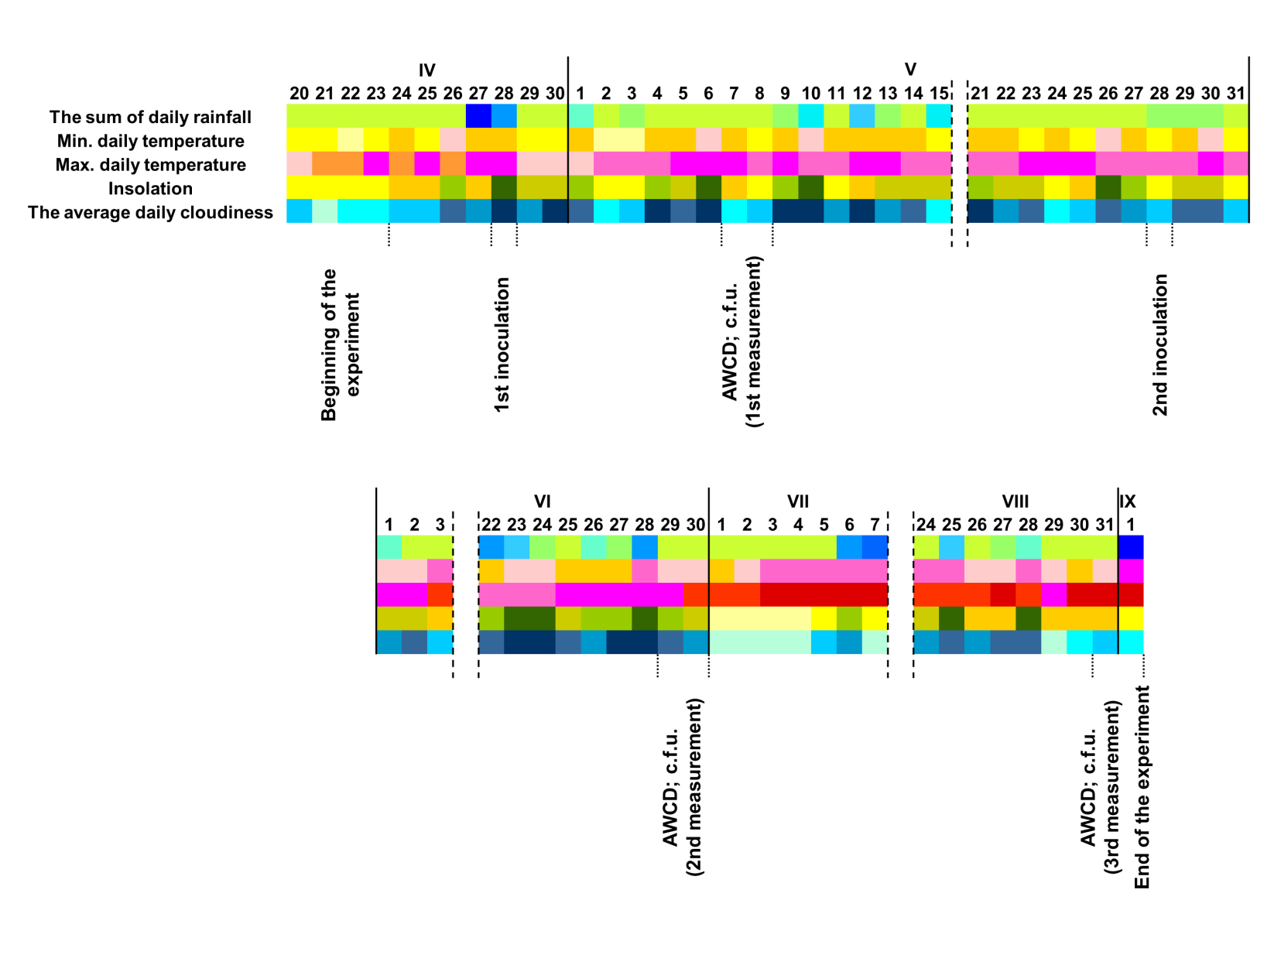
Climatic conditions during the experiment with marked start and end dates as well as time when analysis and microbial inoculation were performed.

Table S1

Parameter | Acronym | Formula
Translocation index | Ti | Ti = [metal concentration in the above-ground part / metal concentration in the roots] × 100
Bioconcetrafion factor | BCF | BCF = metal concentration in the plant/metal concentration in the soil
Metal extraction amount | MEA | MEA = metal concentration in the biomass × dry weight

The parameters describing the efficiency of heavy metals accumulation in the plant biomass of S. dasyclados.

Table S2
 | S-I | S-II | S-III | S-IV | Polish limits*  (mg /kg)
 |  |  |  |  | Urban | Industry
Zn  (mg/kg) | 1919.97  (32.19) | 1100.55  (14.85) | 345.48  (17.32) | 1285.64  (28.46) | <300 | <1000
Pb  (mg/kg) | 954.71  (25.99) | 463.48  (17.32) | 205.86  (21.04) | 680.40  (19.80) | <100 | <600
Cd  (mg/kg) | 32.46  (1.24) | 11.46  (1.24) | 13.51  (1.36) | 20.56  (1.48) | <4 | <15
pH | 7.492  (0.060) | 7.193  (0.032) | 5.797  (0.035) | 7.171  (0.051)
C (%) | 1.836  (0.073) | 0.257  (0.050) | 0.884  (0.107) | 1.811  (0.088)
H (%) | 0.336  (0.045) | 0.061  (0.009) | 0.118  (0.004) | 0.361  (0.021)
N (%) | 0.096  (0.010) | 0.015  (0.001) | 0.033  (0.003) | 0.104  (0.007)
C/N | 19.291  (1.392 | 17.046  (2.430) | 26.529  (2.264) | 17.483  (0.493)
sand (%) | 75 | 96 | 97 | 85
silt (%) | 20 | 2 | 0 | 12
clay (%) | 5 | 2 | 3 | 3
Textural group | loamy fine sand | medium sand | medium sand | loamy medium sand

Physicochemical parameters, heavy metal content (Zn, Pb, Cd) and grain size distribution of the four investigated soils. Mean ± standard deviation (n=3).
*The Decree of the Minister of Environment on 9 September 2002 on standards for soil quality (Dziennik Ustaw 2002, Nr 165, poz. 1359)

Table S3

 | S-I |  |  |  |  | S-II
 | F1 | F2 | F3 | F4 | Total | F1 | F2 | F3 | F4 | Total
 | Zn (mg/kg DW of soil)
Ctr-0 | 510.80  (9.76) | 809.87  (21.57) | 319.22  (19.66) | 274.99  (6.40) | 1914.88  (14.10) | 523.47  (17.59) | 178.32  (11.18) | 188.17  (11.18) | 205.79  (13.34) | 1095.74  (11.59)
Ctr | 601.44  (22.34)* | 829.30  (12.15) | 237.91  (7.07)* | 206.41  (61.58)* | 1875.06  (44.31) | 652.59  (44.93)* | 223.35  (11.89)* | 116.49  (31.08)* | 97.06  (4.75)* | 1089.48  (14.39)
B1 | 681.54  (40.30)*↑ | 894.93  (19.80)*↑ | 135.66  (9.24)*↓ | 97.18  (9.95)*↓ | 1809.31  (19.79)*↓ | 686.87  (29.16)* | 235.71  (16.04)* | 66.49  (4.68)*↓ | 72.61  (11.98)*↓ | 1061.68  (6.30)*↓
B2 | 631.88  (24.71)*↑ | 840.21  (16.88)* | 201.70  (11.98)*↓ | 181.44  (55.04)* | 1855.24  (35.96)* | 650.09  (15.16)* | 232.42  (9.07)* | 103.94  (54.41)* | 92.07  (1.47)*↓ | 1078.52  (28.78)
B3 | 618.15  (15.61)* | 814.40  (37.65) | 233.46  (19.93)* | 202.21  (18.03)* | 1868.22  (20.14)* | 663.41  (10.09)* | 215.00  (2.85)* | 102.33  (11.49)* | 94.57  (10.96)* | 1075.31  (16.52)*
 | Pb (mg/kg DW of soil)
Ctr-0 | 45.08  (6.55) | 595.87  (14.03) | 189.87  (9.24) | 113.79  (17.57) | 944.60  (9.92) | 40.41  (4.00) | 181.83  (14.05) | 130.65  (6.87) | 104.04  (7.95) | 456.93  (5.84)
Ctr | 47.00  (4.52) | 588.94  (22.55) | 185.61  (63.51) | 112.38  (1.22) | 933.92  (44.24) | 79.03  (9.42)* | 161.30  (10.89)* | 121.60  (29.91) | 88.39  (22.84) | 450.32  (5.64)
B1 | 61.21  (8.73)*↑ | 631.00  (7.31)*↑ | 127.19  (7.87)*↓ | 79.30  (3.73)*↓ | 898.69  (5.69)* | 85.69  (7.63)* | 185.32  (6.45)↑ | 112.79  (4.64)* | 54.06  (8.21)*↓ | 437.87  (7.64)*↓
B2 | 55.32  (6.49)*↑ | 600.81  (11.49) | 168.81  (12.65)* | 99.31  (14.41) | 924.26  (6.76)* | 82.68  (4.17)* | 176.19  (17.28) | 124.74  (5.45) | 59.82  (15.07)*↓ | 443.43  (7.34)*
B3 | 54.01  (7.36) | 597.80  (21.44) | 171.45  (7.13)* | 105.07  (6.44)↓ | 928.33  (13.39)* | 82.18  (8.12)* | 171.98  (14.41) | 129.98  (13.91) | 61.83  (5.84)*↓ | 445.98  (6.83)*
 | Cd (mg/kg DW of soil)
Ctr-0 | 16.05  (0.92) | 12.27  (2.04) | 1.22  (0.07) | 2.18  (0.14) | 31.71  (0.97) | 5.53  (0.92) | 2.40  (0.60) | 2.71  (0.07) | 0.22  (0.08) | 10.86  (0.44)
Ctr | 17.43  (4.23) | 8.39  (0.39)* | 1.52  (0.43) | 0.67  (0.09)* | 28.01  (3.44)* | 2.05  (0.42)* | 3.88  (0.62)* | 2.46  (0.52) | 0.85  (0.19)* | 9.24  (0.32)*
B1 | 20.34  (1.09)* | 2.99  (0.16)*↓ | 1.51  (0.44) | 0.76  (0.14)* | 25.61  (1.24)* | 2.65  (0.51)*↑ | 1.30  (0.27)*↓ | 2.39  (0.40) | 0.84  (0.11)* | 7.19  (0.40)*↓
B2 | 18.04  (1.76)* | 6.45  (0.98)*↓ | 1.48  (0.39) | 0.87  (0.10)*↑ | 26.85  (1.08)* | 2.54  (0.48)* | 2.08  (0.21)↓ | 2.55  (0.24) | 0.75  (0.19)* | 7.92  (0.31)*↓
B3 | 17.44  (1.92) | 6.05  (0.24)*↓ | 2.4  (0.52)*↑ | 0.87  (0.14)*↑ | 26.76  (1.03)* | 2.41  (0.41)* | 2.85  (0.50)↓ | 2.44  (0.28)* | 0.83  (0.15)* | 8.54  (0.22)*↓
 | S-III |  |  |  |  | S-IV
 | Zn (mg/kg DW of soil)
Ctr-0 | 212.24  (9.32) | 89.93  (10.95) | 19.30  (0.66) | 17.82  (0.91) | 339.29  (7.27) | 464.67  (11.27) | 427.87  (13.19) | 165.10  (15.08) | 217.97  (24.96) | 1275.60  (11.80)
Ctr | 212.47  (8.89) | 78.58  (1.33)* | 15.82  (1.55)* | 22.96  (3.13)* | 329.83  (5.40)* | 533.18  (20.38)* | 514.03  (18.22)* | 62.79  (3.71)* | 146.35  (14.03)* | 1256.36  (8.83)*
B1 | 195.58  (2.80)*↓ | 56.82  (2.56)*↓ | 13.18  (3.06)* | 13.25  (1.96)*↓ | 278.83  (6.10)*↓ | 568.72  (11.96)*↑ | 474.86  (12.30)*↓ | 53.61  (0.99)*↓ | 109.36  (1.61)*↓ | 1206.55  (12.98)*↓
B2 | 200.83  (3.13)*↓ | 64.31  (2.13)*↓ | 14.60  (1.80)* | 21.90  (2.46)* | 301.65  (4.76)*↓ | 540.87  (7.47)* | 496.79  (45.36)* | 69.64  (8.28)* | 124.04  (5.88)*↓ | 1231.33  (24.61)*↓
B3 | 212.74  (9.72) | 58.59  (1.57)*↓ | 15.20  (4.18)* | 20.17  (1.81)* | 306.69  (8.69)*↓ | 538.83  (4.99)* | 509.00  (80.05)* | 63.32  (4.23)* | 132.86  (3.20)*↓ | 1244.01  (67.89)
 | Pb (mg/kg DW of soil)
Ctr-0 | 34.89  (3.94) | 88.14  (9.75) | 30.50  (2.34) | 45.00  (8.78) | 198.54  (7.56) | 54.87  (8.10) | 371.76  (20.72) | 169.28  (18.03) | 76.63  (15.22) | 672.54  (9.81)
Ctr | 80.56  (5.83)* | 90.12  (7.41) | 5.32  (3.02)* | 14.17  (2.73)* | 190.17  (2.43)* | 132.47  (8.81)* | 332.76  (4.30)* | 163.80  (11.86) | 38.19  (2.26)* | 667.21  (9.32)
B1 | 94.83  (8.02)*↑ | 63.67  (12.68)*↓ | 6.99  (3.87)* | 11.83  (1.97)* | 177.32  (5.03)*↓ | 153.87  (2.37)*↑ | 310.01  (17.53)*↓ | 144.77  (13.05)*↓ | 42.93  (3.16)*↑ | 651.57  (5.08)*↓
B2 | 81.87  (9.69)* | 78.39  (9.03)↓ | 11.16  (10.41)* | 11.20  (2.39)* | 182.61  (9.88)* | 130.93  (8.09)* | 313.21  (26.34)* | 170.02  (8.36) | 47.00  (2.61)*↑ | 661.15  (8.10)
B3 | 83.81  (5.03)* | 79.62  (6.28)↓ | 7.86  (2.96)* | 12.13  (1.80)* | 183.43  (7.53)*↓ | 138.51  (6.01)* | 318.97  (19.47)* | 161.47  (15.84) | 45.79  (2.08)*↑ | 664.74  (3.67)
 | Cd (mg/kg DW of soil)
Ctr-0 | 3.93  (0.77) | 1.97  (0.54) | 5.90  (0.08) | 1.08  (0.07) | 12.89  (1.38)* | 7.24  (0.92) | 6.17  (0.68) | 4.56  (0.37) | 1.28  (0.06) | 19.25  (0.63)
Ctr | 3.50  (0.14) | 3.56  (0.30)* | 2.41  (0.52)* | 0.82  (0.14)* | 10.29  (0.27)* | 7.95  (0.04) | 5.59  (0.41) | 2.36  (0.70)* | 0.75  (0.14)* | 16.66  (0.42)*
B1 | 4.77  (0.40)*↑ | 1.07  (0.34)*↓ | 2.42  (0.44)* | 0.74  (0.14)* | 9.00  (0.33)*↓ | 9.05  (0.09)*↑ | 2.60  (0.47)*↓ | 2.08  (0.29)* | 0.68  (0.19)* | 14.41  (0.24)*↓
B2 | 4.96  (0.28)*↑ | 1.29  (0.60)↓ | 2.14  (0.51)* | 0.79  (0.09)* | 9.18  (0.27)*↓ | 9.10  (0.10)*↑ | 3.21  (0.43)*↓ | 2.24  (0.47)* | 0.72  (0.19)* | 15.28  (0.59)*
B3 | 3.46  (0.31) | 3.37  (1.55) | 2.56  (0.65)* | 0.68  (0.12)* | 10.06  (0.71)* | 6.39  (0.08)↓ | 6.92  (0.41)*↑ | 2.23  (0.29)* | 0.58  (0.13)* | 16.13  (0.66)*↓

The contents of the various speciation forms of Zn, Pb and Cd in 4 studied soils before (Ctr-0) and after the experiment. Mean ± standard deviation (n = 6).
↑↓ - significant increase/decrease compared with the control (uninoculated) – T Test (p < 0.05)
⃰ - significant difference compared with the Ctr-0 (before the experiment) – T Test (p < 0.05).

Table S4
 | Factor 1 | Factor 2
BCF Zn in roots | 0,73 | -0,35
BCF Pb in roots | 0,89 | 0,17
BCF Cd in roots | 0,03 | 0,92
BCF Zn in leaves | 0,89 | 0,19
BCF Pb in leaves | 0,86 | 0,33
BCF Cd in leaves | 0,19 | 0,88
BCF Zn in shoots | 0,93 | 0,18
BCF Pb in shoots | 0,85 | 0,39
BCF Cd in shoots | 0,26 | 0,83
Explained Variance [%] | 51 | 31

Factor loading matrix.

