SUPPLEMENTARY MATERIAL

Scheme 1-SUP. Labeling of the atoms in 2TU. S1 to S4 are the four regions of H-bond formation with water molecules.

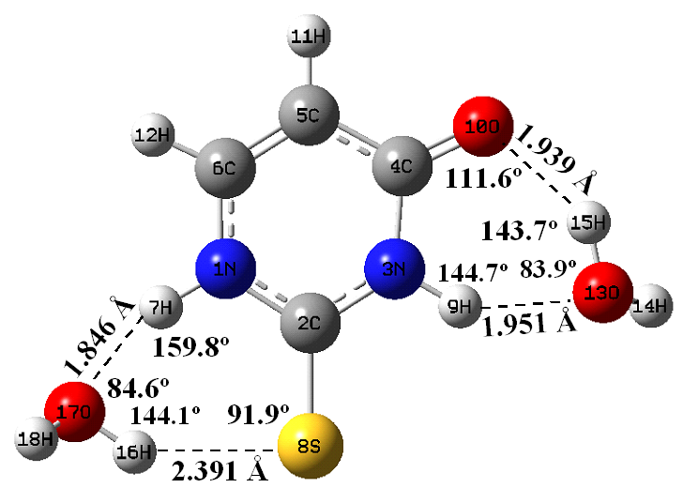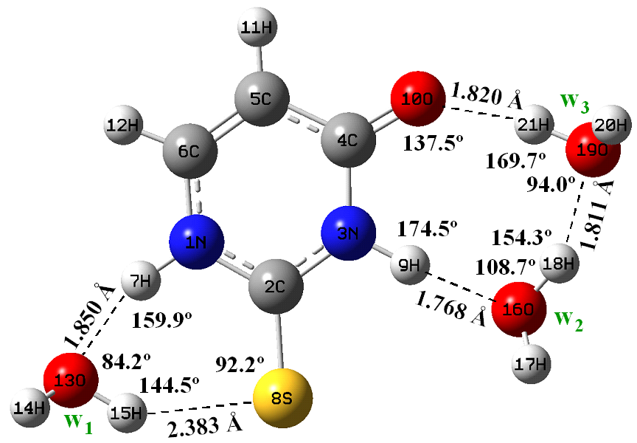
+ 2 H₂O
+ 3 H₂O
E = -890.724588 (G = -890.763584), µ = 3.638 D -967.175637 (-967.218911), µ = 4.775 D

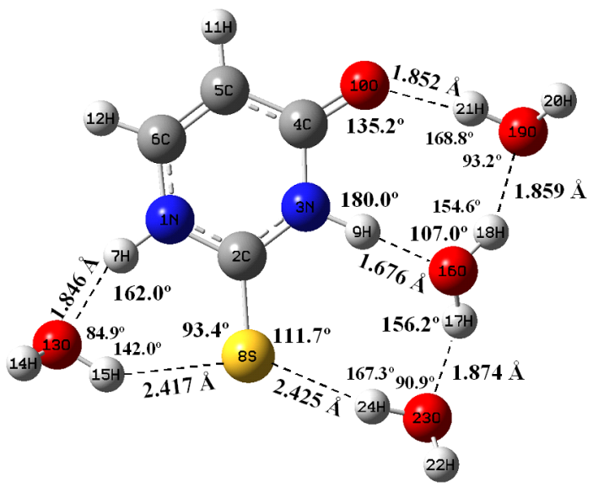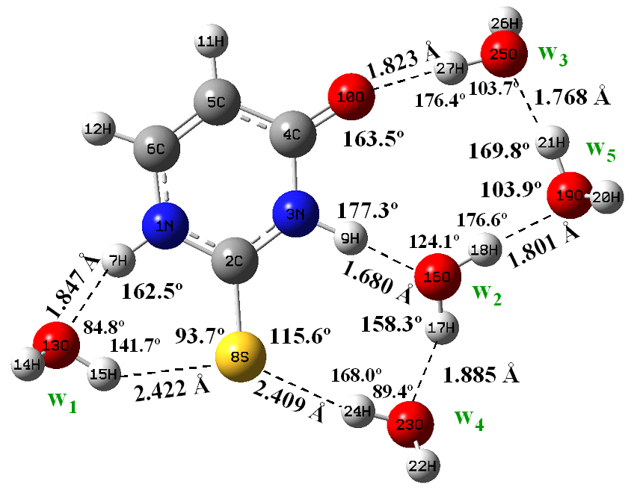
+ 4 H₂O
+ 5 H₂O
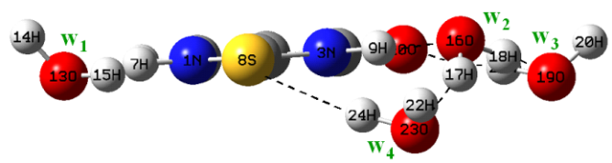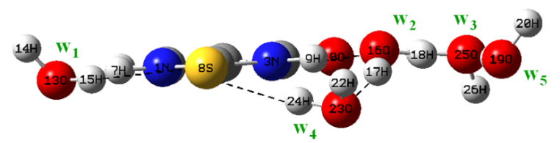
-1043.623837 (-1043.670705), µ= 5.025 D -1120.072089 (-1120.124651), µ= 5.064 D

(Fig. 1-SUP) Optimized most stable hydration clusters of 2TU from two up to 5 water molecules at the B3LYP/6-311+G(2d,p) level. Two views of each cluster are plotted in several cases. The total energy+ZPE and the Free energy G (in parentheses) are in atomic units. The dipole moment (µ) is in Debyes.

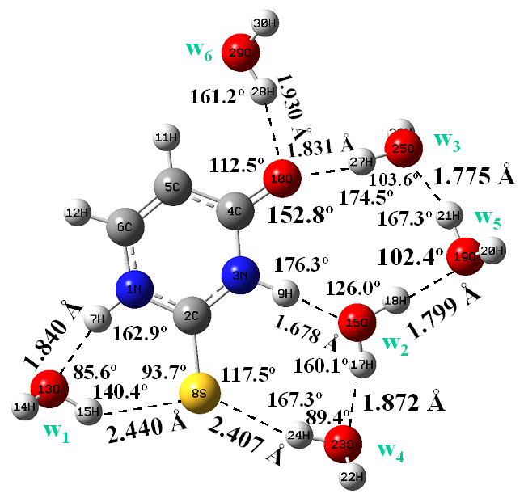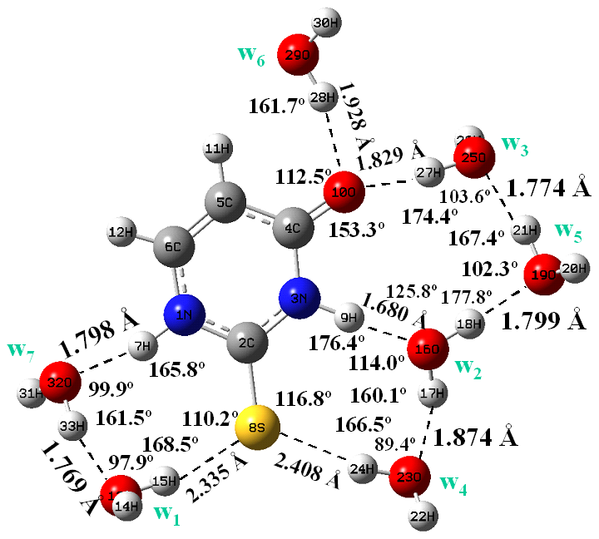
+ 7 H₂O
+ 6 H₂O

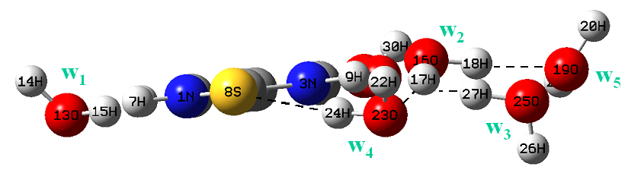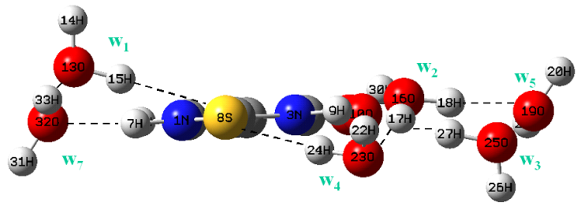
-1196.517128 (-1196.574563 AU), µ= 4.293 D -1272.967966 (-1273.029865 AU), µ= 2.572 D

+ 8 H₂O
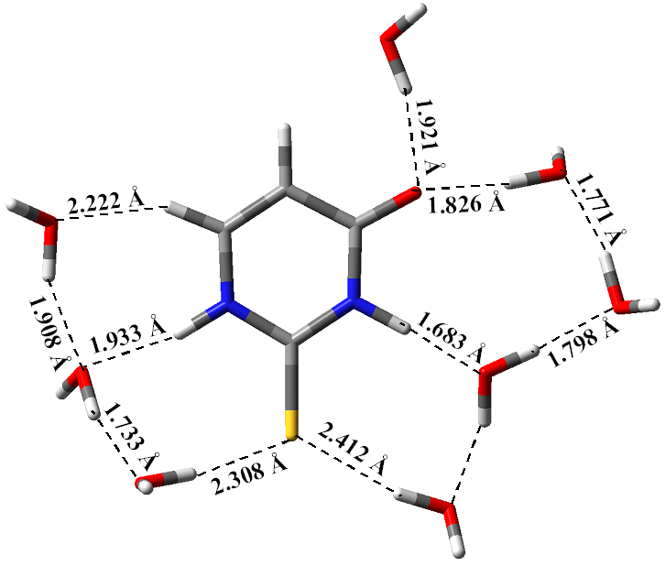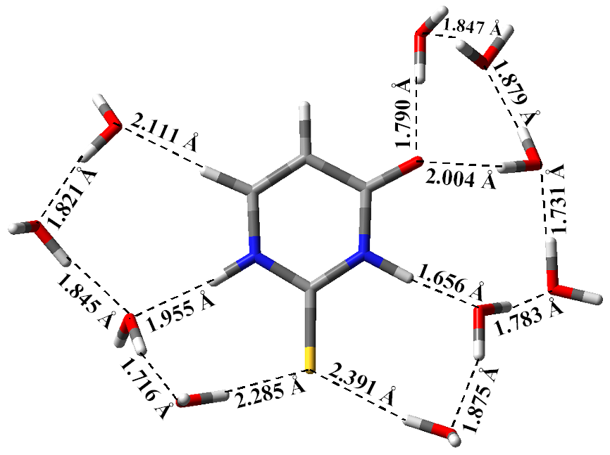
+ 10 H₂O

-1349.414376 (-1349.480530 AU), µ= 5.211 D -1502.313201 (-1502.385980 AU), µ= 6.788 D

(Fig. 2-SUP) Optimized most stable hydration clusters at the B3LYP/6-311+G(2d,p) level of 2TU from 6 to 10 water molecules. Two views of the clusters with 6 and 7 water molecules are shown. The total energy+ZPE and the Free energy G (in parentheses) are in atomic units. The dipole moment (µ) is in Debyes.

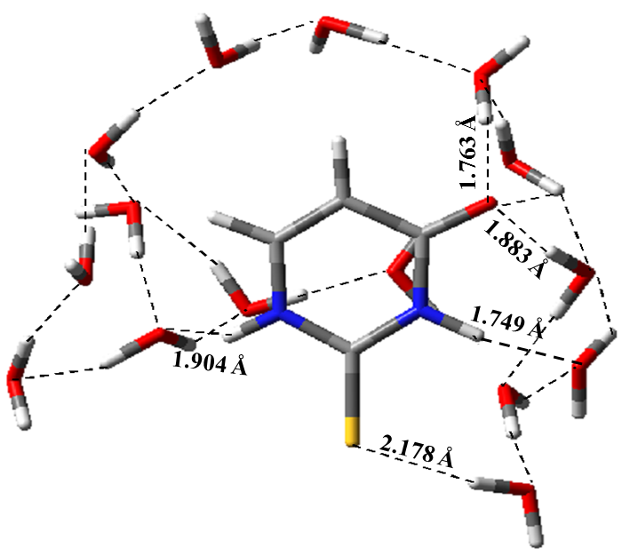
E = -1883.944172 AU (G = -1884.021061 AU), μ=2.289 D
+ 15 H₂O

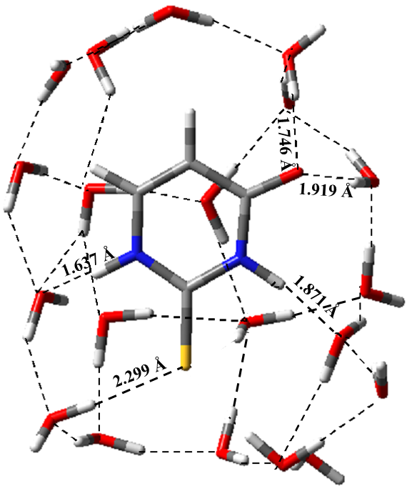
+ 20 H₂O
E = -2266.024165 AU (G = -2266.116386 AU), μ = 10.173 D

(Fig. 3-SUP) Optimized most stable hydration clusters at the B3LYP/6-31G(d,p) level of 2TU with 15 and 20 water molecules. Two views of each cluster are plotted. The total energy+ZPE and the Free energy G (in parentheses) are in atomic units.. The dipole moment (µ) is in Debyes.

(Fig. 4-SUP) Theoretical scaled IR and Raman spectra at the B3LYP/6-31G(d,p) level in the cluster 2TU(H₂O)₁₅.

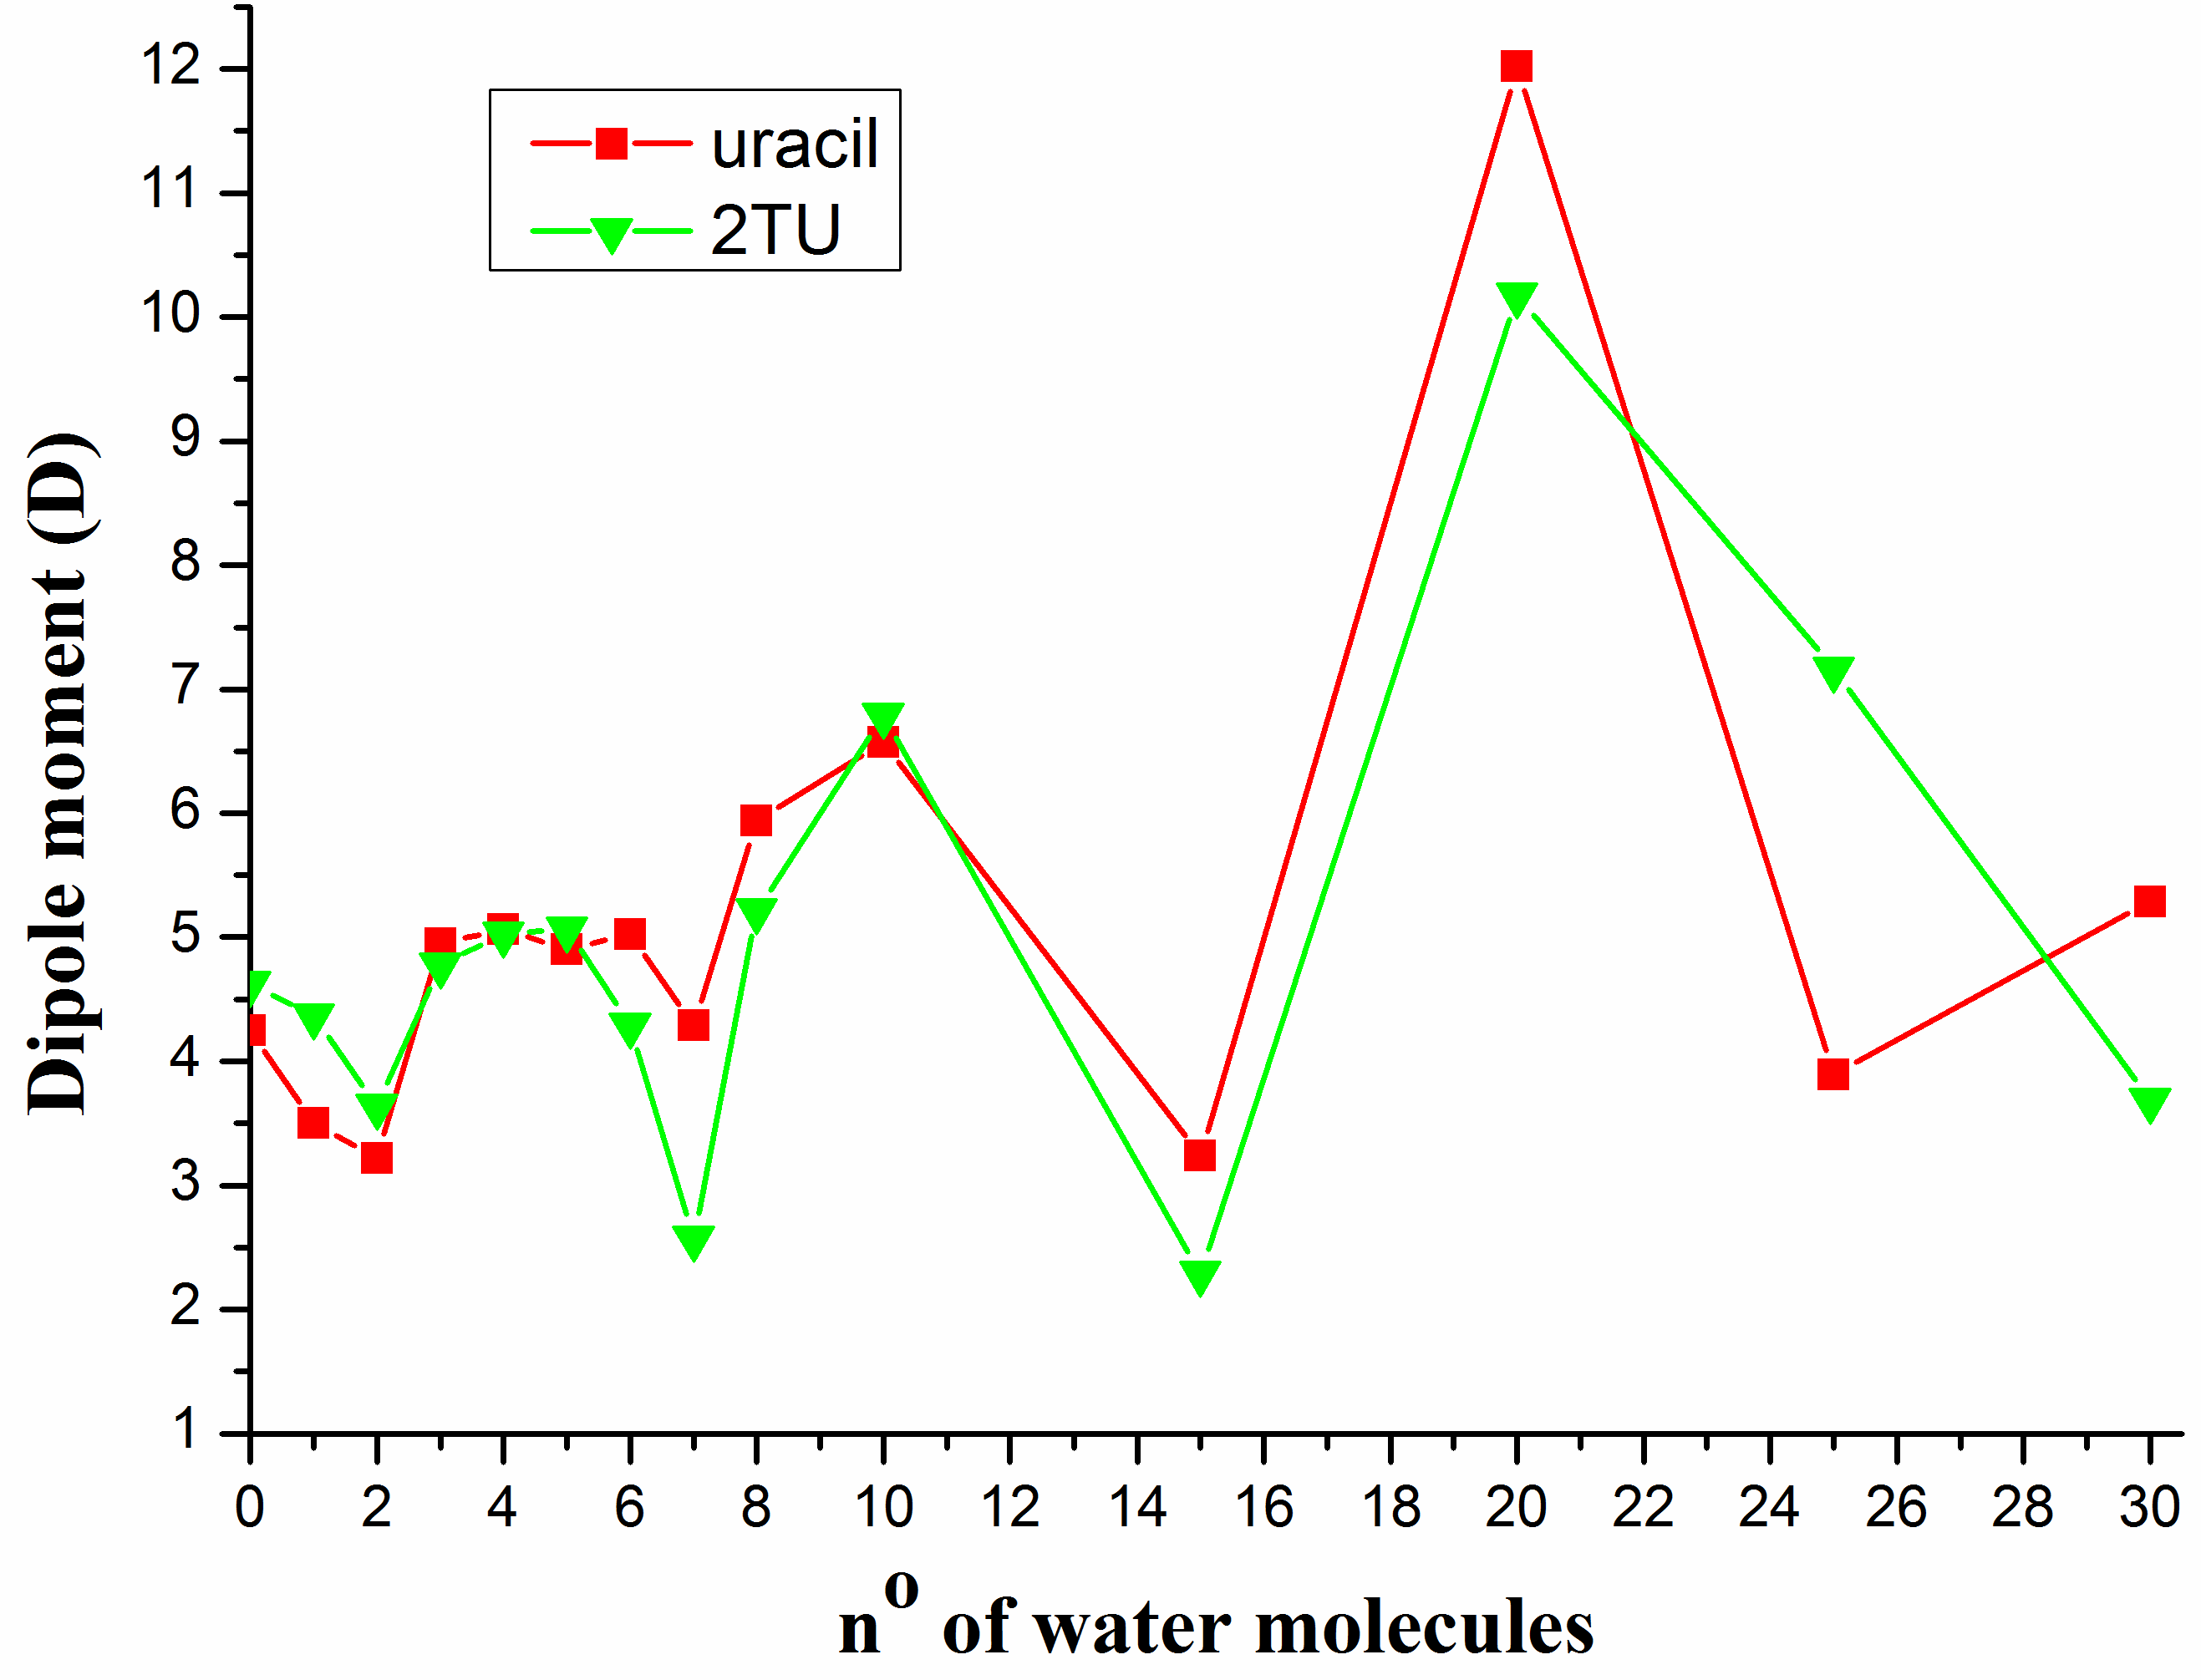

(Fig. 5-SUP) Changes obtained in the dipole moment of 2TU with the increase of the number of water molecules. The calculated values were at the B3LYP/6-31G(d,p) level.

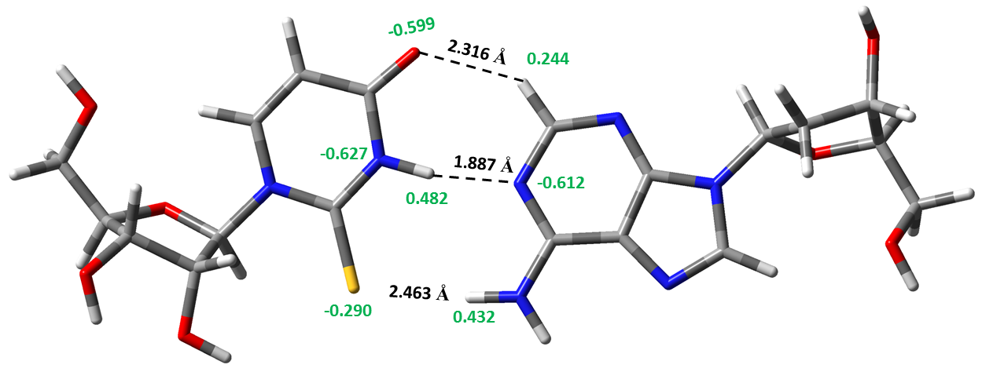
2-thiouridine
2'-deoxyadenosine
E = -2121.891632 AU (G = -2121.960542 AU), μ = 1.419 D

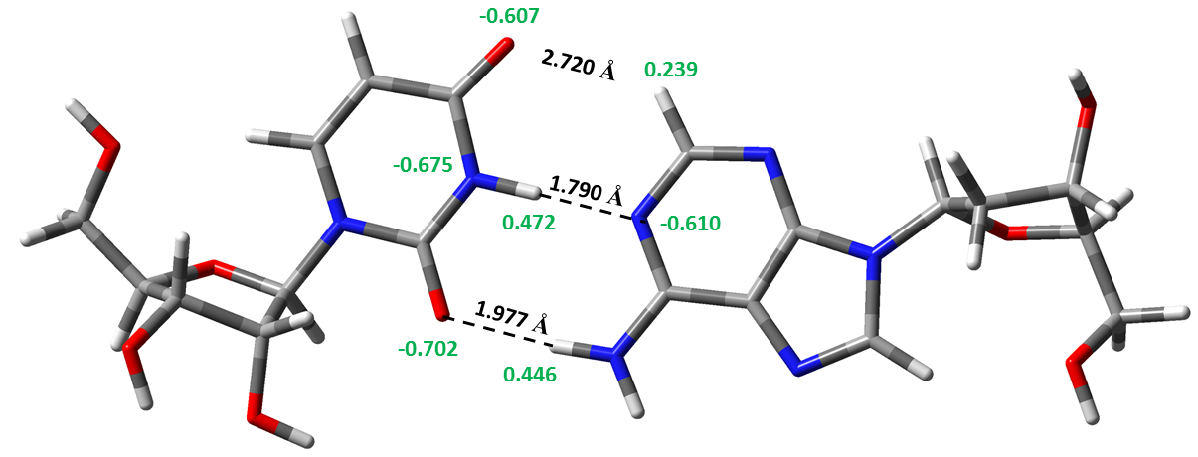
uridine
2'-deoxyadenosine
E = -1798.938590 AU (G = -1799.008241 AU), μ = 4.090 D

(Fig. 6-SUP) Optimum pairs at the B3LYP/6-31G(d,p) level + ZPE of the reverse Watson-Crick 2-thiouridine···2′-deoxyadenosine (dA), and the natural one uridine···dA. The NBO atomic charges are plotted in green colour, the energy in AU and the dipole moment (μ) in Debye.

Table 1-SUP. xyz coordinates of several base pairs optimized structures

2'deoxy-adenosine + 2-thiouridine

N -4.22980800 0.16775600 -0.43660400
C -2.87010400 -0.11328300 -0.36718200
N -2.05654600 0.97811900 -0.21537300
C -2.44915100 2.31629000 -0.10345300
C -3.87865700 2.51896800 -0.16907300
C -4.70104000 1.45965000 -0.33859500
C -5.18876500 -0.96060500 -0.64776300
C -5.56852300 -1.68186700 0.65959700
C -6.89483000 -0.98936300 1.03760500
C -7.50879400 -0.73455500 -0.34328800
O -6.38756100 -0.44740500 -1.19559000
O -1.61710000 3.21475300 0.03892300
H -5.77667600 1.56237300 -0.41009100
H -4.70876700 -1.65486300 -1.33800100
H -7.99637300 -1.65948200 -0.68002400
C -8.51891000 0.39303300 -0.42211800
O -7.95890800 1.56634500 0.16162500
H -9.42362400 0.07214500 0.11498200
H -8.78247400 0.55594500 -1.47593500
H -8.55094300 2.30812600 -0.01242900
C 1.72364200 1.65021100 0.02378800
C 3.11019400 1.36743300 0.04255700
C 3.47260700 0.02448500 -0.05511100
N 0.86894600 0.60367700 -0.08759100
N 4.22358500 2.18241000 0.14388000
N 4.85403600 0.01839500 -0.01856900
N 2.64751500 -1.02741900 -0.16721500
C 1.37031700 -0.64544100 -0.17281400
C 5.23431600 1.34704200 0.10192700
H 6.27570800 1.62826700 0.17737500
C 5.68888800 -1.17506900 -0.09569800
C 6.54701100 -1.26659700 -1.37020500
C 7.92588000 -0.78483100 -0.92016600
C 7.95989700 -1.26767900 0.54119500
C 8.82044800 -0.44184100 1.49075000
O 6.60216300 -1.18336500 1.00530500
O 8.35767100 0.89553600 1.59702200
H 4.98791900 -2.00910000 -0.00554400
H 6.12252900 -0.69935700 -2.19999000
H 7.98706100 0.31121900 -0.94182500
H 8.30161500 -2.31423400 0.54473900
H 8.85750900 -0.93006000 2.47509300
H 9.84629100 -0.39956800 1.10688800
H 7.46854400 0.83563500 1.97547400
N 1.23969900 2.89789700 0.11074600
H 1.89045800 3.66211100 0.19069900
H 0.23199300 3.06461500 0.09257300
H 0.62204000 -1.42848300 -0.25948000
H -1.02852800 0.79493900 -0.16821800
O -7.75752200 -1.83735300 1.78970000
H -7.56607100 -1.71361100 2.72837900
H -6.72069900 -0.03882400 1.55268600
H -4.78300700 -1.58322700 1.41929200
H 9.74381900 -0.84144000 -1.62470800
O 8.93868300 -1.36414400 -1.72702800
H 6.64009200 -2.31234000 -1.68093400
H -4.26332500 3.52651400 -0.09200400
S -2.25756200 -1.67208200 -0.44991000
O -5.82542200 -3.03404900 0.34505700
H -6.54869000 -3.30824600 0.93281700

2'-deoxy-adenosine + Uridine

N -4.25560700 0.23007500 -0.49993000
C -2.86917600 0.01307400 -0.49771700
N -2.10585300 1.13968300 -0.29370000
C -2.56313800 2.43858300 -0.08163200
C -4.00635000 2.57146900 -0.09490100
C -4.78593200 1.48396200 -0.30509100
C -5.09523900 -0.96536000 -0.76637900
C -5.29710700 -1.84711100 0.47842000
C -6.64472900 -1.33047400 1.02144100
C -7.39344500 -1.01307200 -0.27889600
O -6.38081400 -0.54822100 -1.18547200
O -1.76835400 3.36748100 0.09985900
H -5.86789900 1.53228000 -0.32816000
H -4.59429700 -1.53789800 -1.54877800
H -7.82778700 -1.94644600 -0.66289900
C -8.50118400 0.01628700 -0.16935600
O -7.99857700 1.18130900 0.47836500
H -9.32429700 -0.43639400 0.40333100
H -8.86846800 0.24539600 -1.17906200
H -8.67498700 1.86838100 0.44025000
C 1.59059600 1.73694700 -0.00705500
C 2.96642100 1.40806100 0.03510700
C 3.28828300 0.06107400 -0.14252400
N 0.71611500 0.72417100 -0.21609200
N 4.10154500 2.17377200 0.23044100
N 4.66622600 0.00498700 -0.05913900
N 2.43696600 -0.95533000 -0.35334400
C 1.17362900 -0.53230500 -0.37244500
C 5.08503300 1.30798200 0.16567900

H 6.13164400 1.54607300 0.29727800
C 5.46505800 -1.20912500 -0.18573300
C 6.37825800 -1.24032100 -1.42445800
C 7.75036500 -0.84407600 -0.87967000
C 7.69895100 -1.43000400 0.54278200
C 8.54191200 -0.70545600 1.58621900
O 6.32459100 -1.32766000 0.95116600
O 8.12074600 0.63771900 1.76695100
H 4.73396300 -2.02185800 -0.18703200
H 6.01269400 -0.59959800 -2.22841300
H 7.85078300 0.24759400 -0.81886200
H 8.00377300 -2.48630500 0.48566200
H 8.51622600 -1.26219200 2.53385600
H 9.58549100 -0.67485800 1.25218400
H 7.21428700 0.58523900 2.10297200
N 1.12627400 2.98594800 0.14713400
H 1.78530600 3.72874800 0.31435200
H 0.12017400 3.17371500 0.13022100
H 0.40086400 -1.28044300 -0.53429000
H -1.07060300 0.98281000 -0.27967300
O -7.36061100 -2.32667900 1.74660800
H -7.10245300 -2.27227700 2.67582000
H -6.51760500 -0.41813400 1.61343600
H -4.46297500 -1.74376300 1.18407200
H 9.59741200 -0.92332200 -1.50100500
O 8.77908000 -1.40304300 -1.68044000
H 6.45004400 -2.26371400 -1.80699900
H -4.43618500 3.55154000 0.05868700
O -5.45153200 -3.18287800 0.04538700
H -6.09963800 -3.58181500 0.64914200
O -2.39557300 -1.10511700 -0.65947600

C 2.33411700 1.48990100 1.91262800
C 3.58652100 1.84248500 1.36868200
C 3.59533300 2.87277600 0.42964300
N 1.24383500 2.18295300 1.50418900
N 4.85659500 1.32538400 1.55523200
N 4.91498000 2.99268700 0.03528300
N 2.53308700 3.58559900 0.01879000
C 1.40809800 3.17393100 0.60251500
C 5.61808400 2.02601000 0.74152100
H 6.68709000 1.86533800 0.60699300
C 5.37849600 3.87412200 -1.03632300
C 6.65364200 4.65992400 -0.69969500
C 7.78635900 3.87257700 -1.38471400
C 7.05742200 3.17731300 -2.55632200
C 7.54665500 1.77397800 -2.91428200
O 5.66184300 3.14044300 -2.21772400
O 7.38652100 0.86061800 -1.84764200
H 4.52021400 4.52391300 -1.22889400
H 6.79948200 4.79333200 0.37394900
H 8.21554400 3.12913600 -0.70652200
H 7.17661800 3.80730900 -3.45950800
H 6.95313500 1.41137900 -3.76394300
H 8.59777900 1.83015400 -3.22438800
N 2.19902100 0.50956600 2.83361800
H 2.99529200 -0.09814300 2.95280000
H 1.26783000 0.11961400 2.98697500
H 0.49252400 3.69074400 0.32645800
H 6.58604000 5.65634800 -1.15585900
P 8.72877600 0.39253000 -0.94509300
O 9.93184400 0.33558300 -1.82734400
O 8.66494200 1.18126400 0.34665300
O 8.23971600 -1.16784700 -0.62919300
C 7.28165400 -1.38359000 0.39813400
C 7.57316500 -2.71561500 1.10471300
H 7.31460900 -0.54579800 1.10120100
C 5.85774800 -1.59488000 -0.15695000
H 8.61687800 -3.01117600 0.97200900
O 6.77543100 -3.71548900 0.44062900
C 5.67894700 -3.12448200 -0.22045200
H 5.11881900 -1.14514700 0.50963000
H 5.76099200 -1.12208400 -1.13414500
H 5.63753200 -3.49869800 -1.24798400
N 4.43262100 -3.58649600 0.43601000
C 4.30959400 -4.20565300 1.66419000
C 3.14944100 -3.41822200 -0.03507400
H 5.19125400 -4.46802500 2.23277800
N 3.06206100 -4.43563100 2.02127700
C 2.32068200 -3.94361200 0.96235800
N 2.75500900 -2.86581900 -1.19509200
C 0.92885200 -3.85058200 0.73848200
C 1.42786000 -2.84981800 -1.30358900
N 0.50738000 -3.29486300 -0.42046200
N -3.79555800 1.66334200 2.39827800
C -2.56740900 2.15846600 1.99220100
N -1.49155200 1.36709100 2.28225800
C -1.51974700 0.09617300 2.87728900
C -2.84960100 -0.40311600 3.14711300
C -3.91813400 0.38906400 2.91370600
C -5.01673300 2.49492200 2.20527300
C -5.75483500 2.21444100 0.86781600
C -6.94091600 1.34623900 1.33255400
C -7.22141000 1.88220000 2.73864000
O -5.92341500 2.25110200 3.26568000
O -0.47860000 -0.50954600 3.13170400
H -4.93197300 0.07605200 3.13196000
H -4.67011700 3.52799700 2.23518500
H -7.84804400 2.77815200 2.64121800
H -0.54618700 1.71948100 2.00037500
O -8.09019100 1.43987900 0.53179000
H -6.61001300 0.30389700 1.41495100
H -5.10908300 1.68814900 0.15562500
N -3.94003200 -1.35089300 -2.02630100
C -2.67356700 -1.91730000 -2.01465800
N -2.32086600 -2.53073200 -0.84134000
C -3.12723600 -2.72213500 0.28760400
C -4.45985700 -2.18145900 0.15885000
C -4.80352400 -1.50438400 -0.96079800
C -4.37425700 -0.54092700 -3.20543700
C -5.15101800 -1.36137300 -4.25356300
C -6.61943600 -1.04368900 -3.90001400
C -6.53379700 0.39606400 -3.38023500
O -5.23362900 0.48617600 -2.76153500
H -5.77799000 -1.03721300 -1.06759600
H -3.46344700 -0.13404500 -3.64501000
H -6.57235500 1.08324300 -4.23735800
C -7.60920100 0.77852400 -2.38020400
O -7.64569800 -0.20565800 -1.35918200
H -8.57615500 0.83536000 -2.89717500
H -7.38694300 1.76654700 -1.95743300
H -6.99931900 -1.69353400 -3.10688000
H -4.90055600 -2.42893500 -4.19102800
P -8.74166900 0.01638400 -0.09209200
O -10.07276900 0.38429600 -0.65565800
O -8.44809900 -1.10146900 0.86168400
H -5.16951200 -2.30282900 0.96622500
H -2.95929200 -1.41413400 3.51294500
O -7.46241800 -1.09691200 -5.05518700
H -7.93069800 -1.94019100 -5.04271600
O 8.87934000 4.68053500 -1.80483100
H 8.53748800 5.29718300 -2.46811000
C -7.87635000 0.88334400 3.70082400
H -8.41969000 1.42253200 4.49224500
H -8.58590200 0.27522300 3.13275700
O -6.92824500 -0.01115800 4.27605500
H -6.26761300 0.55826700 4.69562400
O -4.86223100 -0.84007800 -5.53695000
H -5.70632500 -0.88593600 -6.01718300
O -6.23347500 3.43023400 0.31910900
H -5.45050800 3.90913900 0.01023500
C 7.24441900 -2.62265100 2.59233700
H 7.95127700 -1.91399600 3.04990700
H 6.23234400 -2.21133800 2.72439300
O 7.35193500 -3.91641800 3.18778400
H 7.05883300 -3.83359200 4.10401100
H -1.33671400 -2.87446900 -0.77105200
O -2.69150900 -3.30714400 1.28469800
H 1.01226800 -2.42062100 -2.21127600
N 0.01814500 -4.31652300 1.62313500
H 0.36502200 -4.52180100 2.54765600
H -0.94688300 -3.99275300 1.53270200
S -2.38882100 3.62852200 1.18200100
S -1.63892500 -1.88405000 -3.33862600

(stable structure not included in the manuscript)

C 1.59534400 -0.48495000 2.04367200
C 2.79760000 0.28781500 2.01301600
C 2.63230600 1.69003000 1.81607200
N 0.41209900 0.17995400 2.00169100
N 4.09640900 -0.04386000 2.11262600
N 3.92339900 2.19906100 1.79070900
N 1.48805900 2.32951200 1.70548300
C 0.41311000 1.50089800 1.84221800
C 4.74951200 1.12335100 1.95310600
H 5.83833400 1.17645000 1.95025400
C 4.24504700 3.57954200 1.29512800
C 5.40505900 4.27141100 2.01891200
C 6.61440400 3.83324300 1.18629000
C 6.01562200 3.75688100 -0.23631400
C 6.63805000 2.70723200 -1.14786400
O 4.60261300 3.48926000 -0.05830800
O 6.79909700 1.44282800 -0.49536500
H 3.29273500 4.10600800 1.38857900
H 5.47902100 4.01352800 3.07734700
H 6.90496000 2.83612500 1.52003600
H 6.11912900 4.74213400 -0.71122700
H 5.98262200 2.54151600 -2.00777500
H 7.60617400 3.07724400 -1.49566300
N 1.59177000 -1.81351400 2.08955200
H 2.47403600 -2.30156100 2.15762400
H 0.69662200 -2.32690300 1.97849200
H -0.55748500 1.98454600 1.86144400
H 5.26877200 5.35464000 1.93453600
P 8.21397800 1.12066500 0.33793200
O 9.17081600 2.25853100 0.12178000
O 7.78975100 0.70239200 1.73043200
O 8.70697300 -0.20552000 -0.50542800
C 8.32616400 -1.52618000 -0.10785100
C 8.53127100 -2.44575200 -1.32748100
H 8.91615900 -1.83320000 0.76207700
C 6.82027900 -1.68696200 0.13365600
H 9.28079700 -2.03138200 -2.00651400
O 7.26624900 -2.45279900 -2.03612300
C 6.29578500 -1.74173700 -1.29958900
H 6.63368600 -2.64597500 0.62939500
H 6.38598200 -0.89624700 0.73803400
H 6.12757600 -0.73746400 -1.70121700
N 5.02032400 -2.46167100 -1.43007800
C 4.84160400 -3.80705900 -1.58170800
C 3.75505600 -1.90886800 -1.37502600
H 5.68970900 -4.46561000 -1.70723200
N 3.56172700 -4.18141000 -1.60695300
C 2.87824800 -3.01265700 -1.47865600
N 3.40741200 -0.63144500 -1.27568700
C 1.48466700 -2.71358100 -1.46254900
C 2.06880900 -0.46560400 -1.30940200
N 1.11904500 -1.40405000 -1.38335500
N -4.43788200 -1.40455300 2.48906700
C -3.28791400 -0.68664800 2.72578400
N -2.12435200 -1.30329500 2.35277600
C -1.98055000 -2.57716500 1.79682500
C -3.22996500 -3.23195400 1.51688200
C -4.39762100 -2.63164400 1.86523600
C -5.76709400 -0.83907900 2.95251400
C -6.31012400 0.27011100 2.00849300
C -7.15015000 -0.59512600 1.07270700
C -7.77117000 -1.62736600 2.01170100
O -6.71064100 -1.86827200 2.98182200
O -0.85197000 -3.03831800 1.57317000
H -5.36420800 -3.07793200 1.65197000
H -5.57988000 -0.45305200 3.95714700
H -8.63188200 -1.19712700 2.53673200
H -1.26162800 -0.74042600 2.41930700
O -8.11724100 0.07110200 0.29336700
H -6.44664900 -1.12637600 0.42556400
H -5.51013700 0.80047300 1.48344900
N -3.36064900 1.03733500 -1.47984800
C -2.02183500 0.74686100 -1.38267600
N -1.69065200 -0.57121600 -1.46402100
C -2.56685100 -1.65625400 -1.65003300
C -3.94934300 -1.27113100 -1.78181500
C -4.28924900 0.03708900 -1.68841300
C -3.84222800 2.45996800 -1.35538400
C -3.97429000 3.16835200 -2.71803000
C -5.48656500 3.03460400 -3.01803600
C -6.10630400 3.05877300 -1.61433000
O -5.10946000 2.45367500 -0.75634600
H -5.32336700 0.35718700 -1.75292100
H -3.10844900 2.97051200 -0.73083900
H -6.24910900 4.10433400 -1.31293500
C -7.42138000 2.31513200 -1.46631400
O -7.23487700 0.97654100 -1.92208000
H -8.18287600 2.82263500 -2.07122000
H -7.73671500 2.32542600 -0.41846700
H -5.71712500 2.08634600 -3.51338000
H -3.33402400 2.70238900 -3.48066900
P -8.17773200 -0.26572400 -1.33487500
O -9.58986700 -0.11370700 -1.79165500
O -7.34932200 -1.51064200 -1.59796300
H -4.71745800 -2.01492600 -1.94916500
H -3.22133500 -4.18975300 1.01618600
O -5.97059700 4.14339000 -3.76661300
H -6.02609700 3.89394500 -4.69766100
O 7.71868700 4.69584100 1.27664900
H 8.48521700 4.15691100 1.00239500
C -8.17431900 -2.93208100 1.32681300
H -8.35537000 -3.69477400 2.09160800
H -9.12352900 -2.75231400 0.80357900
O -7.18203100 -3.42897100 0.44674300
H -7.25116300 -2.90703800 -0.38518300
O -3.64917900 4.52498100 -2.52573900
H -4.26767700 5.02419300 -3.08675900
O -7.13791700 1.15706100 2.72821500
H -6.55978600 1.75380200 3.22376300
C 8.91913900 -3.86693000 -0.92909400
H 9.94786200 -3.83578800 -0.53800400
H 8.26745700 -4.21967100 -0.11211500
O 8.80820700 -4.70218100 -2.06966900
H 9.20447700 -5.55564900 -1.85391000
H -0.67939600 -0.81354000 -1.41060600
O -2.12937400 -2.80767200 -1.69110100
H 1.70955200 0.55959800 -1.28670200
N 0.54830700 -3.65330600 -1.53862900
H 0.83312500 -4.61942100 -1.61029400
H -0.44906600 -3.39600800 -1.53341300
S -3.26062100 0.84934500 3.42119800
S -0.82428600 1.93688900 -1.18381800

Table 2-SUP. Interatomic angles (in degrees) in the simulated base pairs with 2-thiouridine or uridine (A) and 2´-deoxiadenosine (B).

Base pair | Interaction A···(H)B  or H···B | modified base pair with 2-thiouridine | standard base pair with uridine
WC | O4···(H)N6  N3(H)···N  N3-H···N-C_{(B)} | 175.2  175.7  -172.4 | 175.3  178.7  115.5
Reverse WC | O4···H-C_{(B)}  N3-H···N_{(B)}  N3-H···N-C_{(B)} | 140.7  170.5  -178.4 | 134.1  179.5  155.3

Table 3-SUP. Several selected optimized geometric parameters of the uracil ring calculated at the B3LYP/6-31G(d,p) level. Bond lengths in Å

 |  | Bond lengths (Å) |  |  |  |  | Bond angles (º) |  | Torsional angles (º) |  |  | NBO atomic charges
Structure |  | N1-C2 | C2=O | C2-N3 | N3-C4 | C4=O | N1-C2-N3 | C2-N3-C4 | N1-C-N3-C | C2-N3-C-C | C-N1-C-N3 | N1 | O2/S2 | N3 | O4 | N1^{A}
Nucleobasis | U*···A | 1.398 | 1.220 | 1.379 | 1.393 | 1.234 | 113.7 | 127.0 | 0.0 | 0.0 | 0.0 | -0.639 | -0.630 | -0.685 | -0.640 | -0.610
 | 2TU*···A | 1.381 | 1.670 | 1.367 | 1.403 | 1.230 | 114.3 | 126.3 | 0.0 | 0.0 | 0.0 | -0.589 | -0.193 | -0.634 | -0.628 | -0.614
Nucleosides | U*···dA | 1.403 | 1.225 | 1.376 | 1.393 | 1.236 | 114.9 | 127.1 | 0.7 | -0.5 | -0.2 | -0.482 | -0.642 | -0.678 | -0.650 | -0.609
 | U* ···dA rev | 1.397 | 1.235 | 1.366 | 1.406 | 1.225 | 115.6 | 127.2 | 0.8 | -0.6 | -0.3 | -0.481 | -0.681 | -0.679 | -0.610 | -0.610
 | s²U*···dA | 1.390 | 1.677 | 1.370 | 1.399 | 1.233 | 115.2 | 127.2 | 1.1 | -0.4 | -0.8 | -0.437 | -0.198 | -0.630 | -0.640 | -0.610
 | s²U* ···dA rev | 1.387 | 1.688 | 1.361 | 1.412 | 1.224 | 115.7 | 127.2 | 0.7 | 0.0 | -0.7 | -0.439 | -0.241 | -0.630 | -0.604 | -0.611
Nucleotides pair |  | 1.400 | 1.231 | 1.374 | 1.401 | 1.236 | 115.0 | 126.8 | 3.3 | -1.4 | -3.5 | -0.484 | -0.669 | -0.677 | -0.653 | -0.610
 |  | 1.387 | 1.681 | 1.370 | 1.400 | 1.235 | 115.1 | 127.1 | 4.8 | -0.9 | -5.1 | -0.436 | -0.221 | -0.630 | -0.650 | -0.609
*Indicate the nucleobase/nucleoside on which the values are shown. ª O2···H$2_{0}^{A}$

Table 4-SUP. Backbone parameters and furanose ring torsional anglesª calculated in the nucleoside pointed with a “*” in the optimum stable structures of the microhelix at the B3LYP/6-31G(d,p) level. Endocyclic and exocyclic torsional angles in degrees, pseudorotational angle P in degrees, total energy E (+ZPE) in AU, and dipole moments (μ) in Debyes.

Structure |  | χ | ζ | α | β | γ | δ | ε | ε´ | ν₀ | ν₁ | ν₂ | ν₃ | ν₄ | P | ν_{max} | E | μ
Nucleosides | U*···dA | -160.3 | - | - | 172.8 | 51.2 | 85.0 | -158.0 | -34.0 | 3.47 | -25.02 | 35.43 | -34.47 | 19.94 | 13.4 | 36.4 | -1798.937324 | 4.937
 | U* ···dA rev | -157.6 | - | - | 170.3 | 50.5 | 85.1 | -157.0 | -33.4 | 2.39 | -24.06 | 34.93 | -34.58 | 20.68 | 15.0 | 36.2 | -1798.934894 | 4.967
 | s²U*···dA | -157.4 | - | - | 171.5 | 51.1 | 84.7 | -157.8 | -34.4 | 1.72 | -23.7 | 34.98 | -34.98 | 21.38 | 16.0 | 36.4 | -2121.889313 | 6.005
 | s²U*···dA rev | -157.6 | - | - | -170.9 | 50.7 | 84.6 | -157.8 | -34.3 | 1.90 | -23.90 | 35.14 | -35.0 | 21.29 | 15.7 | 36.5 | -2121.885202 | 4.707
Nucleotides pair |  | -156.0 | -103.0 | -50.4 | 155.0 | 58.6 | 87.9 | -141.1^{b} | -93.1^{c} | 3.81 | -22.54 | 31.40 | -29.65 | 16.60 | 11.6 | 32.1 | -4579.427968 | 3.315
 |  | -147.1 | -78.3 | -63.3 | 178.4 | 50.9 | 88.7 | -118.9 | -177.4 | 2.23 | -22.2 | 32.4 | -31.9 | 18.99 | 14.9 | 33.5 | -5225.326782 | 7.074
*Indicate the nucleoside on which the values are shown. ªχ(O4′-C1′-N1-C2), ζ(C3′₀-O3′₀-P-O5′), α(O3′₀-P-O5′-C5′), β(P-O5′-C5′-C4′), γ(O5′-C5′-C4′-C3′), δ(C5′-C4′-C3′-O3′), ε(C4′-C3′-O3′-P₋₁), ε´(H2′-O2′-C2′-C3′), ν₀(C4′-O4′-C1′-C2′), ν₁(O4′-C1′-C2′-C3′), ν₂(C1′-C2′-C3′-C4′), ν₃(C2′-C3′-C4′-O4′), ν₄(C3′-C4′-O4′-C1′). ^{b} On O3′₀. ^{c} On O2′₀

