**Lynda.com**

myUniHub > MyStudy > MyLibrary > Databases > L

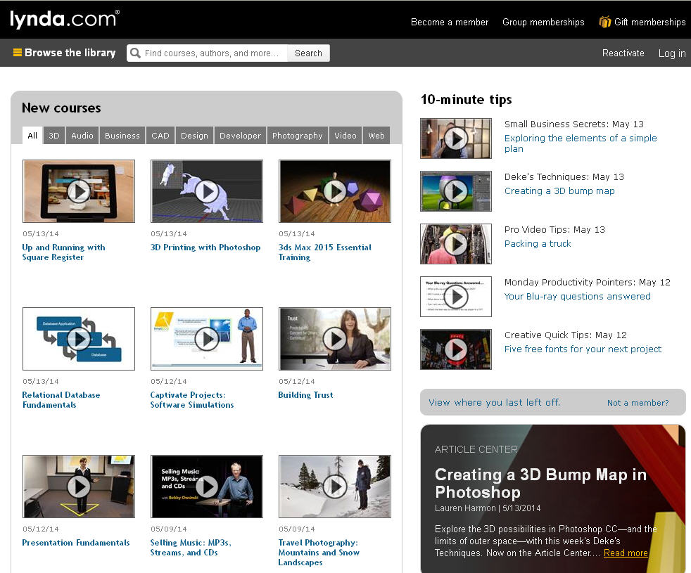

**Library Subject Guides**

myUniHub > MyStudy > MyLibrary

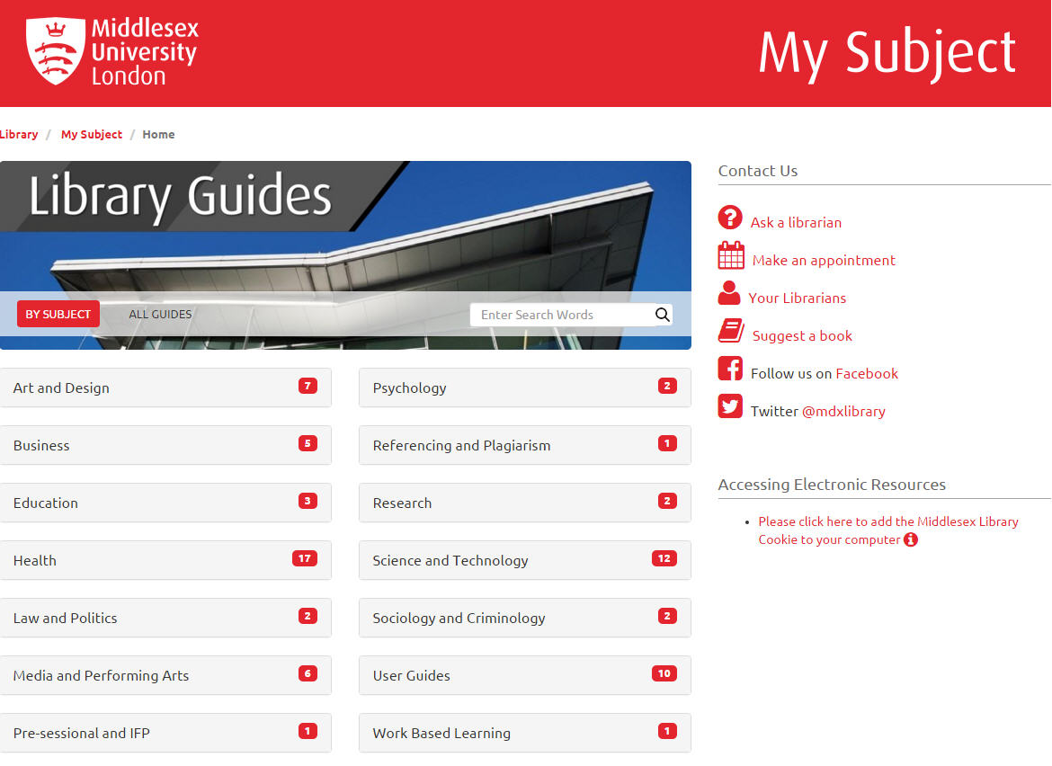

**Cite Them Right**

myUniHub > MyStudy > MyLibrary > Databases > C

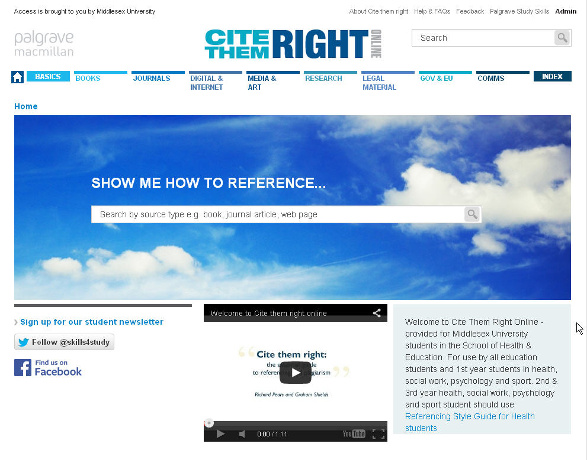

**Britannica Online**

myUniHub > MyStudy > MyLibrary > Databases > B

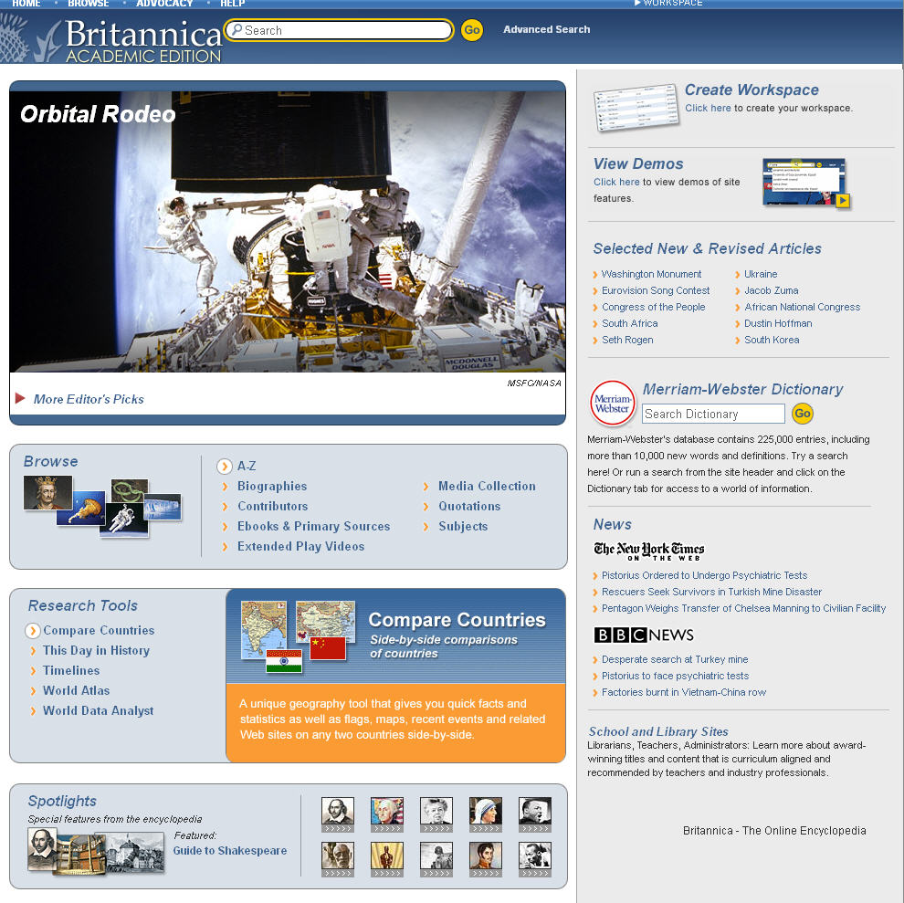

**Box of Broadcasts**

myUniHub > MyStudy > MyLibrary > Databases > B

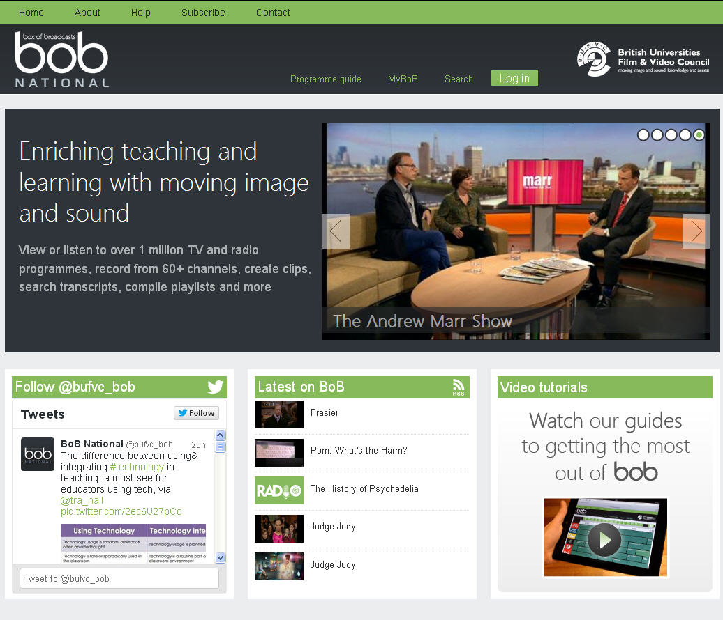

**Library Catalogue**

myUniHub > MyStudy > MyLibrary > Library Catalogue

