**Supplemental File**

*Figure captions*

Figure 1: 1H NMR spectrum of compound **5**

Figure 2: 13C NMR spectrum of compound **5**

Figure 3: Mass spectrum of compound **5**

Figure 4: 2D-docking picture of compound **5** into CDK-2 enzyme active site

Figure 5: 2D-docking picture of compound **6** into CDK-2 enzyme active site

Figure 6: 2D-docking picture of compound **9** into CDK-2 enzyme active site

Figure 7: 2D-docking picture of compound **10** into CDK-2 enzyme active site

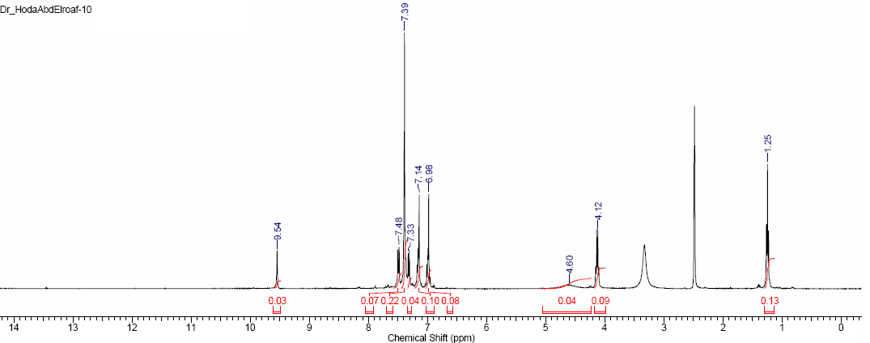

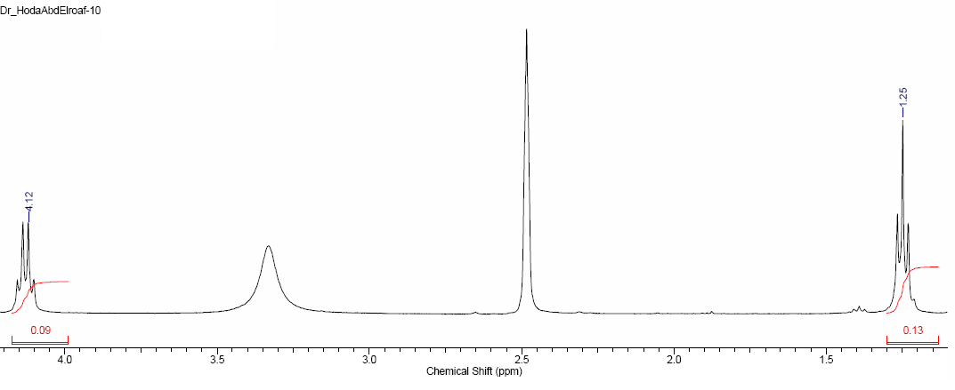

Fig. 1: 1H NMR spectrum of compound **5**

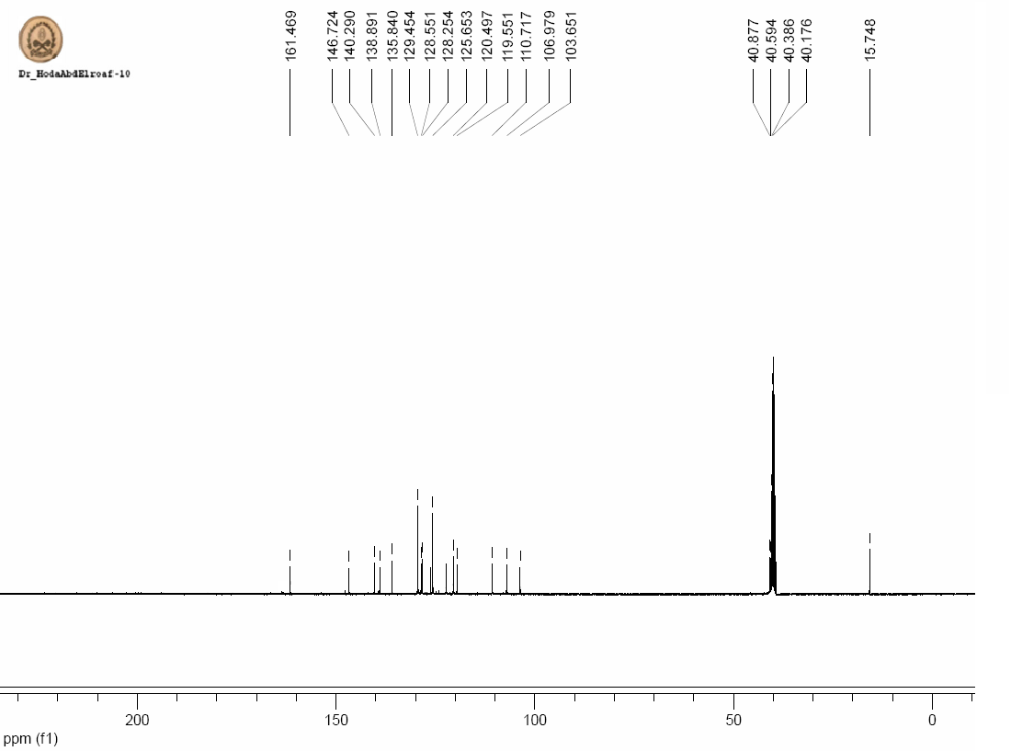

Fig. 2. 13C NMR spectrum of compound **5**

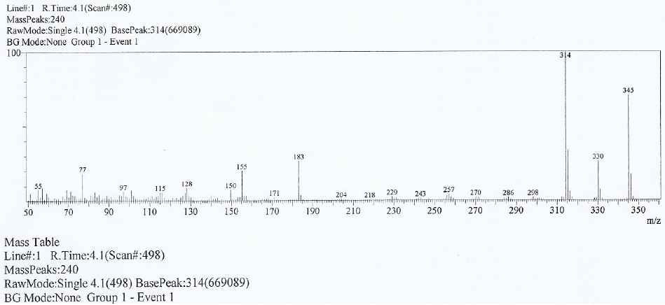

Fig. 3. Massspectrum of compound **5**



Fig. 4: 2D-docking picture of compound **5** into CDK-2 enzyme active site



Fig. 5: 2D-docking picture of compound **6** into CDK-2 enzyme active site



Fig. 6: 2D-docking picture of compound **9** into CDK-2 enzyme active site



Fig. 7: 2D-docking picture of compound **10** into CDK-2 enzyme active site