Profiling of Sputum Inflammatory Mediators in Asthma and Chronic Obstructive Pulmonary Disease
M Bafadhel¹, M McCormick², S Saha³, S McKenna¹, M Shelley¹, B Hargadon¹, V Mistry¹, C Reid¹, D Parker¹, P Dodson², M Jenkins², A Lloyd², P Rugman², Paul Newbold², CE Brightling¹
¹Institute for Lung Health, University of Leicester, United Kingdom
²AstraZeneca, Charnwood, Loughborough, United Kingdom
³ Sheffield Teaching Hospitals NHS Trust, Sheffield, United Kingdom

Address for correspondence and main site of work:
Professor CE Brightling
Institute for Lung Health, Clinical Sciences Wing
University Hospitals of Leicester, Groby Road, Leicester LE3 9QP
Tel: + 44 116 258 3998
Fax: + 44 116 250 2787
Email: ceb17@le.ac.uk

Keywords: COPD; Asthma; Airway Inflammation; Cytokines
Supplementary Table 1
Upper and lower limit of detection of measured sputum cytokines and chemokines in COPD and asthma patients using MSD and Luminex platforms
 | Sputum
pg/ml | Lower limit of quantification | Upper limit of quantification
CCL2 | 3.20 | 10000
CCL3 | 7.47 | 10000
CCL4 | 3.20 | 10000
CCL5 | 2.18 | 10000
CCL11 | 3.20 | 10000
CCL13 | 5.76 | 10000
CCL17 | 0.47 | 10000
CCL26* | 16.00 | 10000
IFN-γ* | 0.30 | 10000
CXCL10 | 3.20 | 10000
CXCL11 | 0.64 | 10000
TNF-α | 1.32 | 10000
TNFRI | 16.00 | 10000
TNFRII | 3.20 | 10000
IL1-β | 0.13 | 10000
IL4* | 0.30 | 10000
IL5 | 0.13 | 10000
IL6 | 0.13 | 10000
IL6-R | 6.61 | 10000
IL8 | 0.13 | 10000
IL10* | 1.15 | 10000
IL13* | 10.88 | 10000
IL17A* | 0.47 | 10000
GMCSF* | 1.32 | 10000
VEGF | 16.00 | 10000
MMP1* | 76.17 | 39000
MMP2* | 593 | 347500
MMP3* | 85.83 | 58500
MMP7 | 181 | 372500
MMP8 | 13000 | 13400000
MMP9 | 433 | 8800000
* Below the limit of quantification > 50% of the time, and not analysed further

Supplementary Table 2
Sputum mediator concentrations in patients with Asthma and COPD
 | COPD | Asthma | p-value
CCL2 | 454 [295 to 699] | 393 [284 to543] | 0.60
CCL3 | 92.9 [50.7 to 170.2] | 77.1 [48.7 to 122.1] | 0.63
CCL4 | 903 [501 to 1630] | 974 [490 to 1938] | 0.88
CCL5 | 3.8 [2.9 to 5.1] | 4.8 [3.5 to 6.7] | 0.35
CCL11 | 56.0 [31.8 to 98.5] | 66.5 [42.3 to 104.6] | 0.64
CCL13 | 15.7 [9.7 to 25.4] | 16.2 [12.1 to 21.6] | 0.92
CCL17 | 12.1 [6.7 to 21.8] | 16.7 [10.9 to 25.4] | 0.38
CXCL10 | 177 [88 to 356] | 253 [141 to 455] | 0.45
CXCL11 | 9.4 [4.1 to 21.6] | 18.3 [9.5 to 35.3] | 0.23
TNF-α | 9.6 [4.4 to 20.6] | 4.9 [2.8 to 8.4] | 0.16
TNFRI | 2254 [1536 to 3308] | 1095 [708 to 1694] | 0.03
TNFRII | 505 [323 to 790] | 198 [116 to 337] | 0.02
IL1-β | 194 [80 to 475] | 74 [40 to 137] | 0.08
IL5 | 0.8 [0.5 to 1.2] | 1.3 [0.8 to 2.1] | 0.14
IL6 | 351 [188 to 654] | 188 [115 to 308] | 0.13
IL6-R | 204 [142 to 294] | 130 [77 to 221] | 0.23
IL8 | 4709 [3314 to 6690] | 1803 [979 to 3322] | 0.01
VEGF | 1794 [1467 to 2196] | 1445 [1098 to 1902] | 0.27
MMP7* | 26.8 [18.9 to 37.9] | 15.6 [9.0 to 27.1] | 0.17
MMP8* | 257 [133 to 495] | 94 [55 to 160] | 0.03
MMP9* | 1002 [550 to 1828] | 336 [196 to 575] | 0.01
Data presented as geometric mean (95% confidence interval), units in pg/ml unless stated otherwise, *ng/ml
Figure Legends
Figure 1
Bar chart representing recovery from exogenous spike of mediators to a) sputum plug which is then treated with either D-PBS or DTT and b) D-PBS treated sputum and buffer control samples (n=4). Asterisked analytes considered to be valid assays with a recovery of >80% from sputum compared to buffer. Horizontal and error bars set at mean and standard error of the mean.

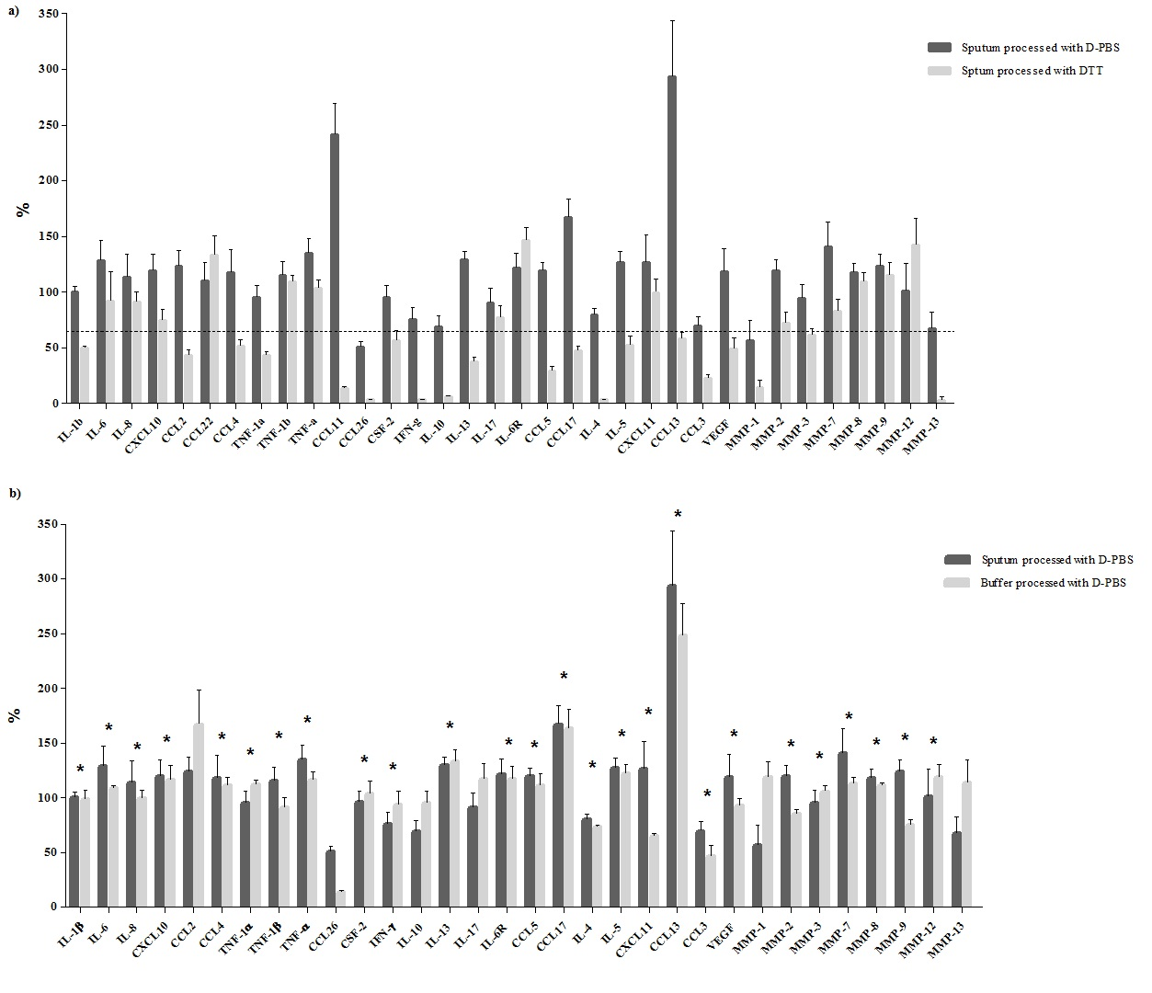

Figure 2
Bar chart comparing measured sputum mediators in asthma and COPD patients with eosinophilic airway inflammatory (top), and non eosinophilic airway inflammatory (bottom) phenotypes. Horizontal and error bars set at geometric mean and 95% confidence interval
