Online Supplement
Long-term Natural History of Intracranial Arterial Stenosis: an MRA follow-up study

Wi-Sun Ryu, MD¹; Sang-Soon Park, MD²; Young-Seo Kim, MD³; Su-Ho Lee, MD⁴; Kyusik Kang, MD, PhD⁵; Chulho Kim, MD⁶; Chul-Ho Sohn, MD, PhD⁷; Seung-Hoon Lee, MD, PhD⁸; Byung-Woo Yoon, MD, PhD⁸

Supplemental Tables
Supplemental table 1. Potential predictors of intracranial arterial stenosis progression
 | Progression (n=13) | Stationary or regression (n=89) | P
Age, y | 69.4 ± 9.7 | 62.6 ± 9.3 | 0.02
Male, % | 8 (61.5) | 46 (51.7) | 0.56
Hypertension, % | 12 (92.3) | 73 (82.0) | 0.69ª
Diabetes mellitus, % | 5 (38.5) | 40 (44.9) | 0.66
Smoking habit, % | 2 (15.4) | 24 (27.0) | 0.51ª
Coronary artery disease, % | 4 (30.8) | 26 (29.2) | 1.00ª
Hyperlipidemia, % | 8 (61.5) | 55 (61.8) | 0.93
Body mass index, Kg/m² | 25.3 ± 2.6 | 24.9 ± 2.9 | 0.63
Duration of follow-up,yr | 5.7 ± 1.1 | 5.7 ± 0.8 | 0.93
Antiplatelet drug use, % | 12 (92.3) | 72 (80.9) | 0.46ª
Anticoagulation use, % | 1 (7.7) | 2 (2.2) | 0.34ª
Statin use, % | 4 (30.8) | 34 (38.2) | 0.76ª
Anti-HT drug use, % | 11 (84.6) | 58 (65.2) | 0.21ª
Multiple stenosis, % | 6 (46.2) | 52 (58.4) | 0.53
Symptomatic stenosis | 8 (61.5) | 29 (32.6) | 0.04
Initial MRA |  |  | 0.67
1T | 4 (30.8) | 21 (23.6)
1.5T | 8 (61.5) | 54 (60.7)
3T | 1 (7.7) | 14 (15.7)
Follow-up MRA |  |  | 0.67ª
1.5T | 2 (15.4) | 11 (12.4)
3T | 11 (84.6) | 78 (87.6)
ª Fisher’s exact test was used.

Supplemental Table 2. Interval change of concomitant asymptomatic stenosis according to progression of symptomatic stenosis
 | Progression (n=8)  6 arteries | Stationary or regression (n=29)  31 arteries
Change of stenosis,%
Regression, n(%) | 1 (17) | 11 (36)
Stationary, n(%) | 5 (83) | 19 (61)
Progression, n(%) | 0 | 1 (3)

Supplemental Figures
Supplemental Figure 1. Flow sheet of study
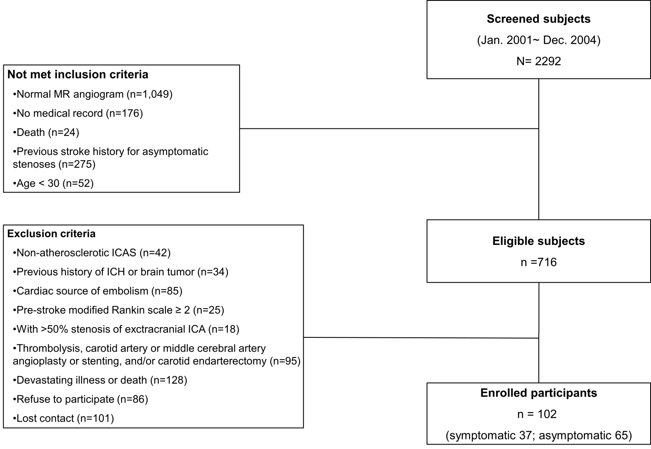

Supplemental Figure 2. Distribution of propensity score in symptomatic and asymptomatic participants
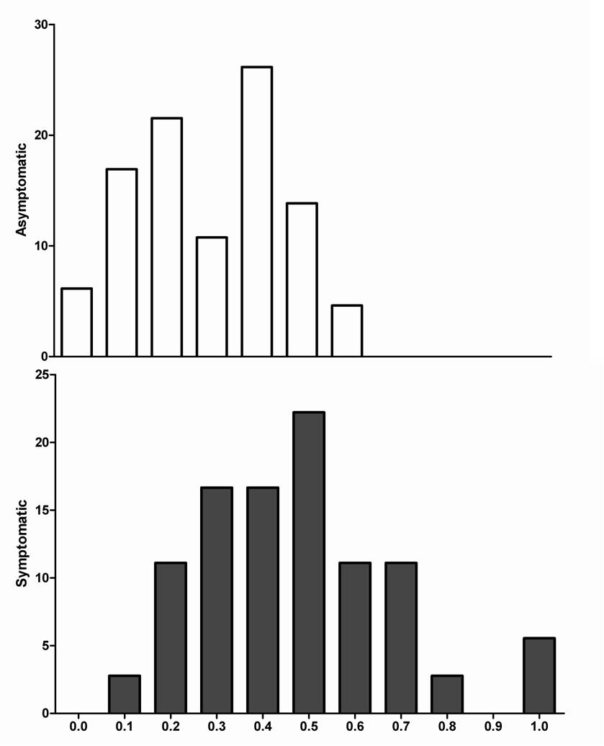
X-axis indicates propensity score.

