**Supplementary Figures :**

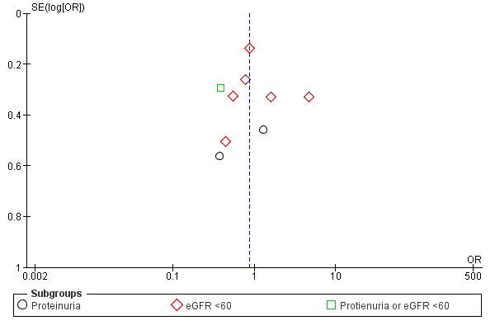

Supplementary Figure A: Funnel plot demonstrating the low risk of publication bias in papers investigating the risk of renal impairment in patients with symptomatic stroke.



Supplementary Figure B: Funnel plot demonstrating the low risk of publication bias in papers investigating risk of renal impairment in patients without symptomatic stroke.

Supplementary information: search strategy

1. brain ischemia/ or brain infarction/ or brain stem infarctions/ or cerebral infarction/ or hypoxia-ischemia, brain/ or stroke/

2. (isch?emi$ adj6 (stroke$ or apoplex$ or cerebral vasc$ or cerebrovasc$ or cva or attack$)).tw.

3. ((brain or cerebr$ or cerebell$ or vertebrobasil$ or hemispher$ or intracran$ or intracerebral or infratentorial or supratentorial or middle cerebr$ or mca$ or anterior circulation) adj5 (isch?emi$ or infarct$ or thrombo$ or emboli$ or occlus$ or hypoxi$)).tw.

4. (lacun$ or small vessel$ or small infarct$ or microinfarct$ or subcortical lesion$ or subcortical infarct$ or microvascular$ or microcirculation$).tw.

5. 1, 2, 3, OR 4.

6. Renal

OR kidney

OR glomerular filtration

OR Microalbuminuria

OR Proteinuria

7: 5 AND 6