Supplementary data
Supplementary Methods
Genotyping
Genomic DNA was isolated from whole blood using the QIAamp DNA Blood Mini Kit (Qiagen, Chadstone, VIC, Australia) according to the manufacturer’s instructions. The PCR amplifications were carried out in a total volume of 20ul containing 2ul of isolated DNA, 2-4 pmol of each primer (Invitrogen, Mulgrave, VIC, Australia), 10ul GoTaq Green Master Mix (Promega, Alexandria, NSW, Australia). Primer sequences used for ApaI were (f) 5'-ACGTCTGCAGTGTGTTGGAC-3', (r) 5'-TCACCGGTCAGCAGTCATAG-3', and for BsmI were (f) 5'-CAGTTCACGCAAGAGCAGAG-3', (r) 5'-ACCTGAAGGGAGACGTAGCA-3' [1]. The cycling conditions 35 cycles at 95°C for 30 s, 61°C for 30 s and 72°C for 30 s. 5ul of amplified DNA was digested in a total volume of 10ul, using 5U restriction enzyme (New England BioSciences, Ipswich, MA, USA). Digestions were performed at 25°C for 3 hours for ApaI, and 65°C for 3.3 hours for BsmI. The ApaI polymorphism resulted in two fragments of 121 and 90 bp for the ‘a’ allele, and the BsmI polymorphism resulted in two fragments of 197 and 39 bp in the presence of the ‘b’ allele. All PCR reactions were carried out in a BioRad MyCycler, and PCR products were sized by electrophoresis on a 3% agarose gel stained with ethidium bromide.
Circulating let-7a and 7b expression by qPCR
25 fmol of each C. elegans spike in control was added to 200ul of plasma, with 750ul Trizol LS. Isolates were resuspended in 50ul nuclease free water (Ultrapure, Life Technologies, Mulgrave, VIC, Australia). Prior to reverse transcription, 3ul of isolate was treated with 2U heparinase I, 1U DNase I, and 15U RNAse inhibitor (New England BioSciences, Ipswich, MA, USA) for 1 hour at 25°C, in a total volume of 14ul. Reverse transcription was performed in a final volume of 20ul containing 0.1mM ATP (New England BioSciences, Ipswich, MA, USA), 1 uM Universal RT-primer (5’CAGGTCCAGTTTTTTTTTTTTTTTVN, where V=A, C and G. N= A, C, G and T, Geneworks, Adelaide Australia), 0.4mM dNTP mix (New England BioSciences, Ipswich, MA, USA), 100 units of reverse transcriptase (M-MulV, New England BioSciences, Ipswich, MA, USA), 1U poly(A) polymerase (New England BioSciences, Ipswich, MA, USA) at 42°C for 1 hour followed by enzyme inactivation at 95°C for 5 minutes. cDNA was diluted in 450ul nuclease free water, and 5ul of this was used in each qPCR reaction. qPCR reactions were performed in triplicate using SYBR green (KAPA SYBR FAST Bio-Rad iCycler 2x qPCR Master Mix, Geneworks, Adelaide, Australia), 0.25µM of each primer (IDT, Coralville, IA, USA) in a final volume of 20ul using a Biorad Iq5. Primer sequences used for let-7a were (f) 5’-CAGTGAGGTAGTAGGTTGTAT-3’, (r) 5’-CGTCCAGTTTTTTTTTTTTTTTAACT-3’, and for let-7b were (f) 5’-GCAGTGAGGTAGTAGGTTT-3’, (r) 5’-CAGTTTTTTTTTTTTTTTAACCACAC-3’ [2]. Cycle conditions and melt curves were performed as per Balcells et al. [2]. Data was analysed using qbase plus (Biogazelle, Technologiepark, Belgium) [3].
Plasma 25(OH) vitamin D levels
Plasma 25(OH) levels were measured in a subset of the cohort (n=80) using a 25(OH) vitamin D ELISA kit for serum and plasma (Enzo Life Sciences, NY, USA), according to the manufacturer’s instructions. Samples for this subset were randomly selected within individual clinic date and locations to ensure representation of all potential UV exposures. Descriptive data (age, sex, total vitamin D intake) did not vary significantly between the subset and the complete cohort.
Calculation of solar activity prior to collection of blood samples
As blood samples for this project were collected over approximately a 10 month period from July-April, we assessed the influence of seasonal UV activity on plasma 25(OH) vitamin D levels. The influence of seasonal UV exposure on plasma 25(OH) levels is known to exhibit a 6-8 week lag [4,5]. Therefore, information on the average solar irradiance was gathered from the National Aeronautics and Space Administration’s (NASA) Total Ozone Mapping Program via NASA’s Aura OMI level 3 Atmospheric portal (http://gdata1.sci.gsfc.nasa.gov/daac-bin/G3/gui.cgi?instance_id=omi) for the 6 weeks prior to the day of blood collection. Values (mW/m²/nm x 10³) were collected for the location of the clinics (Central Coast of NSW, Australia; accurate to 1 degree of latitude/longitude) for a wavelength of 305nm, as this is the closest to the wavelengths responsible for the synthesis of vitamin D in the skin (290-315 nm; UVB) [6]. In the case of invalid TOMS data being received for a date, data was taken for the time period a day before and after the date, and was averaged.
Supplementary Results
Correlations to plasma 25(OH) vitamin D levels
After log transformation to normalise distributions, plasma 25(OH) vitamin D showed a significant correlation with estimated vitamin D intake from diet and supplements (n=80, adjusted r²=0.46, p<0.001, Figure S1). Adjusting for age and sex slightly increased this association (r²=0.49, p<0.001). This is a stronger correlation than reported for younger populations and is likely explained by the increased relative contribution of diet and supplements to plasma 25(OH) levels that occurs in the elderly, due to reduced levels of skin synthesis [7]. Solar activity in the 6 weeks prior to blood collection did not appear to significantly influence plasma 25(OH) levels (adjusted r²=0.02, p=0.16, Figure S2), however estimated time spent in the sun and skin reflectance were not recorded. Average steps per week (recorded by pedometer) and BMI did not appear to influence plasma 25(OH) levels (adjusted r²=0.02, p=0.26 and adjusted r²=0.006, p=0.46, respectively). Therefore, in this elderly cohort it appears that estimated intake is the best predictor of plasma 25(OH) levels.
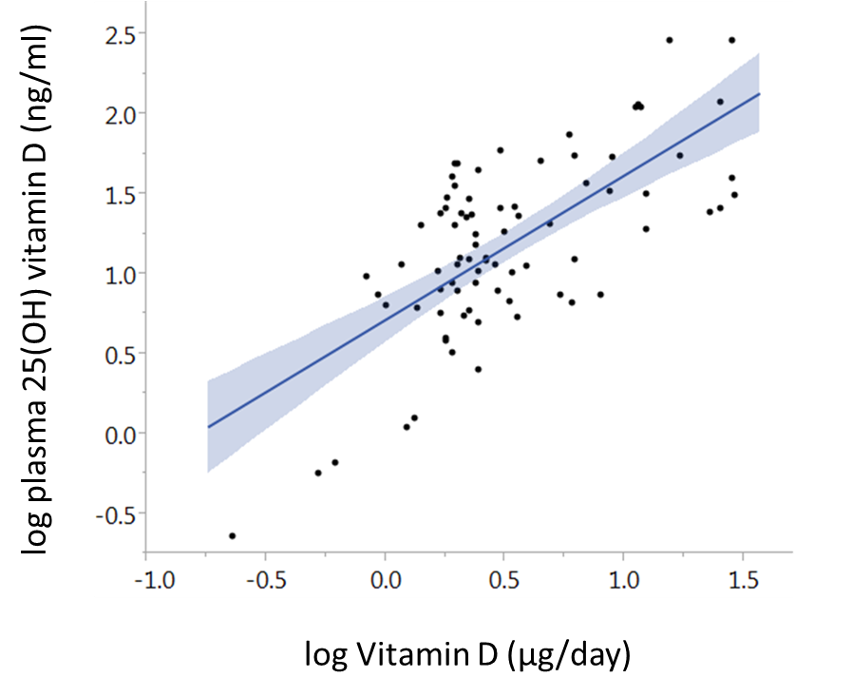
Figure S1: Correlation between log Vitamin D intake (ng/day) and log plasma 25(OH) vitamin D levels. n=80, adjusted r²=0.46, p<0.001

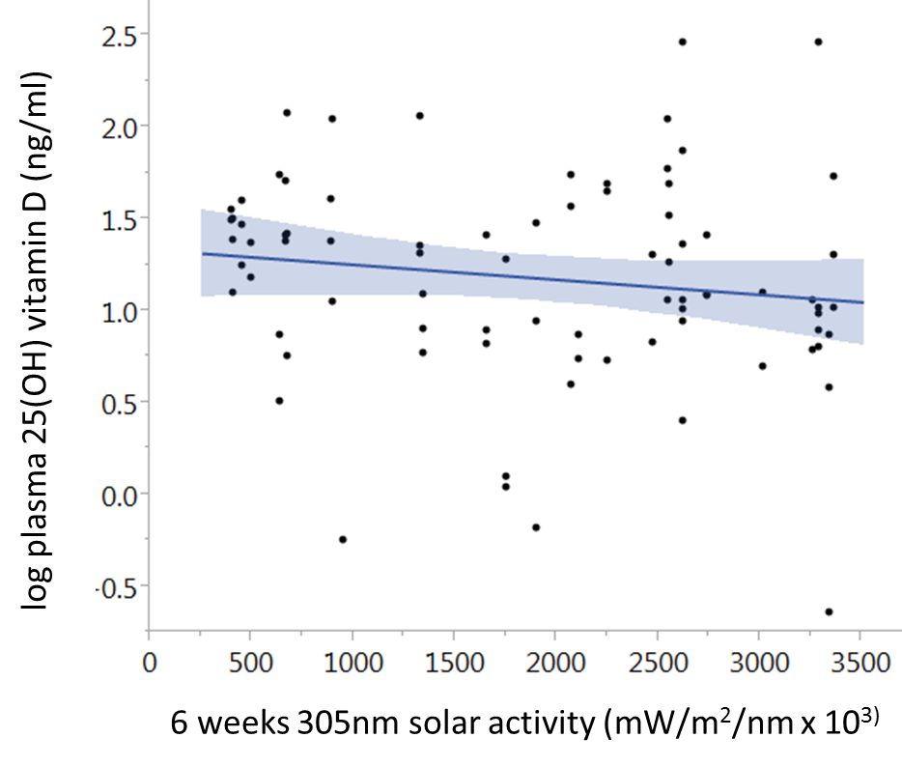

Figure S1: Correlation between 305nm solar activity over 6 weeks prior to blood collection and log plasma 25(OH) vitamin D levels. n=80, adjusted r²=0.02, p=0.16

Influence of genotype on let-7a/b expression
No significant difference was found when let7a/b expression data was analysed by genotype alone (Figure S3).
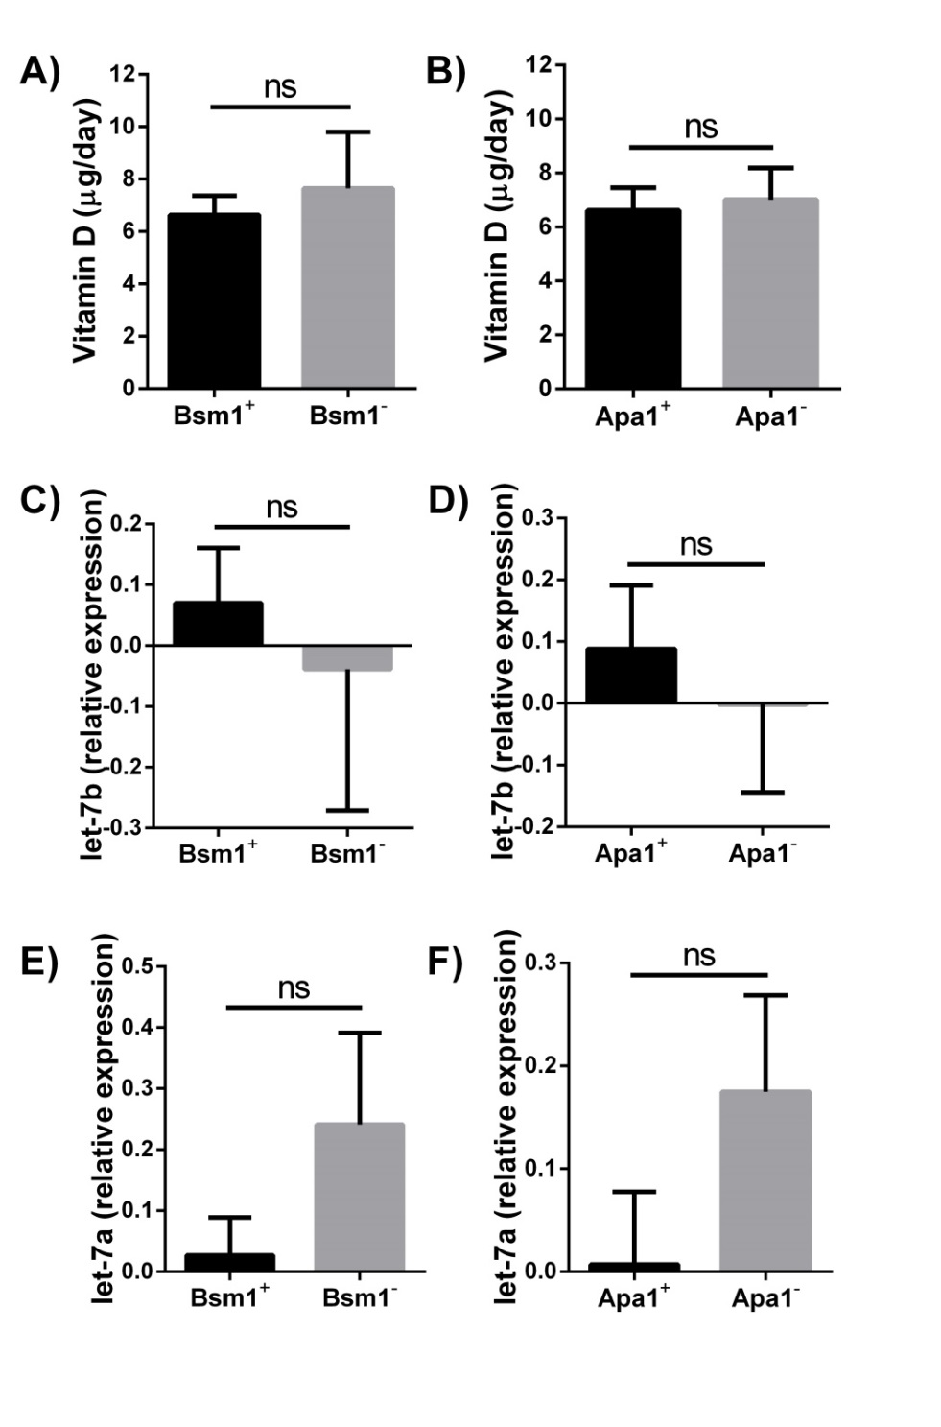
Figure S3: Vitamin D intake by absence/presence of A) BsmI and B) ApaI restriction site polymorphisms. let-7b expression by absence/presence of C) BsmI and D) ApaI restriction site polymorphisms. let-7a expression by absence/presence of E) BsmI and F) ApaI restriction site polymorphisms. BsmI⁻ (restriction site absent) n= 24; BsmI⁺ (restriction site present) n= 176; Apa1⁻ (restriction site absent) n=54; Apa1⁺ (restriction site present) n = 146.

Supplementary References
1 Falleti E, Bitetto D, Fabris C, Cussigh A, Fontanini E, Fornasiere E, Fumolo E, Bignulin S, Cmet S, Minisini R, Pirisi M, Toniutto P: Vitamin d receptor gene polymorphisms and hepatocellular carcinoma in alcoholic cirrhosis. World J Gastroenterol 2010;16:3016-3024.
2 Balcells I, Cirera S, Busk PK: Specific and sensitive quantitative rt-pcr of mirnas with DNA primers. BMC Biotechnol 2011;11:70.
3 Hellemans J, Mortier G, De Paepe A, Speleman F, Vandesompele J: Qbase relative quantification framework and software for management and automated analysis of real-time quantitative pcr data. Genome Biol 2007;8:R19.
4 Pittaway JK, Ahuja KD, Beckett JM, Bird ML, Robertson IK, Ball MJ: Make vitamin d while the sun shines, take supplements when it doesn't: A longitudinal, observational study of older adults in tasmania, australia. PLoS One 2013;8:e59063.
5 Weaver SP, Passmore C, Collins B, Fung E: Vitamin d, sunlight exposure, and bone density in elderly african american females of low socioeconomic status. Fam Med 2010;42:47-51.
6 Macdonald HM: Contributions of sunlight and diet to vitamin d status. Calcif Tissue Int 2013;92:163-176.
7 MacLaughlin J, Holick MF: Aging decreases the capacity of human skin to produce vitamin d3. J Clin Invest 1985;76:1536-1538.

