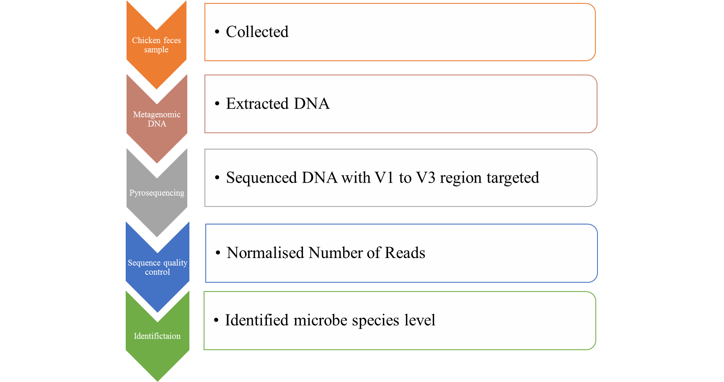
Figure S1. Bioinformatics pipeline for investigation of the microbial population in broiler chicken feces.

Table S1. List of minor (<1%) genus groups in each sample
Name | 1 day | 35 days
AB239481_f_uc | 0 | 0.0452
AB606262_g | 0 | 0.0226
AB626898_g | 0 | 0.0678
AB626922_g | 0 | 0.0226
Acinetobacter | 0 | 0.0226
Aerococcus | 0 | 0.0452
AF018558_g | 0 | 0.0452
AF544207_f_uc | 0 | 0.0226
AJ279038_g | 0 | 0.0226
Alkaliphilus | 0 | 0.0226
AM275436_o_uc_g | 0 | 0.0678
AM277340_g | 0 | 0.0678
AM406061_g | 0 | 0.0226
Anaerofilum | 0 | 0.0226
Arcobacter | 0 | 0.0226
Bacillus | 0 | 0.0226
Bacteroides | 0 | 0.0452
Blautia | 0.01424 | 0.70056
Brevundimonas | 0 | 0.0226
Butyricicoccus | 0 | 0.13559
Carnobacteriaceae_uc | 0.00712 | 0
Cellulosilyticum | 0 | 0.0904
Clostridia_uc_g | 0.00712 | 0.0226
Clostridiaceae_uc | 0.03559 | 0
Clostridiales_uc_g | 0.00712 | 0.29379
Clostridium | 0 | 0.54237
Clostridium_g16 | 0 | 0.0226
Clostridium_g23 | 0 | 0.0678
Clostridium_g6 | 0.37728 | 0.0904
Clostridium_g7 | 0 | 0.0226
Clostridium_g9 | 0 | 0.31638
Comamonas | 0 | 0.0226
Coprobacillus | 0.02136 | 0.0226
Corynebacterium | 0 | 0.31638
Cronobacter | 0.00712 | 0
Dorea | 0 | 0.27119
DQ071456_g | 0 | 0.13559
DQ071484_g | 0 | 0.22599
DQ456434_g | 0 | 0.0226
EF400272_g | 0 | 0.11299
EF406589_g | 0 | 0.0226
EF445272_f_uc | 0 | 0.0226
EF604822_g | 0 | 0.0226
Enterobacter | 0.01424 | 0
Enterobacteriaceae_uc | 0.02136 | 0
Enterococcaceae_uc | 0.02136 | 0
Enterococcus | 0 | 0.22599
Epulopiscium | 0.01424 | 0
Escherichia | 0 | 0.29379
EU381725_g | 0 | 0.29379
Eubacterium_g5 | 0 | 0.0678
Facklamia | 0 | 0.0678
Faecalibacterium | 0 | 0.90395
Festuca | 0.00712 | 0
FJ966226_g | 0 | 0.24859
Gallicola | 0 | 0.18079
Gammaproteobacteria_uc_g | 0.00712 | 0
GQ175418_g | 0 | 0.0904
GQ451199_g | 0 | 0.0226
GQ897562_g | 0 | 0.0226
GQ897654_g | 0 | 0.0226
GQ898349_g | 0 | 0.0226
GU324404_g | 0 | 0.0226
Hedyosmum | 0.03559 | 0
HM124144_g | 0 | 0.0226
HM124151_f_uc | 0 | 0.0452
HM124260_g | 0 | 0.0226
HQ452860_g | 0 | 0.18079
Jeotgalicoccus | 0 | 0.0226
Klebsiella | 0.00712 | 0
Kurthia | 0 | 0.13559
Lachnospiraceae_uc | 0 | 0.47458
Lactobacillaceae_uc | 0.00712 | 0.15819
Lactobacillales_uc_g | 0 | 0.0226
Lactonifactor | 0 | 0.29379
Lysinibacillus | 0 | 0.0904
Mogibacterium_f_uc | 0 | 0.0226
Nicotiana | 0.01424 | 0
Oscillibacter | 0 | 0.0904
Pelomonas | 0.00712 | 0
Peptostreptococcaceae_uc | 0 | 0.0678
Phaseolus | 0.0783 | 0
Planococcaceae_uc | 0 | 0.0226
Poaceae_uc | 0.00712 | 0
Proteobacteria_uc_g | 0.00712 | 0
Pseudoflavonifractor | 0 | 0.18079
Ruminococcaceae_uc | 0 | 0.47458
Ruminococcus_g2 | 0 | 0.0226
Ruminococcus_g3 | 0 | 0.11299
Ruminococcus_g4 | 0 | 0.31638
Secale | 0.00712 | 0
Soonwooa | 0 | 0.0226
Sphingobacterium | 0 | 0.0226
Staphylococcus | 0 | 0.22599
Subdoligranulum | 0 | 0.20339
Syntrophococcus | 0 | 0.11299
Thermohalobacter_f_uc | 0 | 0.0452
Trichococcus | 0 | 0.0904
Triticum | 0.00712 | 0
Wautersiella | 0 | 0.0226
Weissella | 0.00712 | 0.0226

