Supplementary Figure 1. Attention network test (ANT). A schematic of the four types of cue (a) and three types of flanker (b) that are used in ANT with the time courses of events (c).
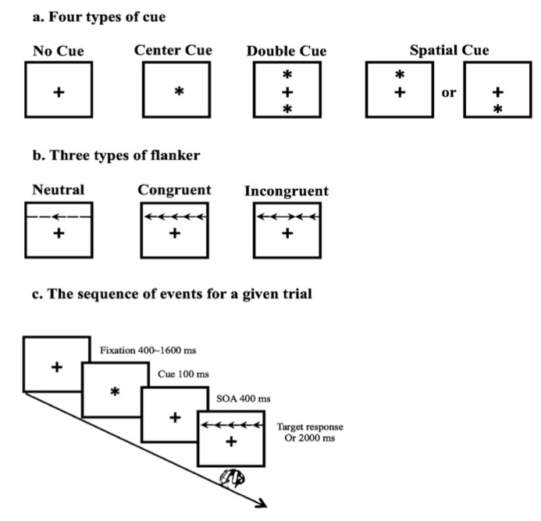

Supplementary Table 1. Demographics and cognitive profiles between healthy and NCD subgroups

 | Healthy  (n=137) | NCD-AD  (n=36) | NCD-Vascular  (n=31) | F  (χ²) | P value
Age | 71.45±3.99 | 73.35±4.91 | 73.46±5.27 | 3.098 | 0.056
Gender (F/M) | 61/76 | 16/20 | 12/19 | 1.800 | 0.168
Education (years) | 9.30±4.26 | 7.56±3.92 | 8.21±3.27 | 3.141 | 0.055
Systolic BP | 139.00±19.46 | 146.08±21.78 | 143.48±17.10 | 2.182 | 0.115
Diastolic BP | 78.19±10.75 | 78.36±8.60 | 81.74±13.47 | 1.379 | 0.254
CSDD | 0.49±1.81 | 0.18±0.72 | 0.26±0.85 | 0.590 | 0.555
PSQI | 5.75±3.15 | 6.24±3.69 | 5.88±3.05 | 1.284 | 0.279
ADL | 6.09±3.37 | 5.19±3.12 | 6.35±3.27 | 3.139 | 0.061
CDR-SOB | 0.34±0.47 | 0.81±0.54 | 0.81±0.70 | 17.915 | <0.001
CMMSE | 28.63±1.17 | 27.22±1.96 | 26.74±1.73 | 30.869 | <0.001
HK MoCA | 27.23±1.85 | 24.11±3.21 | 24.00±2.77 | 44.020 | <0.001
ADAS | 4.91±2.08 | 9.42±2.49 | 8.98±2.63 | 82.615 | <0.001
Delayed recall | 7.64±1.45 | 3.97±0.91 | 5.97±1.08 | 115.717 | <0.001
Digit span backward (DSB) | 3.75±1.32 | 3.00±1.22 | 3.03±0.84 | 7.863 | 0.001
Trail making test B | 67.07±41.26 | 91.21±62.26 | 83.17±38.13 | 4.784 | 0.009
Trail making test A | 12.90±6.37 | 16.87±10.18 | 15.62±6.09 | 5.327 | 0.006
Digit span forward (DSF) | 7.62±1.13 | 7.17±0.94 | 7.00±1.44 | 5.118 | 0.007
Note. Data are raw scores and presented as mean ± SD. CSDD = The Cornell Scale for Depression in Dementia; PSQI = Pittsburgh Sleep Quality Index;
BP: Blood pressure; CDR-SOB = Clinical dementia rating-sum of box; ADL = Activity of daily living scale.

Supplementary Table 2. Scores of attention network functions between healthy and NCD subgroups

 | Healthy  (n=137) | NCD-AD  (n=36) | NCD-Vascular  (n=31) | F | P value
Alerting | 3.95±31.88 | 9.93±44.44 | 7.95±29.58 | 0.525 | 0.592
Orienting | -19.76±28.66 | -24.32±39.31 | -21.56±27.69 | 0.326 | 0.722
Executive control | 59.86±45.86 | 96.96±53.90 | 88.87±44.84 | 11.472 | <0.001
Alerting ratio | 0.0061±0.0469 | 0.0132±0.0583 | 0.0123±0.0425 | 0.432 | 0.650
Orienting ratio | -0.0287±0.0417 | -0.0304±0.0461 | -0.0300±0.0371 | 0.029 | 0.971
Executive control ratio | 0.0889±0.0682 | 0.1318±0.0716 | 0.1288±0.0609 | 8.430 | <0.001
Note. Data are raw scores and presented as mean ± SD.

Supplementary Table 3. Correlation between ANT indices and cognitive functions

 | Alerting |  |  | Orienting |  |  | Executive control
 | r | p |  | r | p |  | r | p
CDR-SOB | -0.207 | 0.256 |  | 0.199 | 0.276 |  | -0.277 | 0.125
CMMSE | 0.234 | 0.197 |  | -0.261 | 0.149 |  | 0.244 | 0.178
HK MoCA | -0.042 | 0.820 |  | 0.052 | 0.776 |  | 0.260 | 0.150
ADAS-Cog | 0.035 | 0.848 |  | 0.199 | 0.274 |  | -0.071 | 0.701
Delayed recall | 0.215 | 0.236 |  | -0.275 | 0.128 |  | 0.279 | 0.122
DSB | 0.230 | 0.205 |  | -0.152 | 0.405 |  | 0.050 | 0.786
CVFT | -0.024 | 0.896 |  | 0.071 | 0.698 |  | 0.047 | 0.800
TMT-B | 0.124 | 0.499 |  | 0.085 | 0.664 |  | -0.062 | 0.736
TMT-A | 0.179 | 0.327 |  | -0.140 | 0.445 |  | -0.122 | 0.507
DSF | 0.176 | 0.336 |  | -0.143 | 0.445 |  | 0.052 | 0.778

