Exploratory vertex-based analysis of a main effect of maternal history of depression on cortical thickness in daughters
We conducted supplementary analyses to explore whether daughters of recurrent depressed (RMD) mothers differed from daughters of never-depressed (CTL) mothers in cortical thickness outside of regions-of-interest identified in analyses comparing RMD and CTL mothers, controlling for the linear effects of age and total brain volume. We found that daughters with a maternal history of depression exhibited significantly thinner gray matter relative to daughters of never-depressed mothers in two clusters, both of which were highly overlapping with the clusters identified in our original vertex-based analysis of mothers (Figure S1). One cluster in the left hemisphere encompassed the fusiform gyrus, superior, middle, and inferior temporal gyri and left lateral occipital gyrus (Cluster-wise probability (CWP) = 0.0001; x/y/z Talairach peak coordinate = -41.29, -12.01, -32.97). Another encompassed these same brain areas in the right hemisphere (CWP = 0.0001; x/y/z Talairach peak coordinate = 17.23, -43.29, -52.66).

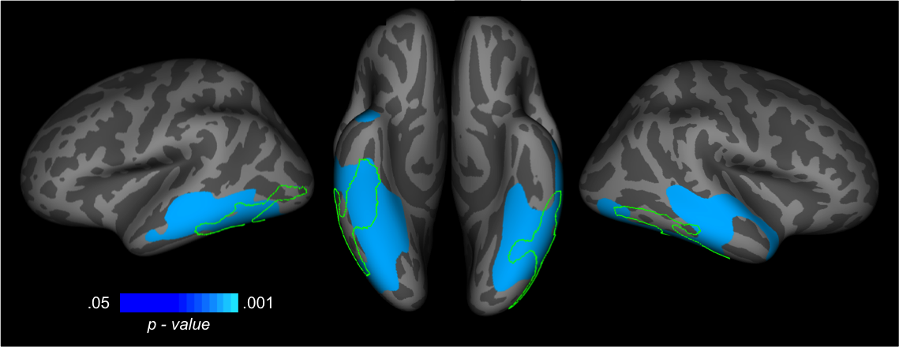
Figure S1. Corrected statistical significance maps showing areas of reduced cortical gray matter thickness in daughters of recurrent depressed mothers versus daughters of never-depressed mothers (blue). Green lines indicate areas regions found to show a main effect of group (remitted depressed, control) in our primary analysis of mothers’ thickness.

