Supplemental Figure 1: Representative histograms of fibroblasts and MSCs stained with fluorophore-conjugated antibodies for different cell surface markers. Isotype controls are in gray.
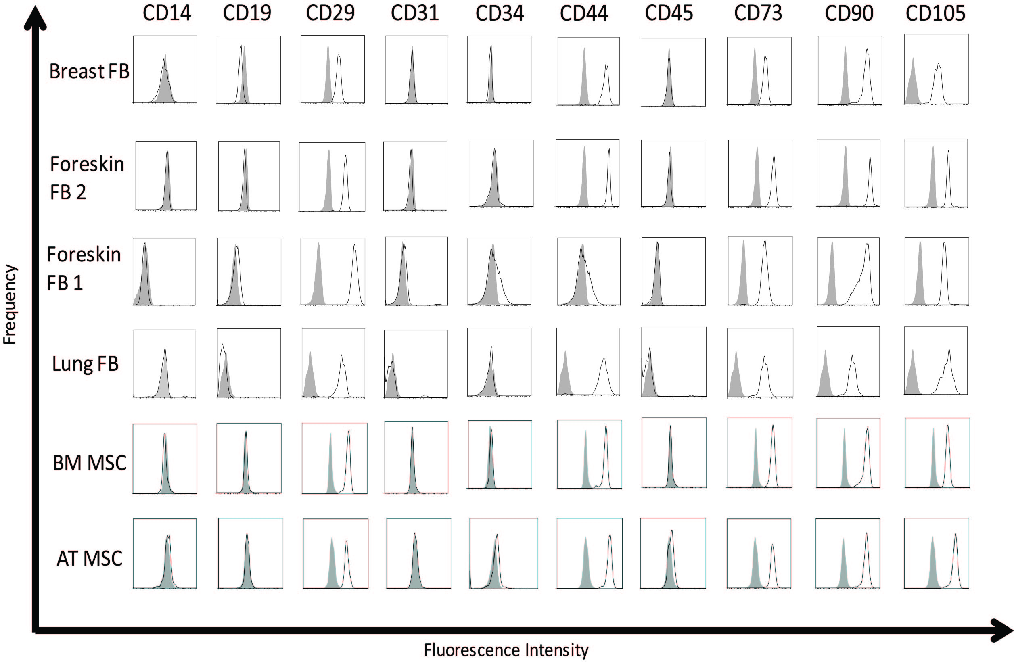

Supplemental Figure 2: MSCs and fibroblasts both express FSP1.
Western blot analysis of FSP1. Alpha-tubulin was used as a loading control.
