Supplementary Information

To accompany the manuscript entitled

**The impact of photovoltaic (PV) installations on downwind particulate matter concentrations: Results from field observations at a 550 MWac utility scale PV plant**

Dwarakanath Ravikumar1, Parikhit Sinha2

1-Arizona State University, USA, 2-First Solar, USA

Comprising:

5 Pages

4 Tables

1. Wind direction, angles and calculation of hourly averages

**Table 1 Wind direction and the corresponding wind angles**



The wind direction data was available on a minutely resolution and to match it with the hourly PM data, we calculated the average of all the angle values recorded in one hour. The average of all the angle values is mapped to the direction using table 1 to arrive at the hourly mean wind direction. By convention in this study, the BAM readings represent the direction to which the wind is blowing. For example, the “E” reading in the BAM represents a wind blowing to the east at an angle between 78.25 to 101.25 degrees.

1. PM readings – Grouping, observation period and wind angles

**Table 2 Grouping, observation period and the wind angles for PM2.5 and PM10 readings at the four BAM stations**

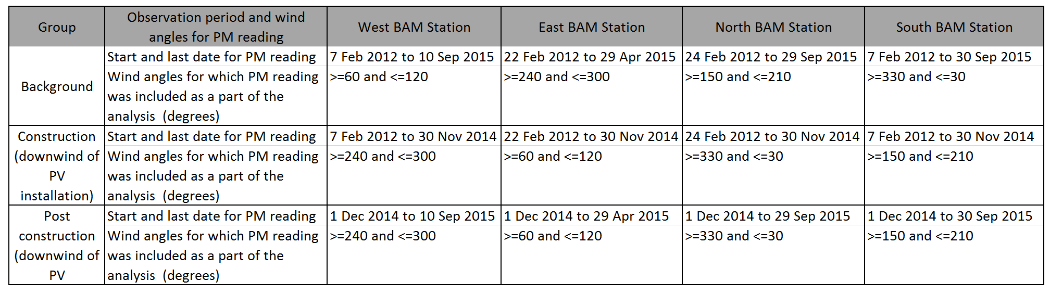

1. Results – Anderson Darling test for normality for PM2.5 and PM10 readings

**Table 3 Anderson Darling test for normality for PM2.5 and PM10 readings for the construction and post construction groups. The null hypothesis is rejected as P values are less than 0.05 and therefore the background, construction and post-construction PM readings across all the BAM stations are not normally distributed.**

Hnull: The PM readings are normally distributed

Halternate: The PM readings are not normally distributed



1. Results – Anderson Darling test for normality for PM2.5 and PM10 readings after Box Cox transformation

**Table 4 Anderson Darling test for normality for PM2.5 and PM10 readings for the background, construction and post construction groups after the Box Cox transformation is applied, to verify if the PM data can be transformed (i.e., from a lognormal distribution) into a normal distribution. The null hypothesis is rejected as P values are less than 0.05 and therefore the background, construction and post-construction PM readings across all the BAM stations are not normally distributed after the transformation.**



Hnull: The PM data points after the Box Cox transformation are normally distributed

Halternate: The PM data points after the Box Cox transformation are not normally distributed