Supplementary Materials

TABLE 1
Demographic, clinical, pathological and α-synuclein immunostain data from 42 pediatric endoscopic biopsies ordered with respect to α-synuclein score
Age | Sex | Clinical history | Acute inflammation score | Chronic inflammation score | Infection | α-Synuclein score
16 y | F | Abdominal pain, diarrhea, blood in stool and nausea, positive H. pylori serology | 0 | 2 |  | 1
16 y | F | Abdominal pain; gastritis | 0 | 0 |  | 1
9 y | F | Chronic chest pain; chronic heartburn | 0 | 0 |  | 1
16 y | M | Failure to thrive, cerebral palsy, gastritis | 0 | 0 | H. pylori | 1
12 y | M | Hematemesis; gastritis | 0 | 1 |  | 1
13 y | F | Diarrhea, abdominal pain; esophagus/ stomach/duodenum appeared normal on EGD | 0 | 0 |  | 1
5.67 y | F | Rectal bleeding, bloody stools | 0 | 0 |  | 1
17 y | F | Weight loss; diarrhea | 1 | 1 |  | 1
15 y | F | Abdominal pain, vomiting, epigastric pain, gastritis | 0 | 0 | H. pylori | 1
15 y | M | Upper gastro-intestinal bleed, duodenal ulcer, gastritis | 1 | 3 | H. pylori | 1
11 y | M | Dysphagia | 0 | 0 | H. heilmannii | 1
16 y | F | Abdominal pain | 2 | 2 | H. pylori | 1
10 y | M | Nausea, vomiting, diarrhea | 0 | 1 | H. pylori | 1
17 y | F | Epigastric pain, vomiting; gastritis | 0 | 0 |  | 2
10 y | M | Bloating; diarrhea; gastritis | 2 | 2 | H. pylori | 2
12 y | M | Abdominal pain; vomiting; severe peptic acid disease | 2 | 2 |  | 2
2.42 y | M | Hematemesis, melena, Kawasaki's disease; ulceration in stomach and duodenum | 1 | 2 |  | 2
1.58 y | F | Vomiting, white plaque on esophagus; stomach and duodenum appeared normal on EGD | 0 | 0 | C. albicans | 2
13 y | F | Gastritis; esophagus and duodenum appeared normal on EGD | 0 | 0 | H. pylori | 2
16 y | F | Dyspepsia; mild gastric erythema; esophagus and duodenum appeared normal on EGD | 0 | 0 | H. pylori | 2
17 y | M | Abdominal pain, nausea, vomiting | 1 | 3 | H. pylori | 2
12 y | F | Abdominal pain; fundic polyp; esophagus, stomach and duodenum appeared normal on EGD | 0 | 0 |  | 2
13 y | M | Diarrhea | 0 | 0 |  | 2
13 y | F | Vomiting, abdominal pain, nausea, vomiting; abdominal pain | 0 | 3 | H. pylori | 2
16 y | F | Abdominal pain, emesis, vomiting, gastric erythema; H. pylori versus NSAID gastritis | 1 | 0 | H. pylori | 2
16 y | F | Nausea | 1 | 2 |  | 2
16 y | F | Abdominal pain, nausea, vomiting | 2 | 2 | H. pylori | 2
13 y | F | Abdominal pain, weight loss | 0 | 0 | H. pylori | 2
15 y | F | Abdominal pain; chronic granulo- matous disease | 1 | 2 |  | 2
0.75 y | M | Vomiting | 2 | 2 | H. pylori | 2
2.5 y | F | Persistent vomiting; esophagitis | 3 | 3 |  | 3
9 y | M | Iron deficiency anemia; gastritis | 1 | 0 | H. pylori | 3
19 y | F | Crohn's disease; unexplained anemia; linear duodenal ulcers; gastric mucosa thickening | 3 | 0 |  | 3
16 y | F | Hematemesis; esophagitis; gastritis | 3 | 2 | H. pylori | 3
7 y | M | Vomiting, abdominal pain; positive H. pylori breath test; nodular gastritis | 1 | 2 | H. pylori | 3
13 y | F | Gastritis | 0 | 2 | H. pylori | 3
16 y | F | Weight loss, diarrhea, vomiting, scleroderma, feeding intolerance | 2 | 2 | C. albicans | 3
2.17 y | M | Respiratory distress/hypoxia, failure to thrive, diarrhea, hypo-albuminemia, rectal bleeding | 3 | 3 |  | 3
9 y | F | Rectal bleeding | 2 | 2 | H. pylori | 3
13 y | F | Diarrhea | 3 | 2 | H. pylori | 3
14 y | M | Dysphagia | 0 | 1 |  | 3
17 y | M | Hematemesis; melena; hemoglobin 6.9; large duodenal ulcer in bulb; nodular gastropathy | 3 | 3 | H. pylori | 3

TABLE 1 LEGEND
Demographic, clinical, pathological and α-synuclein immunostain data from 42 pediatric endoscopic biopsies. Pediatric cases were selected with pathological and/or clinical diagnoses of gastritis, duodenitis, H. pylori, and gastropathy. Slides were stained with α-synuclein and scored for by two pathologists for neurite α-synuclein presence and intensity, as well as inflammation as follows: 1, slight; 2, moderate; 3, high. Acute and chronic inflammation was scored as 1, slight; 2, moderate; 3, intense, based on the degree of infiltration of neutrophils or mononuclear cells, respectively. α-synuclein and inflammation scores are the average of the two readings.

TABLE 2A

Patient | Age at transplant | Sex of recipient | Underlying condition | Donor age | Organs transplanted | Viral infection timeline | Comment
1 | 2 y | M | Volvulus | 0.4 y | Li/SB/Pa | 0 months: Norovirus [RNA PCR]  - 8 years: Rotavirus (x4) [Rota antigen, stool]
2 | 1.5 y | F | NEC | 1 y | SB | + 2 months: Norovirus [RNA PCR]  0 months: Norovirus [RNA PCR]  - 2 months: C. difficile [C. diff toxin gene PCR, stool]  - 2 years: CMV [CMV IgG, blood] | Persistent norovirus infection at follow-up biopsy
3 | 15 y | F | Volvulus | 6 y | SB | + 4 months: Norovirus [RNA PCR]  0 months: Norovirus [RNA PCR]  - 1 year: CMV [CMV IgG, blood]  - 1 year: HHV 6 (IFA antibody panel, blood)  - 2 years: EBV a nd Rubella | Persistent norovirus infection and persistently high levels of α-synuclein at follow-up biopsy
4 | 1.7 y | M | Atresia | 2 y | SB | + 11 months: Norovirus [RNA PCR]  + 8 months: Respiratory Syncytial Virus [Respiratory panel PCR]  + 2 months: Norovirus [RNA PCR]  0 months: Norovirus [RNA PCR]  - 1 year: HHV 6 [HHV 6 DNA Quantitative PCR, blood] | Persistent norovirus infection and persistently high levels of α-synuclein at follow-up biopsy
5 | 5 y | M | Volvulus | 2 y | SB | + 2 months: Norovirus [RNA PCR]  0 months: Norovirus (RNA PCR)  0 months: Rotavirus [Rota antigen EIA, stool] | Concomitant Norovirus and Rotavirus infection and high levels of α-synuclein
6 | 1.3 y | M | NEC | 2 y | Li/SB | + 2 months: - Norovirus [RNA PCR]  0 months: Norovirus [RNA PCR]  - 1 month: BK virus [BK virus DNA quantitative PCR, urine]  - 9 years: C. difficile [C. diff toxin A and B PCR, stool]  - 10 years: Aeromonas [Culture, stool]  - 10 years: C. difficile [C. diff toxin A, B PCR, stool]  - 10 years: HSV [Culture, ileum] | Persistently high levels of α-synuclein despite resolution of norovirus infection at follow-up biopsy
7 | 5 y | F | Psuedo-obstruction | 5 y | SB | + 5 months: Norovirus [RNA PCR]  + 2 months: Norovirus [RNA PCR]  0 months: Norovirus [RNA PCR]  - 2 years: C. difficile [C. diff antigen  EIA, stool]  - 3 years: C. difficile [C. diff toxin gene PCR, stool]  - 4 years: EBV [EBV viral capsid IgG, blood]  - 5 years: CMV [CMV IgG, blood]  - 6 years: EBV [EBV DNA PCR, blood]  - 6 years: CMV [CMV DNA PCR, blood]  - 10 years: CMV [CMV DNA PCR, blood] | Persistent norovirus infection and persistently high levels of α-synuclein at follow-up biopsy
8 | 33 y | F | FAP | 7 y | MV | 0 months: Norovirus [RNA PCR]  - 4 years: EBV [EBV DNA PCR, blood]  - 7 years: EBV [EBV DNA PCR, blood] | No significant α-synuclein observed in biopsy sampled prior to norovirus infection in 33-year old FAP patient duodenum. No prior upper GI viral infection.
9 | 1.3 y | F | Psuedo-obstruction | 0.3 y | Li/SB/Pa | + 1 year: - Norovirus [RNA PCR]  + 2 months: - Norovirus [ RNA PCR]  0 months: Norovirus [RNA PCR]  - 2 months: Adenovirus [Adenovirus antigen, stool]  - 2 years: Norovirus [RNA PCR]  - 4 years: C. difficile [C. diff toxin A and B, ileum] | High levels of α-synuclein during norovirus infection with significant reduction after resolution of norovirus infection.
10 | 1 y | F | NEC | 0.1 y | Li/SB | + 3 months: Norovirus [RNA PCR]  0 months: Norovirus [RNA PCR]  - 1 month: CMV [CMV DNA, blood]  - 4 months: CMV [CMV DNA, blood]  - 1 year: CMV [CMV DNA, blood]
11 | 47 y | F | Mesenteric thrombosis | 33 y | SB | 0 months: Norovirus [RNA PCR]  - 1 month: Enterovirus [Enterovirus PCR, blood]  - 2 months: Adenovirus [Adenovirus antibody, blood]  - 1 year: CMV [CMV DNA PCR, blood]  - 2 years: EBV [EBV DNA PCR, blood]  - 3 years: EBV [EBV DNA PCR, blood]
12 | 3 y | M | NEC | 3 y | SB | 0 months: Norovirus [RNA PCR]  - 1 month: Adenovirus [Adenovirus antigen, stool]  - 1 month: C. difficile [C. diff ntigen, stool]  - 2 months: EBV [EBV DNA PCR, blood]  - 8 months: EBV [EBV DNA PCR, blood]  - 8 months: Adenovirus [Adenovirus antigen, stool]  - 3 years: Respiratory Syncytial Virus [Respiratory viral panel PCR]  - 3 years: Rotavirus [Rota antigen, stool]  - 3 years: Adenovirus [Adenovirus antigen, stool]  - 3 years: Rotavirus [Rota antigen, stool] | No significant α-synuclein observed in native duodenum or grafted jejunum prior to infection. Induction of α-synuclein at the time of norovirus infection in both native and grafted tissue. Chronic shedding of adenoviral antigen in stool.
13 | 2 y | M | Gastro-schisis | 0.4 y | Li/SB/Pa | + 3 months: Norovirus [RNA PCR]:  0 months: Norovirus [RNA PCR]  - 3 months: Group A Streptococcus [Rapid Strep test]  - 4 months: Parainfluenza virus [Respiratory viral panel PCR]  - 1 year: Coronavirus [Respiratory viral panel PCR]  - 2 year: Respiratory Syncytial Virus [Respiratory viral panel PCR]
14 | 0.6 y | M | Volvulus | 0.4 y | Li/SB/Pa | 0 months: Norovirus [RNA PCR]  - 1 month: Parainfluenza virus [Respiratory viral panel PCR]  - 1 year: Coronavirus [Respiratory viral panel PCR]
15 | 4.8 y | F | Tufting | 1.6 y | SB | 0 months: Norovirus [RNA PCR]  - 8 months: CMV [CMV DNA PCR, blood]  - 8 months: EBV [EBV DNA PCR, blood]  - 9 months: Adenovirus [Adenovirus antigen, stool]  - 1 year: EBV [EBV capsid IgG, blood] | No significant α-synuclein observed in biopsy sampled prior to norovirus infection in native duodenum of a 5-year old patient. Induction of α-synuclein in native duodenum at the time of norovirus infection. Chronic asymptomatic shedding of adenovirus antigens in stool.
16 | 3.3 y | M | Gastro-schisis | 1.4 y | Li/SB/Pa | 0 months: Norovirus [RNA PCR]  - 1 month: EBV [EBV DNA PCR, blood]  - 4 months: EBV [EBV DNA PCR, blood]  - 9 months: EBV [EBV DNA PCR, blood]  - 2 years: EBV [EBV DNA PCR, blood] | No significant α-synuclein observed in native duodenum or grafted duodenum and jejunum prior to norovirus infection. Induction of α-synuclein at the time of norovirus infection. No prior upper GI viral infection.
NEC, necrotizing enterocolitis; FAP, familial adenomatous polyposis; SB, small bowel; Li, liver; Pa, pancreas; MV, multivisceral; EBV, Epstein Barr virus; CMV, cytomegalovirus; HHV 6, human herpesvirus 6; PCR, polymerase chain reaction

TABLE 2A LEGEND
Demographic/clinical data and viral histories of intestinal transplant patients with Norovirus infection. The date of the biopsy immediately after initial detection of Norovirus infection is listed as ‘0 months’ and highlighted in bold under ’Viral infection timeline’. The timing of all other studies and biopsies are chronologically referenced relative to the date of the initial biopsy taken at the time of the infection. All viral studies performed prior to the date of Norovirus infection are listed.

TABLE 2B

Patient | Tissue | α-synuclein score before initial Norovirus infection  (‘Pre’ biopsy) | α-synuclein score during initial Norovirus infection (‘During’ biopsy) | α-synuclein score after initial Norovirus infection (‘Post’ biopsy)
1 | Dn |  | 3
1 | Dg |  | 1
1 | Jg |  | 1
2 | Dn |  |  | 1 (+2 mo)
2 | Jg |  | 3
2 | ILg |  |  | 0 (+2 mo)
3 | Dn | 3(-2 mo) | 4 | 3 (+4 mo)
3 | Jg |  | 4 | 3 (+4 mo)
3 | ILg | 4 (-2 mo) |  | 2.5 (+4 mo)
4 | Dn |  | 2.5 | 2.5 (+2 mo)
4 | Jg |  | 3 | 3 (+2 mo)
4 | Dn | 2.5 (-2 mo) | 4
4 | Jg | 2.5 (-2 mo) | 4
4 | ILg | 2(-2 mo) | 0 | 2.5 (+2 mo)
5 | Dn |  | 3
5 | Jg
6 | Dn |  | 3 | 3 (+1 mo)
6 | Jg |  | 2.5 | 3 (+1 mo)
7 | Dn | 2 (-2 mo) | 2
7 | Jg | 2 (-2 mo) | 3 | 2 (+3 mo)
8 | Dg | 0 (-1 mo)
8 | Jg | 0 (-1 mo) | 2
8 | ILg |  | 3 | 2 (+ 1 mo)
9 | Dn |  | 3
9 | Jg |  | 1
10 | Dn |  | 1.5
10 | Jg |  | 2 | 1.5 (+1 mo)
10 | ILg |  |  | 1.0 (+1 mo)
11 | Dn |  | 1.5 | 1.5 (+1 mo)
11 | Jg |  | 2.5
11 | ILg |  | 1.5 | 2 (+5 mo)
12 | Dn | 0 (-6 mo) | 2
12 | Jg | 0 (-6 mo) | 2 | 1.0 (+1 mo)
13 | Dg | 1.5 (-2 mo) | 1.5
13 | Jg |  | 1.5 | 2.5 (+3 mo)
14 | Dn | 1 (-1 mo) | 1
14 | Dg |  |  | 1 (+7 mo)
14 | Jg | 0.5 (-1 mo) | 1 | 1 (+7 mo)
15 | Dn | 0 (-1 mo) | 1.5 | 1 (+3 mo)
15 | Jg | 1 (-1 mo) | 0.5 | 1.0 (+3 mo)
16 | Dn | 0 (-1 mo) | 2
16 | Dg | 0 (-1 mo) | 2
16 | Jg | 0 (-1 mo) | 2
 | Mean α-Synuclein Scores
 | PRE | DURING | POST
Dn | 1.2 | 2.4 | 1.8
Dg | 0.5 | 1.5 | 1.0
Jg | 1.0 | 2.1 | 1.6
ILg | 3 | 1.5 | 1.9
All samples | 1.2 | 2.2 | 1.7

TABLE 2B LEGEND

. α-Synuclein immunostain scores in small bowel of intestinal transplant patients before, during and after initial infection by Norovirus. Samples graded 0 have no detectable α-synuclein. The mean α-synuclein scores increased during Norovirus infection and declined thereafter in both native duodenum and grafted tissue but not in grafted ileum. Yellow highlights indicate patients who had no detectable α-synuclein prior to the Norovirus infection but significant levels during the infection. Dn, native duodenum; Dg, grafted duodenum; Jg, grafted jejunum; Ilg, Grafted ileum.

FIGURE S1

FIGURE S1 LEGEND
Dose dependent maturation of human dendritic cells by α-synuclein. Human monocyte derived dendritic cells were incubated for 48 hours in the presence of either monomeric α-synuclein, or α-synuclein acetylated N-terminal peptide 1-21 at the indicated concentrations, immunostained for surface markers (CD80, CD83, and CD86), and sorted by flow cytometry.
FIGURE S2
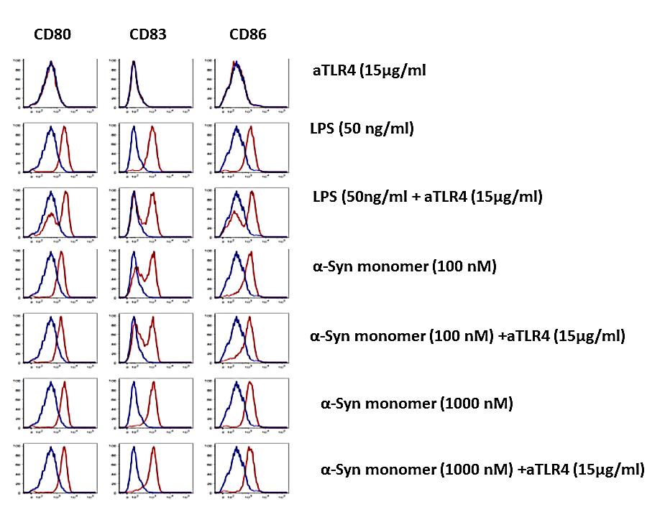
FIGURE S2 LEGEND
α-Synuclein stimulates human dendritic cell maturation in the presence of TLR4 blockade. Human monocyte derived dendritic cells were incubated for 48 hours in the presence of α-synuclein monomer alone or anti-TLR4 antibody, immunostained for surface markers (CD80, CD83, and CD86), and sorted by flow cytometry.

