Quantitative study of developmental biology confirms Dickinsonia as a metazoan
Renee S. Hoekzema, Martin D. Brasier, Frances S. Dunn, and Alexander G. Liu

ELECTRONIC SUPPLEMENTARY INFORMATION

Terminology, and the morphology of Dickinsonia
Dickinsonia, typically preserved as a sedimentary external mould of the upper surface of the organism, is a fossil taxon known from shallow-marine siliciclastic facies of ~560–550 Ma [1]. Multiple species of Dickinsonia have been described, typically distinguished by gross morphology and the number of units they possess [2-5]. Previous researchers have referred to the opposite ends of the longitudinal midline axis in Dickinsonia as front/back [6], the “B-end”/“A-end” [7], or anterior/posterior [8] respectively, with the supposed ‘anterior’ of the organism (often possessing a smooth, broadly triangular region; figure 1) identified by assessment of the perceived direction of movement in specimens associated with Epibaion ichnofossils [8]. In the absence of evidence for a head, mouth or anus there is no obvious reason to assume this organism would have had a specific directionality of movement. We also note that some of these terms are phylogenetically leading, and choose to use the neutral terms “deltoidal” (D) (with the triangular region) and “anti-deltoidal” (AD) to discuss Dickinsonia morphology here (figure 1). Individual units have previously been referred to as segments [4], modules [6,9], pneus [10], and isomers/isomers [11]. Given that Dickinsonia could potentially rest anywhere within the Eukaryota, and that there is currently no way to determine whether these units reflect external annulation, metamerism, or segmentation, we use the neutral term “units” to describe these serially-repeated structures (figure 1).
Although Dickinsonia has a broadly ovate outline, many specimens also possess a small indentation, consistently positioned at the AD-end terminus (e.g. figure 1; figure S1, D1, D4, D10, D16). This indentation was recognised by Wade [4] (her ‘posterior notch’, which she interpreted as similar to the anal lobes of Spinther), but has received little discussion since. The external margins of Dickinsonia reveal that individual units distally widen and flare into a rounded termination [7, 10] , rather than maintaining a constant width along their length (figure 1). Occasionally only one side of the rounded end to each unit is visible, suggesting that adjacent units were seemingly imbricated [4, 11]; an observation supported by rare units that have ‘popped out’ or become dislocated from this imbricated arrangement (e.g. figure 1; figure S1, specimen D17). Therefore at least at the outer margins, it seems that units were not entirely constrained in their movement. The deltoidal region has been considered to reflect a fused segment [4] , but little evidence has been presented in support of this suggestion.

Sources of errors
Our unit length measurements carry uncertainty resulting from both preservational deformation of the specimens, and human error in measurement. The studied Dickinsonia specimens occur on collected slabs that originate from a number of different beds within the Ediacara Member (South Australia), and from several localities, with precise locality and bed information not always available. As such, it has not been possible to assess the impact of tectonic or surface-specific deformation on these specimens, though we note that tectonic deformation of Ediacaran fossil-bearing surfaces in South Australia has been considered to be minimal [12].
Taphonomic and biological deformation of Dickinsonia specimens falls under one of two categories: radial contraction, or non-radial deformation. Radial contraction can be variable in its extent within the Dickinsonia population, and is likely to result from either taphonomic shrinkage following burial, or biological (potentially muscular) contraction [3, 4, 7, 10, 13]. Non-radial deformation can be estimated visually via comparison of individual specimens. The outline of a specimen can be deformed such that the margin no longer appears to continue in a smooth curve as it does for most specimens. Specimen D20 (D. rex) shows significant deformation of its outline, resulting in unit lengths that differ by about 25% on either side of the specimen, and in this instance the least deformed side of the organism was measured. Other specimens show deformation to a lesser extent: specimen D17 has a ‘dent’ in its outline, likely a result of damage or non-uniform contraction. The indented outline appears in our data plots, but does not significantly influence the observed patterns we report.
In terms of human error, not all unit boundaries were clearly visible in every specimen, and so the broadly regular spacing of units within individuals was occasionally extrapolated to fill in missing information. The resultant uncertainty in the unit count was assessed via repeating the entire set of measurements for D6 and D14 and (where possible for a small number of specimens) comparison of our measured data with reported unit counts found in the literature. This indicates that the estimated uncertainty in unit count is one unit for the smaller specimens, and up to five units for the larger specimens. Shifting the measurements from individual specimens by this amount along the unit count axis has negligible impact on our interpretations. By giving a colour to every fifth tracked unit outline, counting errors could be virtually eliminated.
Identification of the external margin of individual units carries relatively more uncertainty for the smaller specimens (D1 to D7), and in specimens showing evidence for taphonomic deformation (D7, D9 and D20). The position of the chosen margin assumed continuity of the margin in a broad arc, and was determined in conjunction with comparison to the other side of the specimen. We estimate the resultant error in unit length measurements to be ~5%, which is small compared to the natural variation observed between unit lengths within individual specimens, and is therefore considered to have little impact on the primary findings (the longest unit of the largest D. costata specimen, D17, is about 750% the length of the longest unit of the smallest specimen D1). For example, replotting specimens D9 and D20 with a 25% increase/decrease in unit lengths did not change their interpretation as D. rex specimens as opposed to D. costata.

Construction of the growth model
The main features of the growth program of D. costata provide the constraints for the model, namely the conserved position of the longest unit; the implementation of a discrete ontogenetic shift; and the existence of a deltoidal region (figure 4). The model is specified by parameters that determine the behaviour of these features: the precise position of the longest unit (33% for D. costata); the maximal number of units (set to 50 in figure 4); the angle of the deltoidal region (set to 32° = π/5 in figure 4), with unit angles varying linearly towards the AD-end. The geometry of the individual units is determined by the unit widths (here set to be constant for simplicity), and by the specifications of a model growth surface, which are determined by the growth rate of the generative zone, and two consecutive growth rates (see figure 4).
We modelled both AD-end and D-end generative zones, and assumed that units are added or inflated in growth phases of different rates at different stages during the life of the organism (guided by our data). For simplicity, units were modelled to change discretely from one phase of growth into another, and the growth rates are set to be a constant free parameter for each phase. We further assume that the growth programs of different units are controlled by the same growth rates, since the growth rates (slopes) for different units appear to be largely consistent in our measurements (figure 3ii), and that the timing of the shifts between growth phases depends linearly on the unit number. The ontogenetic shift observed in the measurements has been modelled as a discrete event for simplicity, and implemented as a discrete insertion ‘stop’; a maximal number of added units after which the model organism continues its growth inflatively and isometrically (i.e. with the same growth rate for every unit). Unit widths are set to a constant size across the specimen and throughout ontogeny. Time is scaled such that the insertion of one unit corresponds to one increment of time, up to the ontogenetic shift. At that point, time is scaled such that all units continue growing at the rate of the second growth phase. Unit shapes are simplified by being modelled as straight lines. The angles of the units with respect to the axis are set to vary linearly between the angle of the deltoidal region, and the angle parallel to the axis at the opposite AD-end.
With these restrictions, the Dickinsonia growth model depends on just seven parameters:
1) The growth rate of the generative zone (γ₀)
2) An initial growth rate (γ₁)
3) A secondary growth rate (γ₂)
4) The position of the longest segment as a fraction of the total number of units (β)
5) The position of the insertion switch, i.e. the maximal number of units (Maxbr)
6) The angular width of the deltoidal region as a fraction of 360° (Δ)
7) The width of the units (d)
A specification of the first five parameters yields a length and angle for every unit at every time. Unit length as a function of unit number (k) and model time (t) can then be represented as a surface in a three-dimensional parameter space, similar to the growth surfaces illustrated in Figure 4. Adding the final two parameters defines the positions of all units in the model at every point in time.
By varying the parameters, ontogeny for other morphotypes can be constructed, including those of D. rex, D. lissa, and D. tenuis (see SI discussion for instructions on how to use the modelling applet). Flattening the growth surface by lowering the values of the growth rates while setting the insertion switch Maxbr very high leads to a morphology similar to D. rex. D. lissa can be recreated by lowering the growth rates further and setting the insertion switch at a high value, as well as allowing the unit lengths and angles to stabilise halfway along the organism. D. tenuis resembles D. costata but with comparatively smaller unit widths, and also a higher insertion switch value.
The applet included in the supplementary material has an additional parameter flat, which can be used to model a flattening of the growth surface, to create a growth model in which units are of similar length in the middle of the axis. The unit angles can be stabilized in the middle of the organism accordingly. This yields a better model of elongated organisms such as D. lissa (see electronic supplementary information).
Variations of this model available from the first author on request include models with offset insertion; second order insertion such as observed in Ediacaran rangeomorphs and extant ferns; and non-radiating angles. It is also possible to allow parameters to co-vary, for example creating a model in which the angle of the deltoidal region depends on time. The model can be further extended to incorporate variations in unit widths along the axis and over time, smoothing of the transitions between growth phases, and curvature of units.

The applet
The computer model for the growth of Dickinsonia costata can be viewed as a video in our interactive applet (available for download at http://people.maths.ox.ac.uk/hoekzema/Applet/). By altering the parameters and visualisation of the model, our growth model can be adapted to reconstruct modes of growth for other organisms constructed by serially repeated units, and to attempt to replicate ontogenetic pathways, some of which can resemble the ontogeny of other Ediacaran taxa. The applet can be opened with the free Wolfram CDF Player, available at http://education.wolfram.com/cdf-player-download.html
The following guide briefly summarises the main features of the applet. After the desired parameter values have been set, pressing the ‘play’ button lets the model run from 0 to 200 time increments, permitting visualisation of the modelled growth.

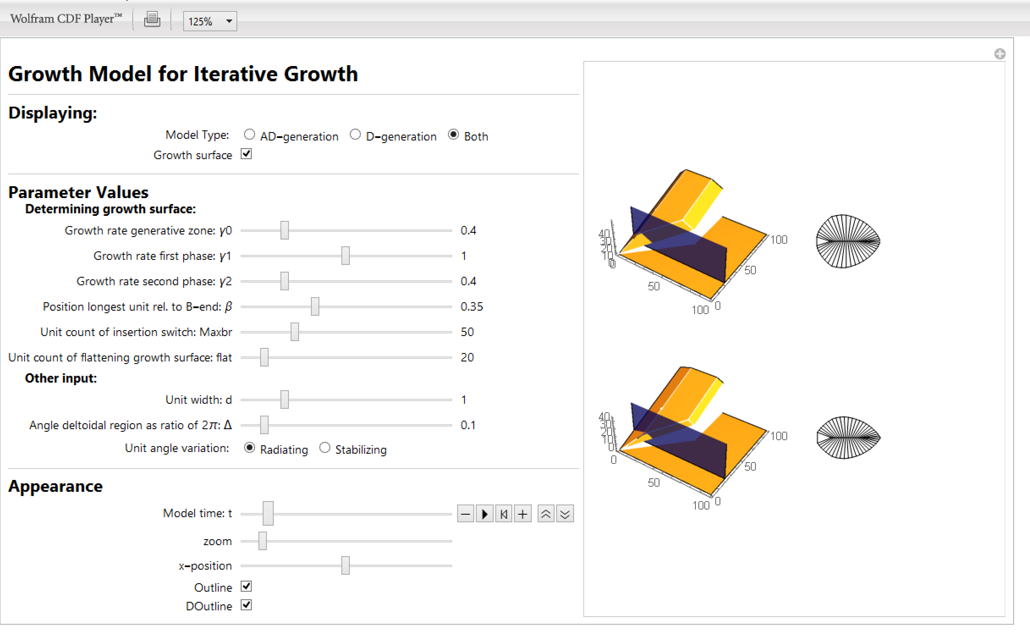
ESI Figure A. A screenshot of the applet window, showing the different parameters that can be varied, and the visualisation window on the right.

Displaying
The applet can display two different modes of insertional growth: AD-end (terminal) or D-end (pre-terminal) insertion of units (see figure 1). These models can also be run at the same time for comparison. Toggling the option "growth surface" displays the outline of unit lengths as a function of the unit number and model time. The unit number is counted from the end opposite the generative zone, such that the unit with number "1" is inserted first (as in figure 1). This means that the direction of the x-axis displaying unit number differs for the AD-end and D-end growth surfaces.

Parameter Values
Parameters determining the growth surface
The parameters γ₀, γ₁ and γ₂ are the unit growth rates, which determine the slopes of the growth surface. The generative zone, at either the AD-end or the D-end, grows with rate γ₀, which determines the non-zero length at which units are inserted. Every unit first grows with rate γ₁ and then passes to rate γ₂, at a model time governed by the parameters β, Maxbr and flat.
The parameter β determines the position of the longest unit with respect to the unit count, which sets the model time at which units switch from rate γ₁ to rate γ₂ (see also figure 4). The value of β ranges from 0 (longest units at the D-end), to 1 (longest unit at the AD-end). As the parameterisation of the x-axis of the growth surface is different for AD-end and D-end insertion, the influence of β appears different for each growth surface.
Maxbr determines the unit count at which an ontogenetic shift occurs, here modelled as a discrete cessation of unit insertion (an end-member case), after which the model organism continues its growth inflatively and isometrically, with all units growing at growth rate γ₂.
The extra parameter flat is not required for the construction of the D. costata model. We have added it to the model to enable elongate morphologies to be modelled whereby unit lengths are similar in the middle of the axis, rather than displaying a clear maximum. The value of flat determines the value of the unit count at which the units begin flattening in the middle of the organism by switching to rate γ₂ earlier than determined by β. If flat is set to a value that is higher than Maxbr then it does not influence the model, since the growth is isometric after Maxbr is reached.

Other inputs
The parameter d determines the width of individual units, which for simplicity is set to be constant along the growth axis. The angle of the deltoidal region as a fraction of 2π is given by Δ, ranging from 0 to 1. The angles of the units vary from the angle of the deltoidal region at the D-end of the organism, to parallel to the longitudinal axis at the AD-end. Two models for the way in which the angles vary between these two parameters have been implemented in the applet. With the option "Radiating", the angles vary linearly from (1-Δ)π at the D-end to 0 at the AD-end, as displayed in the D. costata model in figure 4. With the option "Stabilizing", the angles stabilize halfway along the organism, which is more appropriate for elongating organisms such as D. lissa. The stabilization is implemented with a smoothing function. The function determining the angles is the unique third degree polynomial that ranges between (1-Δ)π and 0, flattening at π/2, for values of Δ below 0.5.

Appearance
Model time can range from 0 to 200 time increments, and may be altered in the applet by displacing the slider, or setting it to vary automatically by pressing the play button. As the model organism can grow large depending on the growth rates, the zoom button allows the user to zoom in or out. The x-position slider moves the model organism left or right. An outline of the model organism connecting the unit ends is displayed when Outline is toggled, while the DOutline connects the D-end units on either side of the axis, closing off the deltoidal region.

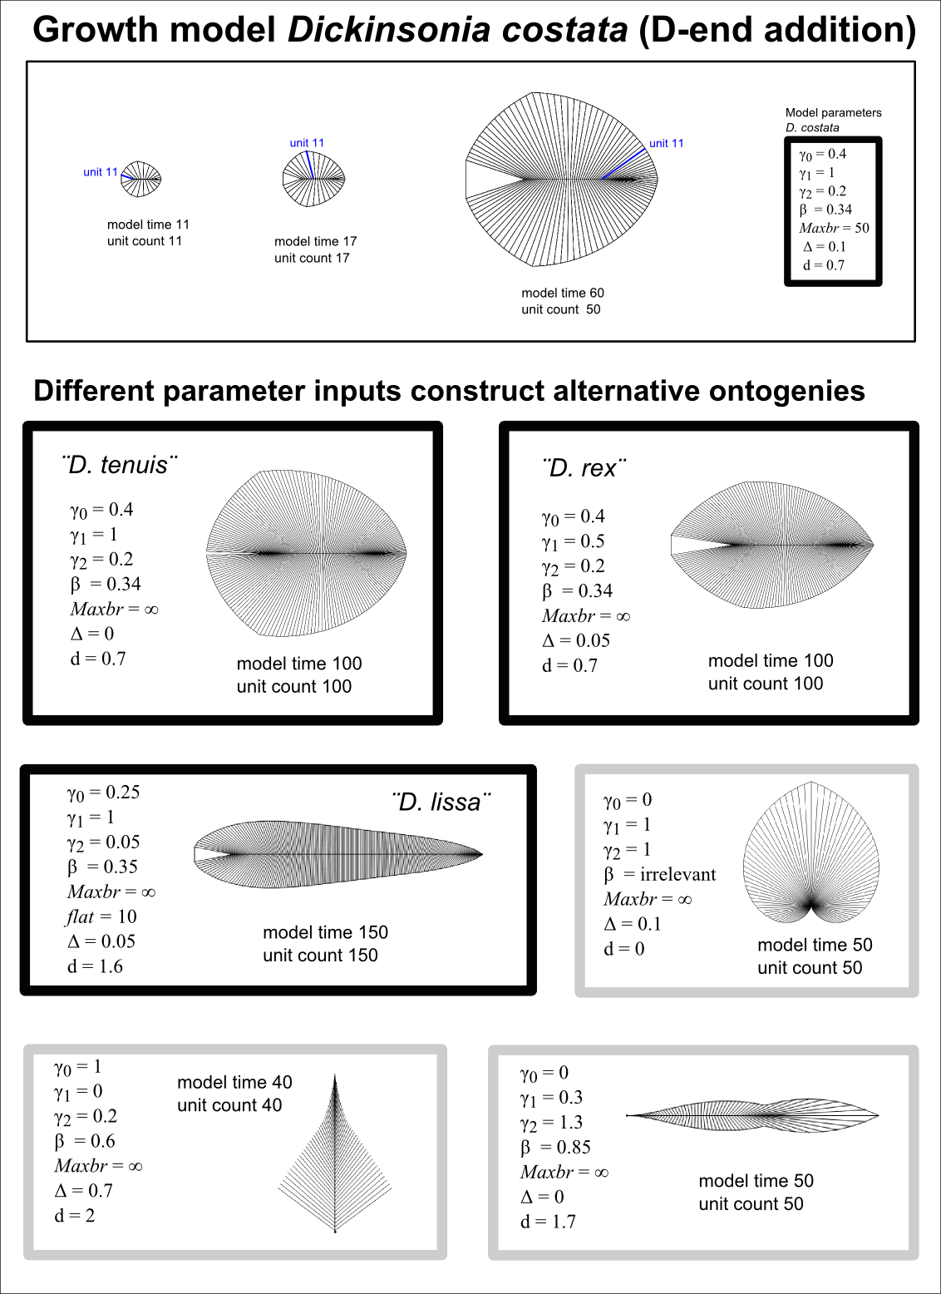
ESI Figure B. Example model outputs, and associated model parameters, for a range of theoretical Dickinsonia-like morphotypes, constructed using our interactive applet.
Supplementary Information (SI) Figures and Tables

Figure S1. Images of all Dickinsonia specimens used in this study. All scale bars = 10 mm. Colour of text corresponds to figure 2, namely red = D. costata specimens showing minimal contraction; green = D. costata specimens showing considerable evidence for contraction; light blue = D. costata specimens showing evidence for moderate contraction; dark blue = D. rex specimens.

Figure S2. The relationship between the relative area of the deltoidal region (compared to the area of the total organism; y-axis) against unit count (x-axis) for studied individual D. costata specimens (n = 16). Colour scheme follows figure 2. The deltoidal region is found to comprise an increasingly smaller proportion of the total organism as unit count increases.

Figure S3. Plot of the length of one side of the deltoidal region (y-axis) against unit count (x-axis) for studied individual D. costata specimens (n = 16), showing that the length of the deltoidal region increases as the number of units increases (i.e. as the organism grows). Colour scheme follows figure 2. In the model assuming a D-end generative zone, this means that the length of the generative zone will also increase in size as growth progresses.

Figure S4. Raw measurement data from the studied Dickinsonia specimens plotted without growth surfaces. n = 20 specimens.

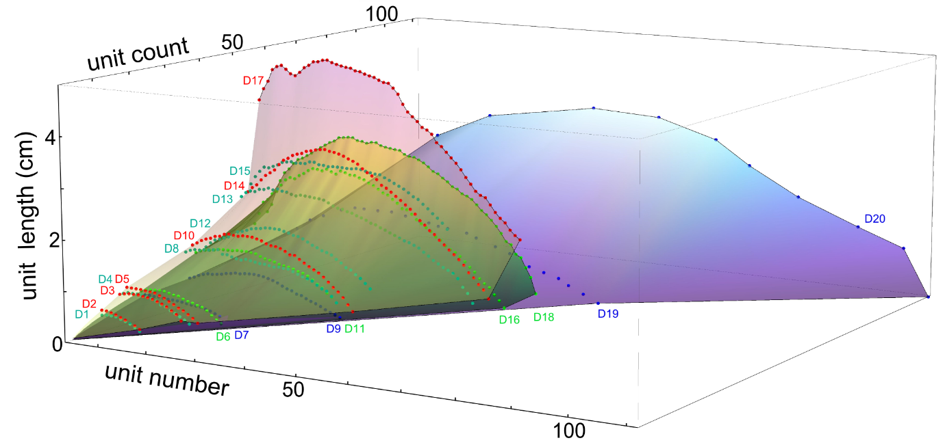
Figure S5. Measurement data from the studied Dickinsonia specimens plotted together with growth surfaces, assuming AD-end insertion. This is the same image as is presented in figure 3Ai, but with all specimens labelled. n = 20 specimens.
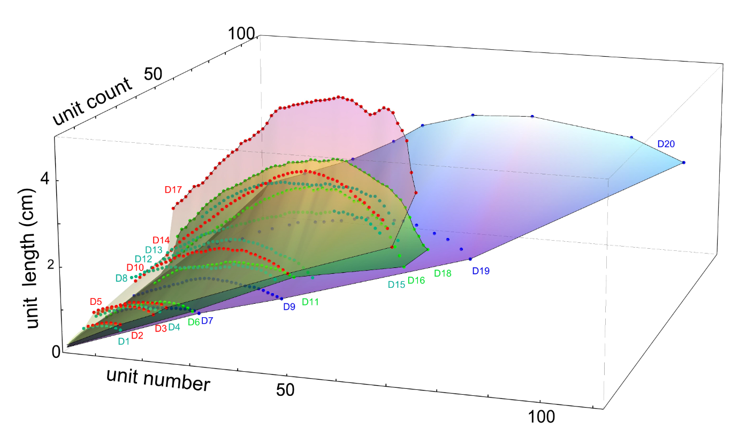
Figure S6. Measurement data from the studied Dickinsonia specimens plotted together with growth surfaces, assuming D-end insertion. This is the same image as is presented in figure 3Bi, but with all specimens labelled. n = 20 specimens.

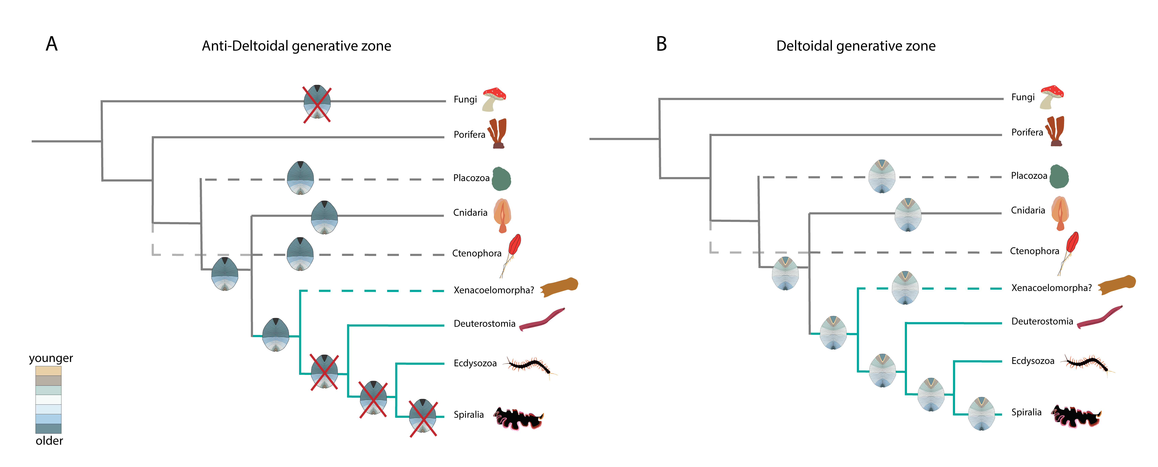
Figure S7. Phylogenetic schematic showing the potential phylogenetic position of Dickinsonia when assuming growth from a terminal anti-deltoidal generative zone as considered by [14, fig 2] (A), or a deltoidal generative zone (B). Dashed lines indicate clades of uncertain phylogenetic placement, and an alternative placement is indicated for Ctenophora. Green indicates bilaterian clades, and red crosses indicate affinities proposed under an assumed anti-deltoidal generative zone but which are not compatible with such a mode of growth.

Table S1. Information regarding Dickinsonia specimens used in this study, all of which originate from the late Ediacaran Ediacara Member of South Australia. Longest unit number is given as a count from the D-end (i.e. assuming AD-end generation). Longest unit relative position is a ratio of longest unit number (see above) divided by the total number of units. SAM: South Australian Museum; UCMP: University of California Museum of Paleontology; BGS: British Geological Survey; OUMNH: Oxford University Museum of Natural History; Cambridge: University of Cambridge Department of Earth Sciences teaching collections.

Table S2. Measurement data from all studied Dickinsonia specimens, giving unit number and unit length in centimetres, to 2d.p. Disparity between unit count (total units) in Table S1 and the greatest unit number measured in each specimen reflects terminal AD-end units that could not be measured (D6, D7, D9, D11, D12, D15).

References in the Supplementary Information
1. Grazhdankin D. 2004 Patterns of distribution in the Ediacaran biotas: facies versus biogeography and evolution. Paleobiology 30 (2), 203-221.
2. Sprigg RC. 1949 Early Cambrian 'jellyfishes' of Ediacara, South Australia, and Mount John, Kimberly District, Western Australia. Transactions of the Royal Society of South Australia 73 (1), 72-99.
3. Glaessner MF. 1966 Precambrian Palaeontology. Earth Science Reviews 1, 29-50.
4. Wade M. 1972 Dickinsonia: polychaete worms from the late Precambrian Ediacara fauna, South Australia. Memoirs of the Queensland Museum 16 (2), 171-190.
5. Jenkins, RJF. 1992 Functional and ecological aspects of Ediacaran assemblages, in Origin and Early Evolution of the Metazoa (eds Lipps JH, Signor PW), pp. 131–176. Plenum Press, New York.
6. Sperling EA, Vinther J. 2010 A placozoan affinity for Dickinsonia and the evolution of late Proterozoic metazoan feeding modes. Evolution and Development 12 (2), 201-209.
7. Brasier MD, Antcliffe JB. 2008 Dickinsonia from Ediacara: A new look at morphology and body construction. Palaeogeography, Palaeoclimatology, Palaeoecology 270, 311-323.
8. Gehling JG, Droser ML, Jensen SR, Runnegar BN. 2005 Ediacaran organisms: relating form and function. Evolving form and function: fossils and development: proceedings of a symposium honoring Adolf Seilacher for his contributions to paleontology, in celebration of his 80th birthday, ed Briggs DEG, Yale University, New Haven, Conn.), 43-67.
9. Evans SD, Droser ML, Gehling JG. 2017 Highly regulated growth and development of the Ediacara macrofossil Dickinsonia costata. PLoS ONE 12 (5): e0176874.
10. Seilacher A. 1989 Vendozoa: organismal construction in the Proterozoic biosphere. Lethaia 22, 229-239.
11. Ivantsov AYu. 2011 Feeding traces of Proarticulata - the Vendian metazoa. Paleontological Journal 45 (3), 237-248.
12. Evans SD, Droser ML, Gehling JG. 2015 Dickinsonia liftoff: evidence of current derived morphologies. Palaeogeography, Palaeoclimatology, Palaeoecology 434, 28-33.
13. Runnegar B. 1982 Oxygen requirements, biology and phylogenetic significance of the late Precambrian worm Dickinsonia, and the evolution of the burrowing habit. Alcheringa 6 (3), 223-239.
14. Gold DA, Runnegar B, Gehling JG, Jacobs DK. 2015 Ancestral state reconstruction of ontogeny supports a bilaterian affinity for Dickinsonia. Evolution & Development 17, 315–324.

