**Electronic Supplementary Material Titles**

**Appendix A1.** Supplementary figure for the location of onshore wind farms included in this study.

**Appendix A2.** Supplementary methods detailing classification of study quality for studies included in the meta analysis.

**Appendix A3.** Rationale for species’ traits selection for species included in the meta analysis.

**Appendix A4.** Additional information on data manipulation and statistical analyses.

**Appendix A5.** Beta coefficients from MCMCglmm models for birds and bats.

**Appendix A6.** Summary of model predictions of collisions per turbine per year for families of birds and bats.

**Appendix A7.** Comparison of model predictions to the IUCN Red List assessment of species vulnerability to the threat of renewable energy.

**Supplementary file S1.** List of all references reviewed in this study.

**Supplementary data collection files S2.** Supplementary R code and supporting files and datasets, providing an example of the trait-based analysis and model predictions for birds, based on one phylogenetic reconstruction method.

**Supplementary file S3.** Model predictions of collisions per turbine per year for bird species worldwide.

**Supplementary file S4.** Model predictions of collisions per turbine per year for bat species worldwide.

**Bird and bat species’ global vulnerability to collision mortality with wind farms revealed through a trait-based assessment Appendix 1. doi:10.1098/rspb.xxxx.xxxx**

Supplementary figure for the location of onshore wind farms included in this study.

Proceedings of the Royal Society B

Author List:

\*Chris B. Thaxter1,6, Graeme M. Buchanan2, Jamie Carr3, Stuart H. M. Butchart4,6, Tim Newbold5,

Rhys E. Green6, Joseph A. Tobias7, Wendy B. Foden8, Sue O’Brien9, James W. Pearce-Higgins 1,6

1British Trust for Ornithology, The Nunnery, Thetford, Norfolk IP24 2PU, UK / The David Attenborough Building, Pembroke Street, Cambridge, CB2 3QZ, UK.

2RSPB Centre for Conservation Science, Royal Society for the Protection of Birds, 2 Lochside View, Edinburgh Park, Edinburgh, EH12 9DH, UK.

3International Union for Conservation of Nature, the David Attenborough Building, Pembroke Street, Cambridge, CB2 3QZ, UK.

4BirdLife International, David Attenborough Building, Pembroke Street, Cambridge, CB2 3QZ, UK.

5Centre for Biodiversity and Environment Research, Department of Genetics, Evolution and Environment, University College London, Gower Street, London,WC1E 6BT, UK.

6Conservation Science Group, Department of Zoology, University of Cambridge, Downing Street, Cambridge CB2 3EJ, UK.

7Department of Life Sciences, Imperial College London, Silwood Park, Buckhurst Rd, Ascot SL5 7PY, UK

8Department of Botany and Zoology, University of Stellenbosch, P/Bag X1, Matieland, 7602 Stellenbosch, South Africa.

9Joint Nature Conservation Committee, Inverdee House, Baxter Street, Aberdeen, AB11 9QA, UK.

\*Corresponding author: telephone: +44(0)1842 750050; fax: +44(0)1842 750030

\*Corresponding Author: Chris B. Thaxter. Email: chris.thaxter@bto.org

(a) birds

**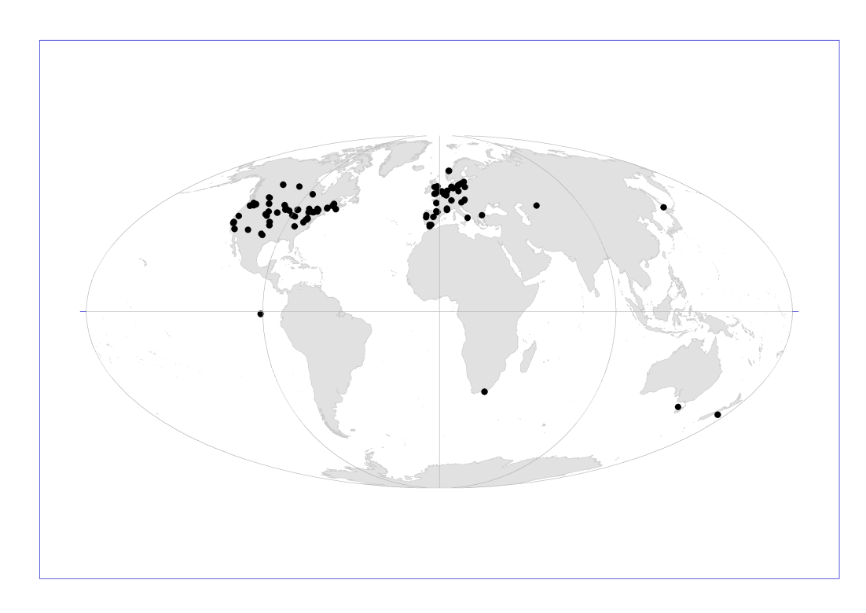**

(b) bats

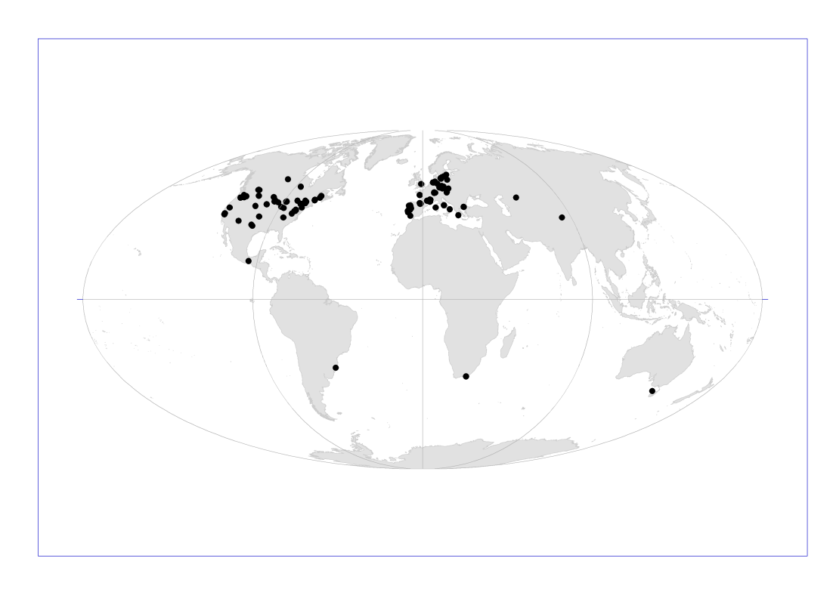

**Figure S1.** Location of wind farms included in the meta-analysis for this study for (a) birds and (b) bats.

**Bird and bat species’ global vulnerability to collision mortality with wind farms revealed through a trait-based assessment Appendix 2. doi:10.1098/rspb.xxxx.xxxx**

Supplementary methods detailing classification of study quality for studies included in the meta analysis.

Proceedings of the Royal Society B

Author List:

\*Chris B. Thaxter1,6, Graeme M. Buchanan2, Jamie Carr3, Stuart H. M. Butchart4,6, Tim Newbold5,

Rhys E. Green6, Joseph A. Tobias7, Wendy B. Foden8, Sue O’Brien9, James W. Pearce-Higgins 1,6

1British Trust for Ornithology, The Nunnery, Thetford, Norfolk IP24 2PU, UK / The David Attenborough Building, Pembroke Street, Cambridge, CB2 3QZ, UK.

2RSPB Centre for Conservation Science, Royal Society for the Protection of Birds, 2 Lochside View, Edinburgh Park, Edinburgh, EH12 9DH, UK.

3International Union for Conservation of Nature, the David Attenborough Building, Pembroke Street, Cambridge, CB2 3QZ, UK.

4BirdLife International, David Attenborough Building, Pembroke Street, Cambridge, CB2 3QZ, UK.

5Centre for Biodiversity and Environment Research, Department of Genetics, Evolution and Environment, University College London, Gower Street, London,WC1E 6BT, UK.

6Conservation Science Group, Department of Zoology, University of Cambridge, Downing Street, Cambridge CB2 3EJ, UK.

7Department of Life Sciences, Imperial College London, Silwood Park, Buckhurst Rd, Ascot SL5 7PY, UK

8Department of Botany and Zoology, University of Stellenbosch, P/Bag X1, Matieland, 7602 Stellenbosch, South Africa.

9Joint Nature Conservation Committee, Inverdee House, Baxter Street, Aberdeen, AB11 9QA, UK.

\*Corresponding author: telephone: +44(0)1842 750050; fax: +44(0)1842 750030

\*Corresponding Author: Chris B. Thaxter. Email: chris.thaxter@bto.org

The detection of carcasses depends on several factors which were accounted for to varying degrees per study. Additionally, these factors were also related to sampling design, such as spacing of visits to detect and recover carcasses and search radius covered, and in some cases, corrected numbers of collisions were presented [1]. We categorised studies by overall quality of information based on the above sources of bias, into a four-level category for birds, and three-level category for bats, the latter combining low and medium categories.

Firstly, where studies had simply estimated collisions per turbine based on number of carcasses found, this almost certainly resulted in an underestimate of collisions by not accounting for sampling design, scavenger removal or efficiency of searching. This was categorised as (1) “very low” confidence for final estimates, and included studies where only information of number of collision victims and number of turbines searched was presented.

Secondly, corrections for sampling design, scavenger removal and observer skill and efficiency of sampling (e.g. between habitats and ecosystems) were frequently applied, but then studies did not fully consider the further aspect of size bias of birds, thus presenting a single “all-bird” estimate rather than individual species estimates. The number of carcasses recovered per species was available for most studies. Therefore, we scaled the all-bird estimate by this proportion to derive likely species-specific estimates [2]. However, this did not fully account for size biases of individual birds and assumes perfect translation of carcass species proportions to corrected species collision rates, hence these were treated as (2) ‘low’ confidence.

Thirdly, studies often presented estimates for small and large birds separately, thus corrected for size/plumage detection to a certain degree, and some studies separated estimates further based on trials of carcass removal of certain groupings, such as ‘raptor species’. These resulted in refined estimates warranting a higher level of certainty in quality of estimates and were classed as (3) ‘medium’. Estimates of mortality of small passerines for North American wind farms, have been derived for ‘small birds’ from ‘all birds’ [2], we use which we used to increase quality from ‘low’ to ‘medium’. The final (4) ‘high’ confidence category was reserved for studies that directly reported estimates for species accounting for the main sources of bias described above. Further, for bat studies, corrections for scavenger removal were often based on proxy bird species, which might bias the correction. Our corrections for study quality there will inevitably be some variation not captured by our classification, for example, correction for unsearchable portions of the survey area were not always reported, and we therefore treat this as a potential source of bias.

**Supplementary References**

1. Huso MMP, Dalthorp D. 2014 Accounting for unsearched areas in estimating wind turbine-caused fatality. *J Wildl. Manage.* **78**, 347–358.
2. Erickson WP, Wolfe MM, Bay KJ, Johnson DH, Gehring JL. 2014 A Comprehensive Analysis of Small-Passerine Fatalities from Collision with Turbines at Wind Energy Facilities. *PLoS ONE* **9**, e107491. (doi:10.1371/journal.pone.0107491)

**Bird and bat species’ global vulnerability to collision mortality with wind farms revealed through a trait-based assessment Appendix 3. doi:10.1098/rspb.xxxx.xxxx**

Rationale for species’ traits selection for species included in the meta analysis.

Proceedings of the Royal Society B

Author List:

\*Chris B. Thaxter1,6, Graeme M. Buchanan2, Jamie Carr3, Stuart H. M. Butchart4,6, Tim Newbold5,

Rhys E. Green6, Joseph A. Tobias7, Wendy B. Foden8, Sue O’Brien9, James W. Pearce-Higgins 1,6

1British Trust for Ornithology, The Nunnery, Thetford, Norfolk IP24 2PU, UK / The David Attenborough Building, Pembroke Street, Cambridge, CB2 3QZ, UK.

2RSPB Centre for Conservation Science, Royal Society for the Protection of Birds, 2 Lochside View, Edinburgh Park, Edinburgh, EH12 9DH, UK.

3International Union for Conservation of Nature, the David Attenborough Building, Pembroke Street, Cambridge, CB2 3QZ, UK.

4BirdLife International, David Attenborough Building, Pembroke Street, Cambridge, CB2 3QZ, UK.

5Centre for Biodiversity and Environment Research, Department of Genetics, Evolution and Environment, University College London, Gower Street, London,WC1E 6BT, UK.

6Conservation Science Group, Department of Zoology, University of Cambridge, Downing Street, Cambridge CB2 3EJ, UK.

7Department of Life Sciences, Imperial College London, Silwood Park, Buckhurst Rd, Ascot SL5 7PY, UK

8Department of Botany and Zoology, University of Stellenbosch, P/Bag X1, Matieland, 7602 Stellenbosch, South Africa.

9Joint Nature Conservation Committee, Inverdee House, Baxter Street, Aberdeen, AB11 9QA, UK.

\*Corresponding author: telephone: +44(0)1842 750050; fax: +44(0)1842 750030

\*Corresponding Author: Chris B. Thaxter. Email: chris.thaxter@bto.org

For birds,hypotheses governing potential sensitivity of species were considered based on species traits selected a priori potential pathways of impacts; predictions were made for each hypothesis and where opposing predictions were equally plausible, non-significant effects were potentially anticipated (Table S1). The following hypotheses were examined:

*(1) Habitat type*–Wind farms could impact species associated with habitats in which wind farms are typically situated. Although all habitats may contain wind farms, it was anticipated that species associated with open open habitats (e.g. farmland, grassland) would offer the greatest potential for collision.

*(2) Foraging strata*– The local niche and height that a species may utilise [1] may influence flight behaviour and therefore collision rates. In the absence of widespread information about speices’ flight height, we used foraging strata as an alternative.

*(3) Diet*– Depending upon the effect of wind turbines upon food availability, species’ diet may have either positive or negative impacts on collision rates. However, we predicted that scavenging and invertebrate consumers were likely to be at higher risk of collision as the availability of such prey may be greater close to turbines [2]. Habitat, foraging strata and diet were specified using binary factors in the analysis for each factor-level, allowing species to occupy multiple levels (e.g. being associated with more than one habitat-type).

*(4) Migration and (5) dispersal distance*– Flight activity, described by variation in both migration strategy and dispersal distance, is likely to be a key determinant of collision rate. We predicted that migrant species and long-distance dispersers may be at higher rate of collision, although not-necessarily in a linear fashion as species travelling longer distances may show differing behaviour such as higher flight altitude, thus in turn reducing their risk. (6) *Population size*– There is likely to be at least a weak relationship between species’ abundance and collision rate [3]. Although we lacked information about local abundances at individual sites, as a surrogate we used an estimate of global population size, which will be related to likely density of a species if present.

*(7) Flight manoeuvrability and (8) body size*– The ability of birds to avoid collision may depend on their flight ability. This is difficult to measure directly, but it can be inferred from Kipp’s Distance (KD), a measure of wing pointedness. We estimated KD as the length from the tip of the first secondary to the tip of the longest primary, measured on the folded wing [4]. Species with longer, more pointed wings are generally stronger fliers with higher levels of dispersal [5]. In addition, they probably spend more time airborne, and may be less manoeuvrable, particularly when their body size is large. For these reasons, we predict that species with high KD will collide more frequently with turbines. However, we note that exceptions to this general pattern will occur, for instance species such as swallows and hummingbirds will have a high KD and high manoeuvrability. Flightless species were not considered the study due to lack of perceived collision impact. We also used body size as an indirect measure of maneuverability, with larger individuals less maneuverable and therefore more likely to collide with wind turbines.

*Life history characteristics of* (10) *clutch size* *and (11)* G*eneration length*. These traits relate to potential correlations between species’ life-history and flight activity, for example due to impacts on parental effort and flight behaviour during the breeding season, generation length and the length of the juvenile period when birds may be more or less susceptible to collision. Traits for birds were not highly correlated (Pearson r < 0.7).

For bats, consideration of species traits for bats were restricted by the amount of data that was available within the PanTHERIA database [7]. Most variables that may govern susceptibility of birds to collision also apply for bats (Table S1), but due to a lack of equivalent trait data it was not possible to test habitat type, diet or foraging strata (see methods). The following variables were therefore considered (numbers of species in the PanTHERIA database are provided): (1) Population group size, defined as the number of non-captive animals in a group that spent most of their time in a 24-hour cycle together [7], 131 species; (2) forearm length, 967 species; (3) body mass, 759 species; (4) Litter size, 426 species; (5) age of sexual maturity, 131 species and (6) gestation length, 190 species. We used population group size as an appropriate measure for population size, forearm length as a measure of manoeuvrability, and litter size, age of sexual maturity and gestation length as measures relating to life-history characteristics. Age at sexual maturity and gestation length were not significantly correlated (R = 0.23, P > 0.05), but body mass and forearm length were (R = 0.92; P < 0.001), so forearm length was excluded – see electronic supplementary material appendix A4 for more information on correlation tests for fixed effects of species traits. Additional variables for bats were also extracted from the IUCN Red List [8], Animal Diversity Web [9], and other databases such as the United Nations Environment Programme (UNEP) ‘EUROBATS’ project initiative [10]. These data sources themselves were reviews of information on the desired traits. A simple definition was provided in [10] for categorising dispersal as a three-tier category of sedentary (<10 km), regional (10-100 km) and long-distance migrants (100+ km), which also tallied with other databases including North American species [9]. Roosting habitiats also followed definitions in [8-10]; however to test the prediction that tree-roosting species may be more vulnerable than species roosting in other habitats [11] – see also electronic supplementary material Table S1 – we simplified roosting definitions to those species associated with roosting in ‘trees’ or not; note this also amalgamated different types of roost sites for daytime, nightime, transitory and maternity roosts [10], which was necessary to avoid over-fitting our model based on a limited number of species. Information on whether a species experienced extended hibernation overwinter was also extracted [8-10].

**Table S1.** Traits of birds and bats, characteristics of wind farms and confounding variables believed to potentially influence vulnerability of species to collision with wind turbines.

|  |  |  |  |
| --- | --- | --- | --- |
| **Trait** | **Taxa applicable to** | **Predictions and rationale for how trait could influence vulnerability to collision** | **Levels / trend assessed** |
| Habitat association | Bird | Habitat association of species will influence vulnerability if species occur where wind farms are situated – species associated with human-impacted artificial habitats and open grassland are predicted to have greater impact than other species. | Artificial, forest, grassland, desert, coastal, marine |
| Roosting habitat | Bat | Tree roosting species will be at greater risk of collision due to species identifying wind turbine structures as trees, and attraction to insect prey [11]. | Tree vs non-tree roosting |
| Foraging strata | Bird | Species foraging in particular strata are more likely to interact with turbines; aerial and tree foragers are more often at turbine height rendering them more vulnerable; ground and water foragers are below turbine height and will be less impacted. | Water, ground, tree, aerial |
| Diet | Bird | Diet may bring species more into contact with wind farms more if their preferred food overlaps with wind farms – scavenger and vertebrate consumers may be more impacted through attraction to areas of high densities of small mammalian prey [6], invertebrate feeders may be more vulnerable if prey is attracted to wind farm; fruit/nectar feeders less impacted due to unlikely abundance of food sources in wind farm locations. | Invertebrate, vertebrate, scavenger, fruit/nectar, plant/seed |
| Migration status | Bird | Migratory species travel greater distances and are therefore more likely to interact with wind farms. | Migrants/non-migrants |
| Dispersal distance | Bird & Bat | Species with larger dispersal distance are more likely to come in contact with wind farms; species with largest dispersal may travel above the height of turbines, reducing collision rates. | Trend over dispersal categories 0-100+ km |
| Hibernation | Bat | Bat species that hibernate are dormant for months of the year, thus reducing their overall exposure and eventual vulnerability to wind farms. | Hiberanting vs not hibernating |
| Kipp's distance | Bird | Related to dispersal. Species with high KD (i.e. thinner, more pointed, wings) have stronger flight ability and therefore increased likelihood of encountering wind farms. In addition, they may have reduced manoeuvrability and less ability to avoid collisions through last-minute adjustments to flight path. | Trend |
| Body mass | Bird & Bat | Larger species are more likely to collide due to reduced manoeuvrability. | Trend |
| Global population | Bird | Species with larger populations collide more frequently than scarcer ones. | Trend |
| Population group size | Bat | Species that live in larger social groups more likely to collide with turbines. | Trend |
| Life history traits | Bird and Bat | Bird and bat species may be k- or r-selected, balancing individual fitness vs current and future reproduction. Collision rates may be higher for breeding individuals than non-breeders as foraging activity is higher for breeders to meet energetic demands of both offspring and parent (\*central to traits below). | General information\* |
| Generation length | Bird | *k*-selected species with longer generation length place greater emphasis on adult condition rather than offspring thus reducing foraging time amounts and risk of collision. Conversely however, k-selected species have more reproductive events per life span resulting in potentially equivalent exposure per reproductive lifespan than species with shorter generation lengths.\* | Trend |
| Clutch size | Bird | *r*-selected bird species with larger clutch size (and brood size) investing more in current reproduction may have greater per capita exposure per unit time to collision than species with smaller clutch sizes\*. | Trend |
| Gestation length | Bat | *k*-selected species with a longer gestation length may be actively gathering more resources over a longer time period than species with reduced gestation lengths, and therefore may be at higher risk of collision\*. | Trend |
| Age at sexual maturity | Bat | *k*-selected species maturing at an older age have longer before breeding constraints occur thus reducing collision\*. | Trend |
| Number of litters per year | Bat | *r*-selected species that are more productive within a given breeding year will forage for their young for longer than those less productive species, and may therefore be at higher risk of collision\*. | Trend |
| Number of wind farms | Bird & Bat | More individual wind farms may influence the overall collision metric for species by providing more information per study, and thus was accounted for. | Trend |
| Turbine size | Bird & Bat | Larger wind turbines may cause increased collision rate due to greater hub height and collision sweep area. | Trend |
| Buffer Area | Bird & Bat | Larger surveyed areas could find more victims, although most studies tailored their survey plot areas to try and encompass all likely victims. | Trend |
| Peer review | Bird & Bat | Peer-reviewed studies subject to strict scrutiny, are more likely correct for carcass detection resulting in higher collision rates (see quality below); however, a high proportion of grey literature also included such corrections. | Peer/non-peer |
| Quality | Bird & Bat | Higher quality studies correct for most sources of bias, higher estimates of collision rates predicted. | Very low, low, medium, high |
| No. years | Bird & Bat | Greater duration of study could influence collision estimates of species, and was therefore accounted for. | Trend |
| Days/year | Bird & Bat | Longer within-year monitoring might lead to higher estimated collision rates, but only if many collision victims were missed outside the monitoring period, which is unlikely since efforts were made to target key periods/life history phases. | Trend |

**Supplemetary references**

1. Hull CL, Stark EM, Peruzzo S, Sims CC. 2013 Avian collisions at two wind farms in Tasmania, Australia: taxonomic and ecological characteristics of colliders versus non-colliders. *N. Z. J. Zool.* **40**, 47–62. (doi: 10.1080/03014223.2012.757243)
2. Long CV, Flint JA, Lepper PA. 2010 Insect attraction to wind turbines: does colour play a role? *Eur.* *J. Wildl. Res.* **57**, 323–331.
3. Ferrer M, de Lucas M, Janss GFE, Casado E, Munoz AR, Bechard MJ, Calabuig CP. 2012 Weak relationship between risk assessment studies and recorded mortality in wind farms. *J. Appl. Ecol.* **49**, 38-46.
4. Baldwin MW, Winkler H, Organ CL, Helm B. 2010 Wing pointedness associated with migratory distance in common garden and comparative studies of stonechats (*Saxicola torquata*). *J. Evol. Biol.* **23**, 1050–1063.
5. [Dawideit BA](https://www.ncbi.nlm.nih.gov/pubmed/?term=Dawideit%20BA%5BAuthor%5D&cauthor=true&cauthor_uid=19040685), [Phillimore AB](https://www.ncbi.nlm.nih.gov/pubmed/?term=Phillimore%20AB%5BAuthor%5D&cauthor=true&cauthor_uid=19040685), [Laube I](https://www.ncbi.nlm.nih.gov/pubmed/?term=Laube%20I%5BAuthor%5D&cauthor=true&cauthor_uid=19040685), [Leisler B](https://www.ncbi.nlm.nih.gov/pubmed/?term=Leisler%20B%5BAuthor%5D&cauthor=true&cauthor_uid=19040685), [Böhning-Gaese K](https://www.ncbi.nlm.nih.gov/pubmed/?term=B%C3%B6hning-Gaese%20K%5BAuthor%5D&cauthor=true&cauthor_uid=19040685). 2009 Ecomorphological predictors of natal dispersal distances in birds. [*J Anim Ecol.*](https://www.ncbi.nlm.nih.gov/pubmed/19040685) **78**, 388–395. (doi: 10.1111/j.1365-2656.2008.01504.x.)
6. Smallwood KS, Thelander C. 2008 Bird mortality in the Altamont Pass Wind Resource Area, California. *J. Wildl. Manage.* **72**, 215–223.
7. Jones KE, Bielby J, Cardillo M, Fritz SA, O'Dell J, David C, Orme L, Safi K, Sechrest W, Boakes EH, Carbone C, Connolly C, Cutts MJ, Foster JK, Grenyer R, Habib M, Plaster CA, Price SA, Rigby EA, Rist J, Teacher A, Bininda-Emonds ORP, Gittleman JL, Mace GM, Purvis A. 2009 PanTHERIA: a species-level database of life history, ecology, and geography of extant and recently extinct mammals. *Ecology* **90**, 2648.
8. IUCN. 2016 The IUCN Red List of Threatened Species, 2016-2. ISSN 2307-8235.<http://www.iucnredlist.org/>. (last accessed 20/10/2016)
9. Animal Diversity Web. 2017 The Animal Diversity Web (ADW), Musuem of Zoology, university of Michigan. <http://animaldiversity.org/> [last accessed 06/07/2017]
10. Barova S. & Streit A. 2016 Action Plan for the Conservation of Bat Species in the European Union - 2016 – 2021: DRAFT. Inf.EUROBATS.AC21.5. European Commission & UNEP Eurobats.
11. Cryan PM, Gorresen PM, Hein CD, Schirmacher MR, Diehl RH, Huso MM, Hayman DTS, Fricker PD, Bonaccorso FJ, Johnson DH, Heist K, Dalton DC. 2014. Behavior of bats at wind turbines. *PNAS* **111***,* 15126-15131.

**Bird and bat species’ global vulnerability to collision mortality with wind farms revealed through a trait-based assessment Appendix 4. doi:10.1098/rspb.xxxx.xxxx**

Additional information on data manipulation and statistical analyses.

Proceedings of the Royal Society B

Author List:

\*Chris B. Thaxter1,6, Graeme M. Buchanan2, Jamie Carr3, Stuart H. M. Butchart4,6, Tim Newbold5,

Rhys E. Green6, Joseph A. Tobias7, Wendy B. Foden8, Sue O’Brien9, James W. Pearce-Higgins 1,6

1British Trust for Ornithology, The Nunnery, Thetford, Norfolk IP24 2PU, UK / The David Attenborough Building, Pembroke Street, Cambridge, CB2 3QZ, UK.

2RSPB Centre for Conservation Science, Royal Society for the Protection of Birds, 2 Lochside View, Edinburgh Park, Edinburgh, EH12 9DH, UK.

3International Union for Conservation of Nature, the David Attenborough Building, Pembroke Street, Cambridge, CB2 3QZ, UK.

4BirdLife International, David Attenborough Building, Pembroke Street, Cambridge, CB2 3QZ, UK.

5Centre for Biodiversity and Environment Research, Department of Genetics, Evolution and Environment, University College London, Gower Street, London,WC1E 6BT, UK.

6Conservation Science Group, Department of Zoology, University of Cambridge, Downing Street, Cambridge CB2 3EJ, UK.

7Department of Life Sciences, Imperial College London, Silwood Park, Buckhurst Rd, Ascot SL5 7PY, UK

8Department of Botany and Zoology, University of Stellenbosch, P/Bag X1, Matieland, 7602 Stellenbosch, South Africa.

9Joint Nature Conservation Committee, Inverdee House, Baxter Street, Aberdeen, AB11 9QA, UK.

\*Corresponding author: telephone: +44(0)1842 750050; fax: +44(0)1842 750030

\*Corresponding Author: Chris B. Thaxter. Email: chris.thaxter@bto.org

**Additional information on the literature review**

Potential biases may arise through exclusion of non-English searches [1], therefore we repeated searches for key European countries using translated keywords as presented in the main paper. Where repeat information was presented in different studies (such as multiple years of monitoring reports), the data were extracted once for the given site.

**Species classification**

In this study, we follow the classification system of IUCN and BirdLife International [2] for species common and latin names of birds and bats, prioritising the first common name if multiple synonyms for a species were available. Data extracted during the literature was therefore matched to this classification system, adjusting the species classification to match that above if the taaxonomy in the paper had changed since it was published. Similar complication arose with use of phylogenetic trees in statistical analyses. Since the phylogentic trees were published, classifications have since been revised in some cases. Tree tip labels (scientific names) were required in the analysis. Consequently, each species entry in the collisons dataset was assigned the corresponding phylogentic tree tip label to allow models to interpret species to the correct node on the tree. For predictions, however, some species were either not present in the original tree and so could not be included, or had been subsequently split into sub-species. Final predictions were made for the tree tip labels and translated back to the current taxonomy of IUCN and BirdLife International. A total of 9,993 bird species and 916 bat species were specified in phylogenetic trees, and a total of 10,425 bird and 1,143 bat species were listed in original species trait databases. We produce predictions for a total of 9,825 bird and 888 bat species that had trait data and phylogeny presence in the analysis, excluding those flightless and extinct species and species with paucity of data.

**Land cover types of wind farms**

We scrutinsed whether the land cover types wind farms reviewed in this study were characteristic land cover types available globally. The proportion of forest, agricultural, shrub and grassland land cover types within a 5 km buffer of the centre point of wind farms were quantified, alongside the dominant habitat habitat as scored at the centroid of the wind farm. Land cover types < 1% were excluded from this comparison. In total, 36% studies were in forests and 29% were in agricultural areas (e.g. artificial landscapes) with fewer in shrub (9%) and grassland (14%) landscapes. The proportion of wind farms where each land cover type was dominant was similar to the above land cover proportions (forest, 37%; agricultural, 30%; shrub, 7%; grassland, 16%), indicating no overall bias in our definition of land cover within 5 km of the wind farm centroid; although we note that there were cases (9% studies) where the dominant land cover type was actually ‘sea’ i.e. for coastal developments. Agricultural land cover (including those without wind farms), however, was over-represented in the review in comparison to percentage of total global land cover (17%), whereas shrub (21%) and grassland (26%) were under-represented and forests percentages were sampled approximately in proportion to their global area (37%).

**Prior specification in analyses**

Within R package MCMCglmm, for the residual model structure (R) we used the prior: R=list(V=diag(c(1,1)),nu=0.002, fix = 2) and for random effects of tip.label and study ID we included the prior: G=list(G1 = list(V=diag(c(1,1e-6)),nu=0.002), G2 = list(V=diag(c(1,1e-6)),nu=0.002, fix = T))). In both cases we specified “fix = TRUE”, fixing the R-structure of the binary part of the data to 1 (because it is not identifiable) and likewise we constrained the random effects G-structure in the same way [3]. For fixed effects we defined a prior with zero mean and high variance (1e4); however to include an offset in the model for log(number of turbines) to model collisions per turbine (per period), we included a strong prior with a mean of 1.0 and very small variance (1e-6) (see Bolker et al. 2012 for more details). Thus, the default prior: B=list(mu=c(0,1)[N.terms],V=diag(c(1e4,1e-6)[N.terms])), for the number of fixed effect terms (n.var) included in the model (N.terms = rep(1,nvar)), was altered at the position where the offset variable was defined, e.g. N.terms[3] = 2. Phylogeny was incorporated directly for each phylogenetic reconstruction method used. This was done by including a random effect for phylogeny and specifying a ‘ginverse’ structure to the model, a list of inverse matrices proportional to the covariance straucture of that random effect; tree tip labels were used to associate the matrices with the random term [4].

**Correlation of fixed effects feeding into the model**

We tested for nonlinear correlations between the traits fittted for both birds and bats (Figs. S2 and S3). For bats, there was no Pearson’s R correlation above 0.7 found for variables included in the final model, altough a correlation of 0.67 was found between litter size and whether species roosted in caves. For birds one pair of variables, gestation length and Kipp’s distance, were correlated at the threshold of R = 0.7.

C:\Users\thaxa_000\AppData\Local\Microsoft\Windows\INetCache\Content.Word\Bird.cor.tif

**Figure S2**. Correlation matrix of fixed effects fed into the bird model; shown are a levels of the effects for variables feeding into the final model of 769 species – see Figure 1 in the main paper for effect levels.



**Figure S3**. Correlation matrix of fixed effects fed into the bat model; shown are a levels of the effects for variables feeding into the final model of 67 species for the trait-based model (out of 72 species with collision data and pseudo-absences), in order from top to bottom along the diaganol: Body mass, litter size, roosting in trees, dispersal category (sedentary, <10 km; regional, 10-100 km, long-distannce > 100 km), and hibernating.

**Model selection**

A model selection and simplification process was considered for this study, based on stepwise model selection to avoid reliance on potentially spurious DIC values from models with non-normal errors [4]. However, a single full model with 105,000 chains took up to 10 days to run and given the large number of traits to individually assess, it was not possible to carry out such a model simplification process. Inclusion of all traits in final predictions may increase variance on final estimates, however a subset of potentially likely traits of migration status, dispersal, artificial habitat, grassland, turbine size and peer review produced similar final outputs. Moreover, sole reliance on P-values overlooked some variables that were very close to not overlapping zero (such as scavenging diets), and inclusion of predictions from the full global, although potentially unorthodox, therefore reflected both model runtime constraints whilst maximising variation across all traits.

**Model fitting**

Given the high number of zeros in the database, we tested zero-inflated models as a primary error structure to examine if zero presence was best modelled through a separate process for excess zeros or whether fixed effects could account for such variation alone. The number of zeros predicted was more than under a standard Poisson distribution, and models subsequently were better fitted with zero-inflated response. Zero-inflated models (zero-inflated, zero-added and hurdle Poisson structures) were much better fitting than a standard Poisson (dDIC < -2.0 in all cases), with the zero-added model the best fitting, hence selected for generating predictions. It was not possible to fully account for spatial autocorrelation in this analysis, however, it is expected that the inclusion of the random effect of study ID was highly site specific and thus likely controlled for much variation. Further, subtly different specifications for the ZAP models and a poisson analysis were also tested, which are detailed in electronic supplementary material appendix A5.

**Quality of model fit**

For MCMCglmm models for birds, effective sample sizes of count model structure coefficients (ID and tip label terms as random effects, and the “units” term for residual variance) were greater than the 20% threshold deemed an approximate minimum requirement of the total number of posterior samples (200 from the 1000 sample size total, after thinning and burn in removal of samples, Table S2) in all but one case; this was the “Mayr Par Sho Ericson” phylogeny reconstruction method for study ID; however the sample size was still suitably high and diagnostic plots were still deemed suitable. Similarly, for the bat models, effective sample sizes slipped slightly below the threshold for the tip label term (Table S2); however overall the graphical model diagnostic checks were still deemed highly suitable.

**Table S2**. (a) Mean posterior coefficients from MCMCglmm models for the random effects of ID and tip label of phylogenetic tree (G-structure) and the residual model structure “units” (R-structure), and (b) Summary of the fit of individual MCMCglmm models to the underlying data, assessed using pseudo-R2 values; for bats an additional ‘no traits’ model is presented, from which eventual predictions are made.

(a)

|  |  |  |  |  |  |  |  |
| --- | --- | --- | --- | --- | --- | --- | --- |
| **Taxa (model type)** | **Phylogeny reconstruction method** | **ID** | | **Tip label** | | **Units** | |
| **Mean (95% LCI,UCI)** | **Sample size** | **Mean (95% LCI,UCI)** | **Sample size** | **Mean (95% LCI,UCI)** | **Sample size** |
| Birds (traits) | Ericson | 1.49 (0.90,2.07) | 410.3 | 1.77 (1.12,2.40) | 264.6 | 1.05 (0.95,1.14) | 568.3 |
|  | Hackett | 1.49 (0.94,2.09) | 503.9 | 1.80 (1.23,2.48) | 361.1 | 1.05 (0.97,1.16) | 485.2 |
|  | Parrot | 1.47 (1.00,2.12) | 296.3 | 1.81 (1.25,2.43) | 260.6 | 1.05 (0.95,1.14) | 648.0 |
|  | Mayr Ericson | 1.47 (0.88,2.02) | 441.1 | 1.84 (1.21,2.51) | 301.5 | 1.05 (0.96,1.17) | 509.1 |
|  | Mayr Hackett | 1.46 (0.88,2.04) | 473.8 | 1.79 (1.13,2.41) | 269.8 | 1.05 (0.95,1.14) | 614.9 |
|  | Mayr Par Sho Ericson | 1.51 (0.98,2.10) | 142.5 | 1.81 (1.22,2.46) | 271.9 | 1.05 (0.97,1.16) | 601.2 |
|  | Mayr Par Sho Hackett | 1.44 (0.92,2.02) | 338.4 | 1.79 (1.17,2.47) | 243.8 | 1.05 (0.95,1.15) | 502.5 |
| Bats (traits) | R package: ape | 1.62 (0.94,2.44) | 809.5 | 3.84 (0.11,11.31) | 160.6 | 1.55 (1.30,1.80) | 831.0 |
| Bats (no traits) | R package: ape | 1.47 (0.87,2.13) | 888.3 | 11.71 (1.60,26.68) | 185.2 | 1.58 (1.36,1.85) | 861.2 |

**Table S2 cont.**

(b)

|  |  |  |  |  |  |  |  |
| --- | --- | --- | --- | --- | --- | --- | --- |
| **Taxa (model type)** | **Phylogeny reconstruction method** | **Marginal R2** | | **Conditional R2** | | | |
| **Random ID + Phylo** | | **Random ID** | |
| **Mean** | **Posterior mode (95% HPD CI)** | **Mean** | **Posterior mode (95% HPD CI)** | **Mean** | **Posterior mode (95% HPD CI)** |
| Birds (traits) | Erickson | 0.46 | 0.45 (0.36-0.56) | 0.85 | 0.85 (0.82-0.88) | 0.64 | 0.65 (0.56-0.71) |
|  | Hackett | 0.46 | 0.45 (0.36-0.56) | 0.85 | 0.85 (0.82-0.88) | 0.64 | 0.66 (0.57-0.72) |
|  | Parrot | 0.46 | 0.45 (0.35-0.56) | 0.85 | 0.85 (0.82-0.88) | 0.64 | 0.64 (0.56-0.72) |
|  | Mayr-Erickson | 0.46 | 0.48 (0.36-0.56) | 0.85 | 0.86 (0.82-0.87) | 0.65 | 0.66 (0.58-0.72) |
|  | Mayr-Hackett | 0.46 | 0.48 (0.36-0.57) | 0.85 | 0.86 (0.82-0.88) | 0.65 | 0.66 (0.58-0.73) |
|  | Mayr-Par-Sho-Erickson | 0.46 | 0.46 (0.36-0.56) | 0.85 | 0.85 (0.82-0.88) | 0.64 | 0.66 (0.57-0.71) |
|  | Mayr-Par-Sho-Hackett | 0.46 | 0.47 (0.34-0.55) | 0.85 | 0.85 (0.81-0.87) | 0.64 | 0.66 (0.56-0.71) |
| Bats (traits) | R package: ape | 0.30 | 0.30 (0.11-0.50) | 0.84 | 0.83 (0.77-0.92) | 0.58 | 0.64 (0.37-0.75) |
| Bats (no traits) | R package: ape | 0.19 | 0.08 (0.04-0.42) | 0.88 | 0.87 (0.81-0.95) | 0.39 | 0.39 (0.16-0.62) |

For birds, the models performed reasonably well in predicting observed data (Fig. S4). Mean predicted collision rates for highest impacted species followed the pattern of predicted rates of collision when ordered from highest to lowest impacted (Fig. S4). However, the variation in the predictions was still large, ranging from just over zero for all species, up to 1.436 (mean across all phylogenetic trees) for Ayres's Hawk-eagle *Hieraaetus ayresii*. For the model predicted well those species impacted most and least (Fig. S4), but predictions for species with no data made up the majority, but not exclusively, values in between these ranges.

C:\Users\christh\AppData\Local\Microsoft\Windows\INetCache\Content.Word\Bird.Rankings.rev.tif

**Figure S4.** Plot of species predictions for birds from MCMCglmm models plotted from the mean posterior distribution with lower and upper credible intervals; species are ranked by the posterior mean prediction and plotted in descending order from the highest to the lowest prediction across species phylogenetic tip labels (9,568 species). Also shown is the species mean collision rate value (red dots) for species feeding into the modelling (769 species).

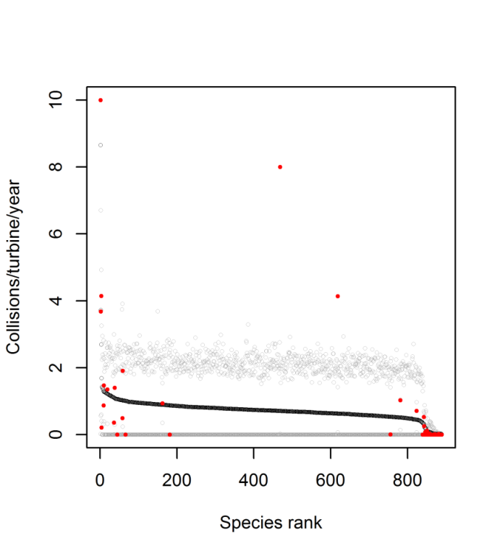

**Figure S5**. Plot of species predictions for bats from the MCMCglmm model contining no species traits, plotted from the mean posterior distribution with lower and upper credible intervals; species are ranked by the posterior mean prediction and plotted in descending order from the highest to the lowest prediction across species (888 species). Also shown is the species mean collision rate value (red dots) for species feeding into the ‘no-trait’ model (72 species).

**Bird predictions**

Full model predictions are provided as supplementary online files S3 and S4, alongside species IUCN Red List Status and population trend from the Red List Database. Predictons were made from global models marginal to the random effect of study ID. For birds, global population size was estimated for only 3,467 species. The variable of population size, however, was not significant, and was therefore contrained to a mean value within the prediction matrix to allow prediction for the full suite of species. To account for variation in survey duration, initial models considered the interaction between terms of study duration (years) and number of days moitoring per year; however, this interaction was not significant and excluded from further models. Therefore, studies that covered part of the year, typically March to October, were thus assumed to equate to annual rates of mortality.

For birds the seven different phylogentic models were averaged, and for both birds and bats, species were ranked according to mean predictions. Given the uncertainty surrounding marine species in this study (see main paper), we separated out “marine” species from “terrestrial” species in these datasets, using the Birdlife habitat categories used in the analysis for species’ habitat association. Species just associated with “marine” and “marine and coastal” were separated firstly into the marine category; however many seabird species were also flagged as having association with breeding habitats particularly grassland and forest; for example Atlantic puffin *Fratercula arctica* is a coastal-marine species that breeds on grassland clifftops slighty further from the immediate coastal habitat. Hence, the species list was further filtered to account for these species, that were also treated as “marine”. Those species that used marine habitats but also used inland habitats extensively such as inland wetlands and artificial habitats (such as some species of gulls, terns, cormorants and ducks), were treated as “terrestrial”. Some marine species were infrequently recorded as collisions within the main dataset with coastal turbines, hence being included in the study, however no offshore studies were included in the analysis (due to lack of data). Given the uncertainty in extrapolating from our model, based only on terrestrial wind farms, we subsequently removed marine species from final predictions Predictions are also mapped globally (Fig. 5) using the MCMC posterior distributions for birds (seven models, 7000 samples) and for bats (1 model, 1000 samples).

**Bat predictions**

We present a final model for bats based on traits, including body size, number of litters per year, dispersal distance, hibernation tendency and whether species used trees for roosting. Information on dispersal was not defined sufficiently for five species, thus reducing this model to 67 species. The final trait-based model contained a significant effect for dispersal distance, which was not available for all species globally. We therefore predicted from a model only containing phylogenetic signal (for 72 species) to produce the final model predictions for bats.

For bats, we also provide predictions for the trait-based model based on those species with data available for modelling. This exercise served to highlight quality of model fit and to compare how predictions from the ‘traits model’ compared to the ‘no-traits’ model (see Fig. S5); predictions from the latter are presented in supplementary online file S4, and Fig. S6 presents this comparison graphically. The trait-based predictions were notably influenced by the inclusion of the dispersal variable, but tallied with observed values of collisions/turbine/year, as species with highest mortality rates were charcaterised at the higher end of Fig. S6. Although overall confidence in the predictions was low (given the large credible intervals), the mean predicted fit line corresponded well to the magnitude of the observed data. The no-traits model predictions tallied well with the trait-based model predictions (Pearsons R = 0.8, Fig S6), however, the no-traits model was a significantly poorer fitting model compared to the trait-based model (dDIC = -9.50). Further, the predictions from the no-traits model, had a relatively shallow slope of collision rate change across ranked species in Fig S5 above, and so caution is necessary in interpretion. Although predictions for bats were based on a model excluding species traits, the similarly high proportion of variance explained by phylogeny for models with and without traits (Table 1 in the main paper) could suggest traits are phylogenetically conserved, but this would need further verification.

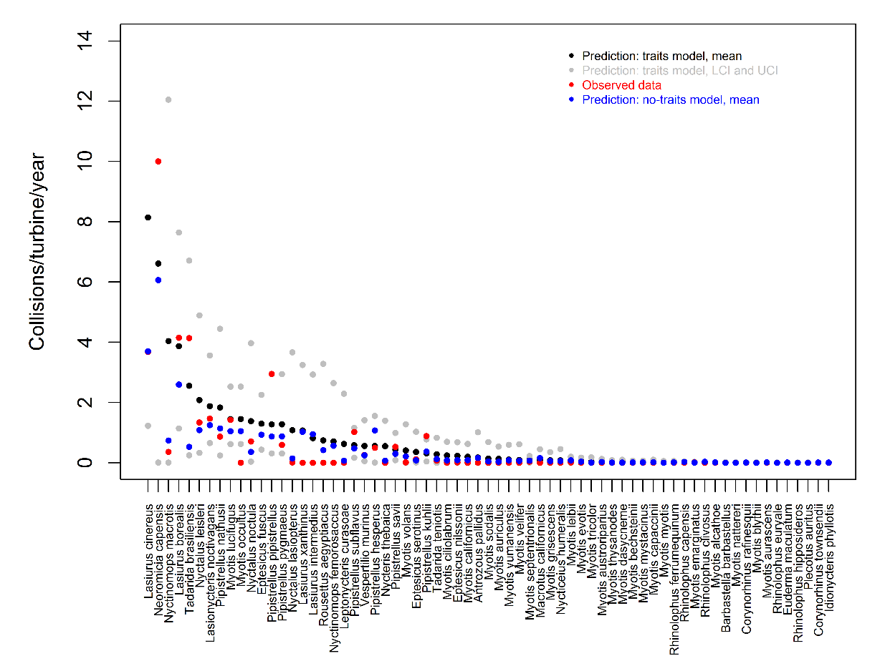

**Figure S6**. Plot of species predictions for bats from MCMCglmm models of the ‘no-traits’ model (used for extrapolating predictions to species globally – see Figure S5) and the trait model, for which predictions could be made for those species modelled. Predictions in both cases are plotted from the mean (black dots) posterior distribution with lower and upper credible intervals (grey dots, UCI, LCI) from the trait model; comparable predictions from the no-traits model (presented also in Figure S3) are presented (blue dots). Species are ranked by the posterior mean prediction of the trait-based model, and plotted in descending order from the highest to the lowest prediction. Also shown is the species mean collision rate value (red dots) for species feeding into the modelling.

**Supplementary references**

1. Amano T, González-Varo JP, Sutherland WJ. 2016 Languages Are Still a Major Barrier to Global Science. *PLoS Biol. 14*: e2000933. (dx.doi:10.1371/journal.pbio.2000933)
2. Birdlife International. 2016 Birdlife datazone. <http://www.birdlife.org/datazone>. (accessed 17/03/2017)
3. Bolker B, Brooks M, Gardner B, Lennert C, Minami M. 2012 Owls example: a zero-inflated, generalized linear mixed model for count data. <https://groups.nceas.ucsb.edu/non-linear-modeling/projects/owls/WRITEUP/owls.pdf>. (last accessed 20/10/2016)
4. Hadfield J. 2016 Package ‘MCMCglmm’, Version 2.22.1. <https://cran.r-project.org/web/packages/MCMCglmm/MCMCglmm.pdf>. (last accessed 12/12/2016)

**Bird and bat species’ global vulnerability to collision mortality with wind farms revealed through a trait-based assessment Appendix 5. doi:10.1098/rspb.xxxx.xxxx**

Beta coefficients from MCMCglmm models for birds and bats.

Proceedings of the Royal Society B

Author List:

\*Chris B. Thaxter1,6, Graeme M. Buchanan2, Jamie Carr3, Stuart H. M. Butchart4,6, Tim Newbold5,

Rhys E. Green6, Joseph A. Tobias7, Wendy B. Foden8, Sue O’Brien9, James W. Pearce-Higgins 1,6

1British Trust for Ornithology, The Nunnery, Thetford, Norfolk IP24 2PU, UK / The David Attenborough Building, Pembroke Street, Cambridge, CB2 3QZ, UK.

2RSPB Centre for Conservation Science, Royal Society for the Protection of Birds, 2 Lochside View, Edinburgh Park, Edinburgh, EH12 9DH, UK.

3International Union for Conservation of Nature, the David Attenborough Building, Pembroke Street, Cambridge, CB2 3QZ, UK.

4BirdLife International, David Attenborough Building, Pembroke Street, Cambridge, CB2 3QZ, UK.

5Centre for Biodiversity and Environment Research, Department of Genetics, Evolution and Environment, University College London, Gower Street, London,WC1E 6BT, UK.

6Conservation Science Group, Department of Zoology, University of Cambridge, Downing Street, Cambridge CB2 3EJ, UK.

7Department of Life Sciences, Imperial College London, Silwood Park, Buckhurst Rd, Ascot SL5 7PY, UK

8Department of Botany and Zoology, University of Stellenbosch, P/Bag X1, Matieland, 7602 Stellenbosch, South Africa.

9Joint Nature Conservation Committee, Inverdee House, Baxter Street, Aberdeen, AB11 9QA, UK.

\*Corresponding author: telephone: +44(0)1842 750050; fax: +44(0)1842 750030

\*Corresponding Author: Chris B. Thaxter. Email: chris.thaxter@bto.org

**Poisson error structure**

A separate initial analysis was conducted for both birds and bats considering only data extracted from the review, before any additional pseudo-absences were added. This analysis served to highlight initial patterns and a comparison to the full model that included the pseudo-absence observations for the final predictions (see methods). The model fitting process was equivalent to the main paper but instead followed a poisson distribution. This analysis showed similar coefficient results to the zero-adjusted poisson (ZAP) model, with noteable patterns for articifical habitats, migration strategy (not a migrant) and dispersal bands (25-49 km and 50-99 km) (Table S3 and Figure S7). Poisson coefficients for grassland and marine habitats were also similar to ZAP albeit not signicant. As with ZAP models, the same quality effects of low and very low quality studies having much lower collision rate estimates than medium or high quality studies was also shown, and a very strong positive coefficient for turbine size (mW) was obtained being almost identical in magnitude to the ZAP models. Overall Poisson model coefficients had smaller variance around posterior means than ZAP models. The similarity between these two separate models suggests strong support for the chosen traits subsequently driving model predictions.

**Zero-adjusted error structure**

Two separate and subtly different ZAP model structures were tested: (1) using a full model whereby all fixed effects included both a count and zero-adjusted term (Table S3), and (2) considered an ecologically appropriate simplified model, whereby fixed effect coefficients were fitted for the count part of the matrix only, retaining zero-inflated coefficient only for the global model intercept (see Bolker et al. 2015). In practice the two models produced very similar results – all traits and variables retained the same direction of effects, therefore predictions were generated from the full model structure (1) above.

**Table S3.** Beta coefficients from full global models for birds showing Poisson models fitted with alternative trees from phylogenetic reconstruction methods (Birdtree.org); shown are mean posterior coefficients with 95% credible intervals.

|  |  |  |  |  |  |  |  |  |  |
| --- | --- | --- | --- | --- | --- | --- | --- | --- | --- |
| **Category** | **Effect** | **Level** | **Erickson** | **Hackett** | **Parrot** | **Mayr Erickson** | **Mayr Hackett** | **Mayr Par Sho Erickson** | **Mayr Par Sho Hackett** |
| DIC |  |  | 10472.41 | 10469.87 | 10475.59 | 10474.11 | 10470.66 | 10471.34 | 10471.86 |
| (Intercept) |  |  | **-3.98 (-5.50,-2.20)\*\*\*** | **-3.99 (-5.85,-2.41)\*\*\*** | **-4.02 (-5.69,-2.33)\*\*\*** | **-4.06 (-5.70,-2.27)\*\*\*** | **-4.01 (-5.54,-2.28)\*\*\*** | **-3.95 (-5.65,-2.22)\*\*\*** | **-4.05 (-5.71,-2.35)\*\*\*** |
| Traits | Habitat | Artificial | **0.29 (0.10,0.52)\*\*** | **0.28 (0.06,0.48)\*** | **0.29 (0.10,0.50)\*\*\*** | **0.30 (0.10,0.49)\*\*** | **0.29 (0.08,0.47)\*\*** | **0.29 (0.09,0.48)\*\*** | **0.29 (0.09,0.48)\*\*** |
|  |  | Forest | -0.08 (-0.39,0.24) | -0.07 (-0.40,0.22) | -0.07 (-0.37,0.25) | -0.06 (-0.37,0.23) | -0.07 (-0.39,0.25) | -0.10 (-0.40,0.20) | -0.07 (-0.38,0.26) |
|  |  | Grassland | 0.17 (-0.03,0.39) | 0.17 (-0.06,0.38) | 0.17 (-0.05,0.39) | 0.17 (-0.06,0.38) | 0.17 (-0.05,0.38) | 0.18 (-0.04,0.41) | 0.18 (-0.05,0.40) |
|  |  | Desert | -0.15 (-0.54,0.23) | -0.13 (-0.51,0.29) | -0.15 (-0.52,0.23) | -0.13 (-0.52,0.27) | -0.15 (-0.53,0.23) | -0.10 (-0.48,0.29) | -0.15 (-0.57,0.21) |
|  |  | Coastal | 0.1 (-0.14,0.36) | 0.10 (-0.15,0.34) | 0.11 (-0.19,0.33) | 0.10 (-0.15,0.35) | 0.11 (-0.19,0.34) | 0.09 (-0.18,0.33) | 0.10 (-0.17,0.33) |
|  |  | Marine | -0.33 (-0.80,0.16) | -0.31 (-0.79,0.19) | -0.32 (-0.90,0.12) | -0.31 (-0.75,0.20) | -0.31 (-0.78,0.23) | -0.32 (-0.78,0.21) | -0.32 (-0.82,0.18) |
|  |  | Wetland | -0.04 (-0.26,0.18) | -0.05 (-0.27,0.16) | -0.05 (-0.26,0.16) | -0.03 (-0.26,0.18) | -0.05 (-0.27,0.17) | -0.05 (-0.25,0.18) | -0.05 (-0.30,0.17) |
|  | Foraging strata | Water | -0.31 (-0.88,0.36) | -0.34 (-0.99,0.24) | -0.35 (-0.96,0.26) | -0.31 (-0.89,0.36) | -0.36 (-1.05,0.23) | -0.30 (-0.91,0.34) | -0.36 (-1.00,0.29) |
|  |  | Ground | -0.04 (-0.29,0.21) | -0.04 (-0.30,0.24) | -0.04 (-0.32,0.21) | -0.03 (-0.27,0.26) | -0.03 (-0.30,0.22) | -0.05 (-0.31,0.21) | -0.03 (-0.31,0.20) |
|  |  | Tree | 0.18 (-0.09,0.47) | 0.19 (-0.06,0.45) | 0.18 (-0.10,0.46) | 0.18 (-0.08,0.45) | 0.18 (-0.08,0.47) | 0.18 (-0.10,0.46) | 0.18 (-0.10,0.46) |
|  |  | Aerial | 0.00 (-0.38,0.34) | 0.04 (-0.32,0.42) | 0.01 (-0.34,0.37) | 0.00 (-0.38,0.34) | 0.01 (-0.34,0.37) | 0.02 (-0.32,0.38) | 0.02 (-0.31,0.39) |
|  | Diet | Invertebrates | 0.13 (-0.26,0.49) | 0.13 (-0.30,0.49) | 0.11 (-0.25,0.54) | 0.14 (-0.21,0.56) | 0.12 (-0.29,0.52) | 0.15 (-0.20,0.56) | 0.11 (-0.27,0.51) |
|  |  | Vertebrates | -0.03 (-0.37,0.28) | -0.04 (-0.36,0.32) | -0.05 (-0.38,0.27) | -0.04 (-0.37,0.25) | -0.05 (-0.35,0.30) | -0.03 (-0.37,0.29) | -0.04 (-0.35,0.29) |
|  |  | Scavenge | 0.26 (-0.15,0.65) | 0.23 (-0.19,0.62) | 0.24 (-0.16,0.62) | 0.24 (-0.16,0.64) | 0.24 (-0.11,0.63) | 0.24 (-0.12,0.64) | 0.25 (-0.17,0.62) |
|  |  | FruiNect | **-0.21 (-0.43,-0.02)\*** | **-0.21 (-0.42,0.01).** | **-0.21 (-0.42,0.01).** | **-0.22 (-0.42,0.00)\*** | **-0.20 (-0.40,0.02).** | **-0.21 (-0.42,0.00).** | **-0.20 (-0.42,0.03).** |
|  |  | PlantSeed | -0.05 (-0.28,0.17) | -0.04 (-0.27,0.20) | -0.05 (-0.30,0.17) | -0.05 (-0.27,0.19) | -0.04 (-0.28,0.17) | -0.04 (-0.28,0.18) | -0.05 (-0.29,0.18) |
|  | Migration status | Not a Migrant | **-0.30 (-0.60,0.04).** | **-0.30 (-0.66,0.02).** | **-0.29 (-0.62,0.04).** | -0.31 (-0.67,0.05) | **-0.30 (-0.63,0.05).** | **-0.31 (-0.69,-0.02)\*** | **-0.30 (-0.62,0.03).** |
|  | Dispersal band | 5-24 | -0.08 (-0.31,0.18) | -0.09 (-0.33,0.13) | -0.09(-0.36,0.13) | -0.08 (-0.35,0.16) | -0.09 (-0.34,0.15) | -0.08 (-0.31,0.17) | -0.09 (-0.36,0.15) |
|  |  | 25-49 | **0.32 (-0.04,0.68).** | **0.30 (-0.04,0.65).** | **0.31 (-0.02,0.66).** | **0.32 (-0.02,0.64).** | **0.31 (-0.03,0.69).** | **0.31 (-0.05,0.64).** | **0.30 (-0.07,0.64).** |
|  |  | 50-99 | **0.34 (-0.09,0.69).** | 0.33 (-0.04,0.73) | **0.34 (-0.06,0.74).** | **0.34 (-0.01,0.73).** | **0.34 (-0.02,0.74).** | **0.33 (-0.06,0.71).** | **0.33 (-0.08,0.67).** |
|  |  | 100-199 | -0.63 (-1.84,0.57) | -0.63 (-1.82,0.48) | -0.63 (-1.82,0.50) | -0.62 (-1.80,0.54) | -0.61 (-1.89,0.47) | -0.62 (-1.79,0.45) | -0.64 (-1.77,0.60) |
|  | Generation |  | 0.06 (-0.02,0.13) | 0.06 (-0.02,0.14) | 0.06 (-0.03,0.14) | 0.06 (-0.01,0.15) | 0.06 (-0.03,0.13) | 0.06 (-0.03,0.14) | 0.06 (-0.03,0.15) |
|  | Kipp’s distance |  | 0.00 (0.00,0.01) | 0.00 (0.00,0.01) | 0.00 (0.00,0.01) | 0.00 (0.00,0.01) | 0.00 (0.00,0.01) | 0.00 (0.00,0.01) | 0.00 (0.00,0.01) |
|  | Body mass |  | -0.05 (-0.20,0.11) | -0.05 (-0.22,0.11) | -0.06 (-0.22,0.11) | -0.05 (-0.20,0.11) | -0.05 (-0.20,0.1) | -0.05 (-0.20,0.10) | -0.06 (-0.22,0.09) |
|  | Population size1 |  | 0.00 (0.00,0.01) | 0.00 (0.00,0.01) | 0.00 (0.00,0.01) | 0.00 (0.00,0.01) | 0.00 (0.00,0.01) | 0.00 (0.00,0.01) | 0.00 (0.00,0.01) |
|  | Clutch size1 |  | 0.01 (-0.07,0.10) | 0.01 (-0.07,0.10) | 0.01 (-0.07,0.09) | 0.02 (-0.07,0.09) | 0.01 (-0.07,0.11) | 0.01 (-0.07,0.10) | 0.01 (-0.08,0.10) |
| Turbine | N. wind farms1 |  | 0.00 (-0.02,0.02) | 0.00 (-0.02,0.02) | 0.00 (-0.02,0.02) | 0.00 (-0.02,0.02) | 0.00 (-0.02,0.01) | 0.00 (-0.02,0.02) | 0.00 (-0.02,0.02) |
|  | Turbine output (MW) |  | **1.06 (0.64,1.48)\*\*\*** | **1.05 (0.63,1.45)\*\*\*** | **1.06 (0.67,1.46)\*\*\*** | **1.05 (0.71,1.49)\*\*\*** | **1.04 (0.63,1.42)\*\*\*** | **1.06 (0.66,1.44)\*\*\*** | **1.05 (0.64,1.48)\*\*\*** |
| Quality | Buffer area1 |  | 0.01 (-0.16,0.18) | 0.01 (-0.15,0.19) | 0.01 (-0.16,0.17) | 0.01 (-0.17,0.17) | 0.01 (-0.17,0.19) | 0.02 (-0.17,0.18) | 0.01 (-0.18,0.18) |
|  | Peer review | Peer | 0.05 (-0.71,0.84) | 0.03 (-0.75,0.75) | 0.03 (-0.76,0.78) | 0.04 (-0.70,0.79) | 0.04 (-0.70,0.80) | 0.02 (-0.74,0.77) | 0.05 (-0.72,0.82) |
|  | Quality | Medium | -0.23 (-0.72,0.29) | -0.24 (-0.76,0.27) | -0.23 (-0.76,0.30) | -0.23 (-0.80,0.26) | -0.23 (-0.80,0.27) | -0.25 (-0.76,0.30) | -0.23 (-0.71,0.34) |
|  |  | Low | **-0.91 (-1.29,-0.51)\*\*\*** | **-0.92 (-1.34,-0.54)\*\*\*** | **-0.91 (-1.29,-0.51)\*\*\*** | **-0.91 (-1.31,-0.54)\*\*\*** | **-0.90 (-1.26,-0.47)\*\*\*** | **-0.93 (-1.30,-0.51)\*\*\*** | **-0.92 (-1.28,-0.52)\*\*\*** |
|  |  | Very Low | **-1.07 (-1.58,-0.53)\*\*\*** | **-1.06 (-1.61,-0.51)\*\*\*** | **-1.07 (-1.66,-0.55)\*\*** | **-1.09 (-1.65,-0.53)\*\*\*** | **-1.07 (-1.64,-0.51)\*\*\*** | **-1.09 (-1.65,-0.55)\*\*\*** | **-1.07 (-1.57,-0.50)\*\*** |
|  | N. years1 |  | 0.02 (-0.11,0.15) | 0.02 (-0.10,0.16) | 0.02 (-0.10,0.17) | 0.02 (-0.13,0.15) | 0.02 (-0.1,0.15) | 0.03 (-0.10,0.16) | 0.02 (-0.13,0.15) |
|  | Monitoring period (d/y) |  | 0.00 (0.00,0.00) | 0.00 (0.00,0.00) | 0.00 (0.00,0.00) | 0.00 (0.00,0.00) | 0.00 (0.00,0.00) | 0.00 (0.00,0.00) | 0.00 (0.00,0.00) |

**Table S4.** Beta coefficients from full global models for birds showing zero-adjusted (ZA) models, allowing model variation in traits within both the count and ZA part of the model (count model coefficients presented); models were fitted with alternative trees from phylogenetic reconstruction methods (Birdtree.org); shown are mean posterior coefficients with 95% credible intervals.

|  |  |  |  |  |  |  |  |  |  |
| --- | --- | --- | --- | --- | --- | --- | --- | --- | --- |
| **Category** | **Effect** | **Level** | **Erickson** | **Hackett** | **Parrot** | **Mayr Erickson** | **Mayr Hackett** | **Mayr Par Sho Erickson** | **Mayr Par Sho Hackett** |
| DIC |  |  | 17663.60 | 18279.85 | 17277.01 | 18320.77 | 17254.79 | 17310.04 | 17253.67 |
| Intercept | Count intercept |  | **-4.41 (-6.37,-2.44)\*\*\*** | **-4.41 (-6.50,-2.41)\*\*\*** | **-4.43 (-6.41,-2.5)\*\*\*** | **-4.37 (-6.26,-2.29)\*\*\*** | **-4.43 (-6.44,-2.49)\*\*\*** | **-4.39 (-6.34,-2.49)\*\*\*** | **-4.46 (-6.32,-2.31)\*\*\*** |
|  | ZA intercept |  | **-6.50 (-9.64,-3.06)\*\*\*** | **-6.12 (-10.46,-3.46)\*\*\*** | **-6.67 (-10.17,-3.34)\*\*\*** | **-6.04 (-9.42,-3.49)\*\*\*** | **-6.78 (-9.81,-3.13)\*\*\*** | **-6.66 (-10.24,-3.33)\*\*\*** | **-6.76 (-10.14,-3.20)\*\*** |
| Traits | Habitat | Artificial | **0.29 (0.05,0.51)\*** | **0.33 (0.12,0.53)\*\*** | **0.31 (0.08,0.51)\*\*** | **0.36 (0.14,0.62)\*\*** | **0.31 (0.09,0.55)\*** | **0.31 (0.06,0.53)\*** | **0.35 (0.13,0.58)\*\*\*** |
|  |  | Forest | -0.04 (-0.41,0.30) | -0.05 (-0.39,0.34) | -0.08 (-0.43,0.24) | -0.06 (-0.36,0.27) | -0.03 (-0.35,0.28) | -0.08 (-0.41,0.27) | -0.01 (-0.38,0.38) |
|  |  | Grassland | 0.21 (-0.04,0.47) | **0.21 (0.02,0.45)\*** | **0.22 (0.00,0.49).** | **0.22 (0.00,0.49).** | **0.24 (0.00,0.44)\*** | 0.21 (-0.05,0.44) | **0.25 (0.01,0.50)\*** |
|  |  | Desert | -0.17 (-0.64,0.20) | -0.16 (-0.59,0.33) | -0.2 (-0.63,0.28) | -0.13 (-0.54,0.30) | -0.18 (-0.62,0.31) | -0.16 (-0.61,0.26) | -0.24 (-0.69,0.19) |
|  |  | Coastal | 0.11 (-0.19,0.40) | 0.10 (-0.22,0.38) | 0.09 (-0.24,0.42) | 0.13 (-0.17,0.38) | 0.11 (-0.20,0.36) | 0.10 (-0.22,0.43) | 0.12 (-0.22,0.42) |
|  |  | Marine | **-0.51 (-1.05,-0.01)\*** | -0.44 (-1.16,0.10) | **-0.47 (-0.97,0.00).** | **-0.55 (-1.12,0.02)\*** | -0.42 (-1.04,0.25) | -0.51 (-1.16,0.16) | **-0.50 (-1.12,0.04).** |
|  |  | Wetland | -0.05 (-0.32,0.21) | -0.07 (-0.33,0.18) | -0.08 (-0.37,0.20) | -0.07 (-0.31,0.19) | -0.11 (-0.35,0.14) | -0.05 (-0.26,0.20) | -0.06 (-0.31,0.20) |
|  | Foraging strata | Water | -0.10 (-0.88,0.75) | -0.23 (-0.98,0.39) | -0.20 (-0.96,0.56) | -0.14 (-0.77,0.46) | -0.16 (-0.94,0.49) | -0.06 (-0.77,0.77) | -0.22 (-1.03,0.51) |
|  |  | Ground | -0.01 (-0.30,0.29) | -0.04 (-0.32,0.24) | -0.02 (-0.27,0.26) | 0.00 (-0.3,0.29) | 0.03 (-0.30,0.34) | -0.05 (-0.35,0.24) | -0.01 (-0.31,0.32) |
|  |  | Tree | 0.21 (-0.08,0.54) | 0.24 (-0.06,0.51) | 0.22 (-0.08,0.58) | 0.20 (-0.09,0.47) | 0.21 (-0.09,0.50) | 0.21 (-0.09,0.51) | 0.18 (-0.14,0.47) |
|  |  | Aerial | -0.05 (-0.44,0.36) | 0.03 (-0.41,0.50) | 0.01 (-0.44,0.38) | 0.01 (-0.48,0.43) | 0.03 (-0.37,0.48) | -0.07 (-0.51,0.33) | -0.04 (-0.49,0.40) |
|  | Diet | Invertebrates | 0.15 (-0.30,0.55) | 0.19 (-0.22,0.61) | 0.18 (-0.3,0.63) | 0.21 (-0.18,0.69) | 0.15 (-0.27,0.60) | 0.22 (-0.26,0.72) | 0.16 (-0.24,0.61) |
|  |  | Vertebrates | -0.05 (-0.42,0.30) | -0.09 (-0.53,0.38) | -0.10 (-0.46,0.26) | -0.10 (-0.48,0.24) | -0.16 (-0.55,0.27) | -0.06 (-0.43,0.35) | -0.10 (-0.46,0.29) |
|  |  | Scavenge | 0.27 (-0.26,0.71) | 0.26 (-0.19,0.73) | 0.30 (-0.14,0.75) | 0.30 (-0.09,0.74) | 0.29 (-0.14,0.75) | 0.31 (-0.13,0.77) | 0.28 (-0.16,0.79) |
|  |  | FruiNect | -0.21 (-0.5.,0.09) | **-0.22 (-0.48,0.01).** | -0.18 (-0.43,0.10) | -0.22 (-0.48,0.03) | -0.19 (-0.43,0.06) | -0.22 (-0.48,0.03) | **-0.21 (-0.46,0.04).** |
|  |  | PlantSeed | -0.13 (-0.38,0.17) | -0.07 (-0.32,0.19) | -0.11 (-0.38,0.14) | -0.09 (-0.33,0.15) | -0.11 (-0.37,0.12) | -0.09 (-0.39,0.14) | -0.14 (-0.38,0.10) |
|  | Generation |  | 0.07 (-0.03,0.16) | 0.07 (-0.04,0.16) | 0.07 (-0.05,0.16) | 0.05 (-0.04,0.14) | 0.06 (-0.02,0.16) | 0.06 (-0.03,0.15) | 0.07 (-0.03,0.17) |
|  | Kipp distance |  | 0.00 (0.00,0.01) | 0.00 (0.00,0.01) | 0.00 (0.00,0.01) | 0.00 (0.00,0.01) | 0.00 (0.00,0.01) | 0.00 (0.00,0.01) | 0.00 (0.00,0.01) |
|  | Migration status | Not a Migrant | **-0.32 (-0.7,0.07).** | -0.36 (-0.79,0.08) | **-0.37 (-0.80,0.07).** | **-0.37 (-0.80,0.07).** | **-0.39 (-0.78,0.01)\*** | **-0.32 (-0.68,0.07).** | **-0.34 (-0.67,0.07).** |
|  | Dispersal band | 5-24 | -0.09 (-0.37,0.16) | -0.12 (-0.41,0.14) | -0.08 (-0.35,0.24) | -0.08 (-0.35,0.24) | -0.09 (-0.40,0.23) | -0.09 (-0.34,0.17) | -0.13 (-0.37,0.17) |
|  |  | 25-49 | **0.38 (-0.01,0.73)\*** | **0.38 (-0.03,0.74).** | **0.45 (0.00,0.90)\*** | **0.45 (0.00,0.90)\*** | 0.31 (-0.09,0.77) | **0.38 (0.03,0.73)\*** | **0.36 (-0.01,0.77).** |
|  |  | 50-99 | **0.38 (-0.05,0.76).** | **0.38 (-0.01,0.76).** | 0.40 (-0.09,0.86) | 0.40 (-0.09,0.86) | 0.35 (-0.07,0.80) | **0.37 (-0.01,0.78).** | **0.42 (0.02,0.86)\*** |
|  |  | 100-199 | -0.82 (-2.28,0.32) | -0.92 (-2.36,0.51) | -0.64 (-1.84,0.57) | -0.64 (-1.84,0.57) | -0.83 (-1.88,0.23) | -0.92 (-1.97,0.33) | -0.79 (-1.98,0.39) |
|  | Body mass |  | -0.08 (-0.28,0.09) | -0.08 (-0.29,0.15) | -0.08 (-0.28,0.12) | -0.07 (-0.28,0.08) | -0.08 (-0.27,0.10) | -0.09 (-0.28,0.13) | -0.12 (-0.32,0.09) |
|  | Population size1 |  | 0.00 (-0.01,0.01) | 0.00 (0.00,0.01) | 0.00 (-0.01,0.01) | 0.00 (-0.01,0.01) | 0.00 (0.00,0.01) | 0.00 (-0.01,0.01) | 0.00 (-0.01,0.01) |
|  | Clutch size1 |  | 0.01 (-0.07,0.11) | 0.01 (-0.11,0.11) | 0.02 (-0.09,0.11) | 0.00 (-0.12,0.10) | 0.01 (-0.08,0.10) | 0.01 (-0.09,0.13) | 0.00 (-0.09,0.10) |
| Turbine | N. wind farms1 |  | 0.00 (-0.02,0.02) | 0.00 (-0.02,0.02) | 0.00 (-0.02,0.02) | 0.00 (-0.02,0.02) | 0.00 (-0.02,0.02) | 0.00 (-0.02,0.03) | 0.00 (-0.02,0.02) |
|  | Turbine output (MW) |  | **1.03 (0.61,1.46)\*\*\*** | **1.02 (0.58,1.48)\*\*\*** | **1.01 (0.57,1.42)\*\*\*** | **1.00 (0.55,1.43)\*\*\*** | **1.05 (0.57,1.51)\*\*\*** | **1.02 (0.57,1.49)\*\*\*** | **1.00 (0.54,1.45)\*\*\*** |
| Quality | Buffer area1 |  | 0.02 (-0.15,0.21) | 0.03 (-0.14,0.24) | 0.03 (-0.15,0.21) | 0.03 (-0.16,0.21) | 0.02 (-0.16,0.20) | 0.02 (-0.17,0.20) | 0.02 (-0.16,0.21) |
|  | Peer review | Peer | 0.15 (-0.65,0.93) | 0.13 (-0.69,0.95) | 0.06 (-0.82,0.78) | 0.10 (-0.77,0.96) | 0.12 (-0.79,0.94) | 0.08 (-0.79,1.02) | 0.13 (-0.75,1.06) |
|  | Quality | Medium | -0.02 (-0.59,0.62) | -0.05 (-0.64,0.53) | -0.09 (-0.65,0.50) | -0.06 (-0.61,0.48) | -0.07 (-0.67,0.47) | -0.09 (-0.68,0.49) | -0.06 (-0.65,0.55) |
|  |  | Low | **-0.91 (-1.32,-0.45)\*\*\*** | **-0.93 (-1.29,-0.48)\*\*\*** | **-0.93 (-1.32,-0.49)\*\*\*** | **-0.97 (-1.36,-0.56)\*\*\*** | **-0.94 (-1.32,-0.51)\*\*\*** | **-0.95 (-1.39,-0.56)\*\*\*** | **-0.92 (-1.31,-0.44)\*\*\*** |
|  |  | Very Low | **-1.43 (-1.99,-0.85)\*\*\*** | **-1.41 (-2.00,-0.72)\*\*\*** | **-1.38 (-1.94,-0.85)\*\*\*** | **-1.56 (-2.23,-0.96)\*\*\*** | **-1.41 (-2.03,-0.77)\*\*\*** | **-1.42 (-2.08,-0.84)\*\*\*** | **-1.51 (-2.14,-0.91)\*\*\*** |
|  | N. years1 |  | 0.06 (-0.09,0.19) | 0.06 (-0.09,0.20) | 0.05 (-0.11,0.19) | 0.06 (-0.06,0.22) | 0.04 (-0.08,0.19) | 0.04 (-0.10,0.20) | 0.03 (-0.11,0.17) |
|  | Monitoring period (d/y) |  | 0.00 (-0.01,0.00) | 0.00 (-0.01,0.00) | 0.00 (-0.01,0.00) | 0.00 (-0.01,0.00) | 0.00 (-0.01,0.00) | 0.00 (-0.01,0.00) | 0.00 (-0.01,0.00) |

C:\Users\christh\AppData\Local\Microsoft\Windows\INetCache\Content.Word\Poisson.coefs.18042017.tif

**Figure S7**. Model averaged count response coefficients from poisson (positive-only) MCMCglmm models after correcting for phylogenetic correlation using models fitted using several different alternative phylogenetic reconstruction methods; shown are the (1) mean posterior predictions, (2) range of mean estimates from each phylogenetic model, (3) posterior standard deviations, (4) mean 95% credible intervals (CIs) and (5) maximum 95% credible intervals across all models; significance of each term (“Sig”) is presented using the maximum level of significance achieved across models.

**Zero-adjusted error structure for bats**

For bats a single model was produced for one phylogenetic tree (see methods); a graphical display of the coefficients is provided in Fig. 1a of the main paper, and for consistency with birds, Table S5 presents the model coefficients (mean, LCI, UCI) from the full model of 67 bat species that lies behind Fig. 1b. Many tree-roosting bat species are also migratory (i.e. to avoid potentially harsher conditions overwinter), hence there was also concern of including both dispersal and tree-roosting variables in the same model. These, variables were not strongly correlated (R = 0.31) in this analysis. For completeness, however, we also present a model excluding dispersal distance (being the more important of the two variables in the multivariate approach), presented separately in Table S5.

**Table S5.** Summary of bat models with coefficients from models presented alongside the number of species that could be included in the model to assess each trait, based on a full model of 67 species.

1. Including dispersal distance

|  |  |  |  |
| --- | --- | --- | --- |
| **Category** | **Effect: Level** | **Coefficient (LCI,UCI)** | **Effective sample size** |
| Intercept | Intercept | -1.98 (-5.33,1.43) | 233.30 |
| Traits | Hibernate: yes | -0.64 (-1.59,0.50) | 595.32 |
|  | Tree roosting: yes | 0.09 (-0.76,0.83) | 241.57 |
|  | Dispersal: 100+ km | **2.19 (0.54,3.44)\*\*** | 165.18 |
|  | Dispersal: 10-100 km | 1.09 (-0.69,2.44) | 180.38 |
|  | Body mass | -0.79 (-4.43,2.40) | 592.57 |
|  | Litter size | -0.06 (-0.79,0.64) | 567.76 |
| Turbine | N wind farms | -0.12 (-0.25,0.01) | 893.68 |
|  | Turbine output (MW) | **0.94 (0.50,1.38)\*\*\*** | 577.82 |
| Quality | Buffer area | -0.16 (-0.37,0.04) | 1000 |
|  | Peer: Peer | 0.37 (-0.59,1.28) | 1000 |
|  | Quality: Medium | -0.40 (-1.42,0.75) | 1000 |
|  | Quality: Low | **-2.07 (-3.19,-0.90)\*\*** | 1000 |
|  | Years | -0.11 (-0.42,0.19) | 777.48 |
|  | Monitoring period (d/y) | 0.00 (0.00,0.00) | 878.40 |

1. Excluding dispersal distance

|  |  |  |  |
| --- | --- | --- | --- |
| **Category** | **Effect: Level** | **Coefficient (LCI,UCI)** | **Effective sample size** |
| Intercept | Intercept | -1.47 (-6.16,3.7) | 167.80 |
| Traits | Hibernate: yes | 0.41 (-0.79,1.62) | 445.29 |
|  | Tree roosting: yes | **0.94 (0.08,1.90)\*** | 468.95 |
|  | Body mass | 0.02 (-0.32,0.35) | 349.43 |
|  | Litter size | -0.76 (-1.65,0.09). | 451.23 |
| Turbine | N wind farms | -0.10 (-0.22,0.04) | 786.68 |
|  | Turbine output (MW) | **0.97 (0.55,1.44)\*\*\*** | 523.56 |
| Quality | Buffer area | -0.16 (-0.36,0.04) | 1000 |
|  | Peer: Peer | 0.26 (-0.60,1.14) | 1074.51 |
|  | Quality: Medium | -0.36 (-1.34,0.74) | 1000 |
|  | Quality: Low | **-2.00 (-3.15,-0.79)\*\*\*** | 1000 |
|  | Years | -0.09 (-0.04,0.23) | 665.17 |
|  | Monitoring period (d/y) | 0.00 (0.00,0.00) | 853.68 |

**References**

1. Barova S. & Streit A. 2016. Action Plan for the Conservation of Bat Species in the European Union - 2016 – 2021: DRAFT. Inf.EUROBATS.AC21.5. European Commission & UNEP Eurobats.

**Bird and bat species’ global vulnerability to collision mortality with wind farms revealed through a trait-based assessment Appendix 6. doi:10.1098/rspb.xxxx.xxxx**

Summary of model predictions of collisions per turbine per year for families of birds and bats.

Proceedings of the Royal Society B

Author List:

\*Chris B. Thaxter1,6, Graeme M. Buchanan2, Jamie Carr3, Stuart H. M. Butchart4,6, Tim Newbold5,

Rhys E. Green6, Joseph A. Tobias7, Wendy B. Foden8, Sue O’Brien9, James W. Pearce-Higgins 1,6

1British Trust for Ornithology, The Nunnery, Thetford, Norfolk IP24 2PU, UK / The David Attenborough Building, Pembroke Street, Cambridge, CB2 3QZ, UK.

2RSPB Centre for Conservation Science, Royal Society for the Protection of Birds, 2 Lochside View, Edinburgh Park, Edinburgh, EH12 9DH, UK.

3International Union for Conservation of Nature, the David Attenborough Building, Pembroke Street, Cambridge, CB2 3QZ, UK.

4BirdLife International, David Attenborough Building, Pembroke Street, Cambridge, CB2 3QZ, UK.

5Centre for Biodiversity and Environment Research, Department of Genetics, Evolution and Environment, University College London, Gower Street, London,WC1E 6BT, UK.

6Conservation Science Group, Department of Zoology, University of Cambridge, Downing Street, Cambridge CB2 3EJ, UK.

7Department of Life Sciences, Imperial College London, Silwood Park, Buckhurst Rd, Ascot SL5 7PY, UK

8Department of Botany and Zoology, University of Stellenbosch, P/Bag X1, Matieland, 7602 Stellenbosch, South Africa.

9Joint Nature Conservation Committee, Inverdee House, Baxter Street, Aberdeen, AB11 9QA, UK.

\*Corresponding author: telephone: +44(0)1842 750050; fax: +44(0)1842 750030

\*Corresponding Author: Chris B. Thaxter. Email: chris.thaxter@bto.org

**Summary of predictions for birds: notable species and families**

Summary predictions of collision per turbine per year are provided for the Order level to show proportionally greater impacted groups of species. Data are separated for passerines (Fig. S8) and non-passerines, respectively (Fig. S9). This appendix provides further level of detail by summarising data at the family level. The finest level of detail for individual species are provided as supplementary datasets S1 and S2, from which quantiles of the data were assigned.

For birds, predictions across all species were on average 0.027±0.023 collisions per turbine per year (mean LCI <0.001, mean UCI, 0.117), and for bats 0.723±0.374 (mean LCI 0.005, mean UCI, 2.065), ranging up to 0.544 (95% Credible Intervals, CIs, <0.001, 1.436) for birds and 8.656 (CIs, 0.021-31.206) for bats. For birds, of the most sensitive Families and Orders were Falconidae, Cathartidae and Accipitidae (Accipitrifomes). The 90% quartile of ordered mean predictions included Red Kite (99% quantile), Griffon Vulture *Gyps fulvus* (99%), Burrowing Owl *Athene cunicularia* (99%) and Red-tailed Hawk *Buteo jamaicensis* (99% quantile), frequently recorded within the dataset. Some families, particularly Apodiformes (swifts) and motacillidae (e.g. wagtails) were scored as sensitive. Further passerine species commonly impacted were also highly predicted, including: European Starling *Sturnus vulgaris* (99%), Northern House-martin *Delichon urbicum* (95%), Red-eyed Vireo *Vireo olivaceus* (95% quantile), Brewer’s Blackbird *Euphagus cyanocephalus* (95%) Western Meadowlark *Sturnella neglecta* (95%), and Northern Flicker *Colaptes auratus* (95%). Marine species are presented separately in this analysis due to restrictions of coverage for of the literature review for those habitats (see methods). However, surprising predictions were generated for some Procellariformes seabirds, such as Northern Fulmar *Fulmarus glacialis* (99% quantile) and Black-footed Albatross *Phoebastria nigripes* (99% quantile), representing correlations of other traits (such as migration and dispersal) for these species that elevated their prediction. Least impacted Families included Coraciiformes such as Alcedinidae (e.g. kingfishers), Gruiformes such as Rallidae (moorhens, rails) and Anseriformes such as Anatidae (ducks, geese and swans), although the latter did include some species that were more highly impacted such as Barnacle Goose *Branta leucopsis* (98% quantile) and Mute Swan (98% quantile).

For bats, the range of predicted mean collisions/turbine/year was small between least and greatest impacted; the most sensitive family were the Craseonycterida, however only one species represented this group. Of particular note was the sensitivity of Vespertilionidae, which contained the largest proportion of species, over 250 species, being among the mid-range of family predictions but with largest standard errors (see Fig 3 in main paper). This family contained the top five species most sensitive to collision, most frequently observed within the main dataset, including Hoary Bat (*Lasiurus cinereus*, 99% quantile), Eastern Red Bat (*Lasiurus borealis*, 99% quantile) Silver-haired Bat (*Lasionycteris noctivagans*, 98% quantile) and Common pipistrelle (*Pipistrellus pipistrellus*, 90% quantile).

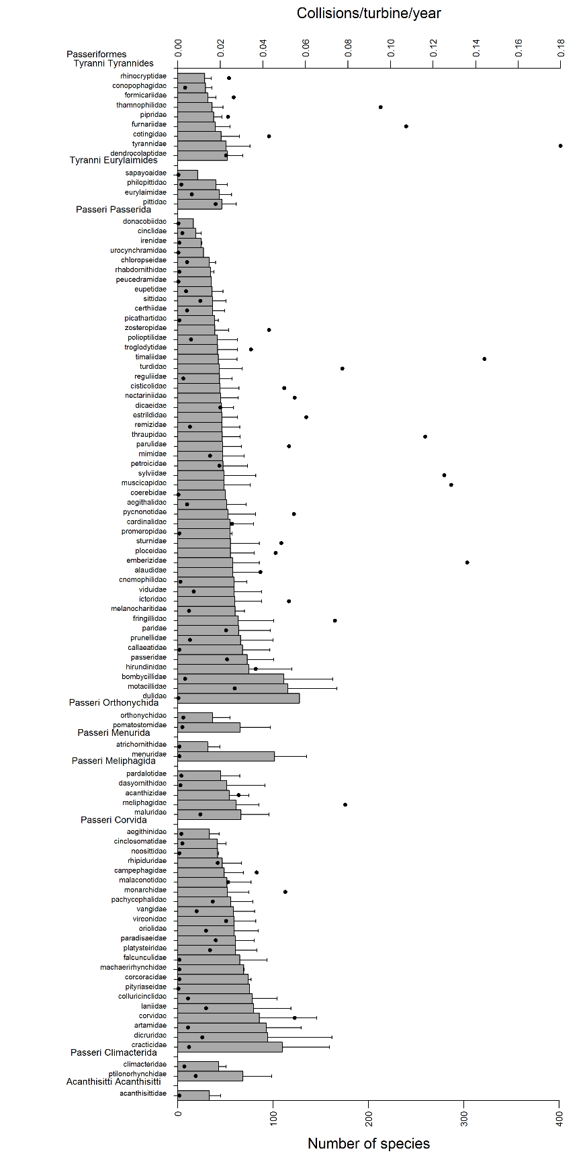

**Figure S8**. Predictions of mean collisions per turbine (per year) (±SD) for passerine birds (5,795 species) from posterior distributions from MCMCglmm models, ordered by mean predicted number of collisions within classification Order; numbers of species per family category are shown by black dots.

**C:\Users\christh\AppData\Local\Microsoft\Windows\INetCache\Content.Word\Bird.Predictions.nonpass.REVISED.TIF**

**Figure S9**. Predictions of mean collisions per turbine (per year) (±SD) for non-passerine birds (3,773 species) from posterior distributions from MCMCglmm models, ordered by mean predicted number of collisions within classification Order; numbers of species per family category are shown by black dots.

**Bird and bat species’ global vulnerability to collision mortality with wind farms revealed through a trait-based assessment Appendix 7. doi:10.1098/rspb.xxxx.xxxx**

Comparison of model predictions to the IUCN Red List assessment of species vulnerability to the threat of renewable energy.

Proceedings of the Royal Society B

Author List:

\*Chris B. Thaxter1,6, Graeme M. Buchanan2, Jamie Carr3, Stuart H. M. Butchart4,6, Tim Newbold5,

Rhys E. Green6, Joseph A. Tobias7, Wendy B. Foden8, Sue O’Brien9, James W. Pearce-Higgins 1,6

1British Trust for Ornithology, The Nunnery, Thetford, Norfolk IP24 2PU, UK / The David Attenborough Building, Pembroke Street, Cambridge, CB2 3QZ, UK.

2RSPB Centre for Conservation Science, Royal Society for the Protection of Birds, 2 Lochside View, Edinburgh Park, Edinburgh, EH12 9DH, UK.

3International Union for Conservation of Nature, the David Attenborough Building, Pembroke Street, Cambridge, CB2 3QZ, UK.

4BirdLife International, David Attenborough Building, Pembroke Street, Cambridge, CB2 3QZ, UK.

5Centre for Biodiversity and Environment Research, Department of Genetics, Evolution and Environment, University College London, Gower Street, London,WC1E 6BT, UK.

6Conservation Science Group, Department of Zoology, University of Cambridge, Downing Street, Cambridge CB2 3EJ, UK.

7Department of Life Sciences, Imperial College London, Silwood Park, Buckhurst Rd, Ascot SL5 7PY, UK

8Department of Botany and Zoology, University of Stellenbosch, P/Bag X1, Matieland, 7602 Stellenbosch, South Africa.

9Joint Nature Conservation Committee, Inverdee House, Baxter Street, Aberdeen, AB11 9QA, UK.

\*Corresponding author: telephone: +44(0)1842 750050; fax: +44(0)1842 750030

\*Corresponding Author: Chris B. Thaxter. Email: chris.thaxter@bto.org

More than half of 54% (31/57) of the IUCN renewable threat species were Accipitiformes species (Table S6). Of these species, a very high proportion (84%, 26/31) were, through MCMCglmm models, predicted to be in the top 90% percentile of the sensitivity dataset, with the lowest ranked species being in the top 75% percentile. However, there was no overall significance of IUCN threat status to explain the variation in collision rate (see main paper). Bird of prey species are primarily included in IUCN for potential risk to wind farm renewables. For birds, other species such as European Herring Gull and Great Indian Bustard identified by IUCN also featured highly in collision predictions (Table S6). For bats, only two species were identified by IUCN: Atacama Mytosis (*Myotis atacamensis*) and Giant Noctule (*Nyctalus lasiopterus*). Atacama Mytosis was predicted in the top 85% quantile however, Giant Noctule was predicted as being far less sensitive, within the bottom 5% percentile.

**Table S6.** Species of bird and bat identified under threat criteria of “renewable energy” within the IUCN Red List, alongside terrestrial quantile prediction rankings. Also included are IUCN Red List status of species and population trend (Increasing ‘↑’, decreasing ‘↓’, stable ‘-’, or unknown ‘?’); bold highlights species falling in the 90% quantile of predictions or above

|  |  |  |  |  |  |  |
| --- | --- | --- | --- | --- | --- | --- |
| **Order** | **Family** | **Scientific name** | **Common name** | **Percentile** | **Status** | **Population** |
| Accipitriformes | Accipitidae | *Gyps coprotheres* | Cape Vulture | **99.97** | EN | ↓ |
|  |  | *Aquila nipalensis* | Steppe Eagle | **99.96** | EN | ↓ |
|  |  | *Aquila chrysaetos* | Golden Eagle | **99.93** | LC | - |
|  |  | *Clanga pomarina* | Lesser Spotted Eagle | **99.90** | LC | - |
|  |  | *Milvus milvus* | Red Kite | **99.87** | NT | ↓ |
|  |  | *Gypaetus barbatus* | Bearded Vulture | **99.85** | NT | ↓ |
|  |  | *Gyps fulvus* | Griffon Vulture | **99.78** | LC | ↑ |
|  |  | *Hieraaetus pennatus* | Booted Eagle | **99.68** | LC | ? |
|  |  | *Pernis ptilorhynchus* | Oriental Honey-buzzard | **99.38** | LC | - |
|  |  | *Neophron percnopterus* | Egyptian Vulture | **99.35** | EN | ↓ |
|  |  | *Circaetus gallicus* | Short-toed Snake-eagle | **99.25** | LC | - |
|  |  | *Haliaeetus albicilla* | White-tailed Sea-eagle | **99.24** | LC | ↑ |
|  |  | *Buteo rufinus* | Long-legged Buzzard | **99.23** | LC | - |
|  |  | *Milvus migrans* | Black Kite | **98.91** | LC | ? |
|  |  | *Pernis apivorus* | European Honey-buzzard | **98.85** | LC | ↓ |
|  |  | *Haliaeetus pelagicus* | Steller's Sea-eagle | **97.16** | VU | ↓ |
|  |  | *Circus aeruginosus* | Western Marsh-harrier | **95.33** | LC | ↑ |
|  |  | *Buteo buteo* | Eurasian Buzzard | **94.17** | LC | - |
|  |  | *Accipiter nisus* | Eurasian Sparrowhawk | **90.58** | LC | - |
|  |  | *Accipiter gentilis* | Northern Goshawk | **90.42** | LC | ? |
|  |  | *Aquila adalberti* | Spanish Imperial Eagle | 89.26 | VU | ↑ |
|  |  | *Accipiter brevipes* | Levant Sparrowhawk | 85.58 | LC | - |
|  |  | *Circus pygargus* | Montagu's Harrier | 80.15 | LC | ↓ |
|  |  | *Circus maillardi* | Reunion Marsh-harrier | 76.17 | EN | ↓ |
|  | Pandionidae | *Pandion haliaetus* | Osprey | 76.64 | LC | ↑ |
|  | Falconidae | *Falco peregrinus* | Peregrine Falcon | **98.51** | LC | - |
|  |  | *Falco tinnunculus* | Common Kestrel | **97.71** | LC | ↓ |
|  |  | *Falco biarmicus* | Lanner Falcon | **97.65** | LC | ↑ |
|  |  | *Falco subbuteo* | Eurasian Hobby | **97.34** | LC | ↓ |
|  |  | *Falco columbarius* | Merlin | **96.80** | LC | - |
|  |  | *Falco eleonorae* | Eleonora's Falcon | **94.58** | LC | ↑ |
| Strigiformes | Strigidae | *Asio flammeus* | Short-eared Owl | **96.26** | LC | ↓ |
|  |  | *Otus angelinae* | Javan Scops-owl | na | VU | ↓ |
| Anseriformes | Anatidae | *Branta ruficollis* | Red-breasted Goose | **98.03** | VU | ↓ |
|  |  | *Melanitta stejnegeri* | Siberian Scoter | 39.27 | LC | ↓ |
|  |  | *Melanitta fusca* | Velvet Scoter | 39.26 | VU | ↓ |
|  |  | *Melanitta nigra* | Common Scoter | 0.97 | LC | ? |
| Caprimulgiformes | Caprimulgidae | *Antrostomus noctitherus* | Puerto Rican Nightjar | na | EN | ↓ |
| Charadriiformes | Charadriidae | *Anarhynchus frontalis* | Wrybill | 25.94 | VU | ↓ |
|  | Haematopodidae | *Haematopus ostralegus* | Eurasian Oystercatcher | **92.26** | NT | ↓ |
|  | Laridae | *Larus argentatus* | European Herring Gull | **98.69** | LC | ↓ |
|  | Scolopacidae | *Calidris tenuirostris* | Great Knot | **94.75** | EN | ↓ |
|  |  | *Limosa limosa* | Black-tailed Godwit | **92.73** | NT | ↓ |
| Galliformes | Phasianidae | *Tragopan blythii* | Blyth's Tragopan | 57.82 | VU | ↓ |
|  |  | *Lyrurus mlokosiewiczi* | Caucasian Grouse | 36.07 | NT | ↓ |
| Gruiformes | Gruidae | *Bugeranus carunculatus* | Wattled Crane | 81.75 | VU | ↓ |
| Otidiformes | Otidae | *Ardeotis nigriceps* | Great Indian Bustard | **98.24** | CR | ↓ |
| Pelecaniformes | Pelecanidae | *Pelecanus philippensis* | Spot-billed Pelican | 87.14 | NT | ↓ |
|  |  | *Pelecanus crispus* | Dalmatian Pelican | 75.34 | VU | ↓ |
| Psittaciformes | Cacatuidae | *Cacatua moluccensis* | Salmon-crested Cockatoo | 52.83 | VU | ↓ |
|  | Psittacidae | *Cyanopsitta spixii* | Spix's Macaw | 72.86 | CR | ? |
| Trogoniformes | Trogonidae | *Apalharpactes reinwardtii* | Javan Trogon | 27.07 | VU | ↓ |
| Passeriformes | Cinclidae | *Cinclus schulzi* | Rufous-throated Dipper | 5.33 | VU | ↓ |
|  | Emberizidae | *Emberiza cineracea* | Cinereous Bunting | 87.07 | NT | ↓ |
|  |  | *Emberiza aureola* | Yellow-breasted Bunting | 74.38 | EN | ↓ |
|  | Sylviidae | *Acrocephalus griseldis* | Basra Reed-warbler | 42.18 | EN | ↓ |
|  | Turdidae | *Cochoa azurea* | Javan Cochoa | 6.55 | VU | ↓ |