**Supporting Information:**

**Stereoselective synthesis of novel monocyclic *trans*-3-halogenated-4-pyrazolyl-β-lactams: Potential synthons and promising biologically active agents**

Shiwani Berry a,Shamsher S. Bari a,Bimal K. Banikb and Aman Bhallaa,*

*aDepartment of Chemistry and Centre of Advanced Studies in Chemistry, Panjab University, Chandigarh 160014, India*

*bCommunity Health Systems of South Texas, 3135 South Sugar Road, Edinburg, Texas 8539, USA*

*Corresponding author. Tel : +91-172-253-4417/ +919872659217, Fax : +91-172-254-5074,

email : [amanbhalla@pu.ac.in](mailto:amanbhalla@pu.ac.in)

|  |  |  |
| --- | --- | --- |
| **Table of content** | | |
| **S. No.** | **Content** | **Page No.** |
| **1.** | General information of experimental section | 2 |
| **2.** | Spectroscopic data for pyrazole substituted Schiff’s base **3a-d** | 3-4 |
| **3.** | Spectroscopic data for 3-bromo/chloro-4-pyrazolyl substituted β-lactams **5a-h** | 4-7 |
| **4.** | Reference | 7 |
| **5.** | 1H, 13C NMR and FT-IR spectra of pyrazole substituted Schiff’s base **3d** | 8-9 |
| **6.** | 1H, 13C NMR and FT-IR spectra of 3-bromo-4-pyrazolyl substituted β-lactam **5a** | 10-11 |
| **7.** | 1H, 13C NMR and FT-IR spectra of 3-bromo-4-pyrazolyl substituted β-lactam **5b** | 12-13 |
| **8.** | 1H, 13C NMR and FT-IR spectra of 3-bromo-4-pyrazolyl substituted β-lactam **5c** | 14-15 |
| **9.** | 1H, 13C NMR and FT-IR spectra of 3-bromo-4-pyrazolyl substituted β-lactam **5d** | 16-17 |
| **10.** | 1H, 13C NMR and FT-IR spectra of 3-chloro-4-pyrazolyl substituted β-lactam **5e** | 18-19 |
| **11.** | 1H, 13C NMR and FT-IR spectra of 3-chloro-4-pyrazolyl substituted β-lactam **5f** | 20-21 |
| **12.** | 1H, 13C NMR and FT-IR spectra of 3-chloro-4-pyrazolyl substituted β-lactam **5g** | 22-23 |
| **13.** | 1H, 13C NMR and FT-IR spectra of 3-chloro-4-pyrazolyl substituted β-lactam **5h** | 24-25 |
|  |  |  |

**General information of experimental section**

Melting points were determined in an open capillary on melting point apparatus (Perfit GSI-MP-3) and are uncorrected. Fourier transform infrared spectra were recorded by using Thermo scientific Nicolet iS50 (FT-IR) spectrophotometer (*υ*max in cm–1). 1H and 13C NMR spectra were recorded on JEOL AL 300 MHz and BRUKER AVANCE II 400 MHz spectrometer using TMS as an internal standard. The elemental analysis (C, H, N) were recorded on Flash 2000 Organic elemental analyzer All the reactions were monitored by thin layer chromatography (TLC) using precoated silica 60 F254, 0.25 mm aluminum plates (Merck) with visualization under UV light. Column chromatography was performed using Merck Silica Gel (60–120 mesh) using ethyl acetate-hexanes (10:90) as an eluant system.

Preparation of novel pyrazole linked 3-halogenated-β-lactams was carried out under dry and deoxygenated nitrogen atmosphere. Phosphorus oxychloride (Merck), triethylamine (Qualigen), hydrazine hydrate (Qualigen) and all other commercially available compounds/reagents/solvents were of reagent grade quality and used without any further purification. Dimethylformamide and dichloromethane were dried and distilled over anhydrous calcium chloride (CaCl2) and phosphorus pentoxide (P2O5) respectively. Toluene was distilled under N2 from sodium-benzophenone immediately before use.

# Experimental data

***General procedure for the preparation of Schiff base (3a-d)***

Solution of aromatic amine (1 mmol) and pyrazole carbaldehyde **4** (1 mmol) in the presence of molecular sieves (4 Å) in dry methylene chloride (15 mL) was stirred at room temperature. Progress of the reaction was monitored by TLC. After the completion, reaction mixture was filtered and solvent was evaporated to yield crude product **3** which was purified by recrystallization from a mixture of methylene chloride and hexane.

*N-[(5′-chloro-3′-methyl-1′-phenyl-1H-pyrazol-4′-yl)methylene]benzenamine (3a)***[1]**

Yellow crystalline solid; yield 85%; mp: 102-103 °C; FT-IR (νmax,cm-1): 1660, 2955; 1H NMR (300 MHz, CDCl3): δ 2.54 (3H, s, CH3), 6.94-7.47 (10H, m, ArH), 8.29 (1H, s, -N=CH-); 13C NMR (75 MHz, CDCl3): δ 14.7, 114.8, 115.8, 118.3, 120.7, 124.8, 125.4, 128.1, 128.9, 129.0, 137.7, 150.4, 151.0, 152.8; Anal. Calcd. for C17H14ClN3: C 69.03, H 4.77, N 14.21%. Found: C 68.87, H 4.73, N 14.13%.

*N-[(5′-chloro-3′-methyl-1′-phenyl-1H-pyrazol-4′-yl)methylene]-4-methoxybenzenamine (3b)***[1]**Yellow crystalline solid;yield: 82%; mp 117-119 °C; FT-IR (νmax,cm-1): 1662, 2959; 1H NMR (300 MHz, CDCl3): δ 2.54 (3H, s, CH3), 3.70 (3H, s, OCH3), 6.75-7.49 (9H, m, ArH), 8.31 (1H, s, -N=CH-); 13C NMR (75 MHz, CDCl3): δ 14.7, 55.2, 114.2, 116.0, 121.8, 124.8, 128.2, 128.5, 129.1, 137.8, 145.7, 149.2, 149.3, 150.3, 158.0; Anal. Calcd. for C18H16ClN3O: C 66.36, H 4.95, N 12.90%. Found: C 66.20, H 4.92, N 12.85%.

*N-[(5′-chloro-3′-methyl-1′-phenyl-1H-pyrazol-4′-yl)methylene](phenyl)methanamine (3c)***[1]** Yellow crystalline solid; yield 79%; mp 129-131 °C; FT-IR (νmax,cm-1): 1632, 2811; 1H NMR (300 MHz, CDCl3): δ2.54 (3H, s, CH3), 4.75 (2H, s, CH2), 7.21-7.53 (10H, m, ArH), 8.35 (1H, s, -N=CH-); 13C NMR (75 MHz, CDCl3): δ 14.7, 65.9, 115.3, 124.8, 126.7, 127.4, 127.5, 127.9, 128.1, 128.3, 128.4, 128.9, 137.8, 139.7, 150.3, 152.7, 152.8; Anal. Calcd. for C18H16ClN3: C 69.79, H 5.21, N 13.56%. Found: C 69.61, H 5.18, N 13.49%.

*N-[(5'-chloro-3'-methyl-1'-phenyl-1H-pyrazol-4'-yl)methylene]-4methyl benzenamine (3d)*Yellow crystalline solid; yield: 80%; mp: 105-107 °C; FT-IR (νmax,cm-1): 1625, 2917; 1H NMR (300 MHz, CDCl3): δ 2.36 (3H, s, CH3), 2.62 (3H, s, CH3), 7.01-7.57 (9H, m, Ar-H), 8.39 (1H, s, -N=CH-); 13C NMR (100 MHz, CDCl3): δ 13.8, 20.4, 20.9, 21.0, 109.5, 115.5, 115.8, 117.2, 118.8, 120.7, 121.1, 125.0, 125.2, 126.5, 128.5, 128.8, 128.9, 129.1, 129.2, 129.3, 129.7, 130.5, 135.4, 137.6, 137.7, 138.3, 150.2, 150.6, 150.9, 152.7, 161.3; Anal. Calcd. for C18H16ClN3: C 69.79, H 5.21, N 11.44%. Found: C 69.52, H 5.08, N 11.31%.

***General procedure for synthesis of 3-bromo/chloro-4-pyrazolyl β-lactam (5a-h)***

Phosphorus oxychloride (POCl3, 0.69 mmol, 1.5 equiv.) was added dropwise to a solution of 2-substituted ethanoic acids **4** (0.55 mmol, 1.2 equiv.), Schiff’s base **3** (0.46 mmol, 1 equiv.) and triethyl amine (1.38 mmol, 3 equiv.) under nitrogen atmosphere, at refluxing temperature, with constant stirring. The reaction mixture was refluxed for 3-4 h. The solvent was evaporated and crude product was extracted with CH2Cl2. The organic layer was washed with water (3x10 ml), 1N HCl (3x10 ml), 5% NaHCO3 (3x10 ml) and brine (3x10 ml), then dried (Na2SO4) and concentrated. The residue was purified by Silica gel column chromatography with hexane/EtOAc (90:10) as eluent to afford pure products **5**.

*trans-1-Phenyl-3-bromo-4-(5'-chloro-3'-methyl-1'-phenyl-1H-pyrazol-4'-yl)-azetidin-2-one (5a)*White solid; yield 75%; mp 118-120 °C; FT-IR (νmax,cm-1): 1760 (C=O); 1H NMR (300 MHz, CDCl3): δ 2.31 (3H, s, CH3), 4.97 (1H, d, *J*= 2.1 Hz, C4–H), 5.05 (1H, d, *J*= 2.1 Hz, C3–H), 7.11-7.52 (10H, m, ArH); 13C NMR (75 MHz, CDCl3): δ 13.0, 29.8, 48.0, 57.9, 61.4, 117.0, 117.1, 124.8, 125.0, 128.5, 129.1, 129.4, 136.9, 137.7, 148.0, 159.8; Anal. Calcd. for C19H15BrClN3O: C 54.76, H 3.63, N 10.08%. Found: C 54.62, H 3.56, N 9.82%.

*trans-1-(4'-Methoxyphenyl)-3-bromo-4-(5'-chloro-3'-methyl-1'-phenyl-1H-pyrazol-4'-yl)-azetidin-2-one (5b)*

Yellowish solid; yield 68%; mp 48-50 °C; IR (νmax,cm-1): 1758 (C=O); 1H NMR (300 MHz, CDCl3): δ 2.19 (3H, s, CH3), 3.65 (3H, s, OCH3), 4.82 (1H, d, *J*= 1.8 Hz, C4–H), 4.90 (1H, d, *J*= 2.1 Hz, C3–H), 6.70-7.43 (9H, m, ArH); 13C NMR (100 MHz, CDCl3): δ 13.1, 55.4, 57.8, 57.9, 61.2, 110.6, 110.8, 114.6, 118.5, 118.6, 124.8, 126.7, 128.6, 129.1, 130.0, 137.5, 148.1, 148.2, 156.9, 159.7; Anal. Calcd. for C20H17BrClN3O2: C 66.20, H 5.20, N 12.90%. Found: C 66.07, H 4.96, N 12.85%.

*trans-1-(Benzyl)-3-bromo-4-(5'-chloro-3'-methyl-1'-phenyl-1H-pyrazol-4'-yl)-azetidin-2-one (5c)* Yellowish solid; yield: 66%; mp 62-64 °C; IR (νmax,cm-1): 1765 (C=O); 1H NMR (300 MHz, CDCl3): δ 2.06 (3H, s, CH3), 3.81 (1H, d, *J*= 15 Hz, CH2Ph), 4.29 (1H, d, *J*= 2.1 Hz, C4–H), 4.63 (1H, d, *J*= 14.7 Hz, CH2Ph), 4.84 (1H, d, *J*= 1.8 Hz, C3–H), 7.05-7.40 (10H, m, ArH); 13C NMR (100 MHz, CDCl3): δ12.5, 45.4, 45.5, 57.0, 57.1 60.7, 61.0, 110.1, 124.9, 126.6, 127.8, 128.2, 128.3, 128.4, 128.6, 128.7, 128.8, 128.9, 129.0, 129.1, 129.2, 133.9, 134.0, 137.3, 137.5, 148.6, 148.7, 161.0; Anal. Calcd. for C20H17BrClN3O: C, 55.77; H, 3.98; N, 9.76%. Found: C, 55.23; H, 3.81; N, 9.29%.

*trans-1-(4'-Methylphenyl)-3-bromo-4-(5'-chloro-3'-methyl-1'-phenyl-1H-pyrazol-4'-yl)-azetidin-2-one (5d)*

White solid; yield 72%; mp 58-60 °C; IR (νmax,cm-1): 1759 (C=O); 1H NMR (300 MHz, CDCl3): δ 2.20 (3H, s, CH3), 2.22 (3H, s, CH3), 4.81 (1H, d, *J*= 2.1 Hz, C4–H), 4.91 (1H, d, *J*= 2.1 Hz, C3–H), 6.99-7.45 (9H, m, ArH); 13C NMR (100 MHz, CDCl3): δ 13.0, 21.0, 57.6, 57.8, 61.2, 110.6, 117.0, 117.1, 124.8, 126.6, 128.6, 129.1, 129.9, 134.2, 134.9, 137.5, 148.1, 160.0; Anal. Calcd. for C20H17BrClN3O: C, 55.77; H, 3.98; N, 9.76%. Found: C, 55.63; H, 3.72; N, 9.54%.

*trans-1-Phenyl-3-chloro-4-(5'-chloro-3'-methyl-1'-phenyl-1H-pyrazol-4'-yl)-azetidin-2-one (5e)* Whitesolid; yield 79%; mp 89-90 °C; IR (νmax,cm-1): 1763 (C=O); 1H NMR (300 MHz, CDCl3): δ 2.24 (3H, s, CH3), 4.87 (1H, d, *J*= 2.1 Hz, C4–H), 4.97 (1H, d, *J*= 2.1 Hz, C3–H), 7.03-7.48 (10H, m, ArH); 13C NMR (75 MHz, CDCl3): δ 13.0, 23.2, 42.8, 57.9, 61.3, 110.8, 117.1, 120.0, 124.8, 125.1, 128.5, 129.1, 129.4, 136.9, 148.0, 160.0; Anal. Calcd. for C19H15Cl2N3O: C 61.30, H 4.06, N 11.29%. Found: C 61.11, H 3.92, N 11.10%.

*trans-1-(4'-Methoxyphenyl)-3-chloro-4-(5'-chloro-3'-methyl-1'-phenyl-1H-pyrazol-4'-yl)- azetidin-2-one (5f)*

Yellowsolid; yield 74%; mp 39-41 °C; IR (νmax,cm-1): 1758 (C=O); 1H NMR (300 MHz, CDCl3): δ2.19 (3H, s, CH3), 3.65 (3H, s, OCH3), 4.83 (1H, d, J= 2.1 Hz, C4–H), 4.90 (1H, d, J *=* 1.5 Hz, C3–H), 6.71-7.43 (14H, m, ArH); 13C NMR (75 MHz, CDCl3): δ 12.8, 29.6, 42.7, 55.1, 57.8, 61.2, 110.7, 114.0, 114.5, 118.4, 121.7, 124.6, 126.3, 128.3, 128.9, 129.9, 130.1, 137.6, 147.9, 156.8, 159.2, 163.2; Anal. Calcd. for C20H17Cl2N3O2: C, 59.71; H, 4.26; N, 10.45%. Found: C, 59.60; H, 4.11; N, 10.30%.

*trans-1-Benzyl-3-chloro-4-(5'-chloro-3'-methyl-1'-phenyl-1H-pyrazol-4'-yl)-azetidin-2-one (5g)* Yellowish solid; yield: 69%; mp 75-77 °C; IR (νmax,cm-1): 1766 (C=O); 1H NMR (300 MHz, CDCl3): δ 2.07 (3H, s, CH3), 3.82 (1H, d, *J*= 14.7 Hz, CH2Ph), 4.30 (1H, d, *J =* 1.8 Hz, C4–H), 4.66 (1H, d, *J*= 14.7 Hz, CH2Ph), 4.85 (1H, d, *J*= 1.8 Hz, C3–H), 7.07-7.41 (10H, m, ArH); 13C NMR (75 MHz, CDCl3): δ12.6, 42.5, 43.9, 45.4, 57.1, 60.9, 110.4, 124.3, 124.8, 127.6, 127.8, 128.1, 128.2, 128.5, 128.6, 128.9, 129.0, 129.1, 133.6, 134.1, 137.8, 148.5, 162.5; Anal. Calcd. for C20H17Cl2N3O: C, 62.19; H, 4.44; N, 10.88%. Found: C, 61.99; H, 4.29; N, 10.75%.

*trans-1-(4'-Methylphenyl)-3-chloro-4-(5'-chloro-3'-methyl-1'-phenyl-1H-pyrazol-4'-yl)-azetidin-2-one (5h)*

Whitesolid; yield 70%; mp 45-47 °C ; IR (νmax,cm-1): 1760 (C=O); 1H NMR (300 MHz, CDCl3): δ 2.21 (3H, s, CH3), 2.23 (3H, s, CH3), 4.83 (1H, d, *J*= 2.1 Hz, C4–H), 4.92 (1H, d, *J*= 1.8 Hz, C3–H), 7.00-7.45 (14H, m, ArH); 13C NMR (75 MHz, CDCl3): δ 13.0, 21.1, 57.9, 61.4, 111.0, 117.1, 124.7, 125.2, 126.3, 128.4, 129.0, 129.2, 129.9, 134.5, 134.6, 147.9, 159.4, 182.9; Anal. Calcd. for C20H17Cl2N3O: C, 62.19; H, 4.44; N, 10.88%. Found: C, 62.06; H, 4.22; N, 10.72%.

**References:**

1. Bhalla, A.; Bari, S. S.; Berry, S.; Vats, S.; Bhalla, J.; Mandal, S.; Khullar, S. *Arkivoc* **2015**, *(vii)*, 10.

**Spectra**

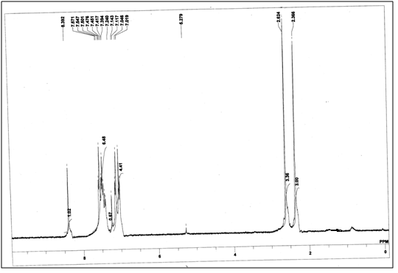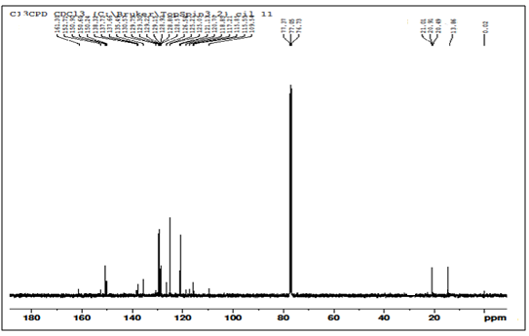



**Figure S1**. 1H NMR (300 MHz, CDCl3) and 13C NMR (100 MHz, CDCl3) spectrum of **3d**

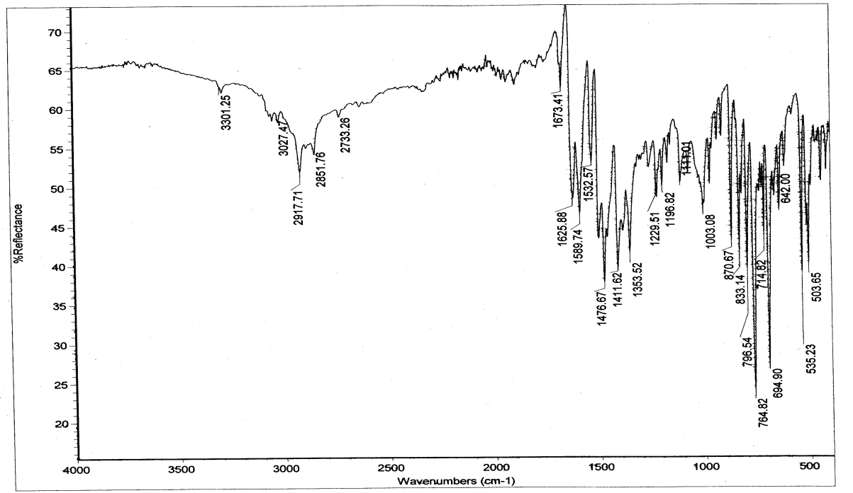



**Figure S2**. FT-IR spectrum of **3d**

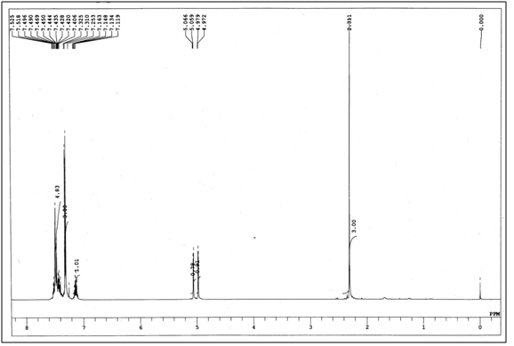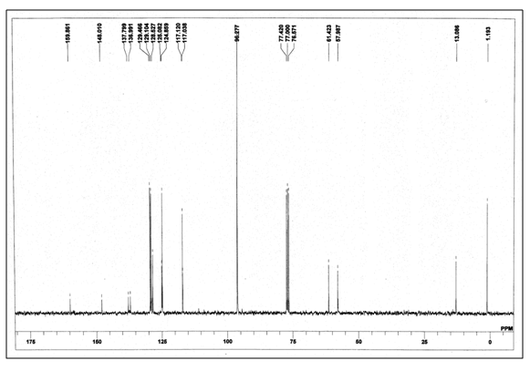



**Figure S3**. 1H NMR (300 MHz, CDCl3) and 13C NMR (75 MHz, CDCl3) spectrum of **5a**

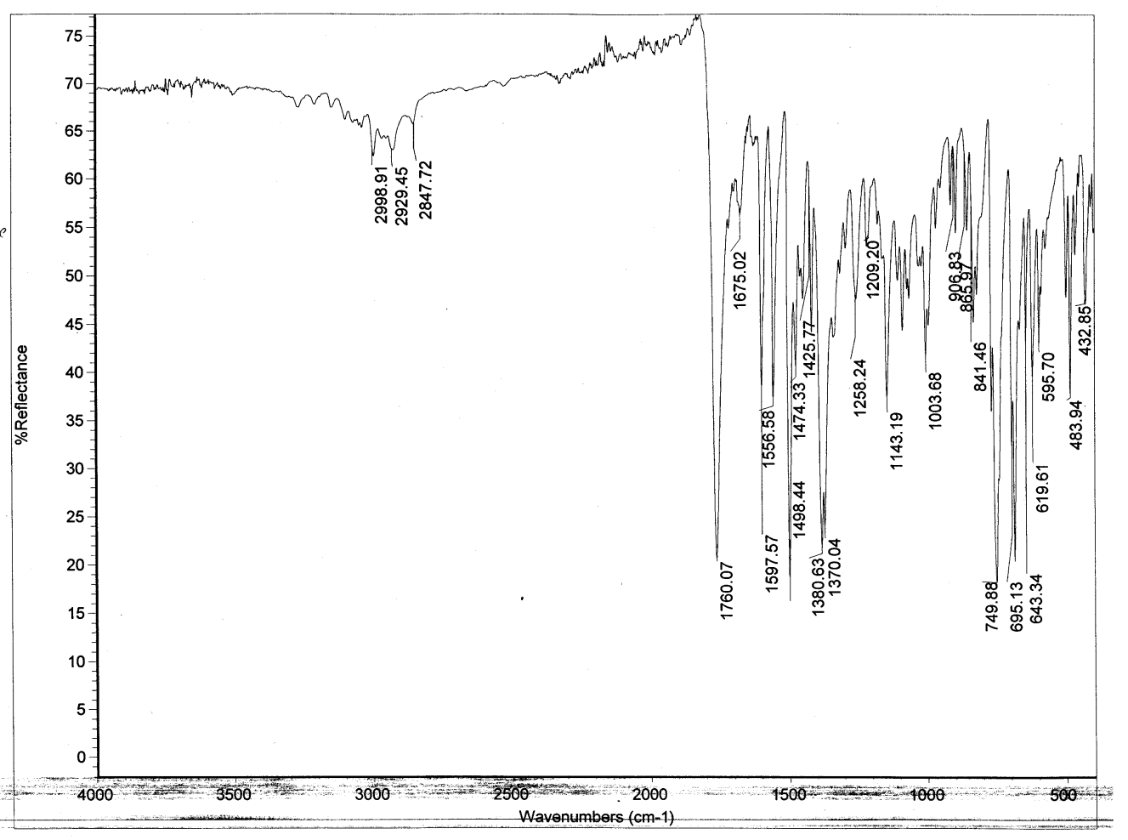



**Figure S4**. IR spectrum of **5a**

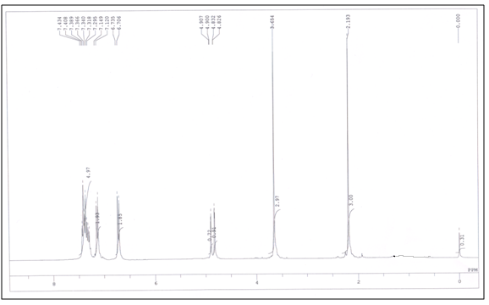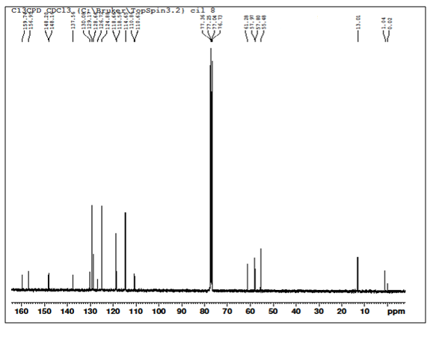



**Figure S5**.  1H NMR (300 MHz, CDCl3) and 13C NMR (100 MHz, CDCl3) spectrum of **5b**

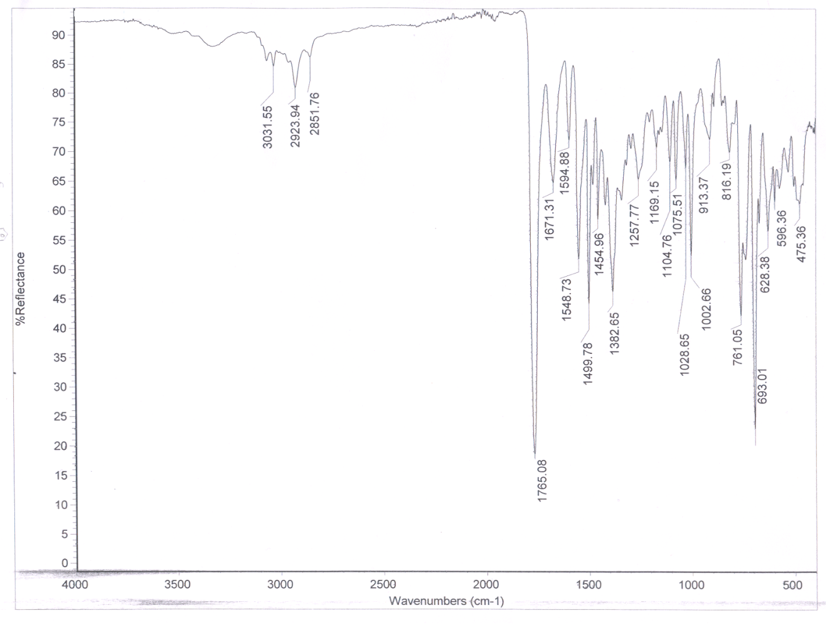



**Figure S6**. IR spectrum of **5b**

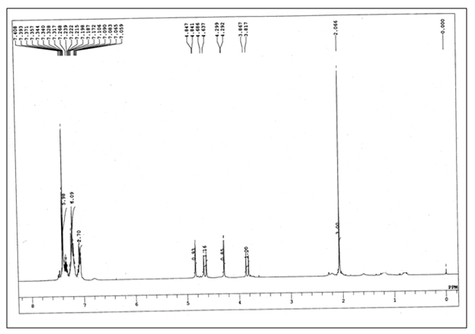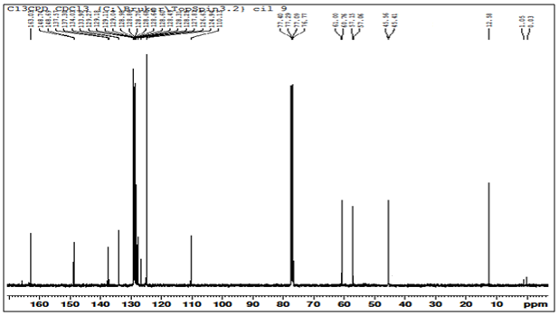



**Figure S7**. 1H NMR (300 MHz, CDCl3) and 13C NMR (100 MHz, CDCl3) spectrum of **5c**

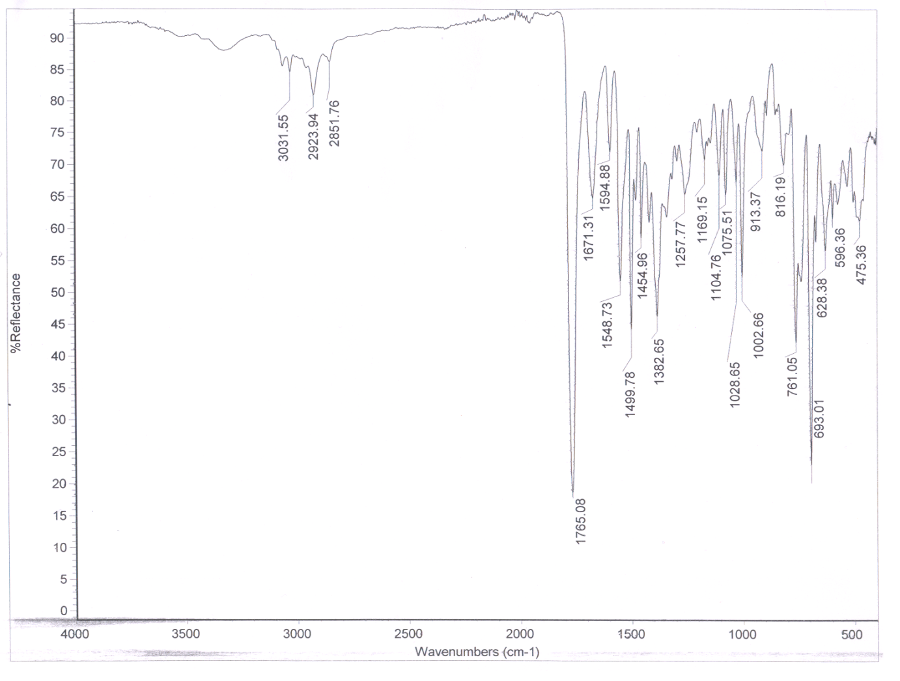



**Figure S8**. IR spectrum of **5c**

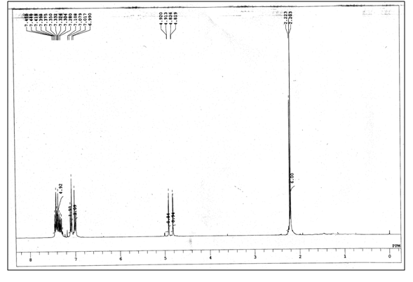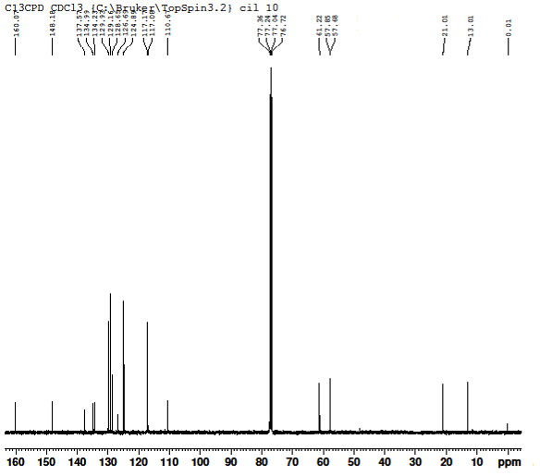



**Figure S9**. 1H NMR (300 MHz, CDCl3) and 13C NMR (100 MHz, CDCl3) spectrum of **5d**

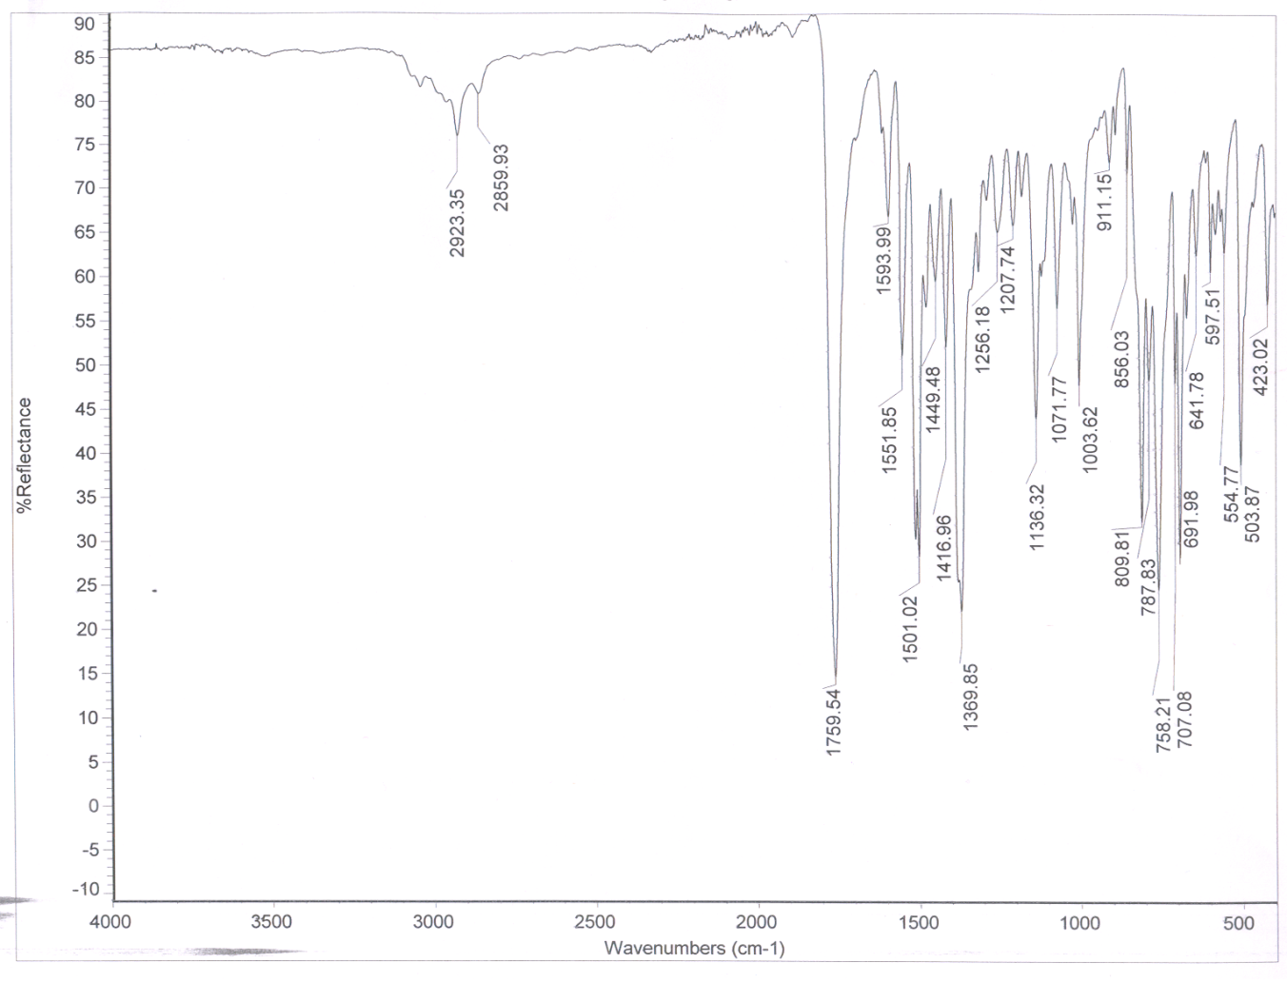



**Figure S10**. IR spectrum of **5d**

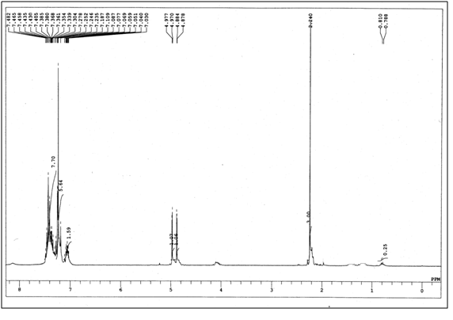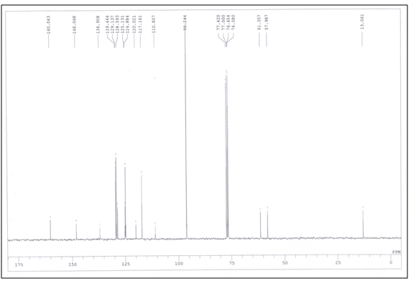



**Figure S11**. 1H NMR (300 MHz, CDCl3) and 13C NMR (75 MHz, CDCl3) spectrum of **5e**

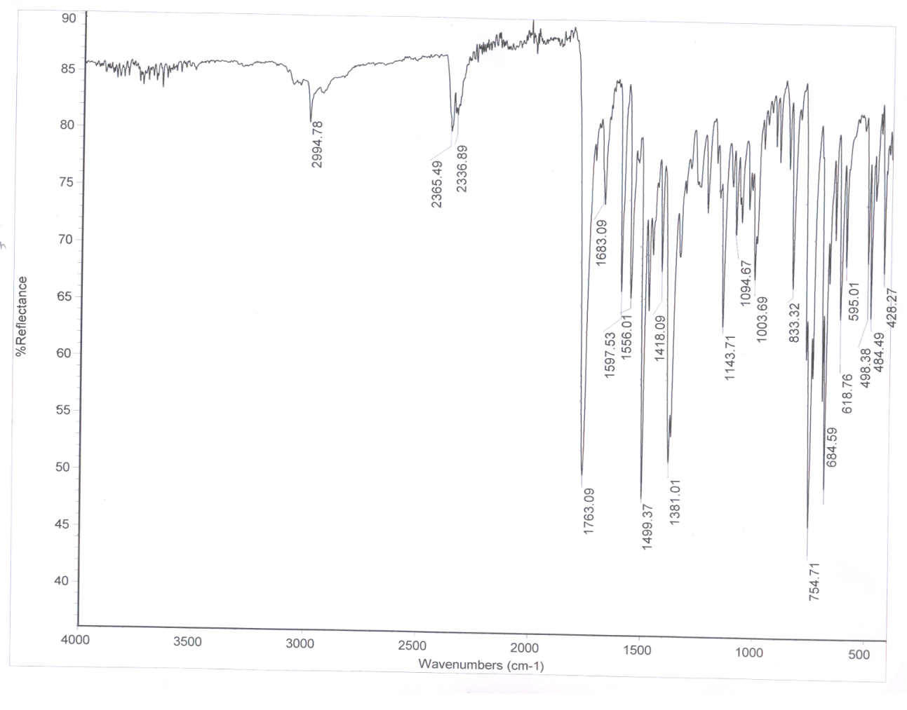



**Figure S12**. IR spectrum of **5e**

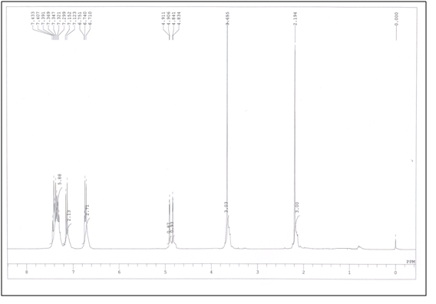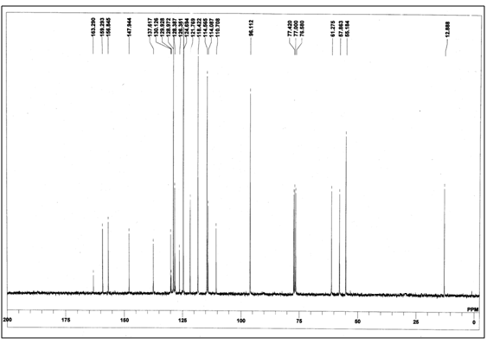



**Figure S13**. 1H NMR (300 MHz, CDCl3) and 13C NMR (75 MHz, CDCl3) spectrum of **5f**

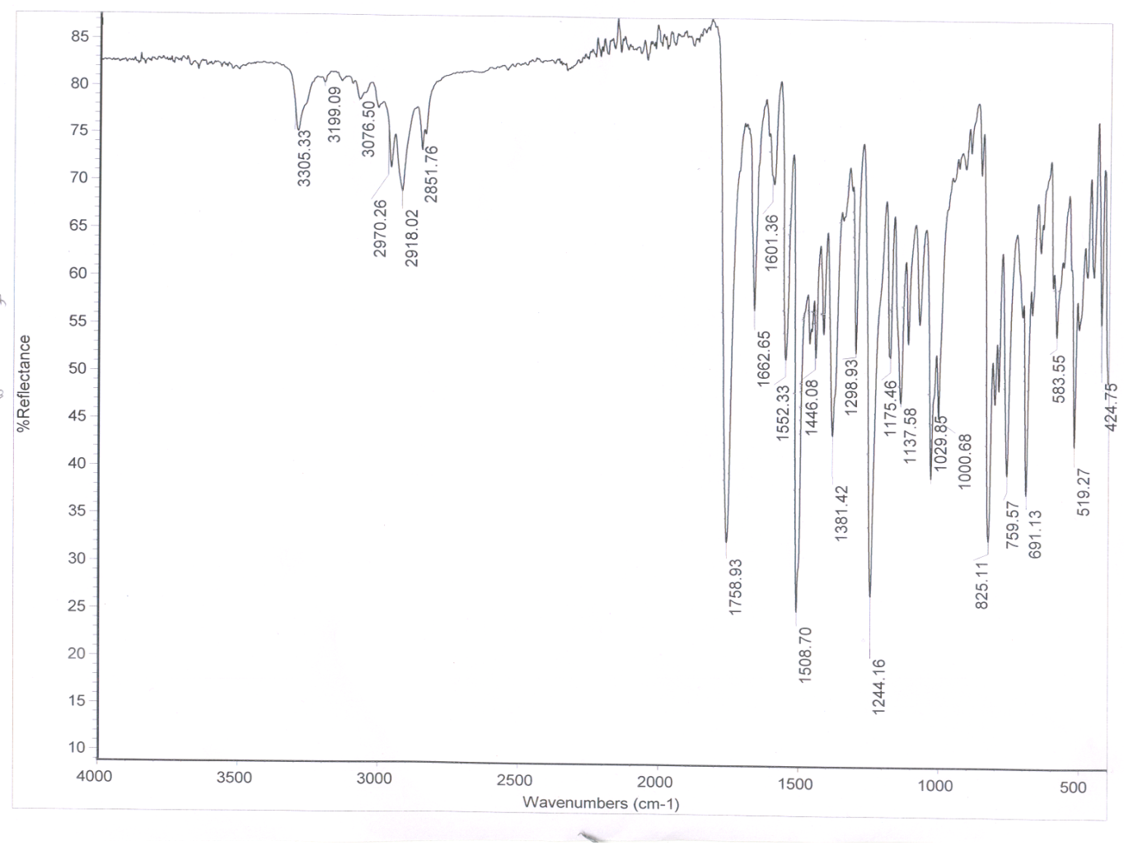



**Figure S14**. IR spectrum of **5f**

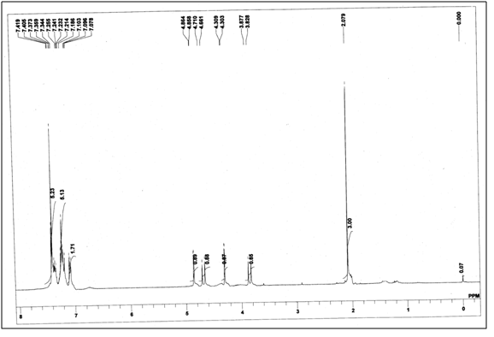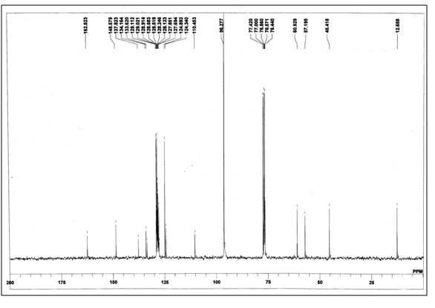



**Figure S15**. 1H NMR (300 MHz, CDCl3) and 13C NMR (75 MHz, CDCl3) spectrum of **5g**

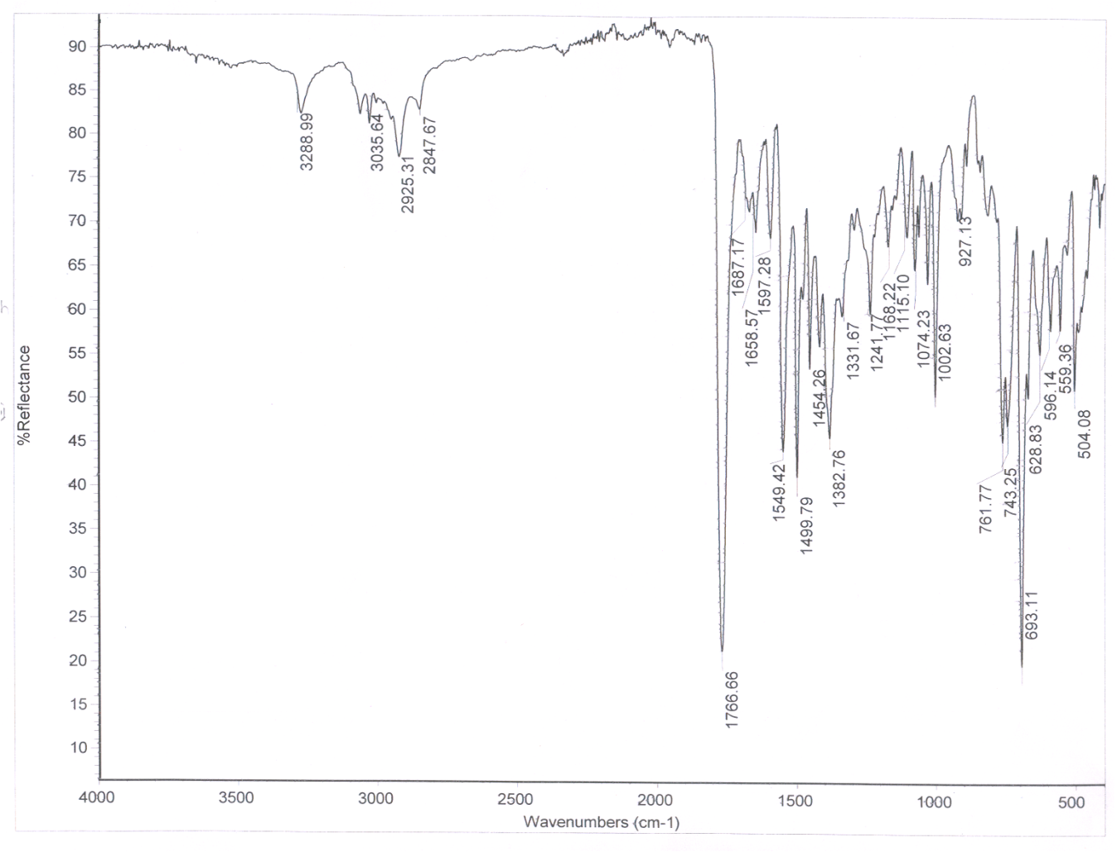



**Figure S16**. IR spectrum of **5g**

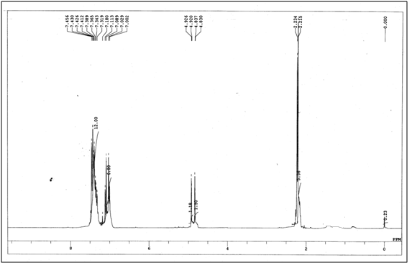



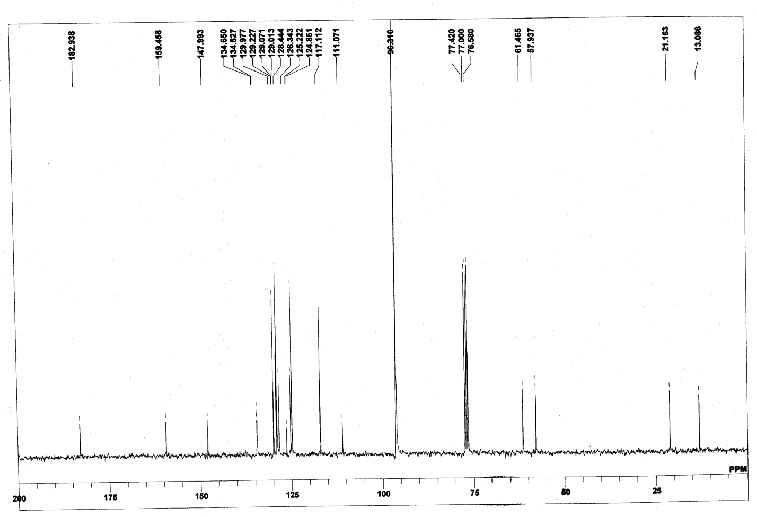



**Figure S17**. 1H NMR (300 MHz, CDCl3) and 13C NMR (75 MHz, CDCl3) spectrum of **5h**

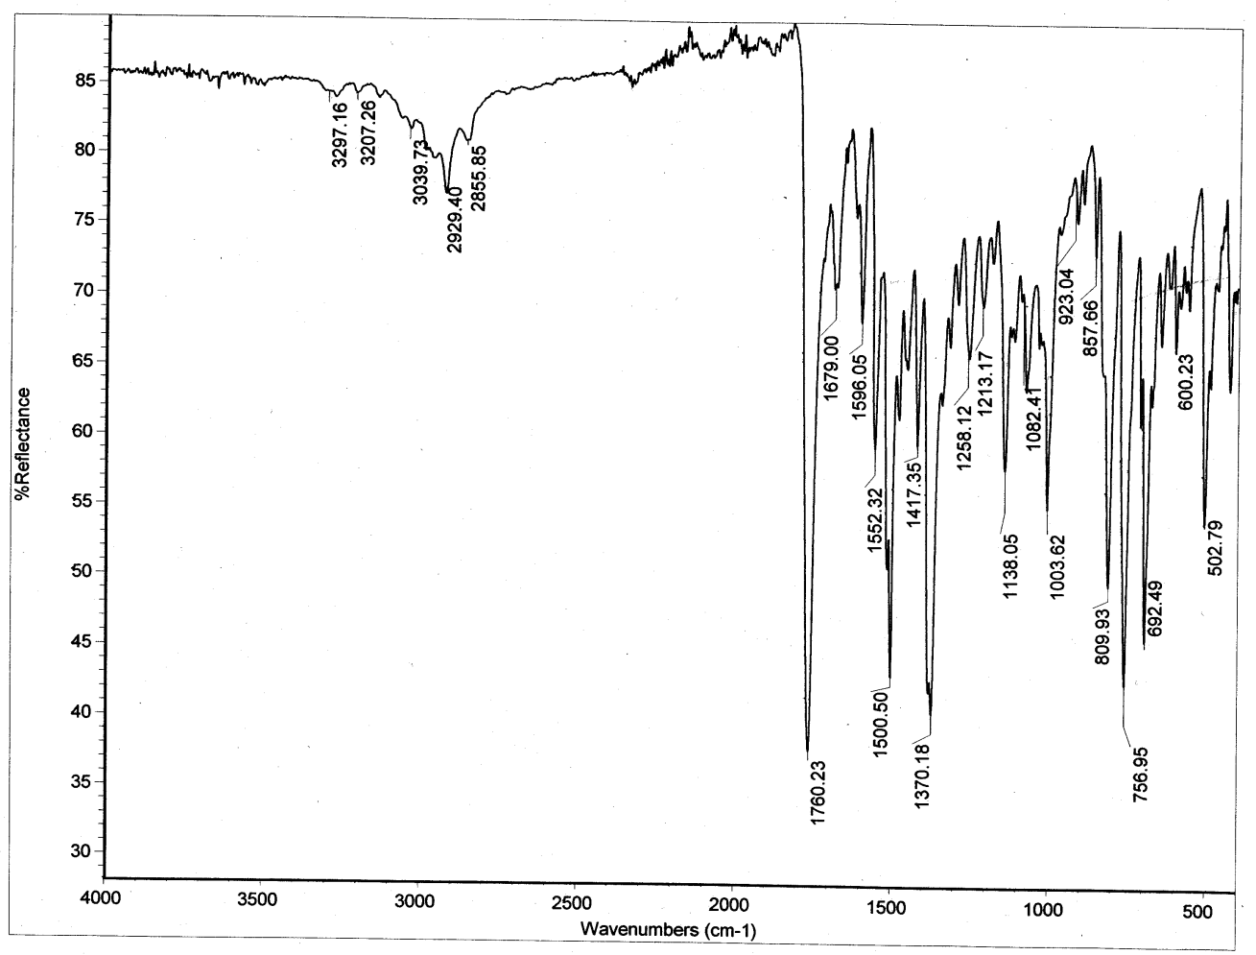



**Figure S18**. IR spectrum of **5h**