Developing a case mix classification for child and adolescent mental health services: the influence of presenting problems, complexity factors, and service providers on number of appointments

Online Supplement

This online supplement provides additional tables and graphs.

Tables S1, S2 and S3 give the distribution of Current View item ratings, which are represented graphically in Figures 1b, 1c, and 1d of the main text. The supplementary tables distinguish between “None” ratings, “Not known” ratings, and missing ratings, which have been aggregated for the purpose of creating the figures in the main text, and for the purpose of cluster analysis and statistical modelling.

Figures S1 and S2 show two of the twenty regression trees grown on development samples taken randomly from our analysis sample. The differences between the two trees exemplify the variation between the trees, thus supporting our conclusion that regression trees did not result in a reliable classification.

Figures S3 and S4a-e illustrate the clusters resulting from the k-medoids cluster analysis: a six-cluster solution and a twenty-six cluster solution.

Table S4 gives full result of the crossvalidation analysis comparing k-medoids clusters, regression trees and the conceptual classification.

Table S1. Current View Problem Description Ratings: Percentages
Problem Description | Severe | Moderate | Mild | None | Not known | Missing
Anxious away caregivers | 2.06 | 7.70 | 16.14 | 57.64 | 8.07 | 8.40
Anxious social | 2.78 | 12.14 | 19.94 | 47.02 | 7.70 | 10.43
Anxious generally | 2.30 | 14.35 | 20.75 | 44.37 | 7.63 | 10.61
Compelled do think | 1.51 | 3.91 | 8.29 | 65.76 | 9.73 | 10.80
Panics | 1.16 | 5.69 | 11.39 | 62.08 | 8.64 | 11.04
Avoids going out | 0.85 | 3.04 | 7.98 | 71.29 | 5.97 | 10.87
Avoids specific things | 1.33 | 4.22 | 5.51 | 68.86 | 8.88 | 11.20
Repetitive problem behaviours | 1.42 | 4.75 | 7.00 | 70.04 | 7.76 | 9.03
Low mood | 2.71 | 18.17 | 25.61 | 42.09 | 6.80 | 4.61
Self harm | 1.42 | 9.73 | 16.90 | 57.84 | 5.23 | 8.88
Extremes of mood | 0.48 | 2.16 | 5.29 | 76.75 | 6.67 | 8.64
Delusional belief hallucinations | 0.09 | 0.83 | 1.68 | 80.19 | 5.31 | 11.90
Drug alcohol difficulties | 0.37 | 1.57 | 2.78 | 80.43 | 6.04 | 8.81
Difficulties sitting still concentrating | 2.60 | 9.51 | 12.64 | 58.85 | 6.28 | 10.12
Behavioural difficulties | 3.67 | 14.59 | 15.04 | 54.69 | 4.72 | 7.28
Poses risk others | 0.63 | 4.40 | 10.10 | 71.05 | 4.85 | 8.97
Carer management problems | 2.80 | 13.03 | 16.38 | 53.60 | 5.79 | 8.40
Toilet problems | 0.68 | 1.82 | 1.84 | 79.29 | 5.01 | 11.37
Traumatic event | 2.45 | 5.90 | 7.43 | 62.13 | 11.09 | 11.00
Eating issues | 0.77 | 2.89 | 7.17 | 72.67 | 5.95 | 10.56
Family relationship difficulties | 7.72 | 20.71 | 22.00 | 36.02 | 6.74 | 6.82
Attachment carer problems | 2.89 | 7.65 | 12.66 | 52.90 | 13.40 | 10.50
Peer relationship difficulties | 3.72 | 16.49 | 23.22 | 41.24 | 6.82 | 8.51
Persistent relationship difficulties | 0.92 | 3.61 | 6.47 | 69.95 | 7.11 | 11.94
Does not speak | 0.22 | 0.46 | 1.16 | 84.36 | 2.49 | 11.31
Gender discomfort | 0.09 | 0.22 | 0.28 | 82.22 | 5.75 | 11.44
Unexplained physical symptoms | 0.66 | 1.99 | 3.67 | 79.75 | 4.77 | 9.16
Unexplained development difficulties | 0.48 | 2.36 | 3.04 | 77.87 | 6.65 | 9.60
Self care issues | 0.57 | 2.03 | 4.22 | 79.64 | 4.15 | 9.38
Adjustment health issues | 0.66 | 2.10 | 3.48 | 79.51 | 4.53 | 9.73

Note: Analysis Sample, n = 4573. Percentages sum to 100 % for each row. Slight deviations are due to rounding.

Table S2: Current View Complexity Factor Ratings: Percentages
Complexity Factor | Yes | No | Not known | Missing
Looked after child | 3.85 | 86.60 | 1.12 | 8.44
Young carer | 2.97 | 85.76 | 2.51 | 8.75
Learning disability | 6.19 | 77.37 | 7.22 | 9.23
Physical health | 5.47 | 82.62 | 2.69 | 9.23
Pervasive developmental disorder | 8.46 | 71.16 | 9.45 | 10.93
Neurological | 3.00 | 83.53 | 4.42 | 9.05
Current protection plan | 3.35 | 84.52 | 3.08 | 9.05
Child in need | 8.62 | 78.11 | 4.15 | 9.12
Refugee or asylum | 0.90 | 88.50 | 1.62 | 8.99
Experience of war | 0.74 | 88.19 | 2.08 | 8.99
Experience of abuse | 11.90 | 69.52 | 7.50 | 11.09
Parental health issues | 19.72 | 60.46 | 8.79 | 11.02
Contact youth justice | 2.86 | 83.10 | 3.26 | 10.78
Financial difficulties | 5.79 | 67.48 | 15.29 | 11.44

Note: Analysis Sample, n = 4573. Percentages sum to 100 % for each row. Slight deviations are due to rounding.

Table S3: Current View Context Problem Ratings: Percentages

Context Problem | Severe | Moderate | Mild | None | Not known | Missing
Home issues | 6.06 | 24.62 | 24.82 | 31.40 | 3.19 | 9.91
School issues | 6.95 | 20.99 | 23.25 | 34.62 | 3.61 | 10.58
Community issues | 1.73 | 7.94 | 14.30 | 57.36 | 8.48 | 10.19
Engagement issues | 0.90 | 3.80 | 7.02 | 69.45 | 7.98 | 10.85
EET Attendance Difficulties | 4.85 | 5.86 | 11.02 | 59.81 | 7.37 | 11.09
EET Attainment Difficulties | 3.37 | 10.85 | 15.53 | 47.39 | 10.58 | 12.29

Note: Analysis Sample, n = 4573. EET: Education/Employment/Training. Percentages sum to 100 % for each row. Slight deviations are due to rounding.

Figure S1. Regression tree with 8 clusters, from the 5th sample random test sample.
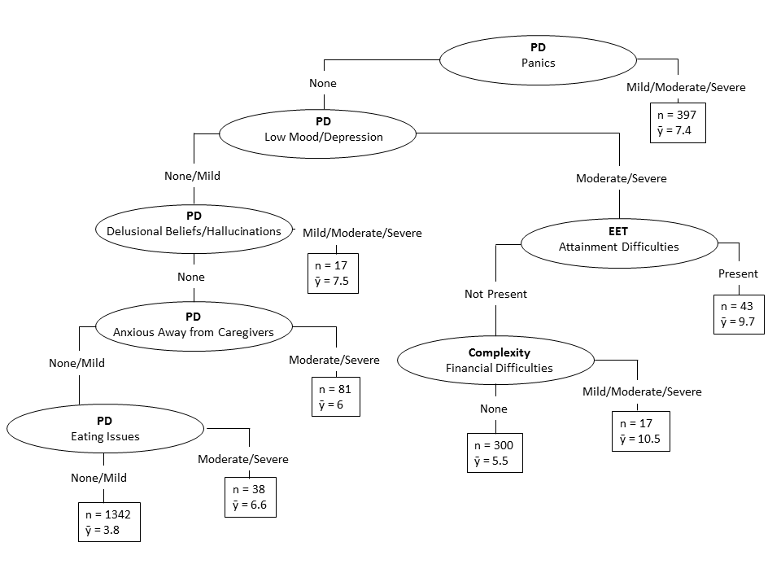

Note: PD: Problem Descriptor; EET: Employment, Education or Training; n: cluster size; $\overline{y}$: observed mean number of appointments in cluster.

Figure S2. Regression tree with 6 clusters, from the 10th random test sample.
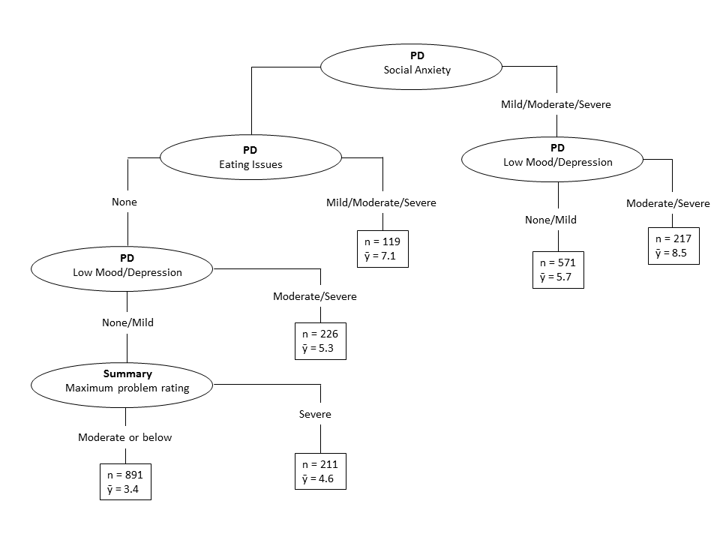
Note: PD: Problem Descriptor; n: cluster size; $\overline{y}$: observed mean number of appointments in cluster.

Figure S3: k-medoids cluster analysis: 6-cluster solution
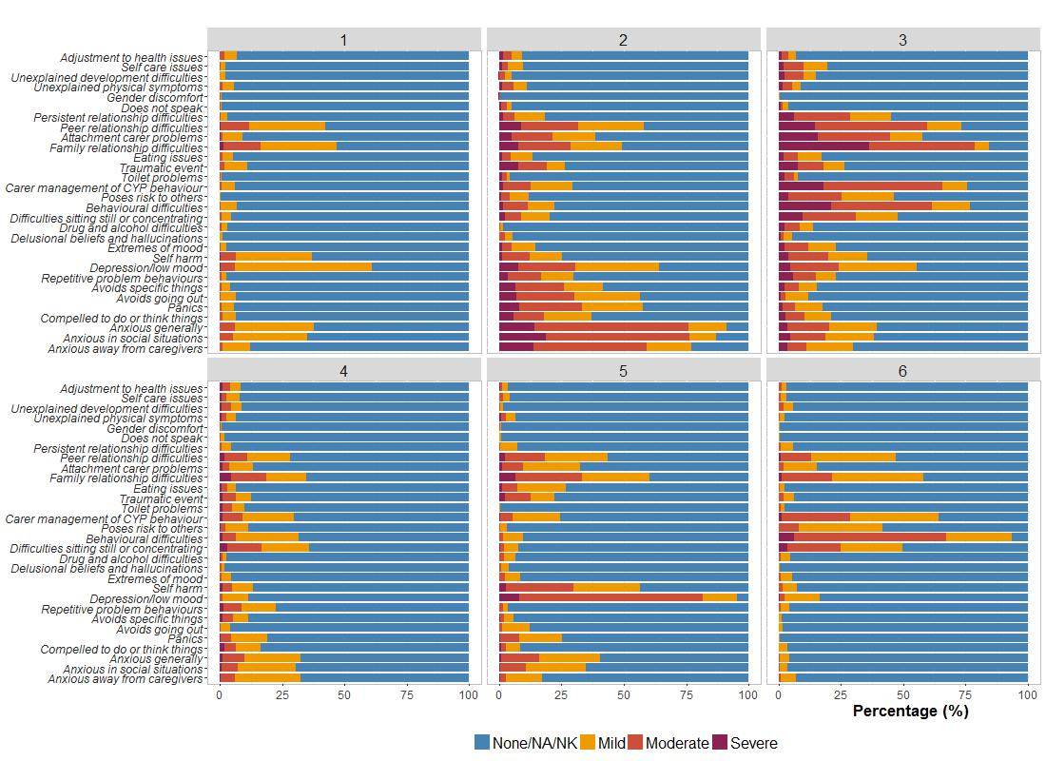
Figure S4a: k-medoids cluster analysis: 26-cluster solution, clusters 1-6
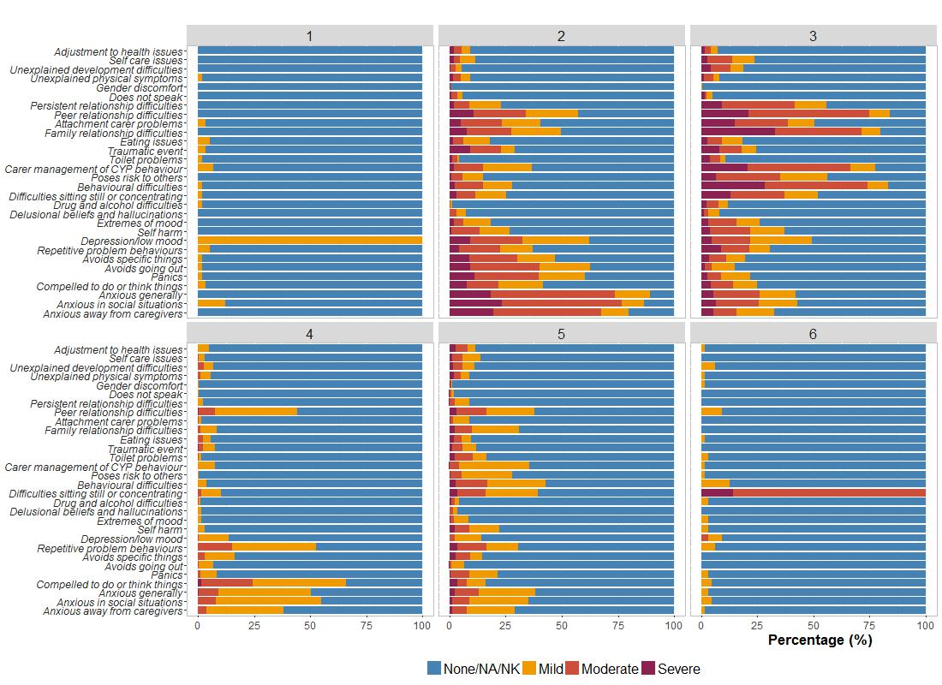

Figure S4b: k-medoids cluster analysis: 26-cluster solution, clusters 7-12
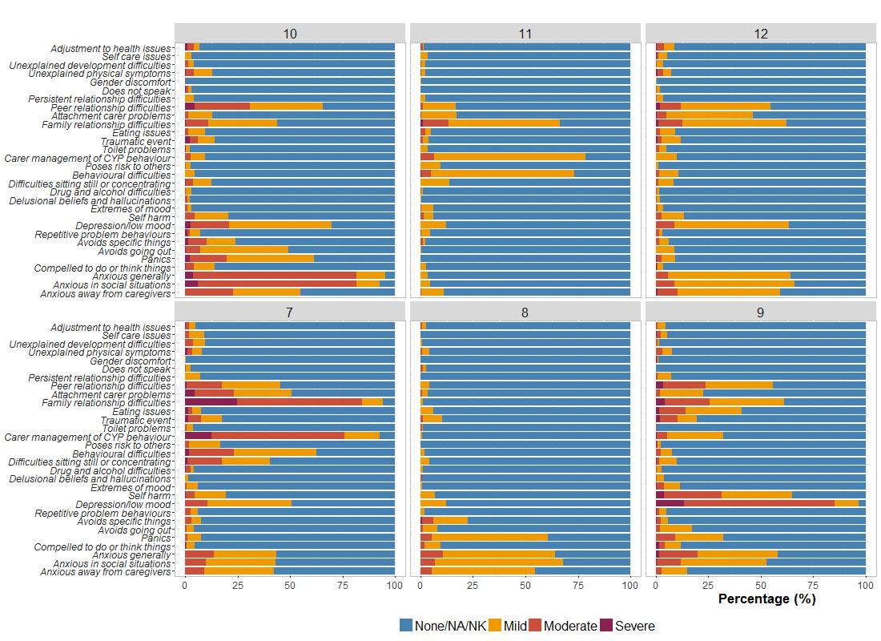
Figure S4c: k-medoids cluster analysis: 26-cluster solution, clusters 13-18
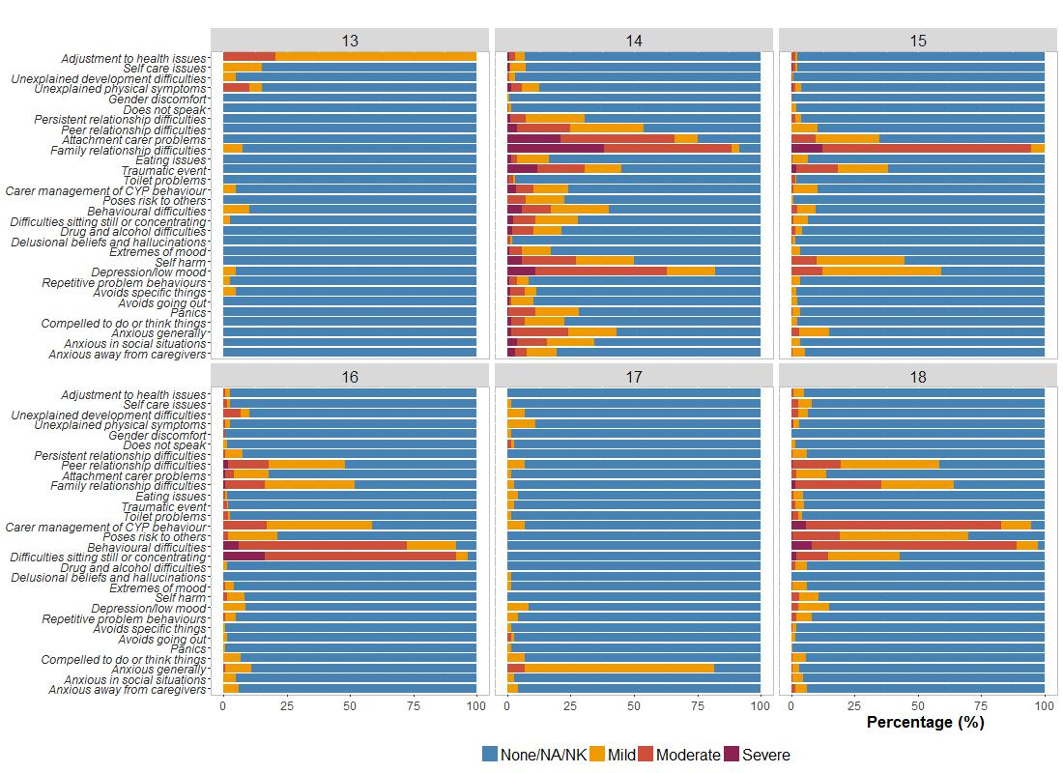
Figure S4d: k-medoids cluster analysis: 26-cluster solution, clusters 19-24
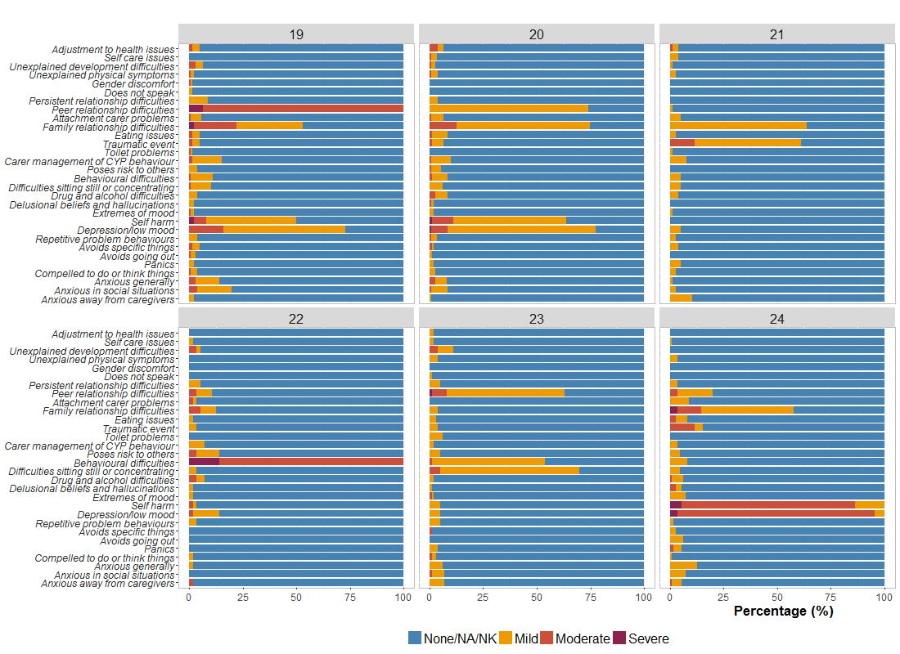
Figure S4e: k-medoids cluster analysis: 26-cluster solution, clusters 25-26
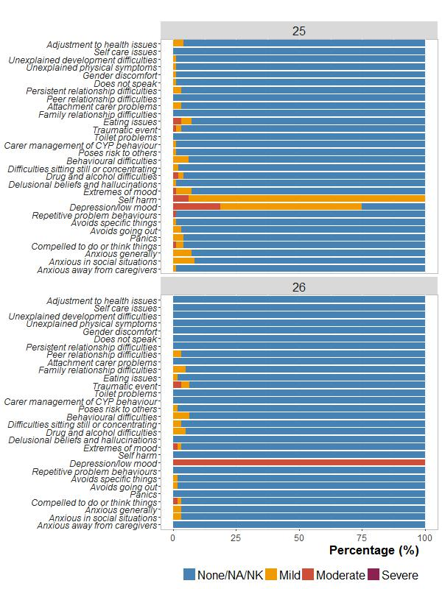
df

Table S4: Model Comparison via Crossvalidation: Testing five classifications on ten random split-half test samples of the Analysis Data Set
 | Log-likelihood | Parameters | AIC | BIC
Test sample 1  K-MEDOIDS: 6 Clusters  K-MEDOIDS: 26 Clusters  REGRESSION TREE: Traditional R²  REGRESSION TREE: Outlier-resistant R²  Conceptual Classification | -5343.45  -5310.49  -5329.78  -5324.95  -5301.99 | 9  29  10  19  20 | 10704.90  10678.98  10679.56  10687.42  10643.98 | 10756.30  10844.61  10736.68  10796.42  10758.21
Test sample 2  K-MEDOIDS: 6 Clusters  K-MEDOIDS: 26 Clusters  REGRESSION TREE: Traditional R²  REGRESSION TREE: Outlier-resistant R²  Conceptual Classification | -5395.81  -5370.37  -5382.21  -5375.53  -5371.55 | 9  29  11  17  20 | 10809.62  10798.74  10786.42  10785.06  10783.10 | 10861.02  10964.37  10849.25  10882.16  10897.33
Test sample 3  K-MEDOIDS: 6 Clusters  K-MEDOIDS: 26 Clusters  REGRESSION TREE: Traditional R²  REGRESSION TREE: Outlier-resistant R²  Conceptual Classification | -5389.30  -5362.93  *  -5378.45  -5363.37 | 9  29  *  14  20 | 10796.60  10783.86  *  10784.90  10766.74 | 10848.00  10949.49  *  10864.86  10880.97
Test sample 4  K-MEDOIDS: 6 Clusters  K-MEDOIDS: 26 Clusters  REGRESSION TREE: Traditional R²  REGRESSION TREE: Outlier-resistant R²  Conceptual Classification | -5324.65  -5298.92  -5327.07  -5311.88  -5292.57 | 9  29  9  22  20 | 10667.30  10655.84  10672.14  10667.76  10625.14 | 10718.70  10821.47  10723.54  10793.41  10739.37
Test sample 5  K-MEDOIDS: 6 Clusters  K-MEDOIDS: 26 Clusters  REGRESSION TREE: Traditional R²  REGRESSION TREE: Outlier-resistant R²  Conceptual Classification | -5338.20  -5310.89  -5314.40  -5304.63  5294.28 | 9  29  10  16  20 | 10694.40  10679.78  10648.80  10641.26  10628.56 | 10745.80  10845.41  10705.92  10732.64  10742.72
Test sample 6  K-MEDOIDS: 6 Clusters  K-MEDOIDS: 26 Clusters  REGRESSION TREE: Traditional R²  REGRESSION TREE: Outlier-resistant R²  Conceptual Classification | -5396.11  -5359.44  -5373.93  -5371.72  -5365.02 | 9  29  12  20  20 | 10810.22  10776.88  10771.86  10783.44  10770.04 | 10861.62  10942.51  10840.40  10897.67  10884.27
Test sample 7  K-MEDOIDS: 6 Clusters  K-MEDOIDS: 26 Clusters  REGRESSION TREE: Traditional R²  REGRESSION TREE: Outlier-resistant R²  Conceptual Classification | -5316.80  -5291.94  -5312.25  -5311.78  -5298.92 | 9  29  20  22  20 | 10651.60  10641.88  10664.50  10667.56  10637.84 | 10703.00  10807.51  10778.73  10793.21  10752.07
Test sample 8  K-MEDOIDS: 6 Clusters  K-MEDOIDS: 26 Clusters  REGRESSION TREE: Traditional R²  REGRESSION TREE: Outlier-resistant R²  Conceptual Classification | -5340.72  -5317.20  -5334.34  -5331.00  -5315.32 | 9  29  13  20  20 | 10699.44  10692.40  10768.93  10816.23  10670.64 | 10750.84  10858.03  10768.93  10816.23  10784.87
Test sample 9  K-MEDOIDS: 6 Clusters  K-MEDOIDS: 26 Clusters  REGRESSION TREE: Traditional R²  REGRESSION TREE: Outlier-resistant R²  Conceptual Classification | -5432.39  -5394.28  -5419.21  -5407.37  -5390.77 | 9  29  9  20  20 | 10858.03  10846.56  10856.42  10854.74  10821.54 | 10934.18  11012.19  10907.82  10968.97  10935.77
Test sample 10  K-MEDOIDS: 6 Clusters  K-MEDOIDS: 26 Clusters  REGRESSION TREE: Traditional R²  REGRESSION TREE: Outlier-resistant R²  Conceptual Classification | -5349.74  -5314.81  -5325.80  -5313.22  5315.93 | 9  29  8  24  20 | 10717.48  10687.62  10667.60  10674.44  10671.86 | 10768.88  10853.25  10713.29  10811.52  10786.09
Note: AIC: Akaike Information Criterion. BIC: Bayesian Information Criterion. * Model did not converge. The smallest (i.e., best) AIC and BIC within each test sample are printed in bold.

