Supplementary Methods
Data Collection
Data were collected for listing date, patient demographics (age, gender, ethnicity, body mass index); etiology of cirrhosis, liver disease complications (ascites, hepatic encephalopathy, varices, and hepatocellular carcinoma), preexisting chronic kidney disease (CKD), listing Model for End Stage Liver Disease (MELD) score, platelet count, serum sodium, and bilirubin. Ascites was stratified to mild to moderate and refractory, with the latter defined based on frequent need for paracentesis or for transjugular intrahepatic portosystemic shunt for managing the ascites. Glomerular filtration rate (GFR) calculated by the Modified Diet in Renal Disease (MDRD)-6 equation was calculated at listing and on follow up every 3 months until removal from LT list. Data were also captured for use of beta blockers and of statins (both at the time of listing and at the time of development of AKI). For patients developing AKI, data were recorded for date of AKI, MDRD-6 at onset of AKI, AKI etiology (prerenal, intrarenal, HRS, or postrenal), treatment received for AKI, outcome from AKI. For patients needing hospital admission for AKI episode, data were collected for duration of hospitalization with number of days in intensive care unit and need for hemodialysis. Data were captured for recurrent AKI among patients surviving the first episode of AKI without receiving LT, with maximum of three separate episodes recorded for each patient. Data were collected on date and type of LT for patients removed from the list due to receipt of LT. Of the prospective cohort providing urine and serum samples and receiving LT, patients were followed until six months for assessment of MDRD-6 and for immune suppression used in the post-transplant period.
Definitions
Acute Kidney Injury: increase in serum creatinine of > 50% from baseline and/or a rise of serum creatinine by > 0.3 mg/dL from the baseline serum creatinine within the past three months in the outpatient setting or from the admission creatinine in the inpatient setting (1). Recovery from AKI was defined with serum creatinine decreasing to baseline value or an absolute value < 1.5 mg/dL, and this value was considered as baseline for defining the subsequent episodes of AKI.
Etiology of Acute Kidney Injury: If the AKI rapidly reversed with volume expansion and withholding diuretics for 48 to 72 hours, the AKI episode was classified as volume responsive prerenal. Post-renal AKI was diagnosed based on renal ultrasonography findings showing obstructive uropathy. If a given AKI episode was not volume responsive and renal ultrasound was normal, the distinction between HRS and intra-renal etiology such as ATN was determined using results of urinalysis, urine sodium, and clinical course of the patient based on standard criteria on diagnosis of HRS (1). All the HRS patients in the study had type 1 HRS defined as rapid rise in serum creatinine over a 2 week period.
Chronic Kidney Disease: MDRD-6 <60 mL/min for>3 months or structural kidney changes on imaging or MDRD-6 <60 in the presence of proteinuria and chronic comorbidities such as diabetes and/or hypertension (2).
Modified Diet for Renal Disease-6: This equation in addition to age, gender, race, and serum creatinine incorporates blood urea nitrogen and serum albumin for calculating the glomerular filtration rate (3). This equation is most accurate in patients with liver cirrhosis and closely approximates GFR measurement using ¹²⁵Iothalamate clearance (3).
Model for End-stage Liver Disease score: was calculated using the standard equation incorporating serum creatinine (mg/dL), total serum bilirubin (mg/dL), and International Normalized Ratio (INR) (4).
Biomarker Assays and Measurements
Urine sample after centrifugation at 1000 rpm and serum separated from the blood sample were stored at -80 degree Celsius. Serum samples were analyzed for NGAL and HE-1 and levels expressed as pg/ml. Urine samples were analyzed for NGAL, Albumin, beta-2 microglobulin, cystatin C, EGF, Osteopontin (OPN), UMOD, IL-18, KIM-1, and FABP using the multiplex kit. The levels of biomarkers in urine were expressed as pg/mg creatinine. ELISA assays were used for measuring HE-1 and FABP2. MSD (Meso Scale Discovery using the electrochemiluminiscent detection technology) assays were used for measuring albumin, beta-2 microglbulin (β2M), Cystatin C, EGF, NGAL, Osteopontin (OPN), UMOD, KIM-1, and IL-18.
For HE-1, the standard curve was set at 25 pg/ml as maximum and 0.390625 pg/ml as the minimum value. Samples were run with no dilution and read at 450 nanometers. The samples were read again at 540 nanometers and the resultant values subtracted from the values generated at 450 nanometers. This was done to correct any optical imperfections in the plate. For FABP, the standard curve was set with 100ng/ml as the maximum value and 0.024414ng/ml as the minimum value. Samples were diluted 2-fold and read at 450 nanometers. For albumin, the standard curve was set with 248026.9pg/ml as the maximum value and 119.2239pg/ml as the minimum value. Samples were diluted 100-fold and read on the sector imager. For B2M, the standard curve was set with 21833.09pg/ml as the maximum value and 7.366163pg/ml as the minimum value. Samples were diluted 100-fold and read on the Sector Imager. For Cystatin C, the standard curve was set with 47311.34pg/ml as the maximum value and 14.43126pg/ml as the minimum value. Samples were diluted 100-fold and read on the sector imager. For EGF, the standard curve was set with 2590.239pg/ml as the maximum value and 0.245213pg/ml as the minimum value. Samples were diluted 100-fold and read on the sector imager. For NGAL, The standard curve was set with 12691.88pg/ml as the maximum value and 0.163943pg/ml as the minimum value. Samples were diluted 100-fold and read on the sector imager. For OPN, the standard curve was set with 112665.4pg/ml as the maximum value and 31.11073pg/ml as the minimum value. Samples were diluted 100-fold and read on the sector imager. For UMOD, the standard curve was set with 114137.7pg/ml as the maximum value and 24.85023pg/ml as the minimum value. Samples were diluted 100-fold and read on the sector imager. For Kim-1, the standard curve was set with 19915.33pg/ml as the maximum value and 5.082271pg/ml as the minimum value. Samples were diluted 10-fold and read on the sector imager. For IL-18, the standard curve was set with 2507.229pg/ml as the maximum value and 0.61102pg/ml as the minimum value. Samples were diluted 5-fold and read on the sector image.
Statistical Analyses
Categorical variables are reported as proportions and continuous variables as mean with standard deviation or as median with corresponding interquartile range. Baseline characteristics of patients with AKI were compared with those without AKI using chi-square test for categorical variables, which are reported as proportions) and student’s t-test for continuous variables, which are reported as mean with standard deviation or median with interquartile range. Cox proportional hazard regression analysis model was built to derive independent predictors for development of AKI. These data are reported as hazard ratio (HR) with 95% confidence interval (95% CI). Variables different at baseline comparing AKI vs. without AKI and any clinically relevant variables were entered in the model. Kaplan Meier curves were obtained on one year cumulative probability of AKI and on cumulative one year waitlist mortality comparing patients with and without AKI. To determine the cumulative probabilities, data were censored at the time of development of AKI, patient mortality, receipt of LT, or data cut-off date of December 2015. Cox proportional hazard regression model was also built to assess independent impact of AKI on patient survival, with the results presented as HR (95% CI).
On the prospective cohort providing biomarker data, serum and urine biomarkers levels are presented as median with interquartile range. Between-group differences were graphically presented using box-and-whisker plots. Differences were evaluated using the Mann-Whitney U-test. We first evaluated differences in the baseline biomarker measurements between subjects whose MDRD-6 >30 compared to those with baseline MDRD-6 ≤30, followed by the same comparison among observations with AKI. We also compared the AKI type among patients developing AKI. In order to identify potential biomarkers associated with renal function recovery at 6 months, we analyzed the subset of transplanted individuals who had baseline MDRD-6 <30. Recovery at 6 months was defined for these individuals as having a 6 month MDRD-6 > 50. P-values less than 0.05 were considered statistically significant. Given overall small sample size, we also noted comparisons with P-values less than 0.1 as suggestive of between-group differences. All statistical analyses were performed using the statistical analysis software SAS 9.4 (Cary, NC).

Supplementary Table 1 Baseline characteristics of the study population for all patients in the study, for patients receiving liver transplant alone (after excluding three simultaneous liver kidney*), and for patients receiving LT alone and urine or serum sample available within a month before LT
 | All patients (N=70) | All patients receiving LT* (N=43) | Sample within 30 days of LT (N=24)
Age in years, Mean (SD) | 57.7 (9.8) | 56.8 (11.3) | 54 (13.7)
Males N (%) | 38 (54) | 23 (53) | 13 (54)
Caucasians N (%) | 59 (84) | 36 (84) | 20 (83)
Diabetes mellitus N (%) | 34 (49) | 18 (42) | 7 (29)
Hypertension N (%) | 32 (46) | 23 (53) | 14 (58)
Chronic kidney disease N (%) | 34 (49) | 19 (44) | 9 (38)
Pre transplant hemodialysis N (%) | 8 (11) | 1 (2) | 0 (0)
Mortality N (%) | 25 (36) | 6 (14) | 4 (17)
Number of prior admissions, Median (IQR) | 2 (0-10) | 2 (0-10) | 2.5 (1-10)
Baseline MDRD-6, Median (IQR) | 37 (13-141) | 40 (13-136) | 32 (13-117)
IQR: Interquartile range; MDRD: Modified diet for renal disease

Supplementary Table 2 Cox proportion hazard regression analysis to determine predictors of acute kidney injury development over one year from listing
 | HR (95% CI)* | P | HR (95% CI)** | P
Listing age ↑ by 5 years | 1.11 (0.95-1.30) | 0.19 | 1.14 (0.99-1.32) | 0.07
% Males | 0.98 (0.62-1.62) | 0.98 | 1.11 (0.72-1.70) | 0.64
Pre-existing CKD | 1.19 (0.70-2.02) | 0.52 | 1.10 (0.65-1.85) | 0.74
Diabetes | 0.88 (0.48-1.63) | 0.68 | 0.93 (0.53-1.64) | 0.81
Beta blockers | 0.86 (0.53-1.40) | 0.55 | 0.87 (0.57-1.33) | 0.52
Statins | 1.02 (0.35-2.97) | 0.97 | 1.14 (0.42-3.11) | 0.79
BMI≥30 vs. <25 | 0.90 (0.49-1.66) | 0.73 | 0.85 (0.45-1.73) | 0.70
BMI≥35 vs. <25 | 0.56 (0.27-1.15) | 0.11 | 0.45 (0.20-1.35) | 0.15
Mild to moderate ascites vs. no ascites | 0.94 (0.47-1.90) | 0.86 | 1.01 (0.54-1.87) | 0.98
Refractory vs. no ascites | 1.18 (0.59-2.35) | 0.65 | 1.19 (0.63-2.24) | 0.60
Listing platelets | 0.999 (0.995-1.003) | 0.63 | 0.999 (0.996-1.003) | 0.65
Listing sodium | 0.91 (0.86-0.96) | 0.0003 | 0.94 (0.89-0.99) | 0.02
Listing MELD ↑ by 3 points | 1.39 (1.26-1.54) | <0.0001 | N/A
MELD<15 (N=76) | N/A |  | 1.0 (1.0-1.0) | Ref.
16-20 (N=89) | N/A |  | 1.46 (0.87-2.44) | 0.15
21-25 (N=27) | N/A |  | 3.35 (1.73-6.50) | 0.0003
26-30 (N=16) | N/A |  | 3.99 (1.67-9.52) | 0.002
>30 (N=24) | N/A |  | 12.23 (5.53-27.1) | <0.0001
*Model with MELD score as continuous variable
** Model with MELD score as categorical variable
Supplementary Table 3 Cox proportional hazard regression analysis model to determine predictors of waitlist mortality at one year from listing for liver transplantation
 | Hazard Ratio | 95% Confidence Interval | P
AKI vs. No AKI | 2.27 | 1.28-4.02 | 0.005
Age at listing | 1.02 | 0.98-1.05 | 0.36
Females | 1.07 | 0.61-1.87 | 0.82
Diabetes Mellitus | 1.23 | 0.70-1.28 | 0.67
Obesity | 1.54 | 0.88-2.70 | 0.13
Listing MELD score | 1.08 | 1.06-1.12 | <0.0001
AKI: Acute Kidney Injury; MELD=Model for End-stage Liver Disease

Supplementary Table 4 Biomarkers levels in serum (pg/ml) and in urine (pg/mg creatinine) comparing samples with MDRD-6 >30 vs. samples with MDRD-6 ≤ 30.
 | MDRD-6 > 30 (N=88) |  |  |  | MDRD-6 ≤ 30 (N=34)
 | N | Median | 1st quartile | 3rd quartile | N | Median | 1st quartile | 3rd quartile | P
Serum Biomarkers (pg/mL)
NGAL | 85 | 174,328 | 94,717 | 306,029 | 34 | 296,316 | 116,702 | 446,379 | 0.038
HE-1 | 85 | 4.13 | 2.81 | 5.87 | 34 | 5.40 | 4.13 | 8.57 | 0.004
Urine Biomarkers (pg/mg creatinine)
Albumin | 75 | 3,606,006 | 1,229,868 | 10,485,329 | 26 | 7,123,995 | 1,209,304 | 18,298,660 | 0.393
Β-2 microglobulin | 75 | 43,266 | 7,460 | 195,296 | 26 | 15,555 | 3,468 | 77,439 | 0.174
Cystatin C | 75 | 23,875 | 8,784 | 66,967 | 26 | 19,945 | 8,844 | 167,771 | 0.957
EGF | 75 | 4,218 | 2,279 | 6,938 | 26 | 2,949 | 1,165 | 4,983 | 0.042
NGAL | 75 | 47,893 | 13,713 | 158,660 | 26 | 43,088 | 17,588 | 149,689 | 0.923
Osteopontin | 75 | 441,917 | 187,445 | 854,445 | 26 | 385,219 | 129,306 | 830,838 | 0.493
Uromodulin | 75 | 2,608,006 | 1,145,555 | 5,236,253 | 26 | 2,049,076 | 1,060,452 | 3,001,765 | 0.340
Interleukin-18 | 75 | 6.85 | 1.19 | 36.50 | 26 | 2.43 | 0.74 | 6.83 | 0.041
KIM-1 | 75 | 1,071 | 376 | 2,390 | 26 | 1,272 | 469 | 3,167 | 0.437
HE-1 | 73 | 0.55 | 0.21 | 1.31 | 26 | 0.50 | 0.19 | 2.38 | 0.736
FABP-2 | 41 | 0.10 | 0.03 | 1.99 | 16 | 0.45 | 0.14 | 2.82 | 0.229
MDRD-6 | 88 | 51 | 41 | 69 | 34 | 23 | 19 | 28 | <0.001
NGAL: Neutrophil gelatinase-associated lipocalin; EGF: Epidermal growth factor; KIM: Kidney injury molecule; HE: Human endothelin; FABP: Fatty acid binding protein; MDRD: Modified diet for renal disease

Supplementary Table 5 Biomarkers levels in serum (pg/ml) and in urine (pg/mg creatinine) samples comparing without vs. with chronic kidney disease at the time of sample collection.
 | No CKD (N=72 ) |  |  |  | CKD (N=62)
 | N | Median | 1st quartile | 3rd quartile | N | Median | 1st quartile | 3rd quartile | P
Serum Biomarkers (pg/ml)
NGAL | 70 | 162,437 | 86,960 | 357,090 | 61 | 211,613 | 151,343 | 339,747 | 0.098
HE-1 | 70 | 4.54 | 2.85 | 7.03 | 61 | 4.23 | 2.88 | 6.19 | 0.672
Urine Biomarkers (pg/mg creatinine)
Albumin | 61 | 2,864,499 | 1,241,857 | 8,614,056 | 50 | 5,821,201 | 1,127,193 | 18,298,661 | 0.058
Β-2 microglobulin | 61 | 22,053 | 7,460 | 165,521 | 50 | 47,513 | 5,302 | 143,138 | 0.793
Cystatin C | 61 | 26,162 | 8,840 | 77,600 | 50 | 19,895 | 8,802 | 66,967 | 0.606
EGF | 61 | 4,600 | 1,800 | 11,435 | 50 | 3,057 | 1,765 | 4,530 | 0.013
NGAL | 61 | 43,837 | 12,396 | 158,660 | 50 | 50,664 | 21,634 | 159,260 | 0.298
Osteopontin | 61 | 429,939 | 153,846 | 854,445 | 50 | 444,304 | 209,451 | 785,382 | 0.716
Uromodulin | 61 | 2,191,388 | 823,544 | 5,409,453 | 50 | 2,474,616 | 1,383,703 | 4,825,843 | 0.518
Interleukin-18 | 61 | 3.09 | 0.74 | 21.68 | 50 | 5.85 | 1.72 | 17.68 | 0.399
KIM-1 | 61 | 829 | 310 | 2,576 | 50 | 1,295 | 482 | 3,167 | 0.341
HE-1 | 59 | 0.45 | 0.20 | 0.89 | 50 | 0.52 | 0.18 | 1.49 | 0.714
FABP-2 | 32 | 0.11 | 0.04 | 1.43 | 30 | 0.55 | 0.05 | 1.39 | 0.223
MDRD-6 | 66 | 51 | 37 | 70 | 56 | 34 | 27 | 45 | <0.001
NGAL: Neutrophil gelatinase-associated lipocalin; EGF: Epidermal growth factor; KIM: Kidney injury molecule; HE: Human endothelin; FABP: Fatty acid binding protein; MDRD: Modified diet for renal disease

Supplementary Table 6 Pre-transplant characteristics, use of calcineurin inhibitors, and recovery of renal function (MDRD-6 >50 mL/min. at six months after transplantation) among 15 patients with MDRD-6 <30 mL/min. and available serum and/or urine sample within a month prior to transplantation
No. | Age | Gender | CKD | DM | Pre-LT GFR | GFR at 6 months | CNI | Recovery
1 | 66 | F | 0 | 1 | 23.3 | 58.9 | 1 | 1
2 | 20 | F | 1 | 0 | 24.6 | 150.3 | 1 | 1
3 | 64 | M | 1 | 0 | 16.5 | 37.1 | 1 | 0
4 | 56 | M | 0 | 1 | 27.9 | 36.0 | 1 | 0
5 | 71 | M | 1 | 0 | 27.7 | 28.5 | 1 | 0
6 | 38 | F | 0 | 0 | 19.5 | 95.6 | 1 | 1
7 | 42 | F | 0 | 0 | 16.7 | 162.4 | 1 | 1
8 | 68 | M | 1 | 0 | 12.9 | 29.4 | 1 | 0
9 | 62 | M | 0 | 1 | 26.8 | 54.9 | 1 | 1
10 | 71 | M | 1 | 0 | 23.0 | 28.5 | 1 | 0
11 | 38 | M | 0 | 0 | 21.2 | 38.6 | 1 | 0
12 | 73 | M | 1 | 0 | 28.5 | 50.0 | 1 | 0
13 | 64 | M | 1 | 0 | 26.2 | 42.2 | 1 | 0
14 | 53 | M | 1 | 1 | 28.8 | 48.4 | 1 | 0
15 | 56 | M | 1 | 1 | 29.7 | 32.9 | 1 | 0

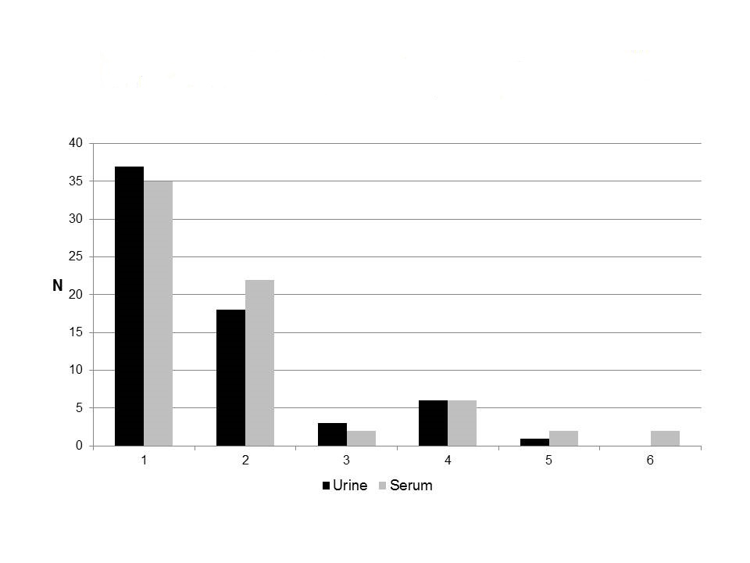
Supplementary Figure 1 Number of patients providing 1, 2, 3, 4, 5, or 6 urine (black bars) or serum (gray bars) from the time of recruitment to the study until removal from the transplant list.

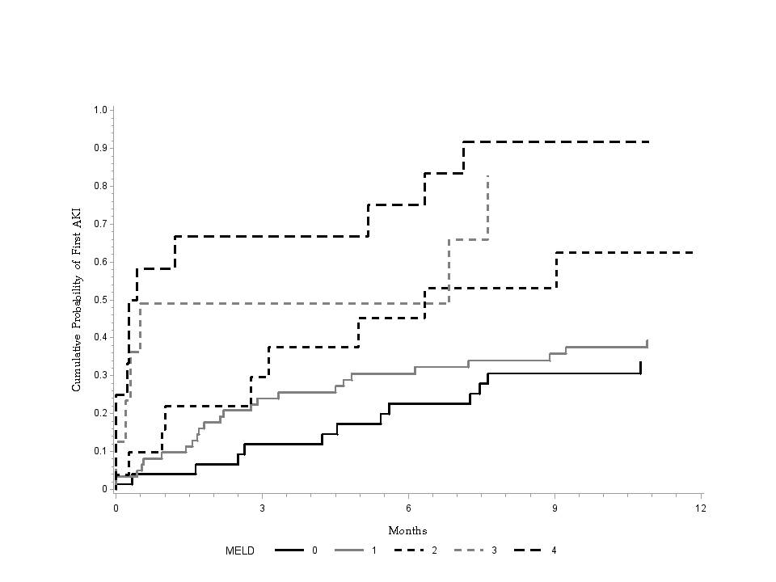

Supplementary Figure 2 Cumulative probability of development of acute kidney injury at one year from listing for liver transplantation, stratified for MELD score at listing. One year cumulative probability of AKI increased linearly with listing MELD score with 31.9% at listing MELD ≤15 (solid black line, N=95), 42.8% at listing MELD 16-20 (solid gray line, N=100), 73.7% at listing MELD 21-25 (dashed black line, N=33), 72.8% at listing MELD 26-30 (dashed gray line, N=19), and 91.7% at listing MELD >30 (top line, N=24).

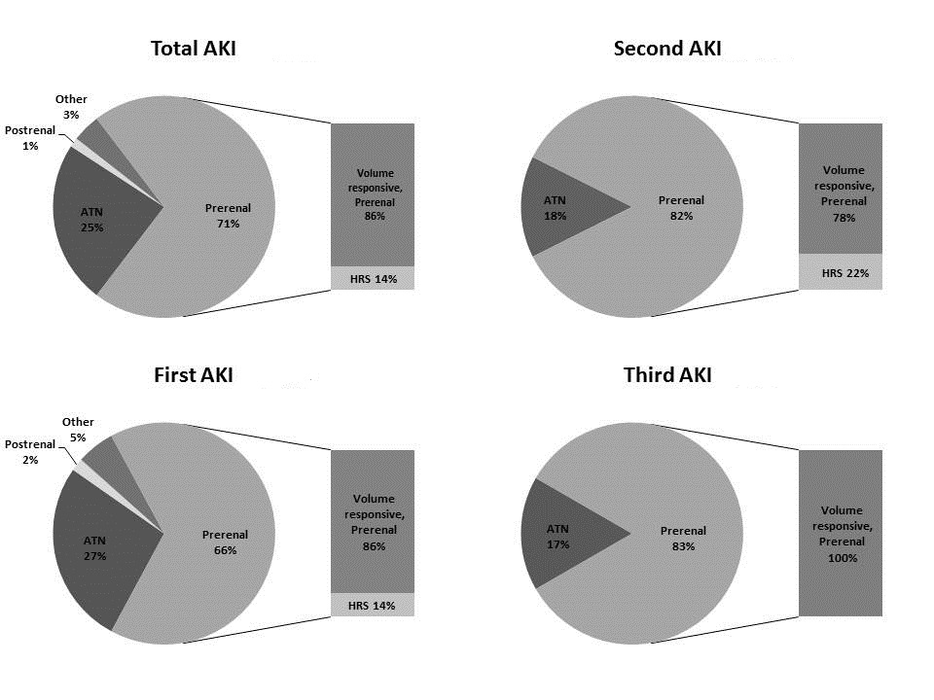

Supplementary Figure 3 Adjudication of cause of acute kidney injury (AKI) among all episodes (top left panel), first episode of AKI (bottom left panel), second AKI episode (top right panel), and third AKI episode (bottom right panel).

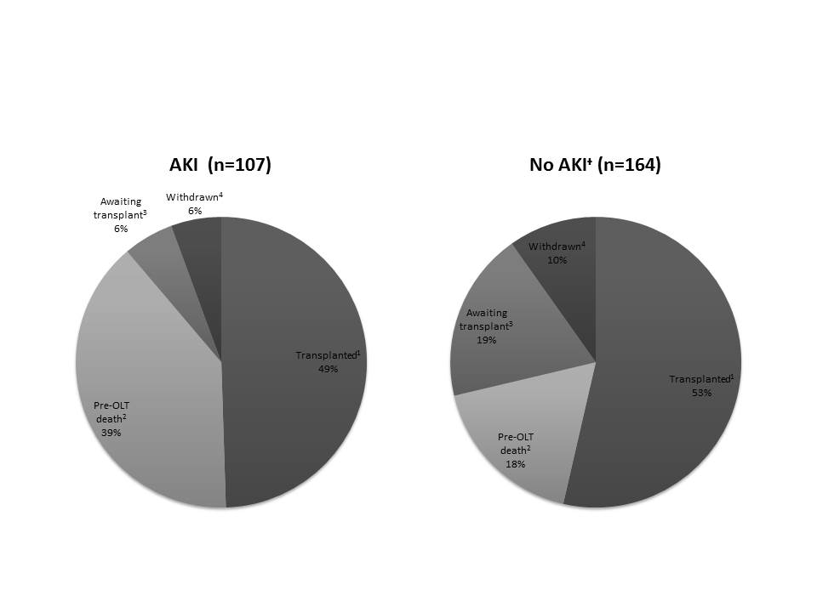

Supplementary Figure 4 Reasons for removal from the transplant list among 107 patients developing acute kidney injury, AKI (left panel) and 164 patients without acute kidney injury (right panel). The results show that patients developing AKI compared to without AKI have higher waitlist mortality and similar transplant rate. At the end of study period, proportion of patients still on the waitlist awaiting transplant was lower for patients with AKI.

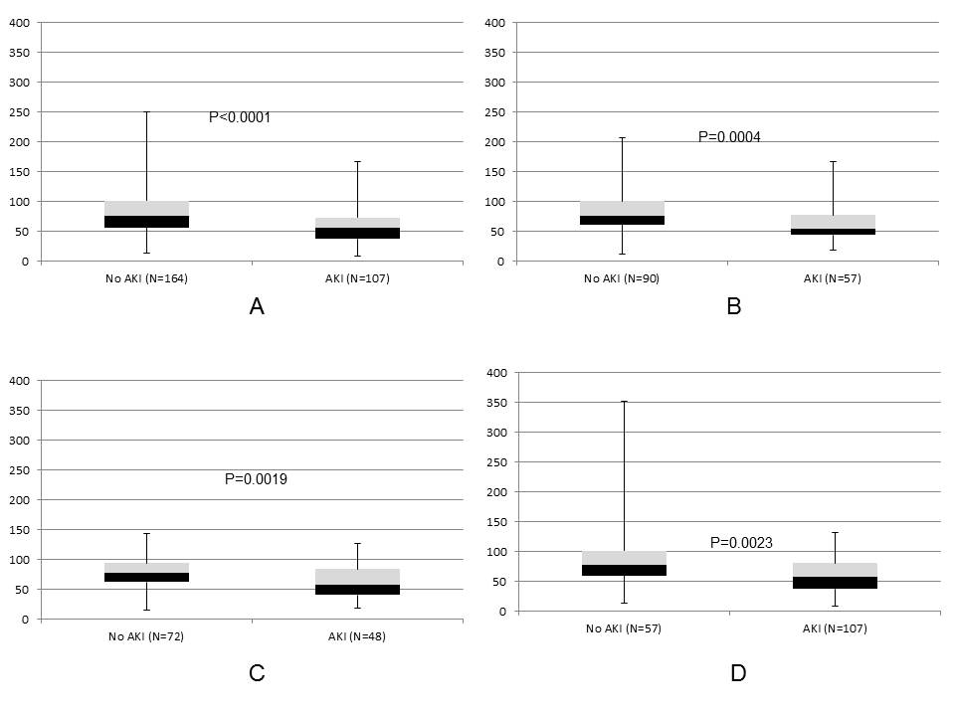

Supplementary Figure 5 Box whisker plots showing modified diet for renal disease-6 glomerular filtration rate (mL/min) at the time of listing (panel A), at 3 months from listing (panel B), at 6 months from listing (panel C), and at 12 months from listing (panel D).

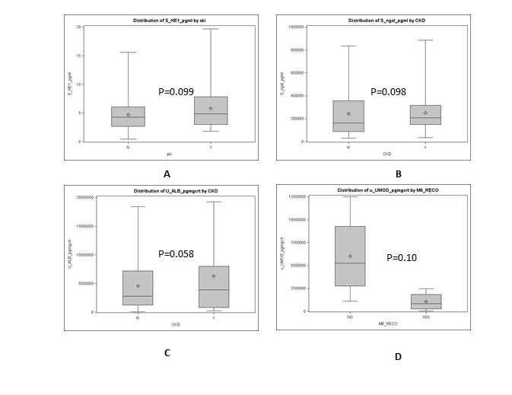

Supplementary Figure 6 Box whisker plots comparing samples without acute kidney injury vs. samples with acute kidney injury for A) serum HE-1 B) serum NGAL; comparing samples without chronic kidney disease vs. with chronic kidney disease for C) urinary albumin; and D) urinary uromodulin within a month prior to liver transplantation, comparing 5 patients without recovery of renal function vs. 10 patients, who recovered their renal function at six months after receiving liver transplant alone. For this analysis, recovery is defined as MDRD-6 >50 mL/min at 6 months after transplant among patients with MDRD-6 <30 mL/min before transplantation.

Supplementary References
1. Angeli P, Gines P, Wong F, Bernardi M, Boyer TD, Gerbes A, Moreau R, Jalan R, Sarin SK, Piano S, Moore K, Lee SS, Durand F, Salerno F, Caraceni P, Kim WR, Arroyo V, Garcia-Tsao G, International Club of A: Diagnosis and management of acute kidney injury in patients with cirrhosis: revised consensus recommendations of the International Club of Ascites. Gut, 64: 531-537, 2015
2. Levey AS, Coresh J, Balk E, Kausz AT, Levin A, Steffes MW, Hogg RJ, Perrone RD, Lau J, Eknoyan G, National Kidney F: National Kidney Foundation practice guidelines for chronic kidney disease: evaluation, classification, and stratification. Annals of internal medicine, 139: 137-147, 2003
3. Francoz C, Nadim MK, Baron A, Prie D, Antoine C, Belghiti J, Valla D, Moreau R, Durand F: Glomerular filtration rate equations for liver-kidney transplantation in patients with cirrhosis: validation of current recommendations. Hepatology, 59: 1514-1521, 2014
4. Wiesner RH, McDiarmid SV, Kamath PS, Edwards EB, Malinchoc M, Kremers WK, Krom RA, Kim WR: MELD and PELD: application of survival models to liver allocation. Liver transplantation : official publication of the American Association for the Study of Liver Diseases and the International Liver Transplantation Society, 7: 567-580, 2001

