ONLINE-ONLY SUPPLEMENTAL MATERIALS
Table 1. Patient Enrollment in RECAP
Study Location, n (%) | Total  (N = 1058)
CAPACITY 2 (PIPF-004) | 335 (31.7)
United States | 220 (20.8)
Rest of world | 115 (10.9)
CAPACITY 1 (PIPF-006) | 268 (25.3)
United States | 229 (21.6)
Rest of world | 39 (3.7)
ASCEND (PIPF-016) | 455 (43.0)
United States | 310 (29.3)
Rest of world | 145 (13.7)
ASCEND, Assessment of Pirfenidone to Confirm Efficacy and Safety in Idiopathic Pulmonary Fibrosis; CAPACITY, Clinical Studies Assessing Pirfenidone in Idiopathic Pulmonary Fibrosis: Research of Efficacy and Safety Outcomes.

Table 2. Summary of ADRs With Incidence in ≥ 5% of Patients in RECAP Compared With Pirfenidone-Treated Patients in the CAPACITY 004/006 and ASCEND Trials
ADR, n (%)* | RECAP |  |  | CAPACITY 004/006 and ASCEND
 | Total  (N = 1058) | Adjusted rate* |  | Total  (N = 623) | Adjusted rate†
 |  | No. of Events | Rate per 100 PEY  (2482 PEY) |  | No. of Events | Rate per 100 PEY  (735.7 PEY)
Total | 786 (74.3) | 3318 | 133.7 | 556 (89.2) | 3081 | 418.8
Nausea | 229 (21.6) | 289 | 11.6 | 202 (32.4) | 284 | 38.6
Diarrhea | 130 (12.3) | 171 | 6.9 | 117 (18.8) | 191 | 26.0
Rash | 123 (11.6) | 179 | 7.2 | 163 (26.2) | 245 | 33.3
Dyspepsia | 92 (8.7) | 106 | 4.3 | 100 (16.1) | 120 | 16.3
Fatigue | 90 (8.5) | 102 | 4.1 | 115 (18.5) | 156 | 21.2
Anorexia | 81 (7.7) | 88 | 3.5 | 71 (11.4) | 75 | 10.2
Photosensitivity reaction | 75 (7.1) | 99 | 4.0 | 58 (9.3) | 84 | 11.4
Dizziness | 66 (6.2) | 82 | 3.3 | 56 (9.0) | 73 | 9.9
Gastroesophageal reflux disease | 66 (6.2) | 73 | 2.9 | 46 (7.4) | 52 | 7.1
Decreased appetite | 64 (6.0) | 68 | 2.7 | 46 (7.4) | 50 | 6.8
Headache | 53 (5.0) | 70 | 2.8 | 63 (10.1) | 84 | 11.4
ASCEND, Assessment of Pirfenidone to Confirm Efficacy and Safety in Idiopathic Pulmonary Fibrosis; ADR, adverse drug reaction; CAPACITY, Clinical Studies Assessing Pirfenidone in Idiopathic Pulmonary Fibrosis: Research of Efficacy and Safety Outcomes; PEY, patient-exposure year.
* AE considered possibly or probably related to pirfenidone by the investigator.
† Adjusted rate per 100 PEY = (total number of events/total years of exposure) × 100.
Table 3. Summary of ADRs That Led to Discontinuation
ADR, n (%)* | Total  (N = 1058) | Adjusted Rate†
 |  | No. of Events | Rate per 100 PEY  (2482 PEY)
Total | 120 (11.3) | 120 | 4.8
Rash | 12 (1.1) | 12 | 0.5
Nausea | 11 (1.0) | 11 | 0.4
IPF | 5 (0.5) | 5 | 0.2
Weight decrease | 5 (0.5) | 5 | 0.2
Decreased appetite | 4 (0.4) | 4 | 0.2
Ovarian cancer recurrent‡ | 1 (0.4) | 1 | < 0.1
Abdominal discomfort | 3 (0.3) | 3 | 0.1
Asthenia | 3 (0.3) | 3 | 0.1
Diarrhea | 3 (0.3) | 3 | 0.1
Dyspepsia | 3 (0.3) | 3 | 0.1
Fatigue | 3 (0.3) | 3 | 0.1
Electrocardiogram QT prolonged | 3 (0.3) | 3 | 0.1
Gastroesophageal reflux disease | 3 (0.3) | 3 | 0.1
Hepatic enzyme increase | 3 (0.3) | 3 | 0.1
Liver function test abnormal | 3 (0.3) | 3 | 0.1
Rash generalized | 3 (0.3) | 3 | 0.1
Abdominal pain | 2 (0.2) | 2 | 0.1
Acute respiratory failure | 2 (0.2) | 2 | 0.1
Anorexia | 2 (0.2) | 2 | 0.1
Erythema | 2 (0.2) | 2 | 0.1
Malaise | 2 (0.2) | 2 | 0.1
Photosensitivity reaction | 2 (0.2) | 2 | 0.1
Pneumonia | 2 (0.2) | 2 | 0.1
Rash erythematous | 2 (0.2) | 2 | 0.1
Benign prostatic hyperplasia§ | 1 (0.1) | 1 | < 0.1
Abdominal distension | 1 (0.1) | 1 | < 0.1
Abdominal pain upper | 1 (0.1) | 1 | < 0.1
Blood creatine phosphokinase increase | 1 (0.1) | 1 | < 0.1
Burning sensation | 1 (0.1) | 1 | < 0.1
Cachexia | 1 (0.1) | 1 | < 0.1
Cardiac failure congestive | 1 (0.1) | 1 | < 0.1
Central nervous system lesion | 1 (0.1) | 1 | < 0.1
Cerebrovascular accident | 1 (0.1) | 1 | < 0.1
Chronic inflammatory demyelinating polyradiculoneuropathy | 1 (0.1) | 1 | < 0.1
Demyelinating polyneuropathy | 1 (0.1) | 1 | < 0.1
Dermatitis allergic | 1 (0.1) | 1 | < 0.1
Disease progression | 1 (0.1) | 1 | < 0.1
Drug eruption | 1 (0.1) | 1 | < 0.1
Dysgeusia | 1 (0.1) | 1 | < 0.1
Dyspnea | 1 (0.1) | 1 | < 0.1
Eczema | 1 (0.1) | 1 | < 0.1
Exfoliative rash | 1 (0.1) | 1 | < 0.1
γ-glutamyltransferase increase | 1 (0.1) | 1 | < 0.1
Gastrointestinal disorder | 1 (0.1) | 1 | < 0.1
Hepatic neoplasm | 1 (0.1) | 1 | < 0.1
Hypoxia | 1 (0.1) | 1 | < 0.1
Lobar pneumonia | 1 (0.1) | 1 | < 0.1
Lung neoplasm malignant | 1 (0.1) | 1 | < 0.1
Mononeuropathy multiplex | 1 (0.1) | 1 | < 0.1
Myocardial infarction | 1 (0.1) | 1 | < 0.1
Pneumocystis jiroveci pneumonia | 1 (0.1) | 1 | < 0.1
Pneumonia aspiration | 1 (0.1) | 1 | < 0.1
Pulmonary embolism | 1 (0.1) | 1 | < 0.1
Rash papular | 1 (0.1) | 1 | < 0.1
Renal failure | 1 (0.1) | 1 | < 0.1
Respiratory failure | 1 (0.1) | 1 | < 0.1
Skin ulcer | 1 (0.1) | 1 | < 0.1
Throat irritation | 1 (0.1) | 1 | < 0.1
Urticaria | 1 (0.1) | 1 | < 0.1
ADR, adverse drug reaction; PEY, patient-exposure year.
* AE considered possibly or probably related to pirfenidone by the investigator.
† Adjusted rate per 100 PEY = (total number of events/total years of exposure) × 100.
‡ Percentage based on the number of women within each dose group.
§ Percentage based on the number of men within each dose group.

Table 4. Summary of TEAEs With the Outcome of Death With Incidence in ≥ 1% of Patients
TEAE, n (%) | Total  (N = 1058) | Adjusted Rate*
 |  | No. of Events | Rate per 100 PEY  (2482 PEY)
Total | 231 (21.8) | 231 | 9.3
IPF | 133 (12.6) | 133 | 5.4
Respiratory failure | 18 (1.7) | 18 | 0.7
Acute respiratory failure | 11 (1.0) | 11 | 0.4
AE, adverse event; IPF, idiopathic pulmonary fibrosis; PEY, patient-exposure year; TEAE, treatment-emergent adverse event.
* Adjusted rate per 100 PEY = (total number of events/total years of exposure) × 100.

Table 5. Summary of ADRs With the Outcome of Death
ADR, n (%)* | Total  (N = 1058) | Adjusted Rate†
 |  | No. of Events | Rate per 100 PEY  (2482 PEY)
Total | 13 (1.2) | 13 | 0.5
Acute respiratory failure | 2 (0.2) | 2 | 0.1
IPF | 2 (0.2) | 2 | 0.1
Cardiac failure congestive | 1 (0.1) | 1 | < 0.1
Cerebrovascular accident | 1 (0.1) | 1 | < 0.1
Hypoxia | 1 (0.1) | 1 | < 0.1
Lobar pneumonia | 1 (0.1) | 1 | < 0.1
Lung neoplasm malignant | 1 (0.1) | 1 | < 0.1
Myocardial infarction | 1 (0.1) | 1 | < 0.1
Pneumocystis jiroveci pneumonia | 1 (0.1) | 1 | < 0.1
Pneumonia | 1 (0.1) | 1 | < 0.1
Respiratory failure | 1 (0.1) | 1 | < 0.1
ADR, adverse drug reaction; IPF, idiopathic pulmonary fibrosis; PEY, patient-exposure year.
* AE considered possibly or probably related to pirfenidone by the investigator.
† Adjusted rate per 100 PEY = (total number of events/total of years of exposure) × 100.

Figure 1. Characterization of Discontinuation in RECAP
- Time to discontinuation from pirfenidone in RECAP*

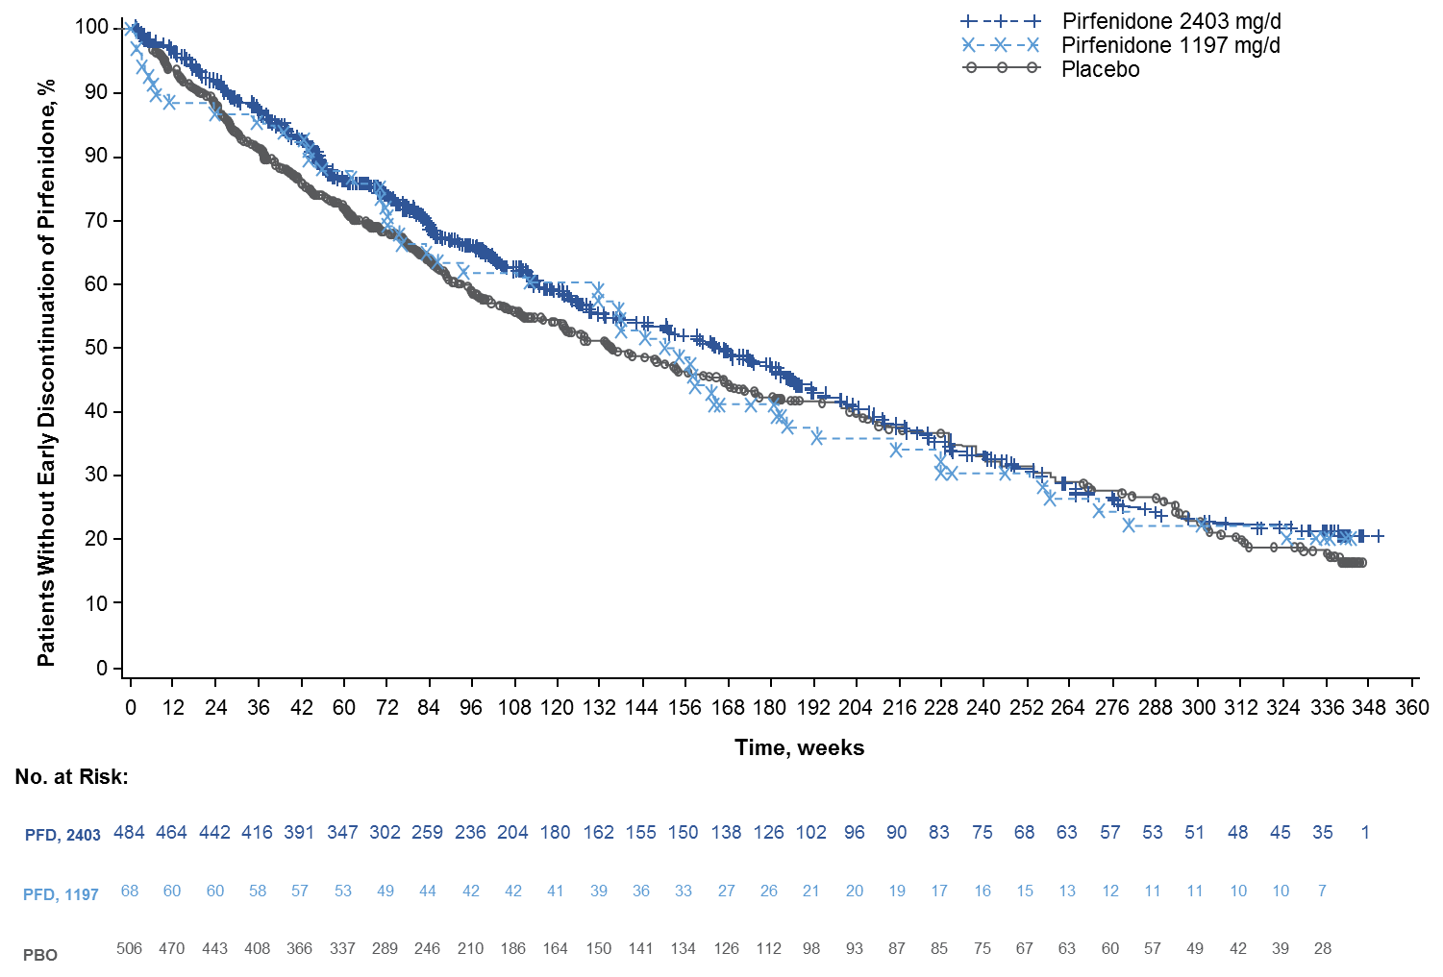
PBO, placebo; PFD, pirfenidone.
* Data as of June 30, 2015, clinical data cut date. All patients who rolled over from the CAPACITY and ASCEND trials received pirfenidone. The three groups represent prior treatment in the phase 3 trials before entering RECAP. Time to event is defined as event date or censoring date minus first dose date, plus one. Patients ongoing at time of clinical data cut date are censored.
B. Discontinuations by reason and time period in RECAP (N = 1058)

Time to Treatment Discontinuation, n (%)* | Reason for Discontinuation
 | AE: IPF† | AE: Other | Death | Lung Transplant | Other
Total | 115 (10.9) | 243 (23.0) | 95 (9.0) | 44 (4.2) | 129 (12.2)
< 1 y | 34 (29.6) | 107 (44.0) | 32 (33.7) | 18 (40.9) | 55 (42.6)
1 to < 2 y | 21 (18.3) | 60 (24.7) | 21 (22.1) | 13 (29.5) | 35 (27.1)
2 to < 3 y | 17 (14.8) | 30 (12.3) | 10 (10.5) | 5 (11.4) | 11 (8.5)
3 to < 4 y | 14 (12.2) | 19 (7.8) | 11 (11.6) | 4 (9.1) | 13 (10.1)
4 to < 5 y | 11 (9.6) | 13 (5.3) | 10 (10.5) | 3 (6.8) | 10 (7.8)
≥ 5 y | 18 (15.7) | 14 (5.8) | 11 (11.6) | 1 (2.3) | 5 (3.9)
AE, adverse event; IPF, idiopathic pulmonary fibrosis.
* Percentages were calculated within reason for individual time periods.
† AE:IPF discontinuations include preferred terms of disease progression, idiopathic pulmonary fibrosis and interstitial lung disease. AEs resulted in study withdrawal.

Figure 2. Mean (95% CI) for Observed and Model-Predicted FVC (mL) Over Time in RECAP*
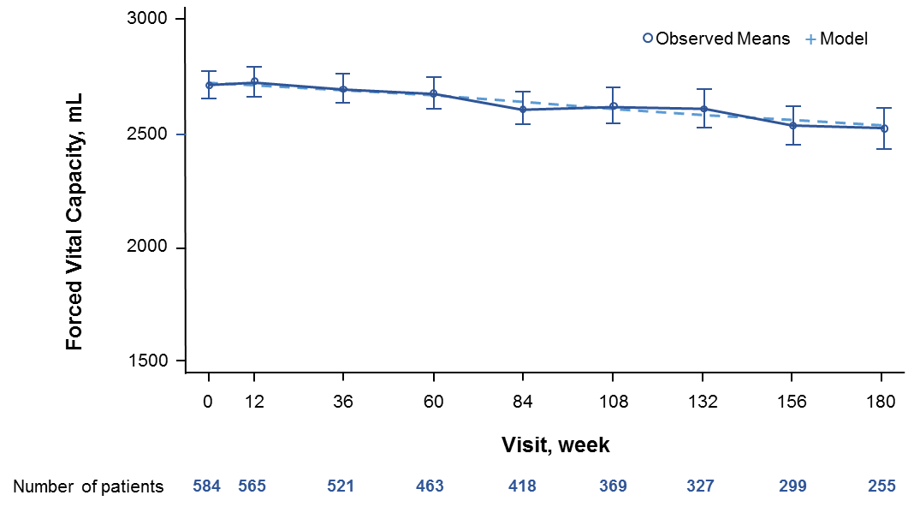

FVC, forced vital capacity.
* Patients rolled over from CAPACITY (n = 603) who were treated with pirfenidone in RECAP with complete FVC data.

